AI Workforce: Governed Multi-Agent Execution Platform
Individual capstone proposal · Runnable deterministic baseline · September 6, 2026

Basic Information
Field | Response
Student name | Manas Arun Tole
Project title | AI Workforce: Governed Multi-Agent Execution Platform
Repository / notebook link | REPLACE BEFORE SUBMISSION: public GitHub repository URL
Configuration location | README.md and .env.example

Section 1. Problem Definition
The project addresses a gap between agents that generate useful text and systems that can safely complete multi-step work. An operator supplies a natural-language objective and optional evidence. The system should return a typed plan, structured tool outputs, an auditable result, and a human approval request before any consequential action. Intended users are project leads delegating repeatable research-to-action tasks.
Success means the workflow completes reproducibly, every state transition is traceable, and no high-risk tool runs without approval. Failure includes an unrecorded action, invalid plan/tool call, missing output, or an irreproducible run.

Section 2. Motivation and Project Scope
Agentic AI is appropriate because the task requires decomposition, specialized roles, tool use, persistent state, and feedback across runs. The semester scope includes manager/planner/executor/critic roles, a risk-aware tool registry, SQLite audit history, human approvals, bounded lesson memory, and an operations console.
Out of scope are high-impact decisions, unrestricted shell or browser access, production authentication, billing, and autonomous code/policy modification. External messaging remains simulated until authorization and idempotency controls are evaluated.

Section 3. Runnable Baseline
The baseline is a deterministic research-to-brief workflow implemented in Python 3.9+, FastAPI, and SQLite. It needs no model key or network connection. The manager creates a plan; knowledge.search records the objective as hypothesis-level evidence; content.synthesize creates an action brief; the critic checks completion and stores a scored lesson.
Implementation: src/ai_workforce/{agents,orchestrator,tools,db,llm}.py. Interfaces: cli.py, sdk.py, app.py, and static/. This is a reasonable baseline because it proves the end-to-end state, tool, output, and evaluation contracts before dynamic planning or live integrations are introduced.

Section 4. Test Case and Baseline Output
Input: “Analyze the AI support pilot evidence and prepare an action brief.” Expected: completed run, two completed steps, quality score 0.85, and no outbound side effect. Actual: all expectations passed in deterministic demo mode.
What worked: research → synthesis → critique completed and persisted a lesson. Known gap: without supplied sources the evidence is explicitly hypothesis-level; the baseline does not perform live web research.
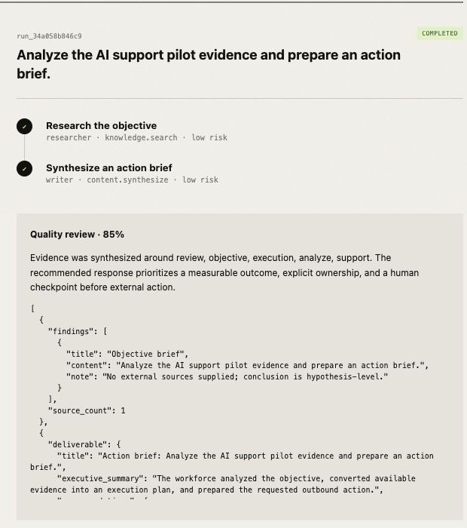
Figure 1. Actual baseline output captured September 6, 2026.

Section 5. Reproducibility and Run Instructions
Requirements: Python 3.9+. From the repository root run: python3 -m venv .venv; source .venv/bin/activate; pip install -e .; workforce run "Analyze the AI support pilot evidence and prepare an action brief." --no-message. No API key or environment variable is required.
Input/expected values are in examples/proposal_baseline_case.json. JSON output appears in the terminal and is stored in data/workforce.db. The submitted screenshot is artifacts/evidence/baseline-success.png. Full instructions are in README.md.

Section 6. Initial Evaluation Plan
Compare the baseline with the improved system on 20 fixed objectives. Measure task completion, trace completeness, evidence correctness, unauthorized-action rate (target 0%), latency, tool failures, and lesson reuse. Three reviewers will rate relevance, factuality, feasibility, and clarity from 1–5; report medians and failures.

Section 7. Limitations and Next Steps
The baseline uses a fixed plan, lexical memory, a structural—not factual—quality score, and simulated connectors. Next phases add source-grounded research, dynamic planning constrained by tool schemas, semantic memory with conflict controls, and an authenticated connector with idempotency. Main risks are scope growth, prompt injection, weak evaluations, and connector safety.

