Capstone Project Proposal
MirrorGPT Lite • Individual runnable baseline • CSE 598

Basic Information
Field | Response
Student name | Manas Tole
Project title | MirrorGPT Lite: A Grounded Personal-Profile Agent
Repository / notebook link | PUBLIC GITHUB URL REQUIRED BEFORE SUBMISSION
Configuration location | README.md (no API key or environment variables required)

Section 1. Problem Definition
The system answers natural-language questions as the owner of a supplied personal profile while remaining grounded in that profile. The intended user is a person building a transparent digital representative. Input is a UTF-8 profile plus one question; output is JSON containing the question, a first-person answer, and supporting evidence. Success means an answer is supported by the profile or the system correctly abstains. An unsupported claim, missed answerable fact, or non-runnable setup is failure.

Section 2. Motivation and Project Scope
Personal agents can save users from repeatedly answering factual questions, but hallucination and privacy errors make them risky. An agentic approach is appropriate because a later system can explicitly retrieve, answer, verify evidence, and decide when to abstain. This semester covers text profiles, grounded question answering, evidence display, conversation context, and repeatable evaluation. Voice/video cloning, autonomous external actions, production authentication, and training a foundation model are out of scope.

Section 3. Runnable Baseline
The runnable baseline is a deterministic Python 3 rule-and-retrieval system with no external libraries or APIs. It reads the profile and question, applies an education rule or expanded keyword retrieval, returns a first-person answer with evidence, and abstains when nothing matches. A local web UI calls the same baseline through a JSON API. This establishes a reproducible floor for task completion, groundedness, and abstention. Files: baseline.py, app.py, web/, examples/test1.txt, tests/, and outputs/test1.json.

Section 4. Test Case and Baseline Output
Sample input: “Where did you go to college?” Expected: identify profile institutions, answer in first person, and cite evidence. Actual: the UI named the University of Washington and The University of Texas at Austin and displayed both evidence lines.
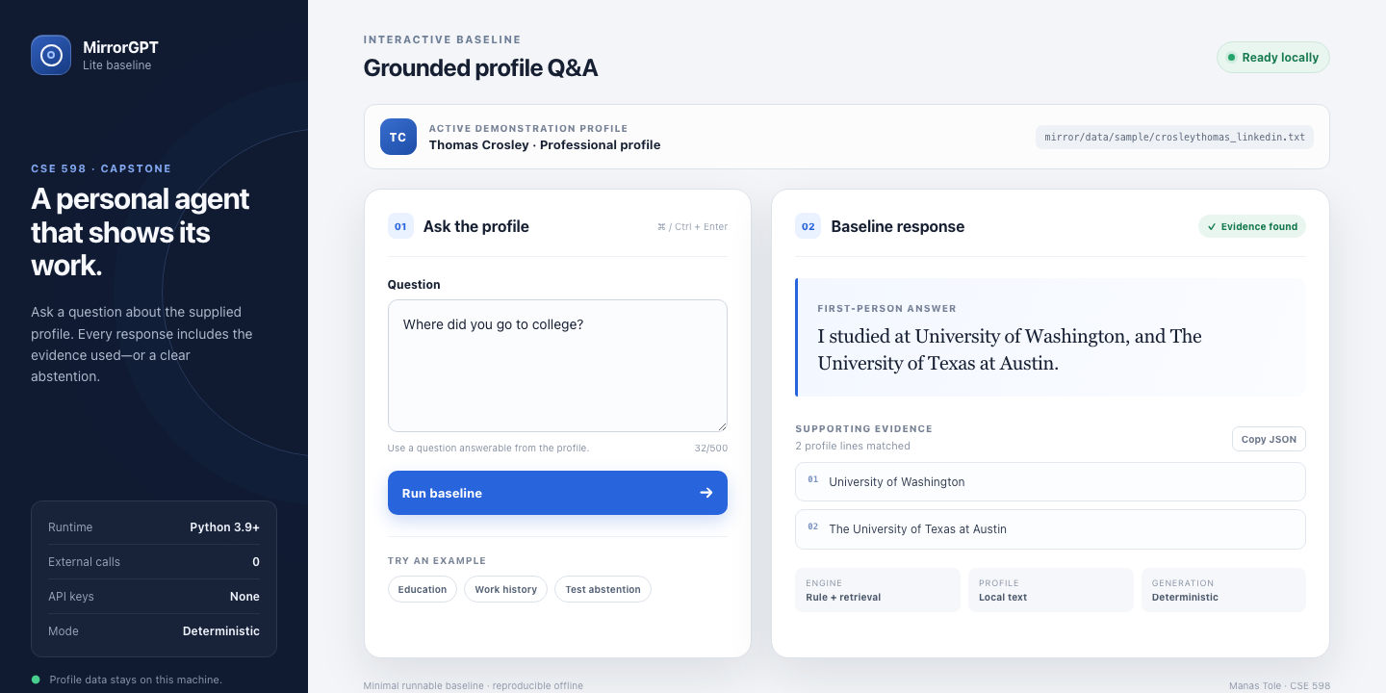
Figure 1. Working local UI with actual grounded baseline output.
What worked: the answer is reproducible, first-person, evidence-backed, and accessible through both UI and CLI. What did not: the rule lists institutions but does not distinguish completed degrees from the incomplete PhD year, illustrating shallow semantics.

Section 5. Reproducibility and Run Instructions
Use Python 3.9+ from the repository root; no package installation, API key, environment variable, or network access is required. Full setup, CLI instructions, inputs, and outputs are in README.md. Start the UI with:
python3 app.py
Open http://127.0.0.1:8765. The CLI test writes outputs/test1.json; verify all three tests with: python3 -m unittest discover -s tests -v.

Section 6. Initial Evaluation Plan
I will build a 40-question set balanced between answerable and unanswerable questions, with manually labeled answers and evidence. Baseline and improved systems will be compared on answer correctness, evidence precision, abstention precision/recall, unsupported-claim rate, median latency, and per-query API cost. Paired per-question results will show whether the agentic workflow improves accuracy and groundedness rather than only fluency.

Section 7. Limitations and Next Steps
The baseline relies on brittle rules and lexical overlap, handles paraphrases and multi-hop questions poorly, has no dialogue memory, and uses a specialized education rule. Next I will add semantic retrieval, an answer-and-citation generator, a verifier/abstention step, conversation state, and privacy filters. Main risks are evaluation-label quality, API cost, and keeping personal data private; a deterministic offline fallback will remain available.

