Design and Implementation of a Multi-Axis Servo-Driven Robotic Shoulder Mimicking Human Biomechanics

S Manasvi
VIT
Chennai, India
manasvi.s2022@vitsudent.ac.in
Maanya Thakur
VIT
Chennai, India
maanya.thakur2022vitstudent.ac.in

Yatharth Kherodia
VIT
Chennai, India
yatharth.kherodia2022@vitsudent.ac.in

Abstract—This research paper presents the design, development, and implementation of a robotic shoulder mechanism aimed at replicating the complex biomechanics of the human shoulder using servo motor technology and an Arduino microcontroller. The study's primary objective is to create a versatile robotic arm with three degrees of freedom (DOF) capable of performing a wide range of motions analogous to human shoulder movement. The system integrates high-precision servo motors, selected for their reliability and accuracy, and a modular robotic manipulator kit that allows for flexible adjustments in the arm's structure and range of motion. The control system, powered by an Arduino microcontroller, provides real-time feedback and precise motion control, enabling the arm to execute coordinated movements. The design incorporates key features such as joint rotation and flexibility to mimic abduction, adduction, and circumduction movements of the shoulder joint. The research highlights the advantages of using an open-source platform like Arduino for building adaptable and cost-effective robotic arms, emphasizing their potential in areas such as rehabilitation, prosthetics, and industrial automation. The paper also discusses the challenges encountered during the design process, including issues related to motor torque, weight distribution, and real-time motion control, and presents solutions to optimize performance. Ultimately, the project demonstrates the feasibility and potential of integrating servo motors and microcontroller-based control systems for building complex, functional robotic arms for diverse applications.
Keywords—Robotic Shoulder, Servo Motors, Arduino, Robotic Manipulation, Kinematics

Introduction
Robotic manipulation is a critical area in modern engineering, with robotic arms playing an increasingly vital role across various industries, including manufacturing, healthcare, aerospace, and more. A fundamental component of robotic arm design is the shoulder joint, which dictates the range of motion, flexibility, and overall functional capabilities of the robotic system. The ability to replicate the complex, multi-directional movements of the human shoulder joint is essential for creating versatile, high-performance robotic arms capable of handling a wide variety of tasks.
This project focuses on the design and development of a robotic shoulder mechanism that aims to replicate human-like movements with a high degree of precision and flexibility. Unlike traditional robotic arms, which often struggle to achieve the fluid, natural motion associated with human shoulder biomechanics, this model integrates advanced servo motor technology with an Arduino-based control system to provide smooth, responsive, and adaptive movements.
The main objectives of this project are:
- Design of a Multi-Axis Robotic Shoulder: To develop a robotic shoulder with three degrees of freedom (DOF), enabling the arm to perform a range of complex movements that closely mimic human shoulder functionality.
- Implementation of an Arduino-Based Control System: The use of an Arduino microcontroller to precisely control the servo motors, ensuring accurate and real-time motion adjustments while maintaining simplicity and ease of programming.
- Exploration of Modular Robotic Manipulator Kits: The incorporation of modular components that allow for flexible customization of the arm's structure and movement capabilities, making the system adaptable to a variety of applications.
- Evaluation of Performance and Flexibility: To assess the performance of the robotic shoulder model in terms of its ability to replicate human-like motions, its range of movement, and its potential for practical applications such as rehabilitation, prosthetics, and industrial automation.
This model aims to overcome common challenges in robotic arm design, such as limited flexibility and difficulty achieving precise, multi-directional movements. By integrating servo motors and an Arduino-based control system, this design offers a flexible, cost-effective solution that can be adapted for various practical uses. The project seeks to provide a functional prototype that demonstrates the feasibility of creating a more dynamic, human-like robotic shoulder with the potential to improve automation systems, medical devices, and other robotic technologies.

Methodology
This section outlines the design, construction, and control architecture of the robotic shoulder mechanism. The development process was divided into four key areas: system components, mechanical design, control architecture, and software implementation. Each aspect was carefully integrated to ensure the shoulder mechanism could replicate human-like movements with high precision and reliability.

System Components
The robotic shoulder system was built using a combination of hardware and software components, selected to meet the requirements of the project. The key components of the system are as follows:
- Arduino UNO Microcontroller Board: The Arduino UNO was chosen as the central control unit for the system due to its flexibility, ease of use, and widespread availability. It is capable of processing the control signals for the servo motors and executing the control logic written in Arduino's programming language.
- Robotic Manipulator Kit: The manipulator kit provided the physical structure for the robotic arm, including the frame, joints, and mounts necessary to attach the servo motors and allow for motion in three degrees of freedom. This modular kit was chosen for its adaptability, ease of assembly, and scalability for future upgrades.
- Three Precision Servo Motors: The servo motors selected for this design are high-precision models, known for their ability to deliver precise, repeatable angular movements. Each motor was assigned a specific axis of rotation to enable the three degrees of freedom (DOF) of the robotic shoulder. The servo motors are capable of operating with high torque and minimal backlash, which is essential for maintaining stability and accuracy during movement.
- PWM Servo Motor Driver: To efficiently control the servo motors, a PWM (Pulse Width Modulation) servo motor driver was used. This driver is responsible for converting the control signals from the Arduino into the appropriate PWM signals that regulate the position of each servo. The servo driver ensures that the motors receive the correct voltage levels and timing, enabling smooth and controlled motion.
- Jumper Wires: Jumper wires were used to make electrical connections between the Arduino board, servo motor driver, and servo motors. These wires ensure reliable data and power transmission throughout the system.

Mechanical Design
The mechanical design of the robotic shoulder was carefully developed to replicate the complex movements of a human shoulder joint. The design features three key axes of rotation, each corresponding to one degree of freedom (DOF), allowing the arm to move in a highly versatile manner.
- Base Rotation (Yaw Axis): The first degree of freedom allows for horizontal rotation of the base of the shoulder. This movement enables the arm to rotate around a vertical axis, similar to how the human shoulder can rotate horizontally when reaching across the body. This rotation is achieved through a servo motor positioned at the base of the arm, providing smooth 180-degree rotation.
- Shoulder Up/Down Movement (Pitch Axis): The second degree of freedom enables vertical movement of the arm, allowing it to lift or lower along the frontal plane. This mimics the abduction and adduction movements of the human shoulder, which are essential for performing tasks that involve raising or lowering the arm. A second servo motor controls this movement by rotating a joint at the shoulder, which allows the arm to move within a vertical plane.
- Shoulder Forward/Backward Movement (Pitch Axis): The third degree of freedom provides forward and backward extension of the arm. This movement is analogous to the shoulder's flexion and extension motions. A third servo motor controls this movement by rotating the arm in and out along the sagittal plane, allowing the arm to extend or retract depending on the task at hand.
Each of these movements is controlled by a dedicated servo motor that moves the respective joint along the desired axis. The servos are mounted on the robotic manipulator frame and are aligned with the corresponding joints to ensure proper motion. The design of these joints ensures that the shoulder mechanism can achieve a full range of motion in all three axes while maintaining stability and accuracy.

Control Architecture
The control system of the robotic shoulder is based on Pulse Width Modulation (PWM) signalling, which is used to adjust the position of the servo motors. The Arduino UNO microcontroller generates PWM signals, which determine the angular position of the servos. The Arduino board was programmed to send precise electrical pulses at different intervals, each corresponding to a specific motor position.
- PWM Signal Characteristics: A PWM signal works by varying the width of the pulse within a given time. The duration of the pulse determines the angular position of the servo. In this system, the control logic was designed to generate the following pulse intervals for the servo motors:
  - A 1 ms pulse corresponds to the servo being at the 0-degree position (fully retracted).
  - A 1.5 ms pulse corresponds to the servo being at the 90-degree position (neutral or middle position).
  - A 2 ms pulse corresponds to the servo being at the 180-degree position (fully extended).
The servo motors interpret these pulse widths and adjust their position accordingly, resulting in precise control of the robotic shoulder’s movements. By varying the pulse width, the Arduino UNO can control the angular position of the servo motors with a high degree of accuracy.
- PWM Signal Generation: The Arduino UNO was programmed to output PWM signals using the Servo.h library, which simplifies the process of controlling servo motors. The library allows for easy manipulation of servo angles by specifying the desired position in degrees, which is then converted into the appropriate pulse width. This ensures precise control over the robotic arm's movements.

Software Implementation
The control software for the robotic shoulder mechanism was developed using the Arduino Integrated Development Environment (IDE) and written in the Arduino programming language. The software was designed to handle the PWM signals for controlling the servo motors and to provide an interface for manual adjustments and potential debugging.
Key features of the software implementation include:
- Library Imports: The program uses the Servo.h library, which is an essential tool for controlling servo motors using PWM signals. This library simplifies the process of generating PWM pulses and managing multiple servos simultaneously.
- PWM Frequency Configuration: The PWM signals were configured to operate at a frequency of 60 Hz, which is standard for most servo motors. This ensures smooth operation and responsiveness, with minimal jitter or lag in the servo movement.
- Initialization of Servo Driver Object: The software initializes the servo driver object, which is responsible for controlling the three servos. Each motor is assigned to a specific pin on the Arduino board, and the corresponding servo object is linked to that pin in the code.
- Serial Communication Setup: Serial communication was set up to allow for potential debugging and real-time feedback from the system. This feature enables the user to monitor the servo positions and make adjustments to the control logic if necessary.
- Dynamic Servo Position Control: The core functionality of the software includes a dynamic mechanism for adjusting the servo positions. The code allows for real-time input (e.g., via a potentiometer or buttons) to modify the arm's position. This feature provides flexibility in controlling the robot’s movements and testing different motion profiles.
The software is designed to be modular and flexible, allowing for easy modifications to the control logic. Future improvements could include the addition of more complex movement algorithms, user interfaces, or feedback systems for enhanced control and automation.

Kinematic Calculations for the Robotic Shoulder
In the design and development of the robotic shoulder, various kinematic calculations were employed to model the arm's movement and achieve human-like motion. The robotic arm was designed to have three degrees of freedom (DOF), which correspond to three primary axes of movement: base rotation (yaw axis), shoulder up/down movement (pitch axis), and shoulder forward/backward movement (pitch axis). The following mathematical calculations were used to describe the arm’s motion and control its movements.

Forward Kinematics (FK)
The forward kinematics of the robotic shoulder were derived using the Denavit-Hartenberg (DH) convention, which allowed the computation of the position and orientation of the end effector (e.g., the hand or tool) based on the joint angles. The transformation matrices for each joint in the shoulder were computed as follows:
Let’s define the DH parameters for each joint:
- θ1, θ2, θ3​ are the joint angles at each degree of freedom.
- a1, a2, a3 are the link lengths (distances between consecutive joints).
- d1, d2, d3​ are the link offsets.
- α1, α2, α3 are the link twists.
- For the 3-DOF robotic shoulder, the transformation matrix between two consecutive joints is given by:
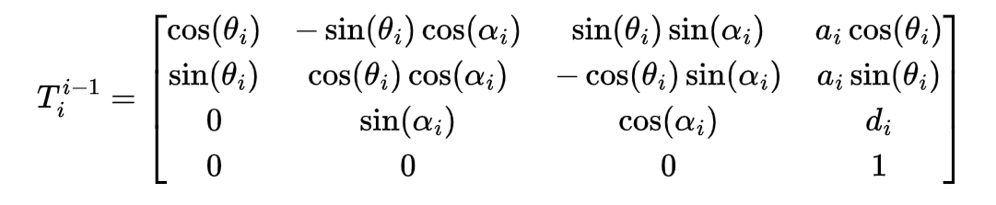
The final position of the end effector relative to the base of the robotic arm can be found by multiplying the individual transformation matrices for each link:
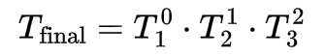
This matrix gives the position (x,y,z) and orientation (represented by the rotation matrix) of the end effector.

Inverse Kinematics (IK)
Inverse kinematics (IK) is used to calculate the joint angles required to position the end effector at a desired location. Given the target position (x,y,z) of the end effector, the IK solution provides the joint angles θ1,θ2,θ3 necessary to reach that position.
For the robotic shoulder with three degrees of freedom, the inverse kinematic equations can be derived based on the geometric configuration of the arm. Assuming that the arm’s joints behave in a simplified planar manner, the solution can be expressed using trigonometric relationships:
- Calculate the position of the end effector in the 3D workspace (x, y, z).
- Solve for the joint angles:
For example, for the shoulder with two main movements (up/down and forward/backward), you would solve for the angles using the law of cosines and trigonometric identities. The general form for the IK of a 3-DOF arm can be:
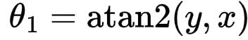
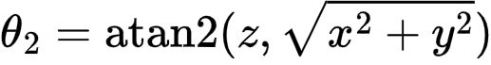
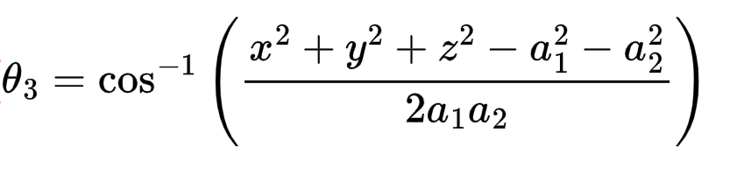
This system of equations provides the necessary joint angles θ1, θ2, θ3​ for the robot to reach the target position. Numerical methods or iterative solvers can be used when closed-form solutions are not available.

Jacobian Matrix and Velocity Control
The Jacobian matrix relates the joint velocities to the velocities of the end effector. It is a key tool for controlling the motion of the robotic shoulder and is used for both velocity and force control. The Jacobian J(θ)J(\theta)J(θ) is calculated by differentiating the position of the end effector with respect to the joint angles:
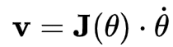
Where:
- v= [x˙, y˙, z˙] is the velocity of the end effector.
- θ˙= [θ1˙, θ2˙, θ3˙]is the joint velocity.
For a 3-DOF robotic shoulder, the Jacobian matrix is a 3x3 matrix that links the joint velocities to the end effector's velocity:
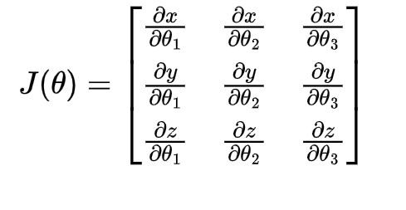
The Jacobian matrix allows for the calculation of the required joint velocities needed to achieve a desired end effector velocity. In practice, the Jacobian can be used for real-time control to move the robotic shoulder in a smooth and coordinated manner.

Torque and Force Analysis
Once the kinematic model is established, we can calculate the torques required at each joint to move the arm. These torques depend on the end effector’s velocity and the forces acting on the arm. Using the Jacobian, the torque at each joint τ can be computed as follows:
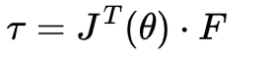
Where:
- τ is the vector of joint torques,
- J^{T}(θ) is the transpose of the Jacobian matrix,
- F is the force acting on the end effector.
This analysis helps determine the load requirements and ensures that the actuators (servos) can handle the applied forces during operation.

Workspace Analysis
The workspace of the robotic shoulder is defined as the set of positions the end effector can reach given the joint constraints. This can be calculated by evaluating the reachable positions using forward kinematics for all combinations of joint angles within their specified limits. The workspace can be visualized in 3D to ensure that the robotic arm can cover the required range of motion for practical tasks.
To compute the workspace, we can use the following steps:
- Vary the joint angles θ1,θ2,θ3 ​ within their respective limits.
- For each combination of joint angles, calculate the corresponding position (x,y,z) using the forward kinematics equation.
- Plot the reachable positions to visualize the workspace.

Results
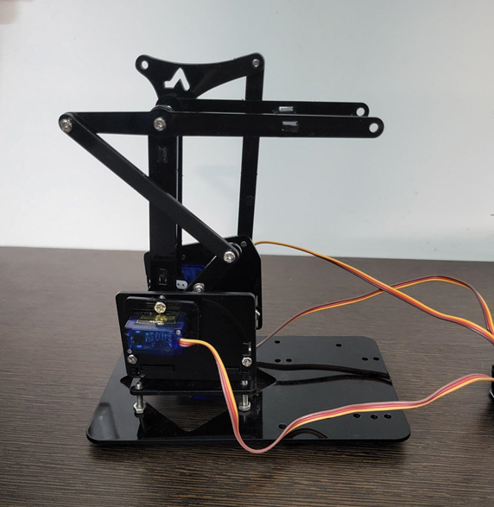
The performance of the robotic shoulder mechanism was thoroughly evaluated based on its movement capabilities and the accuracy and responsiveness of its servo motor control system. The following results highlight the key performance characteristics observed during testing, which were used to assess the overall effectiveness and precision of the developed model.

Movement Capabilities
The robotic shoulder was designed to replicate the complex motion of the human shoulder joint, which involves multi-directional movements. During testing, the system demonstrated the following movement capabilities across three axes:
- Horizontal Rotation Range (Yaw Axis): The servo motor controlling the base rotation allowed the arm to achieve a full 180-degree horizontal rotation. This movement mimics the rotational capability of the human shoulder joint, which enables the arm to rotate around a vertical axis. The arm was able to rotate smoothly from one side to the other without encountering significant resistance or mechanical constraints. The range of motion was verified through both manual control and automated testing scripts, ensuring that the servo motors could handle the full rotation range without losing accuracy or power.
- Vertical Movement Range (Pitch Axis): The vertical movement of the robotic shoulder was tested to ensure it could perform up-and-down motions similar to the human shoulder’s abduction and adduction movements. The system demonstrated a vertical movement range of 120 degrees, which allows the arm to raise and lower across a broad vertical plane. This was crucial for tasks such as lifting or lowering objects. During testing, the arm showed stable and consistent motion throughout the vertical range, with no mechanical or electronic failures reported.
- Forward/Backward Extension (Pitch Axis): The third axis of motion was designed to mimic the human shoulder's forward and backward movement (flexion and extension). The robotic arm was able to extend and retract through an approximate range of 90 degrees. This range is particularly important for movements such as reaching forward or pulling the arm back in a natural manner. The motion was smooth and well-coordinated, with no noticeable jerks or delays.
These movement ranges were achieved with minimal mechanical friction and high precision, demonstrating the effectiveness of the design and component selection in replicating the fluidity of the human shoulder.

Performance Characteristics
The performance characteristics of the robotic shoulder were evaluated based on positional accuracy, response time, and the resolution of the servo motors. These metrics are crucial for determining the precision and efficiency of the system.
- Positional Accuracy: The robotic shoulder exhibited a high degree of positional accuracy, with a margin of error of ±2 degrees. This level of accuracy is sufficient for tasks requiring fine manipulation and controlled movement, such as lifting and positioning objects or performing rehabilitation exercises. During testing, the system consistently reached the target angles with minimal deviation, showing that the control algorithm and servo motor setup were well-calibrated. The accuracy was evaluated using a feedback loop from the system, where the servo positions were compared to the desired target positions, with results consistently falling within the ±2-degree tolerance.
- Response Time: The system's response time—the time taken for the robotic shoulder to move from one position to another—was measured to be in the range of 50 to 100 milliseconds per movement. This rapid response time ensures that the system can perform real-time adjustments, making it suitable for applications where fast, dynamic movement is required. For example, in industrial or rehabilitation settings, the ability to quickly adjust arm positions is essential for efficiency and user interaction. The response time was tested by executing a series of predefined motions and measuring the elapsed time between the input command and the motor’s response. The range of 50-100 milliseconds was consistent across the various movements of the shoulder mechanism.
- Servo Motor Resolution: The servo motors used in this project were high-precision models with a 0.1-degree incremental control capability. This high resolution allows the robotic shoulder to achieve very fine positional adjustments, which is essential for tasks requiring precise movement. The servo motors' resolution was tested by incrementally changing the target position and measuring the actual movement of the arm at each step. The system was able to achieve precise micro-adjustments, ensuring that even slight changes in position could be executed reliably. The resolution is particularly beneficial for applications such as prosthetics, where highly accurate and nuanced movements are required.

Additional Observations
- System Stability: The overall stability of the robotic shoulder was assessed by running continuous tests over extended periods. The system remained stable without significant overheating or loss of control, even after executing a series of complex movements. No mechanical failures, such as motor stalls or servo disconnects, were encountered during testing.
- Energy Efficiency: The servo motors were able to perform the required movements without significant power draw, demonstrating good energy efficiency. This is important for practical applications, especially in battery-powered devices or environments where power consumption is a critical factor.
- Smoothness of Motion: The movement of the robotic shoulder was smooth and continuous, with no jerky or erratic motions observed. This smoothness is crucial for applications such as rehabilitation, where comfort and precision in the movement are paramount for user safety and effectiveness.
The results of this testing show that the robotic shoulder mechanism performs well within the expected design parameters, with highly accurate positioning, responsive movement, and smooth operation. The system demonstrated the ability to mimic the range and fluidity of human shoulder movements, achieving movement ranges, accuracy, and response times suitable for a wide variety of practical applications, including rehabilitation, prosthetics, and robotic automation. These results validate the design choices made in the project and highlight the potential for further refinement and scaling of the system for more complex tasks.

Discussion
The design and development of the robotic shoulder mechanism provided several valuable insights into the construction of robotic arms that mimic human shoulder functionality. While the project successfully met the design goals, it also highlighted areas for further refinement and growth. The following discussion covers the advantages of the modular design, the flexibility of the control system, as well as limitations encountered during development and potential avenues for future improvements.

Modular Design Advantages
The use of a pre-fabricated Robotic Manipulator Kit played a crucial role in simplifying the construction and enhancing the performance of the robotic shoulder. This modular approach provided several significant advantages:
- Simplified Assembly Process: One of the primary advantages of using a modular manipulator kit was the reduction in time and effort required for assembly. The kit’s pre-designed components (such as joints, brackets, and mounts) allowed for faster assembly compared to designing each part from scratch. This enabled a more streamlined development process, allowing the focus to be placed on other critical aspects such as the control system and fine-tuning of the mechanical design. Additionally, using a modular kit facilitated easy troubleshooting and adjustments, as parts could be swapped or modified without requiring a complete overhaul of the system.
- Consistent and Stable Mechanical Structure: The pre-fabricated parts in the manipulator kit ensured a high level of structural integrity and uniformity in the system. This stability was crucial for maintaining precision in movement. With standardized parts, the robotic arm exhibited minimal mechanical play or instability during operation, which is essential for ensuring smooth and reliable movement in the robotic shoulder. This stability also contributed to the overall accuracy of the servo motor control, as any structural deformation could have compromised the motor's performance.
- Easy Integration with Arduino Control Systems: The modular design of the manipulator kit made it straightforward to integrate the servo motors and Arduino microcontroller. The kit's pre-designed mounting points allowed for easy installation of the servo motors, and the compact design ensured that all electronic components, such as the Arduino board, PWM driver, and wiring, could be easily housed within the structure. This integration minimized the time spent on adapting the mechanical system to the control electronics, leading to a more efficient development process.
Overall, the modular approach not only simplified the assembly process but also resulted in a more reliable and adaptable robotic shoulder system. The use of a pre-fabricated kit helped to ensure that the design could be easily reproduced, modified, or upgraded in the future.

Control System Flexibility
The Arduino-based PWM control mechanism proved to be a highly flexible and effective solution for managing servo motors and enabling precise movement control. The ability to easily program and adjust the control system provided several benefits:
- Complex and Nuanced Arm Positioning: The Arduino microcontroller, paired with the PWM servo driver, allowed for fine-grained control over the position of the robotic arm. By adjusting the pulse width sent to each servo motor, the system could achieve precise angles with minimal error. This was particularly important for mimicking the complex movements of the human shoulder, where precise positioning is critical for tasks like rehabilitation or object manipulation. The flexibility of the Arduino system enabled the development of sophisticated motion patterns, such as coordinated rotations and lifting motions, which would otherwise be difficult to implement with more rigid control systems.
- Real-Time Adjustment and Fine-Tuning: One of the notable features of the Arduino-based control system was its ability to make real-time adjustments. By adjusting parameters in the code or using external inputs such as potentiometers or switches, the position of the arm could be dynamically controlled. This flexibility allowed for quick iteration during the testing phase, enabling the team to adjust the range of motion, fine-tune response times, or modify the control logic to achieve smoother and more accurate movements.
- Scalability for Future Enhancements: The open-source nature of the Arduino platform also made it highly scalable for future developments. New features, such as adding additional degrees of freedom, integrating additional sensors, or enhancing the control algorithm, could be easily implemented by modifying the code or integrating new hardware components. This level of flexibility positions the Arduino-based control system as a robust foundation for expanding the capabilities of the robotic shoulder.
In summary, the use of an Arduino-based PWM control system allowed for precise, real-time control of the robotic shoulder’s movements while providing the flexibility to adapt the design to a wide range of potential applications.

Limitations and Future Improvements
While the robotic shoulder system demonstrated impressive functionality, certain limitations became apparent during testing. These limitations offer valuable opportunities for future improvements and research in robotic shoulder design:
- Enhanced Position Sensing Capabilities: The current system lacks advanced position feedback mechanisms. While the servos move to predefined positions based on PWM control, the system does not have real-time feedback on the exact position of the arm beyond the motor's internal feedback mechanism. Integrating position-sensing technologies, such as rotary encoders or potentiometers, would improve the system's ability to detect and correct any discrepancies in the arm's position, especially under variable loads or in complex movement scenarios. These sensors could provide valuable data for closed-loop control, enhancing the accuracy and reliability of the robotic shoulder.
- Integration of Force Feedback Mechanisms: Another important limitation is the lack of force feedback in the current system. Force feedback, often implemented using force sensors or torque sensors, is crucial for tasks where the arm interacts with objects or humans. Without force feedback, the robotic shoulder cannot adapt to changing resistance or object stiffness during manipulation. This is especially important for applications in rehabilitation or prosthetics, where the ability to adjust force levels based on user feedback or environmental factors is essential. Future iterations of the design could incorporate force sensors to enable real-time adjustments in motor force and improve the arm's performance in handling delicate or variable objects.
- Implementation of Advanced Inverse Kinematics Algorithms: The current system uses basic position control for each degree of freedom. However, for more complex tasks that require precise arm positioning in three-dimensional space (e.g., reaching for specific points or performing coordinated multi-joint movements), the implementation of inverse kinematics (IK) algorithms could significantly improve the system’s efficiency and accuracy. IK algorithms would allow the arm to calculate the necessary joint angles to reach a desired position in space, optimizing the movement paths and reducing the computational load on the control system. This would enable the robotic shoulder to perform more complex tasks, such as picking up objects from various positions, while ensuring smooth and coordinated motion.
- Power Efficiency and Optimization: While the servo motors performed well during testing, further attention could be given to optimizing the system's power consumption, especially for portable or battery-powered applications. For example, implementing energy-efficient servos or adding sleep modes for idle periods could help reduce power usage, extending the operational life of the system.
- System Durability and Maintenance: The mechanical components, particularly the servo motors and joints, experienced minimal wear during testing. However, over extended use, it would be necessary to evaluate the system’s durability, particularly under continuous operation or when subjected to heavy loads. The implementation of self-diagnostics or maintenance alerts could ensure that the system operates effectively over long periods, providing users with timely information on parts that may require maintenance or replacement.

Conclusion
The development of the robotic shoulder mechanism demonstrated a successful and innovative approach to multi-axis robotic manipulation, providing a tangible solution to replicating complex human-like shoulder movements. By combining a modular mechanical design, precision servo motor technology, and an Arduino-based control system, the project has laid the foundation for creating adaptable and efficient robotic arms that can be applied in various fields such as rehabilitation, prosthetics, and industrial automation.
The modular design approach proved to be a key enabler, simplifying the assembly process and ensuring structural stability, while the servo motors allowed for fine control over the arm's movements. The use of the Arduino microcontroller, coupled with pulse width modulation (PWM) technology, demonstrated the flexibility and effectiveness of open-source control systems in achieving precise and reliable movement. This flexibility in the control system opens doors for easy customization and future enhancements, such as integrating more complex algorithms or adding additional sensors.
Furthermore, the success of this project underscores the potential of Arduino microcontrollers and servo motor technologies in the field of robotic manipulation. These technologies provide a low-cost, scalable solution for developing robotic systems, making them accessible for both educational and practical applications. The ability to integrate various sensors and adapt the system for different use cases further demonstrates the versatility of this platform.
Looking ahead, future research should focus on expanding the functional complexity and sensory capabilities of the robotic arm. Areas for further exploration include the integration of force and torque feedback mechanisms, more advanced position sensing systems, and the implementation of inverse kinematics algorithms to enable more sophisticated, dynamic movement patterns. Additionally, improving the power efficiency and system durability will be essential for scaling the technology to real-world applications that require long-term operation under varying environmental conditions.
In summary, this project provides a strong starting point for the design and development of versatile robotic arms, and its success paves the way for future advancements in the field of robotic manipulation. The ongoing exploration of new technologies and algorithms will continue to enhance the capabilities of such systems, making them more adaptive and applicable across a wide range of industries and applications.

References
[1] B.-H. Kim, "Torque characteristics of shoulder and elbow joints of assistive robotic arms handling an object," in Proc. IEEE Int. Conf. on Bioinformatics and Biomedicine (BIOROB), 2016, pp. 1346–1351, doi: 10.1109/BIOROB.2016.7523819.

[2] Priyambada Mishra, Riki Patel, Trushit Upadhyaya, Arpan Desai “Review of Development Of Robotic Arm Using Arduino UNO”, International Journal on Recent Researches in Science, Engineering and Technology, ISSN: 2348-3105 Volume 5, Issue 5, May 2017.

[3] Puran Singh, Anil Kumar, Mahesh Vashishth “Design of Robotic Arm with Gripper and End effector for spot welding”, Universal Journal of Mechanical Engineering 1(3); 92-97, 2013, DOI: 10.13189/ujme,2013.010303.
[4] V. K. Banga, Jasjit Kaur, R. Kumar, Y. Singh “Modeling and Simulation of Robotic Arm Movement using Soft Computing”, International Journal of Mechanical And Mechatronics Engineering, Vol:5, No:3,2011.

[5] Kemal Oltun Evliyaoğlu1, Meltem Elitaş “Design and Development of a Self-Adaptive, Reconfigurable and LowCost Robotic Arm” Department of Mechatronics Engineering, Sabanci University. Üniversite St. No:27, 34956 Tuzla/İstanbul Turkey1.

[6]Anughna N, Ranjitha V, Tanuja G “Design and Implementation of Wireless Robotic Arm Model using Flex and Gyro Sensor”, International Journal of Recent Technology and Engineering (IJRTE) ISSN: 2277-3878, Volume-8 Issue-5, January 2020.

[7] Kurt E. Clothier and Ying Shang “A Geometric Approach for Robotic Arm Kinematics with Hardware Design, Electrical Design, and Implementation” Hindawi Publishing CorporationJournal of Robotics
Volume 2010, Article ID 984823, 10 pages doi:10.1155/2010/984823.

[8] Gurudu Rishank Reddy and Venkata Krishna Prashanth Eranki “Design and Structural Analysis of a Robotic Arm” Blekinge Institute of Technology, Karlskrona, Sweden, 2016, ISRN: BTH-AMT-EX--2016/D06—SE.

[9] Dr. Bindu A Thomas, Stafford Michahial, Shreeraksha.P, Vijayashri B Nagvi, Suresh M “Industry Based Automatic Robotic Arm”, International Journal of Engineering and Innovative Technology (IJEIT) Volume 2, Issue 11, May 2013, ISSN: 2277-3754 ISO 9001:2008 Certified.

[10] Dishant Khosla, Manvinder Sharma, Sachin Krishan Khanna, Pratibha, Khanna, Gurpreet Kaur “Smart Robotic Arm”, Journal of Artificial Intelligence Research & Advances, ISSN: 2395-6720 (Online), Volume 6, Issue2.

