OS Lab Experiment 1
Name – Manasvi Raghav
Roll no. - 2301010438

Task 1: Process Creation Utility
Write a Python program that creates N child processes using os.fork(). Each child prints:
- Its PID
- Its Parent PID
- A custom message
The parent should wait for all children using os.wait().

Input :
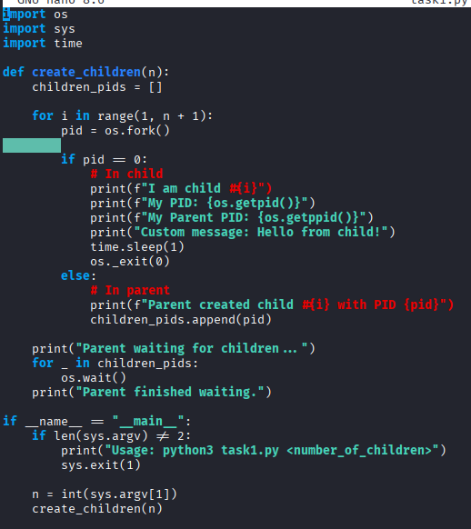

Output :
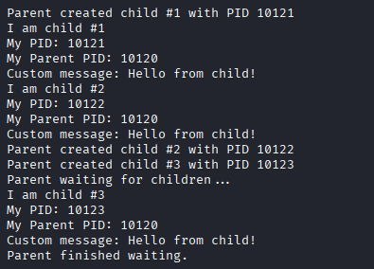

Task 2: Command Execution Using exec()
Modify Task 1 so that each child process executes a Linux command (ls, date, ps, etc.) using os.execvp() or subprocess.run().

Input:

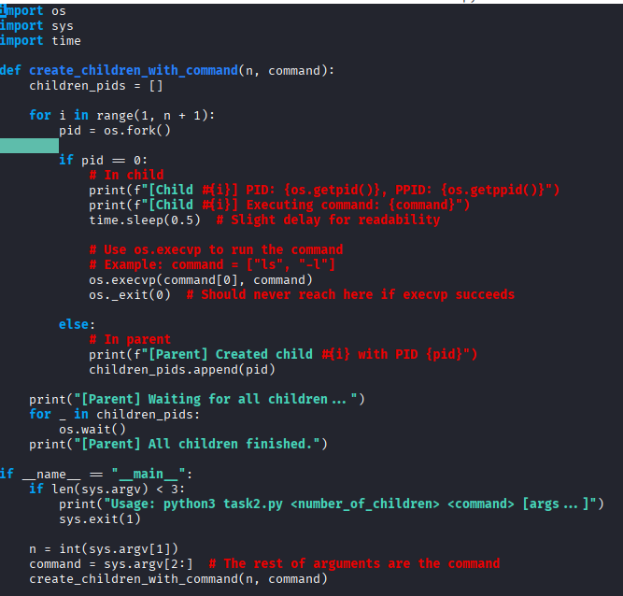

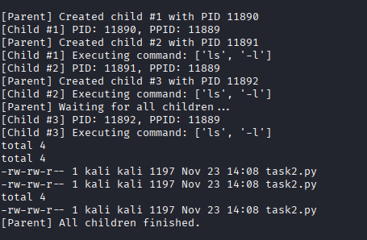
Output :

Task 3: Zombie & Orphan Processes
Zombie: Fork a child and skip wait() in the parent.
Orphan: Parent exits before the child finishes.
Use ps -el | grep defunct to identify zombies.

Input :

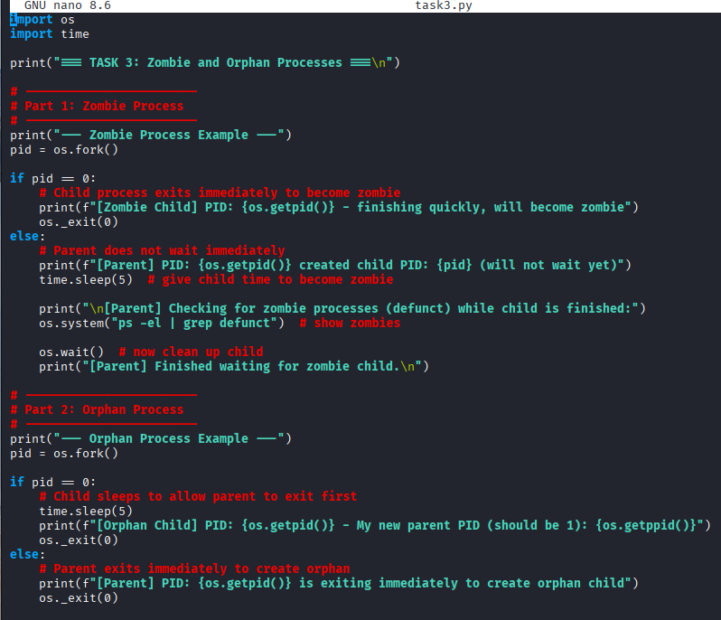
Output :

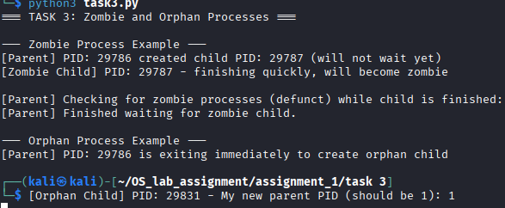

Task 4: Inspecting Process Info from /proc
Take a PID as input. Read and print:
- Process name, state, memory usage from /proc/[pid]/status
- Executable path from /proc/[pid]/exe
- Open file descriptors from /proc/[pid]/fd

Input :
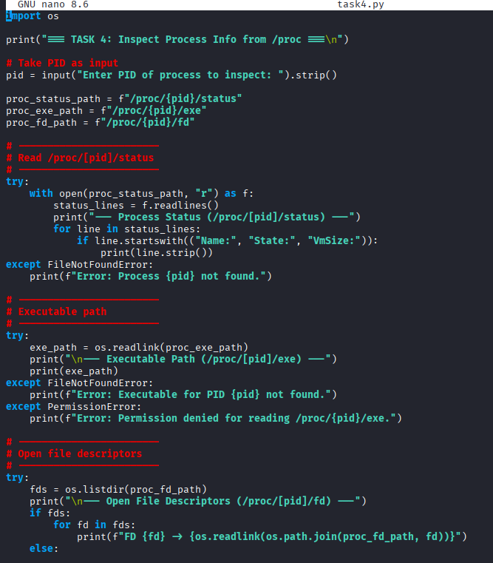
Output :
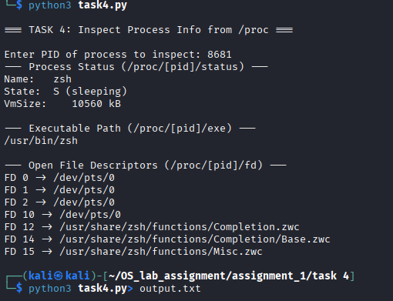

Task 5: Process Prioritization
Create multiple CPU-intensive child processes. Assign different nice() values. Observe and log execution order to show scheduler impact.

Input :
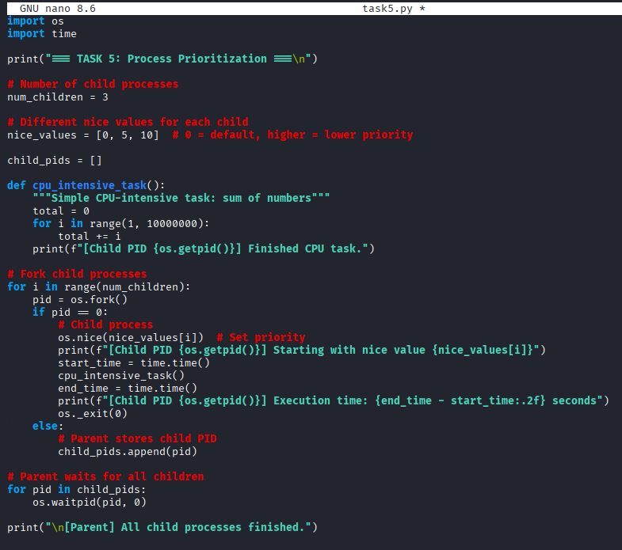

Output :
