OS Lab Assignment 3
School of Engineering and Technology
Course Code & Name: ENCS351 Operating System Lab
Program Name: B.Tech CSE Core Section G

Name: Manasvi Raghav
Roll No: 2301010438
Task 1: CPU Scheduling with Gantt Chart
Write a Python program to simulate Priority and Round Robin scheduling algorithms. Compute average waiting and turnaround times.
INPUT:

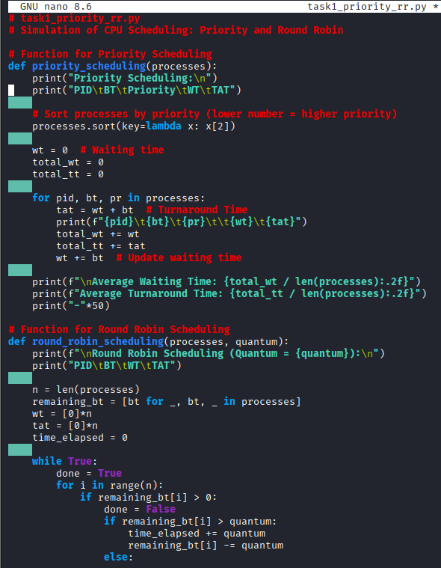
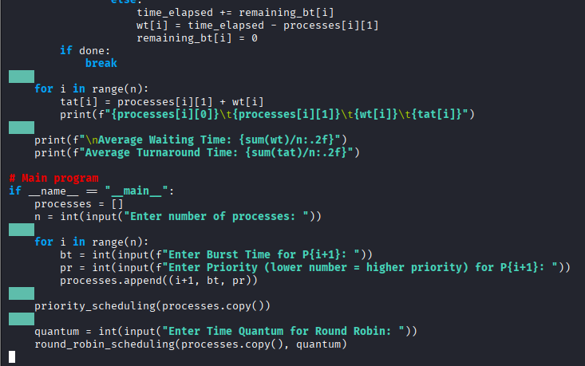

OUTPUT:
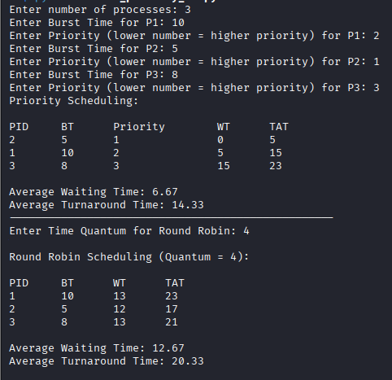

Task 2: Sequential File Allocation
Write a Python program to simulate sequential file allocation strategy.
INPUT:
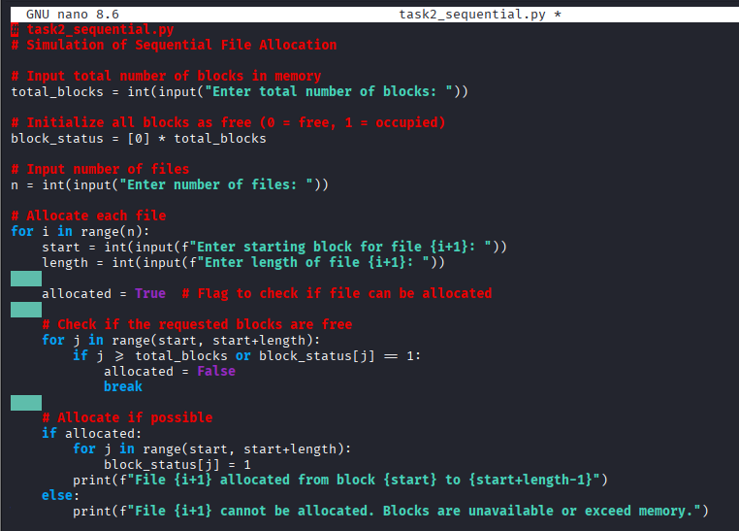

OUTPUT:

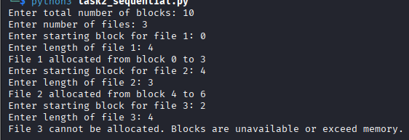

Task 3: Indexed File Allocation
Write a Python program to simulate indexed file allocation strategy.
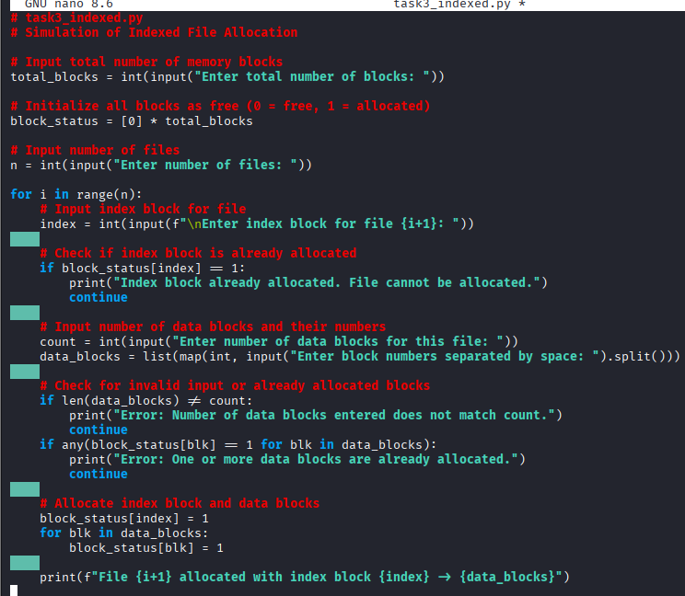

OUTPUT:
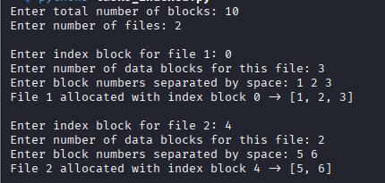

Task 4: Contiguous Memory Allocation
Simulate Worst-fit, Best-fit, and First-fit memory allocation strategies.
INPUT:
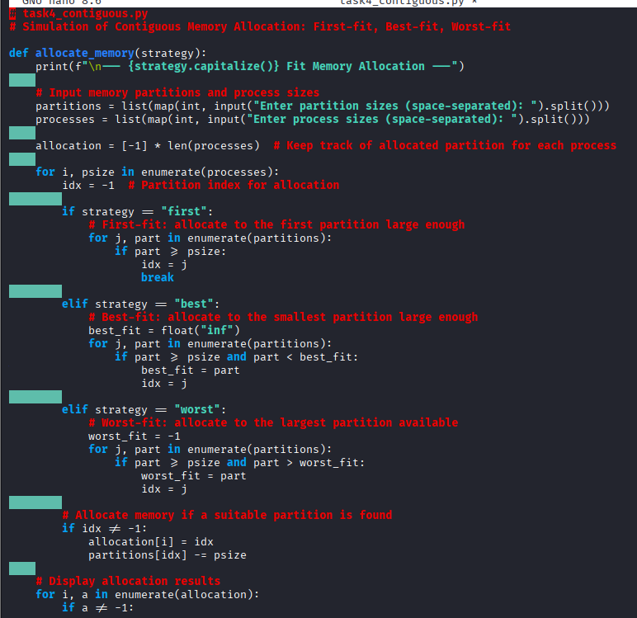
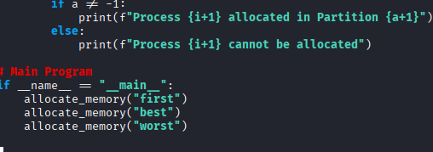

OUTPUT:
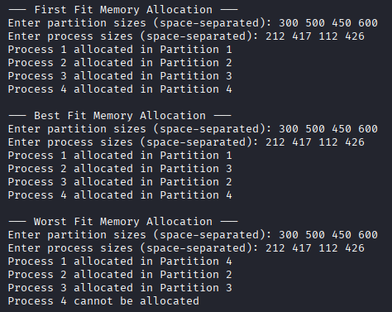
Task 5: MFT & MVT Memory Management
Implement MFT (fixed partitions) and MVT (variable partitions) strategies in Python.
INPUT:
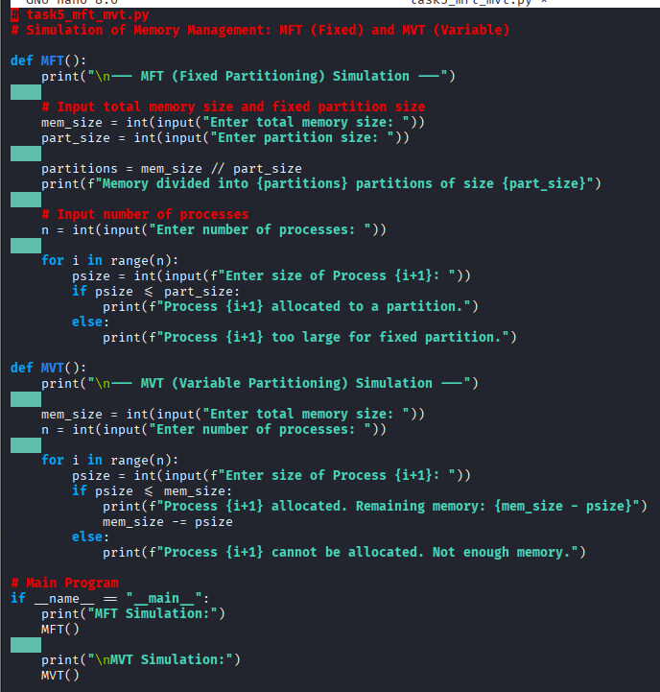
OUTPUT:
