OS Lab Assignment 2
School of Engineering and Technology
Course Code & Name: ENCS351 /Operating System
Program Name: B.Tech CSE Core Section G
Name:Manasvi Raghav
Roll No.:2301010438

Sub-Task 1: Initialize the logging configuration
Objective: Set up the logging system to log messages with timestamps and process names.
import logging
# Setup logger
logging.basicConfig(
filename='process_log.txt',
level=logging.INFO,
format='%(asctime)s - %(processName)s - %(message)s'
)
INPUT:

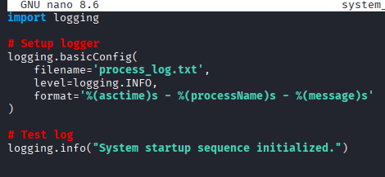
OUTPUT:

Sub-Task 2: Define a function that simulates a process task
Objective: Write a function that mimics the work of a system process.
import time
# Dummy function to simulate a task
def system_process(task_name):
logging.info(f"{task_name} started")
time.sleep(2) # Simulate task delay
logging.info(f"{task_name} ended")

INPUT:

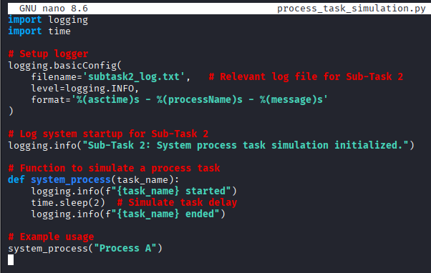

OUTPUT:

Sub-Task 3: Create at least two processes and start them concurrently
Objective: Use the multiprocessing module to initiate parallel tasks.
import multiprocessing
if __name__ == '__main__':
print("System Starting...")
# Create processes
p1 = multiprocessing.Process(target=system_process, args=('Process-1',))
p2 = multiprocessing.Process(target=system_process, args=('Process-2',))
# Start processes
p1.start()
p2.start()
INPUT:
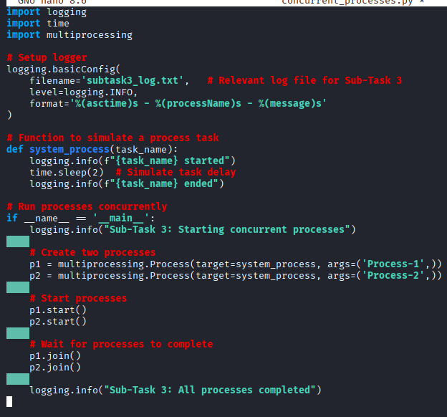

OUTPUT:

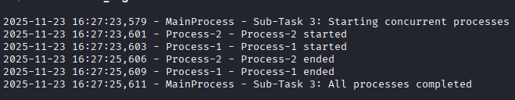

Sub-Task 4: Ensure proper termination and verify logs
Objective: Wait for processes to complete and confirm the shutdown.
# Wait for processes to complete
p1.join()
p2.join()
print("System Shutdown.")

INPUT:
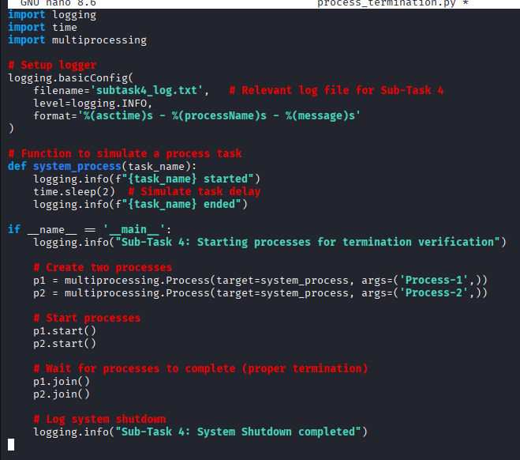
OUTPUT:
