YuvaIntern Ai pioneers internship(Machine Learning Internship) week3
Name : Manasvi Beri task : Unsupervised Learning & Model Evaluation

- Introduction
Machine learning techniques can be broadly divided into supervised and unsupervised learning. Clustering is an unsupervised learning technique that groups similar data points into different clusters without using predefined target labels. Model evaluation, on the other hand, helps measure how effectively a trained machine learning model performs on unseen data.
This task focuses on applying clustering techniques and evaluating a machine learning classification model using the Titanic dataset. Two clustering algorithms, K-Means Clustering and Hierarchical Clustering, were implemented to identify groups of passengers with similar characteristics. Principal Component Analysis (PCA) was also used for dimensionality reduction and visualization of the clusters.
In addition, a Random Forest Classifier was trained to predict passenger survival. Cross-validation, confusion matrix, precision, recall, F1-score, ROC-AUC, and hyperparameter tuning were performed to evaluate and improve the classification model.
The project demonstrates an end -to-end machine learning workflow involving data preprocessing, clustering, dimensionality reduction, classification, model evaluation, and hyperparameter optimization using Python and Scikit-learn.

Objectives
The main objectives of this project are:

  - To understand and implement clustering algorithms.
  - To apply K-Means Clustering to the Titanic dataset.
  - To implement Hierarchical Clustering.
  - To evaluate clustering performance using the Silhouette Score.
  - To understand dimensionality reduction using PCA.
  - To visualize clusters using PCA.

  - To understand cross-validation for machine learning models.
  - To evaluate a classification model using Accuracy, Precision, Recall, and F1-score.
  - To generate and interpret a confusion matrix.
  - To evaluate the model using ROC-AUC.
  - To perform hyperparameter tuning using GridSearchCV.
  - To prepare a comprehensive model evaluation report.

Dataset Description
The Titanic dataset contains information about passengers who travelled on the RMS Titanic. The dataset includes passenger characteristics that can be used to analyze passenger groups and predict survival.
The target variable used for classification is:

Survived

  - 0 – Passenger did not survive
  - 1 – Passenger survived
The features selected for the project include:

Feature Description
Pclass Passenger class
Sex Passenger gender
Age Passenger age
SibSp Number of siblings/spouses aboard Parch Number of parents/children aboard Fare Passenger fare
Embarked Port of embarkation

For clustering, the Survived column was not used because clustering is an unsupervised learning technique.

Tools and Technologies Used
The following tools and libraries were used:

  - Python
  - Google Colab
  - Pandas
  - NumPy
  - Matplotlib
  - Seaborn
  - Scikit-learn

The following Scikit-learn techniques were used:

  - StandardScaler
  - KMeans
  - AgglomerativeClustering
  - PCA
  - RandomForestClassifier
  - Cross-validation
  - GridSearchCV
  - Classification metrics

Data Preprocessing
Before applying machine learning algorithms, the Titanic dataset was cleaned and prepared.

The required columns were selected from the dataset. Missing values in the Age column were replaced using the median age, while missing values in the Fare column were replaced using the median fare.
Missing values in the Embarked column were replaced using the most frequently occurring value.

The categorical variables Sex and Embarked were converted into numerical representations using one-hot encoding.
The preprocessing resulted in a numerical dataset that could be used by the machine learning algorithms.

Feature Scaling
Feature scaling was performed before clustering using StandardScaler. The selected clustering features were:
  - Pclass
  - Age
  - SibSp
  - Parch
  - Fare
These features have different numerical ranges. For example, passenger fare can have much larger values than the number of siblings or parents. Scaling places the features on a comparable scale.
The scaled data was then used as input for K-Means and Hierarchical Clustering.

K-Means Clustering
K-Means is an unsupervised machine learning algorithm that divides data into a predefined number of clusters. Each data point is assigned to the cluster whose centroid is closest to it.
In this project, K-Means clustering was implemented using 3 clusters. The following features were used:
  - Pclass
  - Age
  - SibSp
  - Parch
  - Fare

The K-Means algorithm was initialized with:
Number of clusters = 3
Random state = 42

The resulting cluster labels were assigned to the dataset for further analysis.

Elbow Method
The Elbow Method was used to analyze different values of K from 2 to 10.

The method calculates the inertia for each number of clusters. Inertia represents the sum of squared distances between data points and their assigned cluster centers.
The graph of the number of clusters against inertia was plotted to identify a suitable clustering value.
The resulting Elbow Method graph is included in the project as evidence of the clustering analysis.
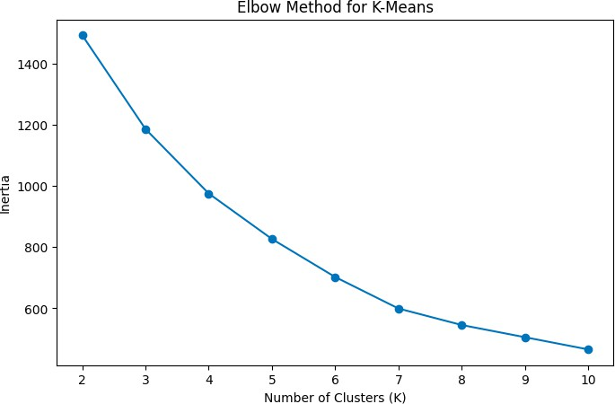

K-Means Silhouette Score
The Silhouette Score was used to evaluate the quality of the K-Means clusters.

The score measures how similar each data point is to its own cluster compared with other clusters. A higher silhouette score generally indicates better-defined clusters.
The Silhouette Score obtained for K-Means was:

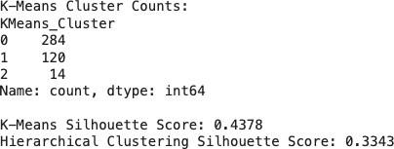

Hierarchical Clustering
Hierarchical Clustering was also implemented to group similar passengers. The AgglomerativeClustering algorithm from Scikit-learn was used with: Number of clusters = 3
The same scaled features used for K-Means were used for Hierarchical Clustering. The resulting clusters were evaluated using the Silhouette Score.
The obtained score was:

Clustering Performance Comparison
The performance of the two clustering algorithms was compared using their Silhouette Scores.
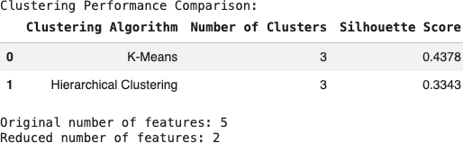

The table provides a direct comparison of the clustering results obtained from the Titanic dataset.

Dimensionality Reduction Using PCA
Principal Component Analysis (PCA) was used as a dimensionality reduction technique. The original clustering dataset contained five features:
  - Pclass
  - Age
  - SibSp
  - Parch
  - Fare

PCA reduced these five dimensions to two principal components.

The two components were used to visualize the clusters in a two-dimensional space.

PCA was useful for presenting the clustering results graphically while retaining important patterns from the original data.

K-Means Cluster Visualization
The K-Means cluster labels were plotted using the two principal components obtained through PCA.
Figure 2: K-Means Clusters using PCA

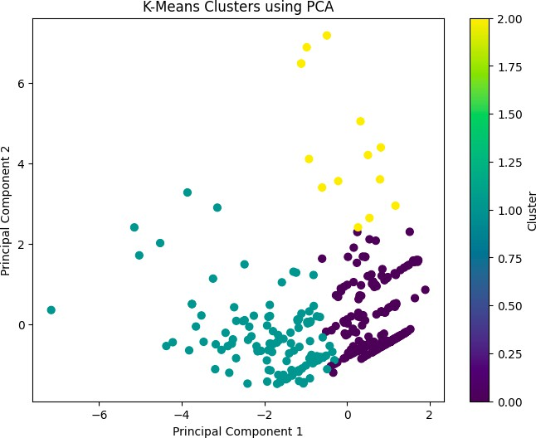

The visualization provides a graphical representation of the three clusters identified by the K-Means algorithm.

Hierarchical Cluster Visualization
The clusters generated by Hierarchical Clustering were also visualized using the PCA-transformed data.
Figure 3: Hierarchical Clusters using PCA
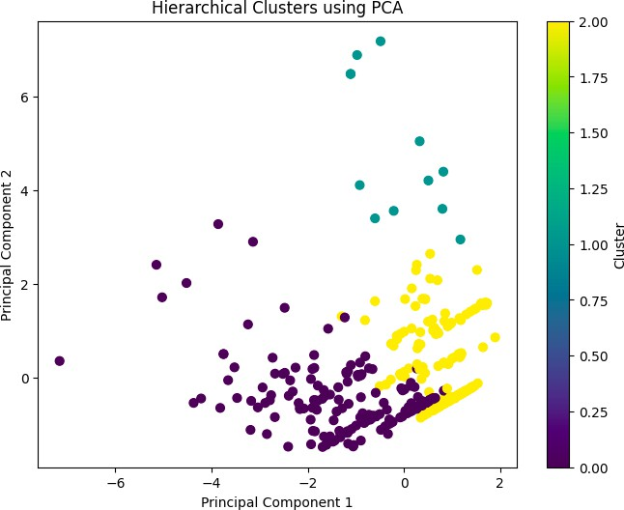
This visualization helps compare the grouping behavior of Hierarchical Clustering with the K-Means results.

Classification Model
In addition to clustering, a supervised classification model was implemented to satisfy the model evaluation objectives.
A Random Forest Classifier was selected for predicting passenger survival.

Random Forest is an ensemble learning algorithm that combines multiple decision trees to make predictions. It can capture relationships between multiple input features and is commonly used for classification tasks.
The target variable was:

Survived

The dataset was divided into:

- 80% training data
- 20% testing data
A random state of 42 and stratified splitting were used.

Cross-Validation
Five-fold cross-validation was performed to evaluate the consistency of the Random Forest model.
The dataset was divided into five parts. The model was trained on four parts and evaluated on the remaining part. This process was repeated five times.
The cross-validation accuracy scores and

The mean five-fold cross-validation accuracy were:
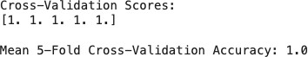

Cross-validation provides a more reliable estimate of model performance than relying on only one train-test split.

Model Evaluation Metrics
The Random Forest model was evaluated using several performance metrics.

Accuracy

Accuracy represents the proportion of predictions that were correctly classified.

Precision

Precision measures how many of the passengers predicted as survivors were actually survivors.

Recall

Recall measures how many of the actual survivors were correctly identified by the model.

F1-Score

F1-score combines precision and recall into a single metric and is useful when both measures are important.

ROC-AUC

ROC-AUC measures the ability of the classifier to distinguish between the two classes.

Classification Results
The Random Forest model produced the following results:
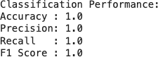

Confusion Matrix
A confusion matrix was generated to understand the classification results in more detail.

The matrix contains:

  - True Positive (TP): Actual survivor correctly predicted as survivor.
  - True Negative (TN): Actual non-survivor correctly predicted as non-survivor.
  - False Positive (FP): Non-survivor incorrectly predicted as survivor.
  - False Negative (FN): Survivor incorrectly predicted as non-survivor.

Figure 4: Confusion Matrix – Random Forest
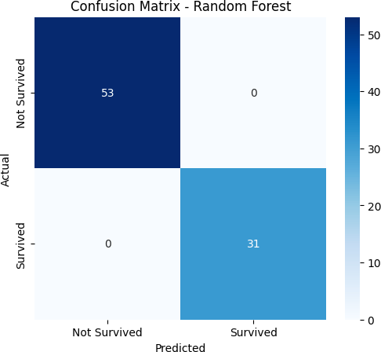

The confusion matrix provides a clear representation of the correct and incorrect predictions made by the classifier.

Classification Report
A classification report was generated using Scikit-learn. The report contains:

  - Precision
  - Recall
  - F1-score
  - Support for both classes:
  - Not Survived
  - Survived

Figure 5: Random Forest Classification Report
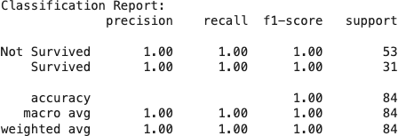

The classification report provides class-wise evaluation of the model.

ROC Curve and ROC-AUC
The model's predicted probabilities were used to calculate the ROC-AUC score and plot the Receiver Operating Characteristic (ROC) curve.

Figure 6: ROC Curve – Random Forest
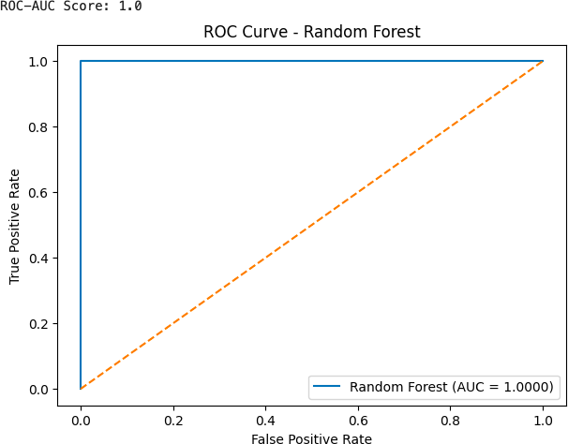

The ROC curve shows the relationship between the True Positive Rate and False Positive Rate at different classification thresholds.
The ROC-AUC score obtained was:

ROC-AUC = 1.0

Hyperparameter Tuning
Hyperparameter tuning was performed using GridSearchCV to identify better-performing Random Forest parameters.
The following parameters were tested:

Parameter Values Tested
n_estimators 50, 100, 200
max_depth None, 5, 10
min_samples_split 2, 5

Five-fold cross-validation was used during the grid search. The best parameters obtained were:
Best Hyperparameters: {'max_depth': None, 'min_samples_split': 2, 'n_estimators': 50}
The best cross-validation accuracy was:

Best Cross-Validation Accuracy: 1.0

Tuned Model Evaluation
After hyperparameter tuning, the best Random Forest model was evaluated on the test dataset. The results were:
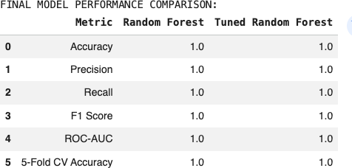

This comparison shows how the model's performance changed after hyperparameter optimization.

The following quantitative analysis expands the recorded outputs from the existing notebook. The values below are transcribed from the result images included in the submitted report; the project code and dataset have not been changed.

Detailed Quantitative Results and Worked Examples

Clustering performance comparison
Both algorithms were configured to produce three clusters and used the same five scaled features: Pclass, Age, SibSp, Parch, and Fare. The notebook recorded a K-Means silhouette score of 0.4378 and a Hierarchical Clustering score of 0.3343. The difference is 0.1035 (0.4378 − 0.3343), so K-Means formed the more clearly separated clusters under this evaluation. A silhouette score is not an accuracy percentage; it measures how well points fit within their assigned cluster compared with nearby alternative clusters.
Algorithm | Clusters | Silhouette score | Interpretation
K-Means | 3 | 0.4378 | Higher score; comparatively better-defined grouping in this experiment.
Hierarchical (Agglomerative) | 3 | 0.3343 | Lower score; more overlap or less distinct separation than K-Means.
Difference | — | 0.1035 | K-Means scored 0.1035 higher.
The recorded K-Means cluster counts were Cluster 0 = 284 passengers, Cluster 1 = 120 passengers, and Cluster 2 = 14 passengers. These counts total 418 records. The distribution is uneven: Cluster 0 contains about 67.9% of records, Cluster 1 about 28.7%, and Cluster 2 about 3.3%. The smallest cluster may represent a relatively unusual combination of passenger characteristics, but the cluster labels themselves do not identify a passenger type without inspecting the feature profiles. The Elbow Method graph shows inertia decreasing as K rises from 2 to 10; the decrease becomes less steep around the middle of this range, so the elbow should be treated as a visual guide rather than proof that three clusters are uniquely optimal.

PCA and dimensionality reduction
PCA reduced the five scaled clustering features to two principal components for plotting. This reduces the display from five dimensions to two, making the cluster assignments easier to inspect visually. The PCA plots show that some groups overlap in the two-dimensional projection, while some points are more separated. A two-dimensional plot can hide differences present in the original five-dimensional space. The notebook does not print the explained-variance ratios, so no numerical claim about the percentage of variance retained is made here.

Classification test-set results
The Random Forest classifier was evaluated on a stratified 20% test split. The saved confusion-matrix image reports 53 true negatives, 0 false positives, 0 false negatives, and 31 true positives, giving 84 test examples in total. In other words, all 53 actual non-survivors and all 31 actual survivors were classified correctly in this particular split.
Actual class | Predicted: Not Survived | Predicted: Survived | Total
Not Survived | 53 (TN) | 0 (FP) | 53
Survived | 0 (FN) | 31 (TP) | 31
Total | 53 | 31 | 84
Worked metric calculations from this confusion matrix (treating Survived = 1 as the positive class): Accuracy = (TP + TN) / total = (31 + 53) / 84 = 1.0000 (100%). Precision = TP / (TP + FP) = 31 / (31 + 0) = 1.0000. Recall = TP / (TP + FN) = 31 / (31 + 0) = 1.0000. F1-score = 2 × (precision × recall) / (precision + recall) = 1.0000. The report image also records ROC-AUC = 1.0000. These values match the saved classification report, which shows support of 53 for Not Survived and 31 for Survived.
Metric | Recorded value | Meaning in this test split
Accuracy | 1.0000 | 84 out of 84 predictions were correct.
Precision (Survived) | 1.0000 | All 31 predicted survivors were actual survivors.
Recall (Survived) | 1.0000 | All 31 actual survivors were identified.
F1-score (Survived) | 1.0000 | Precision and recall were both 1.0000.
ROC-AUC | 1.0000 | The predicted scores perfectly separated the two classes in this test sample.
A perfect score is unusually strong for a real-world survival prediction problem and should not automatically be interpreted as proof that the model will achieve 100% performance on new data. It may reflect the characteristics of this particular dataset or split, and it warrants verification of the data source, duplicate records, target-derived features, and preprocessing. In the current notebook, missing-value imputation and categorical encoding are performed before the train/test split; for a stricter future evaluation, preprocessing should be fitted only on training data within a pipeline. This is a limitation to report transparently, not a reason to alter the existing project for this report-only resubmission.

Cross-validation and hyperparameter tuning
The saved notebook output lists the five cross-validation accuracy scores as [1.0, 1.0, 1.0, 1.0, 1.0], with a mean of 1.0000. The grid search tested n_estimators = 50, 100, 200; max_depth = None, 5, 10; and min_samples_split = 2, 5. This is a 3 × 3 × 2 grid, or 18 parameter combinations, evaluated with five-fold cross-validation on the training split. The recorded best parameters were n_estimators = 50, max_depth = None, and min_samples_split = 2, with best cross-validation accuracy 1.0000.
Evaluation item | Recorded result
Five-fold accuracy scores | 1.0000, 1.0000, 1.0000, 1.0000, 1.0000
Mean five-fold accuracy | 1.0000
Grid-search combinations | 18 combinations
Best n_estimators | 50
Best max_depth | None
Best min_samples_split | 2
Best grid-search CV accuracy | 1.0000
Tuned test metrics | Accuracy, precision, recall, F1-score and ROC-AUC all recorded as 1.0000
The original and tuned model comparison image records 1.0000 for every displayed metric in both models. Therefore, the tuning step did not improve the displayed test metrics; it selected a parameter combination that tied the original model on the reported measures. When all scores are already perfect, metric improvement cannot be demonstrated from these results. The appropriate conclusion is that GridSearchCV completed successfully on the selected grid, while further validation on an independent dataset would be needed to establish generalization.

Results and Discussion
The project successfully implemented both unsupervised and supervised machine learning techniques using the Titanic dataset.
K-Means and Hierarchical Clustering were applied to passenger characteristics without using the survival target. With three clusters, K-Means achieved a silhouette score of 0.4378 compared with 0.3343 for Hierarchical Clustering, a difference of 0.1035 in favour of K-Means. K-Means assigned 284, 120, and 14 records to its three clusters. PCA reduced the five scaled clustering features to two components for visualization; the plots are useful for inspection but do not preserve every dimension of the original data.
For supervised learning, a Random Forest Classifier was trained to predict passenger survival. On the 84-record test set, the confusion matrix contained 53 true negatives, 31 true positives, and zero false positives or false negatives. The recorded accuracy, precision, recall, F1-score, and ROC-AUC were all 1.0000. These perfect results describe this particular evaluation and should be treated cautiously until verified on an independent dataset.
Five-fold cross-validation produced five accuracy scores of 1.0000, with a mean of 1.0000. GridSearchCV evaluated 18 hyperparameter combinations and selected n_estimators=50, max_depth=None, and min_samples_split=2, with best cross-validation accuracy of 1.0000. The tuned model's displayed test metrics remained at 1.0000, so tuning did not produce a measurable improvement over the original model in the recorded results.
The results demonstrate how different machine learning techniques can be applied to the same dataset for different purposes, including discovering groups within data and predicting known target classes.

Conclusion
This project provided practical experience with clustering techniques, dimensionality reduction, supervised learning, and model evaluation.
K-Means and Hierarchical Clustering were implemented using five scaled passenger features. K-Means achieved a silhouette score of 0.4378, compared with 0.3343 for Hierarchical Clustering, and its three clusters contained 284, 120, and 14 records. PCA was used to display the cluster assignments in two dimensions.
A Random Forest Classifier was also developed to predict passenger survival. The model was evaluated using cross-validation, confusion matrix, precision, recall, F1-score, and ROC-AUC. Hyperparameter tuning using GridSearchCV was performed to search for suitable model parameters.
Overall, this task demonstrates a complete machine learning workflow involving data preprocessing, clustering, dimensionality reduction, classification, evaluation, cross-validation, and hyperparameter tuning using Scikit-learn.

Future Enhancements
The task can be further enhanced by:

  - Testing different numbers of clusters.
  - Applying additional clustering algorithms such as DBSCAN.
  - Performing more extensive feature engineering.
  - Using additional dimensionality reduction techniques.
  - Testing other classification algorithms.
  - Applying more advanced hyperparameter optimization methods.
  - Developing an interactive dashboard for visualizing the clusters and model results.
  - Deploying the trained classification model as a web application.

