Yuva Intern AI Pioneers – Machine Learning Internship

PROJECT REPORT

LAPTOP PERFORMANCE DEGRADATION PREDICTOR
Using Machine Learning

Submitted by

Manasvi Beri
B.Tech Artificial Intelligence and Machine Learning 2022- 2026
GitHub Repository: https://github.com/manasviberi/Yuva-intern-AI-Pioneers-internship-ML-week-4-project-on-laptop-performance-degradation-predictor/blob/main/yuva_intern_ai_pioneers_internship_week_4.ipynb

CERTIFICATE
This is to certify that Manasvi Beri has completed the project titled “Laptop Performance Degradation Predictor Using Machine Learning” as part of the Yuva Intern AI Pioneers Machine Learning Internship.
The project demonstrates an end-to-end machine learning workflow including data preparation, preprocessing, exploratory data analysis, model training, evaluation, model serialization, and Flask-based web deployment.

Date: 04-10-2026
Place: Hyderabad Mentor/Coordinator Signature:

DECLARATION
I hereby declare that the project report titled “Laptop Performance Degradation Predictor Using Machine Learning” is prepared as part of my internship work. The implementation, analysis, and documentation presented in this report are based on the project developed during the internship.
The dataset used in this project is synthetically generated for educational and demonstration purposes. Therefore, the results should not be interpreted as real-world hardware performance or failure validation.

ACKNOWLEDGEMENT
I would like to express my sincere gratitude to the Yuva Intern AI Pioneers internship program for providing an opportunity to learn and apply machine learning concepts through a practical project.
I am thankful to the mentors and coordinators for their guidance and support throughout the development of this project. I also thank my institution, faculty members, friends, and everyone who supported me during the completion of this work.

ABSTRACT
The Laptop Performance Degradation Predictor is a machine learning-based web application designed to classify the performance risk of a laptop into three categories: Normal, Moderate, and High. The system uses laptop-related parameters such as CPU usage, RAM usage, disk usage, CPU temperature, GPU usage, battery health, storage capacity, laptop age, daily usage, and running processes.
Data preprocessing techniques including duplicate removal, feature-target separation, label encoding, train-test splitting, and feature scaling were applied. Multiple machine learning algorithms, including Logistic Regression, Random Forest, and XGBoost, were trained and evaluated using accuracy, precision, recall, and F1-score. The selected model was serialized using Joblib and integrated into a Flask web application.
Users can enter laptop parameters through a web interface and receive a predicted performance-risk category. The project demonstrates an end -to-end machine learning workflow from dataset preparation and model development to web-based deployment. Since the dataset is synthetically generated, the system is intended for educational demonstration rather than real-world hardware diagnosis.

TABLE OF CONTENTS
- Introduction
- Problem Statement
- Objectives
- Dataset Description
- System Workflow and Architecture
- Data Preprocessing
- Exploratory Data Analysis
- Machine Learning Models
- Model Evaluation
- Model Serialization
- Flask Web Application
- Testing
- Results and Discussion
- Limitations
- Future Enhancements
- Conclusion
- References

INTRODUCTION
Laptop performance is influenced by several hardware and usage-related factors. High CPU utilization, high RAM consumption, excessive disk usage, elevated temperature, low battery health, limited free storage, long daily usage, laptop age, and a large number of running processes can be associated with reduced responsiveness.
The objective of this project is to develop a machine learning system that accepts a set of laptop performance parameters and classifies the overall performance risk into Normal, Moderate, or High. The project combines data preprocessing, exploratory analysis, supervised machine learning, model serialization, and web deployment.
The final application is implemented using Flask. A user can enter the required parameters through a browser-based interface, after which the backend preprocesses the input and uses the saved machine learning model to produce a prediction.

PROBLEM STATEMENT
It can be difficult for a user to understand whether a combination of laptop hardware and usage conditions indicates normal operation or an increased risk of performance degradation. The project addresses this problem by building a classification model that uses measurable laptop-related parameters to predict a performance-risk category.

OBJECTIVES
- Develop a machine learning-based laptop performance classification system.
- Prepare and preprocess a structured dataset for supervised learning.
- Perform exploratory data analysis to understand the input variables.
- Train and compare multiple classification algorithms.
- Evaluate models using accuracy, precision, recall, and F1-score.
- Select and serialize a suitable trained model using Joblib.
- Develop a Flask backend for serving predictions.
- Create a simple web interface for user input and prediction.
- Demonstrate an end-to-end machine learning application.

DATASET DESCRIPTION
The project uses a synthetically generated structured dataset containing 5,000 records and 13 columns. Twelve columns are input features and one column is the target variable, performance_risk.

Feature | Description
ram_gb | RAM capacity in GB
cpu_usage_percent | CPU utilization percentage
ram_usage_percent | RAM utilization percentage
disk_usage_percent | Disk utilization percentage

cpu_temperature | CPU temperature
gpu_usage_percent | GPU utilization percentage
battery_health_percent | Battery health percentage
storage_capacity_gb | Total storage capacity
free_storage_gb | Available free storage
laptop_age_years | Laptop age in years
daily_usage_hours | Average daily usage
running_processes | Number of running processes
performance_risk | Target class: Normal, Moderate, or High

The dataset is synthetically generated for educational and demonstration purposes. It is not a collection of real laptop telemetry measurements and should not be used as a medical-style or hardware-failure diagnostic system.

SYSTEM WORKFLOW AND ARCHITECTURE
The project follows the workflow below:
- Laptop Dataset
- Data Cleaning
- Exploratory Data Analysis
- Feature and Target Separation
- Label Encoding
- Train-Test Split
- Feature Scaling
- Model Training
- Model Evaluation
- Best Model Selection
- Joblib Model Serialization
- Flask Backend
- Web Interface
- Performance Risk Prediction

DATA PREPROCESSING

Duplicate Removal
The dataset was checked for duplicate records. Duplicate rows were removed where required before model development.

Feature and Target Separation
The twelve laptop-related attributes were used as input features, while performance_risk was used as the target variable.

Label Encoding
The categorical target values Normal, Moderate, and High were converted into numerical labels using LabelEncoder. The encoder was saved so that model predictions could later be converted back to the original class names.

Train-Test Split
The dataset was divided into training and testing subsets using an 80:20 split. Stratification was used to maintain the class distribution between the training and testing data.

Feature Scaling
StandardScaler was applied to the numerical input features. Scaling transforms features to a comparable numerical range and is particularly relevant for models such as Logistic Regression.

EXPLORATORY DATA ANALYSIS
Exploratory Data Analysis was performed to understand the structure and distribution of the dataset. The analysis included inspecting the dataset shape, data types, missing values, duplicates, target distribution, and feature distributions.

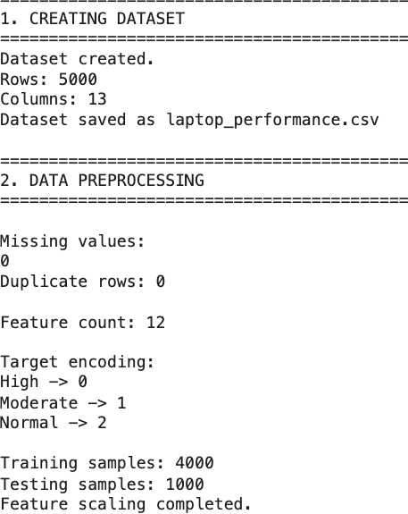

MACHINE LEARNING MODELS

Logistic Regression
Logistic Regression is a supervised classification algorithm used to estimate the probability of classes. It was included as a baseline and performs well when the relationship between the features and class boundaries can be represented effectively.

Random Forest
Random Forest is an ensemble learning algorithm that combines multiple decision trees. It can model non-linear relationships and interactions between features.

XGBoost
XGBoost is a gradient-boosting algorithm that builds an ensemble of decision trees sequentially. It is widely used for structured/tabular machine learning tasks.

MODEL EVALUATION
The trained models were evaluated using Accuracy, Precision, Recall, and F1-score. F1-score was used as the main selection criterion in the project workflow.
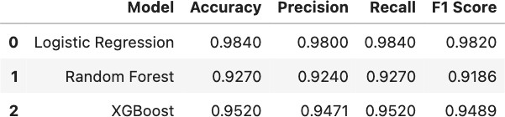

This concludes Logistic Regression as the best model according to the evaluation workflow.

MODEL SERIALIZATION
The selected machine learning model was serialized using Joblib so that it could be loaded later by the Flask application without retraining.
The model directory contains:
- laptop_performance_model.joblib – trained classification model
- scaler.joblib – fitted StandardScaler
- label_encoder.joblib – fitted target LabelEncoder

FLASK WEB APPLICATION
The trained model was integrated into a Flask web application. The application contains a frontend form for collecting the twelve required input values and a backend prediction endpoint.
The main prediction endpoint is POST /predict. The endpoint validates the submitted input, constructs a pandas DataFrame, applies the saved scaler, performs model prediction, converts the numerical prediction back to the original class label, and returns the result as JSON.
The application uses robust file paths based on the location of app.py, allowing the saved model files to be loaded when the project is run locally.

TESTING
The application was tested locally using the Flask development server. Test cases should include normal operating conditions, high resource utilization, low free storage, high temperature, and complete valid input.

Test Case | Input Condition | Expected Output | Actual Output
1 | Low/moderate resource usage | Normal | Normal (61.83%)
2 | High CPU/RAM usage | High/Moderate | Moderate  (84.59%)
3 | Low free storage | Higher risk | High (61.29%)
4 | High temperature and high workload | Higher risk | High  (97.98%)

RESULTS AND DISCUSSION
The project successfully produced a working machine learning web application. The final implementation loads the trained model and preprocessing artifacts and provides predictions through a browser-based interface.
The application was run locally using Flask and tested through the browser at http://127.0.0.1:5000/

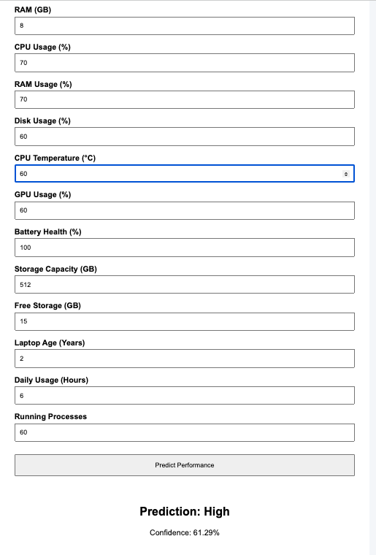

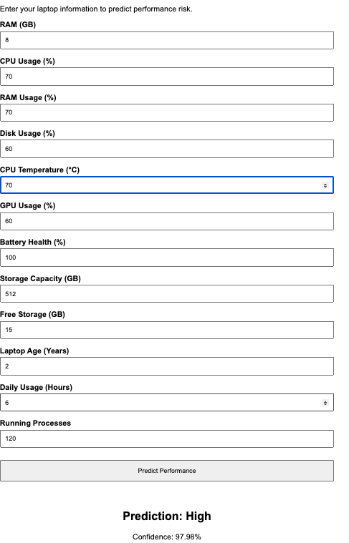

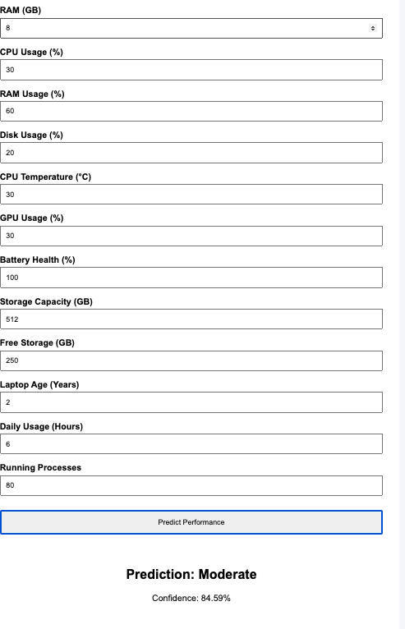

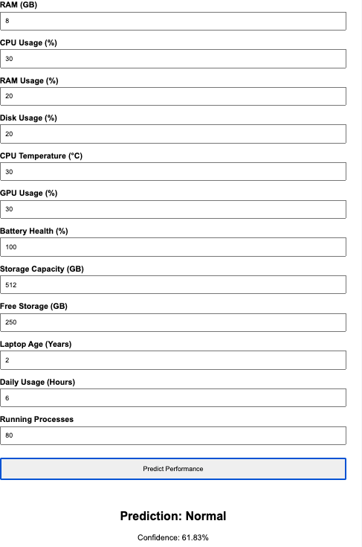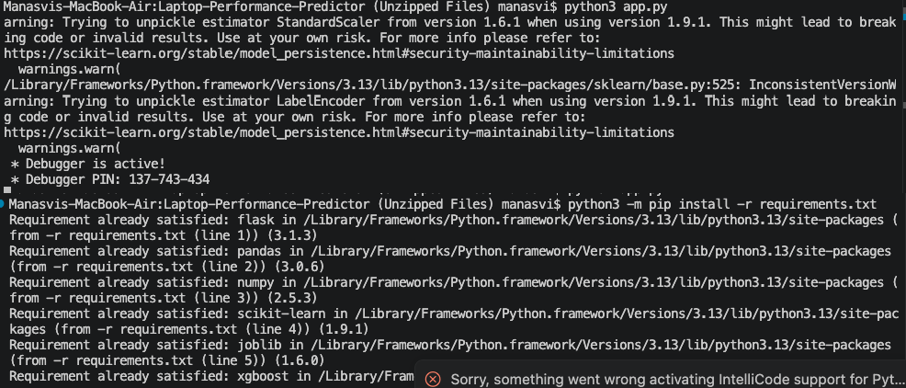

Because the dataset is synthetically generated and the target is constructed from the input variables, model performance should be interpreted as an educational demonstration of the machine learning workflow rather than evidence of real-world predictive accuracy.

LIMITATIONS
- The dataset is synthetically generated for educational purposes.
- The system has not been validated against large-scale real-world laptop telemetry.
- The model predicts a classification category and does not directly diagnose hardware failure.
- The prediction depends on the quality and range of the user-provided input values.
- The current application does not continuously monitor laptop hardware.

FUTURE ENHANCEMENTS
- Collect and use real-world laptop performance telemetry.
- Add continuous monitoring of CPU, RAM, storage, temperature, and battery parameters.
- Develop a desktop or system-tray application.
- Add historical performance tracking and trend visualization.
- Deploy the Flask application to a cloud platform.
- Retrain the model periodically using newly collected data.
- Add user accounts and personalized performance history.

CONCLUSION
The Laptop Performance Degradation Predictor demonstrates a complete machine learning workflow from dataset preparation and preprocessing to model training, evaluation, serialization, and web deployment. Multiple classification algorithms were evaluated, and the selected model was integrated with Flask to provide predictions through a web interface.
The project provides practical experience in Python, data preprocessing, supervised machine learning, model evaluation, Joblib-based serialization, Flask API development, and frontend integration. Since the dataset is synthetically generated, future work should focus on collecting real-world laptop performance data and validating the system under realistic conditions.

REFERENCES
- Python Documentation – https://docs.python.org/

- Pandas Documentation – https://pandas.pydata.org/docs/

- Scikit-learn Documentation – https://scikit-learn.org/stable/

- XGBoost Documentation – https://xgboost.readthedocs.io/

- Flask Documentation – https://flask.palletsprojects.com/

- Joblib Documentation – https://joblib.readthedocs.io/
- Github link: https://github.com/manasviberi/Yuva-intern-AI-Pioneers-internship-ML-week-4-project-on-laptop-performance-degradation-predictor/blob/main/yuva_intern_ai_pioneers_internship_week_4.ipynb

