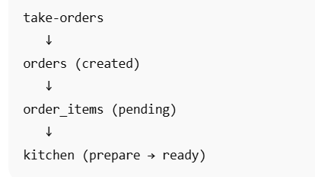

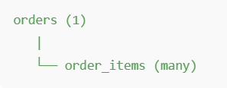

1.menu_items TABLE:
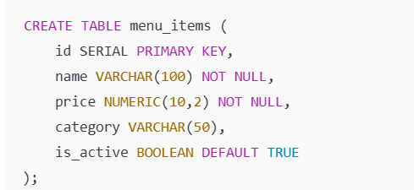
Purpose:
- Master menu
- Read-only during order

Used by
- take-orders.html (menu display)

2…orders TABLE :

Purpose:
- Created when order starts
- Used for tracking

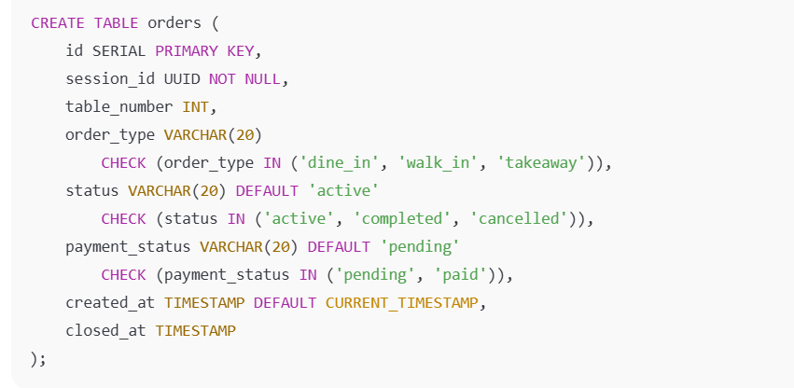
Used by
- take-orders.html
- orders.html
- kitchen.html (read-only)

3……order_items TABLE :

Purpose:
- Stores items inside an order
- Kitchen workflow happens here

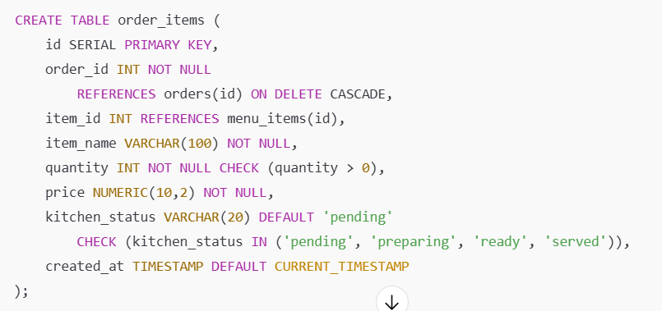

Used by
- take-orders.html (add/edit)
- kitchen.html (status update)
- orders.html (billing view)
- price in float allow
- kitchen saperated table -yes or no

FILE #1 — take-orders.html

PURPOSE: CREATE & MODIFY ORDER

Backend Functions

Function |  | What it does
create_order() |  | Creates new order + session
add_item_to_order() |  | Add item
update_item_qty() |  | Increase / decrease qty
remove_item() |  | Delete item
get_menu_items() |  | Load menu
submit_order() |  | Finalize & lock

FILE #2 — orders.html

PURPOSE: MANAGE

Backend Functions
Function | What it does
get_active_orders() | Show all running orders
get_order_details(order_id) | Full order details (items + status)
filter_orders() | Filter by table / status

FILE #3 — kitchen.html

PURPOSE: COOK & SERVE

Backend Functions
Function | What it does
get_kitchen_orders() | FIFO list
update_kitchen_status() | Preparing / Ready
get_pending_items() | Only uncooked items
mark_served() | Item served

