Tables:
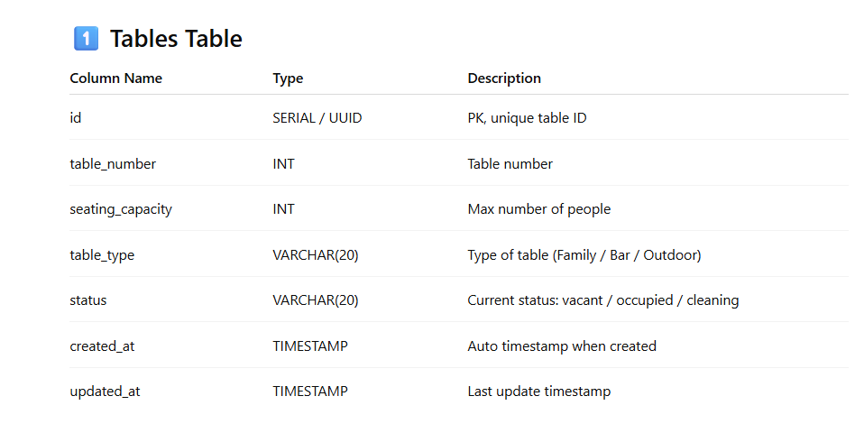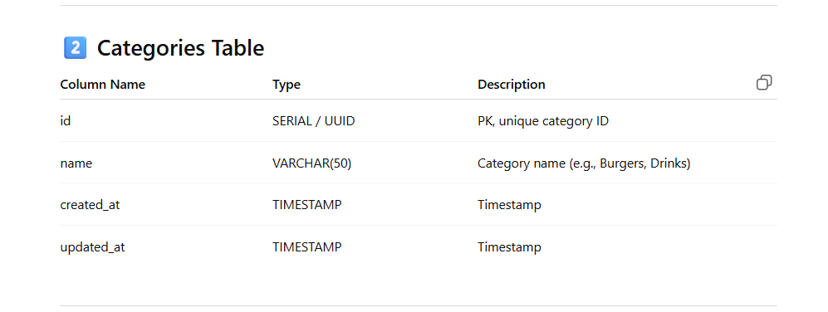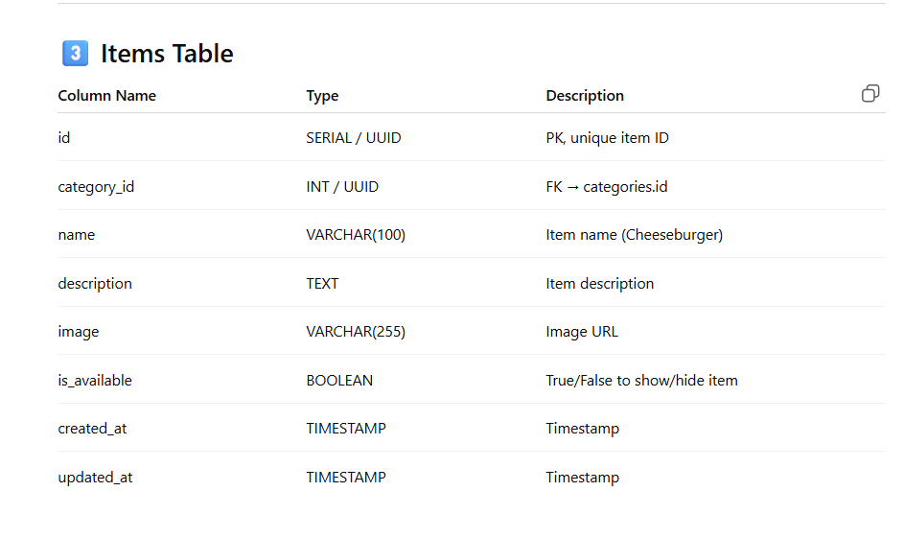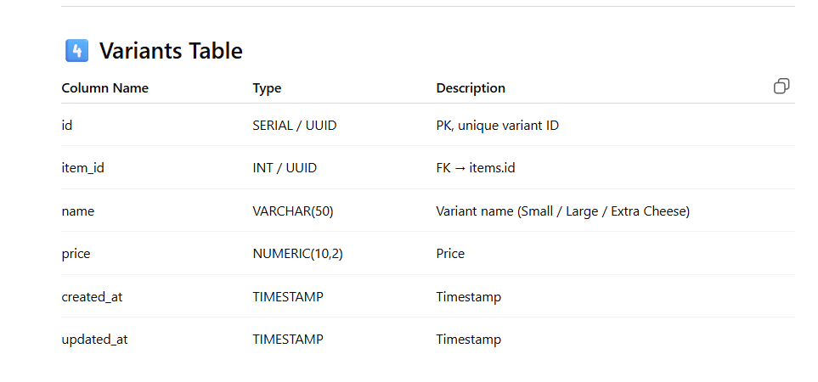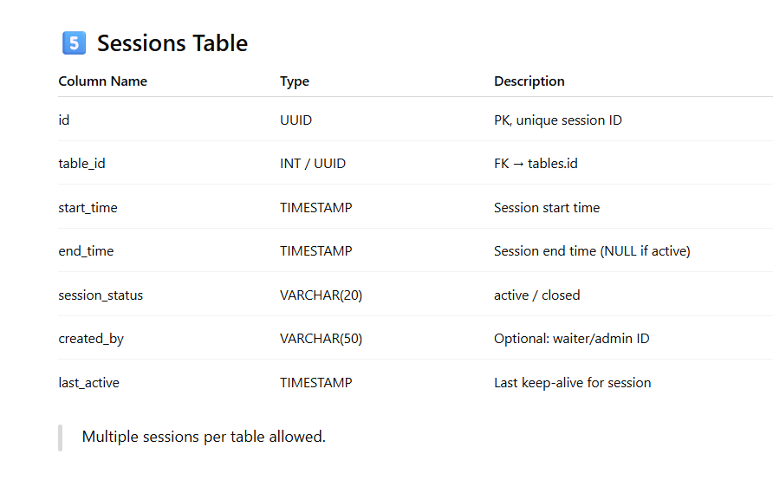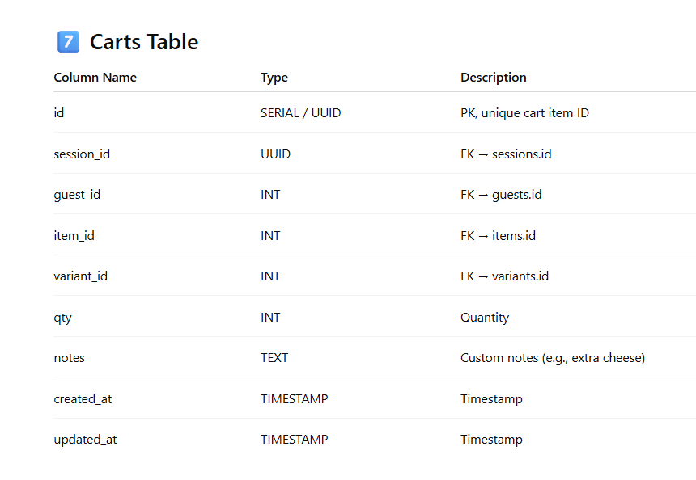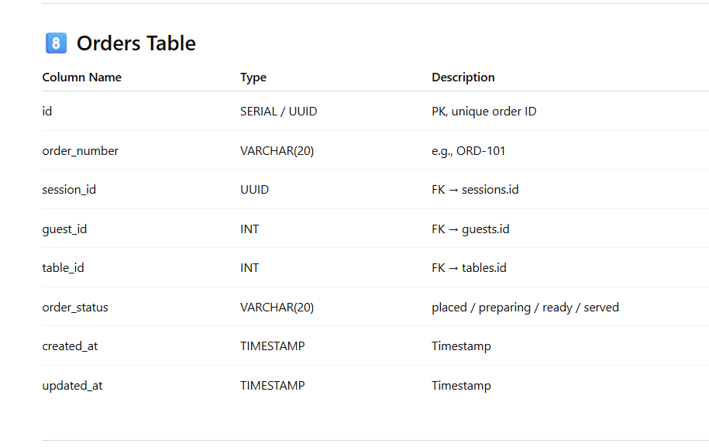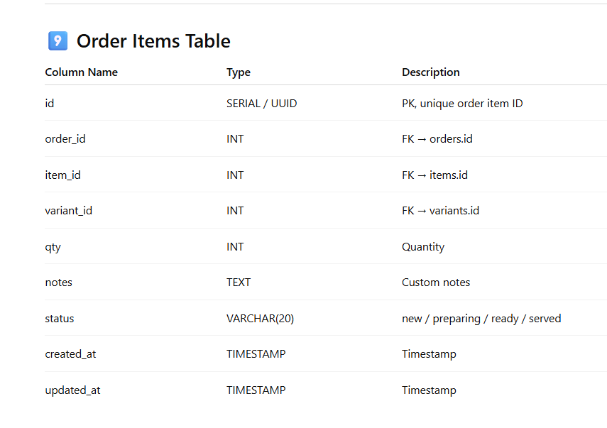

Functions:

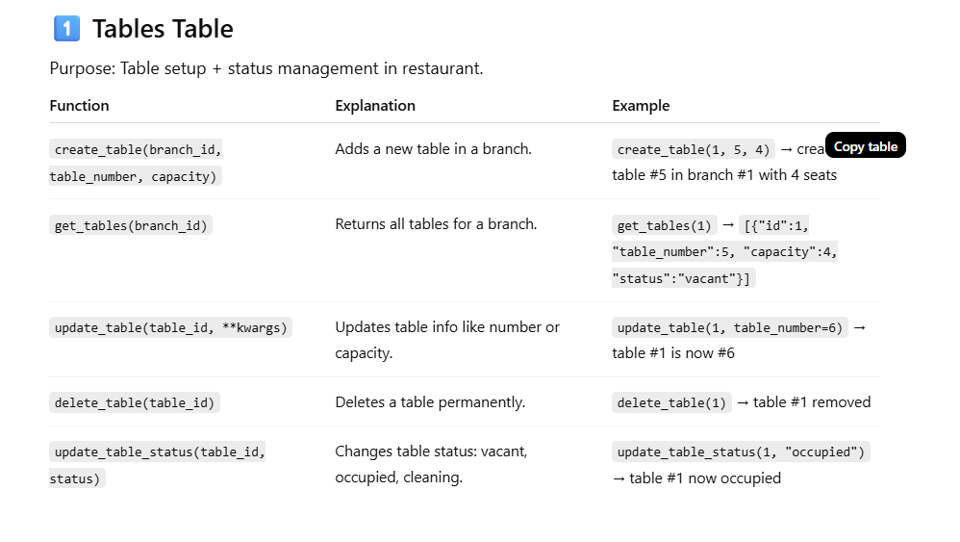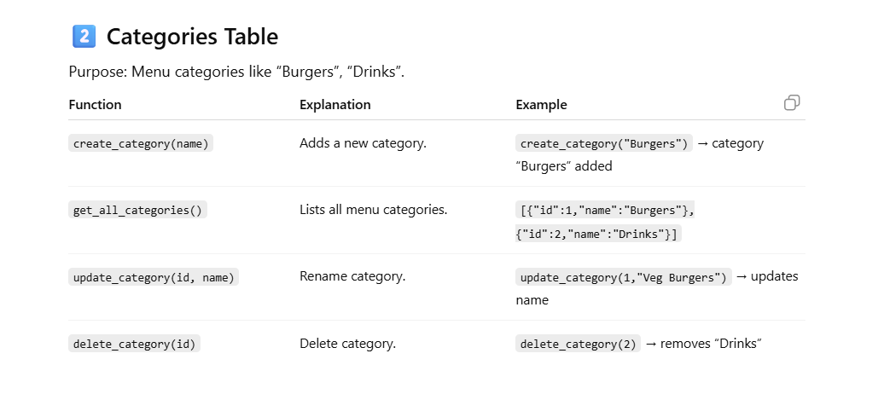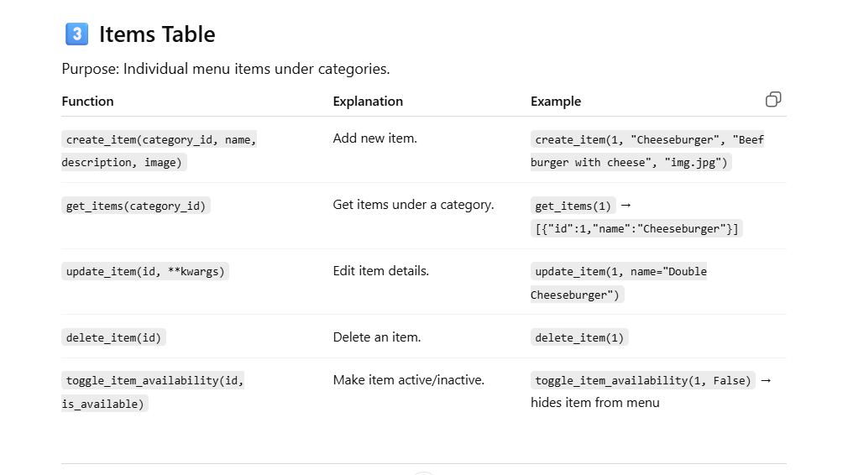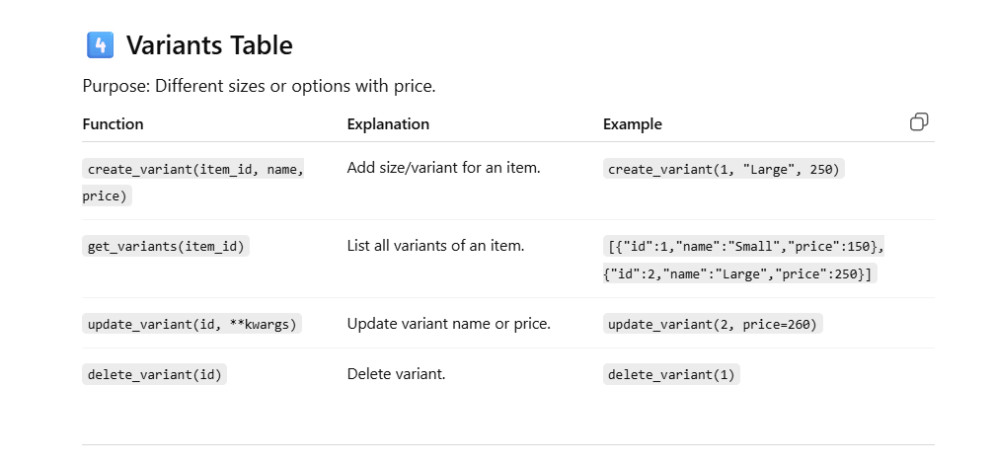
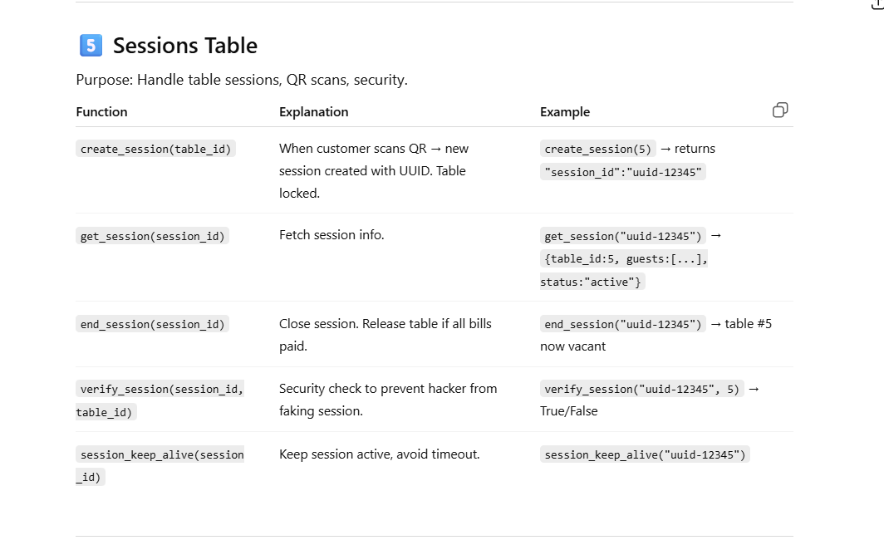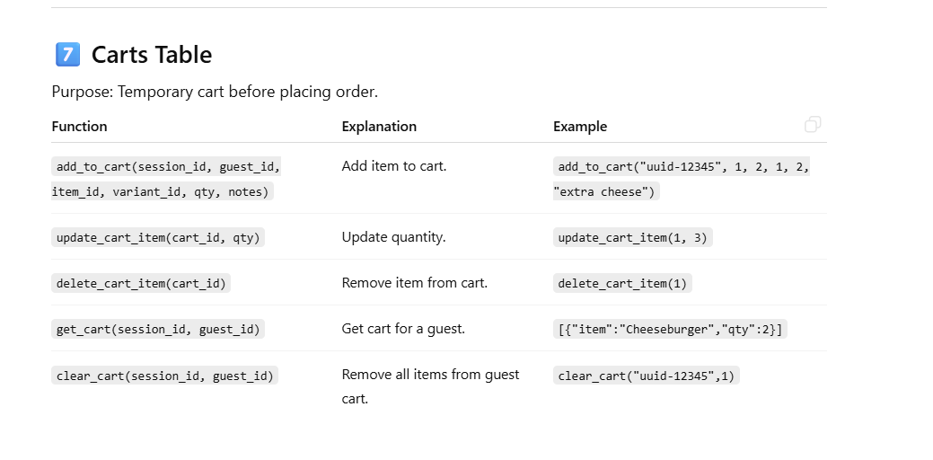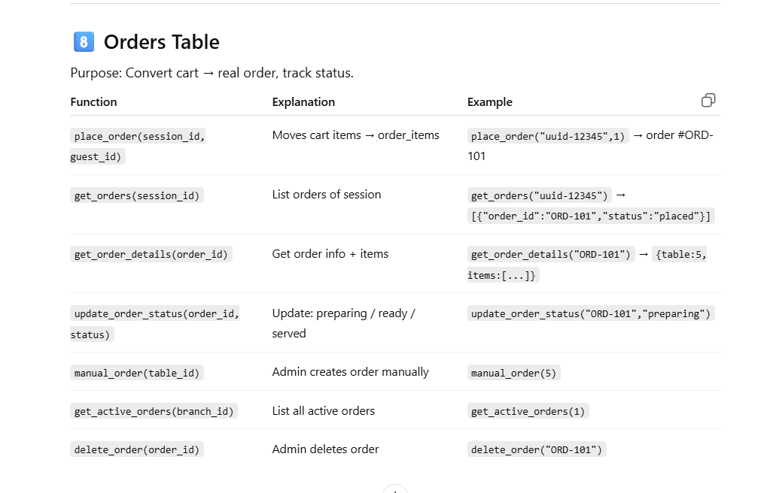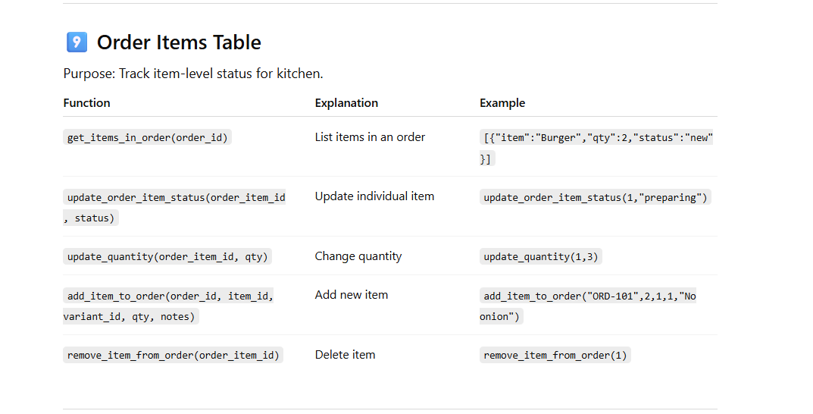

FILE #1 — take-orders.html
🟢 PURPOSE: CREATE the order

This is your order entry screen.

What this file is responsible for:

Creating a new order

Adding/editing items

Assigning table number

Sending order into the system

📌 This page is used ONCE per order

👉 In real life: “Waiter taking order at table”

Why it must exist separately

Needs forms

Needs item selection

Needs editing

Needs staff-level access

🔁 STEP 2: Order exists → restaurant needs to TRACK it

Now the order is in the system.

Who needs to see this?

Manager

Owner

Billing staff

They want to know:

Which table ordered?

Is payment done?

Should I generate bill?

Is this dine-in / walk-in?

📋 FILE #2 — orders.html
🟢 PURPOSE: MANAGE orders

This is your ADMIN / BILLING CONTROL PANEL.

What this file does (from your code):

Shows all active orders

Shows:

Order ID

Session ID

Table

Customer

Items

Payment status

Has actions like:

Go to Billing

View Invoice

Manual Order

This is NOT for cooking.

👉 In real life: “Manager checking which tables need billing”

📌 Orders.html NEVER edits food
📌 Orders.html NEVER cooks
📌 Orders.html cares about money & sessions

This is correct and professional

orders

🔥 STEP 3: Order goes to the kitchen

Now Amit is waiting for food.

Who cares now?

Chef

Kitchen staff

They DO NOT care about:

Price

Customer name

Payment

Billing

They ONLY care about:

Table number

Items

Quantity

Order time

What to cook first

🍳 FILE #3 — kitchen.html
🟢 PURPOSE: PREPARE the order

This is your Kitchen Display Screen (KDS).

From your actual file:

Big table number

Large item text

FIFO logic

Status buttons:

Preparing

Ready / Served

No prices

No billing

No admin controls

👉 In real life: “Screen mounted near stove”

This is EXACTLY how modern kitchens work (PetPooja, Toast, Square all do this).

Your implementation is very solid

kitchen

take-orders

[2:36 pm, 07/01/2026] Manasvi Dobariya: Spice Villa (Restaurant)
│
├── 1. Restaurant Setup
│ ├── Restaurant ID: R101
│ ├── Outlet ID: O1
│ ├── Business Type: Restaurant
│ └── Subscription Plan: Pro
│
├── 2. Table Management
│ ├── Table T1
│ │ ├── Table ID: T1
│ │ ├── QR Code: QR_R101_T1
│ │ └── Status: Occupied
│ │
│ ├── Table T2
│ ├── Table T3
│ └── Table T4
│
├── 3. Table Session (Core Controller)
│ ├── Session ID: S9001
│ ├── Table ID: T1
│ ├── Open Time: 7:00 PM
│ ├── Status: Active
│ └── Purpose: Group multiple people & orders
│
├── 4. Customer Ordering (Same Table, Different People)
│ ├── All customers scan same QR (T1)
│ ├── Menu opens on each mobile
│ │
│ ├── Person A
│ │ ├── Order ID: O1001
│ │ ├── Items: Tea, Sandwich
│ │ ├── Or…
[5:48 pm, 07/01/2026] Manasvi Dobariya: FoodSphere SaaS Platform
│
├── 1. SaaS Level (Multi-Tenant Core)
│ ├── SaaS Platform ID: SAAS-01
│ ├── Architecture: Multi-Tenant
│ ├── Data Isolation: business_id based
│ ├── Supported Business Types
│ │ ├── Restaurant
│ │ ├── Cafe
│ │ ├── Bakery
│ │ └── Bar
│ └── Subscription Management
│ ├── Free
│ ├── Pro
│ └── Enterprise
│
├── 2. Business (Tenant) Onboarding
│ ├── Business Name: Spice Villa
│ ├── Business ID: R101
│ ├── Business Type: Restaurant
│ ├── Subscription Plan: Pro
│ ├── Status: Active
│ └── Created Date: 2026-01-01
│
├── 3. Outlet / Branch Management
│ ├── Outlet ID: O1
│ │ ├── Outlet Name: Spice Villa – City Center
│ │ ├── Address
│ │ └── Status: Active
│ │
│ └── (Future Ready)
│ ├── Outlet O2
│ └── Outlet O3
│
├── 4. Table & QR Management
│ ├── Table T1
│ │ ├── Table ID: T1
│ │ ├── Seating Capacity: 4
│ │ ├── QR Code: QR_R101_O1_T1
│ │ ├── QR Type: Static
│ │ └── Status: Occupied
│ │
│ ├── Table T2
│ ├── Table T3
│ └── Counter / Bar Seat B1
│
├── 5. Table Session (MOST IMPORTANT)
│ ├── Session ID: S9001
│ ├── Business ID: R101
│ ├── Outlet ID: O1
│ ├── Table ID: T1
│ ├── Session Start Time: 7:00 PM
│ ├── Session End Time: NULL
│ ├── Status: Active
│ └── Purpose
│ ├── Group same-table people
│ ├── Allow multiple orders
│ └── Control billing lifecycle
│
├── 6. Customer Entry (Same Table, Many People)
│ ├── All customers scan SAME QR (T1)
│ ├── Each scan validates ACTIVE SESSION
│ ├── If no session → Create new session
│ └── If session exists → Join session
│
│ ├── Customer A
│ │ ├── Customer ID: C1
│ │ ├── Name: Guest A
│ │ └── Orders Placed Independently
│ │
│ ├── Customer B
│ │ ├── Customer ID: C2
│ │ └── Orders Placed Independently
│ │
│ └── Customer C
│ ├── Customer ID: C3
│ └── Orders Placed Independently
│
├── 7. Ordering System (PERSON-WISE)
│ ├── Order ID: O1001
│ │ ├── Customer: C1
│ │ ├── Items
│ │ │ ├── Tea × 1
│ │ │ └── Sandwich × 1
│ │ ├── Order Status: Served
│ │ └── Order Type: Dine-in
│ │
│ ├── Order ID: O1002
│ │ ├── Customer: C2
│ │ ├── Items
│ │ │ ├── Coffee × 1
│ │ │ └── Pasta × 1
│ │ ├── Order Status: Served
│ │ └── Order Type: Dine-in
│ │
│ └── Order ID: O1003
│ ├── Customer: C3
│ ├── Items
│ │ └── Pizza × 1
│ ├── Order Status: Preparing
│ └── Order Type: Dine-in
│
├── 8. Kitchen Display System (KDS)
│ ├── Live Orders Feed
│ ├── Shows
│ │ ├── Item Name
│ │ ├── Quantity
│ │ ├── Order ID
│ │ └── Table ID
│ └── Status Controls
│ ├── Accept
│ ├── Preparing
│ ├── Ready
│ └── Served

🔧 CRUD FUNCTIONS FOR EACH TABLE
3. Tables Functions
python
# app/crud/tables.py
create_table()
get_table_by_id()
get_tables_by_branch()
update_table()
delete_table()
update_table_status()
get_table_by_qr()
generate_table_qr()
get_vacant_tables()
4. Menu Functions
python
# app/crud/menu.py
create_category()
get_category_by_id()
get_categories_by_restaurant()
update_category()
delete_category()
create_item()
get_item_by_id()
get_items_by_category()
update_item()
delete_item()
toggle_item_availability()
update_item_price()
create_variant()
get_variants_by_item()
5. Session Functions
python
# app/crud/tables.py
create_session()
get_session_by_id()
get_session_by_code()
get_active_session_by_table()
get_active_sessions_by_branch()
add_guest_to_session()
remove_guest_from_session()
close_session()
extend_session()
get_session_details()
6. Guest Functions
python
# app/crud/tables.py
create_guest()
get_guest_by_id()
get_guests_by_session()
update_guest_name()
get_guest_by_token()
7. Cart Functions
python
# app/crud/orders.py
add_to_cart()
get_cart_by_guest()
update_cart_item()
remove_from_cart()
clear_cart()
get_cart_total()
8. Order Functions ⭐ Most Important
python
# app/crud/orders.py
create_order() # Main function for take-orders.html
get_order_by_id()
get_order_by_number()
get_orders_by_session()
get_orders_by_guest()
get_active_orders_by_branch() # For orders.html (manager view)
get_kitchen_orders_by_branch() # For kitchen.html (chef view)
update_order_status()
update_kitchen_status()
cancel_order()
add_item_to_order()
remove_item_from_order()
update_order_item()
get_order_timeline()
9. Order Items Functions
python
# app/crud/orders.py
create_order_item()
get_order_item_by_id()
update_order_item_status()
update_order_item_notes()
10. Kitchen Functions ⭐ For kitchen.html
python
# app/crud/kitchen.py
get_kitchen_display() # Main function for kitchen screen
get_pending_orders() # New orders
get_preparing_orders() # Orders being prepared
get_ready_orders() # Orders ready to serve
mark_item_preparing()
mark_item_ready()
mark_order_preparing()
mark_order_ready()
mark_order_served()
get_pending_items_count()
get_kitchen_queue_length()
11. Billing Functions ⭐ For orders.html
python
# app/crud/billing.py
generate_bill() # Generate bill for single order
generate_consolidated_bill() # Bill for all orders in session
generate_guest_bill() # Bill for specific guest
get_bill_by_id()
get_bill_by_order()
get_unpaid_bills_by_branch()
calculate_order_total()
apply_taxes()
generate_bill_number()
update_bill_status()
12. Payment Functions
python
# app/crud/billing.py
record_payment()
get_payments_by_bill()
get_payments_by_date()
get_payment_summary()
refund_payment()
13. Bill Split Functions
python
# app/crud/billing.py
split_bill()
get_split_by_bill()
update_split_status()
calculate_split_amounts()
14. User Functions
python
# app/crud/users.py
create_user()
authenticate_user()
get_user_by_id()
get_users_by_restaurant()
get_users_by_branch()
update_user_role()
reset_password()
deactivate_user()
15. Admin Dashboard Functions
python
# app/crud/admin.py
get_dashboard_stats() # Main stats for dashboard
get_live_table_status() # Real-time table status
get_todays_orders_report()
get_revenue_report()
get_kitchen_performance()
get_staff_performance()
get_popular_items()

🔄 COMPLETE FUNCTION LIST BY FRONTEND
For take-orders.html (Waiter):
text
1. get_table_by_qr()
2. create_session() OR get_active_session_by_table()
3. create_guest() OR add_guest_to_session()
4. get_menu_by_branch()
5. add_to_cart()
6. get_cart_by_guest()
7. create_order() ⭐ MAIN FUNCTION
8. clear_cart()
For orders.html (Manager):
text
1. get_active_orders_by_branch() ⭐ MAIN FUNCTION
2. get_live_table_status()
3. generate_bill() OR generate_consolidated_bill()
4. record_payment()
5. get_unpaid_bills_by_branch()
6. get_dashboard_stats()
7. get_revenue_report()
For kitchen.html (Chef):
text
1. get_kitchen_display() ⭐ MAIN FUNCTION
2. get_kitchen_orders_by_branch()
3. mark_item_preparing()
4. mark_item_ready()
5. mark_order_ready()
6. get_pending_items_count()
7. get_pending_orders()

📝 ACTUAL FUNCTION IMPLEMENTATIONS
Here are the 10 most critical functions you MUST implement:
1. create_order() - Most Important
python
def create_order(db: Session, order_data: schemas.OrderCreate):
"""Main order creation function for take-orders.html"""
# Creates order from guest cart
# Returns: order_id, order_number, status
2. get_active_orders_by_branch()
python
def get_active_orders_by_branch(db: Session, branch_id: int):
"""Get all active orders for manager view (orders.html)"""
# Returns: order_id, table_number, customer_name, items, payment_status
3. get_kitchen_display()
python
def get_kitchen_display(db: Session, branch_id: int):
"""Get kitchen orders for kitchen.html"""
# Returns: orders sorted by FIFO with table numbers, items, status
4. generate_bill()
python
def generate_bill(db: Session, order_id: int):
"""Generate bill for order (orders.html)"""
# Calculates total, tax, creates bill record
5. create_session()
python
def create_session(db: Session, table_id: int):
"""Start new table session when QR scanned"""
# Creates session, generates session_code
6. get_menu_by_branch()
python
def get_menu_by_branch(db: Session, branch_id: int):
"""Get complete menu for branch"""
# Returns: categories with items and variants
7. add_to_cart()
python
def add_to_cart(db: Session, guest_id: int, item_data: dict):
"""Add item to guest cart"""
# Adds item to cart table
8. update_order_status()
python
def update_order_status(db: Session, order_id: int, status: str):
"""Update order status (placed → preparing → ready → served)"""
# Updates status and triggers WebSocket notifications
9. record_payment()
python
def record_payment(db: Session, bill_id: int, payment_data: dict):
"""Record payment for bill"""
# Updates bill status to paid/partially paid
10. get_dashboard_stats()
python
def get_dashboard_stats(db: Session, branch_id: int):
"""Get dashboard statistics for admin"""
# Returns: active tables, today's orders, revenue, pending items

🎯 SUMMARY - WHAT YOU NEED TO CREATE:
DATABASE TABLES (15):
text
1. restaurants
2. branches
3. tables
4. categories
5. items
6. variants
7. sessions
8. guests
9. orders
10. order_items
11. carts
12. bills
13. payments
14. bill_splits
15. users

MAIN FUNCTIONS (45+):
- Restaurant/Branch: create_restaurant(), create_branch()
- Tables/Sessions: create_session(), get_table_by_qr()
- Menu: get_menu_by_branch(), create_item()
- Orders: create_order(), get_active_orders_by_branch(), get_kitchen_display()
- Billing: generate_bill(), record_payment()
- Admin: get_dashboard_stats(), get_live_table_status()
3 MAIN ENDPOINTS:
- /orders/create → create_order() → For take-orders.html
- /orders/active → get_active_orders_by_branch() → For orders.html
- /kitchen/display → get_kitchen_display() → For kitchen.html

