L.D. COLLEGE OF ENGINEERING, AHMEDABAD
Department of Information Technology
Data Science (BE05016021)
Project Based Learning (PBL) Activity Report
Intelligent Customer Segmentation and Marketing Campaign Optimization System
Customer segmentation, campaign response prediction and an interactive decision-support dashboard using the Customer Personality Analysis dataset
Submitted by
Manasvi
Enrolment No.: ____________________
Under the guidance of
Prof. ____________________
Academic Year 2026–27

Abstract
Retail companies often run marketing campaigns without a clear understanding of which customers are likely to respond, which leads to inefficient spending and poor targeting. This project develops a data-driven customer intelligence system using the Customer Personality Analysis dataset (2,240 customers, 29 attributes). After cleaning and feature engineering (2,054 customers retained), descriptive analytics is used to understand customer demographics, spending and purchase channels. Sampling and estimation techniques provide confidence intervals for key business measures and statistically test the differences between responders and non-responders. A multiple linear regression model predicts customer spending (R² = 0.71). K-Means clustering identifies four customer segments – Premium Spenders, Established Families, Budget Families and Young Starters – showing that half of the customers generate about 90% of revenue. Logistic Regression, Decision Tree and Random Forest classifiers are trained to predict campaign response; Logistic Regression performs best with a test ROC-AUC of 0.885 and a recall of 81%. A targeting simulation shows that contacting only the top 30% of customers ranked by the model captures about 80% of responders with 70% fewer contacts, turning a loss-making campaign into a profitable one. All results are delivered through an interactive Streamlit dashboard that allows business users to explore segments, evaluate models, score new customers and download campaign target lists.
Keywords: customer segmentation, K-Means, logistic regression, random forest, campaign response prediction, confidence interval, stratified sampling, Streamlit dashboard

Table of Contents
1. Introduction 4
1.1 Background – A Real-World Case Study 4
1.2 Problem Statement 4
1.3 Objectives 4
1.4 Scope of the Project 4
2. Literature Review 5
3. Dataset Description 5
4. Methodology 6
5. Data Preprocessing and Feature Engineering 7
5.1 Data Quality Issues and Treatment 7
5.2 Feature Engineering 7
6. Exploratory Data Analysis 8
7. Sampling and Estimation 11
7.1 Point Estimates and Confidence Intervals 11
7.2 Effect of Sample Size 12
7.3 Simple Random vs Stratified Sampling 12
7.4 Bootstrap and the Central Limit Theorem 13
7.5 Sample Size Planning 13
7.6 Hypothesis Testing (α = 0.05) 13
8. Linear Regression – Predicting Customer Spending 13
9. Customer Segmentation using K-Means 15
10. Classification – Predicting Campaign Response 17
10.1 Approach 17
10.2 Results 17
10.3 Drivers of Campaign Response 18
10.4 Business Impact – Targeting Simulation 19
11. Application Development – Interactive Dashboard 20
12. Business Insights and Recommendations 25
13. Conclusion and Future Scope 26
13.1 Conclusion 26
13.2 Limitations 26
13.3 Future Scope 26
References 26
Appendix: Project Structure and How to Run 27

1. Introduction

1.1 Background – A Real-World Case Study
Marketing is one of the largest costs for a retail business. In a traditional mass campaign every customer receives the same offer through mail, phone, catalog or e-mail, and the company pays for every contact. In the company studied in this project, only about 15% of customers accepted the most recent campaign, which means roughly 85% of the contact cost produced no sales. At the same time, customers are very different from each other – in income, family situation, spending habits and preferred channels – so a single offer cannot suit everyone.
Data science allows a company to move from mass marketing to targeted, personalised marketing: understanding who its customers are (segmentation), predicting who will respond (classification) and estimating how valuable each customer is (regression). This project applies these techniques to a real retail dataset and packages the results as a decision-support application for marketing teams.

1.2 Problem Statement
To analyse customer demographic, behavioural and purchase data in order to identify meaningful customer segments and to build a classification model that predicts customer response to marketing campaigns, so that the company can target the right customers with the right offers and reduce wasted marketing spend. An interactive dashboard must present segments, model predictions and campaign insights to business stakeholders.

1.3 Objectives
- Clean and prepare the customer data, and engineer meaningful features.
- Perform descriptive analytics (EDA) to understand customer behaviour and campaign performance.
- Apply sampling and estimation: confidence intervals, random vs stratified sampling, bootstrap, sample-size planning and hypothesis testing.
- Build a linear regression model to estimate customer spending.
- Segment customers using K-Means clustering and recommend a marketing strategy for each segment.
- Build and compare Logistic Regression, Decision Tree and Random Forest models to predict campaign response.
- Quantify the business impact of model-based targeting.
- Develop an interactive Streamlit dashboard for business stakeholders.

1.4 Scope of the Project
The project covers the complete data science life cycle – data understanding, preparation, analysis, modelling, evaluation and deployment as an application. It uses one historical dataset from a single retail company; real-time data integration with a CRM system is outside the scope and is discussed as future work.

2. Literature Review
Customer segmentation and response modelling are well-studied problems in marketing analytics. The following works form the background for the methods used in this project.
- Market segmentation (Wedel & Kamakura, 2000): Describe segmentation as dividing a heterogeneous market into homogeneous groups that respond similarly to marketing actions, and review clustering-based methods. This supports the use of behavioural and demographic variables to form actionable segments.
- RFM analysis (Hughes, 1994): Introduced Recency, Frequency and Monetary value as the key indicators of customer value in database marketing. Recency, purchase counts and total spending engineered in this project follow the same idea, and Recency indeed emerged as one of the strongest predictors of response.
- Data mining in CRM (Ngai, Xiu & Chau, 2009): Reviewed data-mining applications in customer relationship management and found clustering and classification to be the most frequently used techniques for customer identification, attraction and retention – the two techniques combined in this project.
- Campaign response prediction (Moro, Cortez & Rita, 2014): Predicted the success of bank telemarketing calls with data-driven models and showed that ranking customers by predicted probability and contacting only the top fraction greatly increases campaign efficiency – the approach used in the targeting simulation of this project.
- K-Means and cluster validation (MacQueen, 1967; Rousseeuw, 1987): K-Means partitions observations into k clusters by minimising within-cluster variance; the silhouette coefficient measures how well each observation fits its cluster. Both are used to build and validate the customer segments.
- Random Forests (Breiman, 2001): Proposed an ensemble of decorrelated decision trees that reduces the overfitting of single trees and provides feature importance – used here as the ensemble model compared with Logistic Regression and a single Decision Tree.
- Learning from imbalanced data (He & Garcia, 2009): Showed that accuracy is misleading on imbalanced data and recommended cost-sensitive learning and metrics such as recall, F1 and ROC-AUC. This project uses class weighting and these metrics because only 15% of customers respond.
Research gap addressed: many studies focus on either segmentation or response prediction. This project combines both – the segment produced by clustering is used as an input to the response model – and connects the model output directly to a business decision (how many customers to contact and the resulting profit) through an interactive application.

3. Dataset Description
Table 1: Dataset overview
Property | Details
Name | Customer Personality Analysis
Source | Kaggle – kaggle.com/datasets/imakash3011/customer-personality-analysis
Size | 2,240 customers × 29 attributes (tab-separated file)
Target variable | Response – 1 if the customer accepted the offer in the last campaign (15% positive)

Table 2: Dataset attributes
Group | Columns | Description
Customer profile | ID, Year_Birth, Education, Marital_Status, Income, Kidhome, Teenhome, Dt_Customer, Recency, Complain | Demographics, household, enrolment date, days since last purchase, complaints
Spending (2 years) | MntWines, MntFruits, MntMeatProducts, MntFishProducts, MntSweetProducts, MntGoldProds | Amount spent per product category
Purchase channels | NumDealsPurchases, NumWebPurchases, NumCatalogPurchases, NumStorePurchases, NumWebVisitsMonth | Purchases by channel and website visits
Campaign response | AcceptedCmp1–AcceptedCmp5, Response | Acceptance of the five earlier campaigns and the last campaign
Others | Z_CostContact, Z_Revenue | Constant columns (cost 3 per contact, revenue 11 per response)

4. Methodology
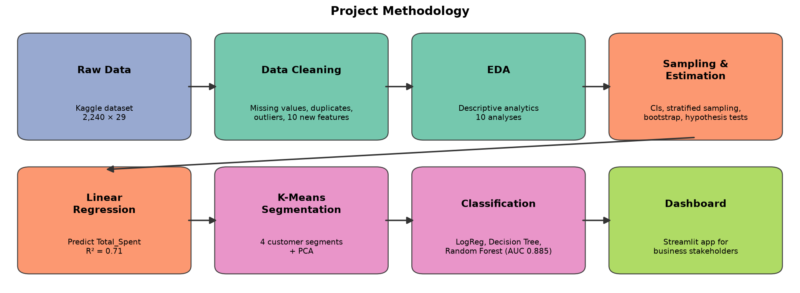
Figure 1: Project methodology
Table 3: Mapping of project steps to course topics
Step | Course topic | Techniques
Data cleaning | Data preprocessing | Median imputation, duplicate and outlier removal, category grouping, feature engineering
EDA | Descriptive analytics | Distributions, group comparisons, correlation analysis
Sampling & estimation | Sampling and estimation | t- and z-confidence intervals, SRS vs stratified sampling, bootstrap, sample-size formula, t-test, chi-square test
Spending prediction | Linear regression | Simple and multiple linear regression, OLS significance, residual diagnostics, cross-validation
Segmentation | Clustering | Standardisation, K-Means, elbow method, silhouette score, PCA
Response prediction | Logistic regression & classification | Logistic Regression, Decision Tree, Random Forest, GridSearchCV, ROC-AUC, confusion matrix, gains/lift
Application | Software development | Streamlit dashboard with Plotly charts

Tools: Python 3.13, pandas, NumPy, SciPy, statsmodels, scikit-learn, Matplotlib, Seaborn, Plotly, Streamlit, Jupyter Notebook and Git/GitHub.

5. Data Preprocessing and Feature Engineering

5.1 Data Quality Issues and Treatment
Table 4: Data cleaning summary
Issue found | Treatment
182 duplicate customers (identical in all columns except ID) | Removed
24 missing values in Income | Filled with the median (robust to outliers)
Z_CostContact and Z_Revenue are constant; ID is only an identifier | Dropped
Impossible birth years (1893, 1899, 1900) | Removed customers born before 1940
Extreme income value (666,666) | Removed incomes above 600,000
Invalid marital labels (Absurd, YOLO, Alone) | Grouped into Partner (Married/Together) and Single
Five education levels | Grouped into Undergraduate, Graduate, Postgraduate

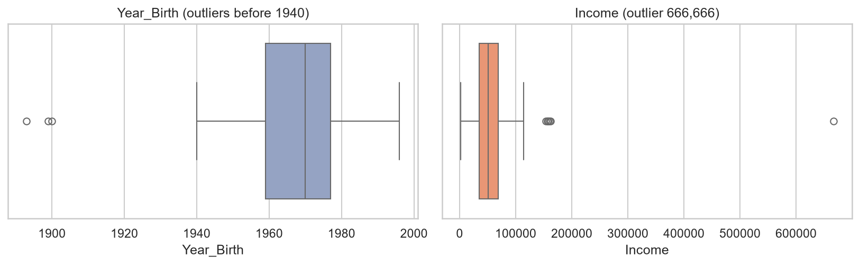
Figure 2: Outliers in Year_Birth and Income before cleaning
After cleaning, 2,054 customers remain with no missing values. The cleaning logic is implemented once in utils.py so that the notebook and the dashboard use identical preprocessing.

5.2 Feature Engineering
Table 5: Engineered features
New feature | Definition
Age | 2014 − Year_Birth (data collected in 2014)
Total_Spent | Sum of the six Mnt* spending columns
Children | Kidhome + Teenhome
Partner | 1 if Married or Together
Family_Size | 1 + Partner + Children
Is_Parent | 1 if Children > 0
Total_Purchases | Deals + Web + Catalog + Store purchases
Total_Accepted_Cmp | AcceptedCmp1 + … + AcceptedCmp5
Customer_Days | Days since enrolment (to the latest enrolment date)
Edu_Code | 0 = Undergraduate, 1 = Graduate, 2 = Postgraduate

6. Exploratory Data Analysis
The average customer is 45 years old, earns about 52,000 per year and spent about 606 in two years. Spending is strongly right-skewed: most customers spend little while a small group spends a lot.
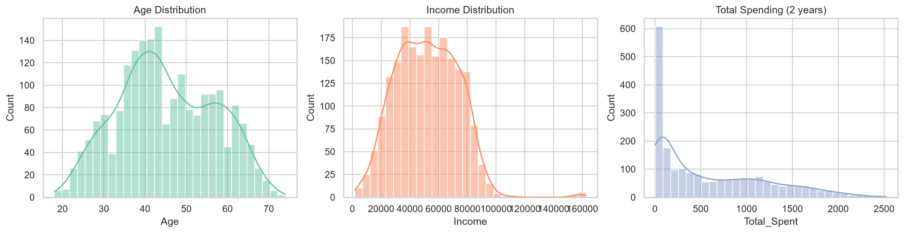
Figure 3: Distribution of Age, Income and Total Spending
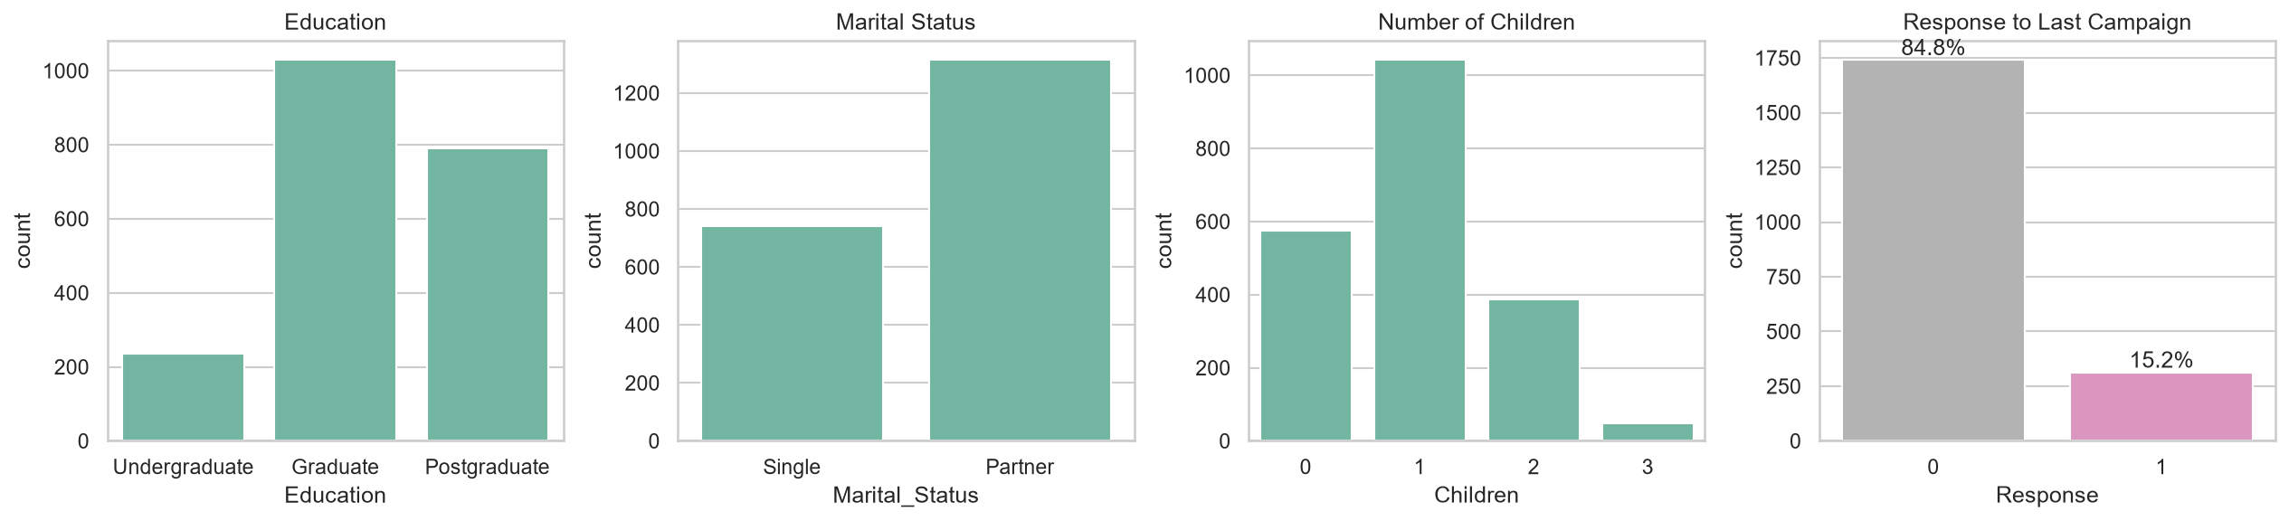
Figure 4: Customer profile and response to the last campaign
Only 15.2% of customers responded to the last campaign, so the target classes are imbalanced (85:15).
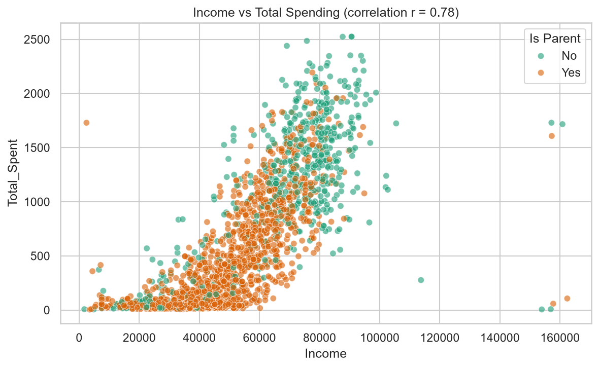
Figure 5: Income vs Total Spending (r = 0.78)
Income and spending have a strong positive relationship (r = 0.78). Customers without children dominate the high-spending region; non-parents spend about 6 times more than parents (median 1,190 vs 202).
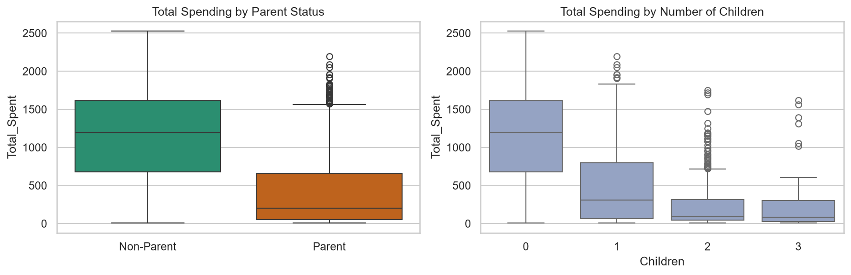
Figure 6: Spending of parents vs non-parents
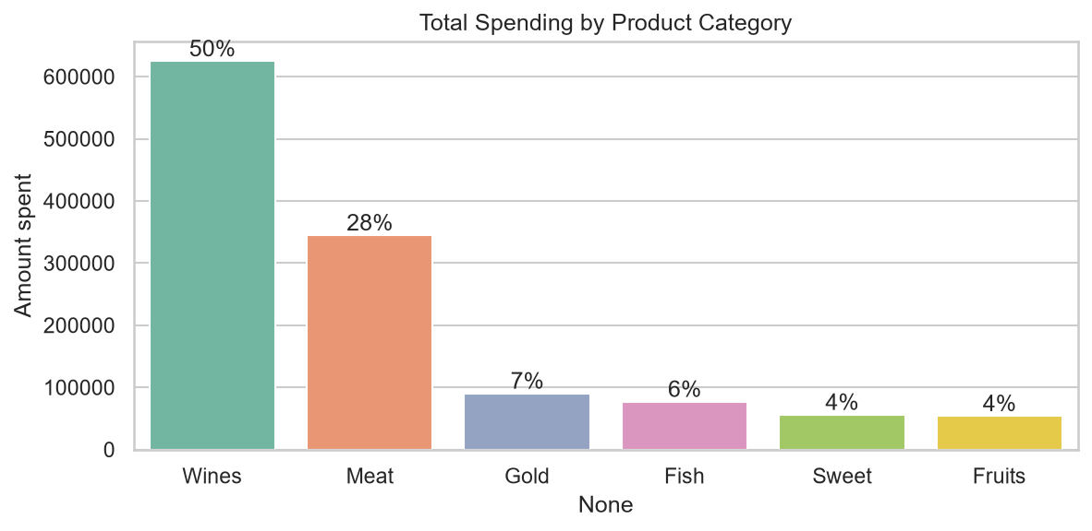
Figure 7: Spending by product category
Wine (50%) and meat (28%) account for about 78% of revenue. In-store is the main purchase channel (39% of purchases), followed by web (28%) and catalog (18%); 16% of purchases use a discount.
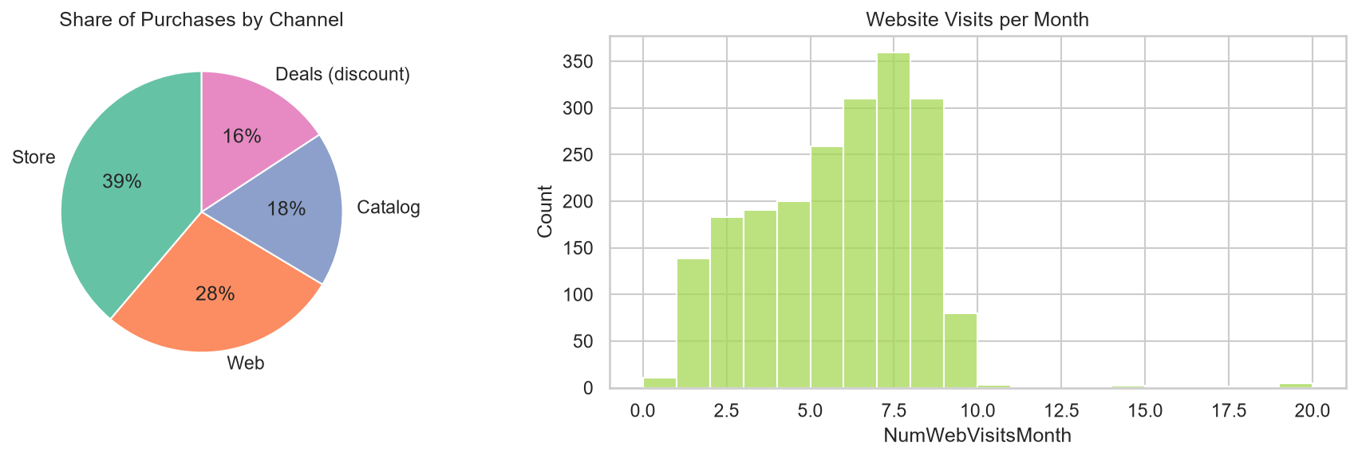
Figure 8: Purchase channels and website visits
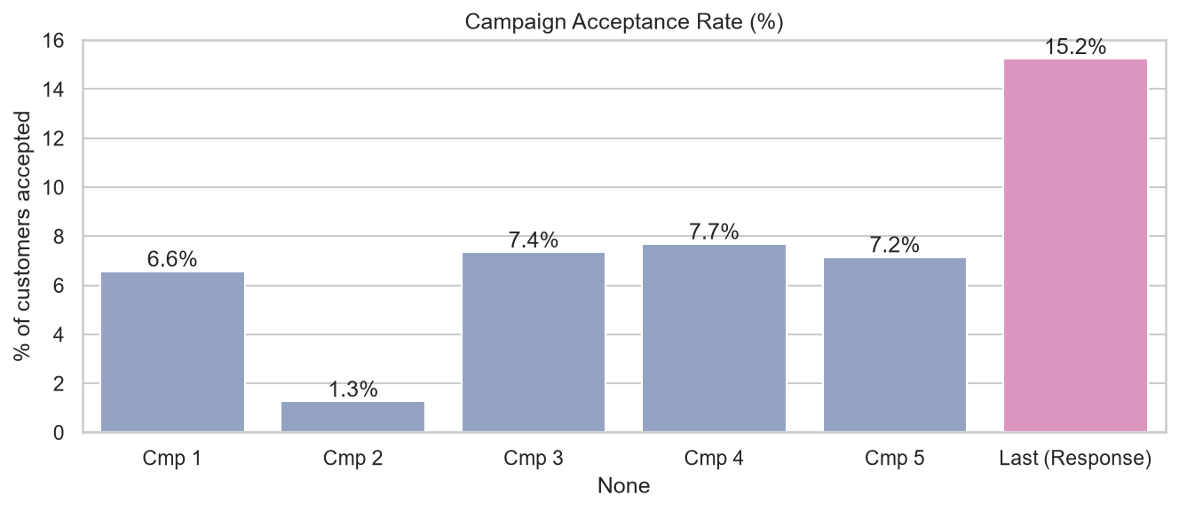
Figure 9: Acceptance rate of each campaign
Earlier campaigns had very low acceptance (1.3%–7.7%); campaign 2 almost completely failed. Even the most recent campaign was accepted by only 15.2% of customers.
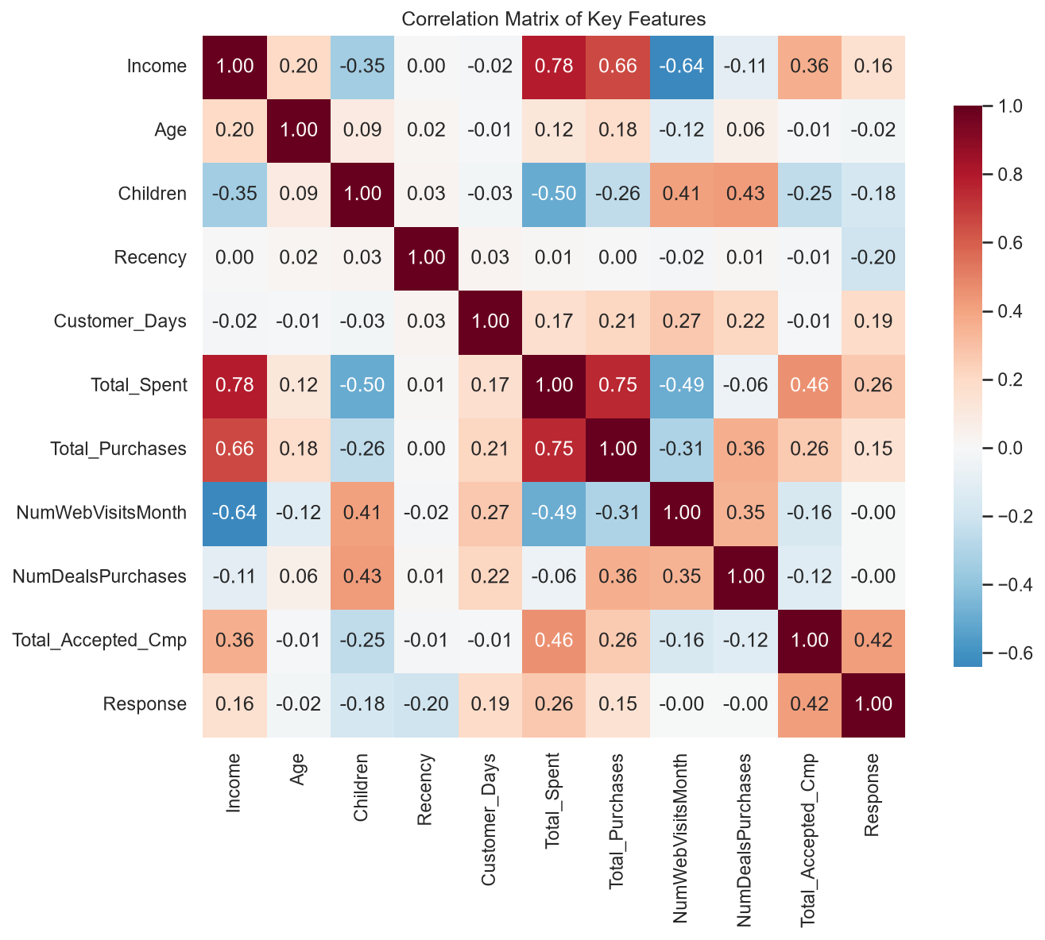
Figure 10: Correlation matrix of key features
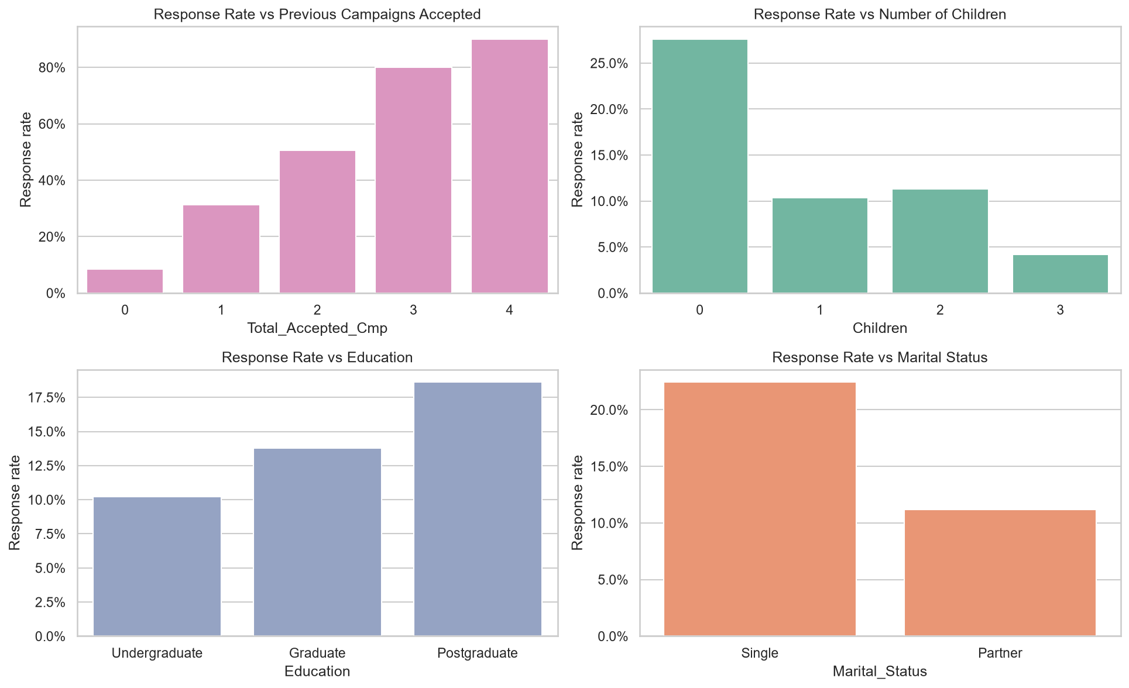
Figure 11: Response rate by previous acceptances, children, education and marital status
Response rises sharply with previous acceptances (8% for none, 31% for one, 51% for two and above 80% for three or more). Customers without children (28%), singles (22%) and postgraduates (19%) respond more often.
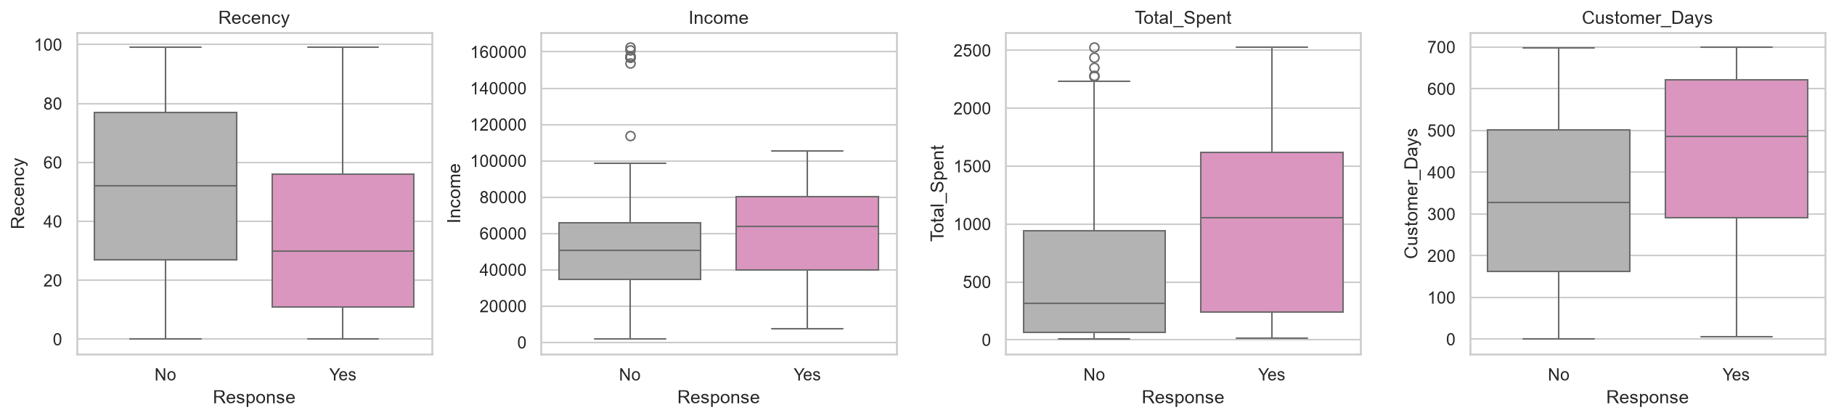
Figure 12: Responders vs non-responders
Responders bought more recently (35 vs 51 days), earn more (≈60,000 vs ≈51,000), spend almost twice as much (≈980 vs ≈540) and have been customers for longer (≈443 vs ≈336 days).

7. Sampling and Estimation

7.1 Point Estimates and Confidence Intervals
For means, the t-interval x̄ ± t(α/2, n−1)·s/√n is used because the population standard deviation is unknown. For the response proportion, the z-interval p̂ ± z(α/2)·√(p̂(1−p̂)/n) is used.
Table 6: Point estimates and 95% confidence intervals
Parameter | Point estimate | 95% confidence interval
Mean Total_Spent | 606.4 | 580.4 – 632.5
Mean Income | 52,036 | 51,107 – 52,965
Mean Age | 45.1 | 44.6 – 45.6
Mean Recency (days) | 49.0 | 47.7 – 50.2
Response rate | 15.2% | 13.7% – 16.8%

7.2 Effect of Sample Size
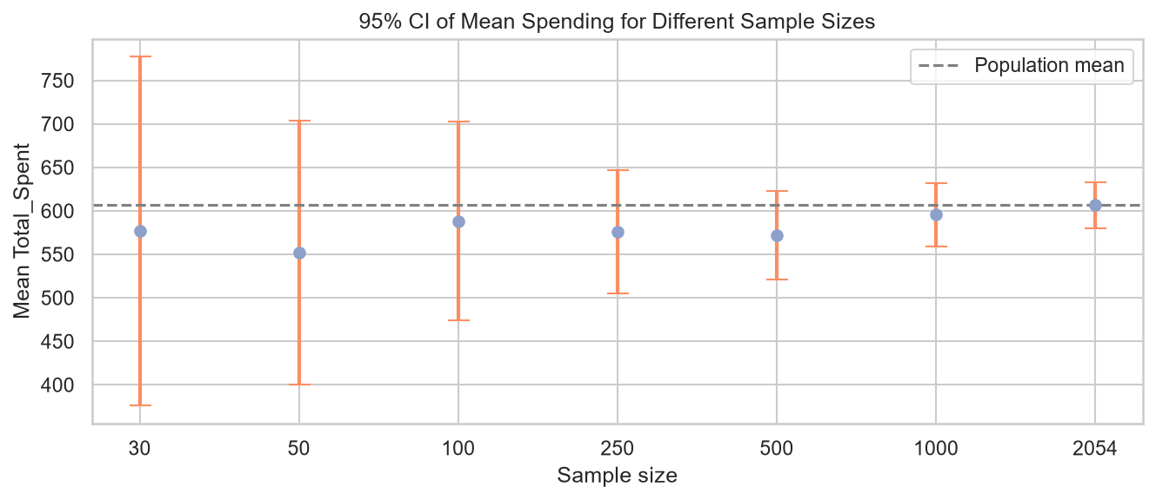
Figure 13: 95% confidence interval of mean spending for different sample sizes
The width of the confidence interval falls from 401 at n = 30 to 52 at n = 2,054, roughly in proportion to 1/√n. Larger samples give more precise estimates.

7.3 Simple Random vs Stratified Sampling
Two hundred samples of 300 customers were drawn with each method. With simple random sampling, the response rate in a sample varied from 10% to 20% purely by chance (standard deviation 1.9 percentage points). Stratified sampling by Response kept it at 15.3% in every sample. For this reason the train/test split for the classification models is stratified.
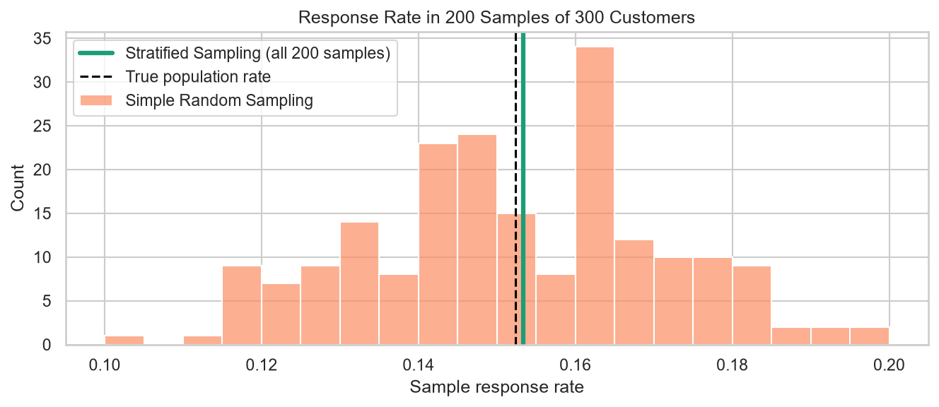
Figure 14: Response rate in 200 samples: simple random vs stratified sampling

7.4 Bootstrap and the Central Limit Theorem
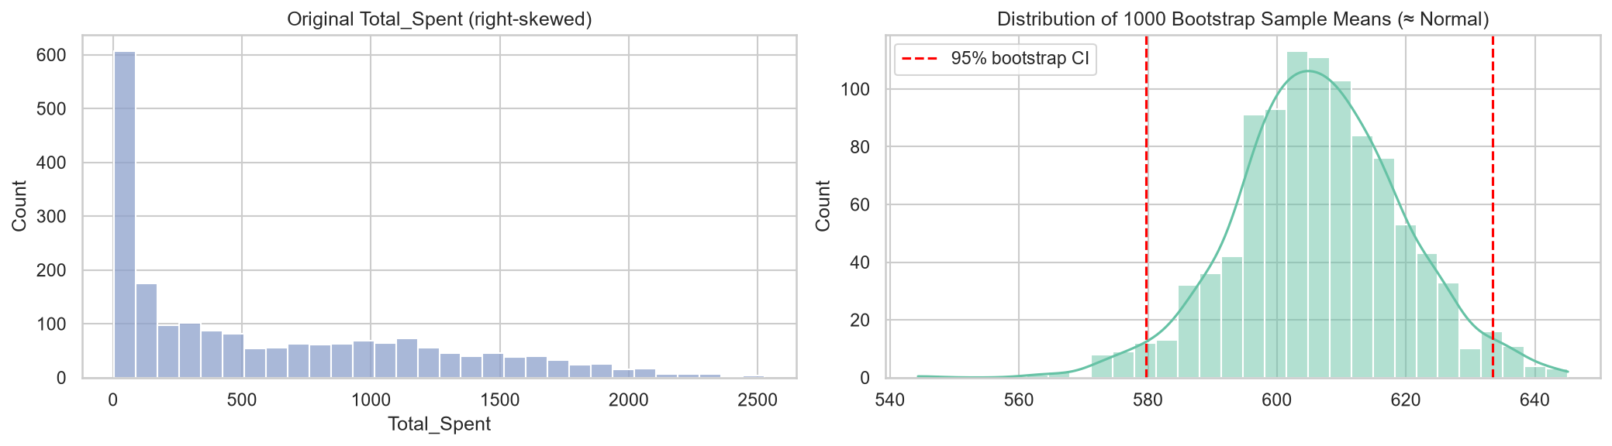
Figure 15: Original spending distribution and the distribution of 1,000 bootstrap means
Although spending is skewed, the distribution of bootstrap sample means is approximately normal, illustrating the Central Limit Theorem. The bootstrap 95% interval (579.7 – 633.5) closely matches the t-interval.

7.5 Sample Size Planning
Using n = z²·p(1−p)/E² with p = 0.152, a pilot campaign needs about 552 customers to estimate the response rate within ±3% at 95% confidence (199 for ±5%, 1,241 for ±2%).

7.6 Hypothesis Testing (α = 0.05)
Table 7: Hypothesis test results
Variable | Test | Result | p-value | Decision
Total_Spent | Welch t-test | Responders 980 vs 539 | < 0.001 | Significant
Income | Welch t-test | 60,127 vs 50,581 | < 0.001 | Significant
Recency | Welch t-test | 35 vs 51 days | < 0.001 | Significant
Customer_Days | Welch t-test | 443 vs 336 days | < 0.001 | Significant
Age | Welch t-test | 44.5 vs 45.2 years | 0.319 | Not significant
NumWebVisitsMonth | Welch t-test | 5.30 vs 5.33 | 0.887 | Not significant
Education | Chi-square | χ² = 13.19, df = 2 | 0.001 | Associated
Marital_Status | Chi-square | χ² = 45.48, df = 1 | < 0.001 | Associated
Is_Parent | Chi-square | χ² = 93.44, df = 1 | < 0.001 | Associated
Complain | Chi-square | χ² = 0.00, df = 1 | 1.000 | Not associated

The tests confirm that responders differ significantly from non-responders in spending, income, recency and tenure, and that education, marital status and parenthood are associated with response. Age, website visits and complaints show no significant relationship.

8. Linear Regression – Predicting Customer Spending
The target is Total_Spent. The features are Income, Age, Children, Partner, Education, Recency, Customer_Days and NumWebVisitsMonth. The spending and purchase-count columns are excluded because Total_Spent is computed from them (data leakage). Data is split 80/20 into training and test sets.
Table 8: Linear regression performance
Model | Test R² | RMSE | MAE | 5-fold CV R²
Simple LR (Income only) | 0.631 | 382.7 | 285.1 | 0.609
Multiple LR (8 features) | 0.712 | 338.2 | 247.5 | 0.699

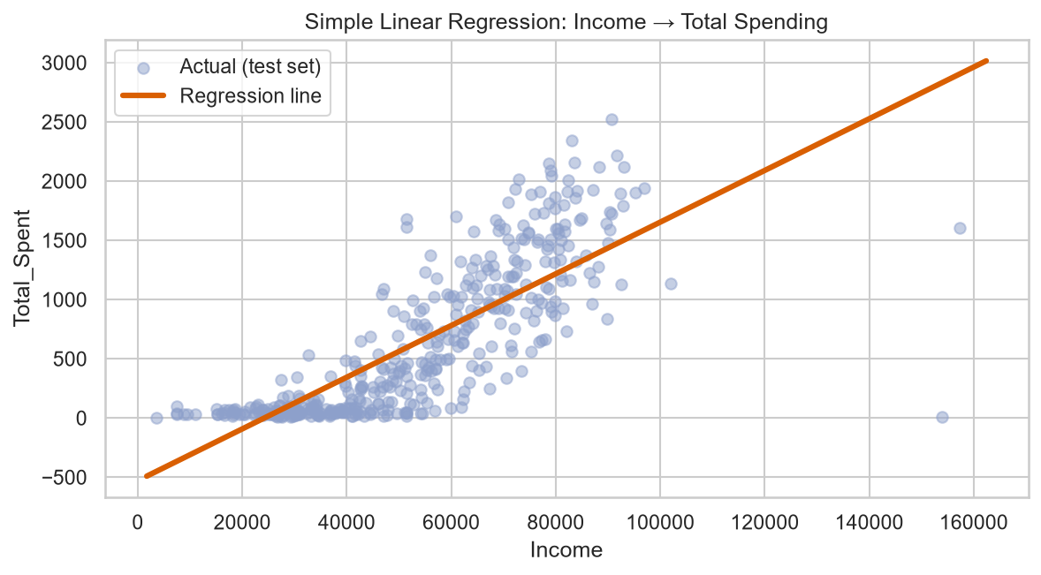
Figure 16: Simple linear regression: Income → Total Spending
Table 9: OLS coefficients (training set)
Feature | Coefficient | p-value | Significant
Income | 0.020 | < 0.001 | Yes
Children | −216.6 | < 0.001 | Yes
Customer_Days | 0.483 | < 0.001 | Yes
NumWebVisitsMonth | 9.96 | 0.035 | Yes
Recency | 0.402 | 0.150 | No
Partner | −8.14 | 0.629 | No
Age | 0.096 | 0.896 | No
Edu_Code | −1.62 | 0.899 | No

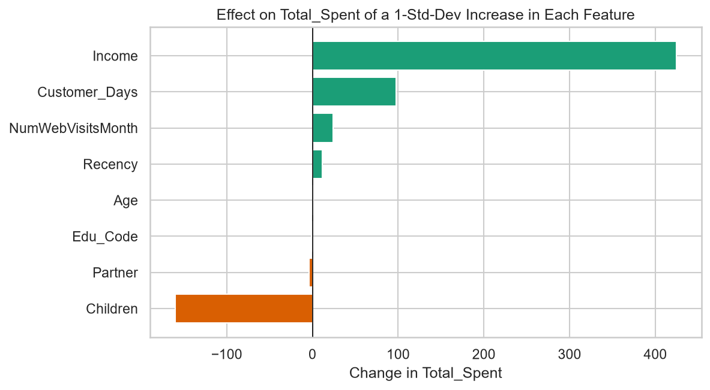
Figure 17: Effect of a one-standard-deviation increase in each feature
Income is the strongest driver (+1,000 income ≈ +20 spending) and each additional child reduces spending by about 217. Each year as a customer adds about 175. The multiple model explains 71% of the variation in spending, and the cross-validated R² (0.70) shows the model is stable.
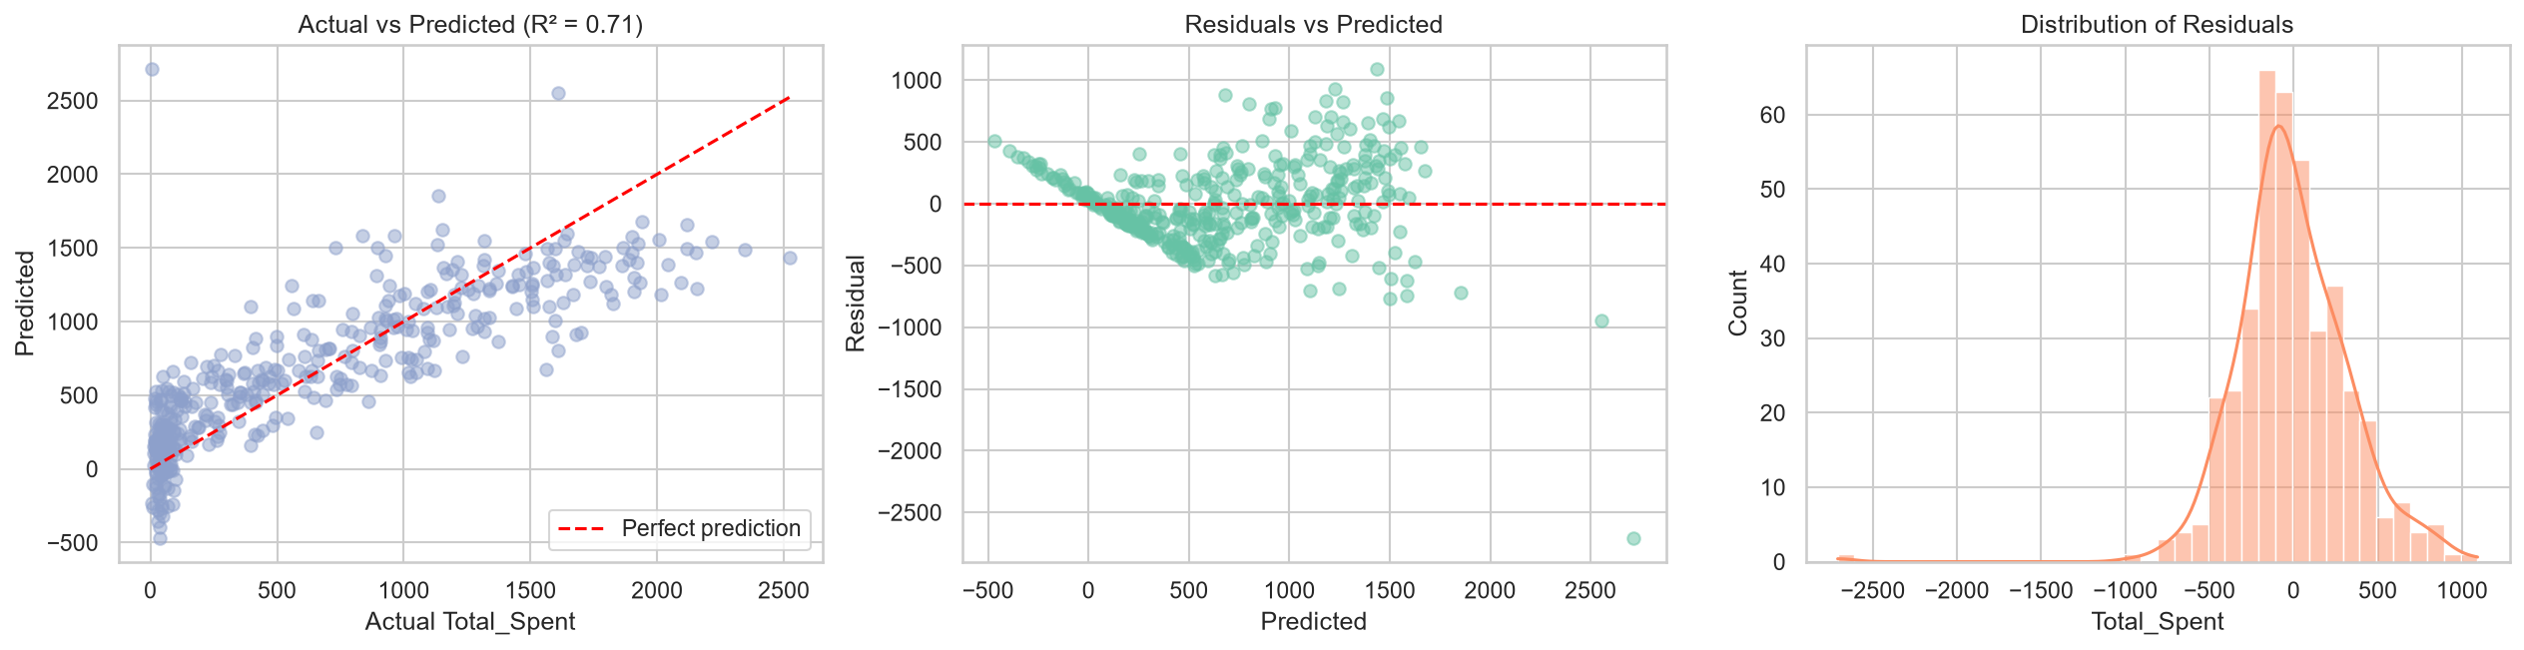
Figure 18: Regression diagnostics: actual vs predicted, residuals
Limitations: the residual plot shows a curved pattern and increasing spread for larger predictions (heteroscedasticity), and some predictions for low-income customers are negative (clipped to zero in the dashboard). Modelling log(spending) or a non-linear model could improve this.

9. Customer Segmentation using K-Means
Seven features – Income, Total_Spent, Age, Children, Total_Purchases, Recency and NumWebVisitsMonth – were standardised and clustered with K-Means. Standardisation is essential because K-Means uses Euclidean distance.
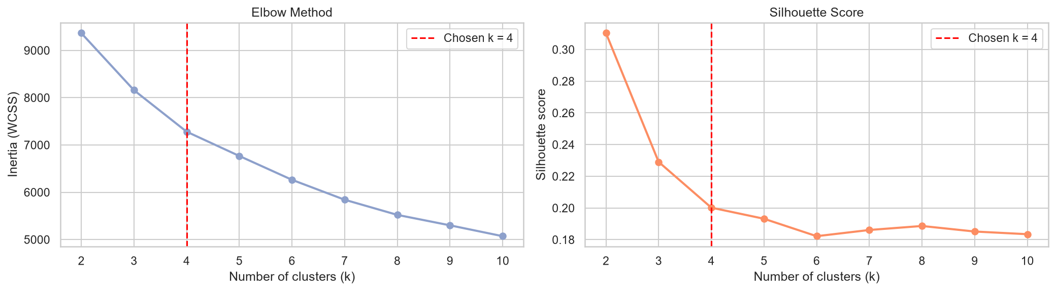
Figure 19: Elbow method and silhouette score
The elbow curve bends at k = 4 (the drop in inertia falls from about 880 for k = 3→4 to about 510 for k = 4→5). Although k = 2 has the highest silhouette score (0.31), it only separates high and low spenders, which is too coarse for marketing. From k = 4 the silhouette is almost flat (≈0.20), so k = 4 was selected.
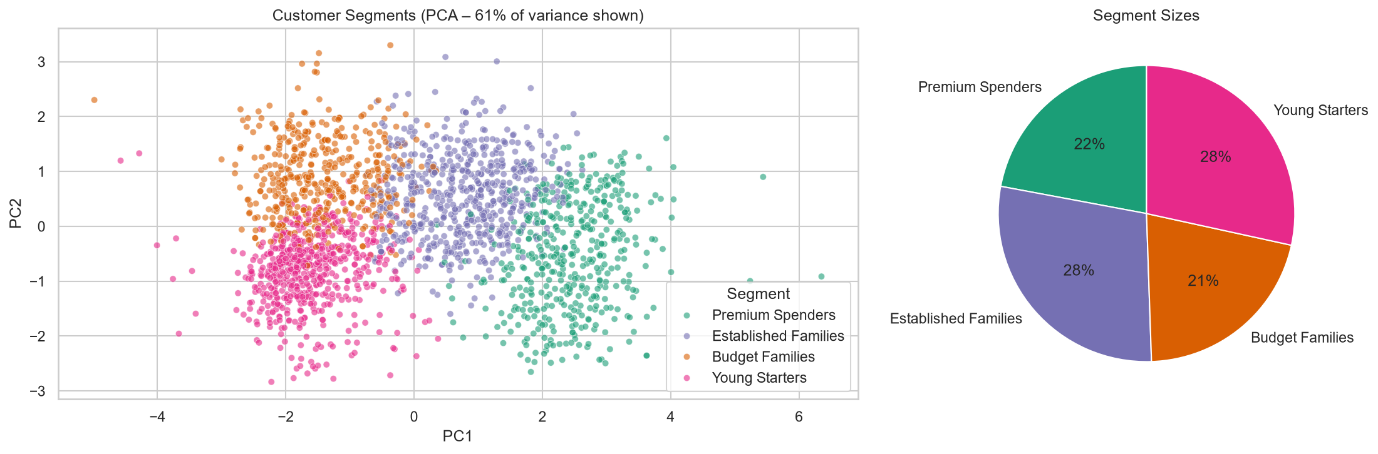
Figure 20: Customer segments in two dimensions (PCA, 61% of variance)
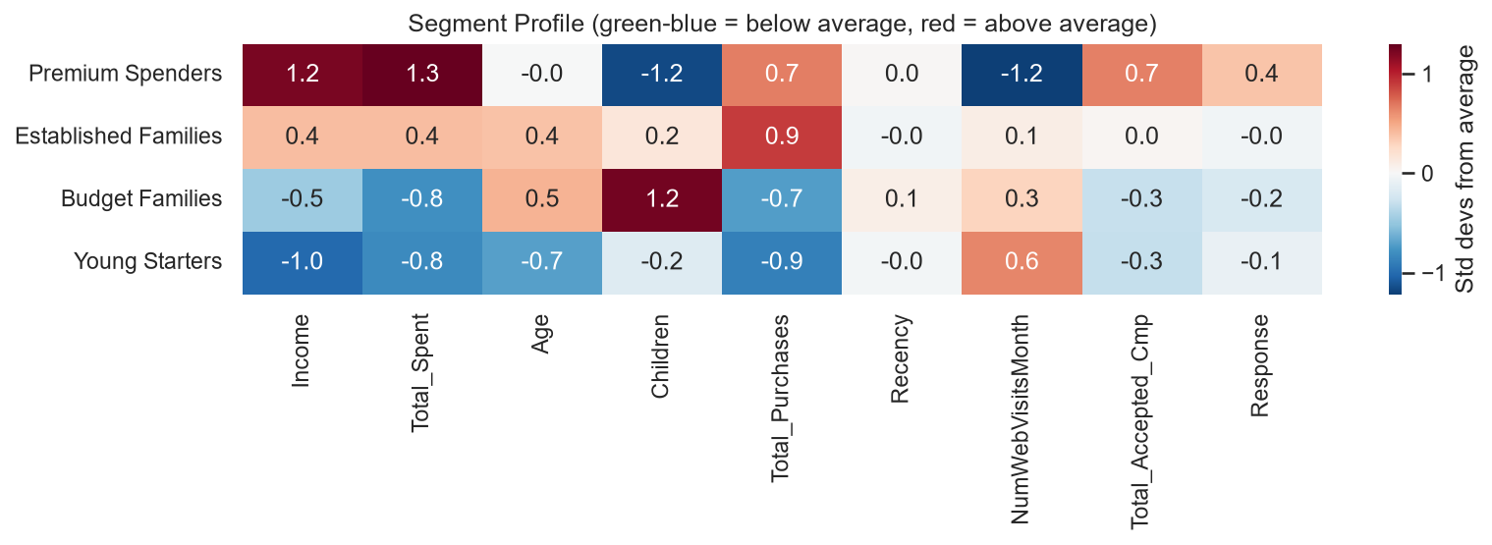
Figure 21: Segment profiles relative to the overall average
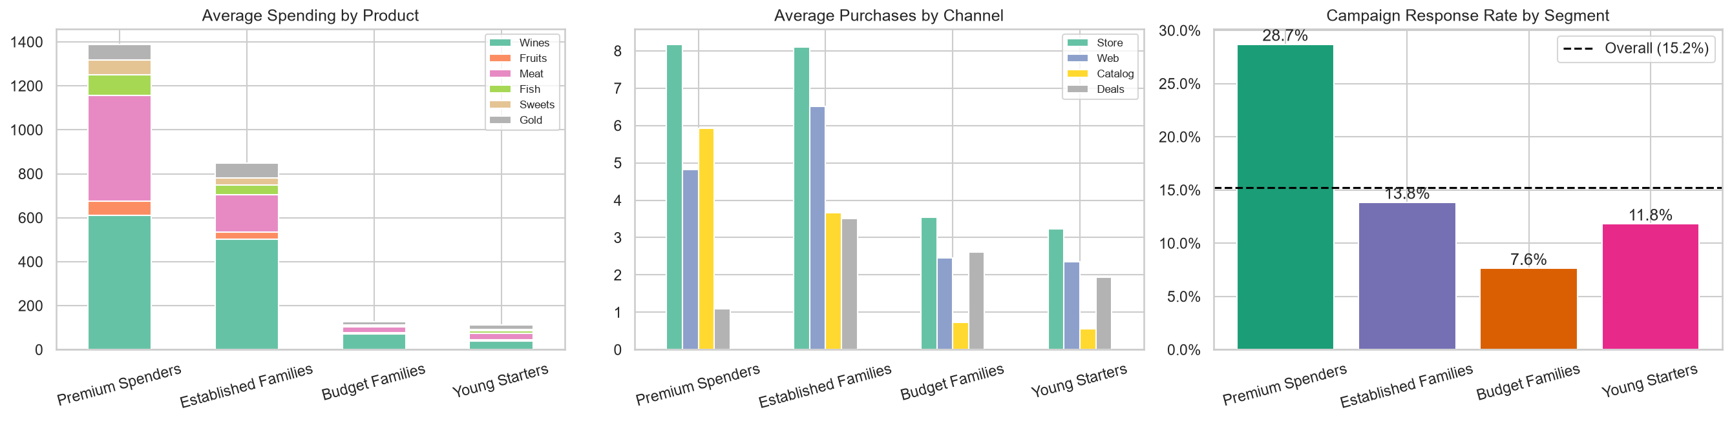
Figure 22: Spending, channels and response rate by segment
Table 10: Customer segments
Segment | Customers | Profile | Revenue share | Response rate
Premium Spenders | 453 (22%) | Income ≈78k, almost no children, catalog buyers, rarely use deals | 50.5% | 28.7%
Established Families | 585 (28%) | Income ≈61k, age ≈50, teenagers at home, longest tenure, heavy deal users | 39.8% | 13.8%
Budget Families | 432 (21%) | Income ≈42k, ≈2 children, few purchases | 4.4% | 7.6%
Young Starters | 584 (28%) | Age ≈37, income ≈30k, visit the website most but buy little | 5.3% | 11.8%

Table 11: Segment strategies
Segment | Recommended marketing strategy
Premium Spenders | Luxury wine and meat offers, VIP/loyalty programme, catalog campaigns; include in every campaign.
Established Families | Value bundles and deals, store and catalog promotions, upgrade offers towards premium products.
Budget Families | Discount coupons, family and kids' bundles, in-store promotions; keep contact cost low.
Young Starters | Web and mobile promotions, first-purchase coupons and retargeting to convert browsing into buying.

Key finding: Premium Spenders and Established Families make up 50% of customers but generate about 90% of revenue and 67% of all campaign responders.

10. Classification – Predicting Campaign Response

10.1 Approach
- Features: 22 customer attributes (demographics, spending, channels, recency, tenure, previous acceptances, complaints) plus the segment from K-Means (one-hot encoded) – 26 features in total.
- Stratified 80/20 split: 1,643 training and 411 test customers, both with 15.2% responders.
- Class imbalance: class_weight = "balanced", so errors on the rare responder class cost more.
- Tuning: GridSearchCV with 5-fold stratified cross-validation on the training set; the best model is chosen by cross-validated ROC-AUC, keeping the test set for the final unbiased evaluation.
- Baseline: predicting "No" for everyone gives 84.7% accuracy but 0% recall, so recall, precision, F1 and ROC-AUC are used instead of accuracy alone.

10.2 Results
Table 12: Classification model comparison (test set, 411 customers)
Model | CV AUC | Accuracy | Precision | Recall | F1 | Test AUC
Logistic Regression | 0.892 | 0.791 | 0.408 | 0.810 | 0.543 | 0.885
Decision Tree | 0.825 | 0.723 | 0.329 | 0.778 | 0.462 | 0.788
Random Forest | 0.885 | 0.837 | 0.478 | 0.683 | 0.562 | 0.875

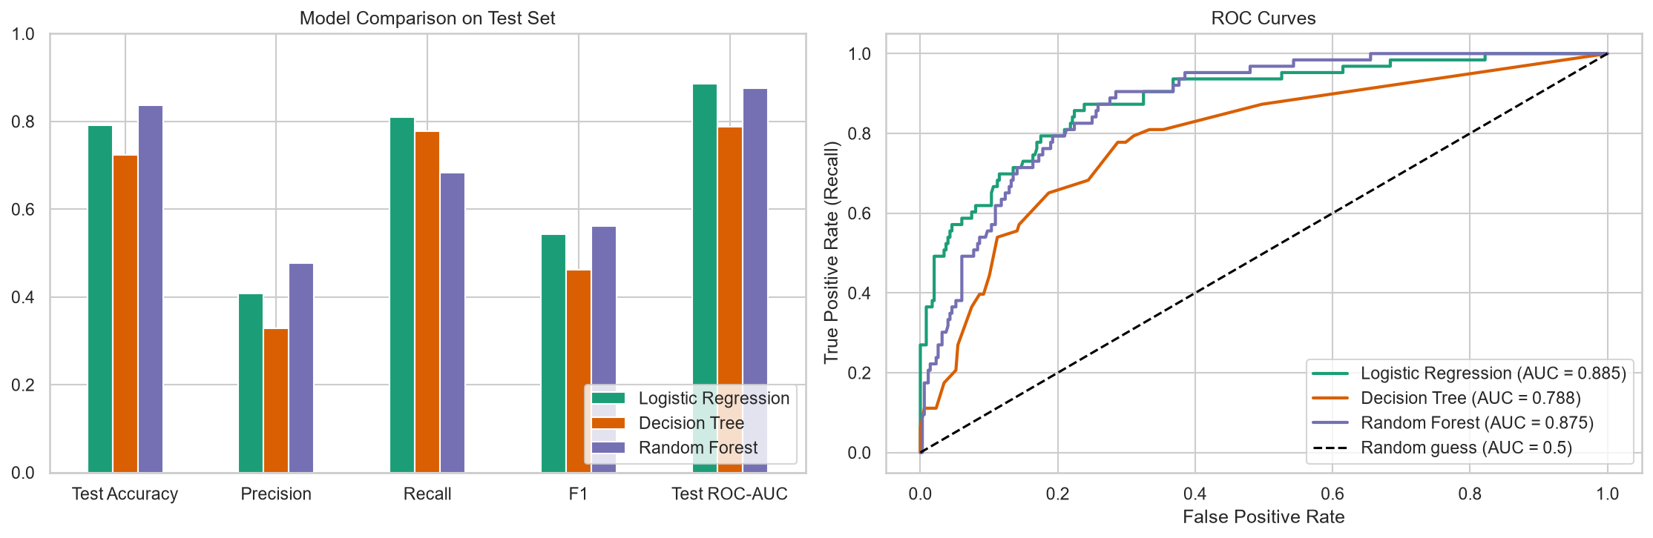
Figure 23: Model comparison and ROC curves
Logistic Regression is the best model (CV AUC 0.892, test AUC 0.885) and has the highest recall (81%). Random Forest is close (AUC 0.875) with higher precision but lower recall. The Decision Tree is weakest (AUC 0.788) but easiest to explain. The simpler linear model performs best because the main relationships are close to linear and additive, and the dataset (≈2,000 customers) offers limited extra structure for a complex ensemble to exploit.
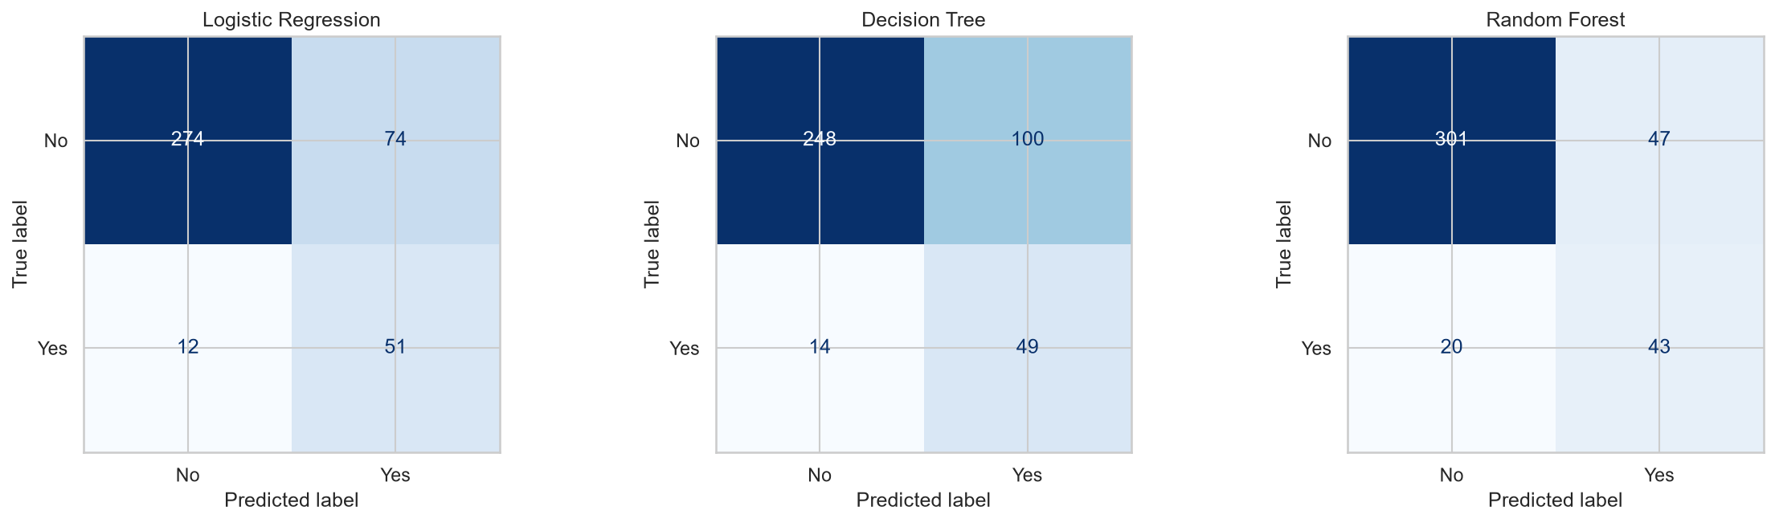
Figure 24: Confusion matrices
The Logistic Regression model correctly finds 51 of the 63 responders in the test set (12 missed) and correctly skips 274 of 348 non-responders, with 74 false positives. For marketing, a missed responder (lost sale) usually costs more than one extra contact, so high recall with moderate precision is the preferred trade-off.

10.3 Drivers of Campaign Response
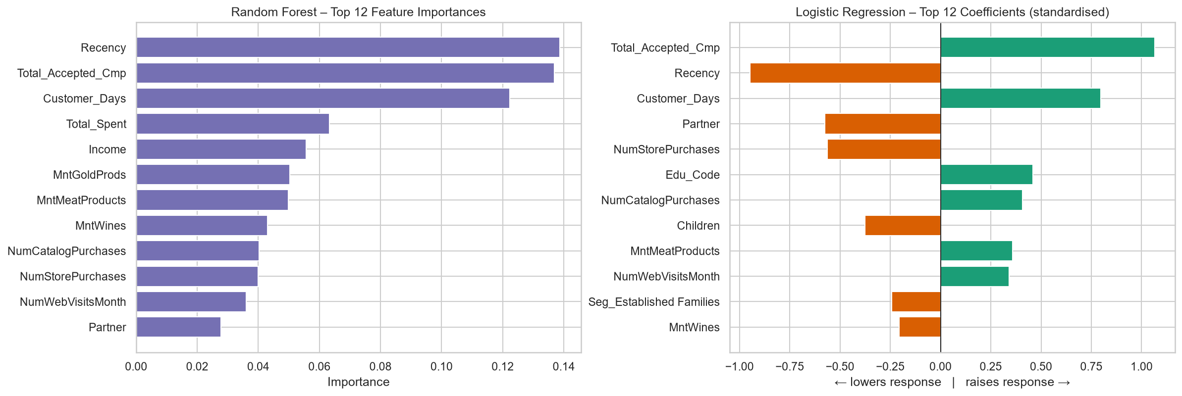
Figure 25: Random Forest feature importance and Logistic Regression coefficients
- Previous campaign acceptances (+): odds of responding ×2.9 per standard deviation – past responders respond again.
- Recency (−): recent buyers are much more likely to respond (odds ×0.39 per standard deviation of more days).
- Customer tenure (+): long-standing customers respond more (odds ×2.2).
- Partner and children (−): singles and customers without children respond more.
- Catalog purchases, meat spending and education (+) increase response.
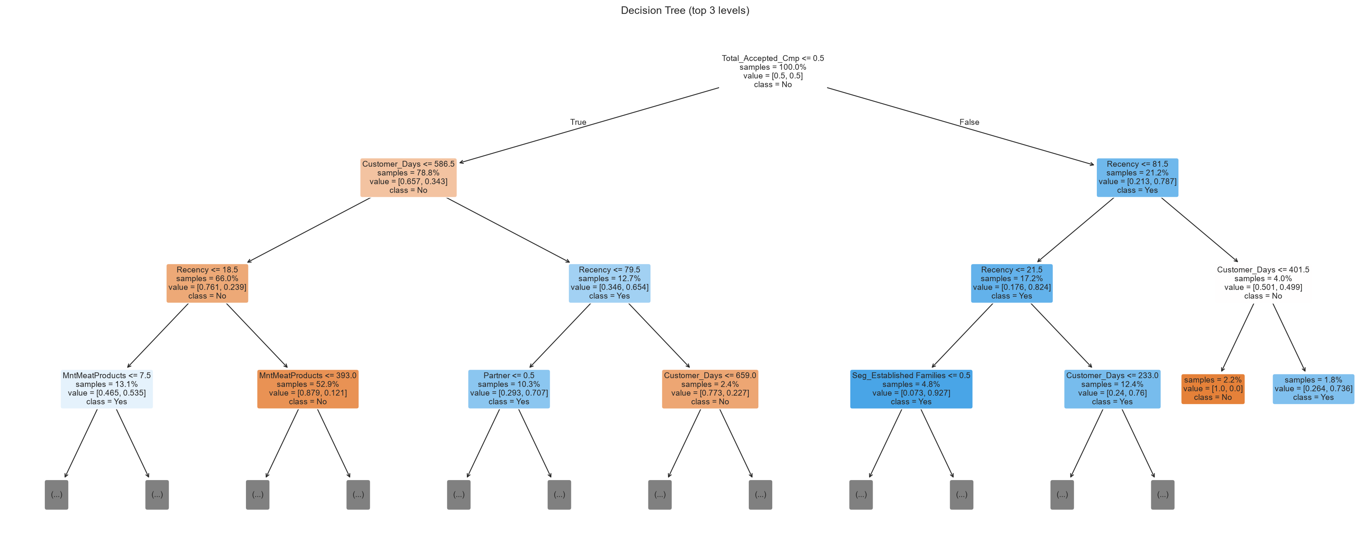
Figure 26: Decision tree (top three levels)

10.4 Business Impact – Targeting Simulation
Table 13: Cumulative gains on the test set (Logistic Regression)
Contact top | Responders captured | Response rate of contacted | Lift
10% | 49.2% | 75.6% | 4.9×
20% | 68.3% | 52.4% | 3.4×
30% | 79.4% | 40.7% | 2.7×
40% | 87.3% | 33.5% | 2.2×
50% | 93.7% | 28.6% | 1.9×
100% | 100.0% | 15.3% | 1.0×

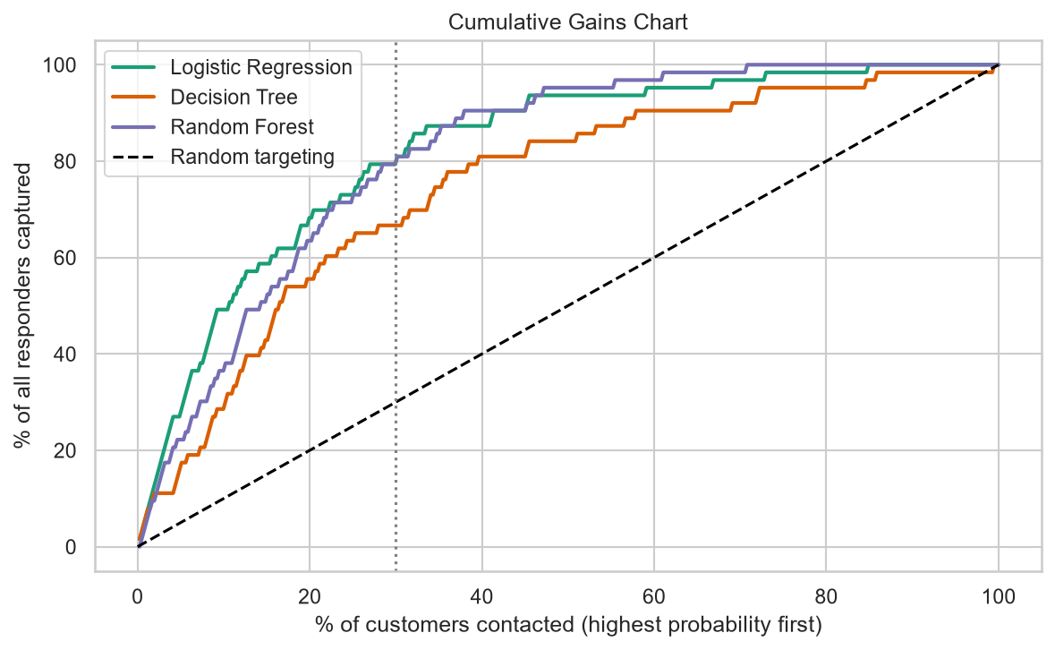
Figure 27: Cumulative gains chart
Contacting only the top 30% of customers ranked by the model captures about 80% of responders at a response rate of about 41% (2.7× better than random), while reducing the number of contacts by 70%. Using the dataset's own cost (3 per contact) and revenue (11 per response), contacting all 2,054 customers produces a loss of 2,719, whereas contacting the model's top 30% produces a profit of 979.

11. Application Development – Interactive Dashboard
An interactive dashboard was developed in Streamlit with Plotly charts so that marketing managers can use the analysis without writing code. It loads the cleaned data and trained models and has five pages, with a sidebar filter to focus on selected segments.
Table 14: Dashboard pages
Page | Purpose
Overview | KPI cards (customers, income, spending, revenue, response rate), revenue by product, channels, campaign acceptance
Customer Segments | Segment cards, PCA plot, response by segment, product and channel mix, segment explorer with strategy
Model Performance | Model comparison table, ROC curves, confusion matrices, feature importance, regression results
Predict a Customer | Form to enter a customer's details; returns segment, response probability, expected spending and a campaign decision
Campaign Targeting | Choose the % of customers to contact, cost and revenue; shows responders captured, profit, gains chart and a downloadable target list

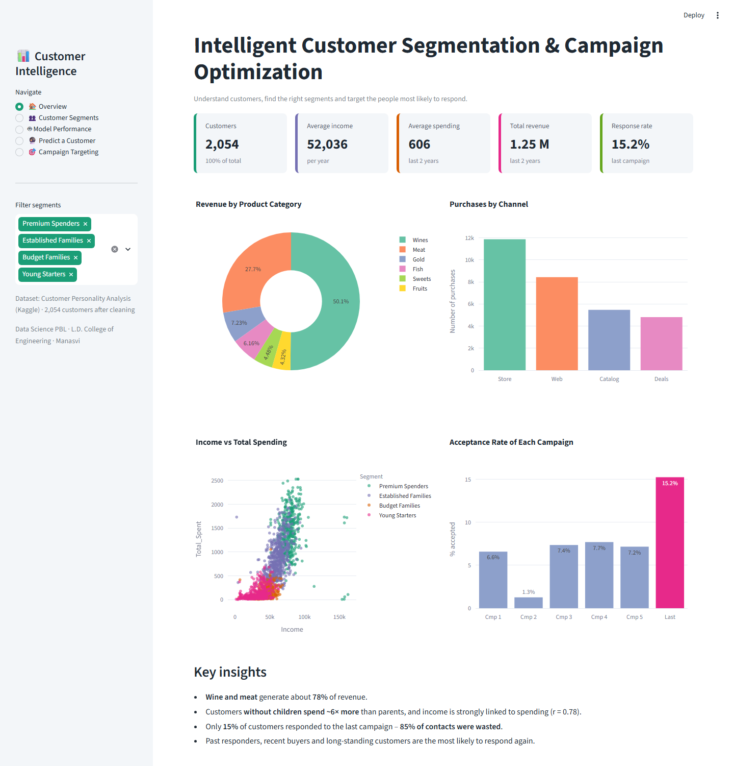
Figure 28: Dashboard – Overview page
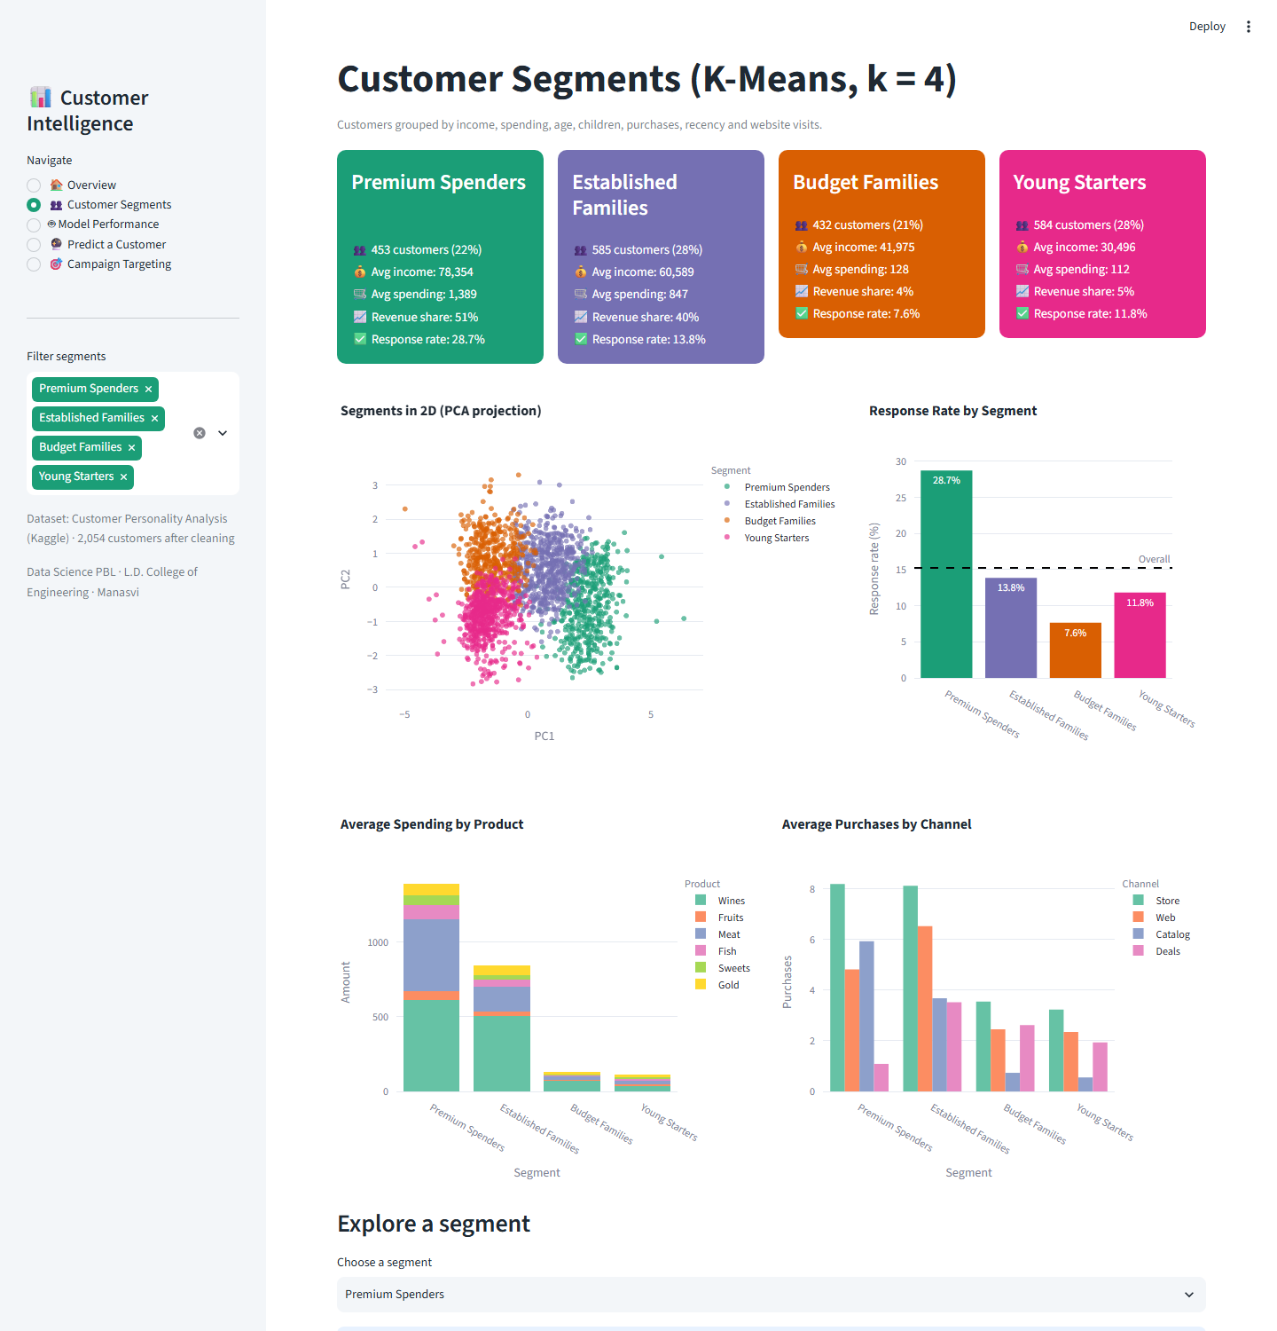
Figure 29: Dashboard – Customer Segments page
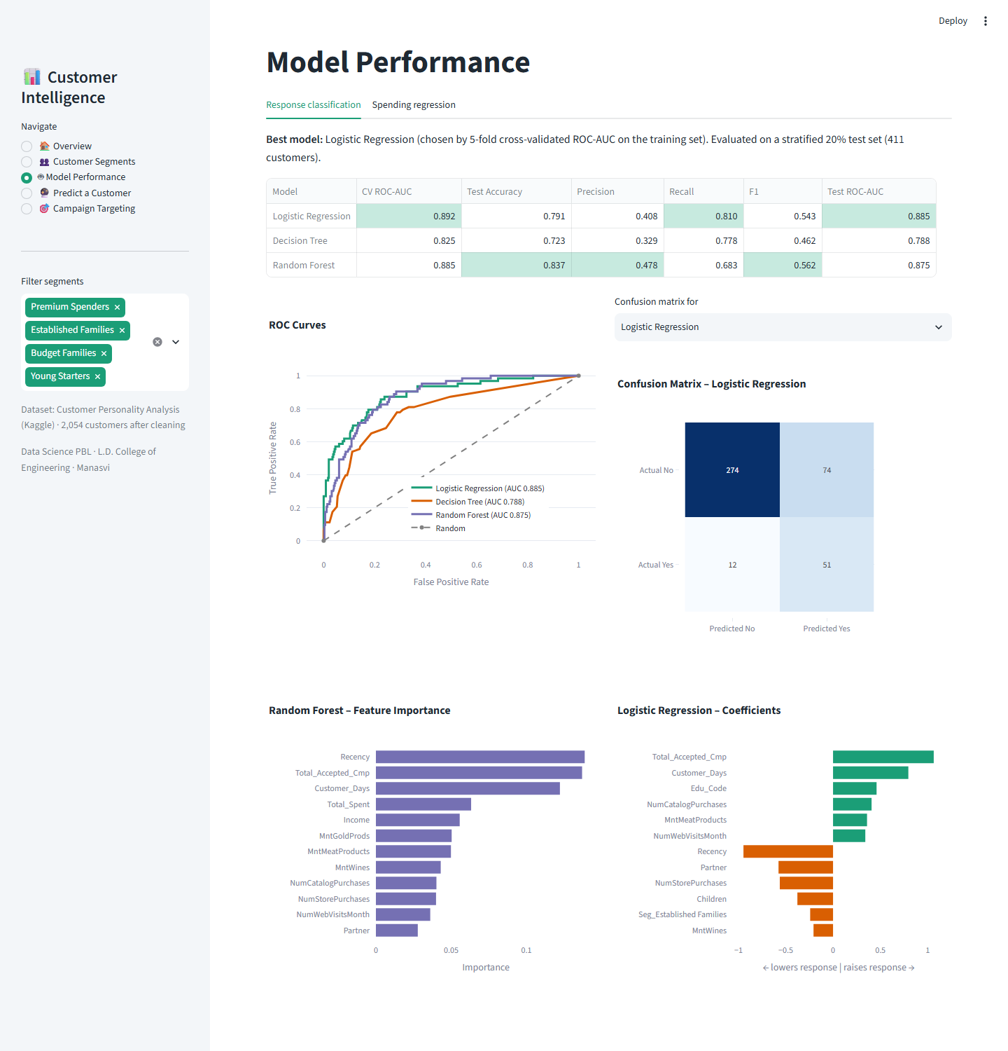
Figure 30: Dashboard – Model Performance page
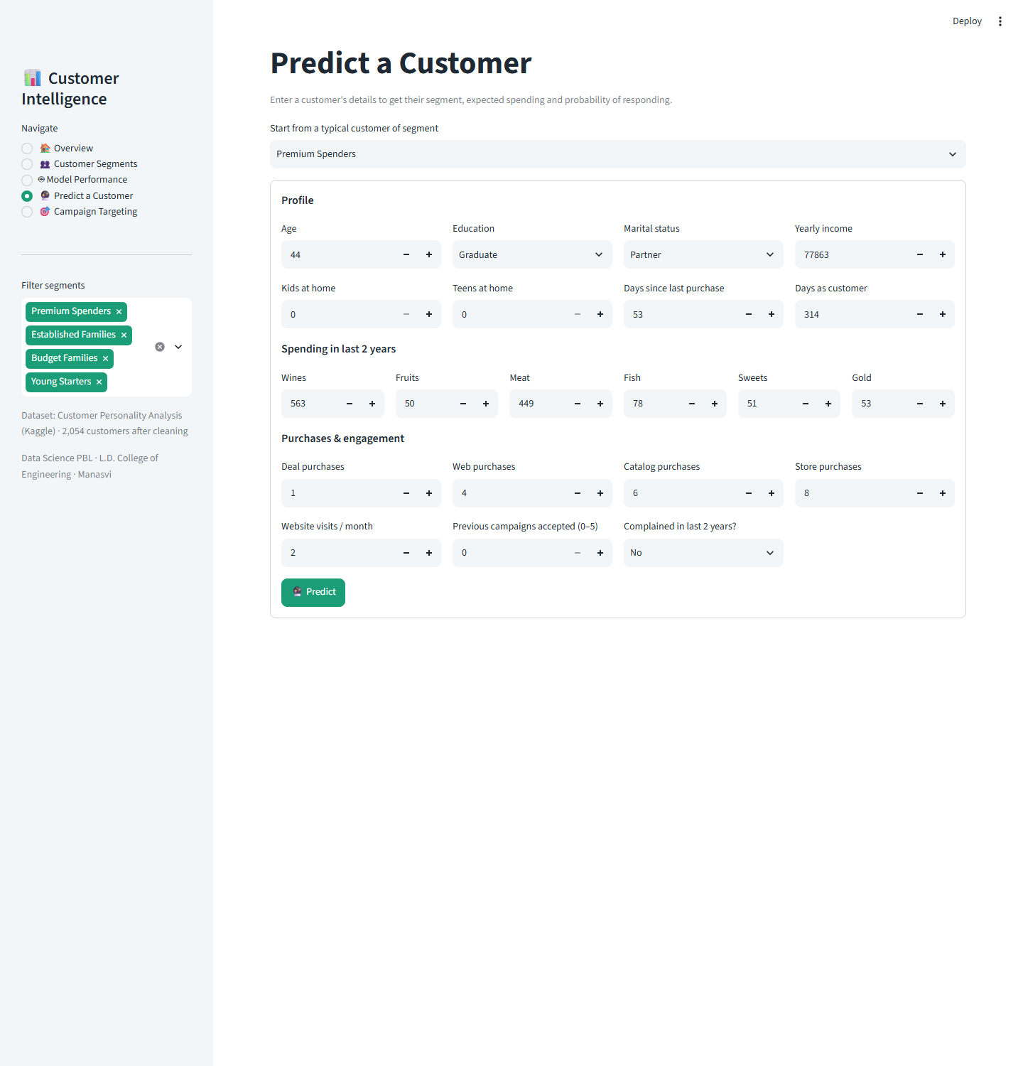
Figure 31: Dashboard – Predict a Customer page
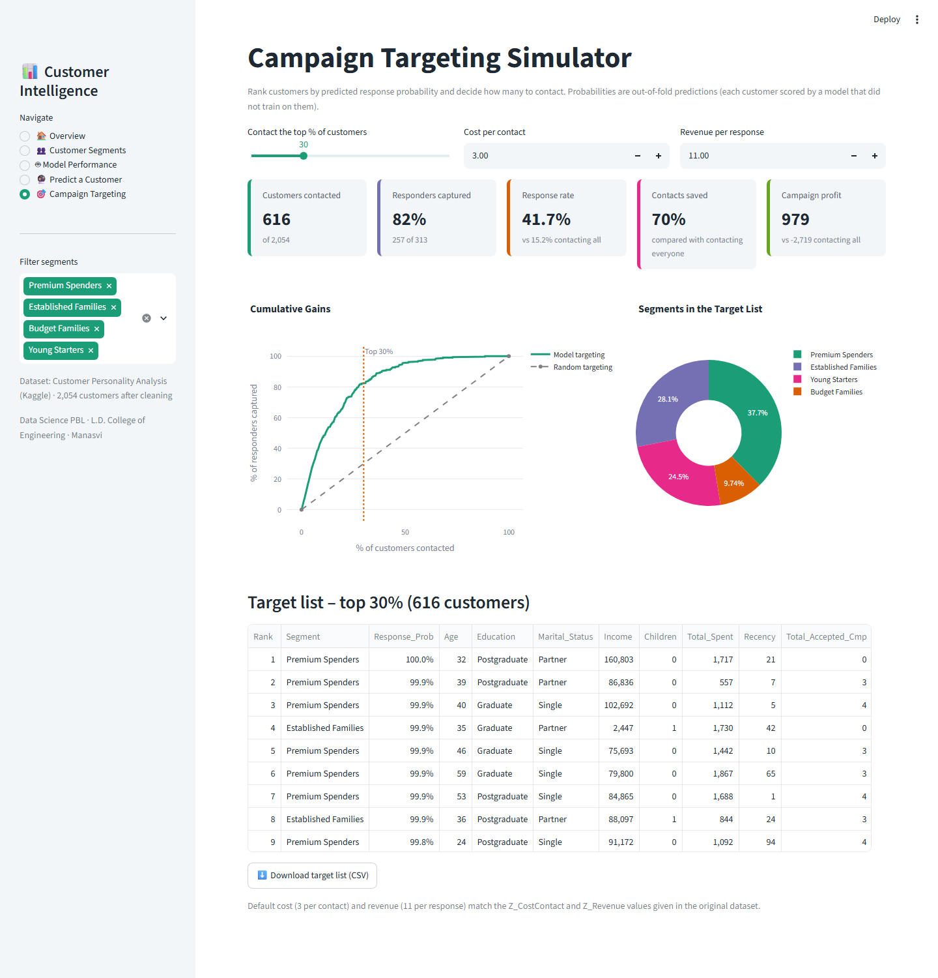
Figure 32: Dashboard – Campaign Targeting page

12. Business Insights and Recommendations
- Stop mass campaigns. With a 15% response rate, contacting everyone loses money. Rank customers with the response model and contact only the top 30–40%.
- Prioritise Premium Spenders and Established Families. They generate about 90% of revenue and two-thirds of responders; offer premium wine and meat products, loyalty rewards and value bundles.
- Re-target past responders and recent buyers first. Previous acceptance and recency are the strongest predictors of response.
- Use low-cost digital channels for Budget Families and Young Starters, such as e-mail coupons and web promotions, since their response and spending are low.
- Focus product campaigns on wine and meat, which make up 78% of revenue, and use smaller categories for cross-selling bundles.
- Run pilot campaigns of about 550 customers to estimate the response to a new offer within ±3% before a full launch.

13. Conclusion and Future Scope

13.1 Conclusion
This project built a complete customer intelligence system on a real retail dataset. Data cleaning and EDA revealed that spending is driven by income and family situation and that only 15% of customers respond to campaigns. Sampling and estimation quantified key business measures with confidence intervals and confirmed the main differences between responders and non-responders statistically. Linear regression explained 71% of the variation in customer spending. K-Means clustering identified four actionable segments, and Logistic Regression predicted campaign response with a ROC-AUC of 0.885. Model-based targeting can capture about 80% of responders with 70% fewer contacts, turning an unprofitable campaign into a profitable one. The Streamlit dashboard makes these insights directly usable by business stakeholders.

13.2 Limitations
- The data comes from one company and one time period, so results may not generalise to other businesses.
- Income is self-reported and some customers have unusual combinations (e.g., very high income with almost no spending).
- Linear regression assumptions (linearity, constant variance) are only partly satisfied.

13.3 Future Scope
- Try gradient boosting models (e.g., XGBoost) and resampling methods such as SMOTE.
- Calibrate predicted probabilities and choose the decision threshold by expected profit.
- Build product-specific response models (wine, meat, gold) for personalised offers.
- Integrate the dashboard with a live CRM database and deploy it on the cloud for the marketing team.
- Run A/B tests to measure the real uplift of model-based targeting.

References
[1] Akash Patel (imakash3011). Customer Personality Analysis [Dataset]. Kaggle. https://www.kaggle.com/datasets/imakash3011/customer-personality-analysis
[2] Wedel, M., & Kamakura, W. A. (2000). Market Segmentation: Conceptual and Methodological Foundations (2nd ed.). Springer.
[3] Hughes, A. M. (1994). Strategic Database Marketing. Probus Publishing.
[4] Ngai, E. W. T., Xiu, L., & Chau, D. C. K. (2009). Application of data mining techniques in customer relationship management: A literature review and classification. Expert Systems with Applications, 36(2), 2592–2602.
[5] Moro, S., Cortez, P., & Rita, P. (2014). A data-driven approach to predict the success of bank telemarketing. Decision Support Systems, 62, 22–31.
[6] MacQueen, J. (1967). Some methods for classification and analysis of multivariate observations. Proceedings of the Fifth Berkeley Symposium on Mathematical Statistics and Probability, 1, 281–297.
[7] Rousseeuw, P. J. (1987). Silhouettes: A graphical aid to the interpretation and validation of cluster analysis. Journal of Computational and Applied Mathematics, 20, 53–65.
[8] Breiman, L. (2001). Random forests. Machine Learning, 45(1), 5–32.
[9] He, H., & Garcia, E. A. (2009). Learning from imbalanced data. IEEE Transactions on Knowledge and Data Engineering, 21(9), 1263–1284.
[10] Hosmer, D. W., Lemeshow, S., & Sturdivant, R. X. (2013). Applied Logistic Regression (3rd ed.). Wiley.
[11] Efron, B., & Tibshirani, R. J. (1993). An Introduction to the Bootstrap. Chapman & Hall.
[12] Pedregosa, F., et al. (2011). Scikit-learn: Machine learning in Python. Journal of Machine Learning Research, 12, 2825–2830.
[13] Streamlit documentation. https://docs.streamlit.io

Appendix: Project Structure and How to Run
Source code repository: https://github.com/manasvigohil28/Customer-Segmentation-Campaign-Optimization
- app.py – Streamlit dashboard
- utils.py – shared cleaning and feature engineering
- notebooks/analysis.ipynb – complete analysis (data cleaning to classification)
- data/ – original and processed datasets
- models/ – trained models (.pkl) and metrics.json
- figures/ – all charts
- report/ – project report and dashboard screenshots
- requirements.txt – Python packages
Run: pip install -r requirements.txt, then streamlit run app.py (opens at http://localhost:8501).

