In the previous lecture we discussed prototypes of varying degrees of fidelity ranging from high to low and what kind of feedback they may elicit.

In this discussion we are going to set the basis for what a Physical Computing artifact is followed by brainstorming an idea for an interactive artifact and quickly paper prototyping it to seek feedback from the audience. The process is scaffolded by providing a handouts that will help them think about what they want their art to communicate, and also handouts they can cut-paste to paper prototype the look and feel and functioning of their prototype.

Class Outline

**Lecture**

Setting the stage-

What is Physical computing?- input, output, processing and form

Examples of interactive art

**Activity**

Day of the dead activity- brainstorming and paper prototyping an interactive puppet

**Informal Critique**

Presenting puppet ideas and eliciting feedback

**Assignments**

Invention Studio Tour and GVU Prototyping Lab Orientation

**Due:** Two weeks from now before class of Week 5

**Lecture/Discussion**

What is Physical Computing?

**Physical Prototyping**

# What is it?

“ Physical Computing is an approach to computer-human interaction design that starts by considering how humans express themselves physically. Computer interface design instruction often takes the computer hardware for given — namely, that there is a keyboard, a screen, speakers, and a mouse or trackpad or touchscreen — and concentrates on teaching the software necessary to design within those boundaries. In physical computing, we take the human body and its capabilities as the starting point, and attempt to design interfaces, both software and hardware, that can sense and respond to what humans can physically do.” - [Tom Igoe](https://itp.nyu.edu/physcomp/)

Anatomy of Physical computing projects:

Input

Output

Computing

Form

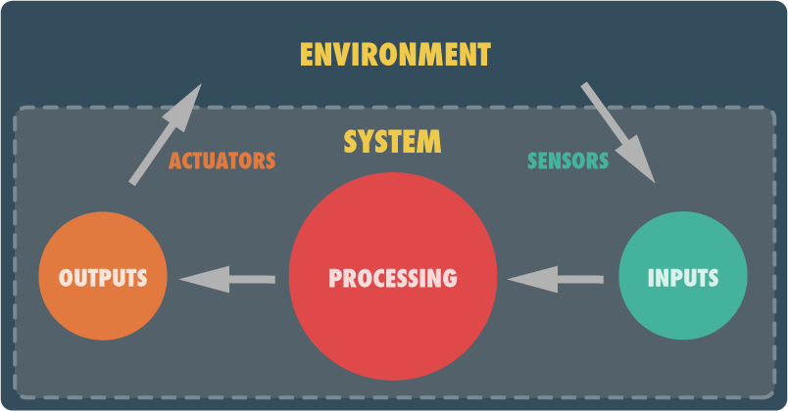Fig 1. Abstraction of a Physical Computing device

Demonstrate examples of 2-3 interactive artifacts and discuss them along the four dimensions of interactivity

Sample-Richard Clarkson’s [Interactive cloud lam](http://www.richardclarkson.com/cloud/)p

**Low Fi Prototyping Activity, Day of the dead puppet**

*This activity was prepared and led by Dr. Betsy DiSalvo*

Materials: [Easel pad sticky sheets such as this for students to sketch on](http://www.staples.com/Staples-Stickies-23-inch-x-20-inch-Repositionable-Tabletop-Easel-Pad/product_958102), markers, sharpies, tape to stick sheets on the tabletop, questionnaire handout for brainstorming, arduino parts handout for initiation to sensors,skeleton handouts for quick prototyping , magnets to display artifacts on the board, felt, colored sheets, elmers glue, scissors, scale etc.

The goal of this activity is for students to brainstorm an Interactive Day of the Dead Puppet and to present their ideas on paper.

**Step 1:**

Set the stage for the activity by talking about the Day of the Dead parade, why it’s celebrated and how do people partake in the parade

  
Fig 2. Day of the dead parade in progression

Step 2:

Give students about 10 minutes to fill out the questionnaire handout. This handout is to help them think about their puppet, whose memory is it paying tribute to etc. Some students may not want to share personal details and so they may make a puppet in the memory of a deceased celebrity.

Step 3:

Next ask students to think about their own Day of the dead puppet and write down the Inputs and Outputs of their Puppet as well as the processing/computation that takes place in between.

Step 4:

Now using handouts and other craft material (fig. 4), ask students to fill out the following states for their puppet as seen in fig. 3.



Fig 3. Different stages of the puppet artifact students have to paper prototype

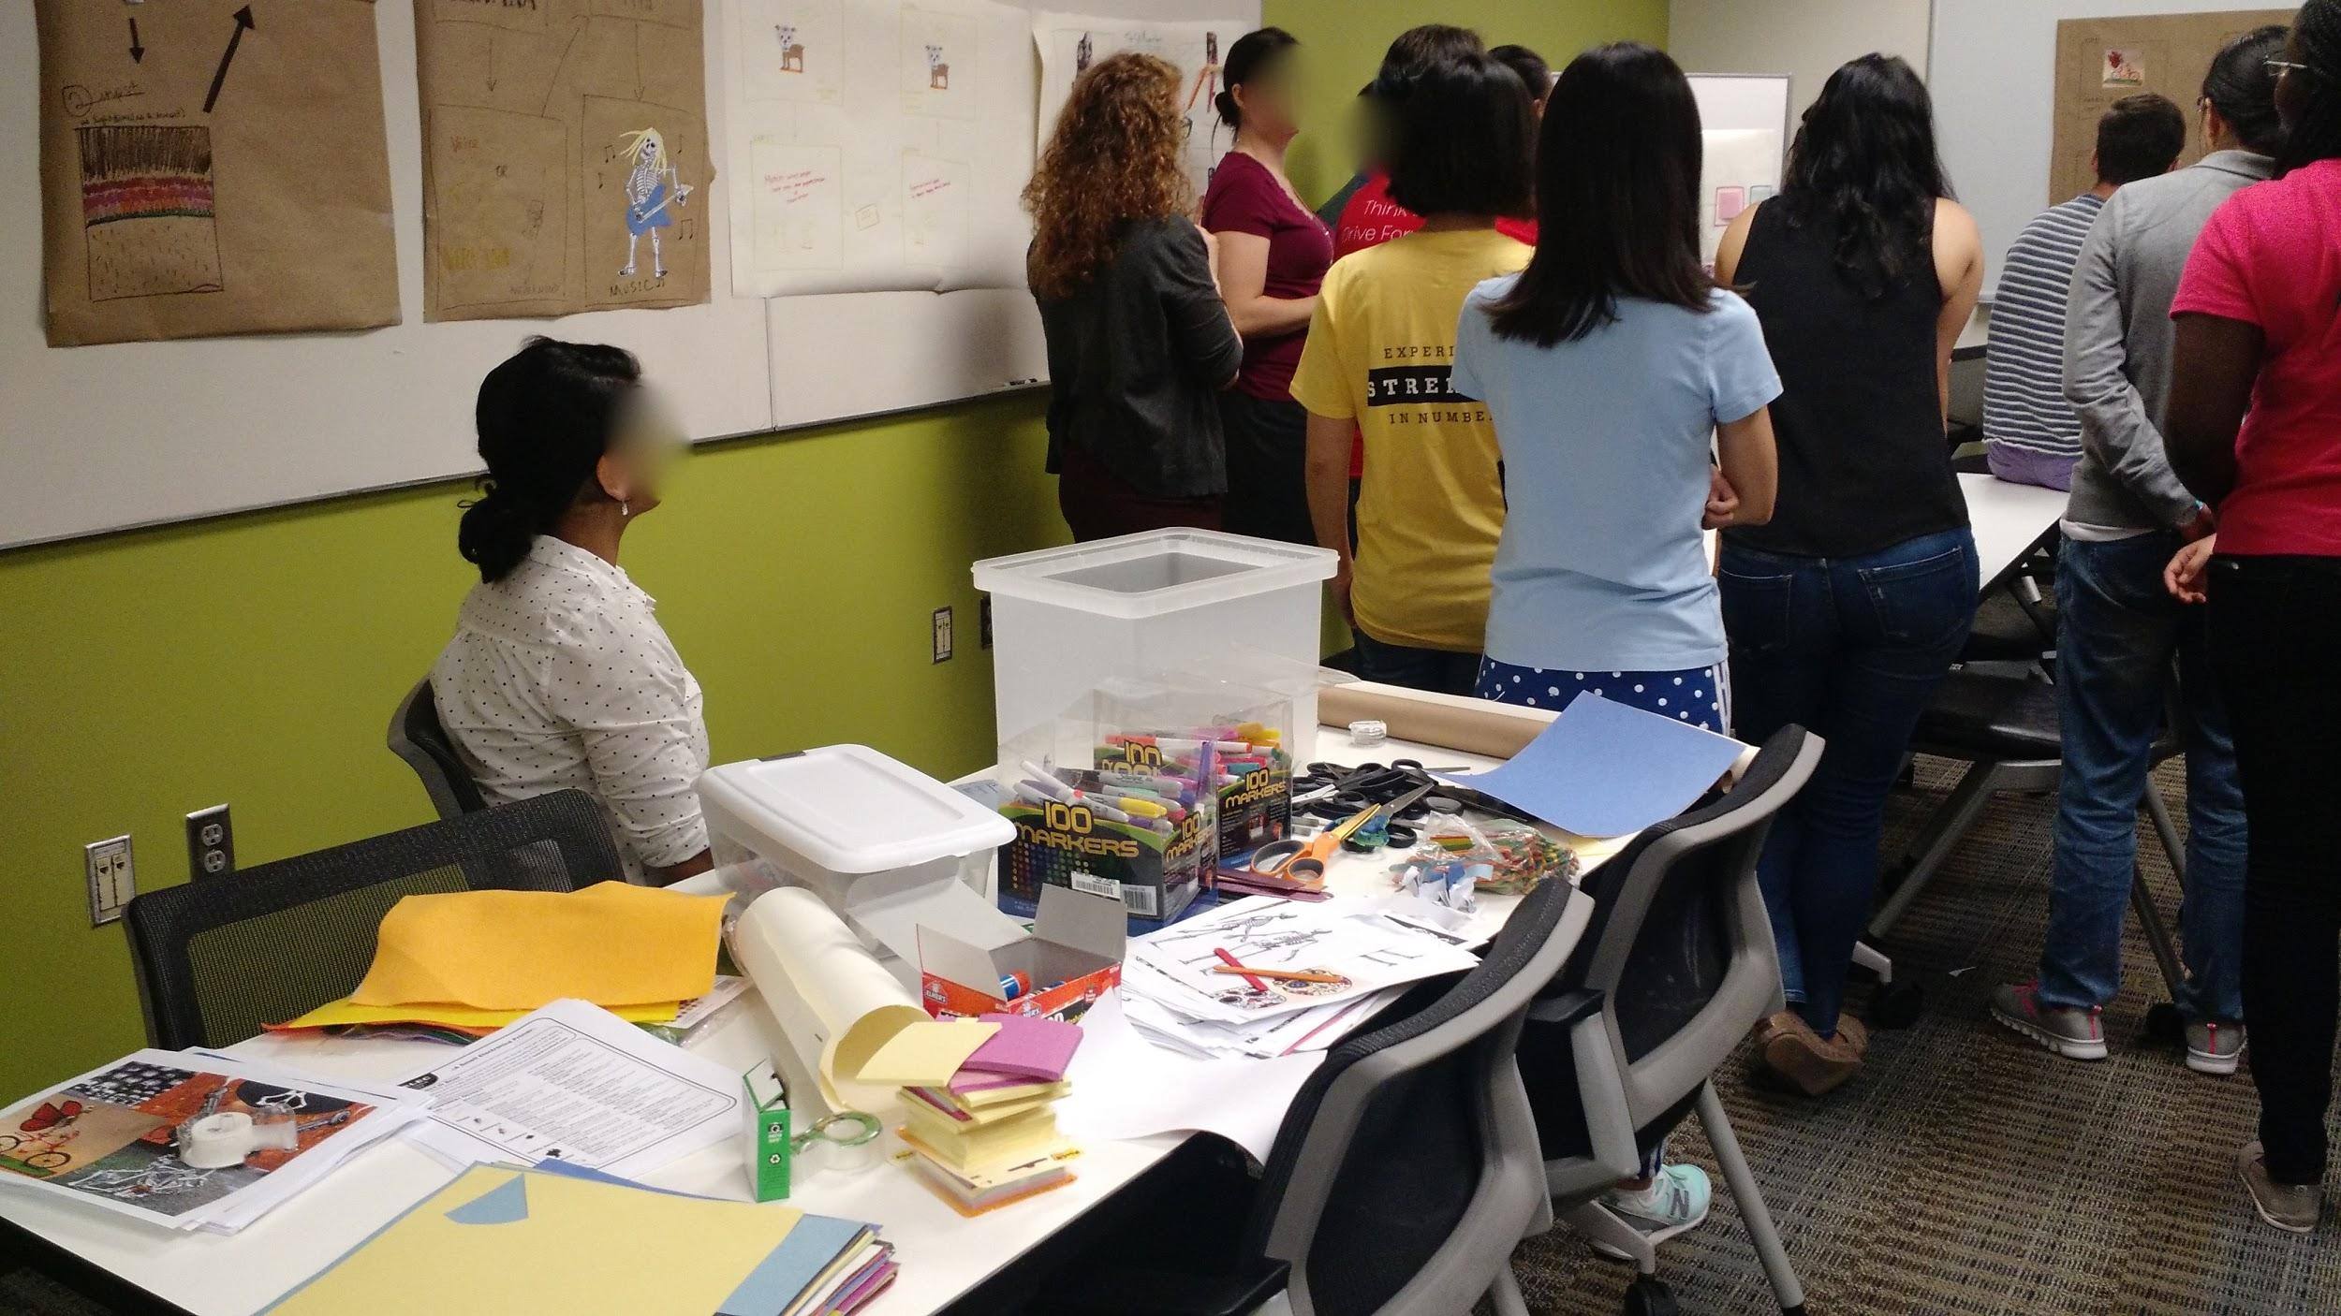  
Fig 4. Materials laid out in the front of the class for students to grab for their artifact

Step 5: Students then put up their pieces on whiteboards using tape and can choose to present to the rest of the classroom.

**Informal Critique**

Students then round-up around the presenting student’s work and engage in an informal critiquing process wherein they-

Say something they like about the idea

Ask a question about something that was unclear

Provide constructive feedback on what could have been improved

Suggest ways in which they would have done something differently (this may help the presenting student to take the feedback less personally as the ‘critic’ is suggesting ways they would do things differently rather than pointing out flaws in the presenting student’s work.

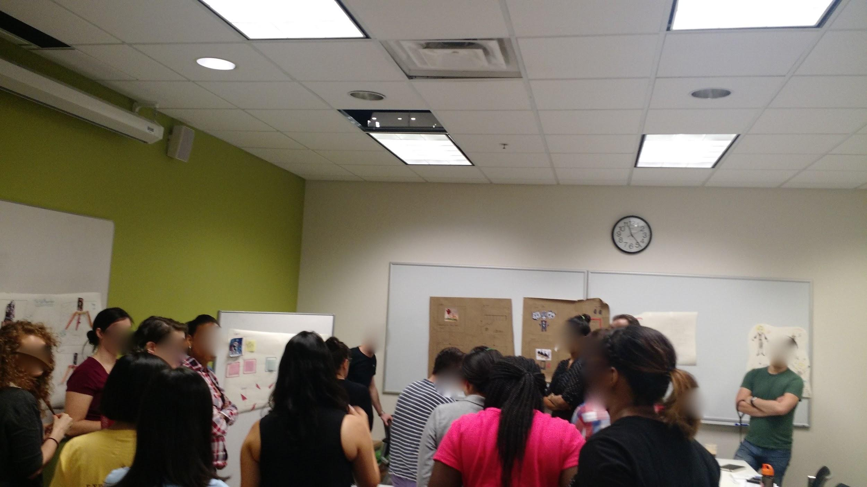Fig 5. Students gathered around another student’s work and engaging in discussion about the artifact