Laser Cutting Resources

# What can you do with a laser cutter?

## Cut, etch, engrave

<http://makemode.co/drawing-setup-for-laser-cutting/>

<https://docs.google.com/presentation/d/15ozAO4y2cqnl5oN3skqhR6HrJGHVyRJc0QmmcloJ1lQ/edit?usp=sharing>

# Setting up a file for Laser Cutting

## Pick vector-drawing software

### Inkscape

### Adobe Illustrator

### Affinity Designer

### Other option

## Prepare file using Tutorial

<http://www.instructables.com/id/Laser-Cutting-for-Absolute-Beginners-Custom-Laser/>

<http://art.colostate.edu/wp-content/uploads/sites/6/2014/07/Laser-step-by-step-tutorial.pdf>

<http://www.cutlasercut.com/resources/drawing-guidelines/adobe-illustrator-cs-r>

<https://wiki.fablab.berlin/index.php?title=Laser_Cutting_Introduction_(Epilog)&redirect=no>

## Creative commons Resources

Not everybody is an artist so feel free to use Creative Commons resources from places such as The Noun Project with the right attribution.

# Pick a Material for Laser Cutting

<https://www.pololu.com/docs/0J24/3>

# Using a Laser Cutter

<http://fab.cba.mit.edu/content/tools/universal_laser/>

<http://www.wikihow.com/Use-a-Laser-Cutter>

<http://www.instructables.com/id/How-to-Use-a-Laser-Cutter/>

# Find a Laser Cutter @ GT

GVU Prototyping Lab

Invention Studio

COA’s design shop

# Go Beyond 2D

<http://www.instructables.com/id/Laser-Cut-3D-Models/>

<http://www.instructables.com/id/Laser-Cut-Phone-Holder-Intro-to-Acrylic-Bending/>

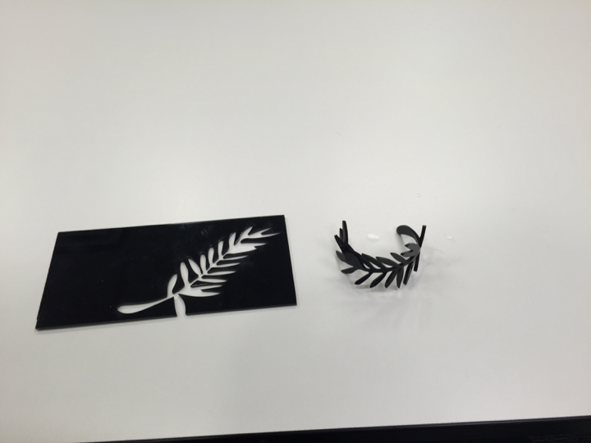

Fig 4. A laser cut bracelet made using vector graphics from the Noun Project and bent using a heat gun to form a curve

# Other resources

<https://www.epiloglaser.com/laser-cutting/laser-cutting.htm>