SQL PRACTICAL – DDL, DML, DCL AND TCL
File 1: 01_DDL_DML_DCL_TCL.sql
Database: BANK MANAGEMENT SYSTEM
Q1 – CREATE TABLE
CREATE DATABASE bank_management;
USE bank_management;
CREATE TABLE bank_transactions (
txn_id INT PRIMARY KEY,
customer_name VARCHAR(50),
branch_name VARCHAR(50),
transaction_type VARCHAR(20),
amount DECIMAL(10,2),
transaction_date DATE
);
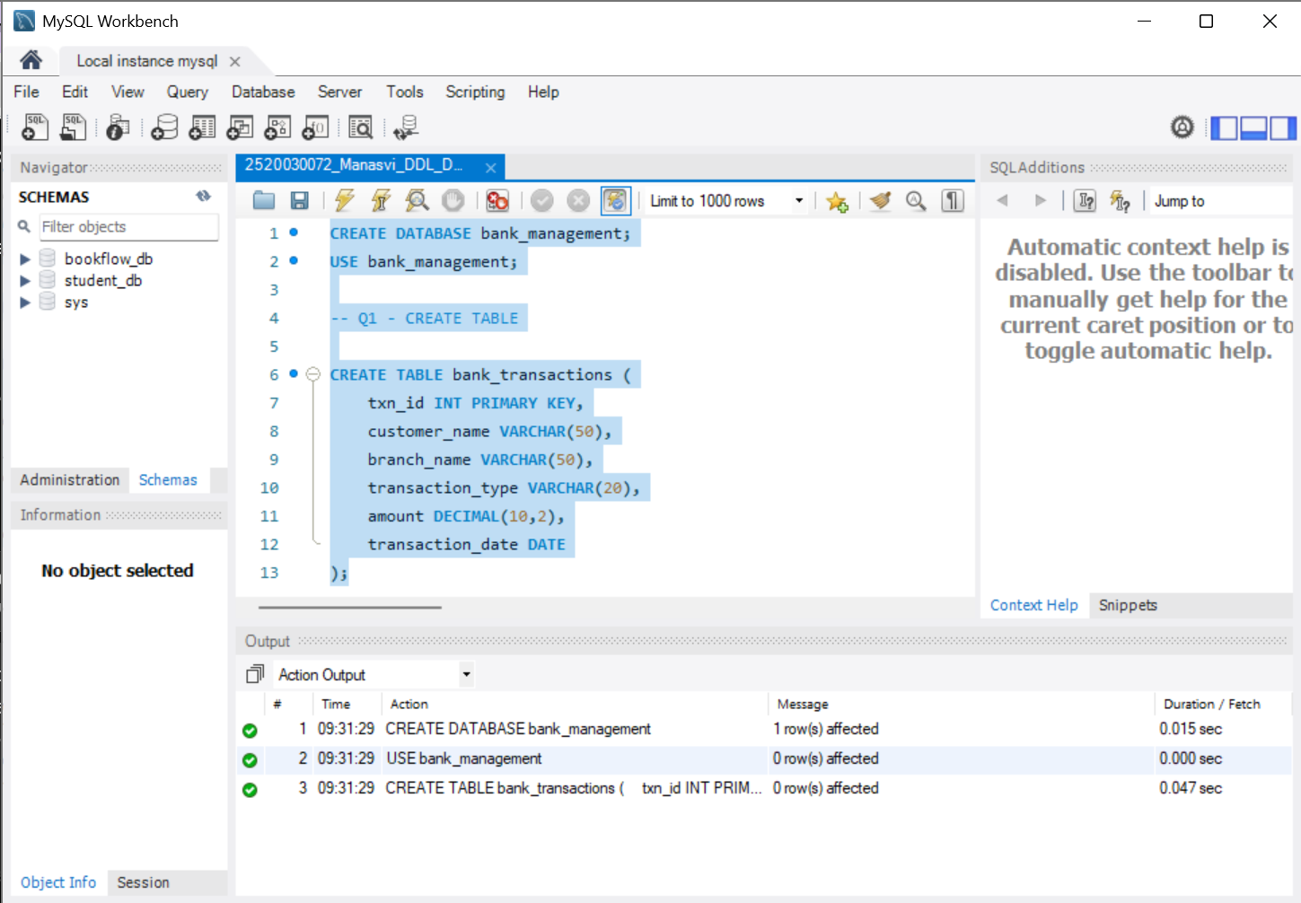
Q2 – ALTER TABLE ADD COLUMN
ALTER TABLE bank_transactions
ADD account_no VARCHAR(20);
Q3 – ALTER TABLE MODIFY COLUMN
ALTER TABLE bank_transactions
MODIFY customer_name VARCHAR(100);
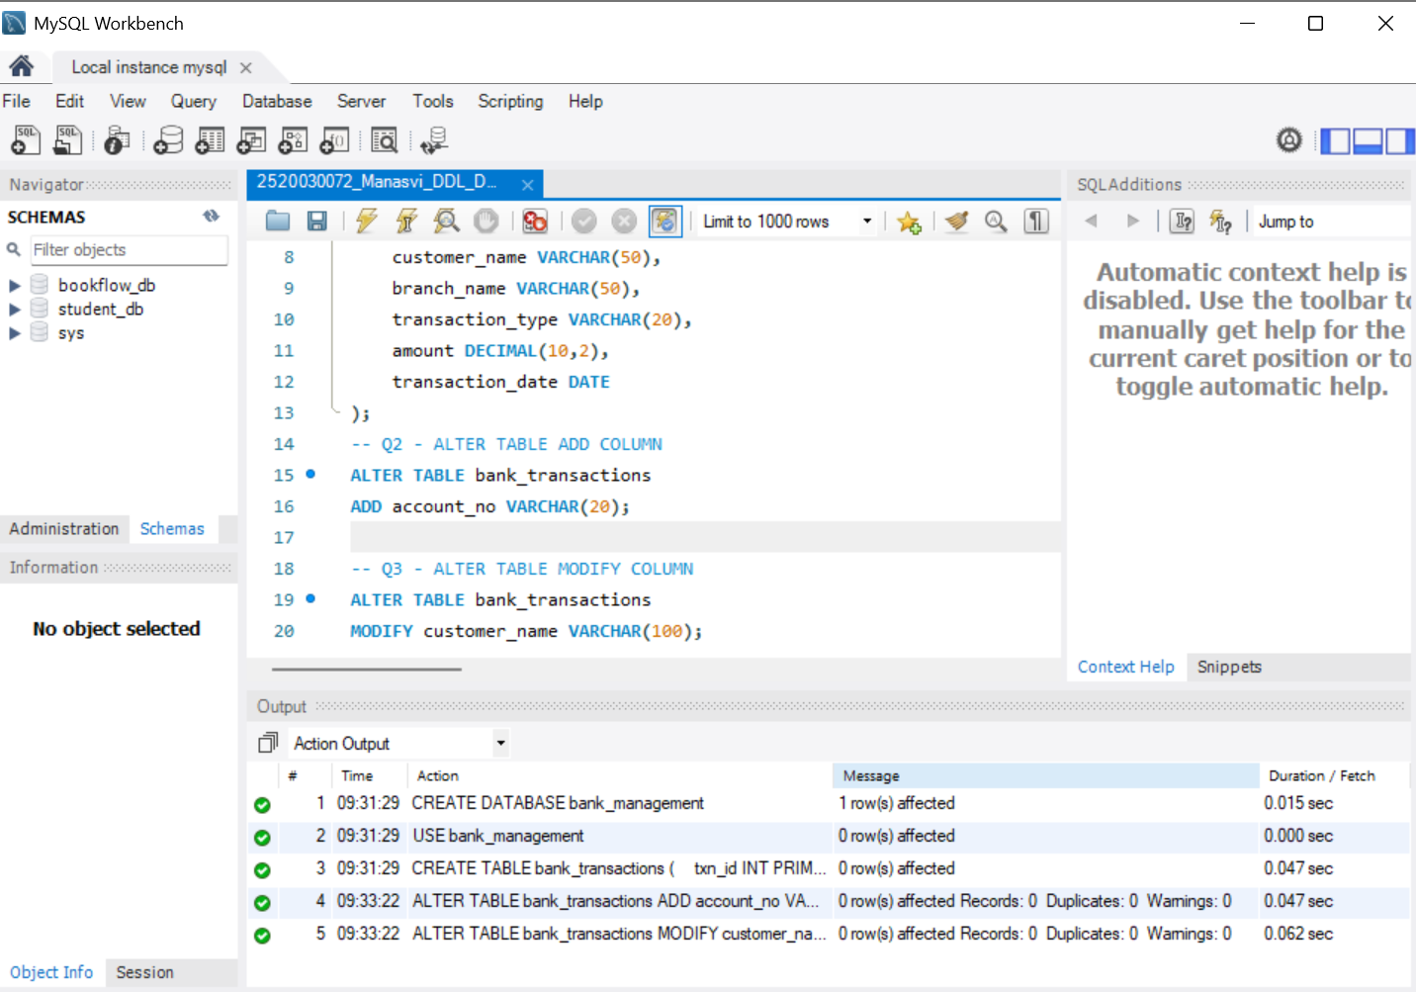
Q4 – RENAME TABLE
RENAME TABLE bank_transactions
TO customer_transactions;
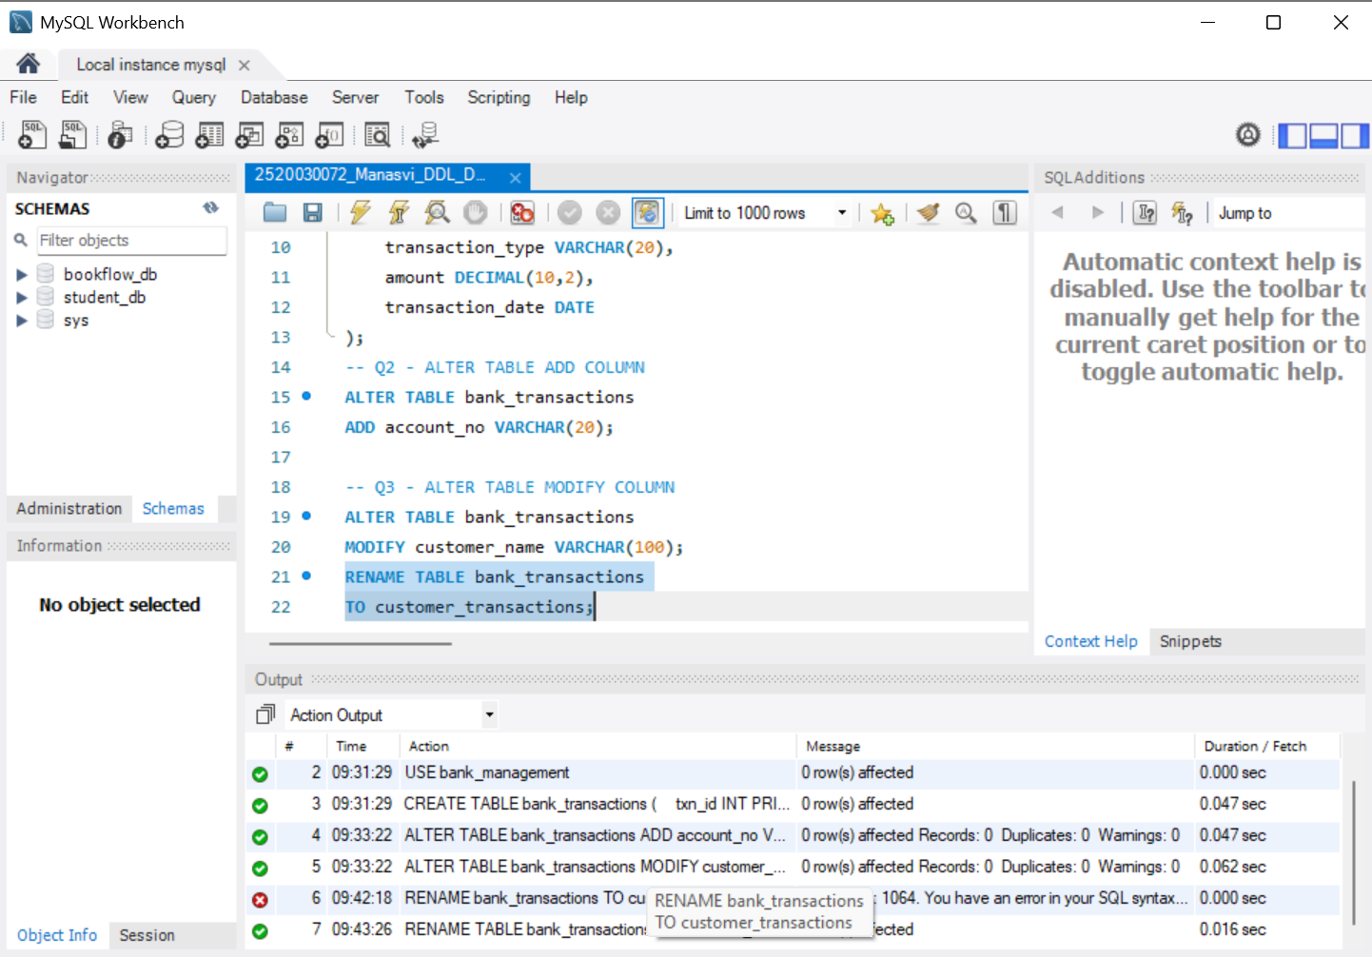
Q5 – TRUNCATE TABLE
TRUNCATE TABLE customer_transactions;
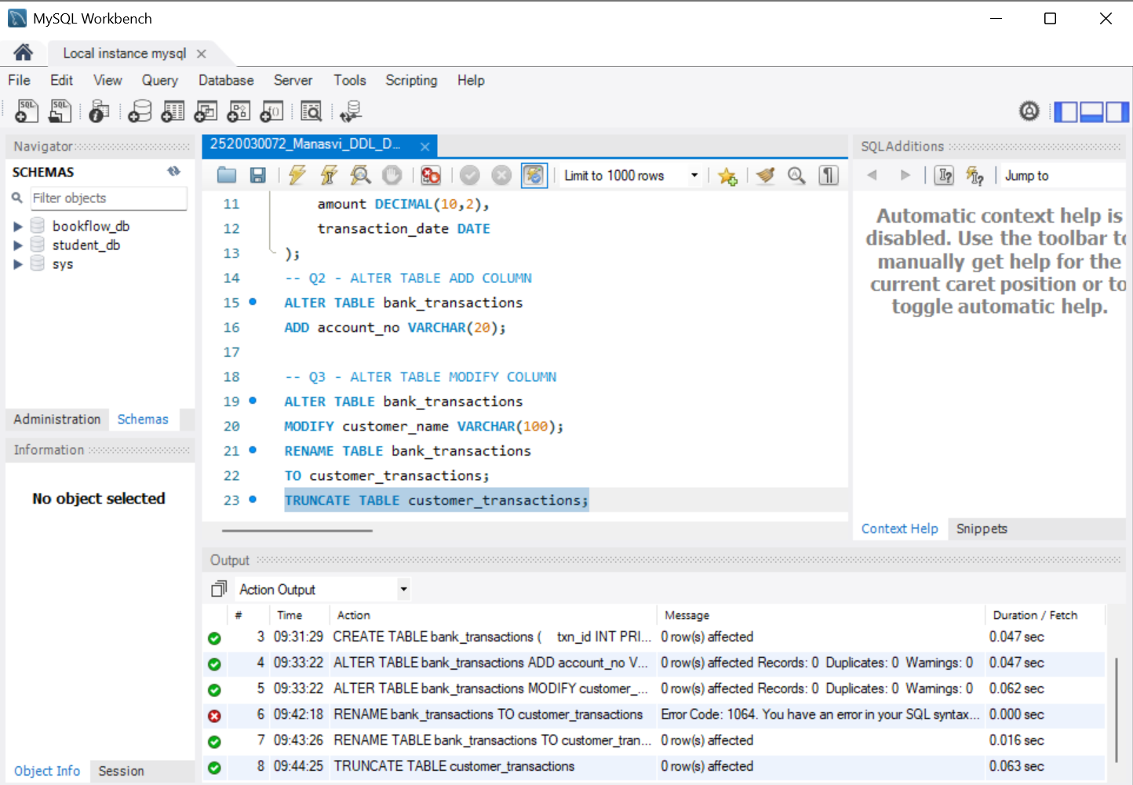
Q6 – DROP TABLE
DROP TABLE bank_backup;
Reference execution note: bank_backup was not present in the created database, so the reference query returned an error No successful Q6 output was recorded.
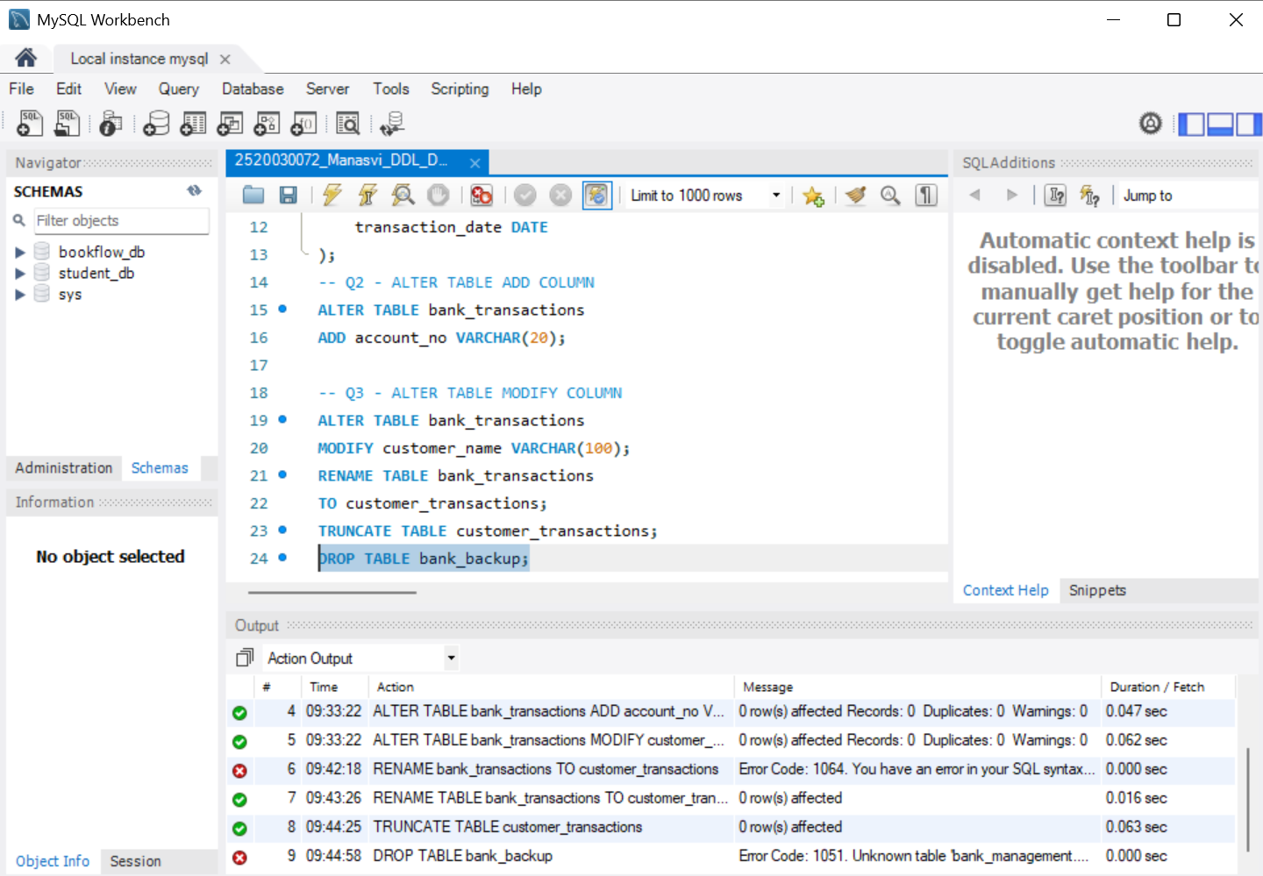
Q7–Q12 – DML AND SELECT OPERATIONS
INSERT INTO customer_transactions
(txn_id, customer_name, branch_name, transaction_type, amount, transaction_date)
VALUES
(101,'Ravi','Hyderabad','Deposit',5000,'2024-01-05'),
(102,'Sita','Hyderabad','Withdrawal',2000,'2024-01-06'),
(103,'Kiran','Vijayawada','Deposit',12000,'2024-01-08'),
(104,'Anil','Vizag','Deposit',8000,'2024-01-10'),
(105,'Priya','Hyderabad','Withdrawal',3500,'2024-01-11'),
(106,'Ramesh','Vizag','Deposit',15000,'2024-01-12'),
(107,'Keerthi','Vijayawada','Withdrawal',1000,'2024-01-13'),
(108,'Rahul','Hyderabad','Deposit',9000,'2024-01-14'),
(109,'Sneha','Vizag','Withdrawal',4000,'2024-01-15'),
(110,'Madhu','Vijayawada','Deposit',11000,'2024-01-16');
-- Q7
INSERT INTO customer_transactions
(txn_id, customer_name, branch_name, transaction_type, amount, transaction_date)
VALUES
(111,'Venu','Vizag','Deposit',7000,'2024-01-18');
-- Q8
UPDATE customer_transactions
SET amount = 5000
WHERE txn_id = 105;
-- Q9
DELETE FROM customer_transactions
WHERE txn_id = 111;
-- Q10
SELECT *
FROM customer_transactions;
-- Q11
SELECT *
FROM customer_transactions
WHERE transaction_type = 'Deposit';
-- Q12
SELECT *
FROM customer_transactions
ORDER BY amount DESC;
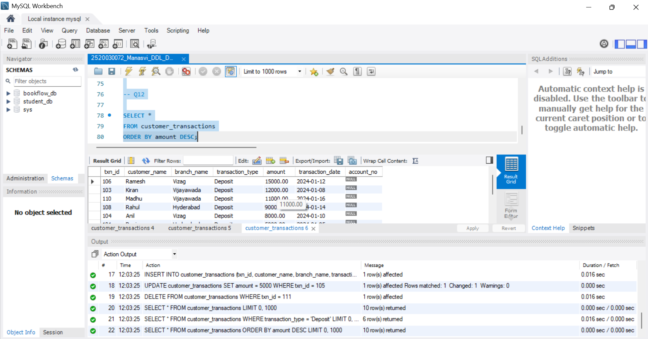
Q13–Q16 – DCL OPERATIONS
CREATE USER 'Auditor1'@'localhost' IDENTIFIED BY 'Auditor123';
CREATE USER 'BranchManager'@'localhost' IDENTIFIED BY 'Manager123';
-- Q13
GRANT SELECT
ON customer_transactions
TO 'Auditor1'@'localhost';
-- Q14
GRANT ALL
ON customer_transactions
TO 'BranchManager'@'localhost';
-- Q15
REVOKE SELECT
ON customer_transactions
FROM 'Auditor1'@'localhost';
-- Q16
REVOKE ALL
ON customer_transactions
FROM 'BranchManager'@'localhost';
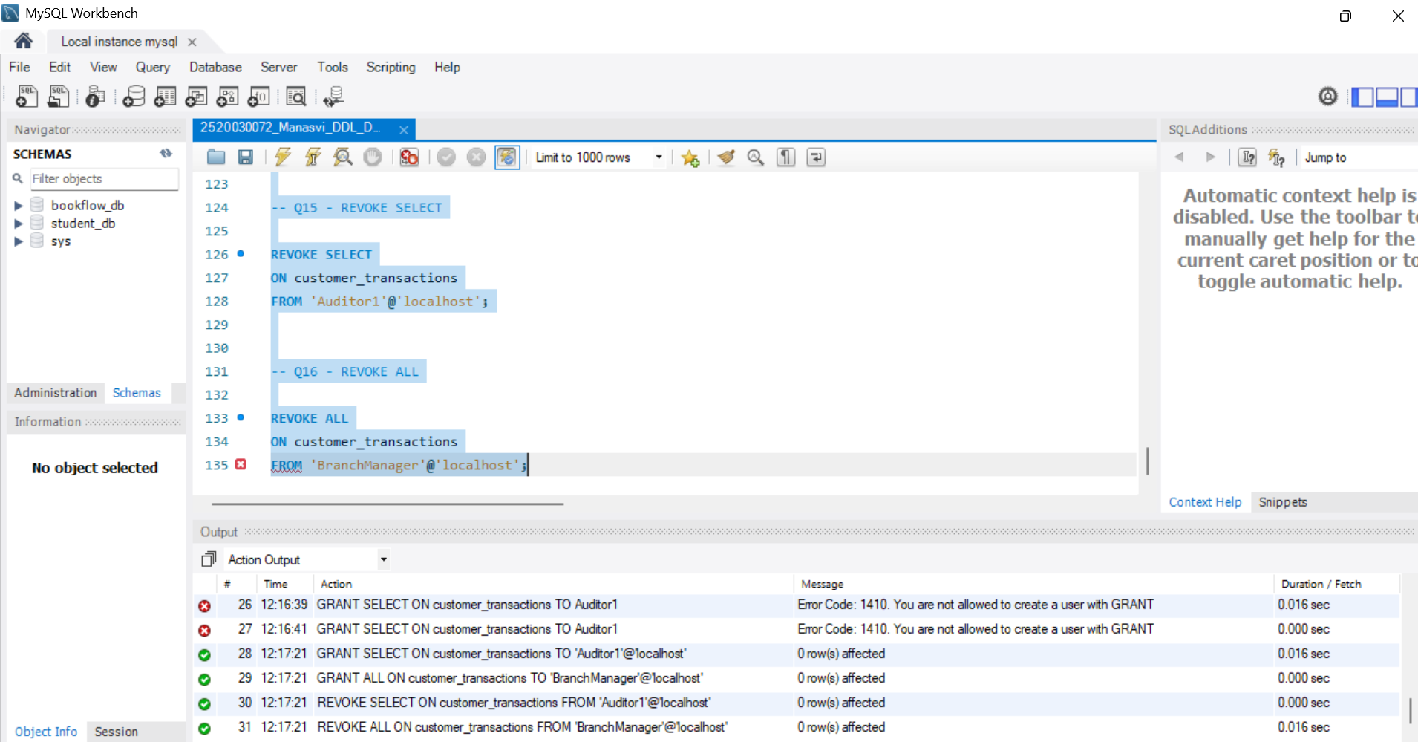
Q17–Q19 – TCL OPERATIONS
-- Q17
UPDATE customer_transactions
SET amount = 6000
WHERE txn_id = 101;
COMMIT;
-- Q18-Q19
SET autocommit = 0;
SAVEPOINT Before_Update;
UPDATE customer_transactions
SET amount = 99999
WHERE txn_id = 102;
ROLLBACK TO Before_Update;
COMMIT;
SET autocommit = 1;
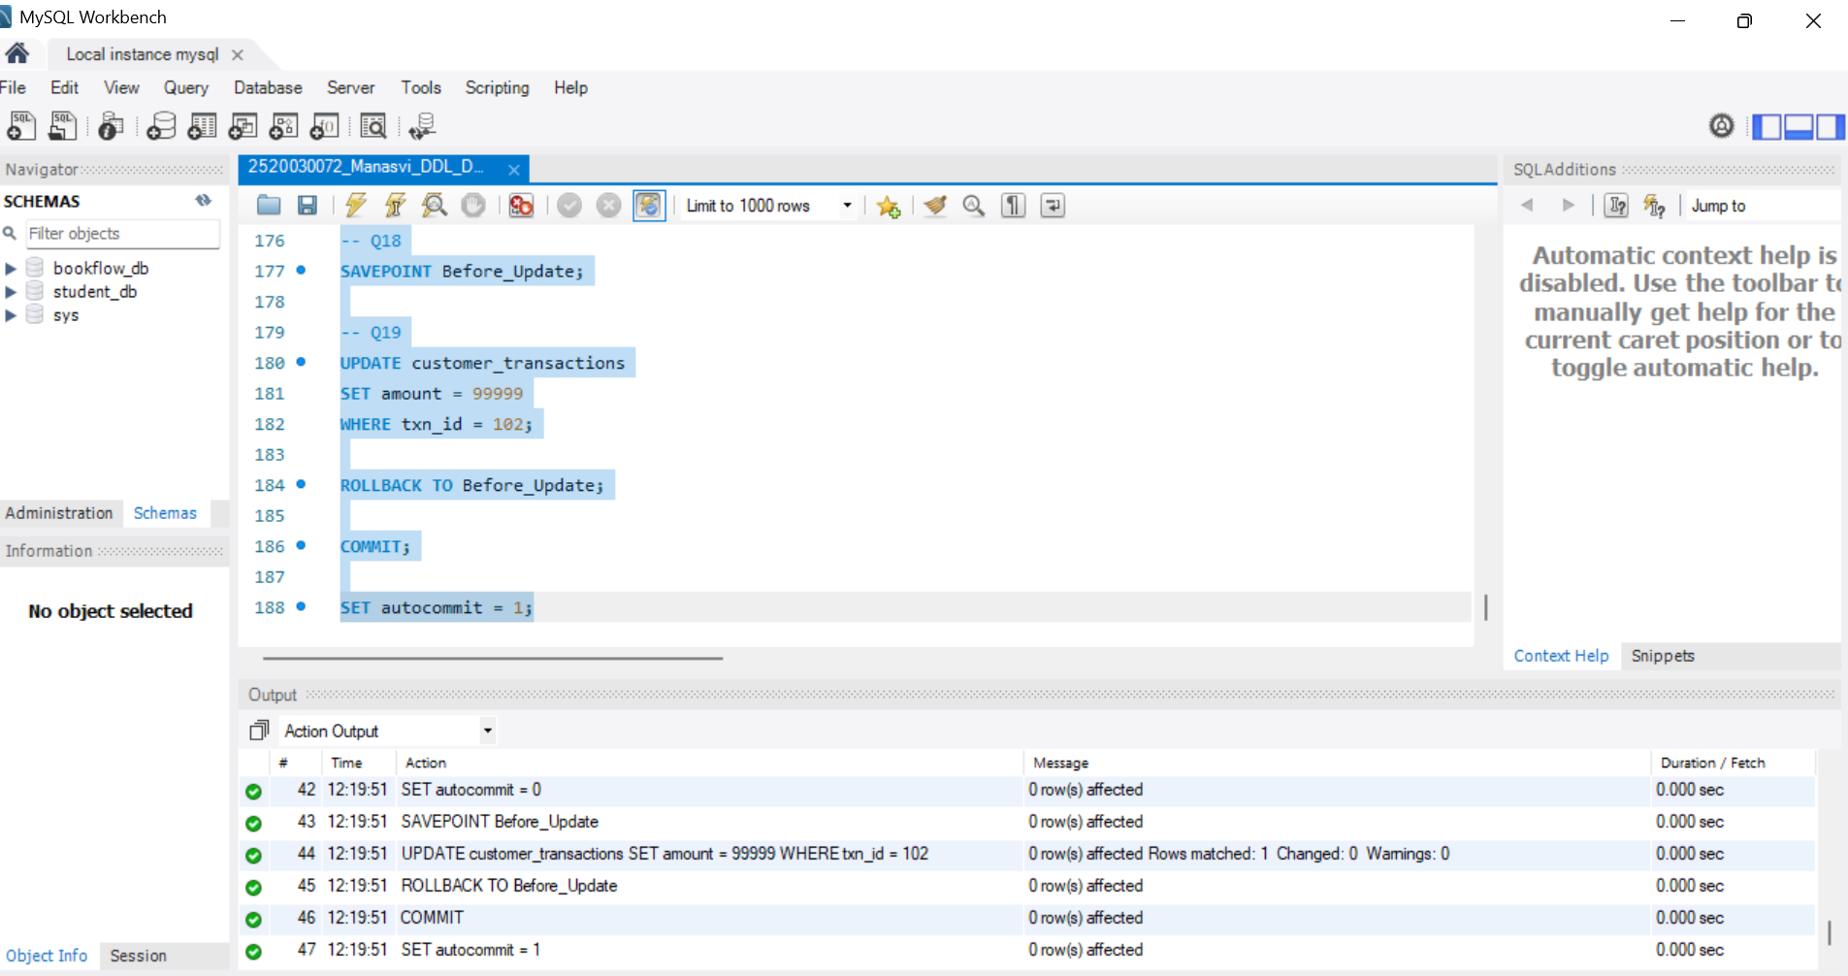
Q20 – FULL TCL EXAMPLE
SET autocommit = 0;
UPDATE customer_transactions
SET amount = 7000
WHERE txn_id = 101;
SAVEPOINT SP1;
UPDATE customer_transactions
SET amount = 9000
WHERE txn_id = 102;
ROLLBACK TO SP1;
COMMIT;
SET autocommit = 1;
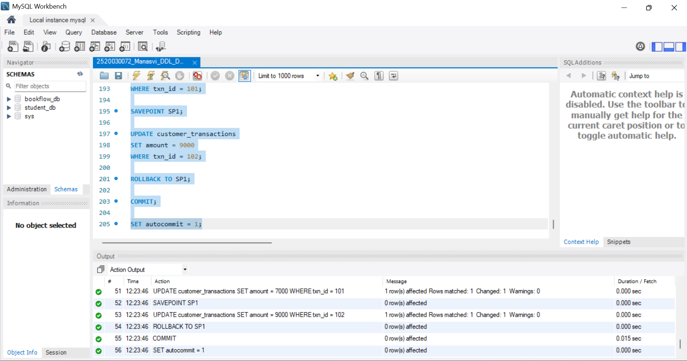
File 1 execution completed: Q1–Q20.

