ACID PROPERTIES & ISOLATION
Name: Manasvi
Roll No: 2520030072
Course Code: 25CS1302E
Aim: To demonstrate transaction control using COMMIT, ROLLBACK and SAVEPOINT, and to observe transaction isolation levels using MySQL Workbench.
The transaction was started, ₹5000 was deposited into Account 10001, and COMMIT permanently saved the change.
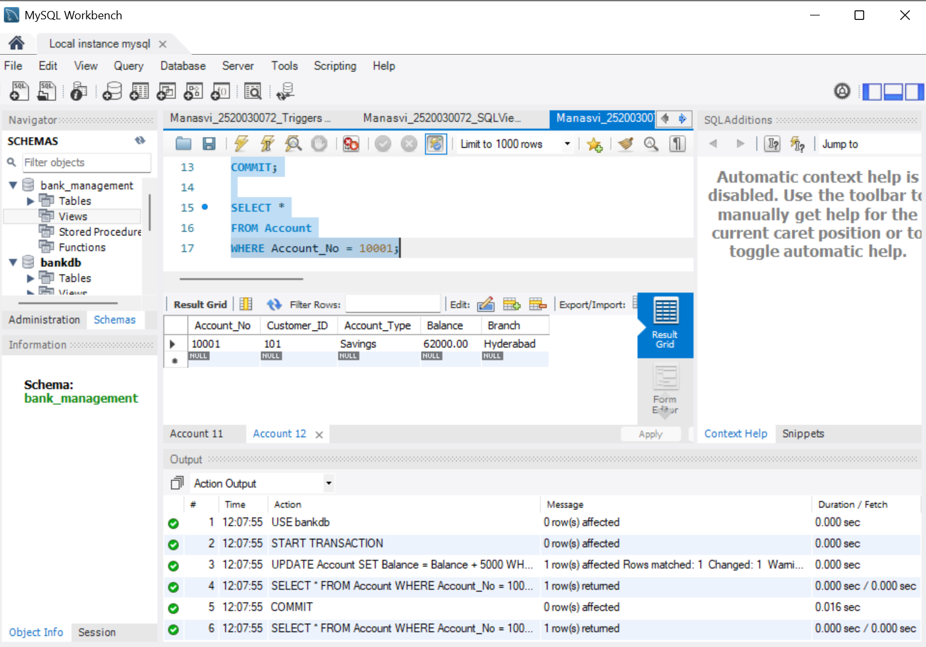
2. SAVEPOINT
A deposit was made to Account 10001, a savepoint was created, and the later withdrawal was rolled back to that savepoint before COMMIT.
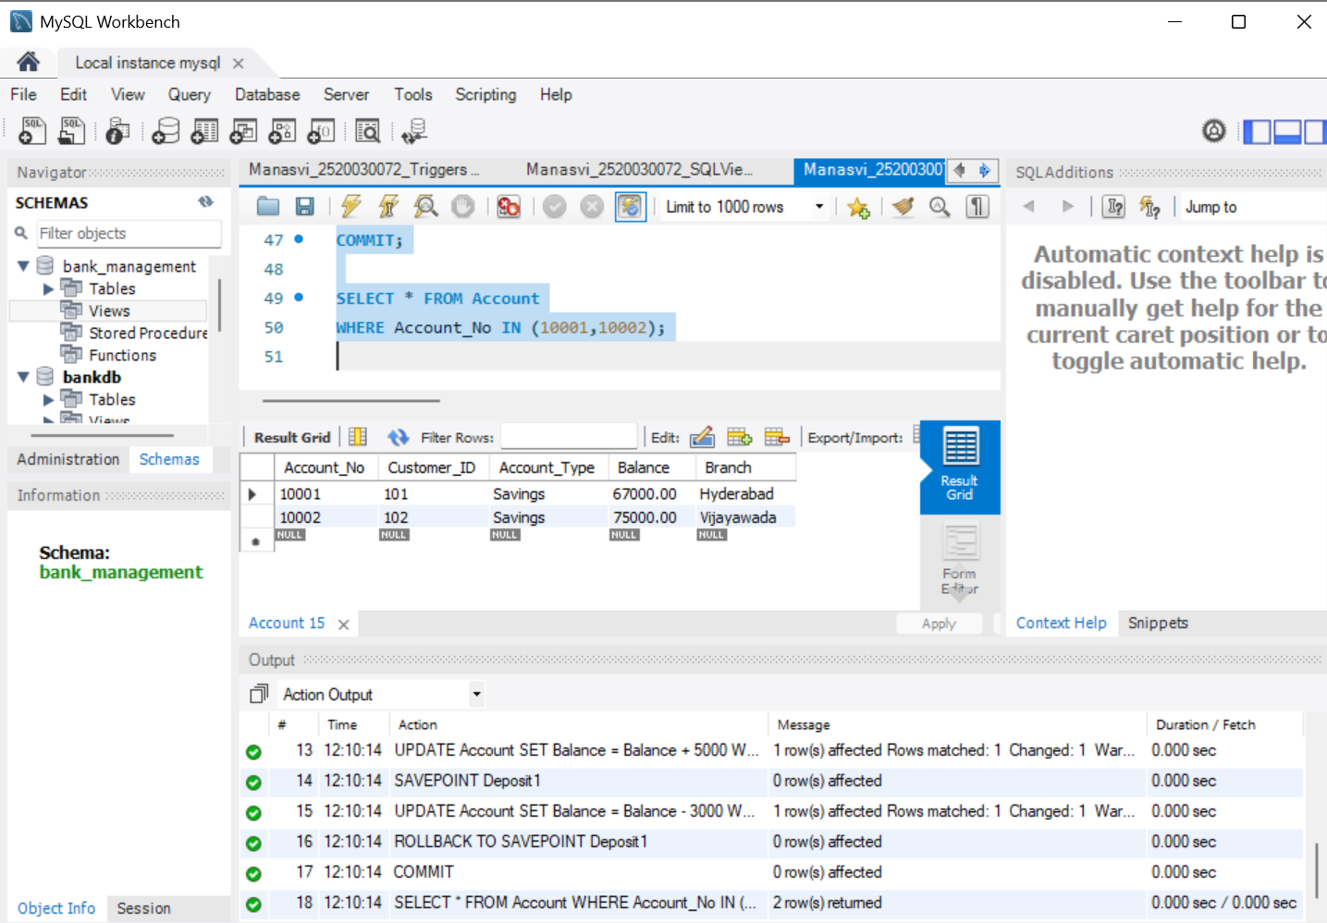
3. ROLLBACK / ATOMICITY
A transaction update was attempted and then ROLLBACK was used, so the unwanted change was cancelled and the original balance was restored.
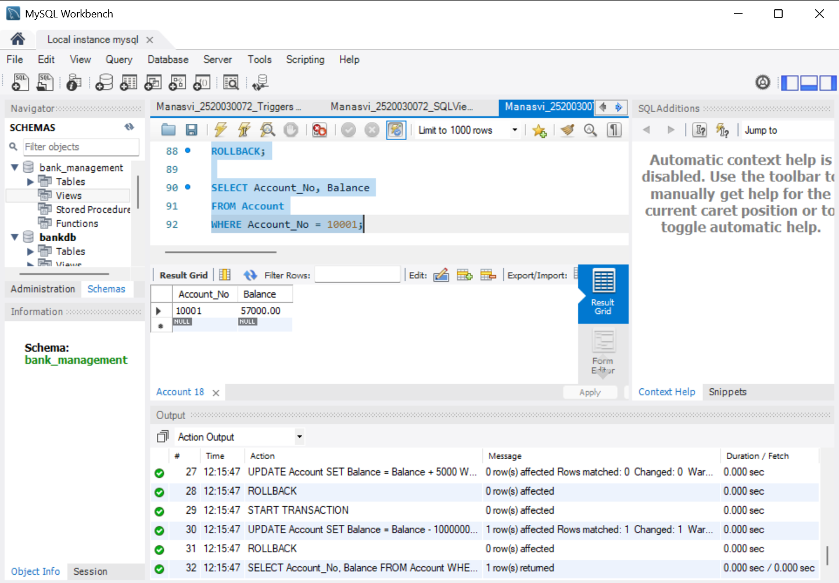
4. SAVEPOINT RESULT
The SAVEPOINT operation was executed and the rollback to the savepoint was completed before committing the valid changes.
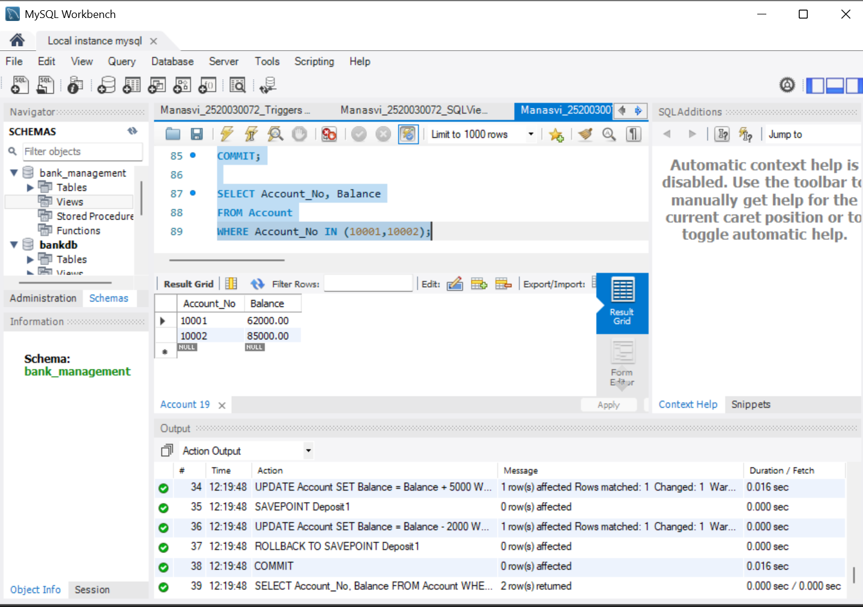
5. TRANSACTION ISOLATION LEVEL
The current session isolation level was checked and the result showed REPEATABLE-READ.
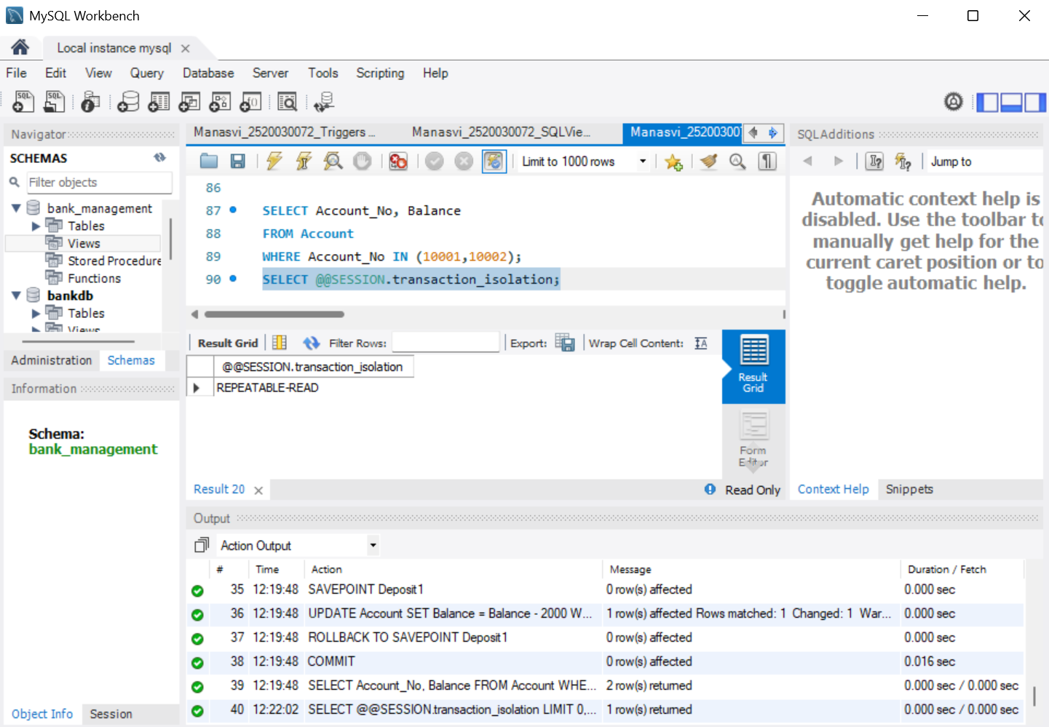
6. READ UNCOMMITTED
READ UNCOMMITTED was selected, a transaction updated Account 10001, and the updated balance was viewed within the transaction.
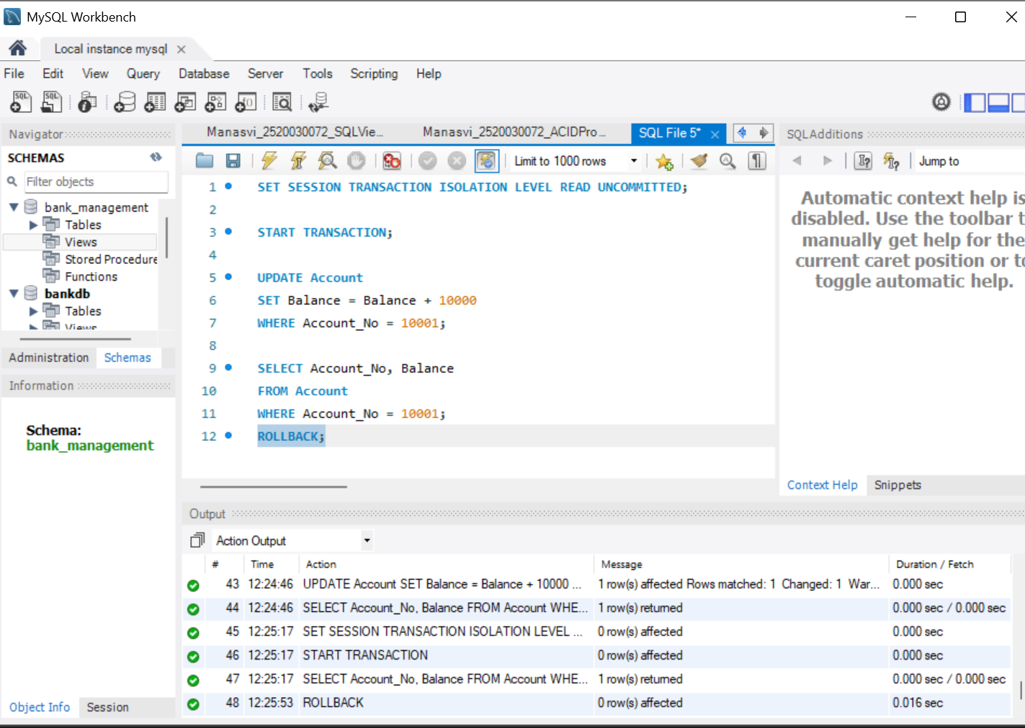
7. READ COMMITTED
A READ COMMITTED transaction was started and the balance of Account 10001 was read before the later transaction activity.
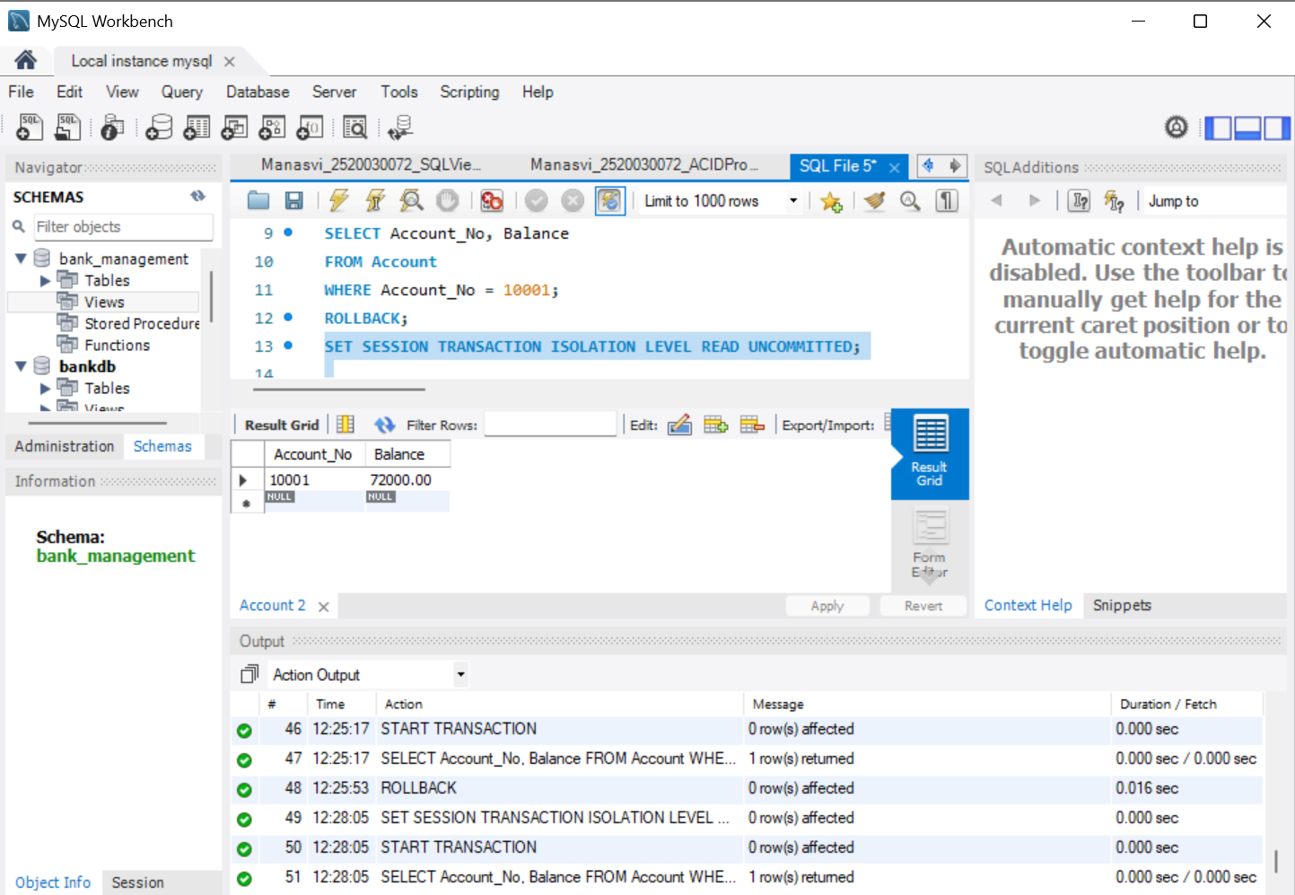
8. READ COMMITTED
A second transaction was started and the existing committed balance was checked while demonstrating transaction isolation.
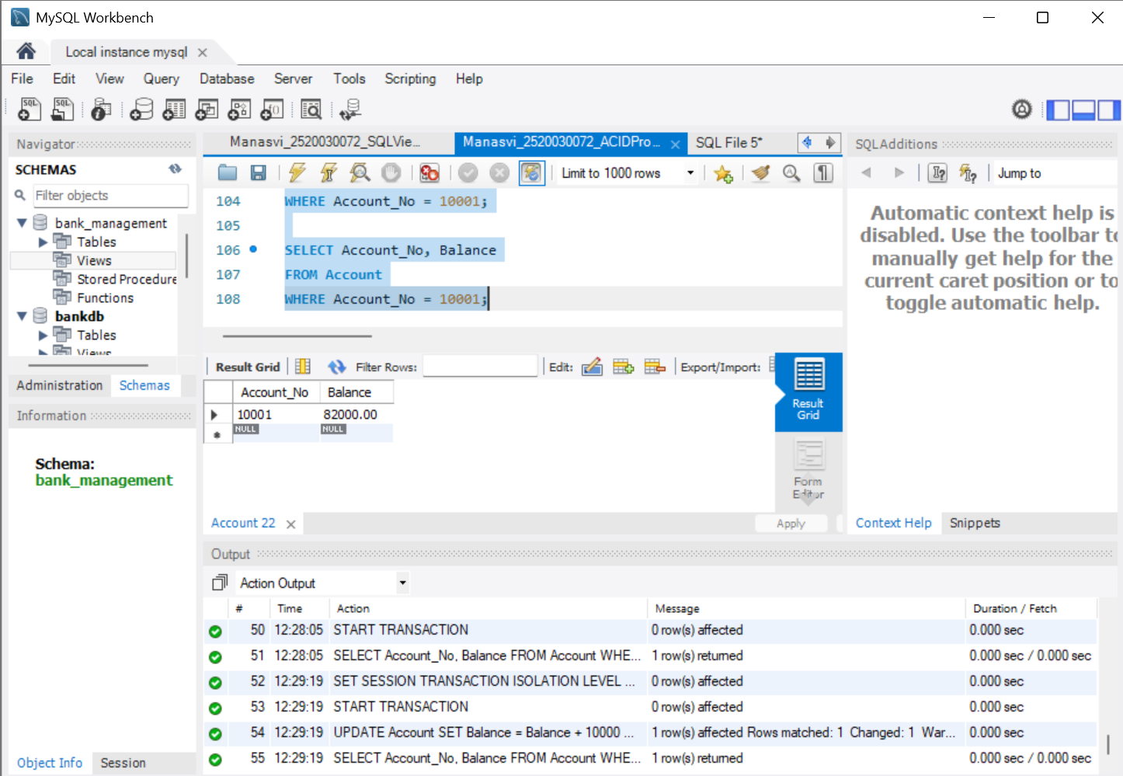
9. READ COMMITTED UPDATE
The session isolation level was set and Account 10001 was updated by ₹10000, after which the new balance was verified.
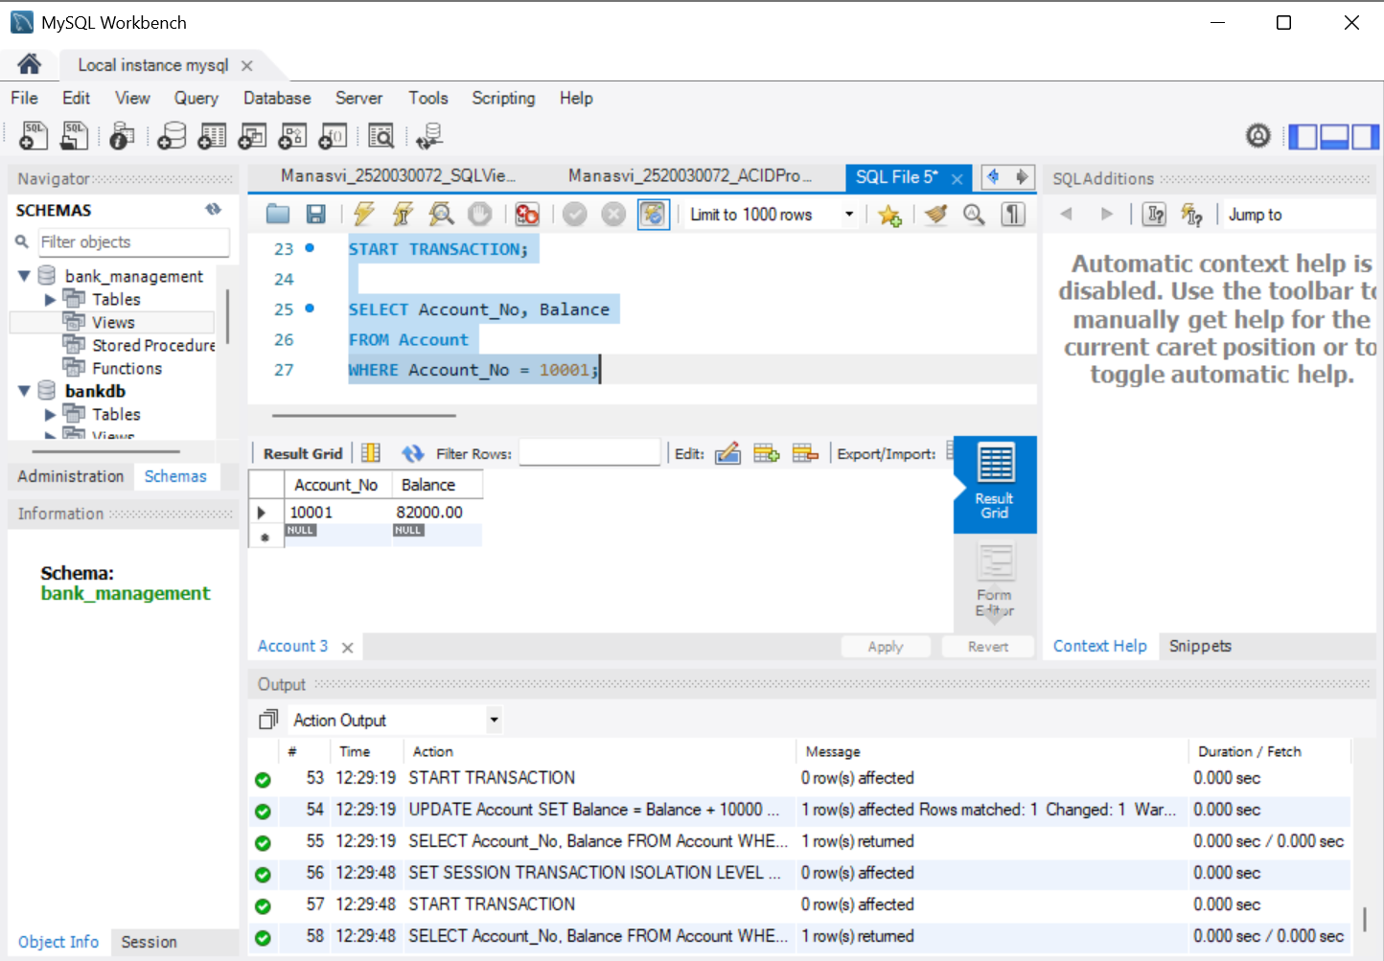

Result: The transaction operations and isolation-level demonstrations were executed successfully in MySQL Workbench, with the displayed outputs documenting the observed results.
Conclusion: COMMIT, ROLLBACK and SAVEPOINT were demonstrated, and transaction isolation behavior was verified through the executed SQL transactions.

