2520030072_Physician_Department
SQL Practical Record
Name: Manasvi
Roll Number: 2520030072
Topic: Physician and Department SQL Queries
Database: hospital_db
Aim
To create physician and department tables and perform SQL operations such as INNER JOIN, WHERE, LIKE, COUNT, GROUP BY, HAVING, ORDER BY, IN, NOT IN, EXISTS, MAX and MIN.
Procedure
1. Create the hospital_db database and select it.
2. Create the physician table and insert the physician records.
3. Create the department table and insert the department records.
4. Execute the SQL queries in batches and verify each result in MySQL Workbench.
5. Record the successful execution outputs in the practical document.
Table Creation and Data Insertion
CREATE DATABASE IF NOT EXISTS hospital_db;
USE hospital_db;

CREATE TABLE IF NOT EXISTS physician (
employeeid INT PRIMARY KEY,
name VARCHAR(100),
position VARCHAR(100),
ssn VARCHAR(20)
);

INSERT INTO physician VALUES
(1,'John Dorian','Staff Internist','111111111'),
(2,'Elliot Reid','Attending Physician','222222222'),
(3,'Christopher Turk','Surgical Attending Physician','333333333'),
(4,'Percival Cox','Senior Attending Physician','444444444'),
(5,'Bob Kelso','Head Chief of Medicine','555555555'),
(6,'Todd Quinlan','Surgical Attending Physician','666666666'),
(7,'John Wen','Surgical Attending Physician','777777777'),
(8,'Keith Dudemeister','MD Resident','888888888'),
(9,'Molly Clock','Attending Psychiatrist','999999999');

CREATE TABLE IF NOT EXISTS department (
departmentid INT PRIMARY KEY,
name VARCHAR(100),
head INT
);

INSERT INTO department VALUES
(1,'General Medicine',4),
(2,'Surgery',7),
(3,'Psychiatry',9);
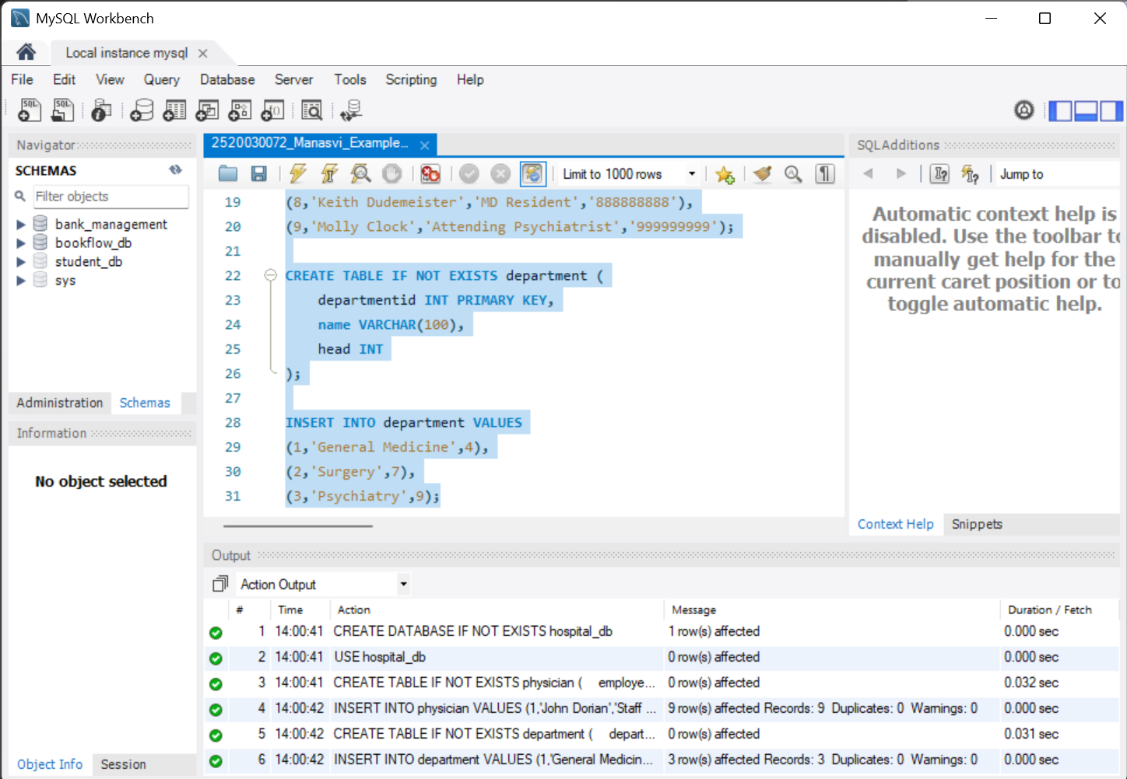
Execution of database/table creation and data insertion.
Questions 1 to 5
-- Q1 INNER JOIN
SELECT d.name AS Department,
p.name AS Head_Physician
FROM department d
JOIN physician p
ON d.head = p.employeeid;

-- Q2 WHERE
SELECT *
FROM physician
WHERE position = 'Surgical Attending Physician';

-- Q3 LIKE
SELECT *
FROM physician
WHERE name LIKE 'John%';

-- Q4 COUNT
SELECT COUNT(*) AS Total_Physicians
FROM physician;

-- Q5 COUNT DISTINCT
SELECT COUNT(DISTINCT position) AS Different_Positions
FROM physician;
Observed result for Q5: Different_Positions = 7.
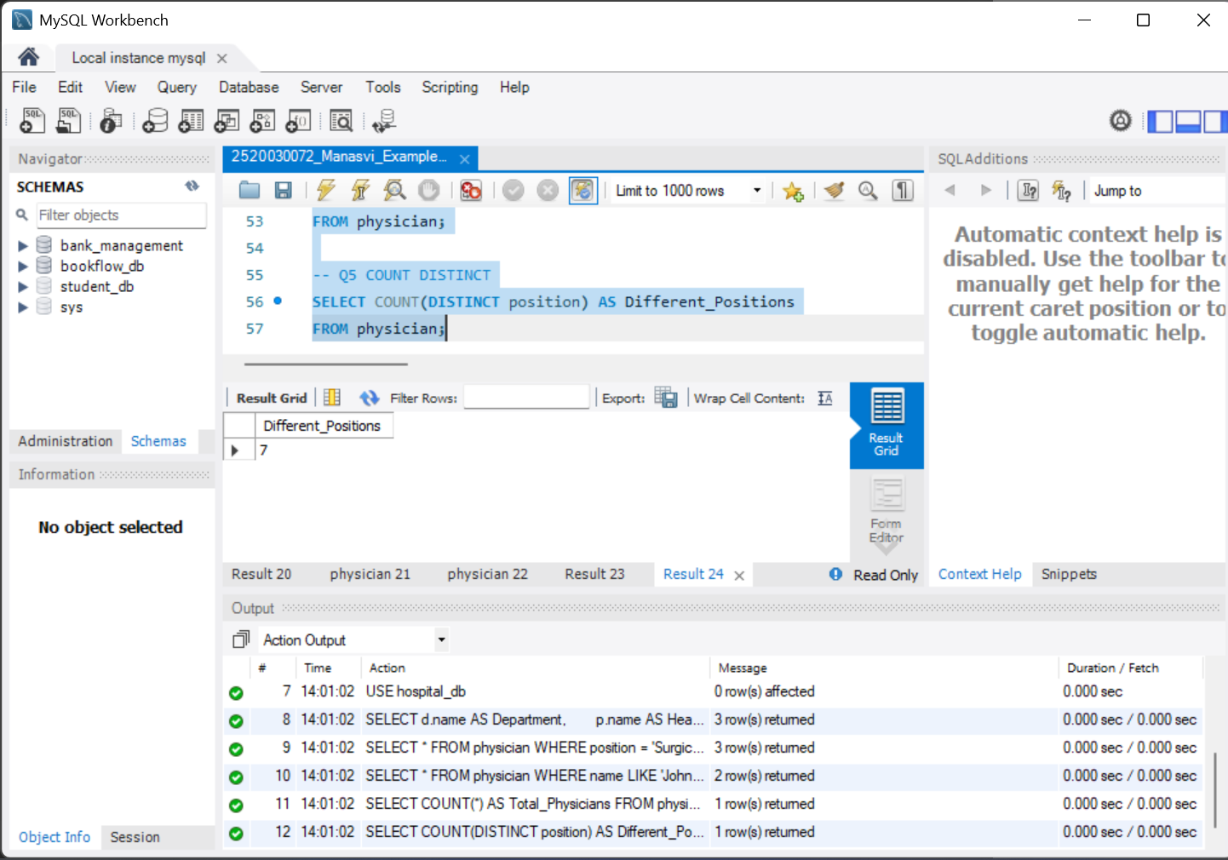
Execution of Questions 1 to 5.
Questions 6 to 11
-- Q6 GROUP BY
SELECT position,
COUNT(*) AS Total_Employees
FROM physician
GROUP BY position;

-- Q7 GROUP BY + HAVING
SELECT position,
COUNT(*) AS Total_Employees
FROM physician
GROUP BY position
HAVING COUNT(*) > 1;

-- Q8 ORDER BY ASC
SELECT *
FROM physician
ORDER BY name ASC;

-- Q9 ORDER BY DESC
SELECT *
FROM physician
ORDER BY employeeid DESC;

-- Q10 WHERE + IN
SELECT *
FROM physician
WHERE employeeid IN
(
SELECT head
FROM department
);

-- Q11 NOT IN
SELECT *
FROM physician
WHERE employeeid NOT IN
(
SELECT head
FROM department
);
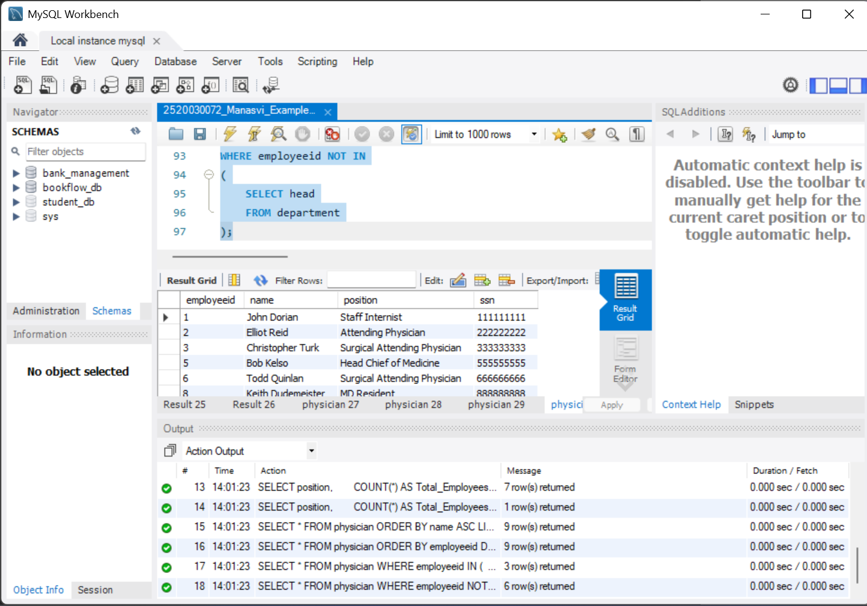
Execution of Questions 6 to 11.
Questions 12 to 16
-- Q12 GROUP BY + ORDER BY
SELECT position,
COUNT(*) AS Total_Employees
FROM physician
GROUP BY position
ORDER BY Total_Employees DESC;

-- Q13 WHERE + LIKE
SELECT *
FROM physician
WHERE position LIKE '%Attending%';

-- Q14 JOIN + WHERE
SELECT p.name
FROM physician p
JOIN department d
ON p.employeeid = d.head
WHERE d.name = 'Surgery';

-- Q15 JOIN + ORDER BY
SELECT d.name,
p.name
FROM department d
JOIN physician p
ON d.head = p.employeeid
ORDER BY d.name;

-- Q16 WHERE + NOT LIKE
SELECT *
FROM physician
WHERE position NOT LIKE '%Surgical%';
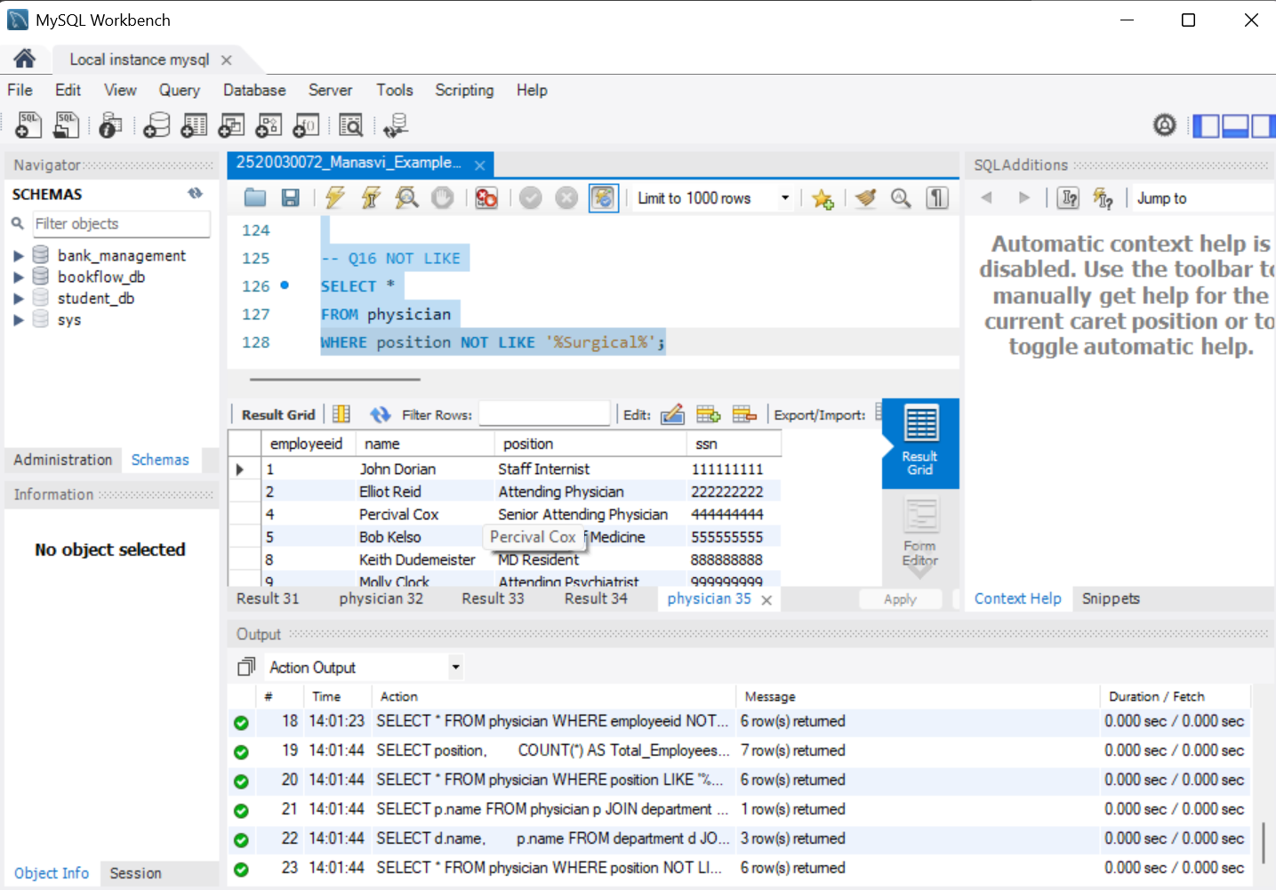
Execution of Questions 12 to 16.
Questions 18 to 20
-- Q18 EXISTS
SELECT *
FROM department d
WHERE EXISTS
(
SELECT 1
FROM physician p
WHERE p.employeeid = d.head
);

-- Q19 MAX
SELECT MAX(employeeid) AS Highest_Employee_ID
FROM physician;

-- Q20 MIN
SELECT MIN(employeeid) AS Lowest_Employee_ID
FROM physician;
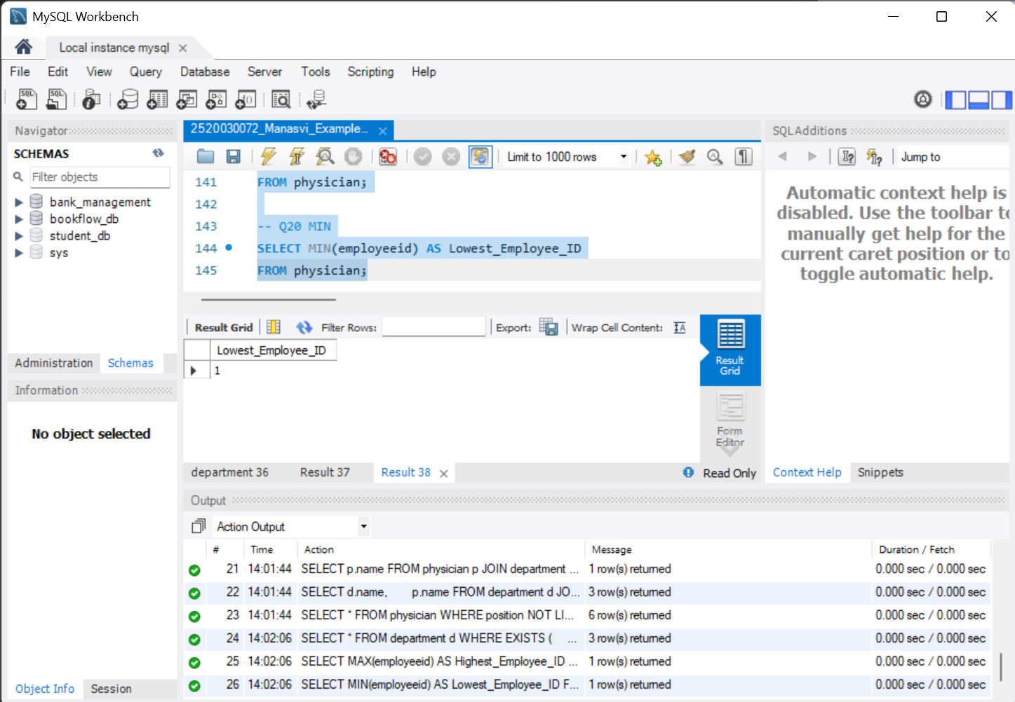
Execution of Questions 18 to 20.
Result
All executed query batches shown in the screenshots completed successfully. The outputs confirm the use of filtering, pattern matching, aggregation, grouping, sorting, joins, subqueries and existence checks.
Note
Question 17 was omitted from this record because it repeats the same GROUP BY + HAVING operation already demonstrated in Question 7.
Conclusion
The physician and department database operations were successfully implemented and executed in MySQL Workbench. The practical covered the required SQL concepts without repeating the redundant query.

