SQL VIEWS PRACTICAL
Name: Param Manasvi
Roll No: 2520030072
Course Code: 25CS1302E
Aim: To practice creating, querying, updating and deleting SQL Views using MySQL Workbench.
The existing banking tables were used for the Views practical. Repeated table-creation and data-insertion steps were not repeated.
1. Created a simple view to display customer details.
Screenshot 1 – Customer_View was created successfully and displayed the customer records from the Customer table.
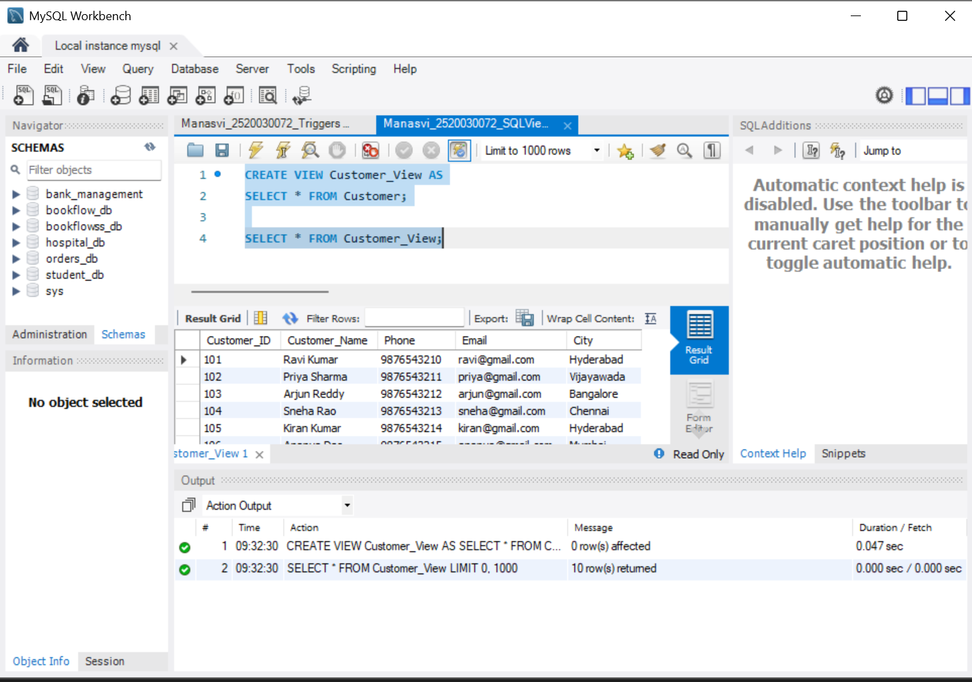

2. Created a view using JOIN to combine Customer and Account information.
Screenshot 2 – Customer_Account_View combines customer and account details using a JOIN. The result shows customer name, city, account number, account type and balance.
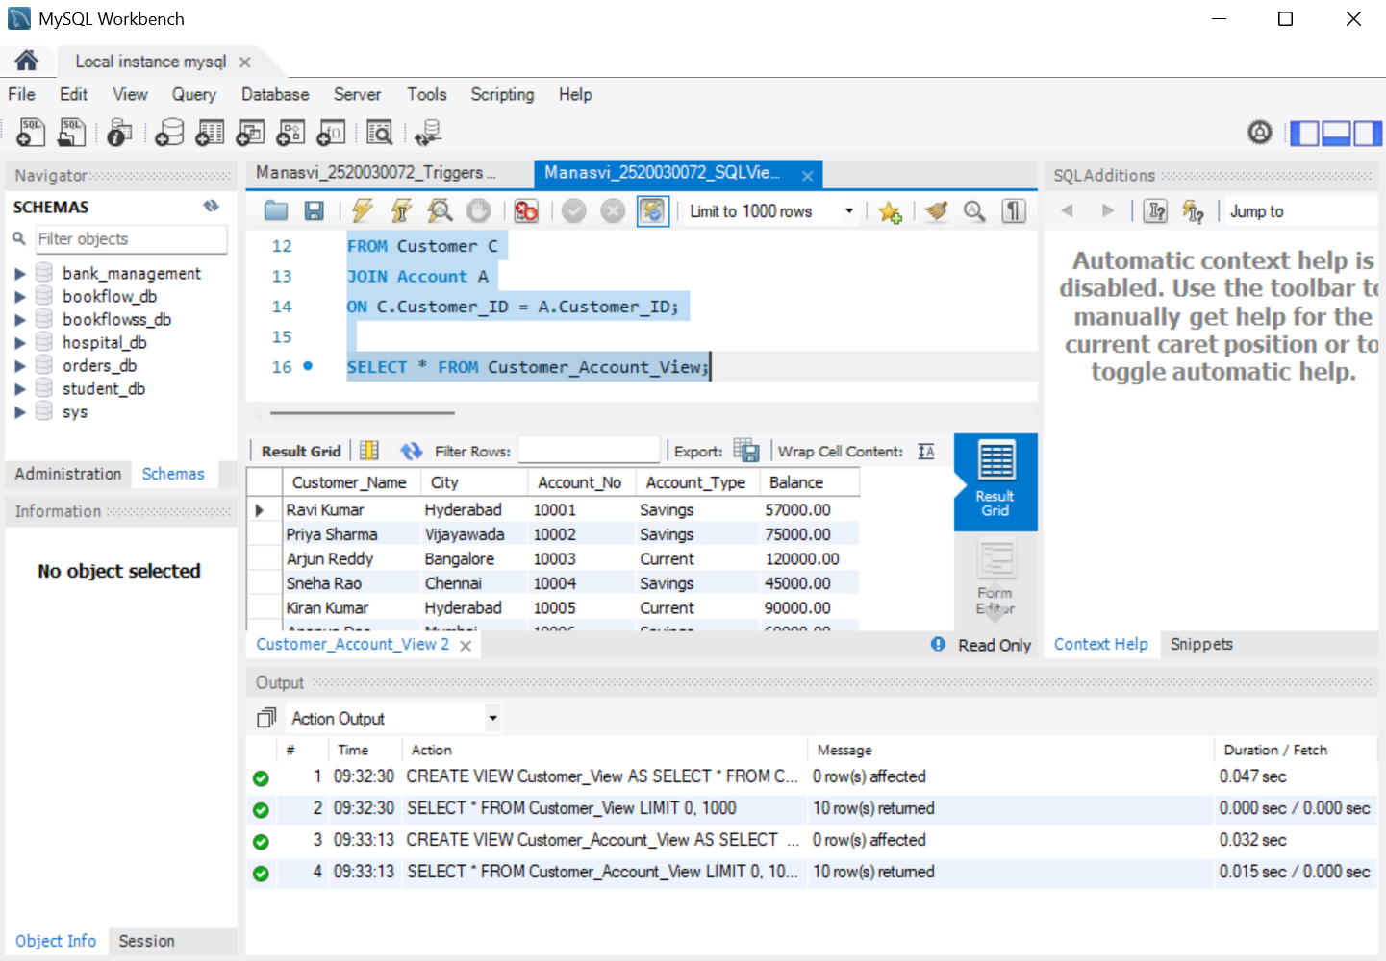

3. Created a view using GROUP BY to calculate total balance branch-wise.
Screenshot 3 – Branch_Total_Balance groups account records by branch and calculates the total balance for each branch.
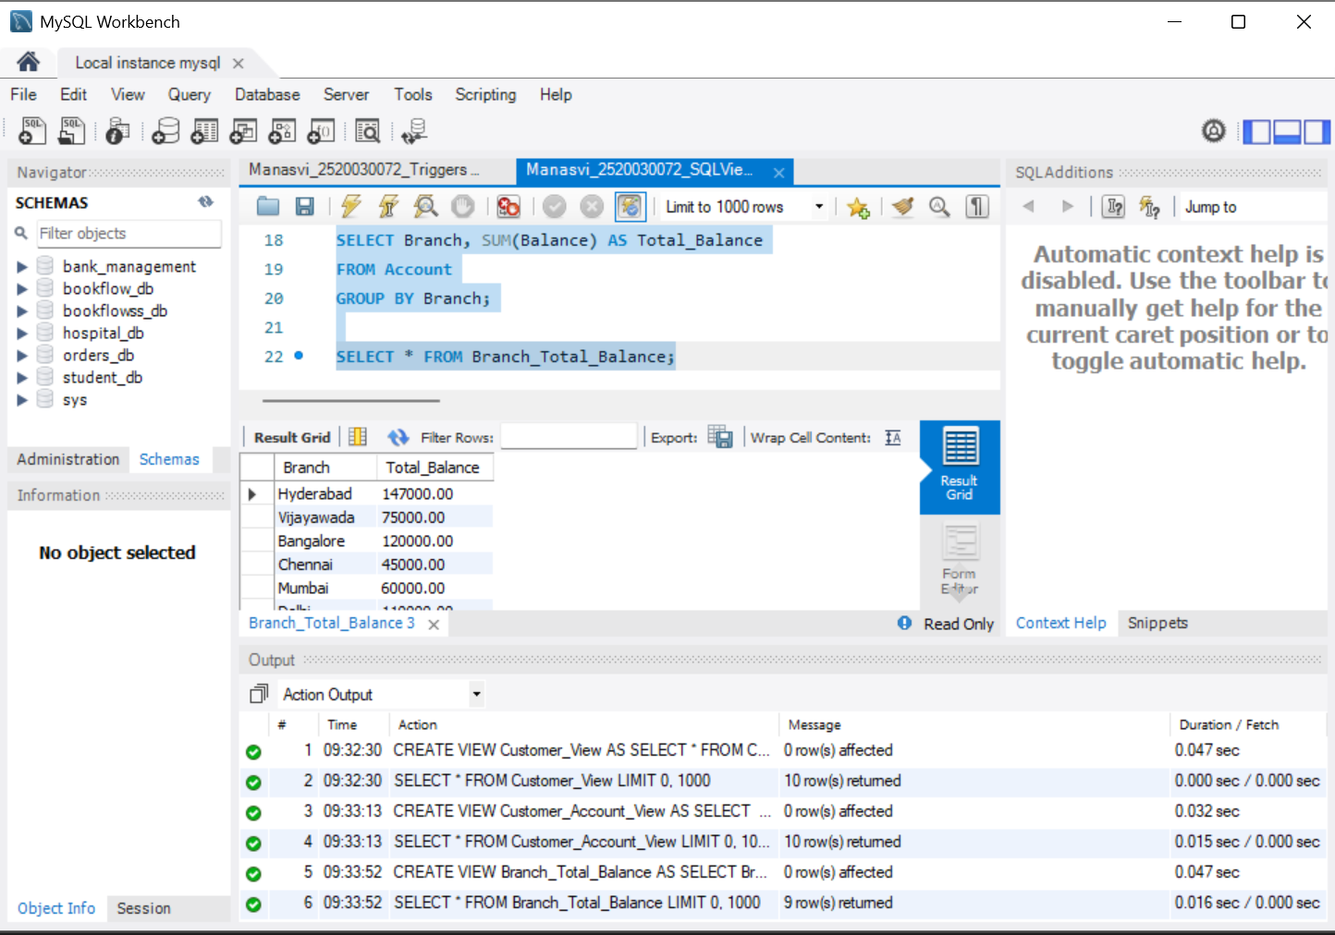

4. Created a view using GROUP BY and HAVING to filter high-balance branches.
Screenshot 4 – Rich_Branches uses GROUP BY and HAVING to display branches whose total balance is greater than 100000.
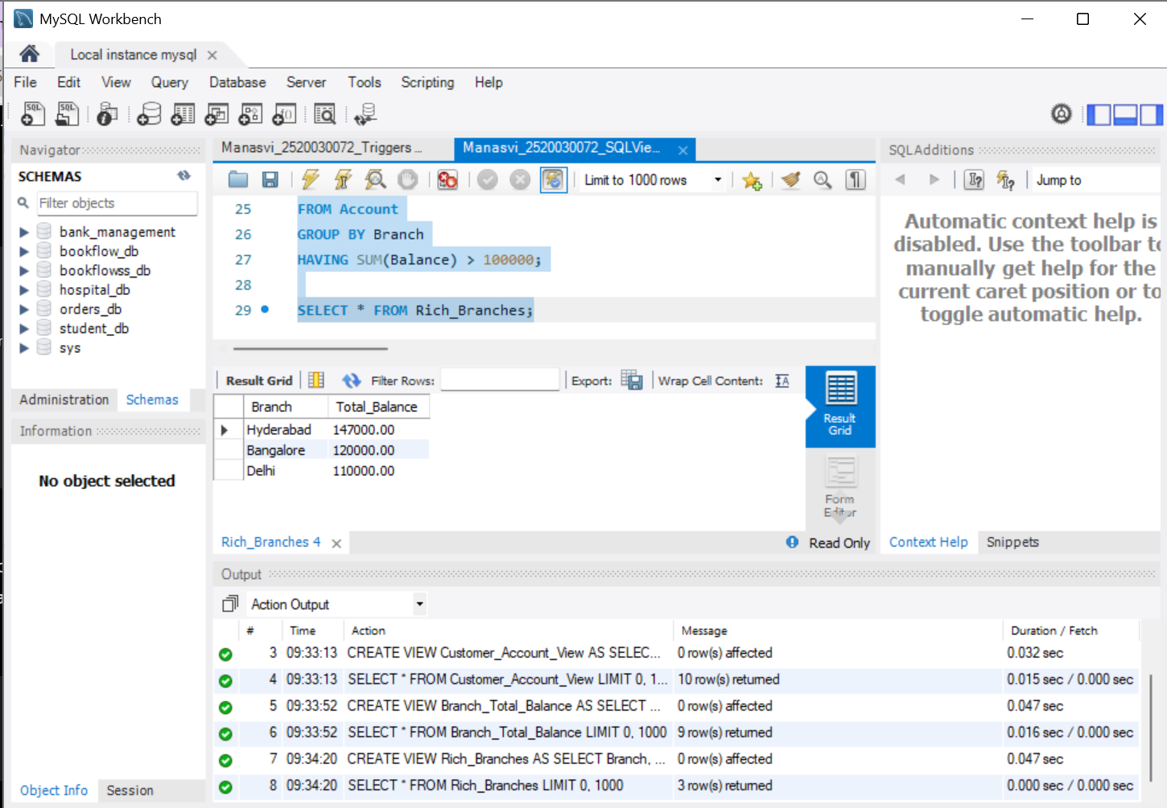

5. Created a view to display only deposit transactions.
Screenshot 5 – Deposit_Transaction_View displays only deposit transactions from Bank_Transaction. The result shows the transaction IDs, accounts, amounts and dates.
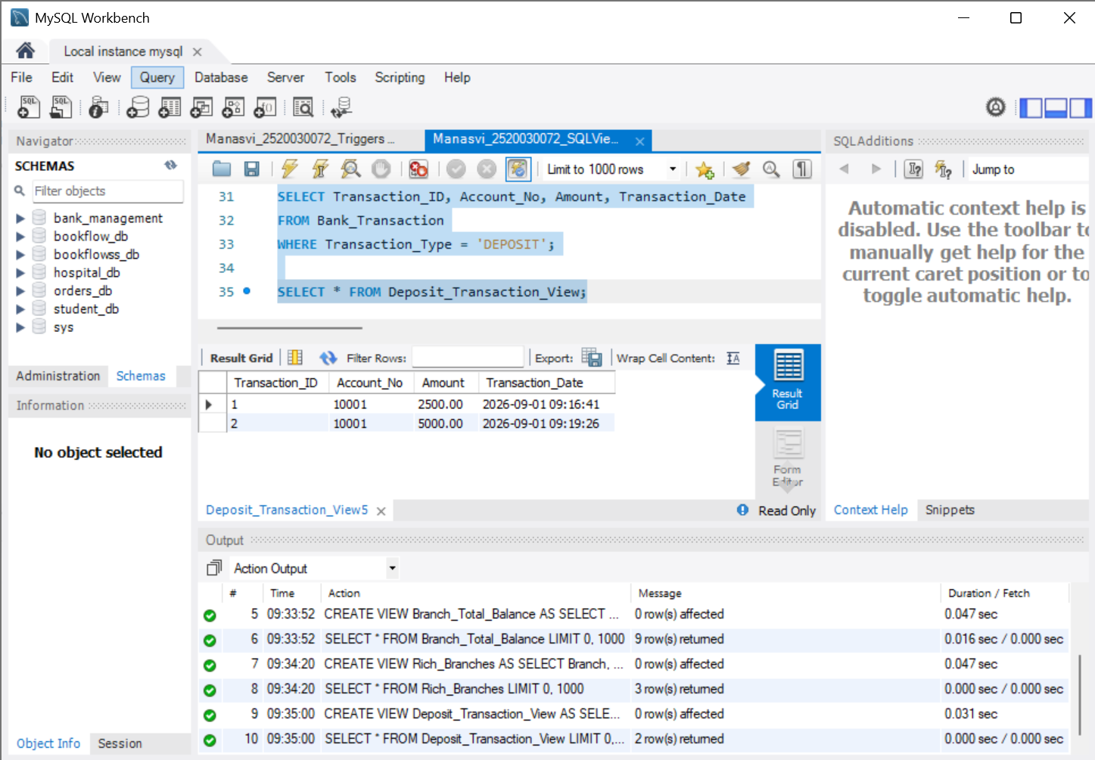

6. Created a view using multiple-table JOINs to display customer transactions.
Screenshot 6 – Customer_Transaction_View joins Customer, Account and Bank_Transaction to show customer-wise transaction details.
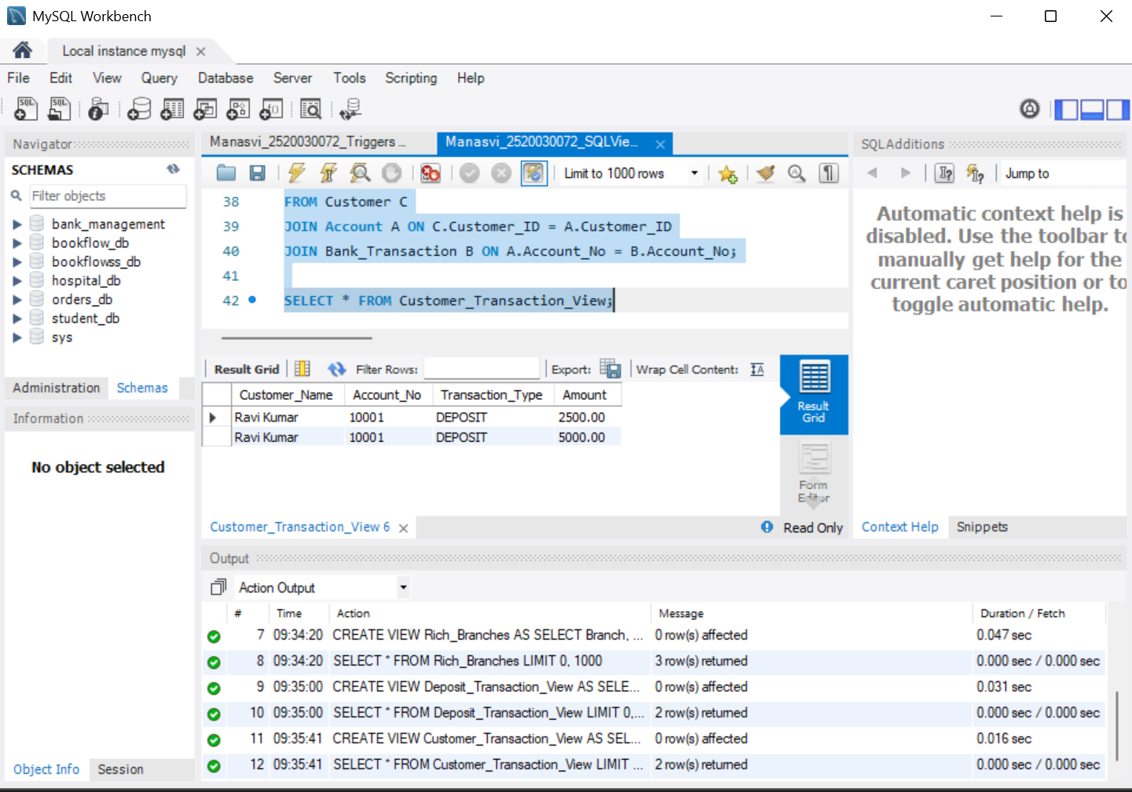

7. Created a view using aggregate functions with HAVING to identify high-balance branches.
Screenshot 7 – High_Balance_Branches filters grouped branch balances using HAVING and displays branches with total balances above 100000.
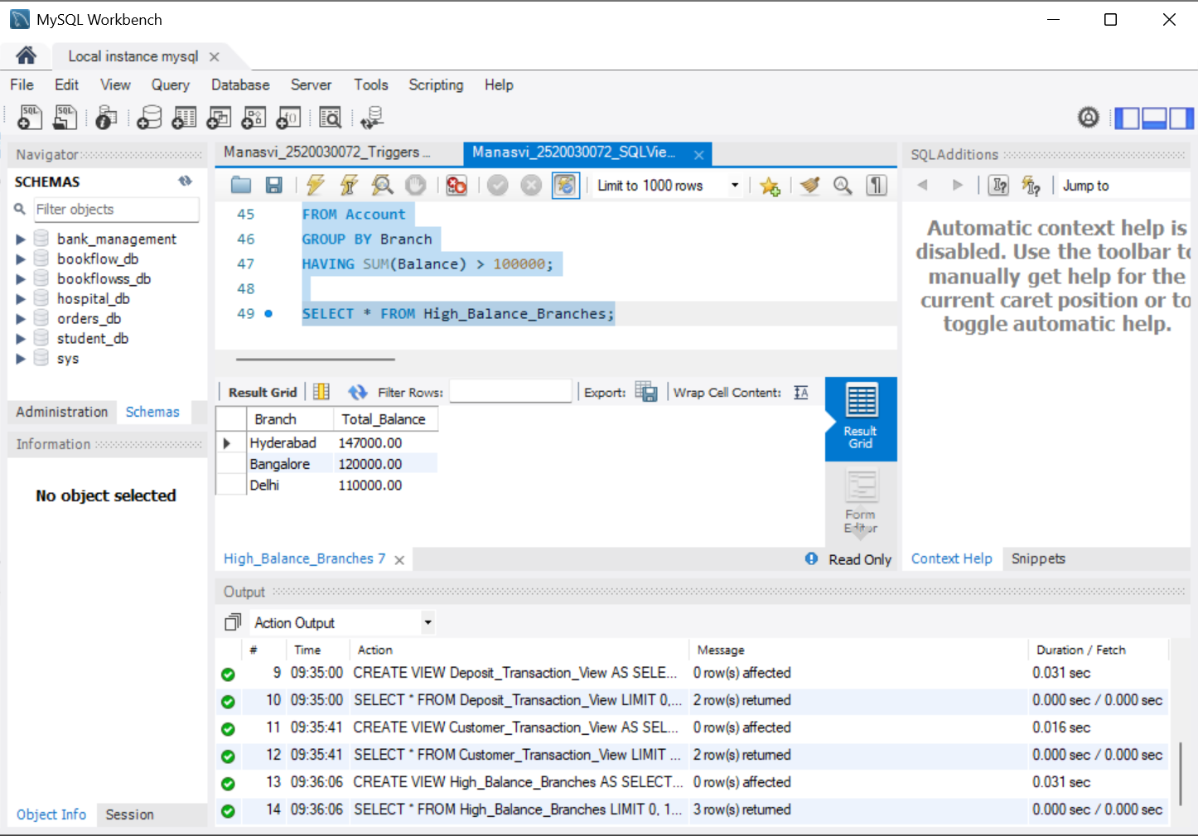

8. Updated an existing view using CREATE OR REPLACE VIEW.
Screenshot 8 – Customer_View was updated using CREATE OR REPLACE VIEW to show only customers from Hyderabad. The updated view returns two records.
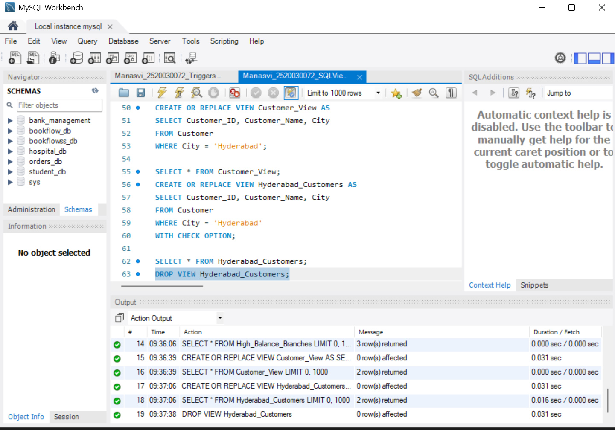

9. Created a view using WITH CHECK OPTION.
Screenshot 9 – Hyderabad_Customers was created with WITH CHECK OPTION and successfully displayed the customers belonging to Hyderabad.
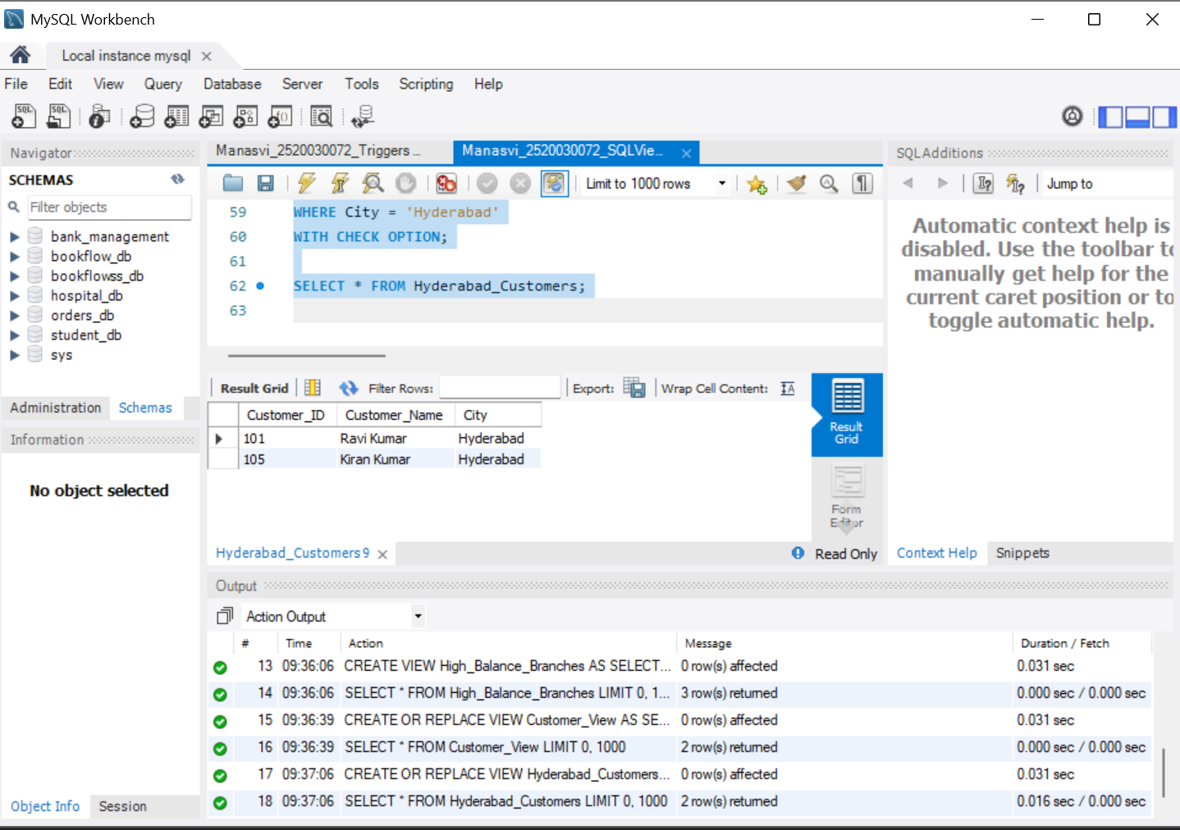

10. Dropped the temporary view using DROP VIEW.
Screenshot 10 – The temporary Hyderabad_Customers view was dropped successfully using DROP VIEW.
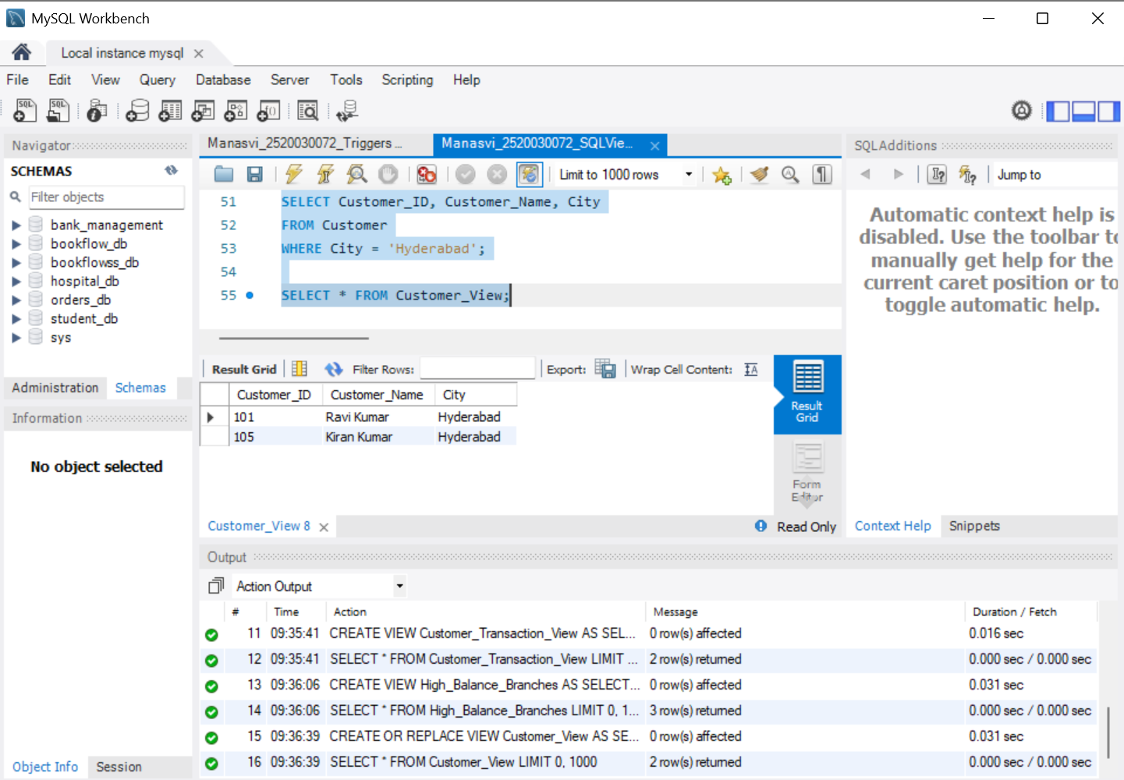
Result: The required SQL Views operations were successfully implemented and executed in MySQL Workbench. The outputs confirm simple views, JOIN views, aggregate views, GROUP BY, HAVING, view replacement, WITH CHECK OPTION and DROP VIEW.
Conclusion: SQL Views were successfully created and tested using the banking database. Only the main unique operations were documented without repeating duplicate tasks.

