DBSE & DBD PRACTICAL
Name: Param Manasvi
Roll No: 2520030072
Course Code: 25CS1302E
Banking Database – Triggers and Stored Procedures
Aim:
To practice database creation, table creation, stored procedures and triggers using MySQL Workbench.
1. Created the BankDB database and selected it for the practical.
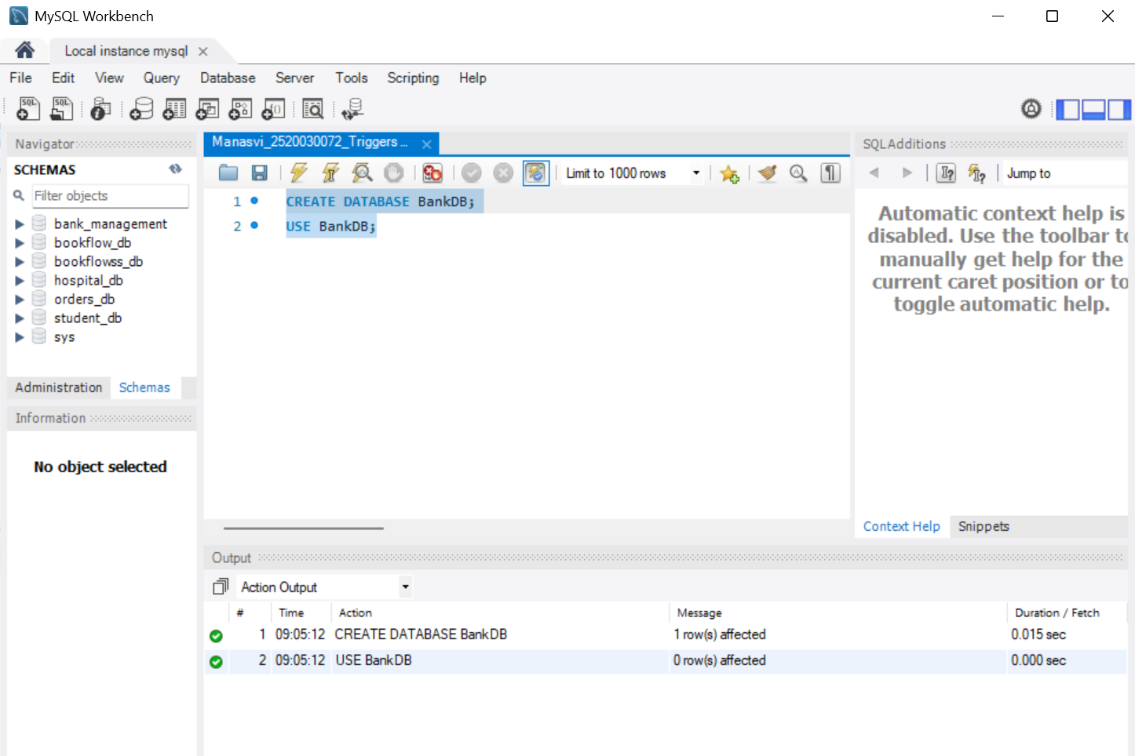
Screenshot 1 – BankDB was created and selected successfully. Timestamp: 09:05:12.
2. Created the required banking tables. Similar table-creation steps are grouped together to avoid duplicate screenshots.
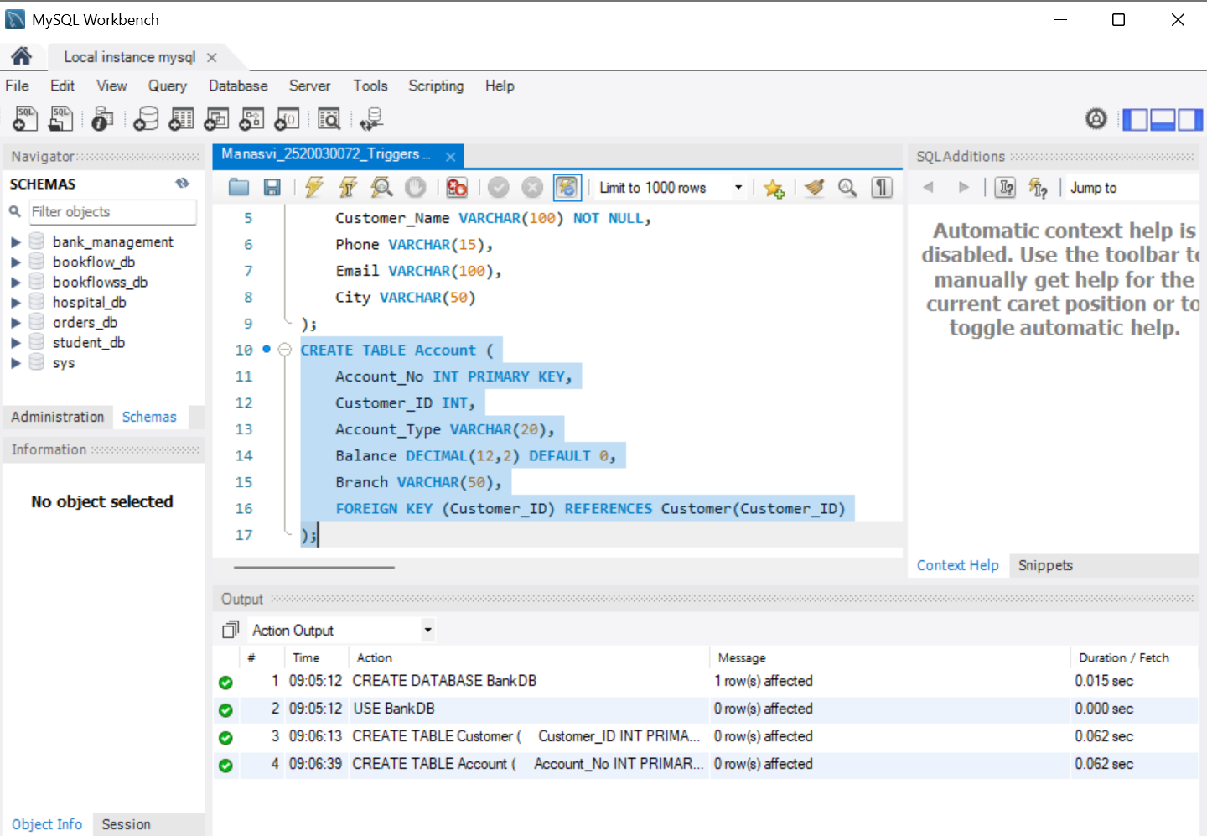
Screenshot 2 – Customer table created successfully with its primary key and required fields. Timestamp: 09:06:13.
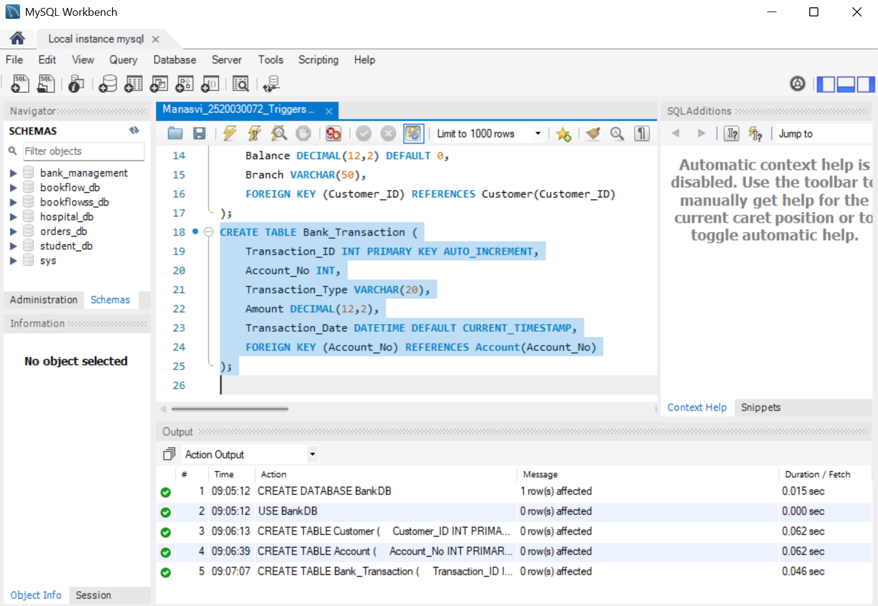
Screenshot 3 – Bank_Transaction table created with AUTO_INCREMENT transaction ID and foreign-key relationship. Timestamp: 09:07:07.
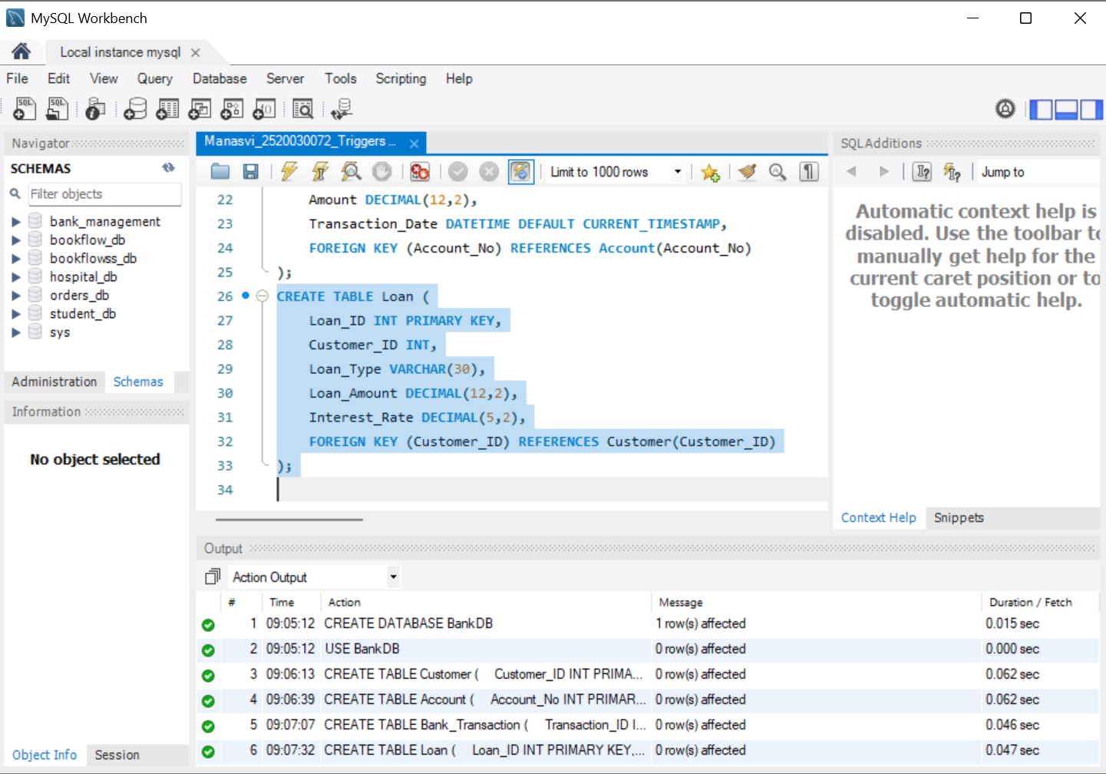
Screenshot 4 – Loan table created with customer reference and loan details. Timestamp: 09:07:32.
3. Inserted the required customer and account records, including 10 customers and 10 accounts.
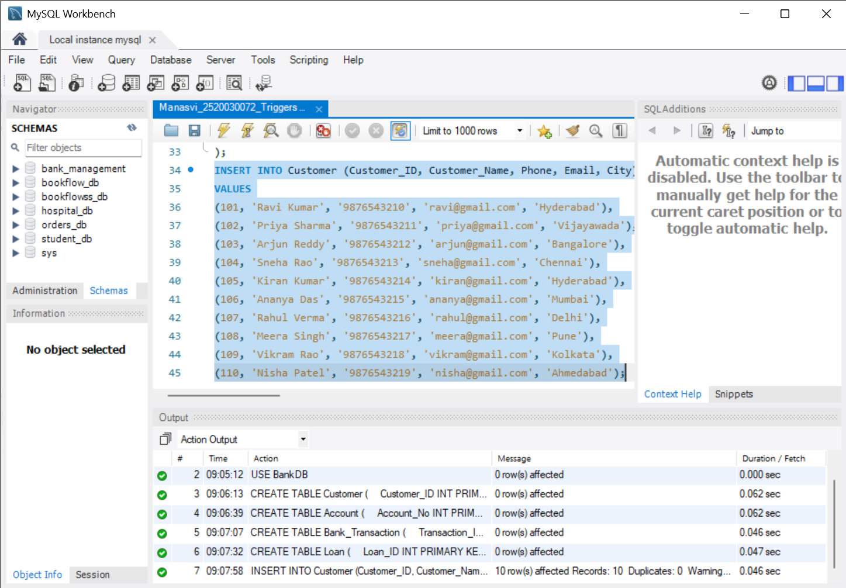
Screenshot 5 – Ten customer records inserted successfully. Timestamp: 09:07:58.
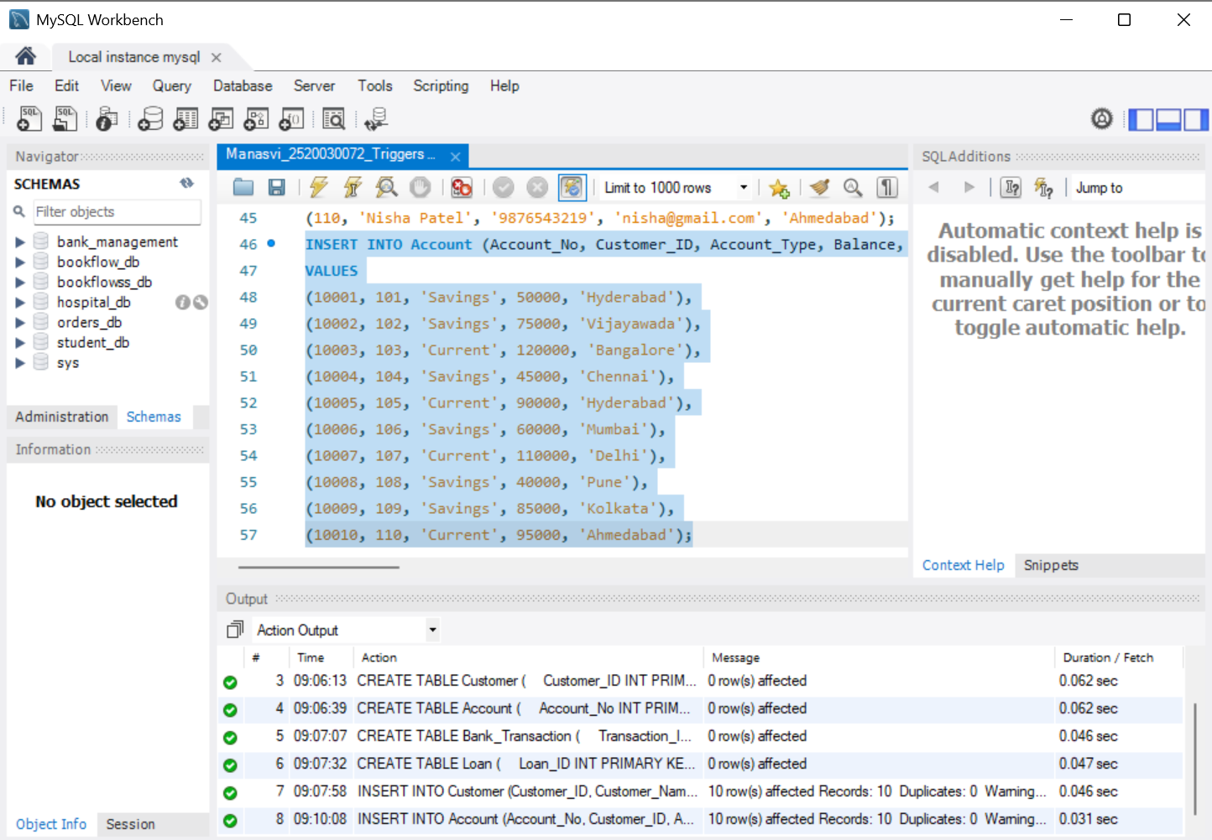
Screenshot 6 – Ten account records inserted successfully. Timestamp: 09:10:08.
4. Created and tested a stored procedure to deposit money into an account.
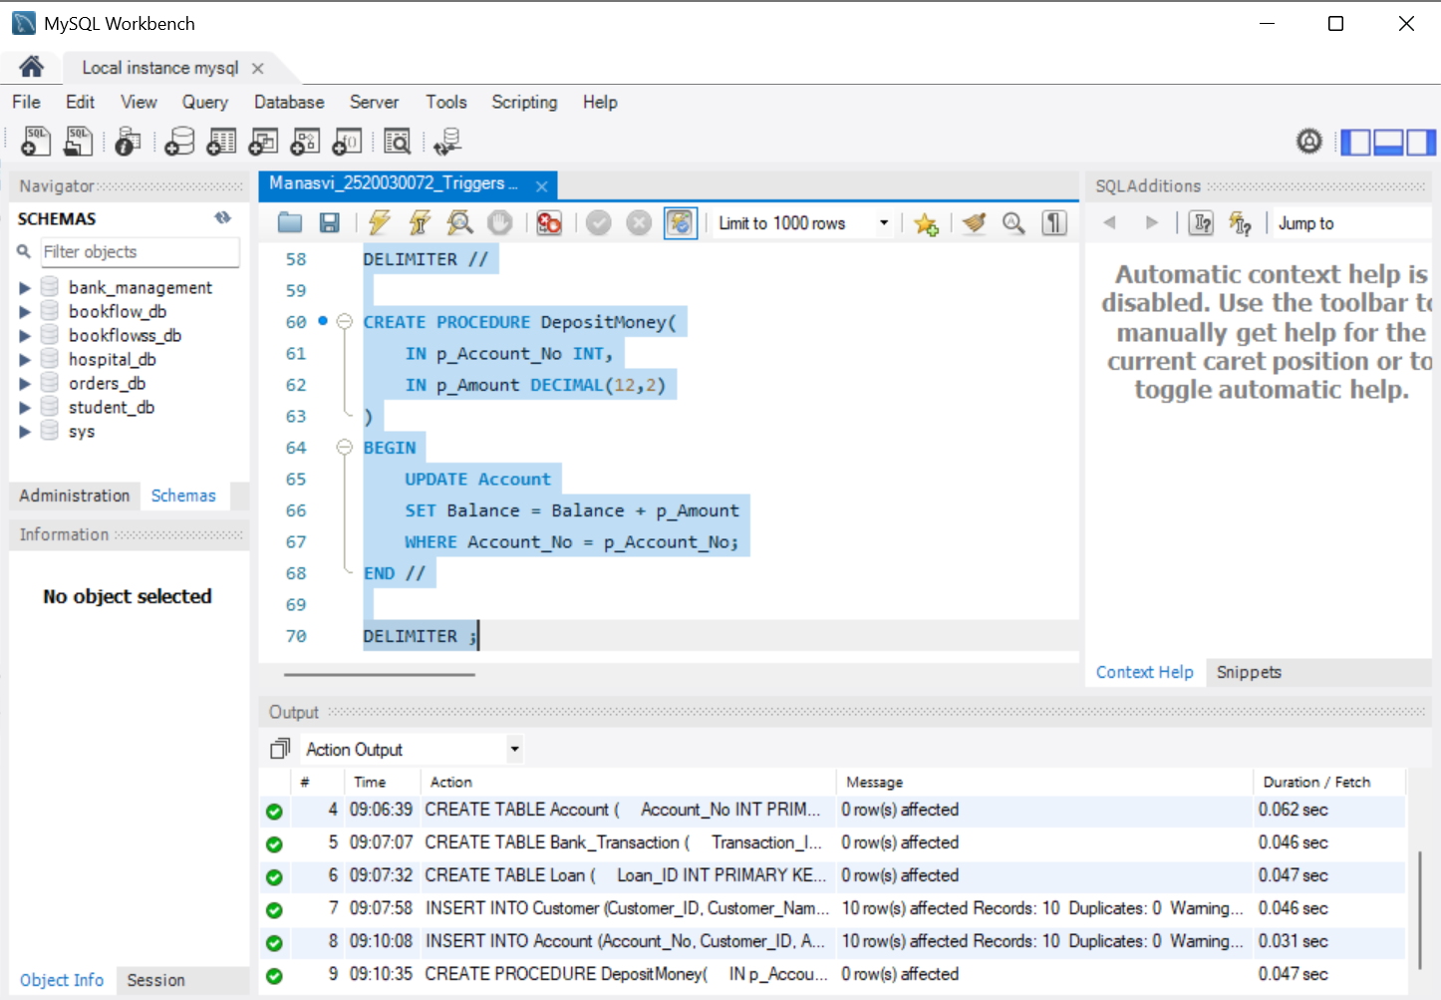
Screenshot 7 – DepositMoney procedure created successfully. Timestamp: 09:10:35.
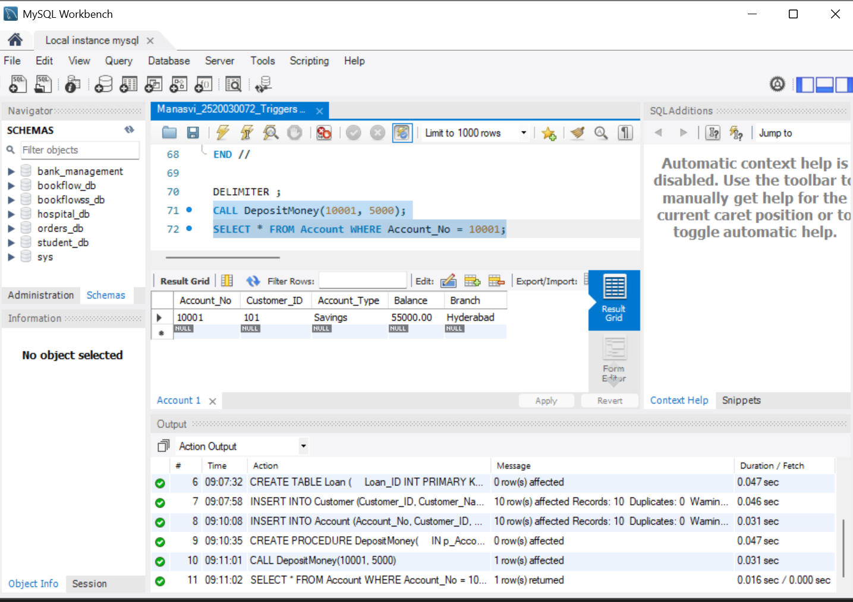
Screenshot 8 – Deposit procedure executed successfully; balance changed from 50,000 to 55,000. Timestamp: 09:11:01–09:11:02.
5. Created and tested a stored procedure to withdraw money from an account.
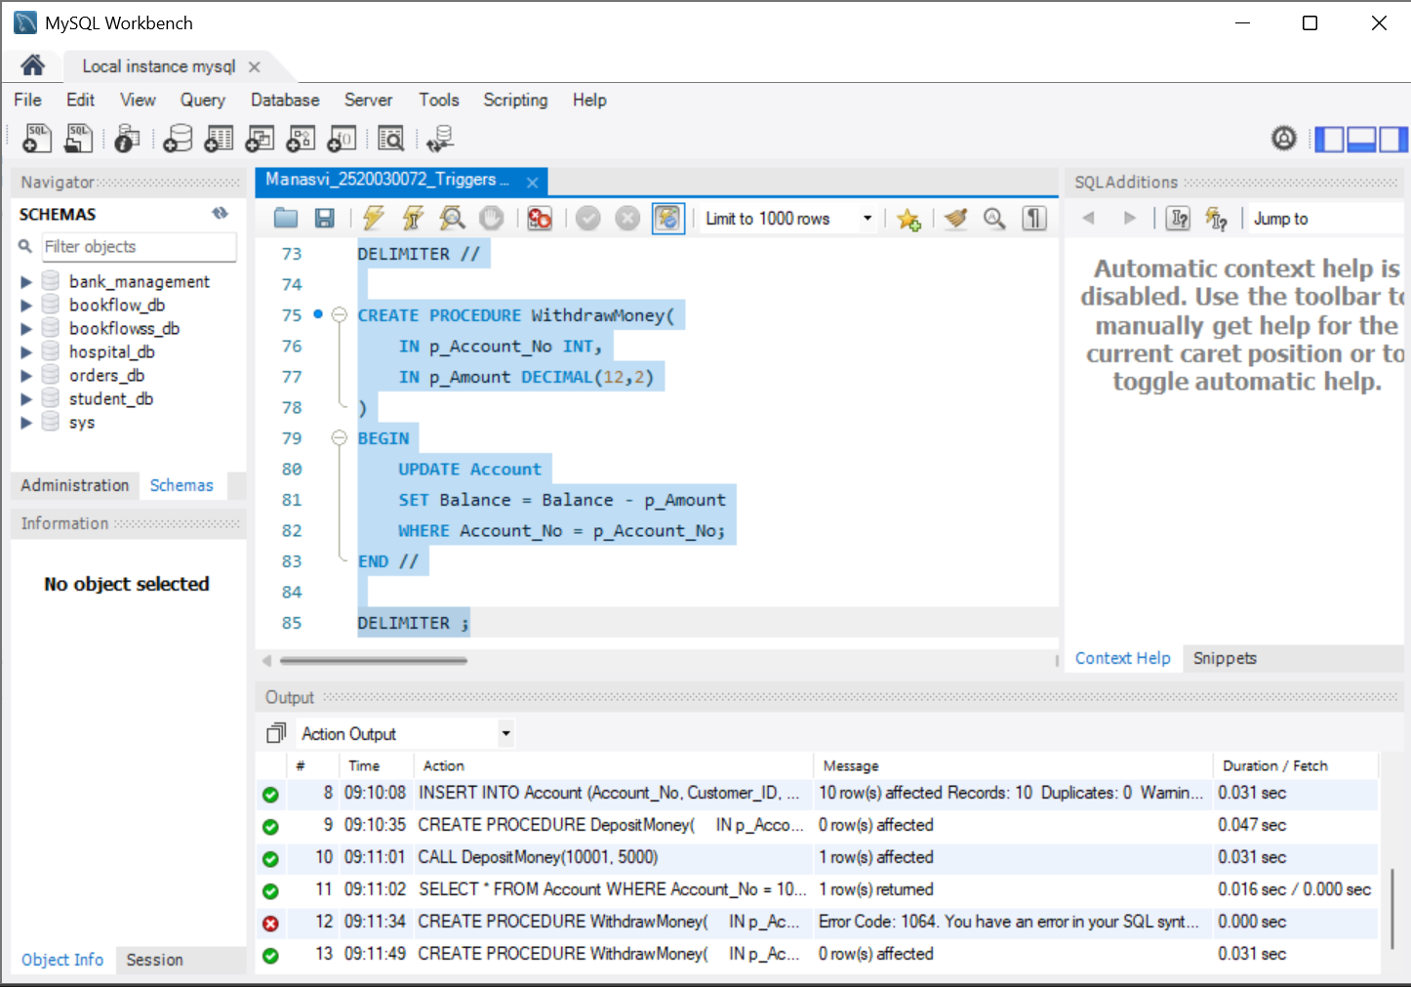
Screenshot 9 – WithdrawMoney procedure was successfully created. Successful creation timestamp: 09:11:49.
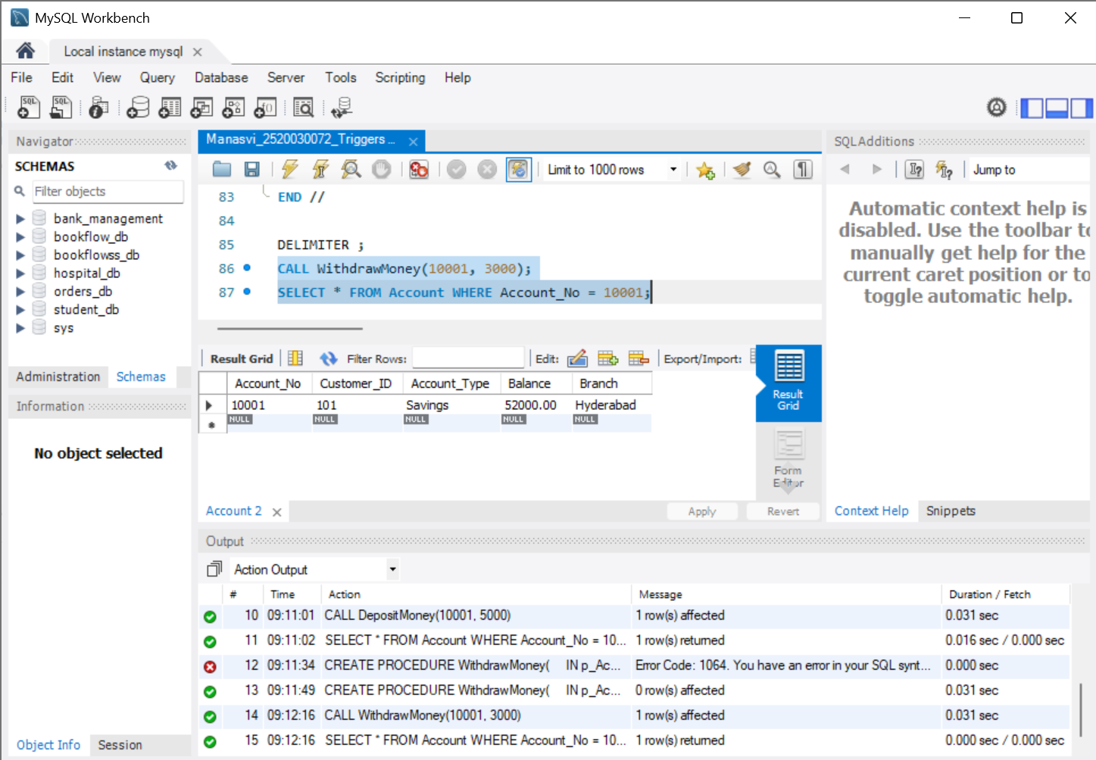
Screenshot 10 – Withdrawal procedure executed successfully; balance changed from 55,000 to 52,000. Timestamp: 09:12:16.
6. Created a BEFORE INSERT trigger to reject zero or negative transaction amounts and tested the validation.
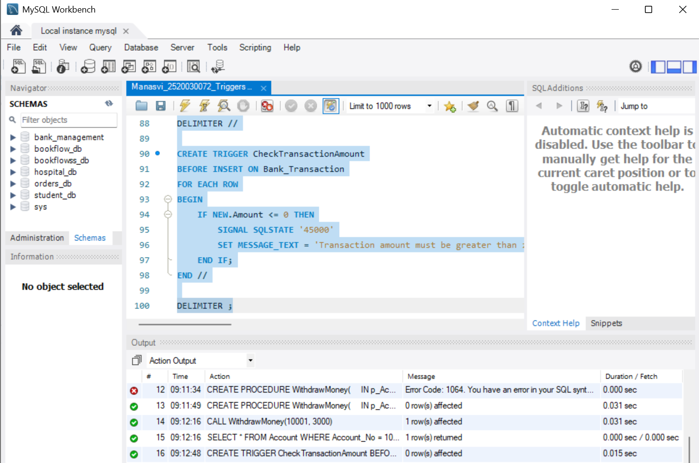
Screenshot 11 – CheckTransactionAmount trigger created successfully. Timestamp: 09:12:48.
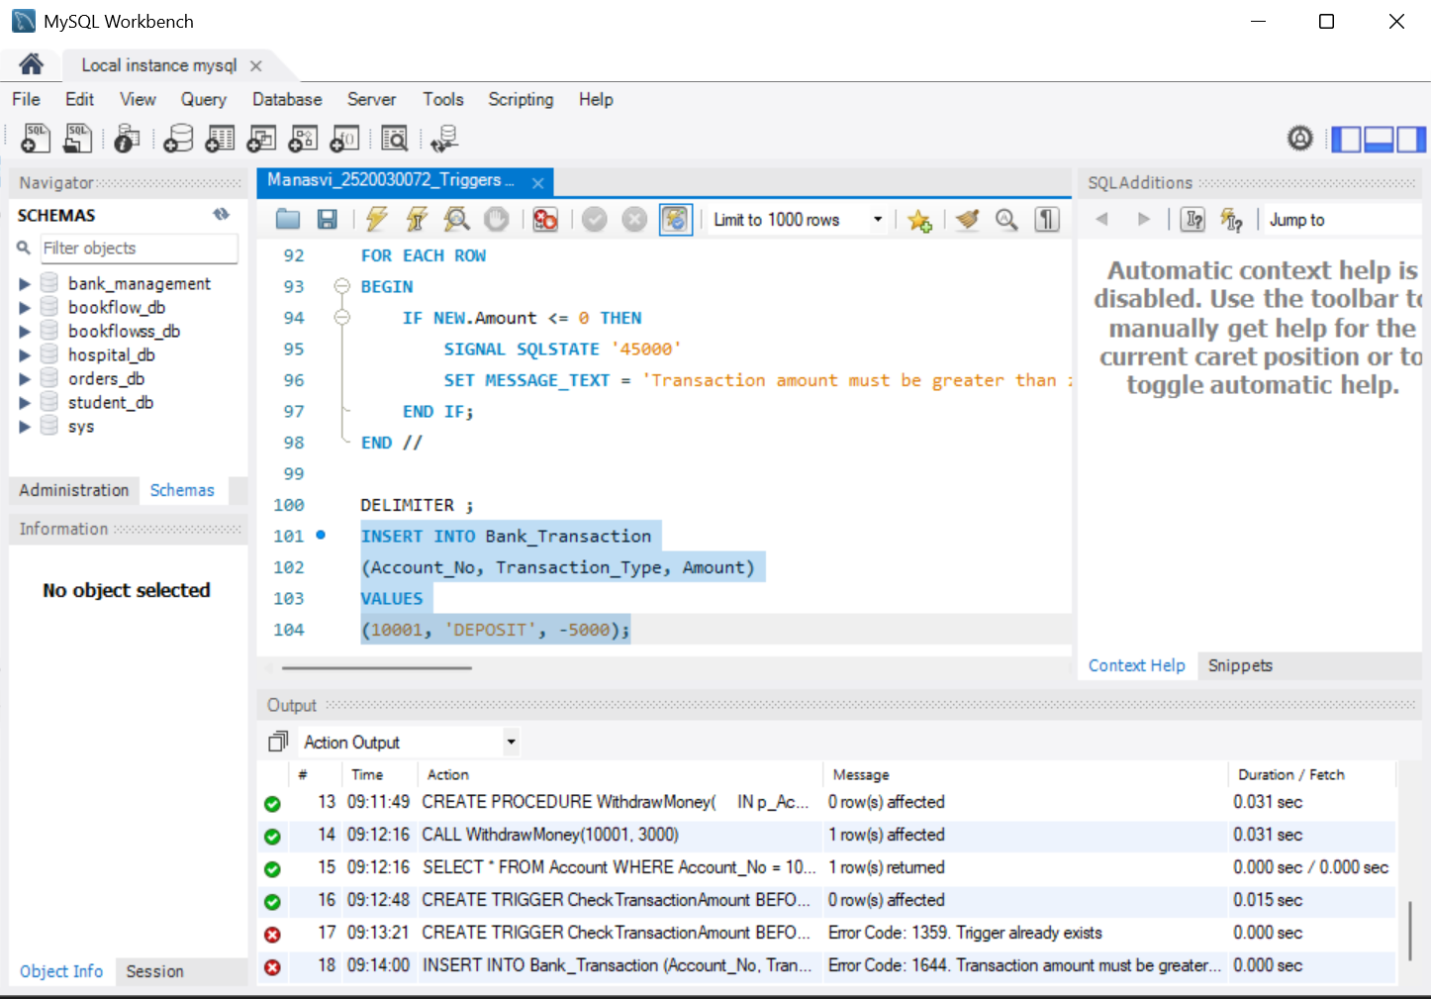
Screenshot 12 – Negative transaction amount was rejected by the trigger. Timestamp: 09:14:00.
7. Created a transaction audit table and an AFTER INSERT trigger to automatically record transactions.
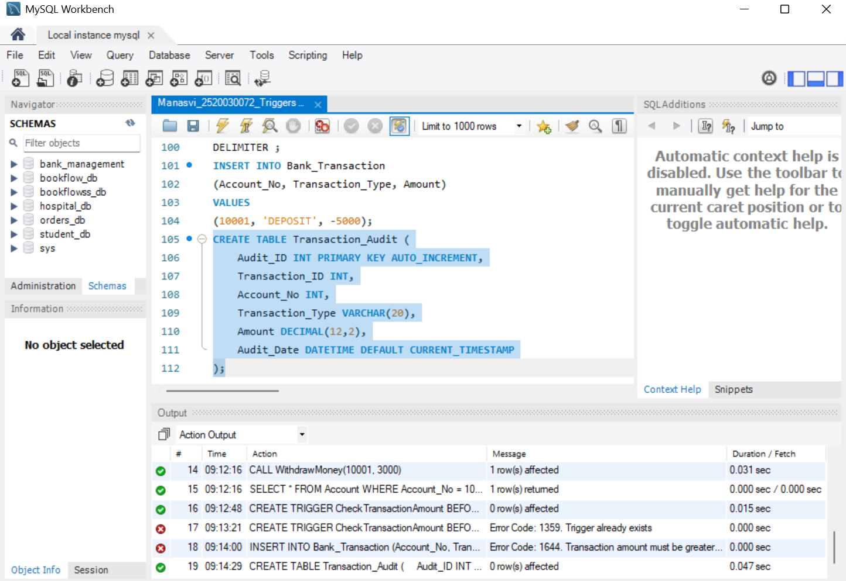
Screenshot 13 – Transaction_Audit table created successfully. Timestamp: 09:14:29.
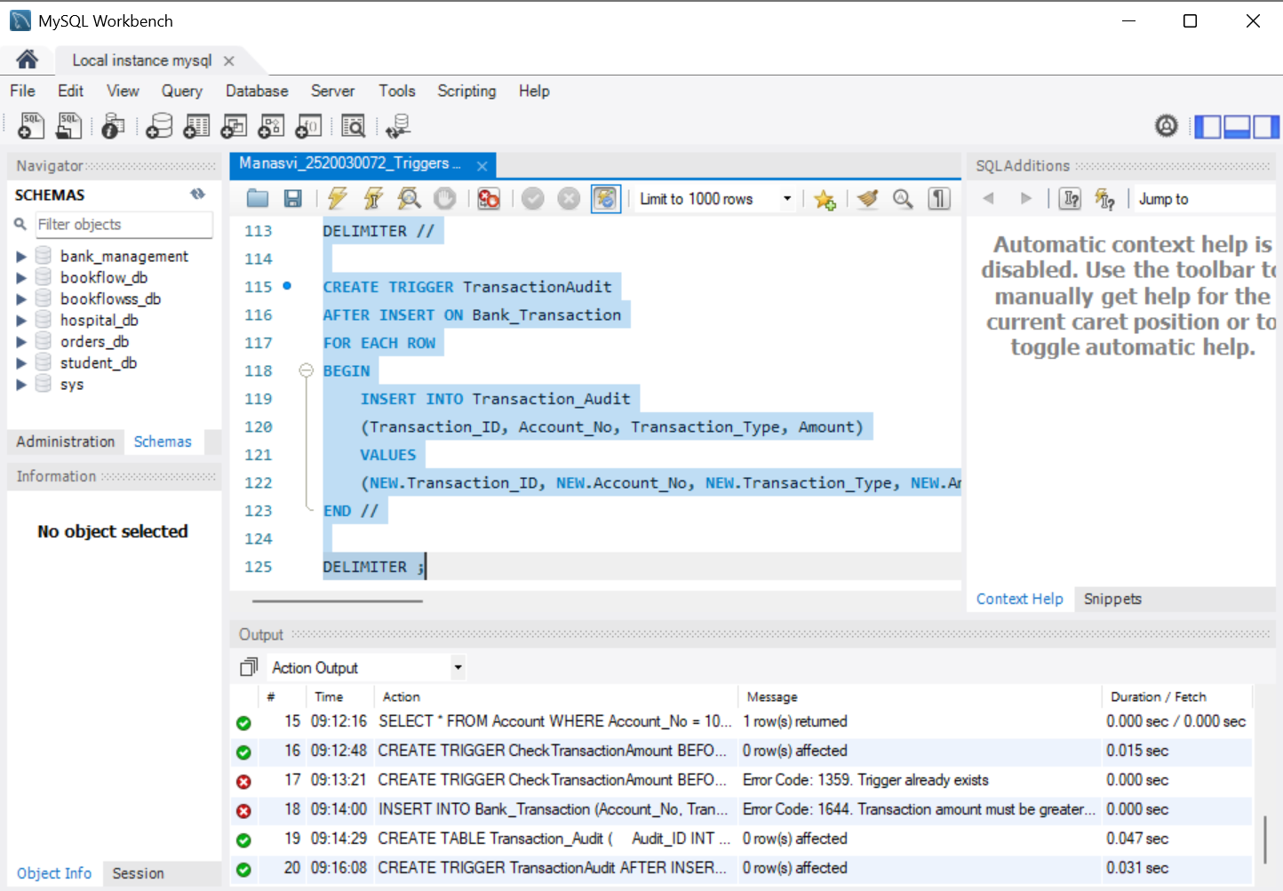
Screenshot 14 – TransactionAudit trigger created successfully. Timestamp: 09:16:08.
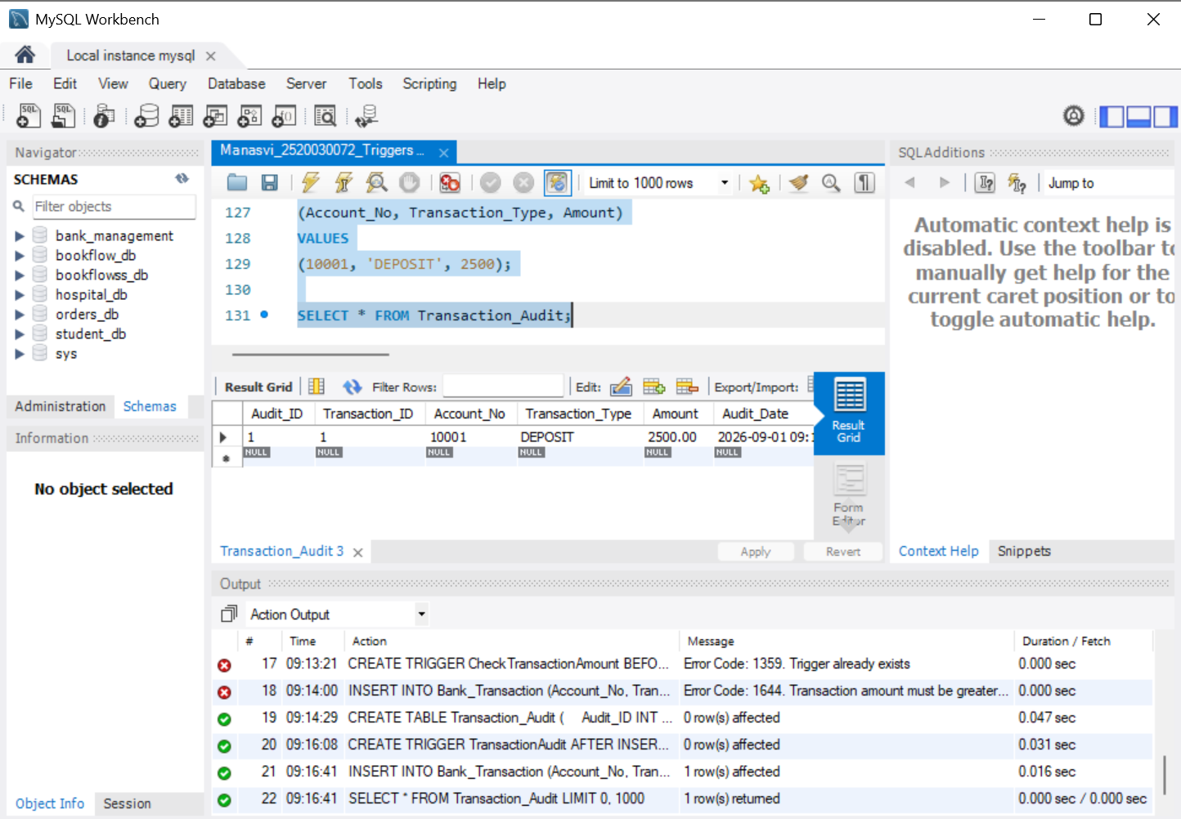
Screenshot 15 – Inserted transaction was automatically recorded in Transaction_Audit. Timestamp: 09:16:41.
8. Created and tested a trigger that automatically updates the account balance after a deposit or withdrawal transaction.
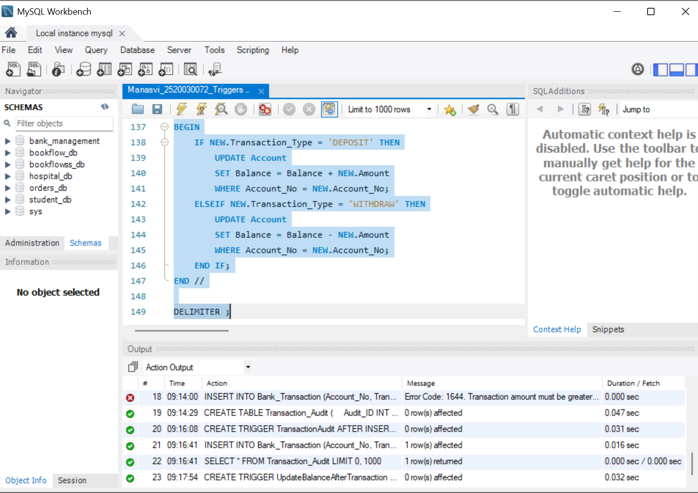
Screenshot 16 – UpdateBalanceAfterTransaction trigger created successfully. Timestamp: 09:17:54.
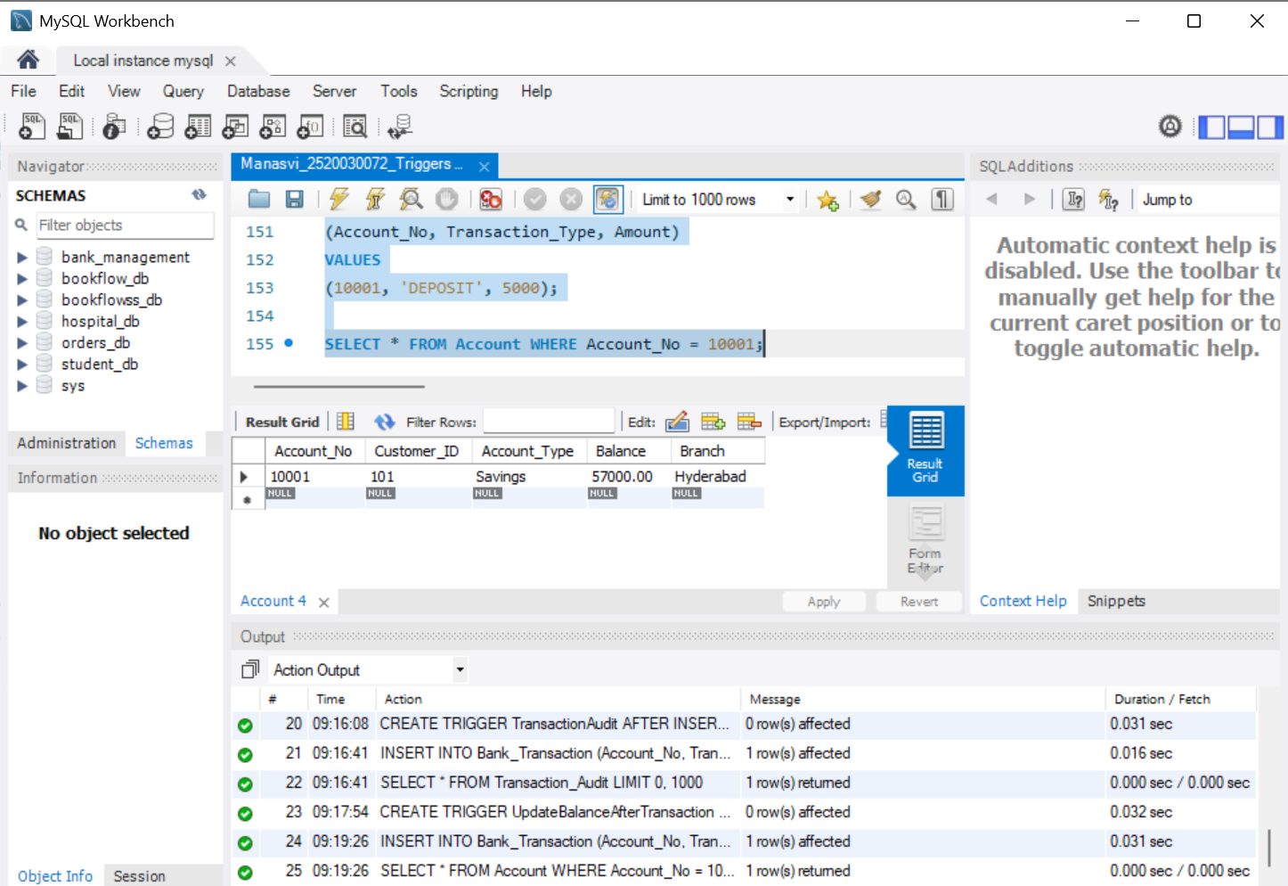
Screenshot 17 – Automatic balance update verified; balance increased from 52,000 to 57,000. Timestamp: 09:19:26.
9. Created and tested a trigger that prevents withdrawals when the available balance is insufficient.
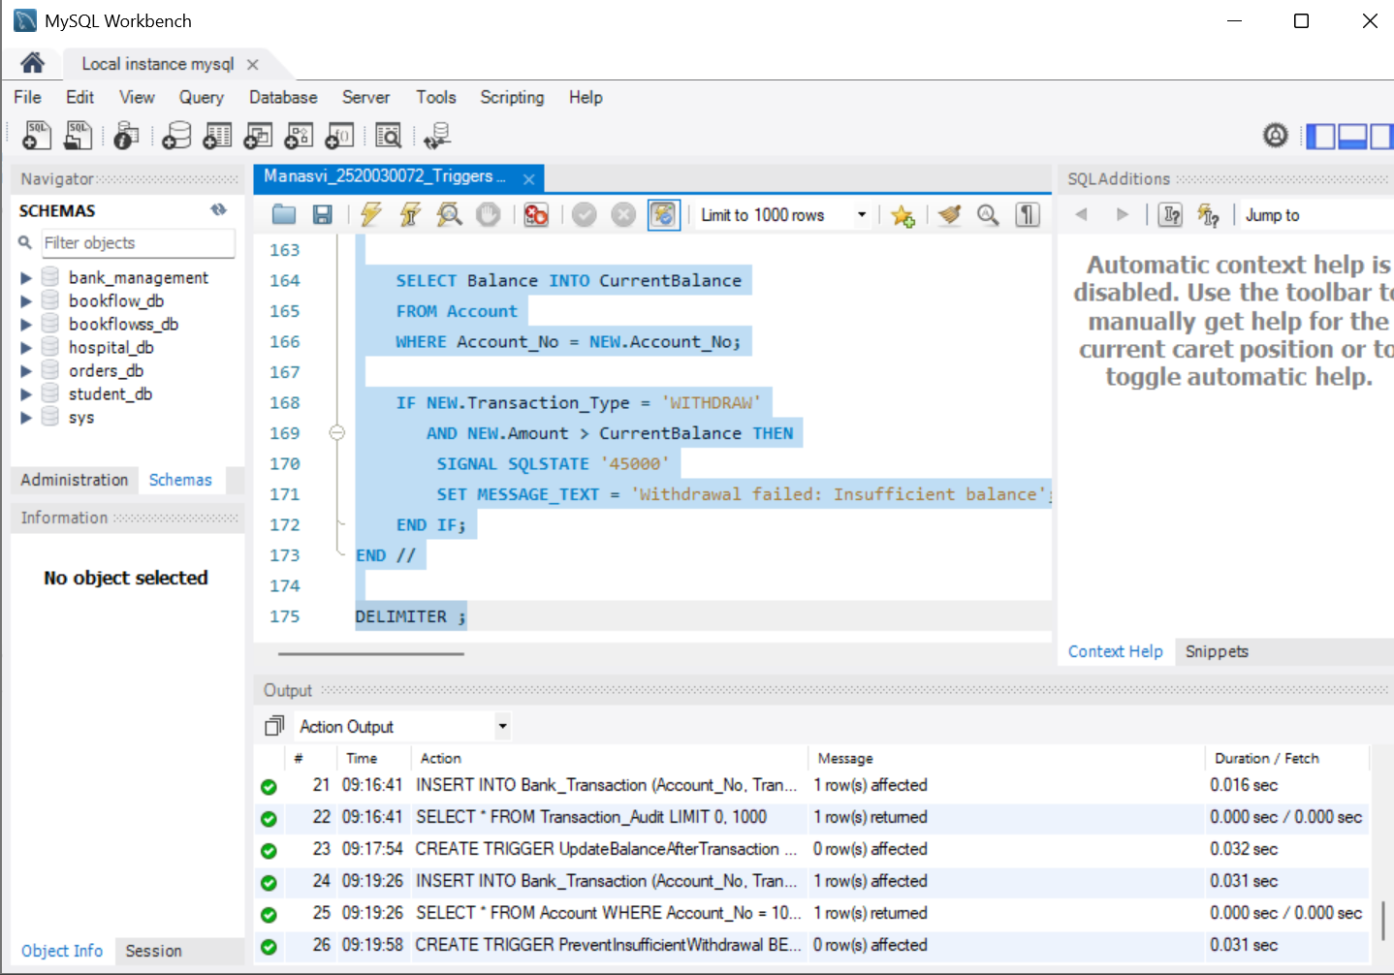
Screenshot 18 – PreventInsufficientWithdrawal trigger created successfully. Timestamp: 09:19:58.
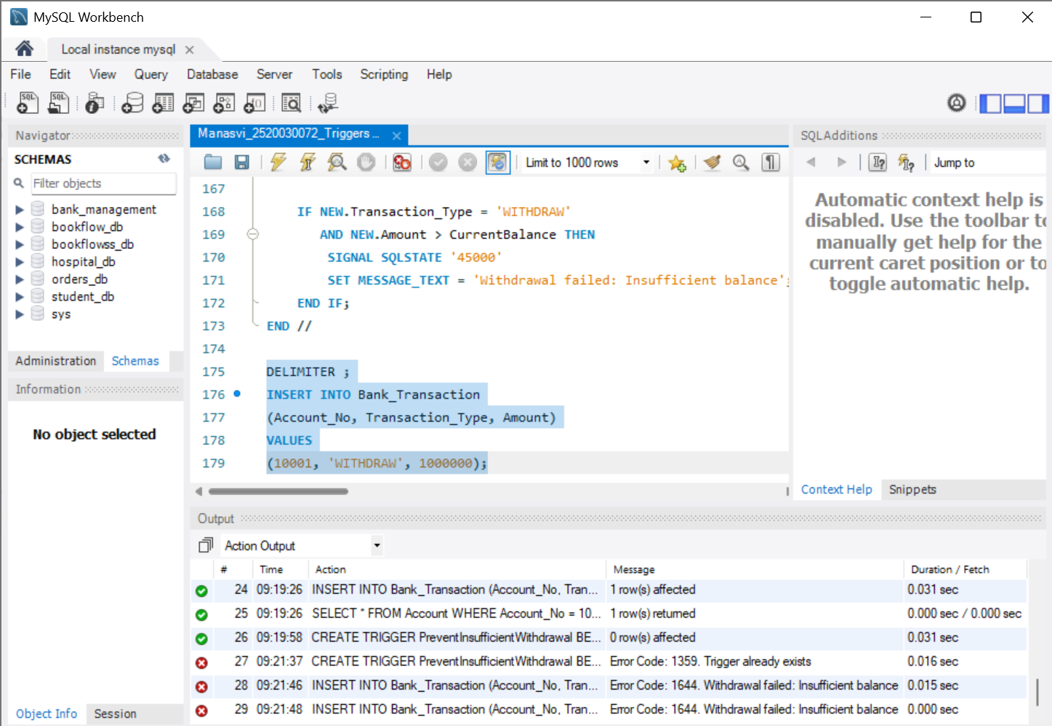
Screenshot 19 – Withdrawal exceeding the available balance was rejected with an insufficient-balance error. Timestamp: 09:21:46.
10. Similar procedures, triggers and practice variations were not repeated where they demonstrated the same concept. The selected screenshots document the main unique concepts and their successful tests.
Result:
The banking database was successfully created and the main stored procedures, triggers, transaction auditing and balance-validation operations were implemented and tested in MySQL Workbench.

