SQL PRACTICE – WHERE, HAVING, GROUP BY AND ORDER BY
2520030072
Aim: To practice SQL queries using WHERE, ORDER BY, GROUP BY, HAVING, aggregate functions and BETWEEN.
Step 1: Create database, table and insert data
Create the orders database and table, insert the given records, and display the table.
Execution Code
CREATE DATABASE IF NOT EXISTS orders_db;
USE orders_db;
CREATE TABLE IF NOT EXISTS orders (
ord_no INT PRIMARY KEY,
purch_amt DECIMAL(10,2),
ord_date DATE,
customer_id INT,
salesman_id INT
);
INSERT INTO orders VALUES
(70001,150.50,'2012-10-05',3005,5002),
(70009,270.65,'2012-09-10',3001,5005),
(70002,65.26,'2012-10-05',3002,5001),
(70004,110.50,'2012-08-17',3009,5003),
(70007,948.50,'2012-09-10',3005,5002),
(70005,2400.60,'2012-07-27',3007,5001),
(70008,5760.00,'2012-09-10',3002,5001),
(70010,1983.43,'2012-10-10',3004,5006),
(70003,2480.40,'2012-10-10',3009,5003),
(70012,250.45,'2012-06-27',3008,5002),
(70011,75.29,'2012-08-17',3003,5007),
(70013,3045.60,'2012-04-25',3002,5001);
SELECT * FROM orders;
Execution Screenshot
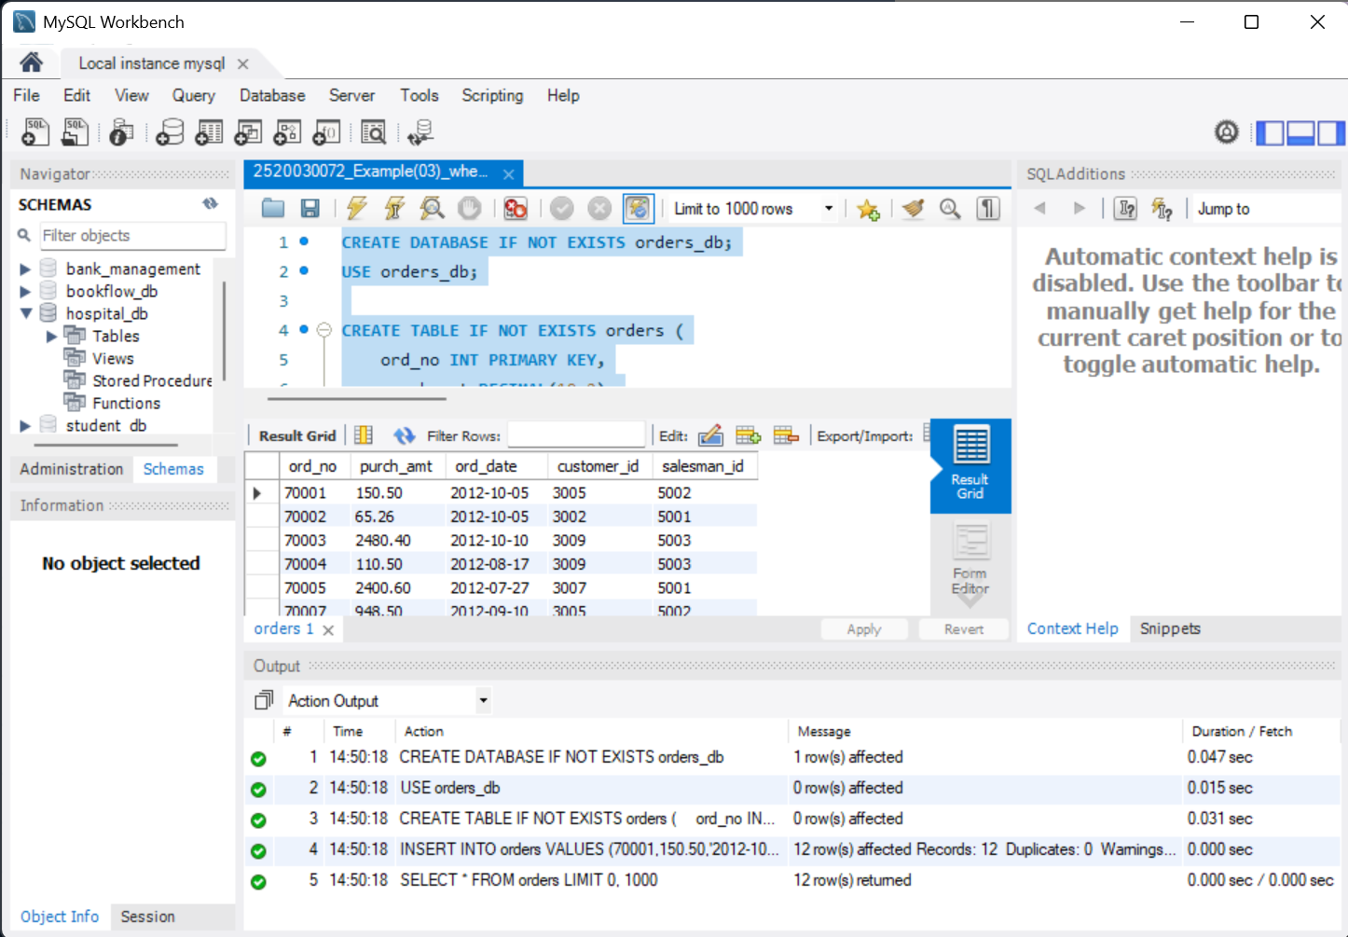

Step 2: WHERE and ORDER BY (Q1–Q5)
Filter records using WHERE and arrange them using ORDER BY.
Execution Code
USE orders_db;
-- Q1
SELECT * FROM orders WHERE purch_amt > 2000;
-- Q2
SELECT * FROM orders WHERE ord_date = '2012-09-10';
-- Q3
SELECT * FROM orders WHERE salesman_id = 5001;
-- Q4
SELECT * FROM orders ORDER BY purch_amt DESC;
-- Q5
SELECT * FROM orders ORDER BY ord_date;
Execution Screenshot
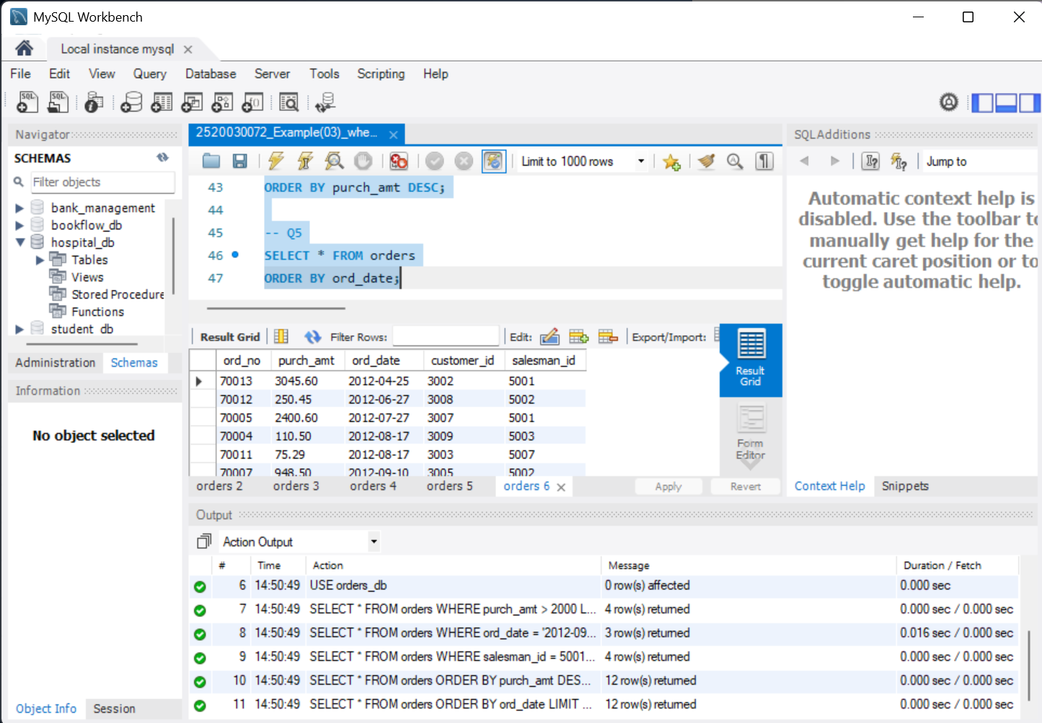

Step 3: Aggregate Functions (Q6–Q10)
Use SUM, AVG, MAX, MIN and COUNT to obtain summary values.
Execution Code
-- Q6
SELECT SUM(purch_amt) AS total_revenue FROM orders;
-- Q7
SELECT AVG(purch_amt) AS average_order FROM orders;
-- Q8
SELECT MAX(purch_amt) AS highest_order FROM orders;
-- Q9
SELECT MIN(purch_amt) AS lowest_order FROM orders;
-- Q10
SELECT COUNT(*) AS total_orders FROM orders;
Execution Screenshot
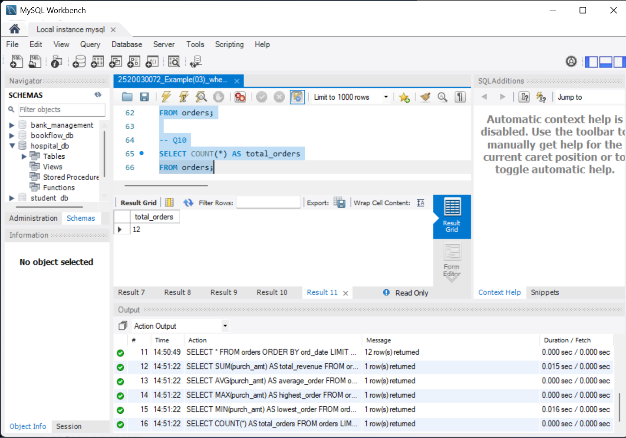

Step 4: GROUP BY and HAVING (Q11–Q15)
Group records by salesman or customer and filter grouped results.
Execution Code
-- Q11
SELECT salesman_id, SUM(purch_amt) AS total_sales
FROM orders GROUP BY salesman_id;
-- Q12
SELECT customer_id, SUM(purch_amt) AS total_purchase
FROM orders GROUP BY customer_id;
-- Q13
SELECT customer_id, MAX(purch_amt) AS highest_purchase
FROM orders GROUP BY customer_id;
-- Q14
SELECT salesman_id, SUM(purch_amt) AS total_sales
FROM orders GROUP BY salesman_id
HAVING SUM(purch_amt) > 3000;
-- Q15
SELECT customer_id, SUM(purch_amt) AS total_purchase
FROM orders GROUP BY customer_id
HAVING SUM(purch_amt) > 2500;
Execution Screenshot
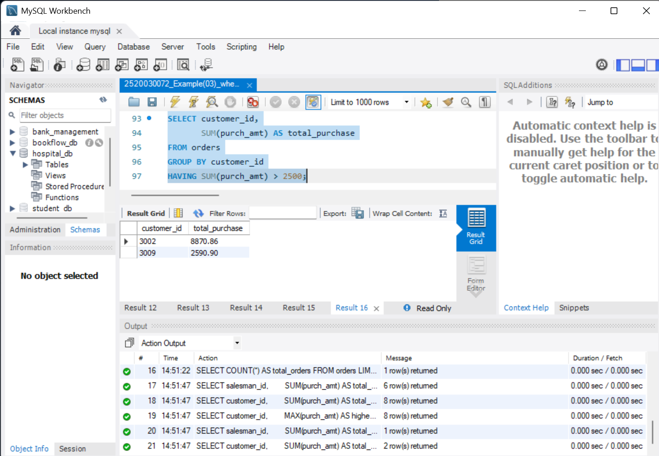

Step 5: HAVING, ORDER BY and BETWEEN (Q16–Q18)
Use COUNT, SUM, MAX, HAVING, ORDER BY and BETWEEN.
Execution Code
-- Q16
SELECT customer_id, COUNT(*) AS total_orders
FROM orders GROUP BY customer_id
HAVING COUNT(*) > 1;
-- Q17
SELECT customer_id, SUM(purch_amt) AS total_purchase
FROM orders
GROUP BY customer_id
HAVING SUM(purch_amt) > 1000
ORDER BY total_purchase DESC;
-- Q18
SELECT customer_id, MAX(purch_amt) AS max_purchase
FROM orders
GROUP BY customer_id
HAVING MAX(purch_amt) BETWEEN 2000 AND 6000;
Execution Screenshot
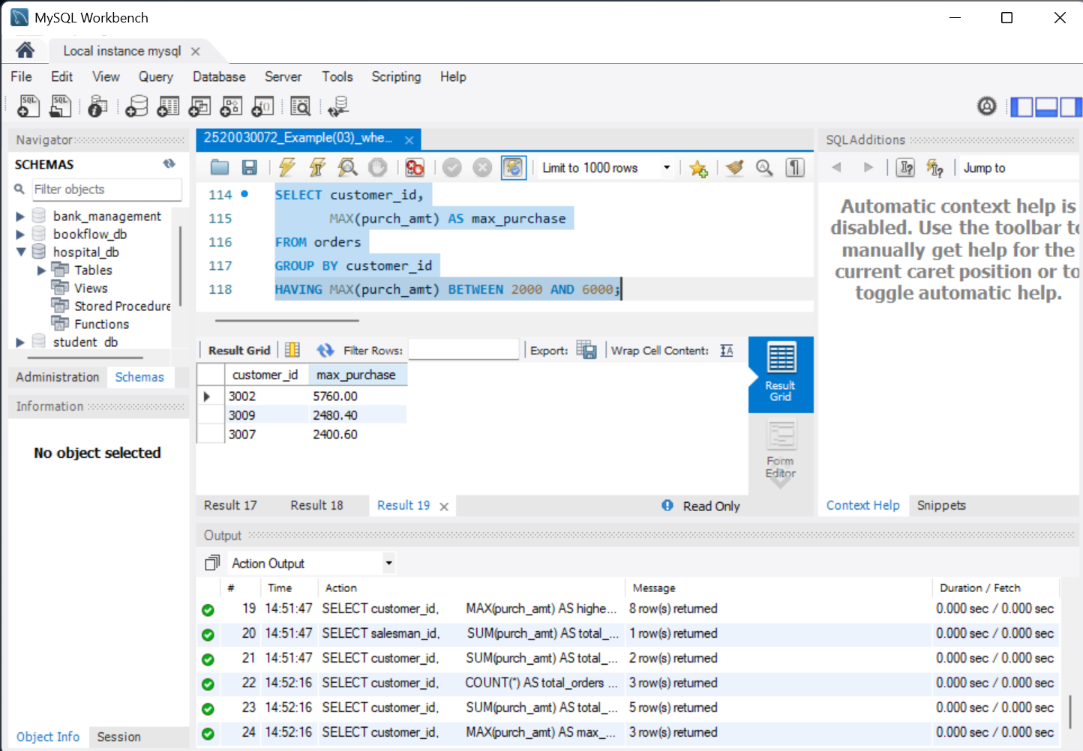

Step 6: Final grouped queries and verification (Q19–Q20)
Find salesmen with at least two orders, daily highest purchases above 2000, and verify the record count.
Execution Code
-- Q19
SELECT salesman_id, COUNT(*) AS total_orders
FROM orders GROUP BY salesman_id
HAVING COUNT(*) >= 2;
-- Q20
SELECT ord_date, MAX(purch_amt) AS highest_purchase
FROM orders GROUP BY ord_date
HAVING MAX(purch_amt) > 2000;
-- Final verification
SELECT COUNT(*) AS total_records FROM orders;
Execution Screenshot
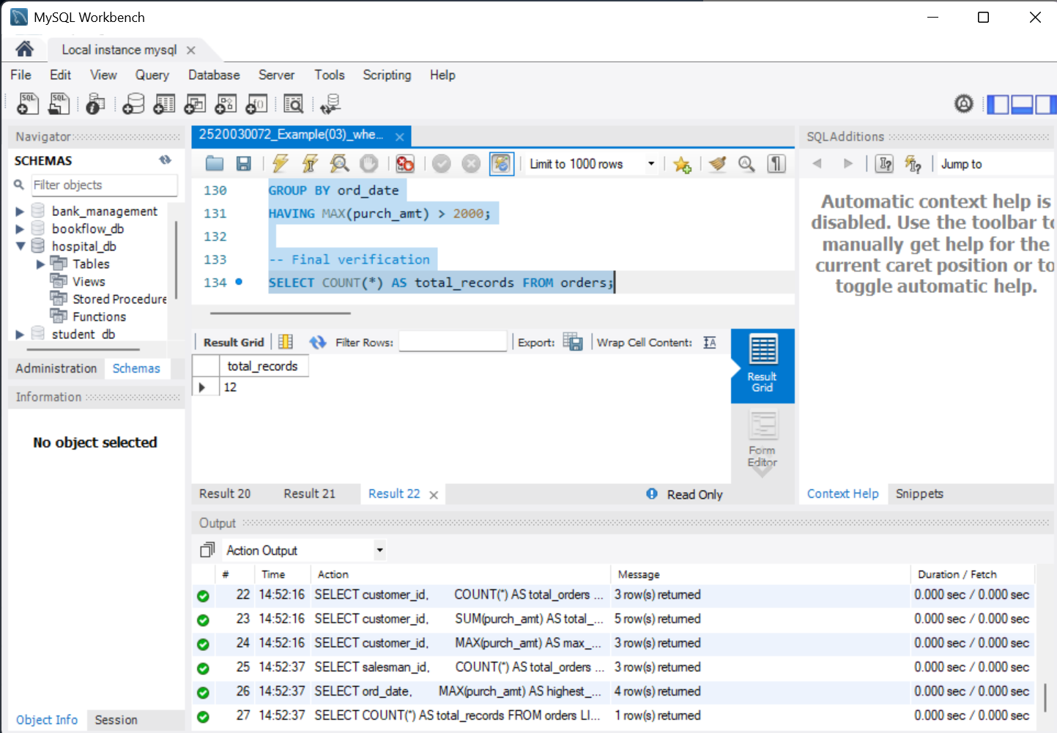
Result: The SQL practice queries were executed successfully. Final record count: 12.

