2520030072_Joins_Sets
SQL Practical Record
Name: Param Manasvi
Roll Number: 2520030072
Database: bookflow_db
Topic: SQL Joins and Set Operations
Aim
To implement and execute SQL JOIN operations and set operations using the bookflow_db database, and verify the results in MySQL Workbench.
Requirements
MySQL Workbench and the existing bookflow_db database containing the members, books and loans tables.
Procedure
1. Open MySQL Workbench and select the bookflow_db database.
2. Verify the available tables using SHOW TABLES.
3. Verify the structure of the loans table using DESCRIBE loans.
4. Verify the existing members and books records before performing JOIN operations.
5. Verify the existing loan records using SELECT * FROM loans.
6. Perform an INNER JOIN between members and loans using member_id.
7. Perform an INNER JOIN between loans and books using book_id.
8. Perform a three-table INNER JOIN between members, loans and books.
9. Perform LEFT JOIN and RIGHT JOIN operations and execute JOIN queries with WHERE, ORDER BY and GROUP BY.
10. Perform UNION and UNION ALL operations and implement INTERSECT and EXCEPT using JOIN-based equivalents.
11. Perform CROSS JOIN and SELF JOIN operations.
12. Verify the output of each query in the Result Grid.
SQL Operations Performed
1. Database and table verification
USE bookflow_db;
SHOW TABLES;

DESCRIBE loans;
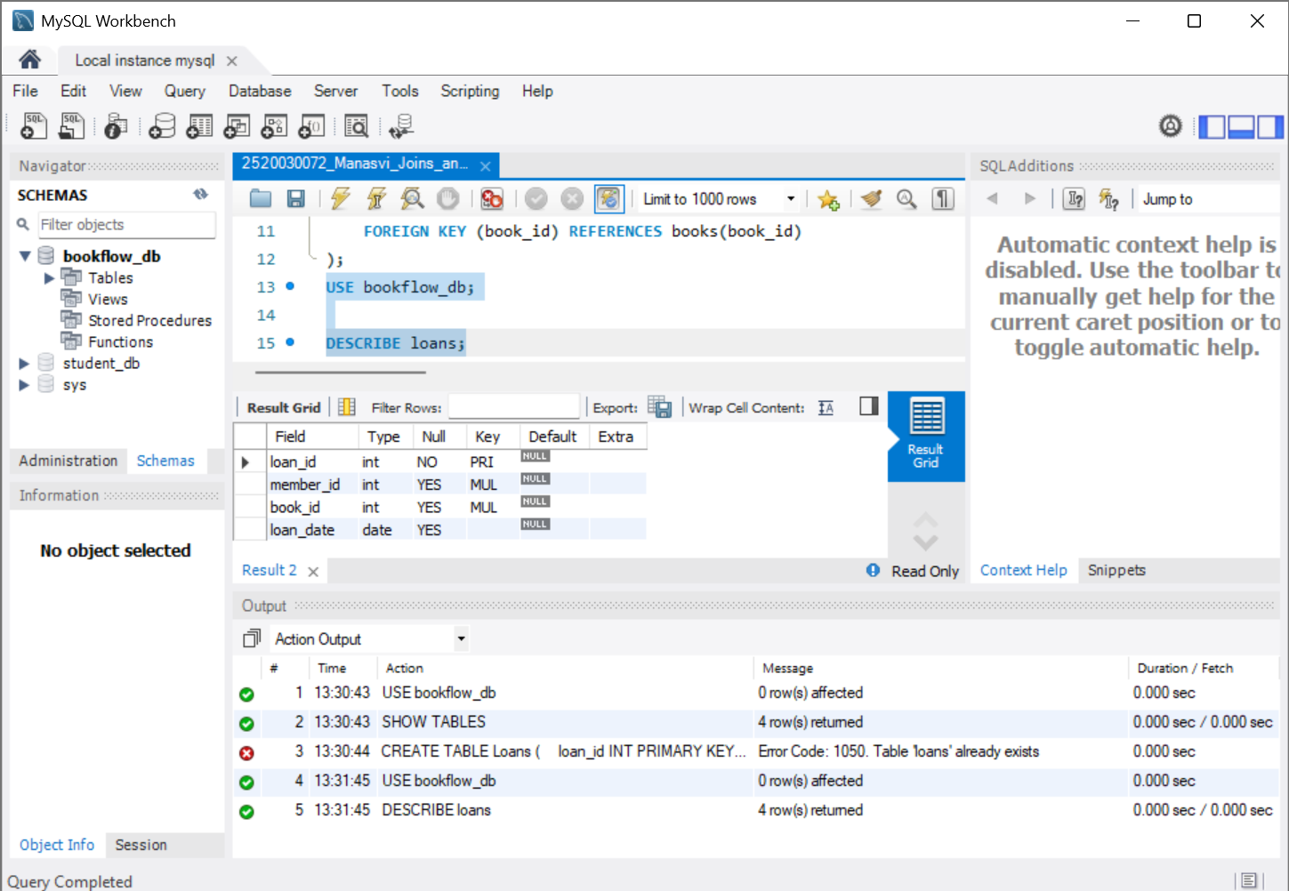
Verification of the Loans table structure using DESCRIBE loans.
2. Verify members and books
USE bookflow_db;

SELECT * FROM members;
SELECT * FROM books;
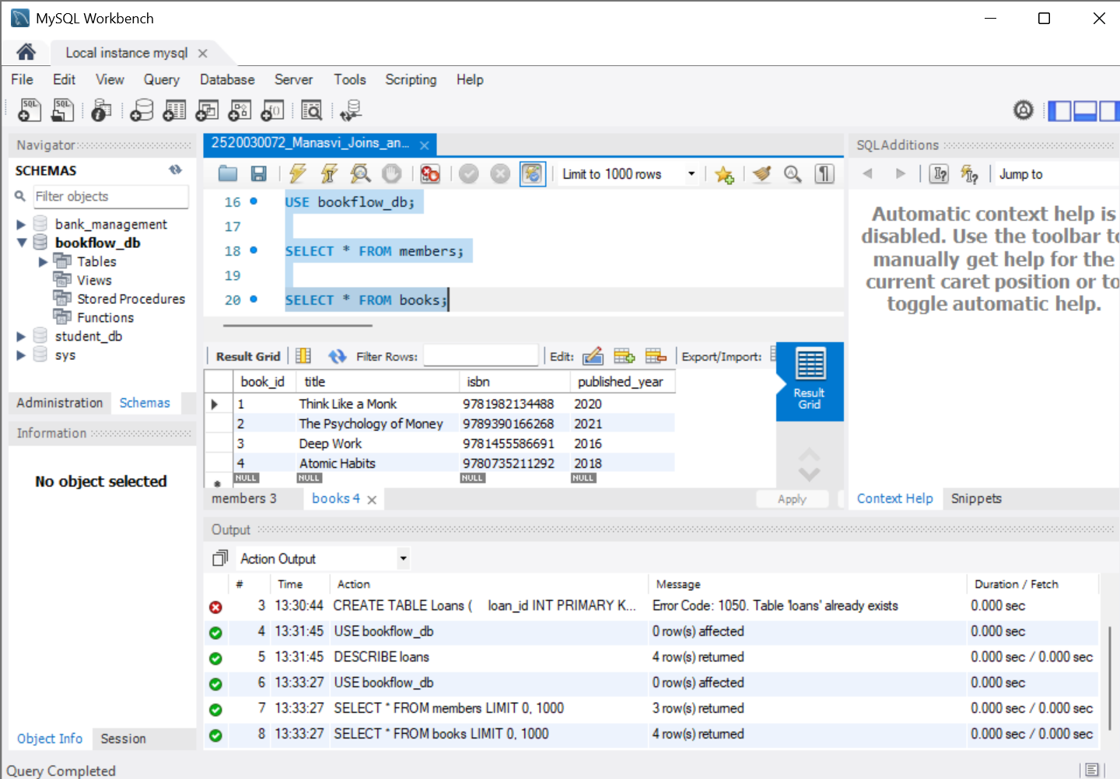
Verification of existing members and books records.
3. Verify loan records
USE bookflow_db;

SELECT * FROM loans;
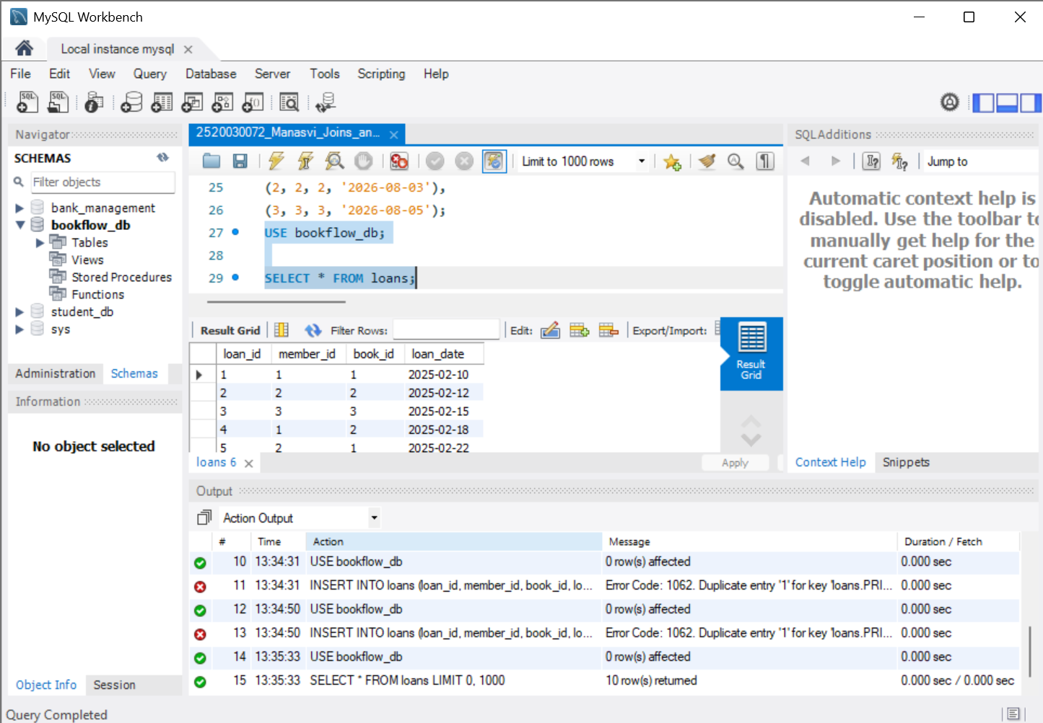
Verification of the existing loan records.
4. INNER JOIN: Members and Loans
SELECT
members.member_id,
members.full_name,
loans.loan_id,
loans.book_id,
loans.loan_date
FROM members
INNER JOIN loans
ON members.member_id = loans.member_id;
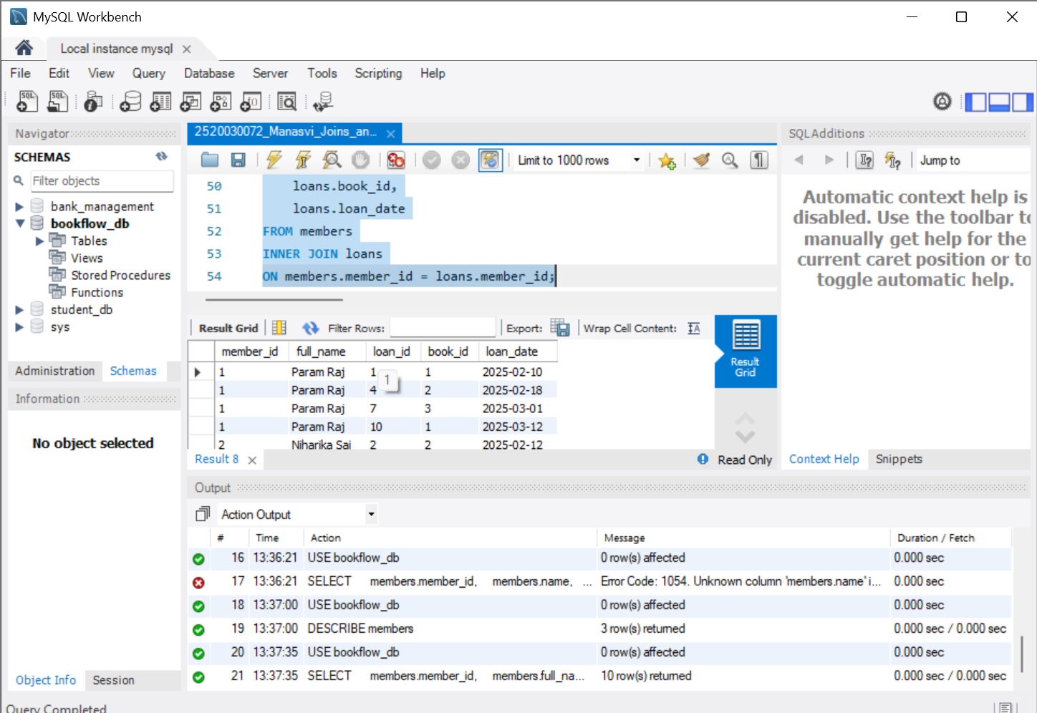
Successful INNER JOIN between members and loans.
5. INNER JOIN: Loans and Books
SELECT
loans.loan_id,
loans.member_id,
books.book_id,
books.title,
loans.loan_date
FROM loans
INNER JOIN books
ON loans.book_id = books.book_id;
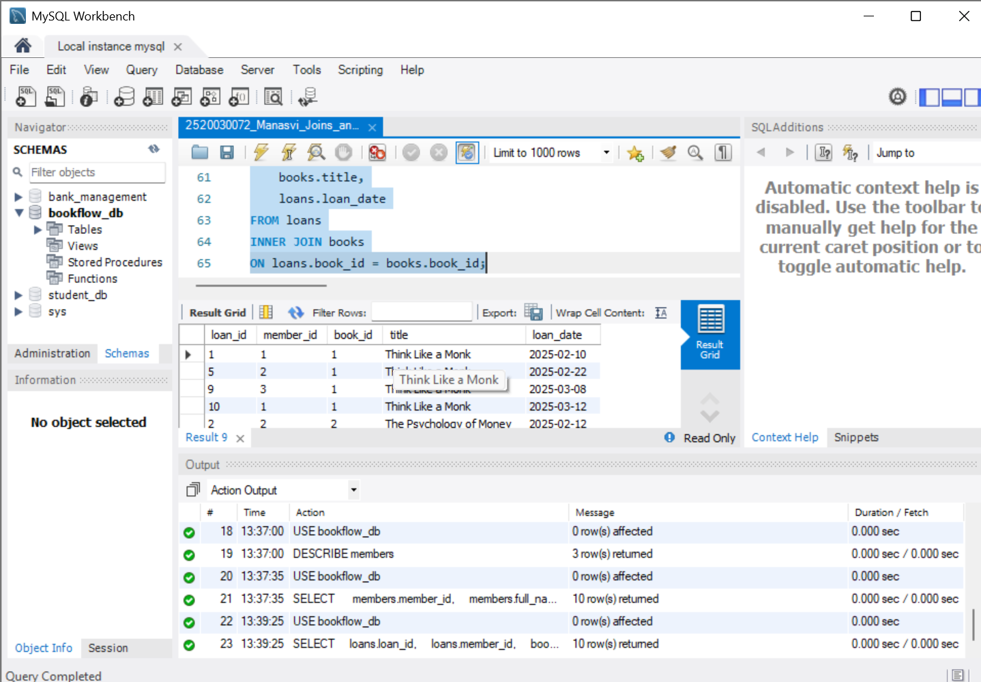
Successful INNER JOIN between loans and books.
6. Three-table INNER JOIN
SELECT
members.member_id,
members.full_name,
books.book_id,
books.title,
loans.loan_id,
loans.loan_date
FROM members
INNER JOIN loans
ON members.member_id = loans.member_id
INNER JOIN books
ON loans.book_id = books.book_id;
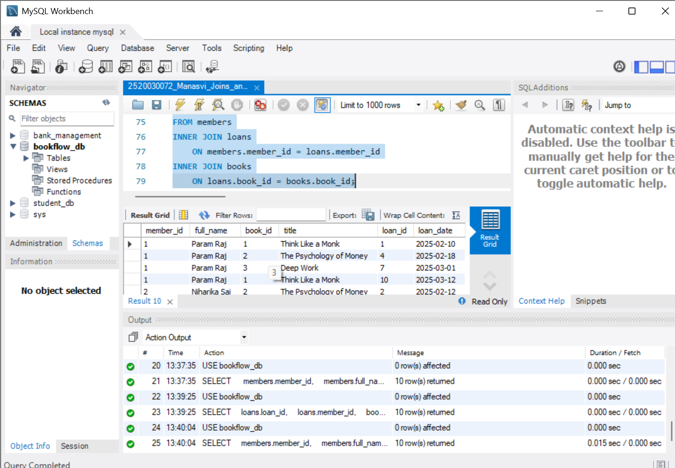
Successful three-table INNER JOIN.
7. LEFT JOIN, RIGHT JOIN and aggregate JOIN queries
-- LEFT JOIN
SELECT
members.member_id,
members.full_name,
loans.loan_id,
loans.book_id,
loans.loan_date
FROM members
LEFT JOIN loans
ON members.member_id = loans.member_id;

-- RIGHT JOIN
SELECT
members.member_id,
members.full_name,
loans.loan_id,
loans.book_id,
loans.loan_date
FROM members
RIGHT JOIN loans
ON members.member_id = loans.member_id;

-- LEFT JOIN: Members and Books through Loans
SELECT
members.full_name,
books.title,
loans.loan_date
FROM members
LEFT JOIN loans
ON members.member_id = loans.member_id
LEFT JOIN books
ON loans.book_id = books.book_id;

-- JOIN with WHERE
SELECT
members.full_name,
books.title,
loans.loan_date
FROM members
INNER JOIN loans
ON members.member_id = loans.member_id
INNER JOIN books
ON loans.book_id = books.book_id
WHERE books.published_year > 2019;

-- JOIN with ORDER BY
SELECT
members.full_name,
books.title,
loans.loan_date
FROM members
INNER JOIN loans
ON members.member_id = loans.member_id
INNER JOIN books
ON loans.book_id = books.book_id
ORDER BY loans.loan_date;

-- JOIN with GROUP BY
SELECT
members.full_name,
COUNT(loans.loan_id) AS total_loans
FROM members
LEFT JOIN loans
ON members.member_id = loans.member_id
GROUP BY members.member_id, members.full_name;

-- Aggregate JOIN
SELECT
books.title,
COUNT(loans.loan_id) AS times_borrowed
FROM books
LEFT JOIN loans
ON books.book_id = loans.book_id
GROUP BY books.book_id, books.title;
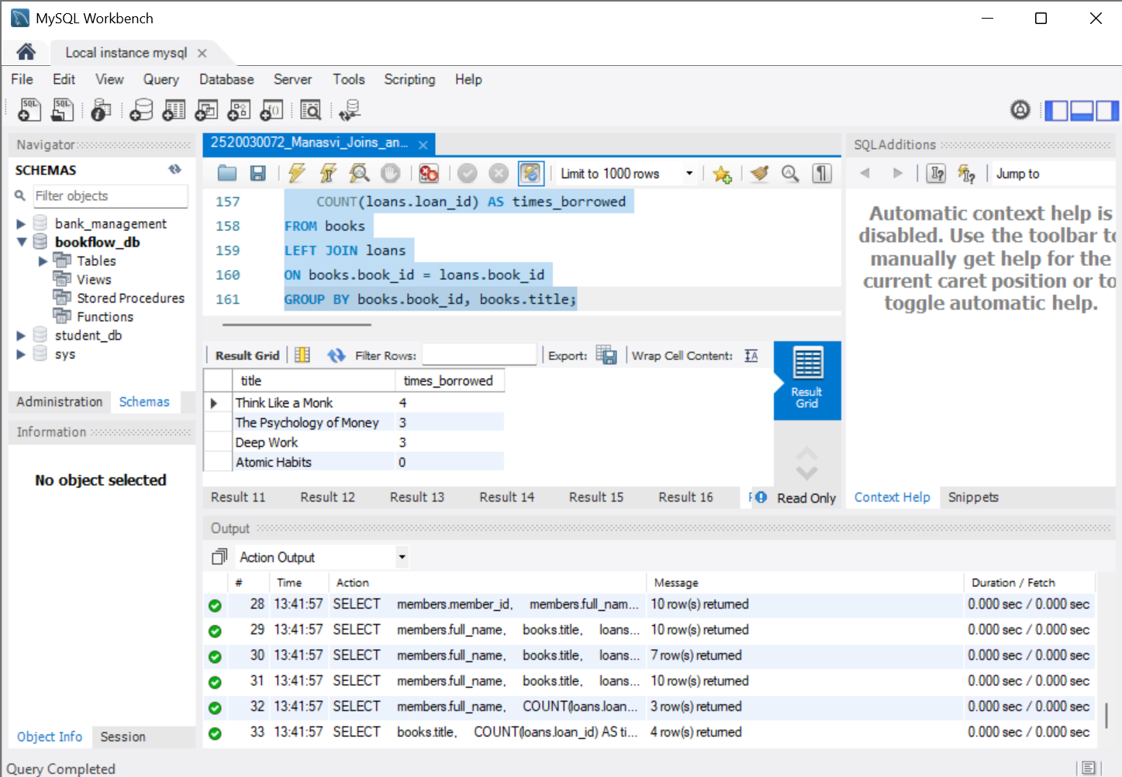
Successful LEFT/RIGHT JOIN and aggregate JOIN queries.
8. Set Operations
-- UNION
SELECT member_id FROM members
UNION
SELECT member_id FROM loans;

-- UNION ALL
SELECT member_id FROM members
UNION ALL
SELECT member_id FROM loans;

-- INTERSECT equivalent using INNER JOIN
SELECT DISTINCT members.member_id
FROM members
INNER JOIN loans
ON members.member_id = loans.member_id;

-- EXCEPT equivalent using LEFT JOIN
SELECT members.member_id
FROM members
LEFT JOIN loans
ON members.member_id = loans.member_id
WHERE loans.member_id IS NULL;
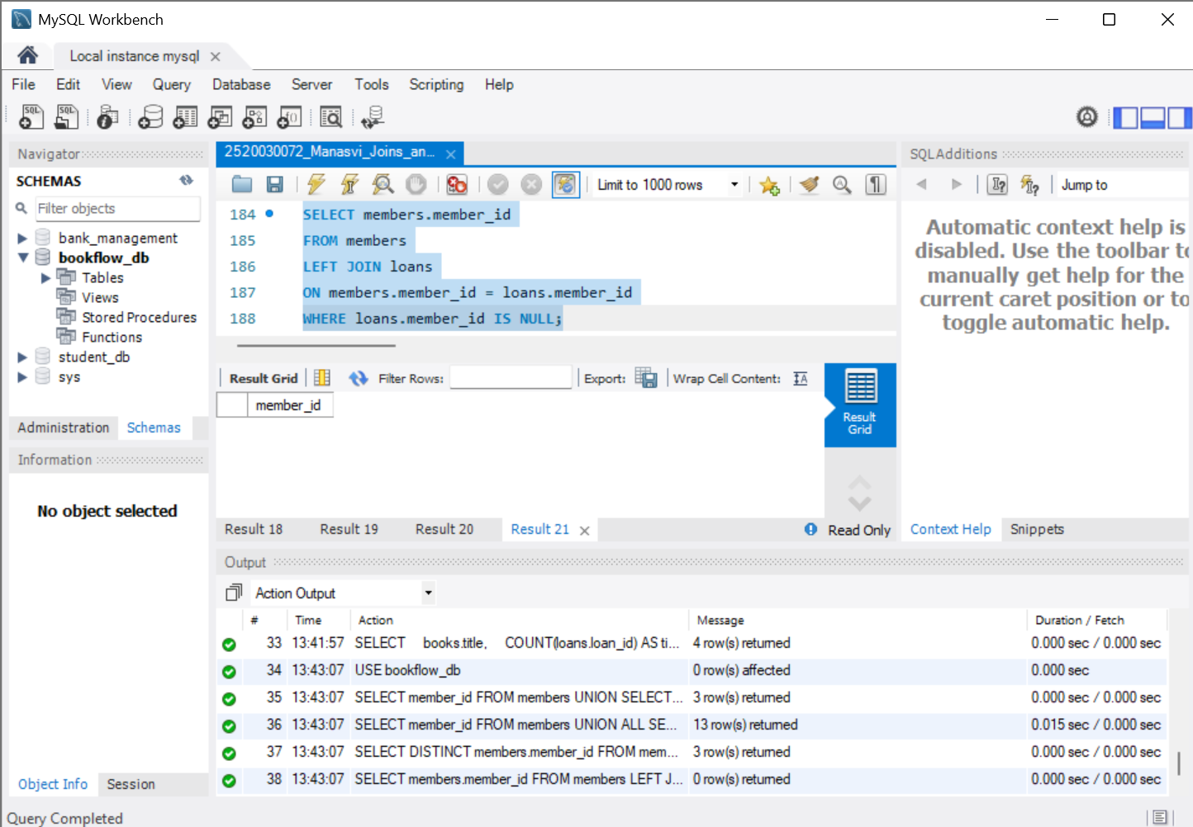
Successful UNION, UNION ALL, INTERSECT equivalent and EXCEPT equivalent queries.
9. CROSS JOIN and SELF JOIN
-- CROSS JOIN
SELECT
members.full_name,
books.title
FROM members
CROSS JOIN books;

-- SELF JOIN
SELECT
m1.full_name AS member1,
m2.full_name AS member2
FROM members m1
INNER JOIN members m2
ON m1.member_id < m2.member_id;
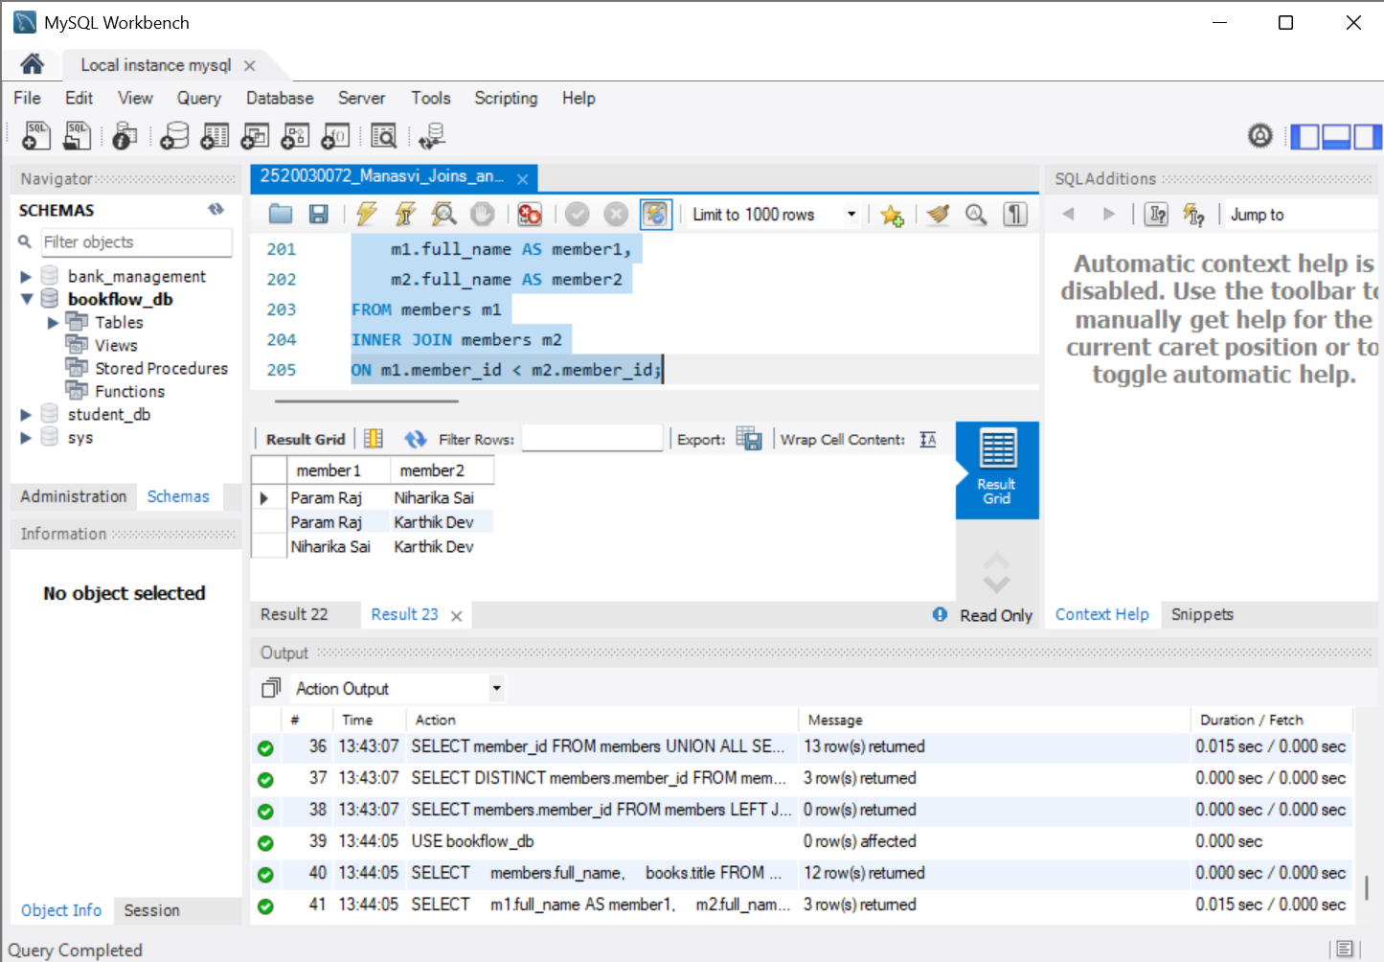
Successful CROSS JOIN and SELF JOIN queries.
Result
All required JOIN and set-operation queries were executed successfully in MySQL Workbench. The Result Grid outputs confirm the successful execution of the operations.
Conclusion
The practical demonstrated how SQL JOINs combine related data from multiple tables and how set operations combine or compare query results. INNER JOIN, LEFT JOIN, RIGHT JOIN, CROSS JOIN, SELF JOIN, UNION, UNION ALL and JOIN-based equivalents for INTERSECT and EXCEPT were successfully implemented.

