DATABASE SYSTEM ENGINEERING AND DISTRIBUTED BACKEND DEVELOPMENT
Week 2 Practical Report
Name: Param Manasvi
Roll No: 2520030072
Course Code: 25CS1302E
Database: bookflow_db
Step 1 - Verified existing database and tables.
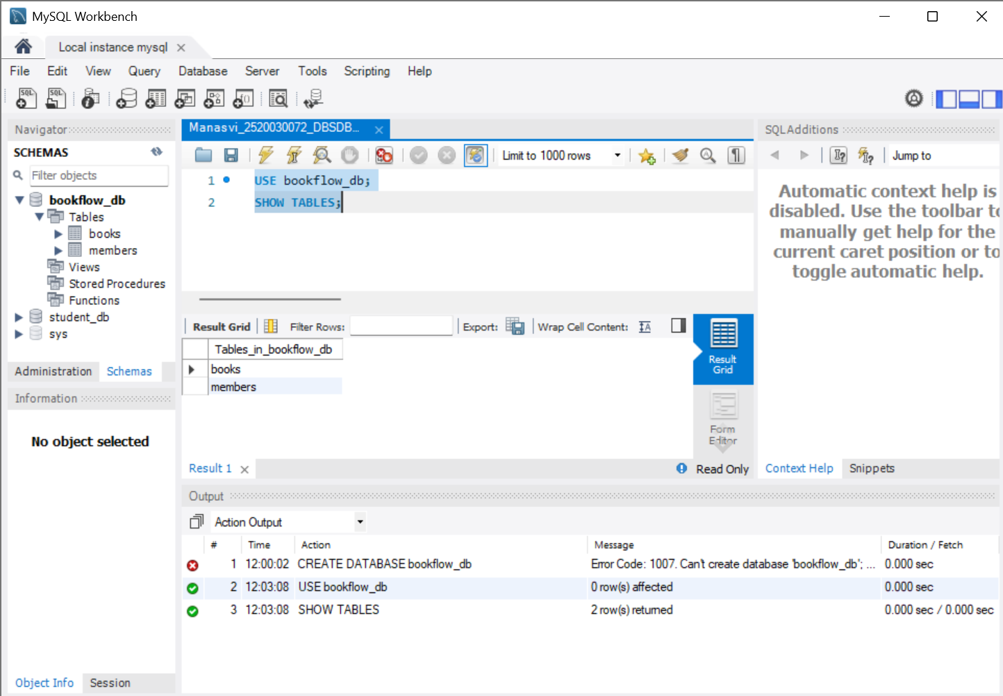
Fig 1: Verified existing database and tables.
Step 2 - Created Loans table.
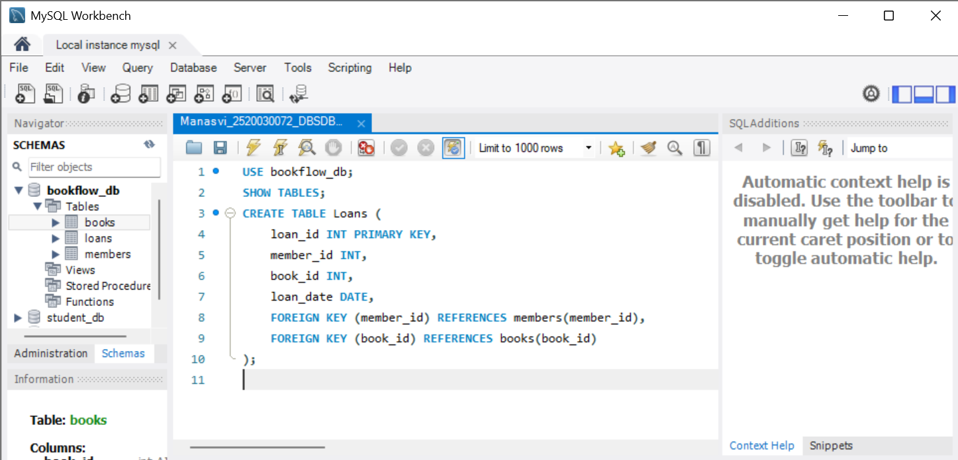
Fig 2: Created Loans table.
Step 3 - Inserted and displayed loan records.
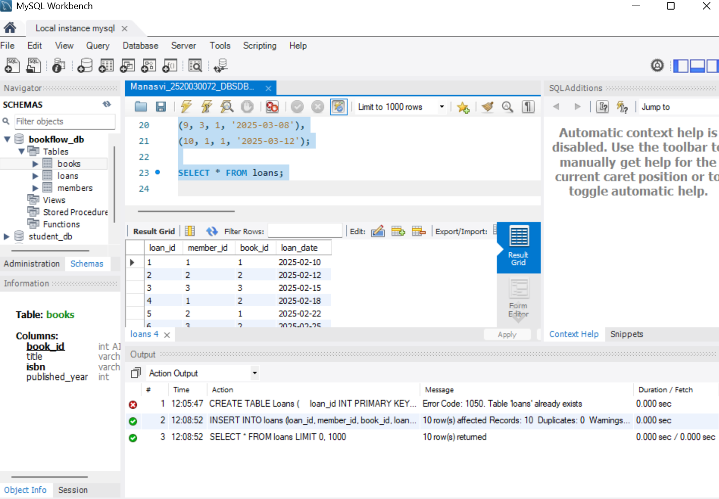
Fig 3: Inserted and displayed loan records.
Explanation: Inserted and displayed loan records.
Step 4 - Executed INNER JOIN query.
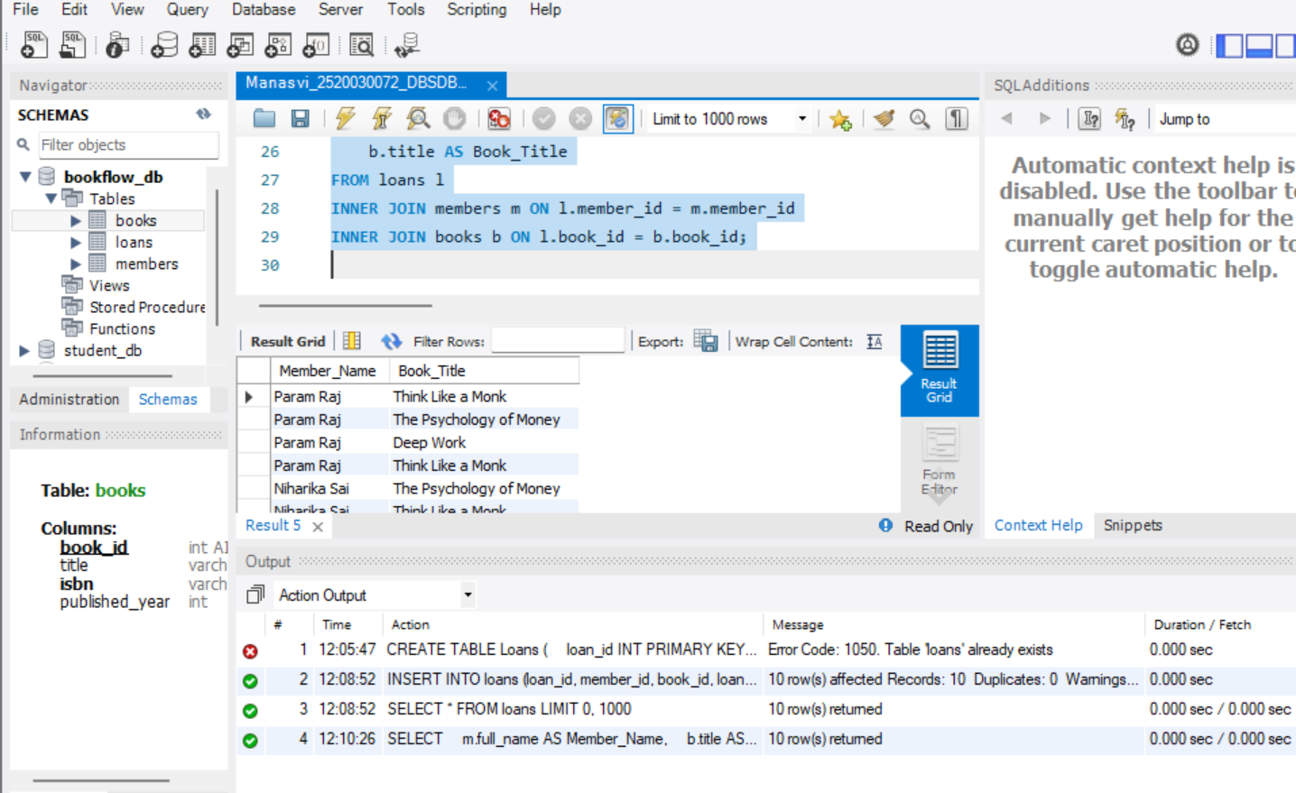
Step 5 - Executed GROUP BY query.
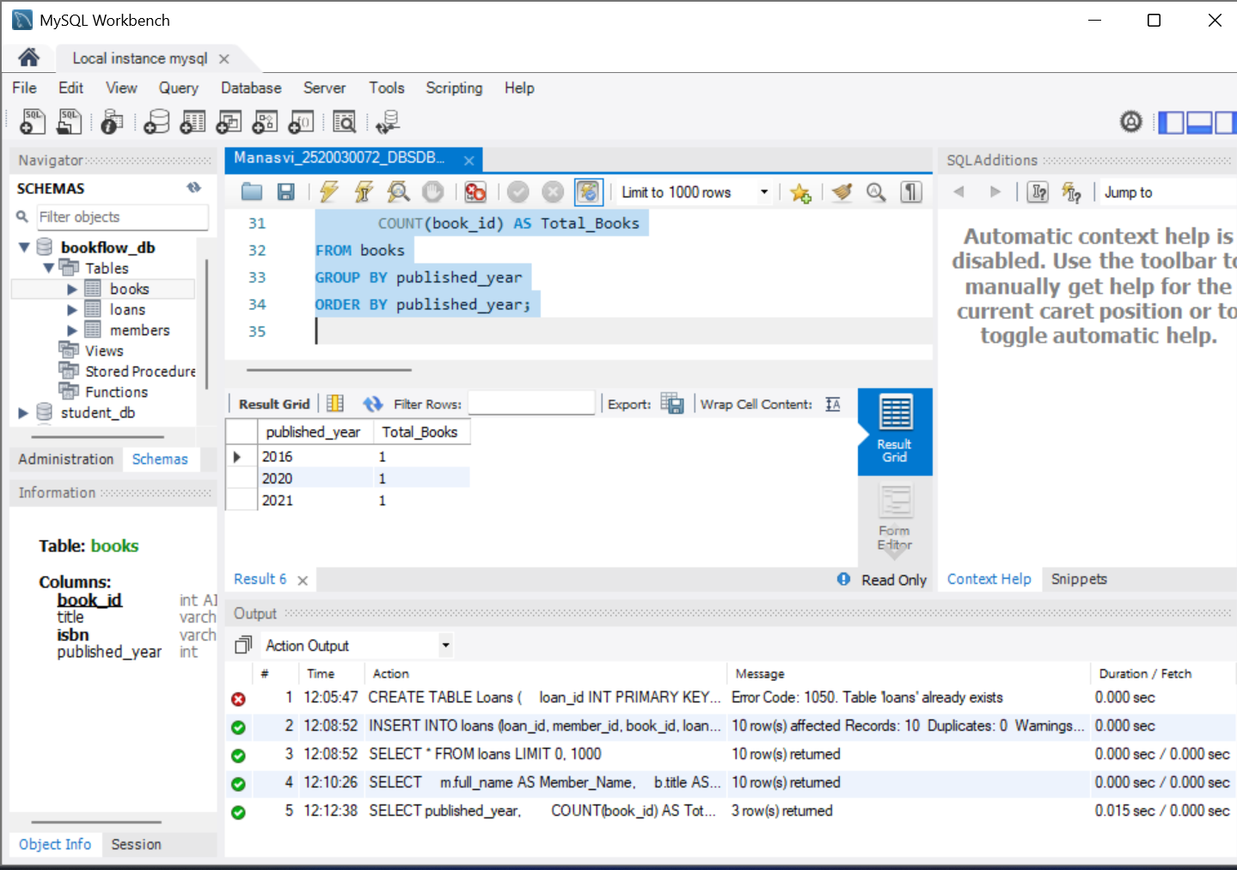
Fig 5: Executed GROUP BY query.
Step 6 - Created Donation_History table.
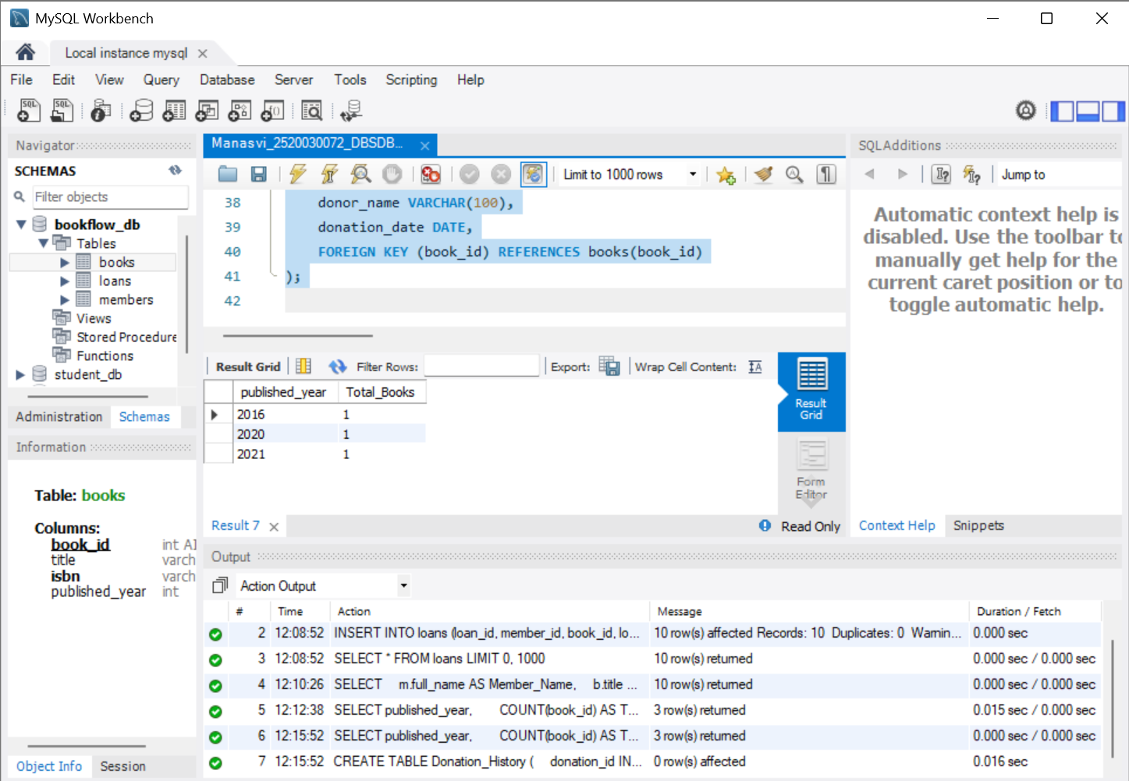
Fig 6: Created Donation_History table.
Step 7 - Performed transaction using START TRANSACTION and COMMIT.
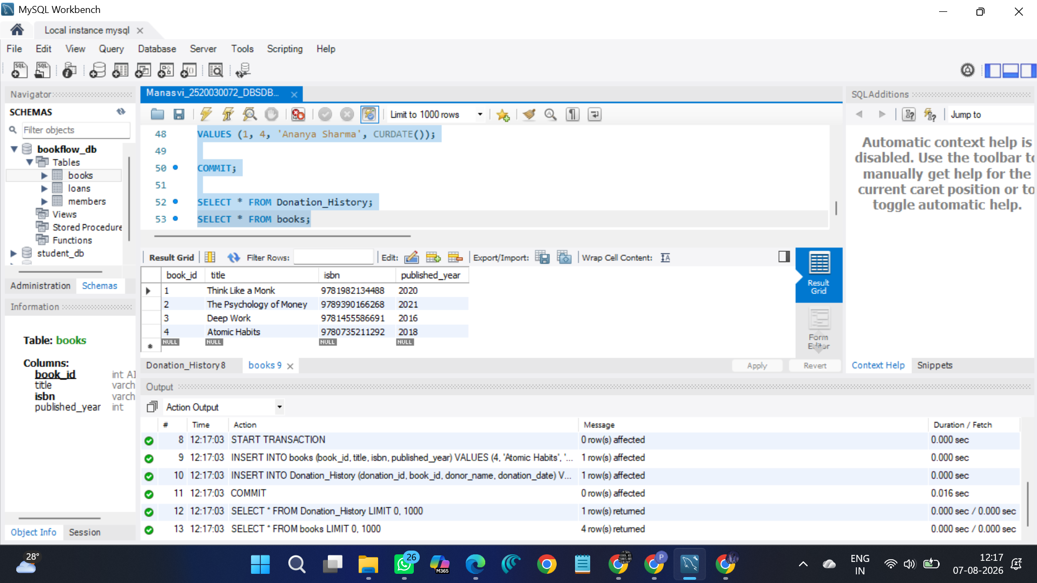
Fig 7: Performed transaction using START TRANSACTION and COMMIT.
Step 8 - Created index and searched by ISBN.
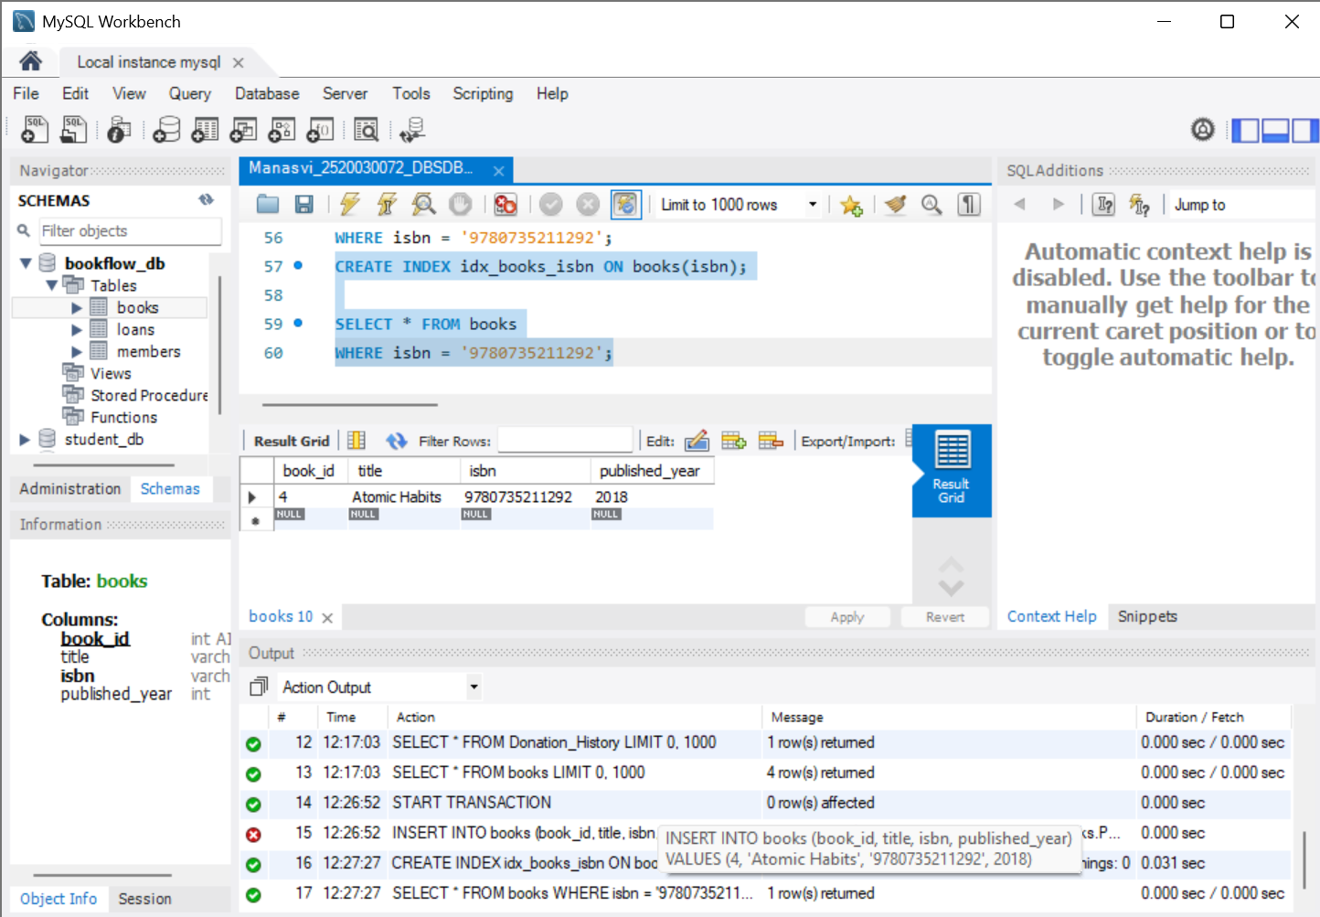
Fig 8: Created index and searched by ISBN.
Result
Successfully performed JOIN operations, GROUP BY aggregation, transaction management and indexing using MySQL Workbench.

