DBSE & DBD WEEK 1 PRACTICAL
Name: Param Manasvi
Roll No: 2520030072
Course Code: 25CS1302E
Week 1: DDL Commands and Constraints
Aim:
To practice Data Definition Language (DDL) commands and constraints using MySQL Workbench.
1. Created the database bookflow_db.
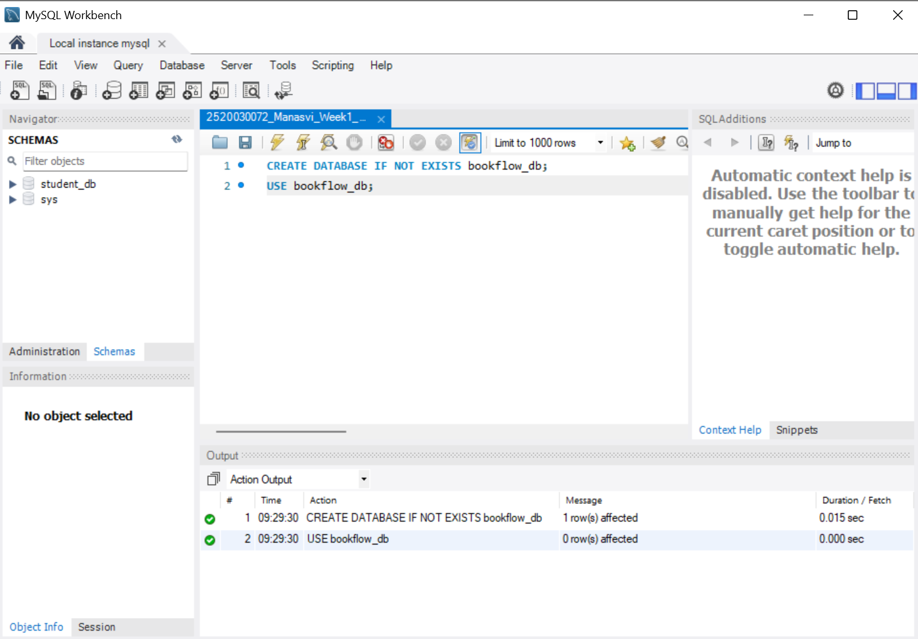
2. Created the Books table using PRIMARY KEY, NOT NULL, UNIQUE and CHECK constraints.
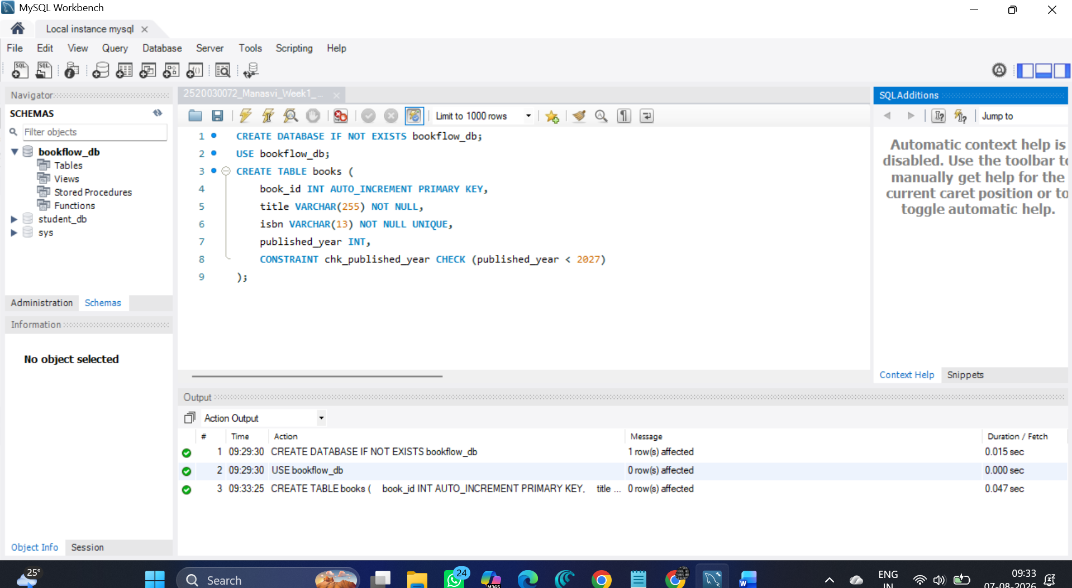
3. Created the Members table using PRIMARY KEY, NOT NULL and UNIQUE constraints.
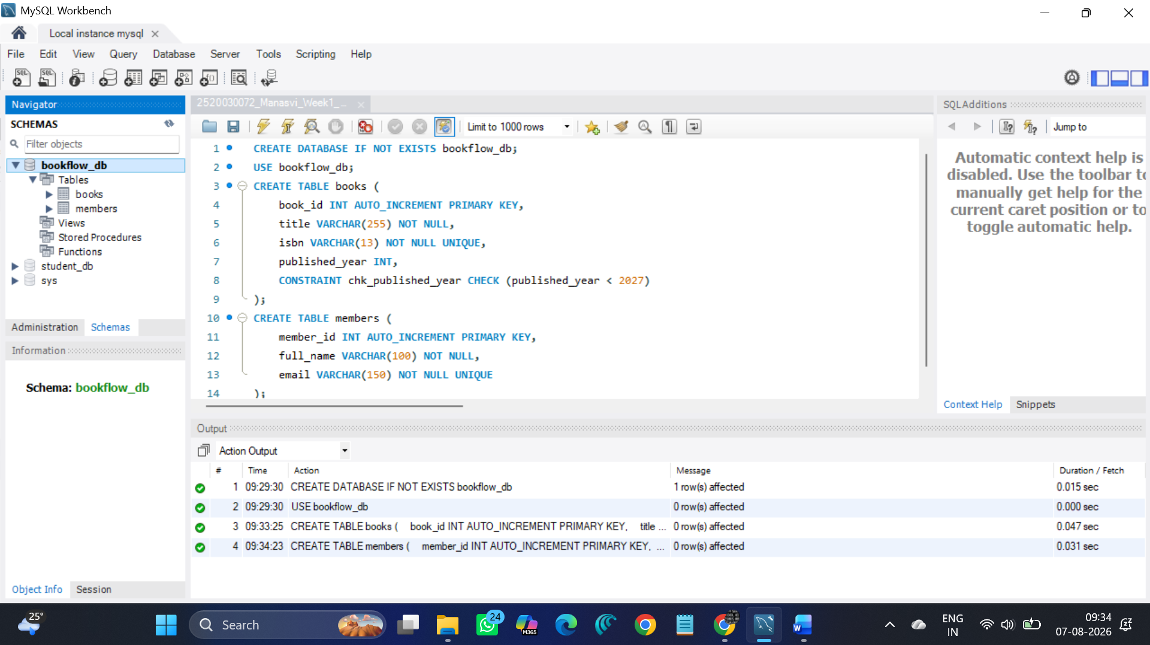
4. Inserted records into the Books table and displayed them.
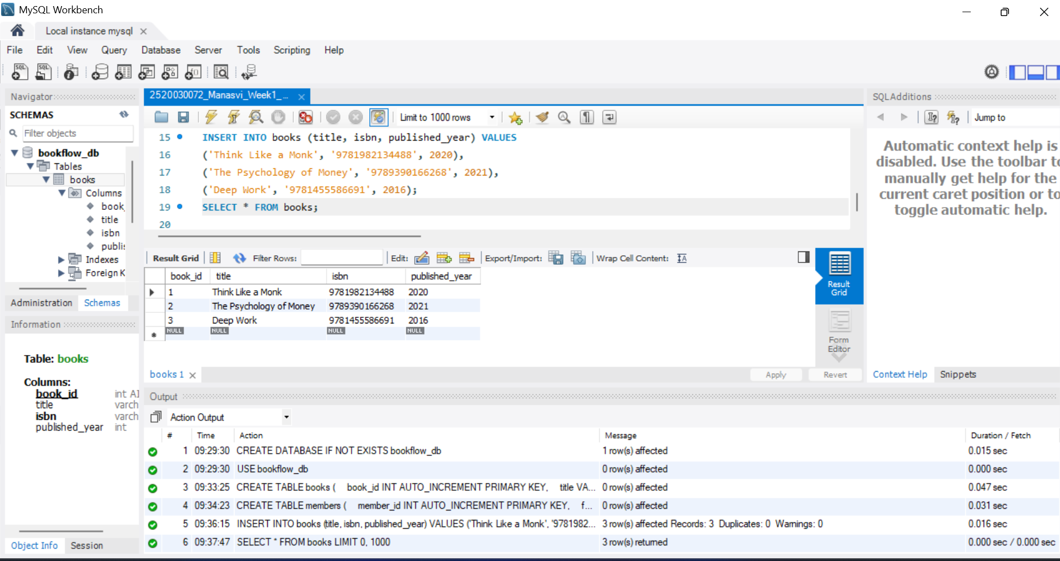
5. Inserted records into the Members table and displayed them.
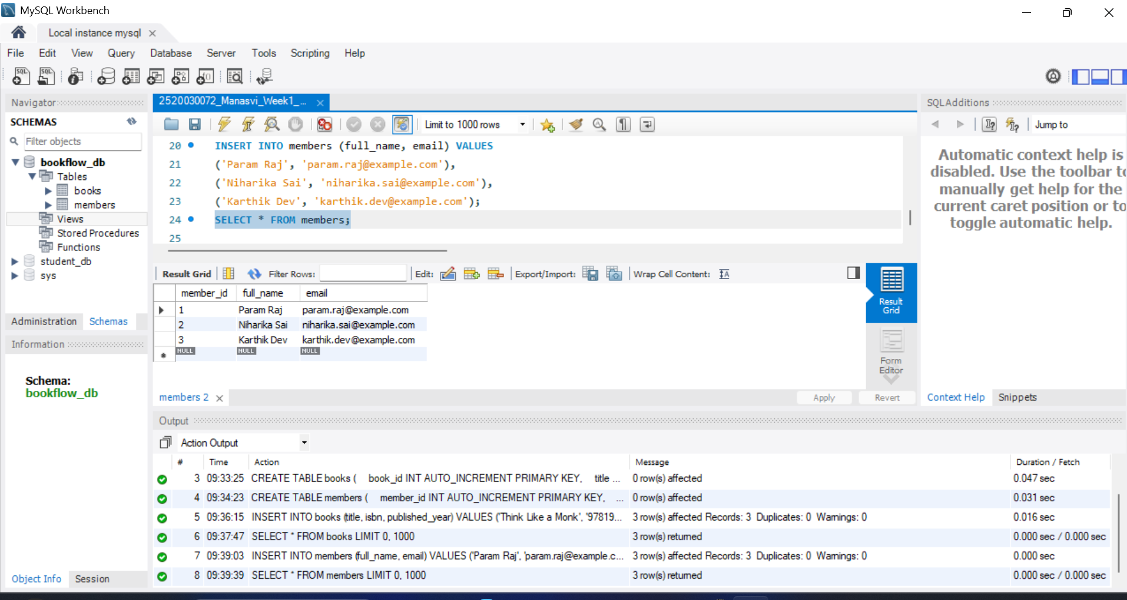
6. Verified the structure of Books table using DESCRIBE.
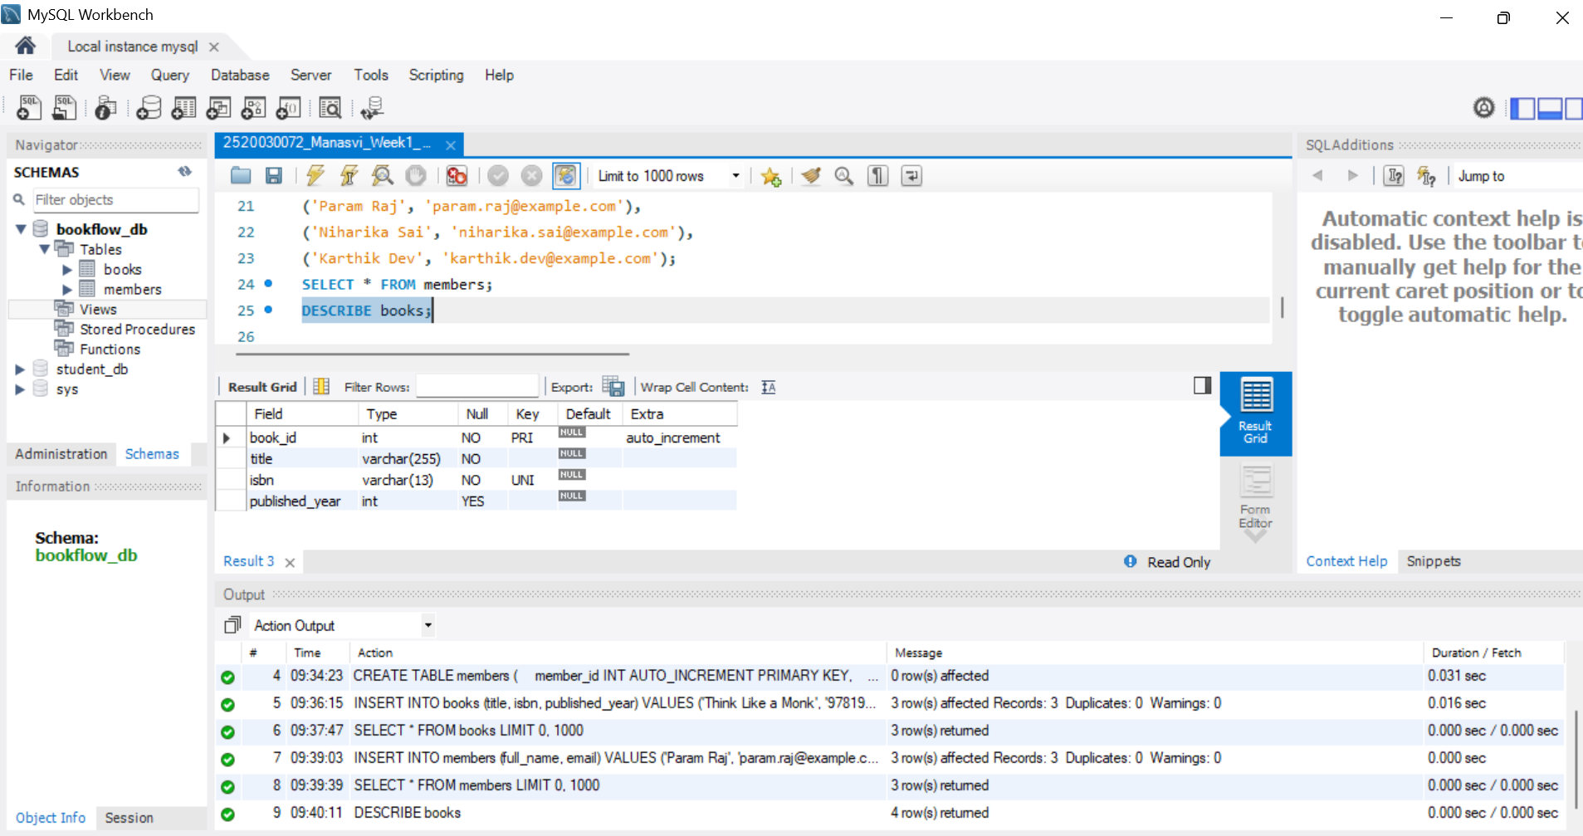
7. Verified the structure of Members table using DESCRIBE.
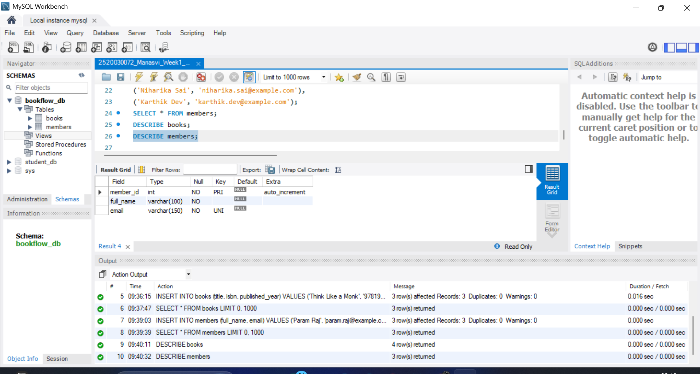
8. Tested UNIQUE, NOT NULL, CHECK and UNIQUE(email) constraints.
