“Student Grievance Redressal Portal (SGR Portal)”
A Project Report Submitted in the partial fulfillment of the requirements for the award of the degree of
BACHELOR OF TECHNOLOGY
In
DEPARTMENT OF COMPUTER SCIENCE AND ENGINEERING
By
PARAM MANASVI : 2520030072
BURLA VIDA SWETHA : 2520030100

Under the Esteemed Guidance of

Pavitra Duggineni
Associate Professor
Department of Computer Science and Engineering

Koneru Lakshmaiah Education Foundation
(Deemed to be University estd. u/s. 3 of the UGC Act, 1956)
Off-Campus: Bachupally-Gandimaisamma Road, Bowrampet, Hyderabad, Telangana - 500 043.
Phone No: 7815926816, www.klh.edu.in

K L (Deemed to be) University
DEPARTMENT OF COMPUTER SCIENCE AND ENGINEERING


Declaration
The Project Report entitled “Student Grievance Redressal Portal (SGR Portal)” is a record of Bonafide work of PARAM MANASVI – 2520030072 and BURLA VIDA SWETHA – 2520030100, submitted in partial fulfillment for the award of B. Tech in Computer Science and Engineering to K L University. The results embodied in this report have not been copied from any other department / University / Institute.
PARAM MANASVI – 2520030072
BURLA VIDA SWETHA – 2520030100

K L (Deemed to be) University
DEPARTMENT OF COMPUTER SCIENCE AND ENGINEERING


CERTIFICATE
This is to certify that the mini project based report entitled “Student Grievance Redressal Portal (SGR Portal)” is a bonafide work done and submitted by PARAM MANASVI – 2520030072 and BURLA VIDA SWETHA – 2520030100 (Team Number: 1), in partial fulfillment of the requirements for the award of the degree of BACHELOR OF TECHNOLOGY in the Department of Computer Science and Engineering, K L (Deemed to be University), during the academic year 2025-2026.
Signature of the Guide
Signature of the Course Coordinator Signature of the HOD



ACKNOWLEDGEMENT
The success of this project would not have been possible without the timely help and guidance rendered by many people. We wish to express our sincere thanks to everyone who assisted us in the completion of this project.
We are deeply grateful to our guide, Pavitra Duggineni, Associate Professor, Department of Computer Science and Engineering, whose continuous support, technical direction, and encouragement made it possible for us to design and build the Student Grievance Redressal Portal from concept to a working, demonstrable product.
We also extend our gratitude to the Head of the Department, Department of Computer Science and Engineering, for providing us with the facilities, resources, and academic environment necessary to complete this project-based work.
We thank all the members of the teaching and non-teaching staff who assisted us directly or indirectly during this project. Finally, we sincerely thank our parents, friends, and classmates for their kind support and cooperation throughout our work.
PARAM MANASVI – 2520030072
BURLA VIDA SWETHA – 2520030100

Abstract
Educational institutions routinely receive grievances relating to academics, examinations, infrastructure, hostel facilities, transportation, and administration. Traditional grievance-handling methods — written applications, emails, or in-person reporting — are slow, undocumented, and offer students little to no visibility into how their complaint is progressing. Administrators, in turn, struggle to monitor grievance volumes, officer workloads, and resolution trends across the institution.
The Student Grievance Redressal Portal (SGR Portal) addresses this gap by providing a centralized, role-based web platform through which students can register grievances, track their status in real time, and receive feedback once a case is resolved; officers can review, act upon, and resolve the cases assigned to them; and administrators can oversee the complete grievance lifecycle across the institution through a dedicated analytics and management console.
The system is built on the MERN-adjacent stack of React.js (with Vite) on the front end, Node.js with Express.js on the back end, and MySQL as the relational data store, communicating through a JSON-based REST API secured with JWT authentication and bcrypt password hashing. The platform exposes three distinct, role-aware dashboards — Student, Officer, and Admin — all backed by a shared database and a common set of REST endpoints, with real-time-style synchronisation achieved through on-demand refresh of shared state.
Key functional highlights include ten predefined grievance categories with sub-categories, priority tagging, an anonymous-submission option, unique token-based tracking, a per-grievance status timeline, officer assignment and manual escalation (up to three levels), officer availability toggles, a star-rating feedback mechanism, in-app notifications, and an analytics dashboard with monthly trend charts, category-wise distribution, and officer performance metrics rendered using Recharts.
In summary, the SGR Portal delivers a complete, reliable, and transparent digital replacement for manual grievance handling — reducing administrative overhead, improving accountability at every stage of the resolution workflow, and giving students a single, trustworthy channel through which to be heard.

Index
S.No. | Chapters | Topics | Page No.
 |  | Declaration | 3
 |  | Certificate | 4
 |  | Acknowledgement | 5
 |  | Abstract | 6
1 | Introduction | 1.1 Background of the project  1.2 Problem statement  1.3 Scope of the project  1.4 Objectives  1.5 Importance of the application  1.6 Target users / audience | 9-10
2 | System Requirements | 2.1 Hardware requirements  2.2 Software requirements  2.3 Development tools and frameworks | 11-12
3 | Technology Stack | 3.1 Front-end  3.2 Back-end  3.3 Database  3.4 Version control  3.5 APIs / external services | 13-14
4 | System Architecture | 4.1 High-level architecture diagram  4.2 Description of each layer  4.3 Deployment architecture | 15-16
5 | Design | 5.1 UI/UX design approach  5.2 ER Diagram / Database schema | 17-18
6 | Implementation | 6.1 Module-wise implementation  6.2 Front-end logic  6.3 API integration  6.4 Authentication & Authorization | 19-25
7 | Features | 7.1 List of main features  7.2 How each feature works | 26-27
8 | Testing | 8.1 Postman testing  8.2 Integration testing  8.3 Tools used for testing  8.4 Test cases and results | 28-29
9 | Deployment | 9.1 Steps to deploy  9.2 Environment configuration  9.3 Hosting of frontend and backend | 30-31
10 | Challenges & Limitations | 10.1 Issues faced  10.2 Solutions applied  10.3 Current limitations / known bugs | 32
11 | Future Enhancements | 11.1 Planned features  11.2 Possible integrations / optimizations | 33
12 | Conclusion | 12.1 Summary of the project  12.2 What was achieved  12.3 Skills learned during development | 34
13 | References | Books, tutorials, APIs, documentation sites used | 35
14 | Appendices | A. Screenshots of the app  B. Sample code snippets  C. Installation / setup instructions  D. User manual / guide  E. Field verification records | 36-42

CHAPTER 1 — INTRODUCTION

1.1 Background of the Project
Educational institutions are large, dynamic communities in which students routinely encounter issues that need to be reported and resolved — problems ranging from academic disputes and examination discrepancies to infrastructure faults, hostel complaints, and transportation delays. Historically, such issues have been handled through informal or semi-formal channels: handwritten applications submitted to a department office, emails sent to individual staff members, or verbal complaints raised in person. None of these channels create a searchable, time-stamped record, and none give the student any visibility into what happens to their complaint after it is raised.
As institutions have grown in size and complexity, this informal approach has become a genuine operational bottleneck. Grievances get misplaced, responses are inconsistent, and there is no single view that shows an administrator how many complaints are open, how long they have been open, or which staff member is responsible for resolving them. The idea for the Student Grievance Redressal Portal grew directly out of this observation: a modern institution needs a single, structured, web-based system that captures a grievance the moment it is raised and follows it through to resolution.
Growth in accessible web development frameworks — React for building fast, componentised user interfaces, Node.js and Express for lightweight REST APIs, and mature relational databases such as MySQL — has made it realistic for a small team to build and demonstrate a production-shaped grievance management system within an academic project timeline, without depending on any third-party SaaS product.

1.2 Problem Statement
Student grievances in most institutions are managed through manual, paper- or email-based procedures. This makes it difficult to track the current status of a complaint, to maintain a consistent historical record, and to guarantee timely resolution. Students frequently have no visibility into how their grievance is progressing once it has been submitted, while the staff responsible for resolving grievances have no centralised queue, workload view, or reporting mechanism. Administrators, who are ultimately accountable for institutional service quality, lack the tools to monitor grievance-handling activity across departments in real time.
The Student Grievance Redressal Portal is designed to solve this problem by providing a single, centralised system that supports grievance submission, real-time status tracking, officer assignment and workload management, administrative oversight and reporting, and secure, persistent storage of every grievance record in a relational database.

1.3 Scope of the Project
The scope of the SGR Portal spans the complete grievance lifecycle inside a single institution: submission by a student, triage and assignment by an administrator, investigation and resolution by an officer, and closure with optional student feedback. The system is built as a three-tier web application — a React single-page front end, a Node.js/Express REST API, and a MySQL database — and is designed to be fully responsive so that it can be used from a desktop, laptop, tablet, or smartphone browser without any additional installation.
The current implementation covers three user roles (Student, Officer, Admin), ten grievance categories with associated sub-categories, priority tagging, anonymous submission, token-based tracking, a full audit timeline per grievance, manual escalation up to three levels, officer availability management, in-app notifications, and an analytics dashboard for administrators. Integrations such as SMS/email notification gateways, institutional ERP systems, and a native mobile application are outside the scope of the current build and are discussed in Chapter 11 (Future Enhancements).

1.4 Objectives
- Provide a centralized platform through which students can submit grievances digitally, from any device, without depending on paper forms or informal channels.
- Enforce role-based access control so that Students, Officers, and Admins each see only the functionality and data relevant to their role.
- Keep grievance information synchronised across all three dashboards so that a status change made by an officer is immediately visible to the student and the administrator.
- Persist all grievance, user, and audit data securely in a MySQL database with a normalised, well-indexed schema.
- Give officers a structured resolution workflow — from viewing an assigned case, to updating its status, to recording remarks — that replaces ad-hoc email threads.
- Give administrators oversight and reporting tools, including a KPI dashboard, category and monthly trend charts, and officer performance metrics.

1.5 Importance of the Application
The SGR Portal directly improves transparency and accountability in grievance handling. Because every grievance receives a unique token and a persisted timeline, students can verify the exact status of their complaint at any time, and administrators can audit exactly when a case was assigned, escalated, or resolved and by whom. This removes the ambiguity inherent in email- or paper-based processes.
The application also reduces administrative overhead. Instead of manually collating complaints from multiple channels, an administrator can view every grievance in the institution from a single searchable, filterable table, assign officers with a click, and generate at-a-glance analytics on category distribution, monthly volume, and officer performance — work that would otherwise require manually compiling spreadsheets.
Finally, the anonymous-submission option and the escalation mechanism give students confidence that sensitive grievances (for example, those involving a specific staff member) can still be raised and, if unresolved at the first level, escalated for higher-level attention, which encourages more honest and complete reporting of institutional issues.

1.6 Target Users / Audience
- Students — who need to raise academic, infrastructure, examination, hostel, transportation, or administrative complaints and track them to resolution.
- Grievance Redressal Officers / Faculty — who are assigned cases within their department and are responsible for investigating and resolving them within a reasonable timeframe.
- Administrators — who are responsible for institution-wide oversight: assigning officers, managing escalations, managing officer and student accounts, and reviewing analytics and feedback.

CHAPTER 2 — SYSTEM REQUIREMENTS

2.1 Hardware Requirements
Because the SGR Portal is a browser-based web application, its hardware requirements are modest on both the development and the end-user side. For development and local testing, a machine with an Intel Core i5 (or equivalent AMD Ryzen 5) processor, a minimum of 8 GB of RAM (16 GB recommended when running the Vite dev server, a local MySQL instance, and a code editor simultaneously), and at least 5 GB of free SSD storage for the Node.js toolchain, npm packages, and MySQL data directory is sufficient.
For the end user, the client-side hardware requirements are minimal, since all business logic executes on the server and the browser only renders the React interface. Any desktop, laptop, tablet, or smartphone capable of running a modern evergreen browser (Chrome, Edge, Firefox, or Safari) with a stable internet connection of at least 1–2 Mbps is sufficient to use every feature of the portal, including the chart-based analytics dashboards.
Component | Development Machine | End-User Device
Processor | Intel Core i5 / AMD Ryzen 5 or higher | Any dual-core processor, 1.6 GHz+
RAM | 8 GB minimum, 16 GB recommended | 2 GB minimum
Storage | 5 GB free (Node modules, MySQL data) | Negligible (browser cache only)
Display | 1366×768 or higher | Any modern smartphone / tablet / desktop display
Network | Broadband, for npm installs and Git | 1–2 Mbps stable connection

2.2 Software Requirements
The development environment relies on Node.js (v18 or later) and its bundled npm package manager to run both the Vite-based React client and the Express server. MySQL Server 8.0 or later is required to host the relational database defined in schema.sql. A code editor such as Visual Studio Code is used for day-to-day development, and Postman is used to exercise and validate the REST API independently of the front end.
On the client side, no software installation is required by the end user beyond a modern web browser — the entire Student, Officer, and Admin experience runs inside the browser as a single-page application served by Vite in development and as static, bundled assets in production.
Layer | Software
Operating System (dev) | Windows 10/11, macOS, or Ubuntu Linux
Runtime | Node.js 18+ (JavaScript / npm ecosystem)
Database Server | MySQL 8.0+
IDE | Visual Studio Code
API Testing | Postman
Version Control | Git and GitHub
Client Requirement | Any evergreen browser (Chrome, Edge, Firefox, Safari)

2.3 Development Tools and Frameworks
The front end is scaffolded and bundled with Vite, chosen for its near-instant hot-module-reload during development and its fast, optimised production build. React 18 provides the component model, React Router 6 handles client-side navigation, Axios is used for all HTTP communication with the REST API, and Recharts renders the analytics charts on the Admin and Officer dashboards.
The back end is built with Express.js on Node.js. The mysql2 driver provides a promise-based connection pool to MySQL, jsonwebtoken issues and verifies signed JWTs for authentication, bcryptjs hashes and compares user passwords, cors enables cross-origin requests from the Vite dev server, dotenv loads environment configuration, and multer is available for handling multipart form data (file uploads). nodemon is used in development to auto-restart the server on file changes.
Git and GitHub are used for version control and collaboration between the two team members, with the repository organised into two top-level workspaces — client/ and server/ — each with its own package.json and dependency tree, as documented in the project's README.md.

CHAPTER 3 — TECHNOLOGY STACK

3.1 Front-End
The client application (client/) is a React 18.2 single-page application scaffolded with Vite 5.2. Navigation between the public landing page, the login page, and the three role-specific dashboards is handled by React Router DOM 6.22. All server communication goes through Axios 1.6, and the data-visualisation widgets on the Officer and Admin dashboards (monthly trend lines, category pie charts, officer performance bars, status distribution) are built with Recharts 2.12. Application state — the logged-in user, the in-memory grievance and notification caches — is managed through React's built-in Context API via two providers, AuthContext and GrievanceContext, rather than an external state-management library, keeping the client dependency footprint intentionally small.

3.2 Back-End
The server (server/) is a Node.js application built on Express 4.18. It exposes a REST API under the /api prefix, organised into six route modules — auth, grievances, officers, students, analytics, and notifications — each mounted independently in index.js. A shared middleware pair, protect and authorize (in middleware/auth.js), verifies the caller's JWT and restricts individual endpoints to specific roles (student, officer, admin).

3.3 Database
Data is persisted in MySQL 8+, accessed through the mysql2 driver's promise-based connection pool (config/db.js). The schema (server/schema.sql) defines seven core tables — users, students, officers, categories, grievances, grievance_timeline, and notifications — described fully in Chapter 5 (Design). Passwords are never stored in plain text; they are hashed with bcryptjs before being written to the users table.

3.4 Version Control
The project is tracked with Git and hosted on GitHub, with the client and server maintained as sibling workspaces inside a single sgr-portal repository. Sensitive configuration — database credentials and the JWT signing secret — is kept out of version control in a server/.env file and loaded at runtime via dotenv.

3.5 APIs and Supporting Libraries
Library | Version | Purpose
react / react-dom | ^18.2.0 | Component-based UI rendering
react-router-dom | ^6.22.0 | Client-side routing
axios | ^1.6.7 | HTTP client for REST API calls
recharts | ^2.12.7 | Charts for analytics dashboards
vite | ^5.2.0 | Dev server and production bundler
express | ^4.18.3 | REST API framework
mysql2 | ^3.9.2 | MySQL driver / connection pool
jsonwebtoken | ^9.0.2 | JWT issuance and verification
bcryptjs | ^2.4.3 | Password hashing
cors | ^2.8.5 | Cross-origin request handling
dotenv | ^16.4.5 | Environment variable loading
multer | ^1.4.5-lts.1 | Multipart / file-upload handling

CHAPTER 4 — SYSTEM ARCHITECTURE

4.1 High-Level Architecture Diagram
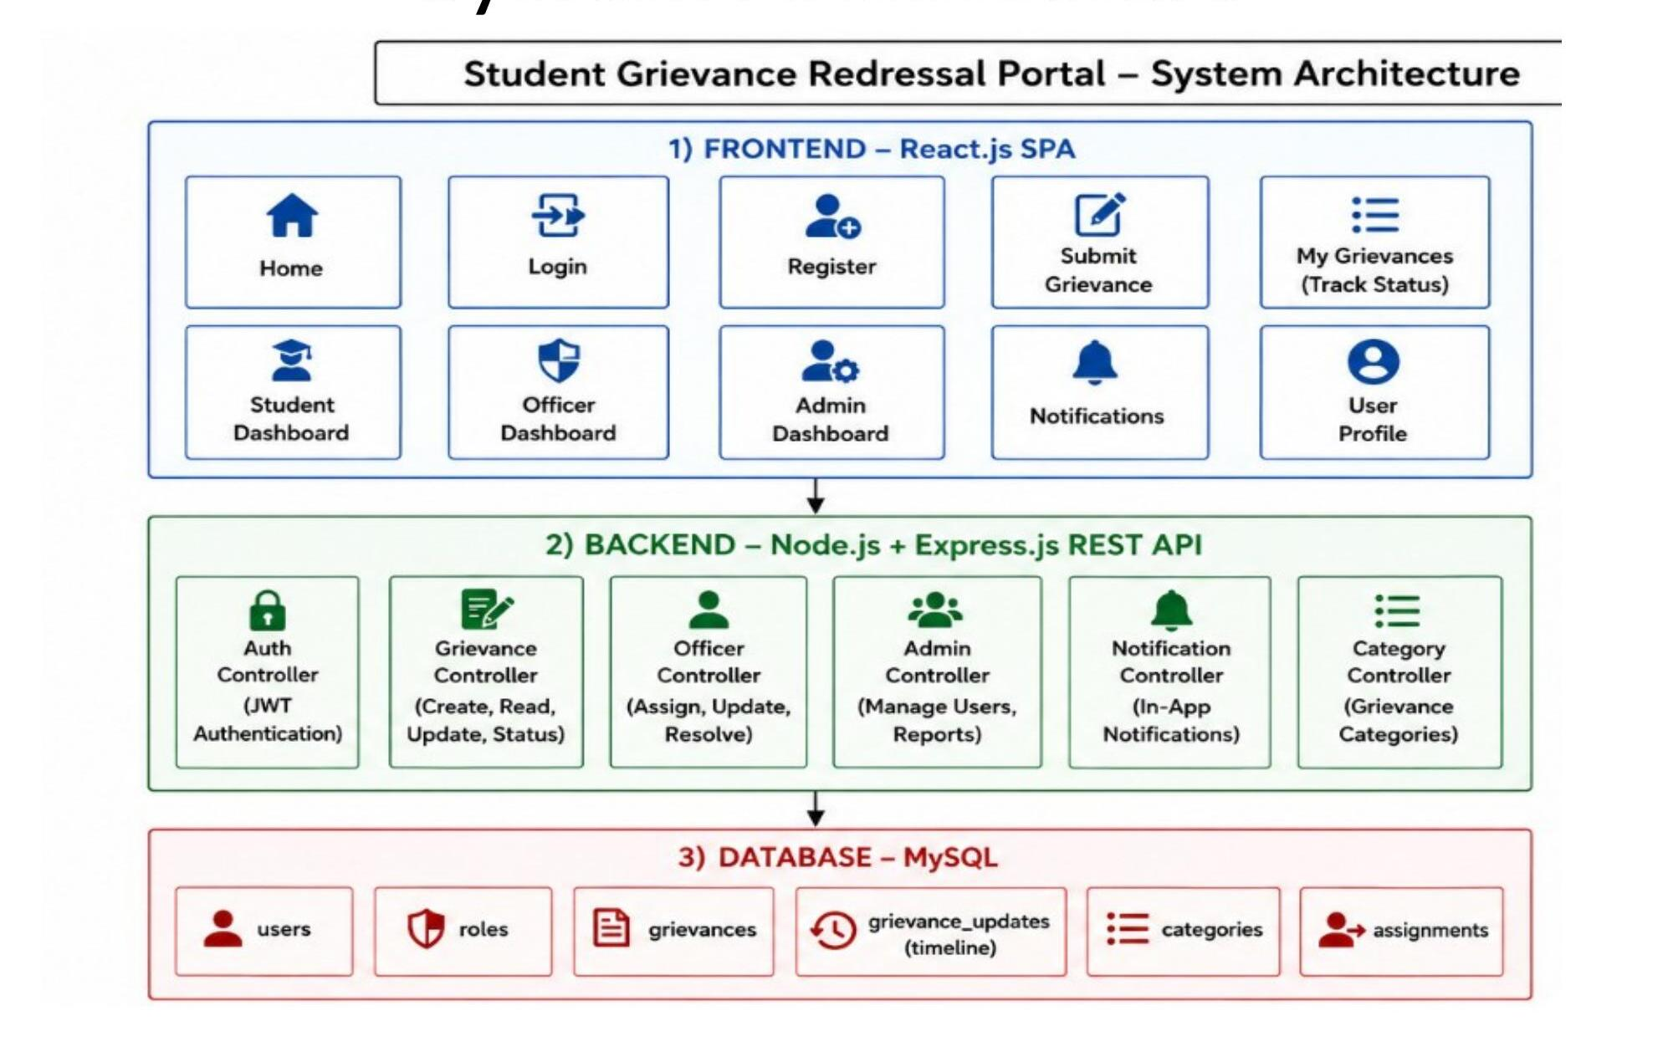
Fig. 4.1 — SGR Portal three-tier system architecture (Frontend / Backend / Database)

4.2 Description of Each Layer
Frontend Layer — React.js SPA
The frontend is a single-page application that renders eleven functionally distinct pages/views across three role-aware dashboards: Home (landing page), Login, Register, Submit Grievance, My Grievances (track status), Student Dashboard, Officer Dashboard, Admin Dashboard, Notifications, and User Profile. Navigation between views does not trigger a full page reload; React Router swaps the rendered component while a persistent Sidebar and top bar remain in place.
Backend Layer — Node.js + Express.js REST API
The backend exposes six controllers, each responsible for one resource area: the Auth Controller (JWT-based login, registration, and session retrieval), the Grievance Controller (create, read, update, status transitions), the Officer Controller (assignment, escalation, and resolution actions from the officer's perspective), the Admin Controller (user and officer management, reporting), the Notification Controller (in-app notification delivery), and the Category Controller (grievance category / sub-category lookups). Every protected route passes through the shared protect and authorize middleware before reaching its controller logic.
Database Layer — MySQL
The database layer stores six logical entities — users, roles (expressed as an ENUM on users), grievances, grievance_updates (implemented as the grievance_timeline table), categories, and assignments (expressed as the student_id / officer_id foreign keys on grievances) — as shown in the architecture diagram above and detailed further in the ER diagram in Chapter 5.

4.3 Deployment Architecture
In its current form the application is designed for a straightforward two-process deployment: the Express API runs as a standalone Node.js process (started with npm start or, in development, nodemon), and the Vite-built React client is served as a static bundle from any static file host or CDN. The two processes communicate purely over HTTP(S) via the /api/* REST endpoints, which keeps the frontend and backend independently deployable — for example, the client can be hosted on a static host such as Netlify or Vercel while the API and MySQL database run on a conventional Node-friendly host such as Render, Railway, or a self-managed VM, with CORS configured on the server to allow only the deployed client origin.
For local development, both processes run on the developer's machine — the Vite dev server on port 5173 and the Express API on port 5000 (configurable via the PORT environment variable) — with CORS explicitly restricted to http://localhost:5173 in index.js. Environment-specific values (database credentials, JWT secret, allowed origin) are isolated in server/.env so that the same codebase can be promoted from a local, to a staging, to a production environment purely through configuration. Deployment steps and environment variables are covered in full in Chapter 9.

CHAPTER 5 — DESIGN

5.1 UI/UX Design Approach
The interface is designed around a consistent shell shared by all three roles: a fixed dark sidebar carrying the SGR Portal logo, the logged-in user's name and role badge, and role-specific navigation links, paired with a light-themed content area whose top bar shows the current page title, a refresh control, a notification bell with an unread-count badge, and the user's avatar. Each role is given a distinct accent colour — indigo for Student, green for Officer, red for Admin — so that, at a glance, users and administrators reviewing screenshots can immediately identify which dashboard is being shown.
The public landing page introduces the platform with a concise hero section ("A transparent, role-based platform to raise, track, and resolve academic and administrative concerns — with real-time updates and smart escalation") followed by summary statistics (10+ categories, 3 user roles, 3 escalation levels, 15+ features) and three role-preview cards, before directing the visitor to the login page.

5.2 ER Diagram / Database Schema
The MySQL schema (server/schema.sql) is a normalised, seven-table relational design. users is the base identity table shared by every role; students and officers extend it with a one-to-one relationship keyed on the same primary key, following a class-table-inheritance pattern so that role-specific attributes (roll number/department/year for students; department/phone/availability status for officers) do not pollute the base users table. grievances is the central fact table, referencing users twice — once as student_id (who raised it) and once as officer_id (who it is assigned to) — and carries its own lifecycle fields: token, priority, status, escalated, escalation_level, timestamps, and optional feedback fields. grievance_timeline is an append-only audit log, one row per state change, foreign-keyed to grievances. notifications is a simple per-user inbox table. categories stores the ten grievance categories and their sub-categories used to populate the Submit Grievance form.
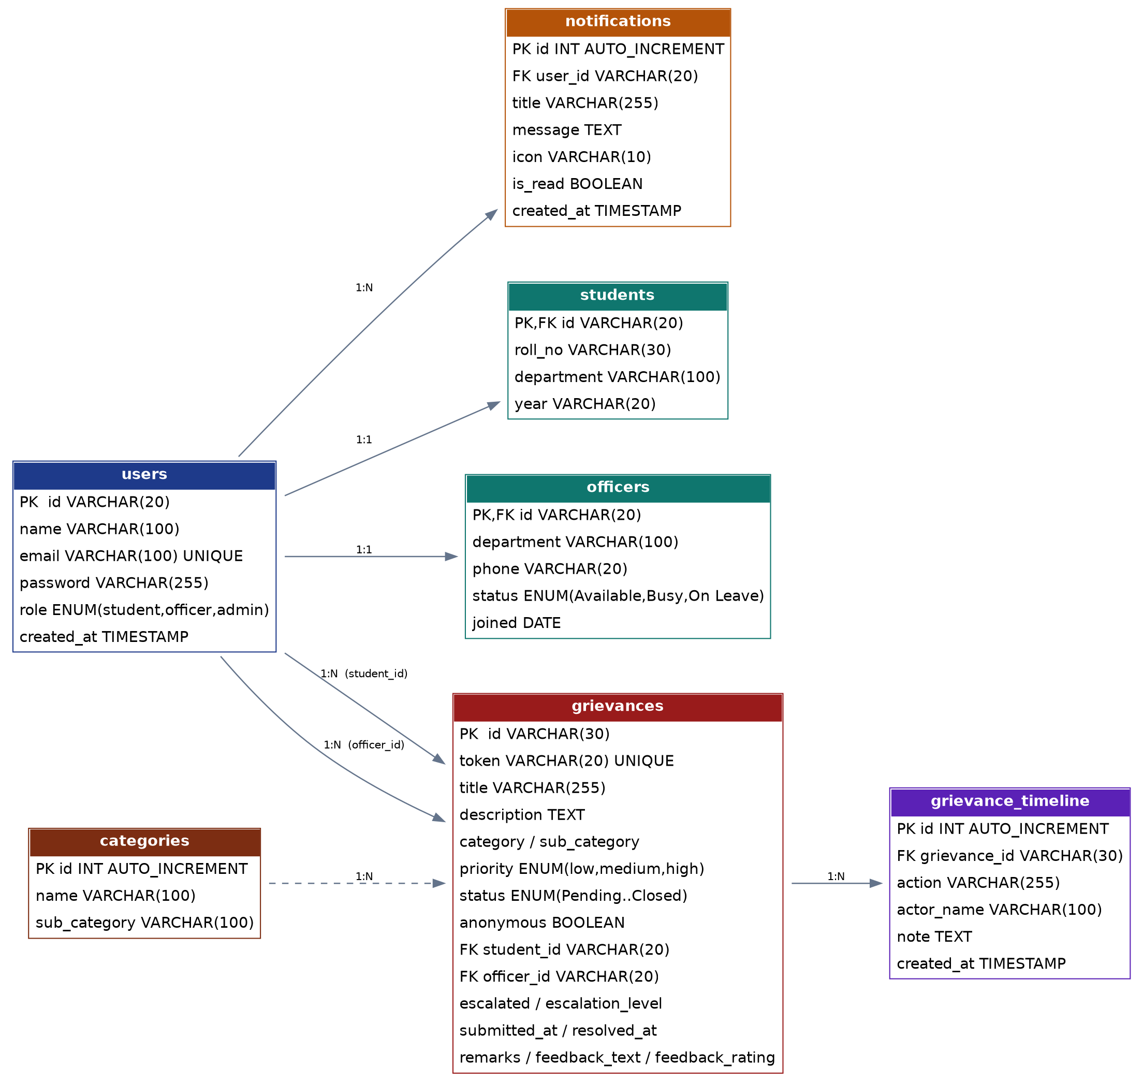
Fig. 5.1 — Entity–Relationship diagram of the SGR Portal MySQL schema
Referential integrity is enforced with foreign keys and cascading rules appropriate to each relationship: deleting a user cascades to their students/officers extension row and to their notifications, while a grievance's student_id or officer_id is set to NULL (rather than the grievance itself being deleted) if the referenced user is removed, preserving historical grievance records even if an account is later deactivated. Indexes are defined on grievances.student_id, grievances.officer_id, grievances.status, and grievances.submitted_at to keep the dashboard queries (which frequently filter by these columns) performant as the table grows.

CHAPTER 6 — IMPLEMENTATION

6.1 Module-Wise Implementation
The client is organised into five top-level page modules under client/src/pages/, two shared component modules under client/src/components/, two context providers under client/src/context/, and a shared utility module (helpers.js). The screenshots below, taken directly from the running application, illustrate each module.
Landing Page (LandingPage.jsx)
The public entry point of the application. It presents the platform's value proposition, headline statistics, and three role-preview cards (Student Portal, Officer Portal, Admin Portal), each summarising the capabilities available once a user signs in.
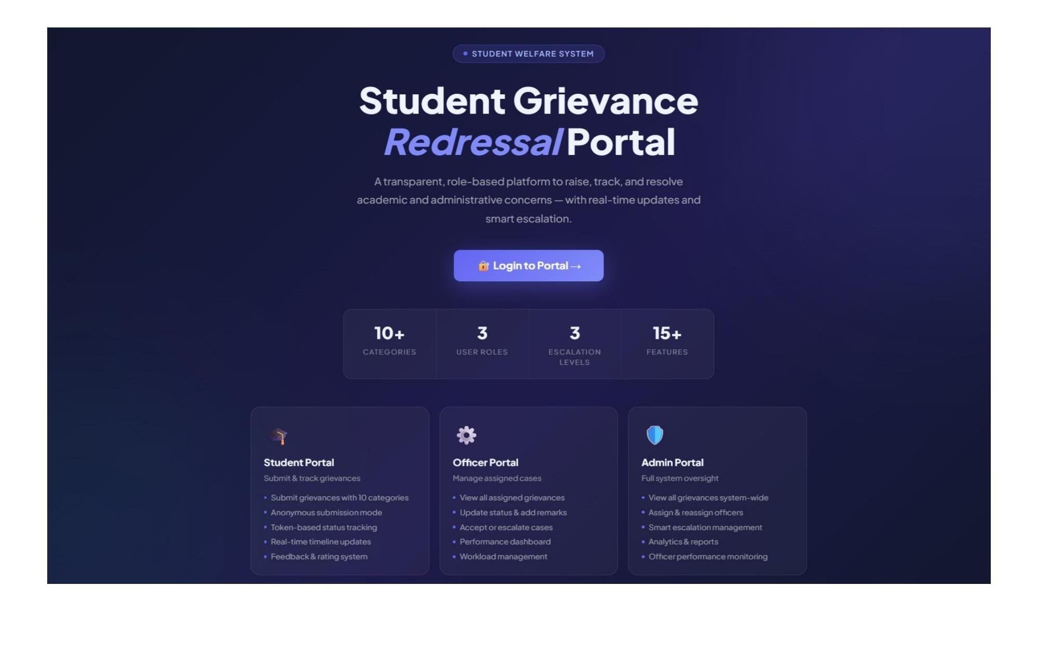
Login Page (LoginPage.jsx)
A single, unified sign-in form used by all three roles. Beneath the email/password fields, a "Quick Demo Access" panel lists the three demo accounts (Admin, Student, Officer) so that examiners or first-time users can explore each dashboard without needing to register a new account.
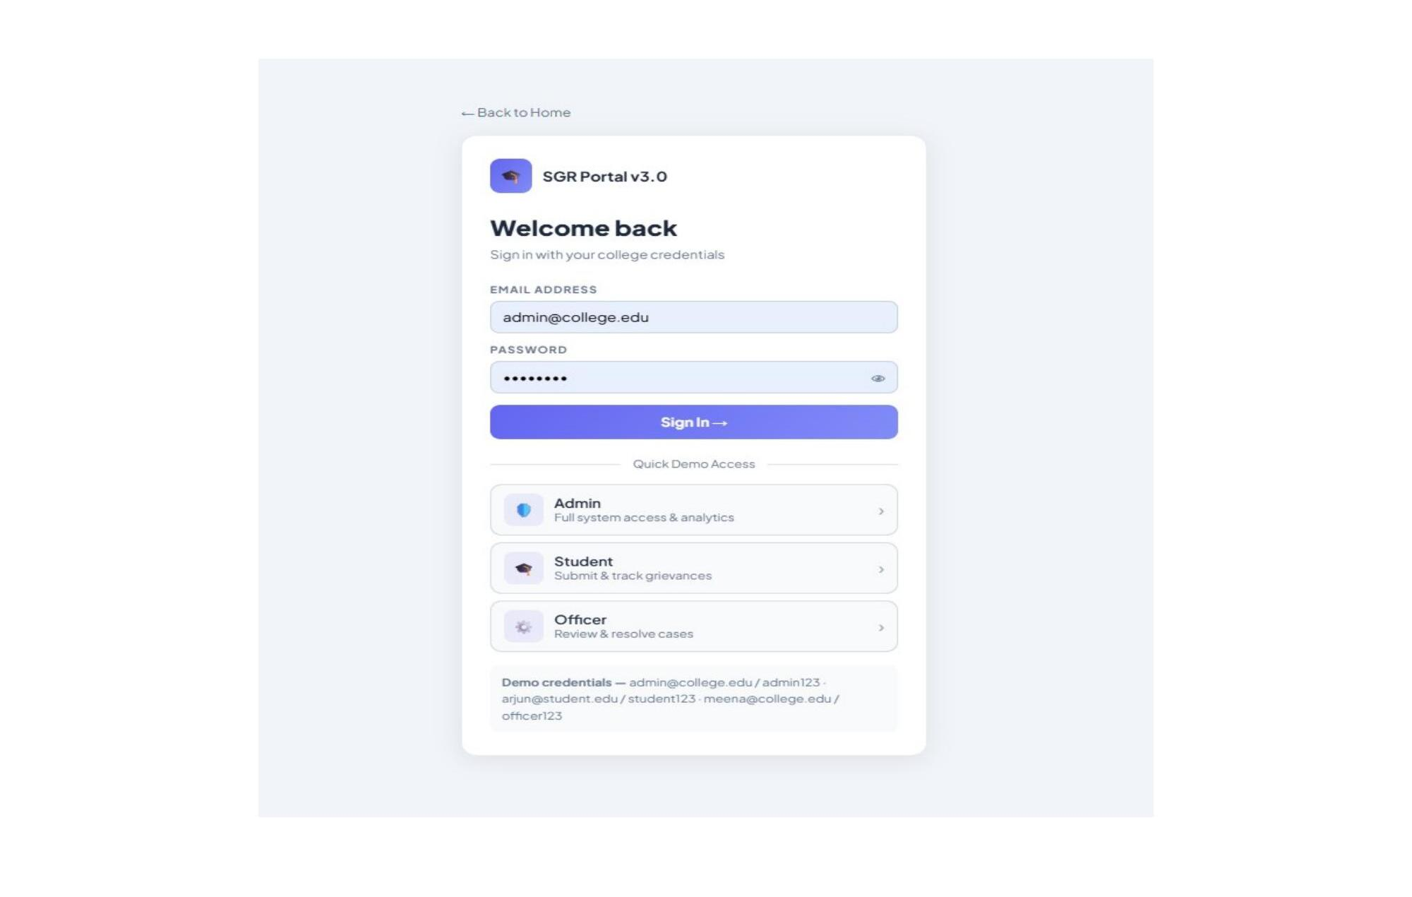
Admin Dashboard — Overview (AdminDashboard.jsx)
The administrator's landing view after login. It surfaces eight live KPI cards (Total, Pending, In Progress, Resolved, Escalated, Officers, Students, Resolution Rate), a monthly submitted-vs-resolved trend line, a category-distribution pie chart, and a live feed of the most recent grievances raised across the institution.
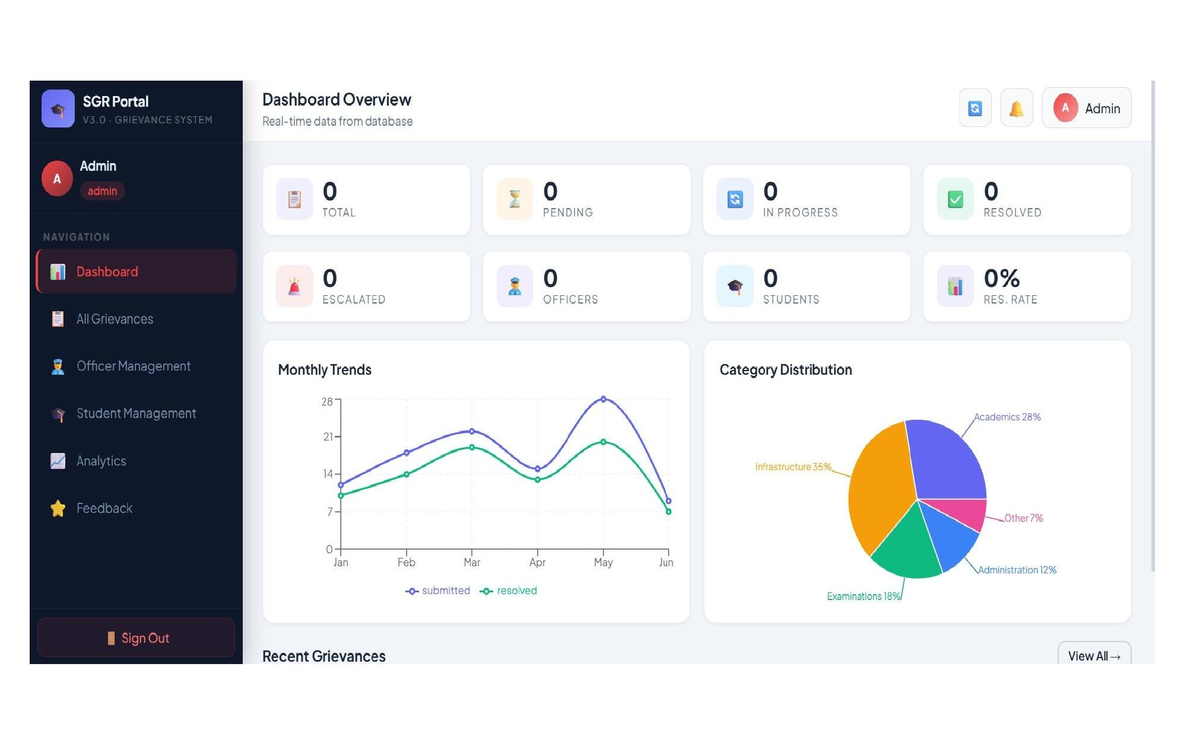
Admin Dashboard — Analytics & Reports
A dedicated analytics tab that expands on the overview with a submitted-vs-resolved bar chart by month, the same category-distribution pie chart, an officer-performance panel, and a status-distribution summary (Pending / In Progress / Resolved / Escalated / Resolution Rate) — all computed live from the analytics REST endpoints described in Chapter 3.
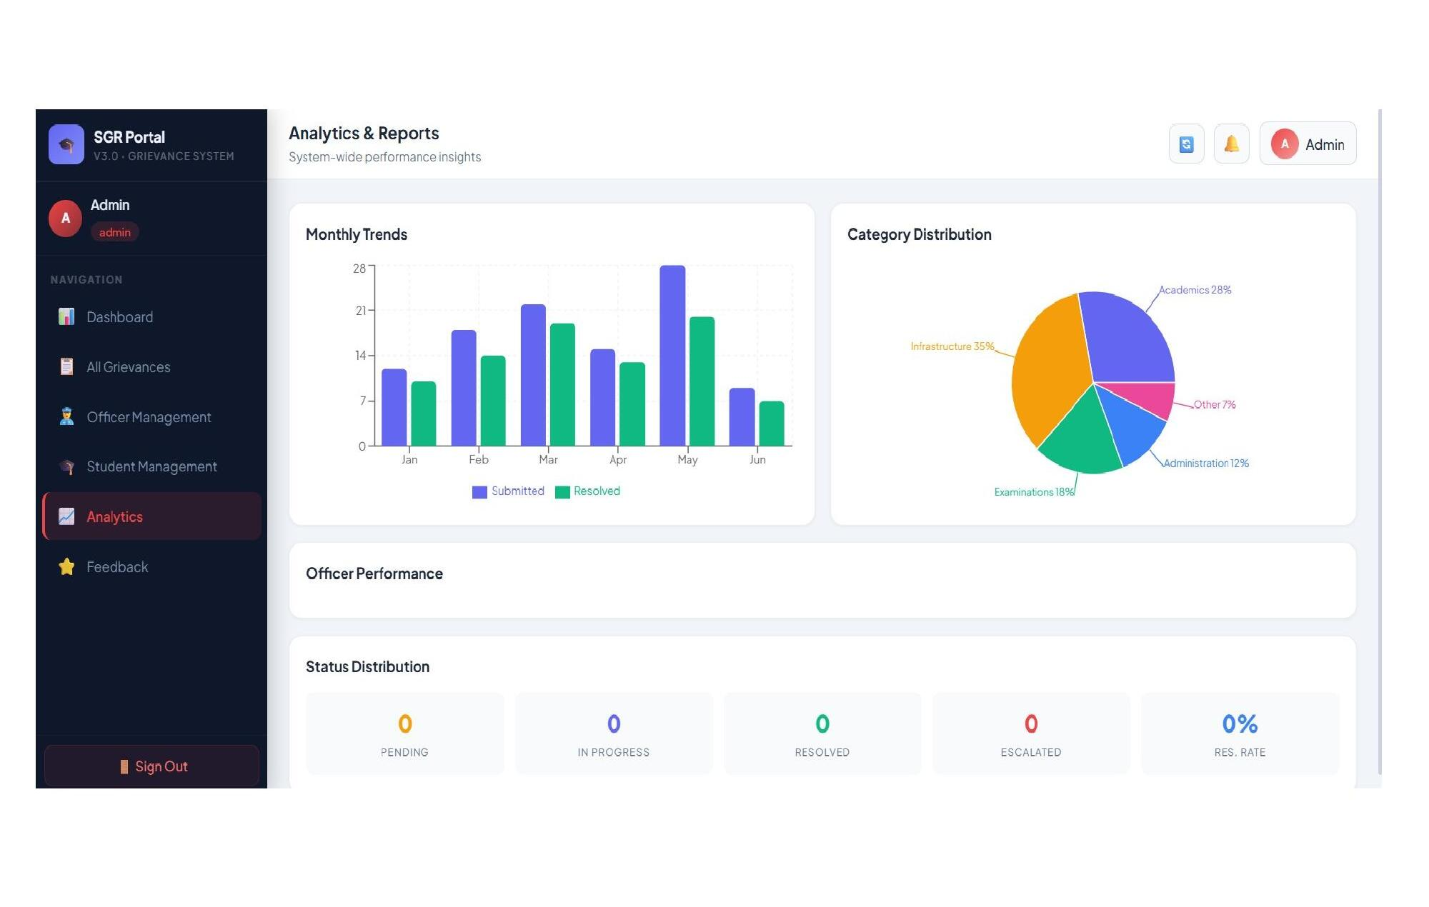
Admin Dashboard — All Grievances
A searchable, filterable, institution-wide grievance table showing every case's token, title, category, student, assigned officer, submission date, live status, and priority, with quick-access View and Assign actions and an escalate control, so an administrator can triage the entire grievance queue from one screen.
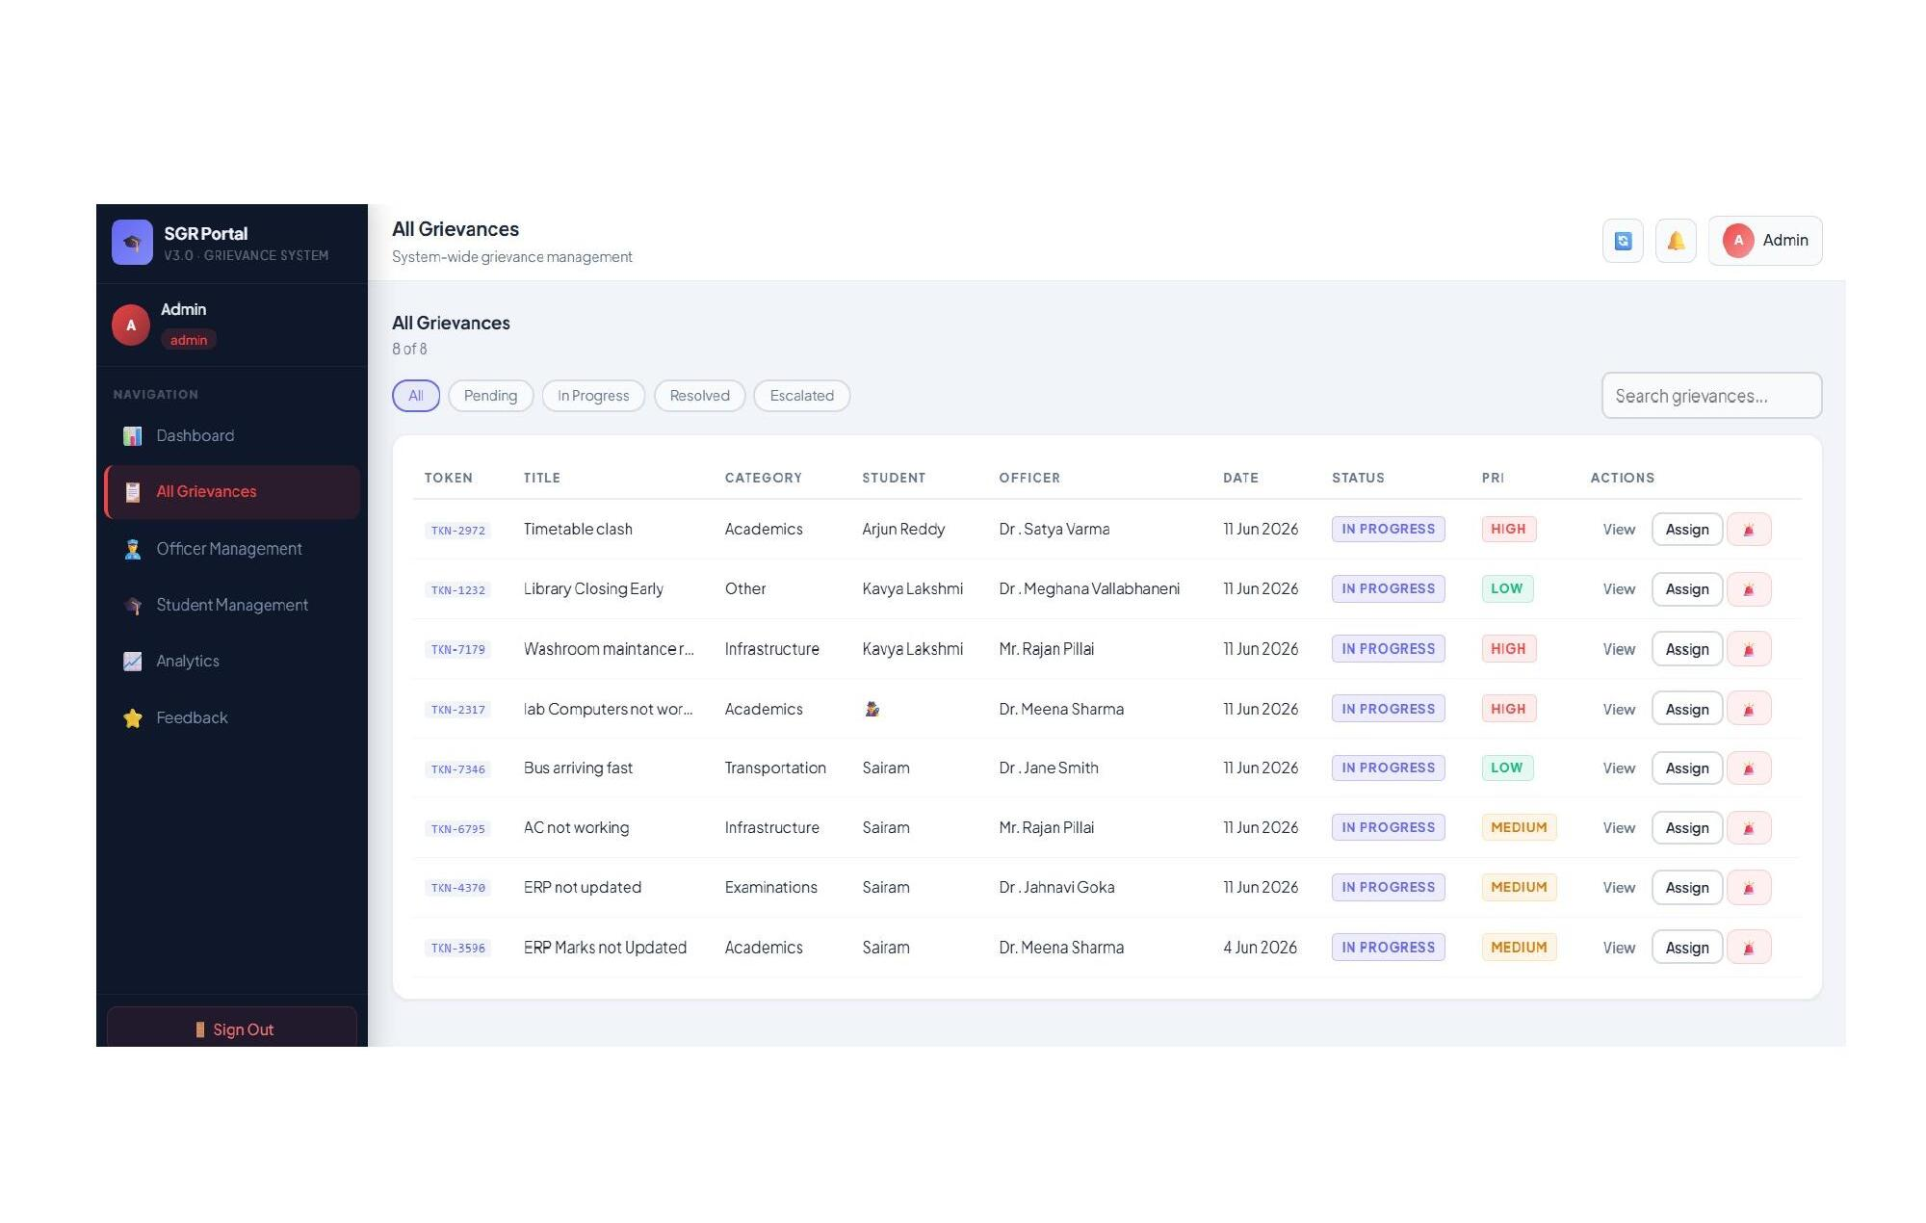
Student Dashboard — Overview (StudentDashboard.jsx)
The student's personal landing view, showing four summary cards (Total Submitted, Pending, In Progress, Resolved), a recent-grievances feed with live status/priority badges and escalation flags, and a personal resolution-rate progress bar.
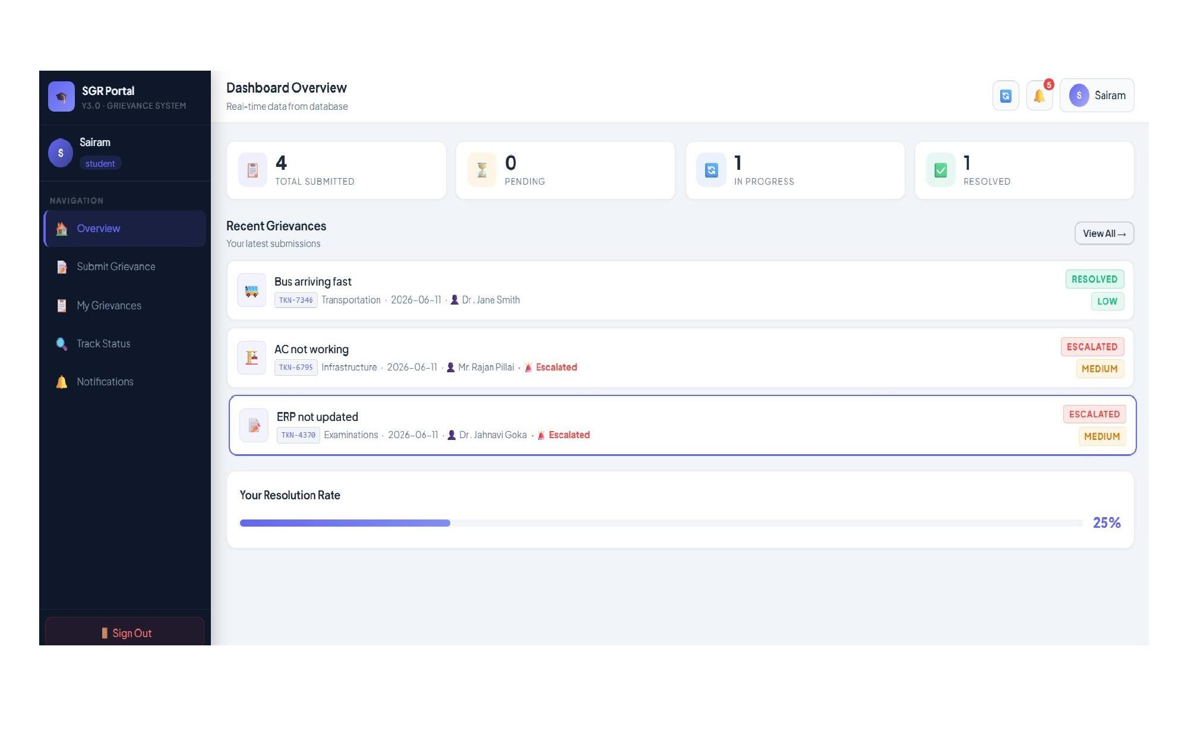
Student Dashboard — Submit Grievance
The grievance-submission form: a title field, a category and dependent sub-category selector (drawing from the ten seeded categories), a priority selector, a free-text description field, and an "Submit Anonymously" checkbox that hides the student's identity from the assigned officer while the grievance is still tracked internally by token.
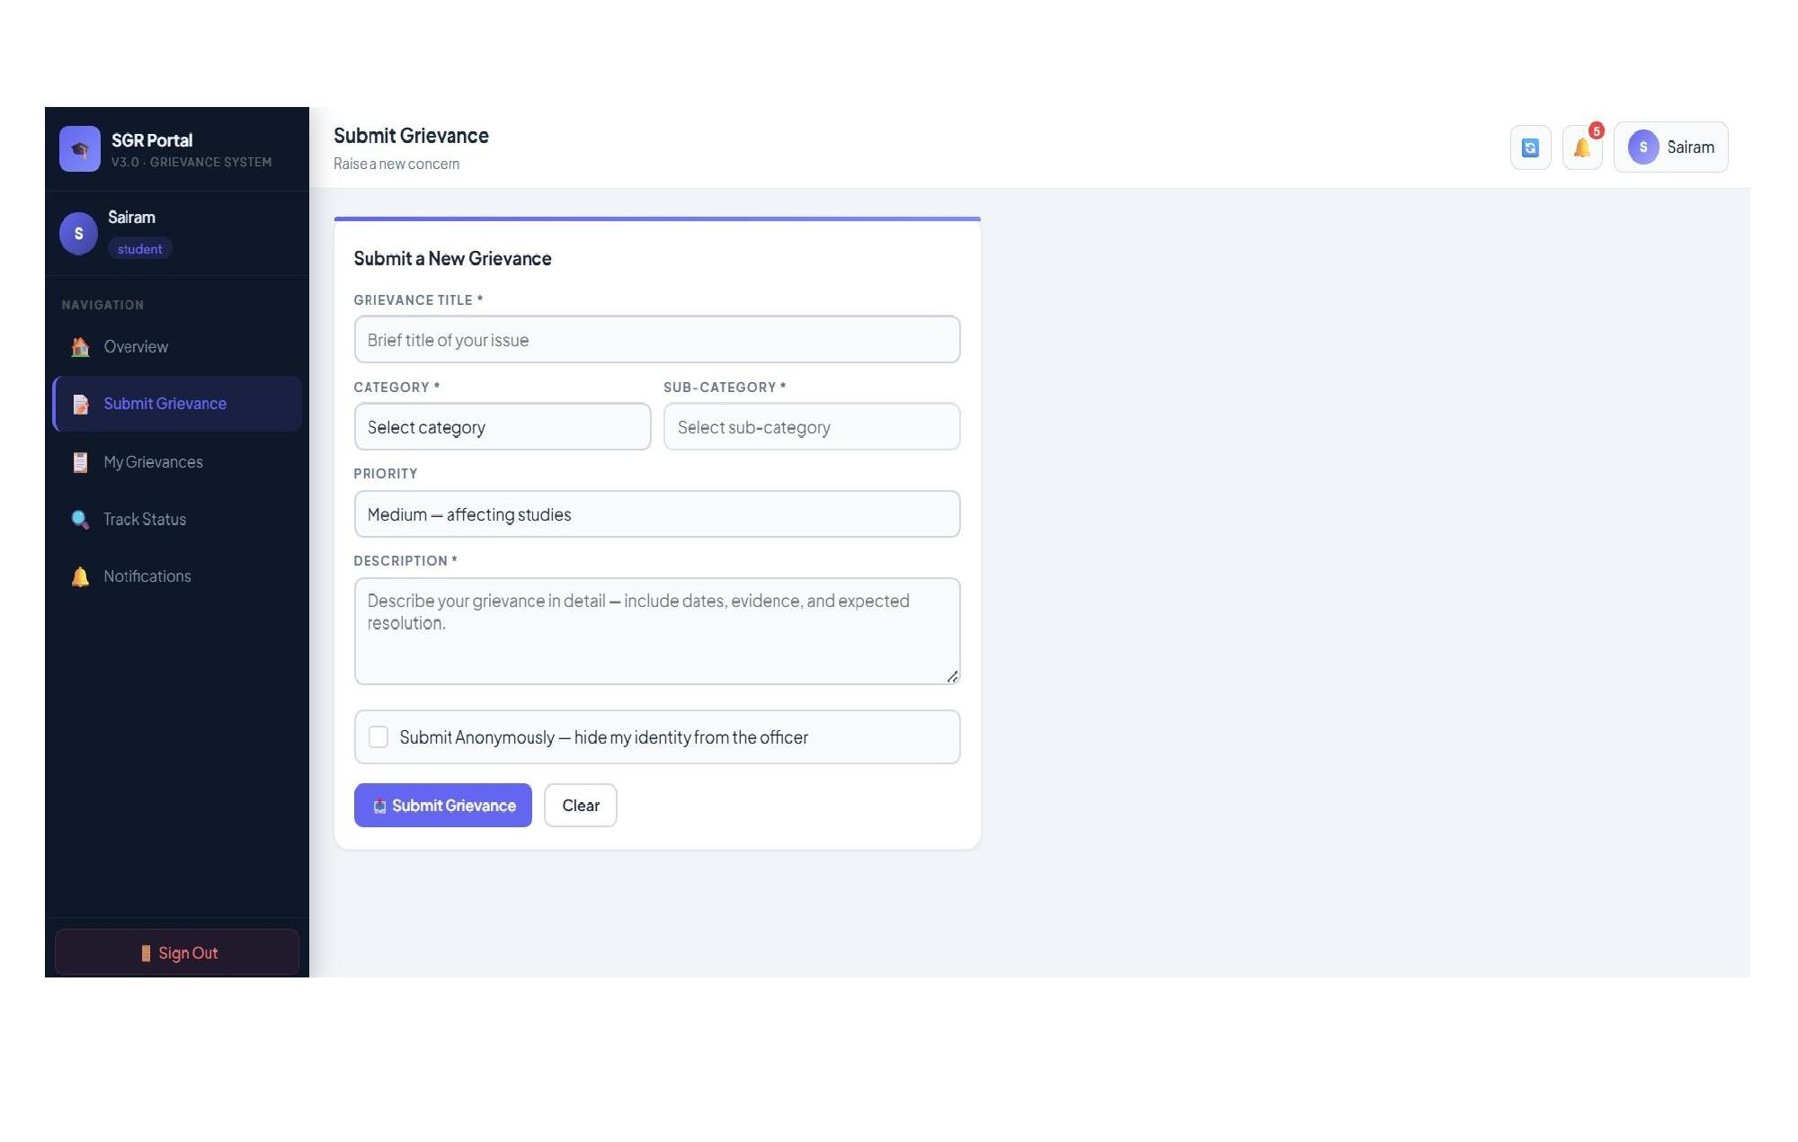
Student Dashboard — My Grievances
A personal, filterable history of every grievance the logged-in student has submitted, each shown with its token, category, submission date, assigned officer, live status, priority, and escalation flag, letting the student track every case they have ever raised in one place.
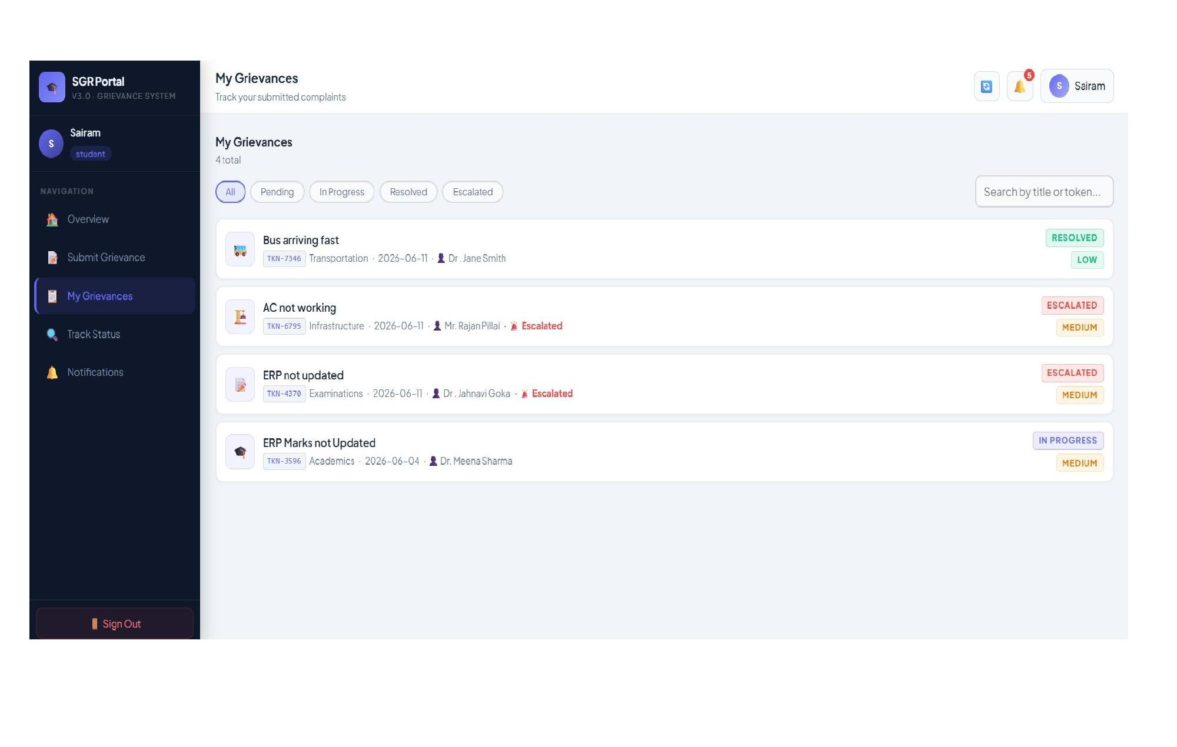
Student Dashboard — Notifications
A reverse-chronological feed of in-app notifications — primarily officer-assignment events — each timestamped and linked back to the grievance token it concerns.
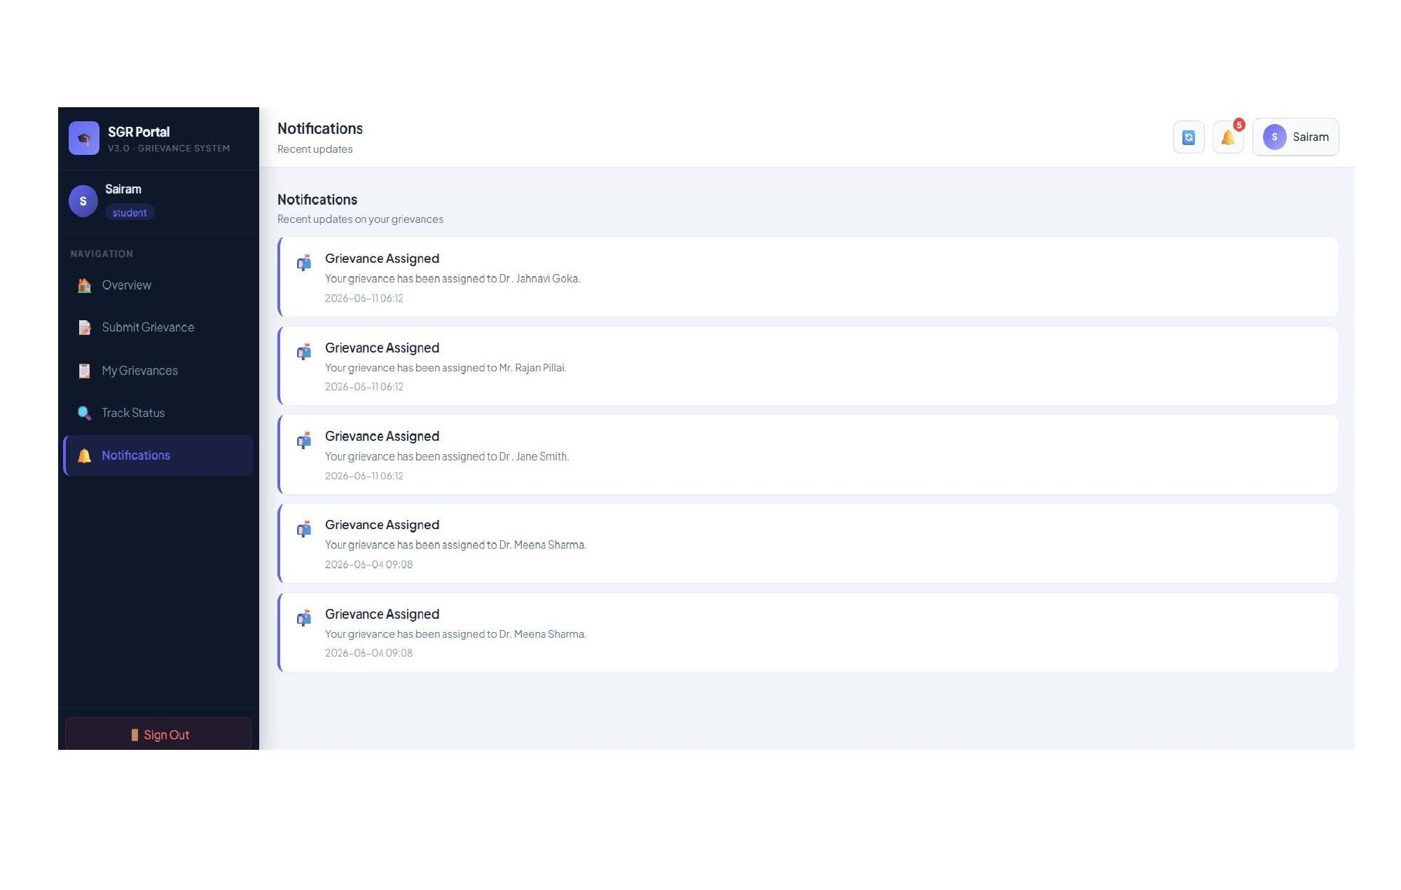
Officer Dashboard — Overview (OfficerDashboard.jsx)
The officer's landing view: assigned/pending/in-progress/resolved/escalated counters, an availability toggle (Available / Busy / On Leave), a personal resolution-rate summary, and a recent-assignments feed.
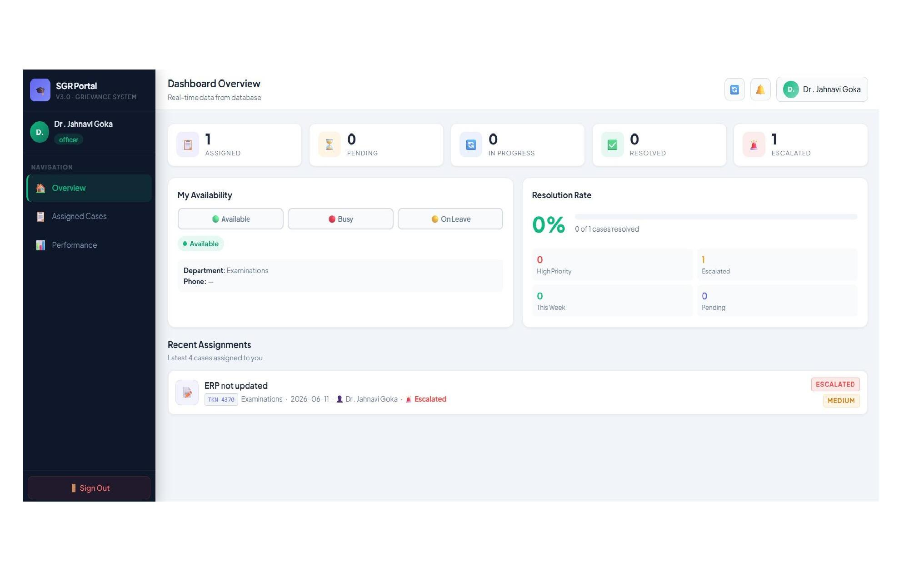
Officer Dashboard — Performance
A personal analytics tab showing total resolved cases, resolution rate, active caseload, escalated-case count, a case-distribution pie chart, a monthly activity bar chart, a priority breakdown (High / Medium / Low), and a list of recently resolved cases.
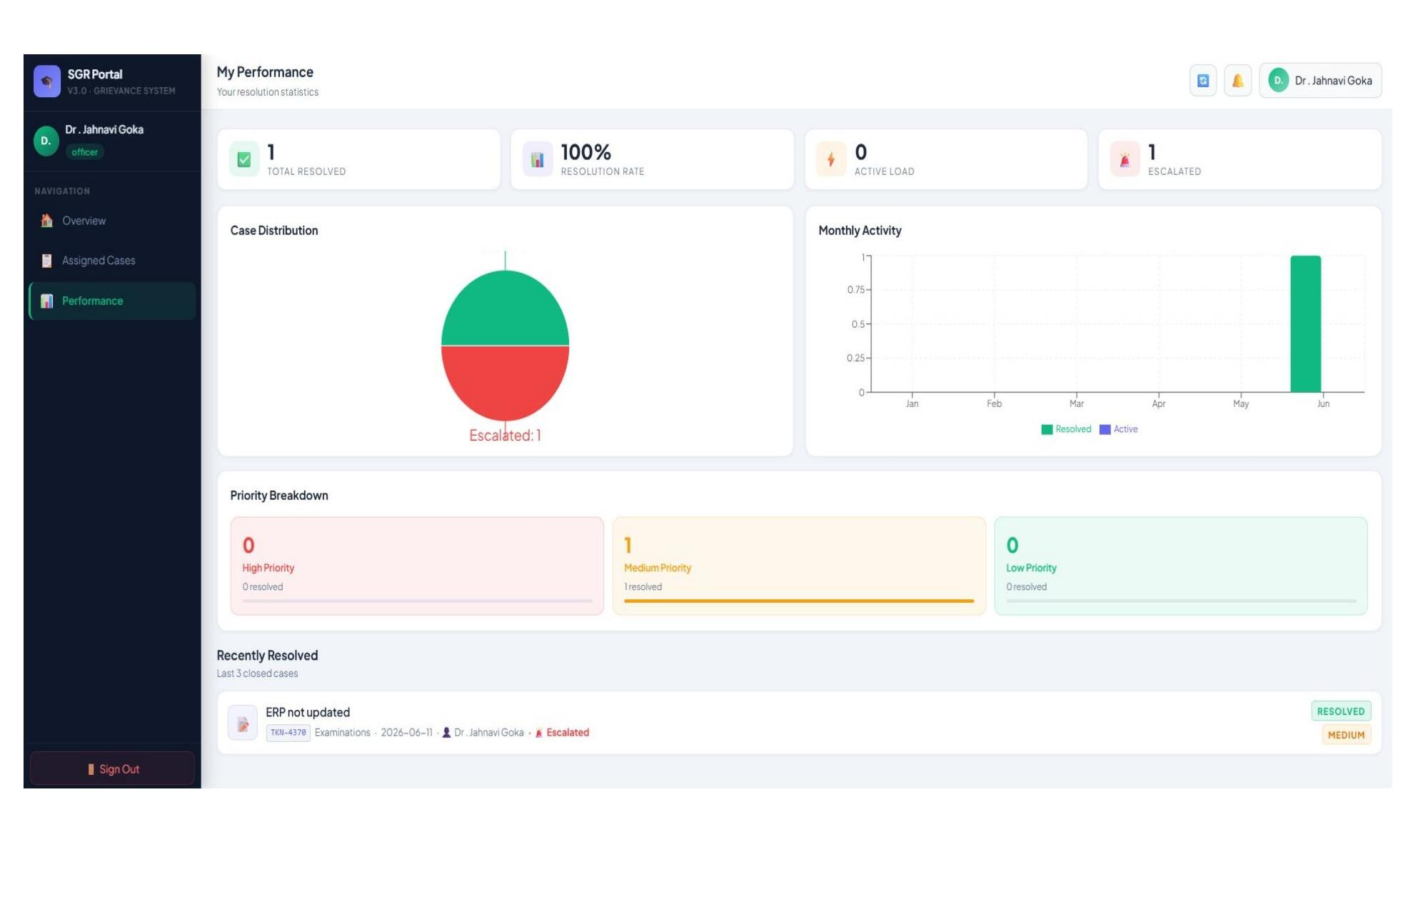

6.2 Front-End Logic — State Management
Rather than adopting an external state-management library, the client relies on two React Context providers. AuthContext owns the authenticated user object and exposes login/logout actions, persisting the JWT and user profile to localStorage so that a session survives a page refresh. GrievanceContext owns the shared, in-memory cache of grievances, officers, and notifications for the current session, exposing a fetchAll() function (wired to the manual refresh button in the top bar) that re-pulls the latest data from the REST API and updates every subscribed component — this is what gives the three dashboards their real-time-like, always-current feel without a persistent WebSocket connection. The root AppShell component (App.jsx) reads the active tab from local component state and renders the corresponding page component, alongside a TOPBAR lookup table that maps each tab to its title and subtitle.

6.3 API Integration
All server communication is centralised through Axios, with the base URL and the Authorization: Bearer <token> header configured once (after a successful login) and reused by every subsequent request. Each page module calls the specific REST endpoint it needs — for example, the Submit Grievance form issues a POST to /api/grievances, while the Admin "All Grievances" table issues a GET to /api/grievances and a PATCH to /api/grievances/:id/assign when an administrator assigns an officer. The complete endpoint surface is documented in Chapter 8 and Chapter 9.

6.4 Authentication & Authorization
Authentication is implemented with JSON Web Tokens. On a successful POST to /api/auth/login, the server verifies the submitted password against the bcrypt hash stored in the users table and, on success, signs a JWT (using JWT_SECRET, with an expiry controlled by JWT_EXPIRES_IN) containing the user's id, role, name, and email. The client stores this token and attaches it to every subsequent request.
On the server, the protect middleware (server/middleware/auth.js) rejects any request to a protected route that lacks a valid Bearer token, and attaches the decoded payload to req.user. A second middleware, authorize(...roles), is composed on top of protect for role-restricted routes — for example, PATCH /api/grievances/:id/assign and every route under /api/officers and /api/students is wrapped in authorize('admin'), ensuring that only an authenticated admin account can create, edit, or delete officer and student records or reassign a grievance.

CHAPTER 7 — FEATURES
The diagram below summarises how the platform's features connect into a single end-to-end workflow across the three roles — Student, Officer, and Admin — including the grievance status lifecycle (Pending → In Progress → Resolved/Closed) and the real-time-style synchronisation that keeps all three dashboards current.
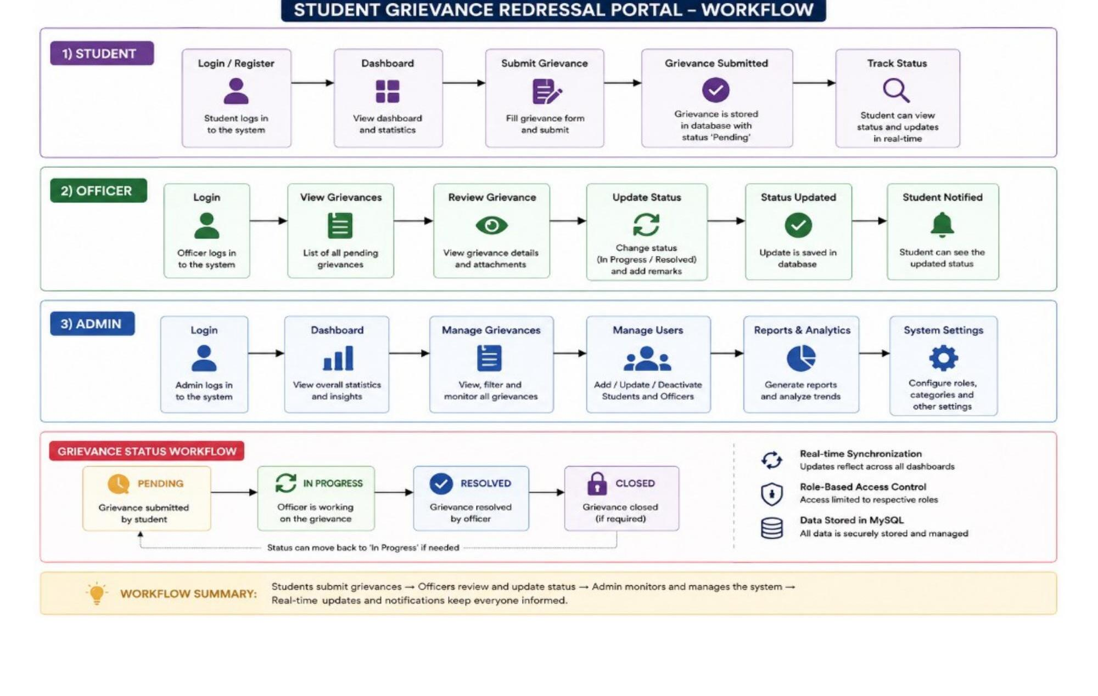
Fig. 7.1 — SGR Portal end-to-end workflow across Student, Officer, and Admin roles

7.1 List of Main Features
Student
- Submit grievances across 10 categories and their sub-categories, with a priority selector and free-text description.
- Anonymous-submission mode, which hides the student's identity from the assigned officer.
- Unique token generation for every grievance, enabling quick lookup and reference.
- Real-time-style status tracking (Pending → In Progress → Resolved / Escalated → Closed) with a full timeline per case.
- Searchable, filterable personal grievance history ("My Grievances").
- Star-rating feedback and written comments once a grievance is resolved.
- In-app notifications for key events such as officer assignment.
Officer
- A queue of all cases assigned to the officer, with full grievance detail and any attachments.
- Status updates (In Progress / Resolved) with the ability to attach resolution remarks.
- Availability toggle (Available / Busy / On Leave) that is visible to administrators when assigning new cases.
- A personal performance dashboard: resolution rate, case distribution, monthly activity, and priority breakdown.
Admin
- A single, searchable, filterable table of every grievance in the institution.
- Officer assignment and reassignment for any grievance.
- Manual escalation of unresolved cases, up to three escalation levels.
- Full CRUD management of officer and student accounts.
- An 8-card KPI dashboard (Total, Pending, In Progress, Resolved, Escalated, Officers, Students, Resolution Rate).
- Institution-wide analytics: monthly submitted-vs-resolved trends, category distribution, and officer-performance charts.
- A dedicated feedback-review tab showing student ratings and comments on resolved cases.

7.2 How Each Feature Works
Grievance Submission and Tracking
When a student submits the Submit Grievance form, the client issues a POST /api/grievances request with the title, category, sub-category, priority, description, and the anonymous flag. The server generates a unique token, inserts a new row into grievances with status Pending, and writes the first entry ("Grievance Submitted") into grievance_timeline. The student can subsequently view this grievance, its live status, and its full timeline from My Grievances or by looking it up on the public Track Status page using the token alone — which is what makes anonymous submission possible while still allowing the student to follow their own case.
Assignment and Resolution Workflow
An administrator assigns an officer to a Pending grievance via PATCH /api/grievances/:id/assign (restricted to the admin role by the authorize middleware). This updates the grievance's officer_id, appends an "Assigned" entry to its timeline, and creates a notification for both the officer and the student. The officer then works the case from their Assigned Cases queue, moving it through In Progress to Resolved via PATCH /api/grievances/:id/status, optionally attaching remarks at each step; every transition is timestamped in grievance_timeline, giving a complete, auditable history of who did what and when.
Escalation
If a grievance is not resolved satisfactorily or within an acceptable timeframe, an administrator can escalate it via PATCH /api/grievances/:id/escalate, which increments escalation_level (capped at 3) and sets the escalated flag, surfacing the case with a red "Escalated" badge on every dashboard that lists it, so it receives priority attention.
Feedback
Once a grievance reaches Resolved status, the originating student can submit a 1–5 star rating and written feedback via POST /api/grievances/:id/feedback. This is stored on the grievance record itself (feedback_rating, feedback_text) and surfaces in the Admin's Feedback Reviews tab, giving the institution a direct measure of resolution quality as perceived by the student.

CHAPTER 8 — TESTING

8.1 Postman Testing
Every REST endpoint exposed by the Express server — across the auth, grievances, officers, students, analytics, and notifications route modules — was exercised independently of the React client using Postman. This isolated backend logic (validation, role authorization, database writes) from front-end behaviour and made it possible to confirm, for instance, that /api/grievances/:id/assign correctly returns a 403 Forbidden with the message "Role 'student' is not authorised for this route" when called with a student's token, before the corresponding UI control was even wired up.

8.2 Integration Testing
Once individual endpoints were verified in isolation, the full request/response cycle was tested end-to-end through the actual React client: registering and logging in as each of the three seeded roles, submitting a grievance as a student and confirming it appeared correctly in the Admin's All Grievances table, assigning it to an officer and confirming the officer's Assigned Cases list and notification feed updated correctly, and finally resolving it and confirming the student could see the resolved status and submit feedback. This integration pass was repeated for the escalation flow and for the officer-availability toggle.

8.3 Tools Used for Testing
Tool | Purpose
Postman | Manual REST API testing — request construction, header/token management, response inspection
MySQL Workbench / CLI | Direct inspection of table state after each API operation, to confirm writes matched expectations
Browser DevTools | Network-tab inspection of Axios requests/responses; React component state inspection
Manual / exploratory testing | Role-based walkthroughs across Student, Officer, and Admin dashboards

8.4 Test Cases and Results
# | Test Case | Expected Result | Result
1 | Login with valid admin credentials (admin@college.edu) | JWT issued; redirected to Admin Dashboard | Pass
2 | Login with incorrect password | 401 Unauthorized returned; error shown on form | Pass
3 | Access /api/officers with a student token | 403 Forbidden — role not authorised | Pass
4 | Submit grievance with all required fields | Grievance created with unique token; status = Pending | Pass
5 | Submit grievance anonymously | Student identity withheld from officer view; token still traceable by student | Pass
6 | Admin assigns officer to a Pending grievance | officer_id updated; timeline entry added; notifications created | Pass
7 | Officer updates status to Resolved | Status + resolved_at updated; timeline entry recorded | Pass
8 | Admin escalates a grievance twice | escalation_level increments to 2; escalated = true; badge shown | Pass
9 | Admin escalates a grievance beyond level 3 | escalation_level capped at 3 | Pass
10 | Student submits feedback on a Resolved grievance | feedback_rating and feedback_text stored; visible in Admin Feedback tab | Pass
11 | Officer toggles availability to "On Leave" | officers.status updated; reflected on Admin officer cards | Pass
12 | Unauthenticated request to a protected route | 401 — "No token, authorisation denied" | Pass

CHAPTER 9 — DEPLOYMENT

9.1 Steps to Deploy
1. Database
Provision a MySQL 8+ instance and run the schema script to create the database, tables, and seed data (three demo officers, two demo students, and one admin account):
mysql -u root -p < server/schema.sql
2. Backend
Install server dependencies, configure server/.env with the target database credentials, and start the API:
cd server npm install npm run dev # development, via nodemon npm start # production
By default the API listens on the port specified by the PORT environment variable and exposes a health-check endpoint at GET /api/health for uptime monitoring.
3. Frontend
Install client dependencies and either run the Vite dev server for local development, or build a static production bundle for deployment:
cd client npm install npm run dev # local development on http://localhost:5173 npm run build # production build, output to client/dist

9.2 Environment Configuration
Server-side configuration is isolated in server/.env, keeping secrets out of version control. The variables consumed by the application are:
Variable | Purpose
PORT | Port the Express API listens on (defaults to 5000)
DB_HOST | MySQL server hostname
DB_USER | MySQL user with access to the sgr_portal database
DB_PASSWORD | Password for the above MySQL user
DB_NAME | Database name (sgr_portal)
JWT_SECRET | Signing secret used to issue and verify JWTs
JWT_EXPIRES_IN | Token lifetime (for example, 7d)
On the client, the CORS origin allowed by the server (currently http://localhost:5173 in index.js) must be updated to the deployed frontend's URL before going to production, and the Axios base URL on the client must point at the deployed API's address.

9.3 Hosting of Frontend and Backend
Because the client is built to static assets (client/dist) and the server is a standalone Express process talking to MySQL, the two halves of the application can be hosted independently: the client bundle on any static host or CDN (for example Netlify, Vercel, or GitHub Pages), and the Express API together with the MySQL database on any Node-friendly host (for example Render, Railway, an AWS EC2 instance, or a managed database service such as AWS RDS / PlanetScale for MySQL specifically). This separation keeps the deployment simple, keeps hosting costs low for an academic project, and mirrors how the application already runs in local development — two independent processes communicating purely over HTTP.

CHAPTER 10 — CHALLENGES & LIMITATIONS

10.1 Issues Faced During Development
- Role-based access control across three dashboards — designing a single set of REST endpoints that correctly and consistently restricted actions by role (student / officer / admin) required carefully layering the protect and authorize middleware on every route, rather than relying on the client to hide UI elements alone.
- Keeping three dashboards in sync — with no persistent WebSocket connection, ensuring that a status change made by an officer was promptly visible on the student's and admin's dashboards required a deliberate refresh strategy (the manual refresh control plus re-fetch after every mutating action) inside GrievanceContext.
- Schema design for auditability — the initial schema stored only the current status of a grievance; this was revised to add the separate grievance_timeline table so that the full history of a case — not just its latest state — could be reconstructed and displayed.
- Anonymous submissions vs. traceability — supporting anonymous grievances while still letting the submitting student track their own case required token-based lookup that does not depend on exposing the student's identity to the assigned officer.

10.2 Solutions Applied
- Centralised middleware — the protect / authorize middleware pair in server/middleware/auth.js is applied consistently across every route file, so authorization logic lives in one place rather than being duplicated per controller.
- Explicit refresh cycle — a fetchAll() function in GrievanceContext, triggered both manually (refresh button) and automatically after any create/update action, keeps every dashboard's view of the shared grievance and notification data current without the complexity of a real-time transport layer.
- Append-only timeline table — grievance_timeline decouples "current state" (on grievances) from "history of state changes" (on grievance_timeline), giving every dashboard an accurate audit trail with a simple, indexed query.
- Token as the public identifier — every grievance is given a short, unique token at creation time; this token, rather than the student's identity, is what is shown to the assigned officer for anonymous cases, while the student's own My Grievances view is always scoped to their authenticated session.

10.3 Current Limitations / Known Bugs
- There is no real-time push channel (WebSockets / Server-Sent Events); dashboard updates rely on manual or action-triggered refresh rather than instant push notifications.
- Email and SMS notifications are not yet implemented — notifications are currently in-app only, visible when the user is logged in.
- File/document attachments on a grievance are not yet exposed in the UI, although multer is already included as a server dependency in anticipation of this feature.
- Officer assignment is manual; there is no automatic load-balancing or category-based auto-routing of new grievances to the least-loaded officer in the relevant department.
- The analytics dashboards currently compute metrics on read, without a caching layer, which would need attention at a much larger data volume than the current academic deployment.

CHAPTER 11 — FUTURE ENHANCEMENTS

11.1 Planned Features
- Email and SMS notifications — extending the existing in-app notification system so students and officers are alerted outside the portal when a grievance is assigned, updated, or resolved.
- Mobile application support — a companion mobile client (or a PWA wrapper around the existing responsive React front end) for on-the-go grievance submission and tracking.
- AI-based grievance categorisation — automatically suggesting a category and sub-category from the free-text description at submission time, reducing manual selection errors.
- Advanced analytics dashboards — predictive resolution-time estimates, department-wise heat maps, and trend forecasting layered on top of the existing Recharts-based analytics.
- Document upload functionality — activating the already-included multer dependency to let students attach supporting evidence (photos, PDFs) to a grievance, and officers attach resolution proof.
- Integration with institutional ERP systems — linking student and officer accounts to the institution's existing ERP/SIS so that user provisioning does not need to be managed separately in the portal.

11.2 Possible Integrations or Optimisations
- Automatic officer assignment based on category, department, and current workload, rather than fully manual assignment by the admin.
- A WebSocket or Server-Sent-Events channel to replace the current manual/action-triggered refresh with genuine real-time updates across dashboards.
- Caching (e.g. Redis) for the analytics endpoints once grievance volume grows large enough that computing metrics on every request becomes a bottleneck.
- Rate limiting and refresh-token rotation on the authentication layer to further harden the API against abuse.
- Automated end-to-end and unit test suites (e.g. Jest + Supertest for the API, React Testing Library for the client) to replace the current manual Postman/exploratory testing process described in Chapter 8.

CHAPTER 12 — CONCLUSION

12.1 Summary of the Project
The Student Grievance Redressal Portal was designed and built to replace the manual, paper- and email-based grievance handling common in educational institutions with a single, centralised, role-based web platform. Using React on the front end, Node.js/Express on the back end, and MySQL for persistent storage, the project delivers a working three-tier system in which students submit and track grievances, officers review and resolve the cases assigned to them, and administrators oversee the entire grievance lifecycle through a dedicated management and analytics console.

12.2 What Was Achieved
The completed system implements the full grievance lifecycle — submission, assignment, in-progress tracking, resolution, escalation, and feedback — backed by a normalised seven-table MySQL schema and a REST API secured with JWT authentication and role-based authorization. All three dashboards (Student, Officer, Admin) were built and verified end-to-end, together with supporting features such as token-based tracking, anonymous submission, in-app notifications, officer availability management, and an analytics suite covering monthly trends, category distribution, and officer performance. Every REST endpoint was individually validated with Postman, and the complete user journeys for all three roles were verified through integration testing, as detailed in Chapter 8.

12.3 Skills Learned During Development
- Designing and normalising a relational database schema for a multi-role, audit-sensitive application, including the use of an append-only timeline table for historical traceability.
- Building a secure REST API with Express, including JWT-based authentication and layered, role-based authorization middleware.
- Structuring a non-trivial React application around the Context API for shared state, without needing an external state-management library.
- Using Recharts to build a data-driven analytics dashboard from live API data.
- End-to-end debugging across the full stack — tracing an issue from a React component, through an Axios call, into an Express route, and finally into a MySQL query.
- Practical experience with the full software-project lifecycle: requirements, architecture, implementation, testing, and deployment planning, documented across the chapters of this report.

CHAPTER 13 — REFERENCES
- React.js Documentation — https://react.dev/
- Node.js Documentation — https://nodejs.org/en/docs
- Express.js Documentation — https://expressjs.com/
- MySQL 8.0 Reference Manual — https://dev.mysql.com/doc/
- Vite Documentation — https://vitejs.dev/
- React Router Documentation — https://reactrouter.com/
- MDN Web Docs — https://developer.mozilla.org/
- OWASP Web Security Guidelines — https://owasp.org/

CHAPTER 14 — APPENDICES

Appendix A — Screenshots of the Application
The following pages present representative screenshots of the SGR Portal covering the public landing page and all three role-based dashboards, captured directly from the running application.

A.1 — Landing page

A.2 — Login page with quick demo access

A.3 — Admin Dashboard: overview / KPI cards

A.4 — Admin Dashboard: analytics & reports

A.5 — Admin Dashboard: all grievances

A.6 — Student Dashboard: overview

A.7 — Student Dashboard: submit grievance

A.8 — Student Dashboard: my grievances

A.9 — Student Dashboard: notifications

A.10 — Officer Dashboard: overview

A.11 — Officer Dashboard: performance

Appendix B — Sample Code Snippets
B.1 — JWT Authentication Middleware (server/middleware/auth.js)
const jwt = require('jsonwebtoken') // Verify JWT on protected routes const protect = (req, res, next) => { const authHeader = req.headers.authorization if (!authHeader || !authHeader.startsWith('Bearer ')) { return res.status(401).json({ message: 'No token, authorisation denied' }) } const token = authHeader.split(' ')[1] try { const decoded = jwt.verify(token, process.env.JWT_SECRET) req.user = decoded // { id, role, name, email } next() } catch { res.status(401).json({ message: 'Token is not valid' }) } } // Role guard — usage: authorize('admin') or authorize('admin','officer') const authorize = (...roles) => (req, res, next) => { if (!roles.includes(req.user.role)) { return res.status(403).json({ message: `Role '${req.user.role}' is not authorised for this route` }) } next() } module.exports = { protect, authorize }
B.2 — Database Schema Excerpt (server/schema.sql)
CREATE TABLE IF NOT EXISTS grievances ( id VARCHAR(30) PRIMARY KEY, token VARCHAR(20) NOT NULL UNIQUE, title VARCHAR(255) NOT NULL, description TEXT NOT NULL, category VARCHAR(100), sub_category VARCHAR(100), priority ENUM('low','medium','high') DEFAULT 'medium', status ENUM('Pending','In Progress','Resolved','Escalated','Closed') DEFAULT 'Pending', anonymous BOOLEAN DEFAULT FALSE, student_id VARCHAR(20) REFERENCES users(id) ON DELETE SET NULL, officer_id VARCHAR(20) REFERENCES users(id) ON DELETE SET NULL, escalated BOOLEAN DEFAULT FALSE, escalation_level TINYINT DEFAULT 1, submitted_at TIMESTAMP DEFAULT CURRENT_TIMESTAMP, resolved_at TIMESTAMP NULL, remarks TEXT, feedback_text TEXT, feedback_rating TINYINT CHECK (feedback_rating BETWEEN 1 AND 5), INDEX idx_student (student_id), INDEX idx_officer (officer_id), INDEX idx_status (status), INDEX idx_submitted (submitted_at) );
B.3 — Sample Protected Route (server/routes/grievances.js)
// Admin-only: assign an officer to a grievance router.patch('/:id/assign', authorize('admin'), async (req, res) => { const { officerId } = req.body await pool.query( 'UPDATE grievances SET officer_id = ? WHERE id = ?', [officerId, req.params.id] ) await pool.query( 'INSERT INTO grievance_timeline (grievance_id, action, actor_name) VALUES (?,?,?)', [req.params.id, 'Officer Assigned', req.user.name] ) res.json({ message: 'Officer assigned successfully' }) })

Appendix C — Installation / Setup Instructions
Complete step-by-step installation instructions are provided in Chapter 9 (Deployment). In brief:
- Run server/schema.sql against a MySQL 8+ instance to create the sgr_portal database and seed demo accounts.
- Copy server/.env.example (or create server/.env) with PORT, DB_HOST, DB_USER, DB_PASSWORD, DB_NAME, JWT_SECRET, and JWT_EXPIRES_IN.
- From server/, run npm install then npm run dev to start the API on the configured port.
- From client/, run npm install then npm run dev to start the Vite dev server on http://localhost:5173.
- Log in using one of the seeded demo accounts (see Appendix D) or register a new student account.

Appendix D — User Manual / Quick-Start Guide
Role | Demo Email | Demo Password | First Steps
Admin | admin@college.edu | password | Review the KPI dashboard, then open All Grievances to assign an officer to a Pending case.
Student | arjun@student.edu | password | Open Submit Grievance, fill in the form, and track it from My Grievances using the generated token.
Officer | meena@college.edu | password | Open Assigned Cases, review a case, and update its status once resolved.
Note: the credentials above are seeded by server/schema.sql strictly for demonstration and evaluation purposes and should be changed or removed before any real deployment.

Appendix E — Field Verification Records
. 

