OSSP-PRACTICAL-1

- Develop a C program that demonstrates how a Linux operating system executes a command entered by a user that 1. Accept a Linux command as input. 2. Create a child process using fork(). 3. Execute the command in the child process using an appropriate exec() system call. 4. Allow the parent process to wait for the child using wait (). 5. Display the Process ID (PID) of both parent and child processes.
- Created a file named prac1.c using
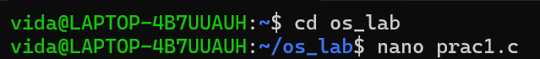
- Compiled and ran the program where the command “ls” is entered.
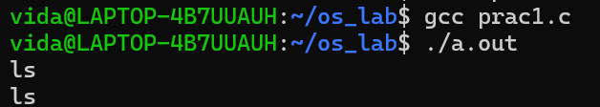
- The Child PID has been returned followed by its command execution while the parent process waited till the child process completes.
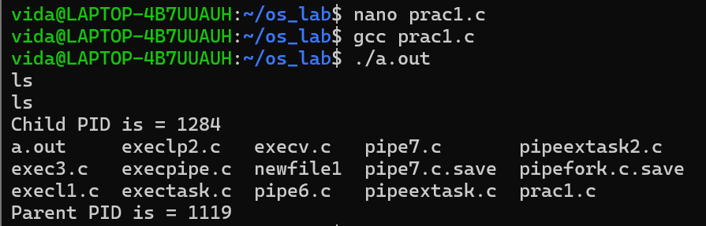
Using Linux terminal commands (uname, lscpu, lsblk, ps, top), investigated the relationship between hardware resources and operating system services
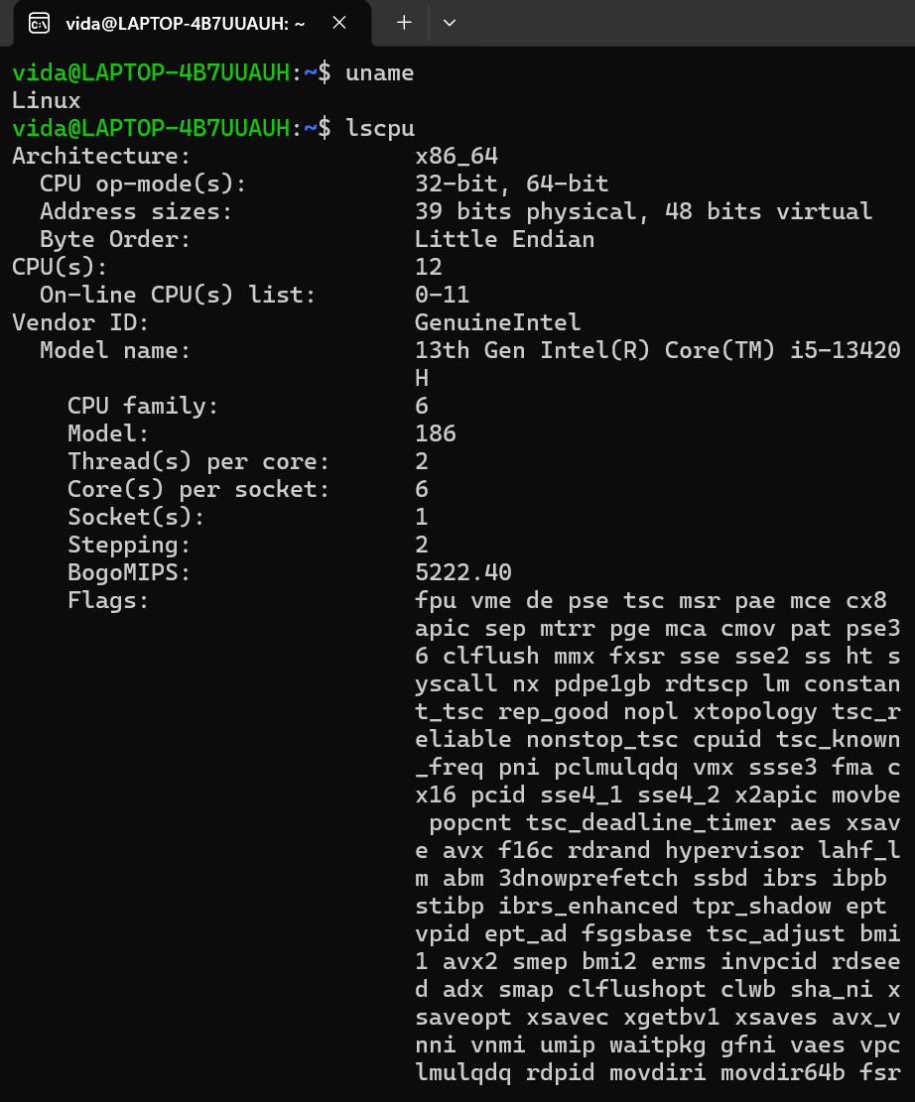
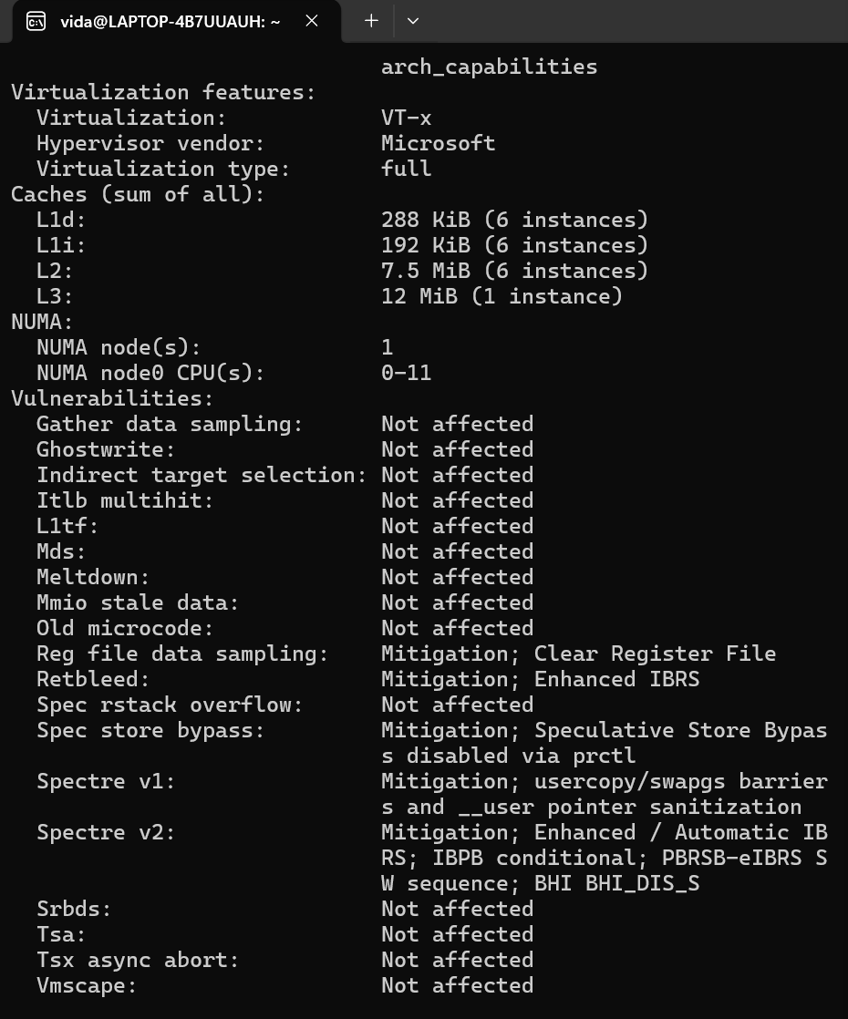
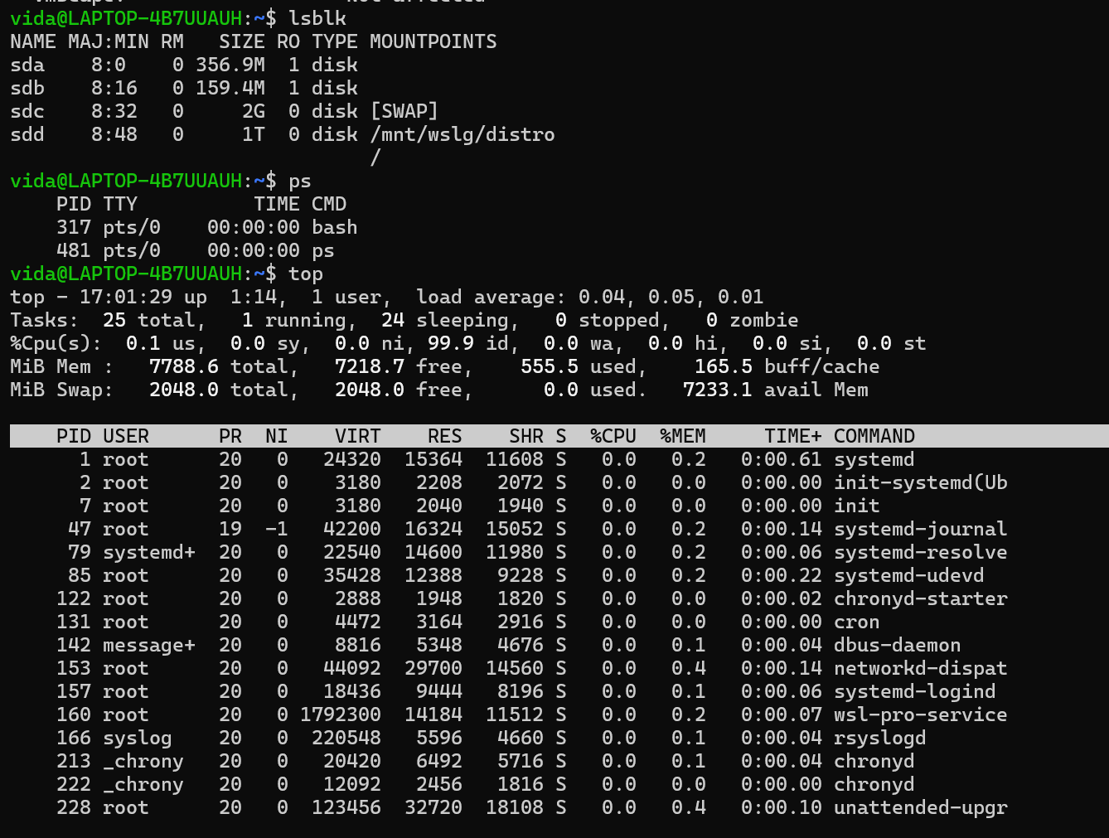
1. uname
It displays basic information about the Linux operating system and kernel.
2. lscpu
It displays CPU information such as the number of CPUs, cores, architecture, and processor details.
3. lsblk
It displays the storage devices and partitions available in the system.
4. ps
It shows the processes currently running in the system.
5. top
It shows running processes along with their CPU and memory usage in real time.

Hardware and the Operating System :
The operating system acts as a link between applications and computer hardware.
- CPU: The OS schedules processes and assigns them CPU time.
- Memory: The OS allocates RAM to processes and keeps their memory spaces separate.
- Storage: The OS manages storage devices and organizes data into files and directories.
- I/O Devices: The OS uses device drivers to communicate with devices such as keyboards, displays, and network cards.

