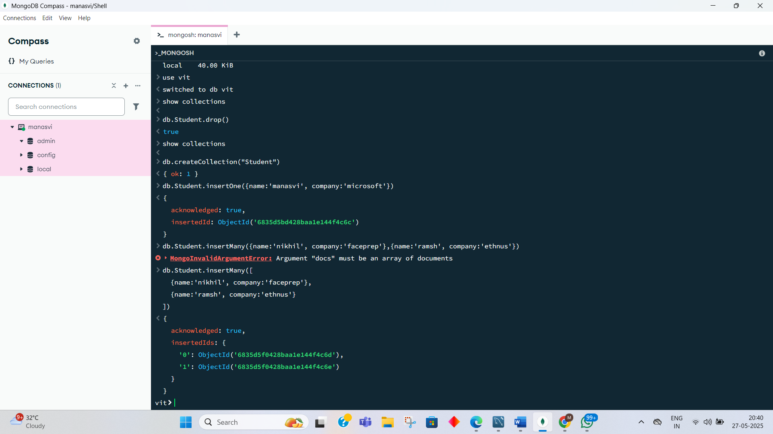
MONGODB [27TH MAY 2025]

Date: 27.05.2025
MongoDB – Day 1
Today was the first proper class on MongoDB. Till now (last 10 days), we mainly did the setup, like installing stuff, Java basics, and SQL.
In today’s class, we opened MongoDB Compass and started using mongosh (MongoDB Shell).
We did:
- show databases – to see what’s already there
- use vit – to switch or create a database
- Created a collection called Student
- Inserted data using insertOne() and insertMany()
- Made a small mistake on purpose to see the error 😅 (docs not in array)
- Then corrected it with proper array format.
The screenshot I attached shows all the commands I tried and the output I got.

