Lab Homework 1

Submitted by : Manas Vishal (01971464)

Homework on introduction to jupyter notebook and importing datasets

Task 1 : Introduction to jupyter lab/notebooks

* We first start the jupyterlab session either via terminal or through a navigator like anaconda or jupyter. I personally prefer terminal paired with miniconda for low memory usage.
* We then upload the test notebook provided in the class using “Upload” button 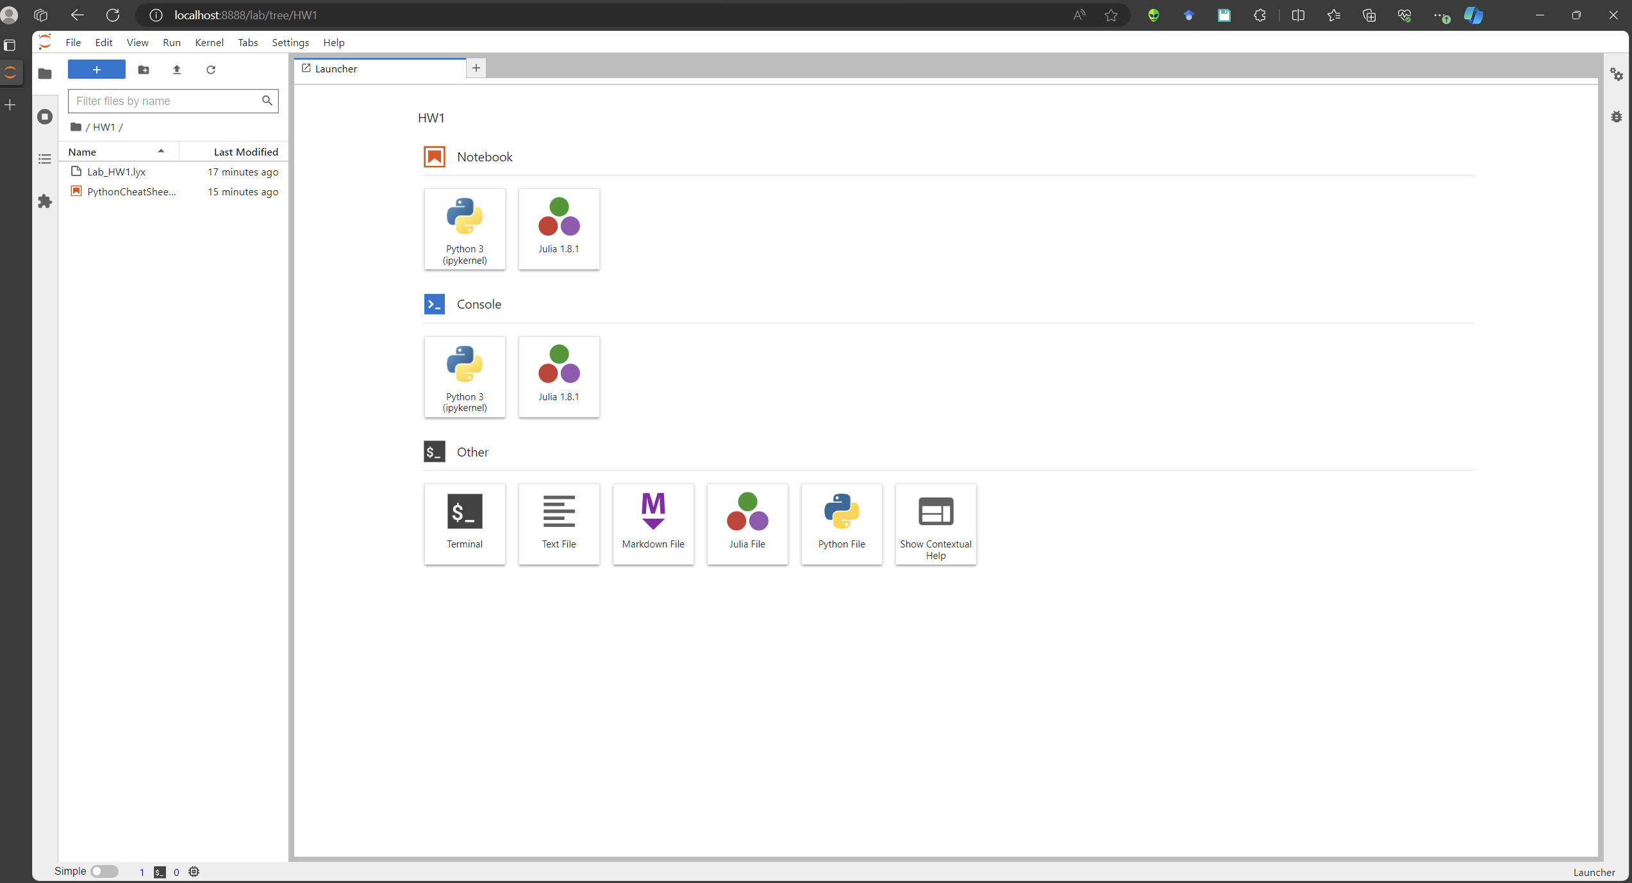

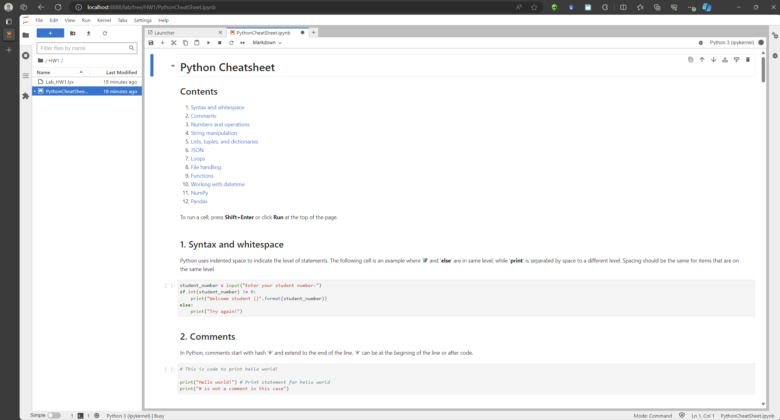

* We go through the notebook and execute the blocks of code by using Shift + Enter and later with the Run all cells function
* It is noted that Jupyter notebook also allows markdown for ease of presentation

Task 2 : Downloading data

* A new notebook is initiated to download and read data for this task

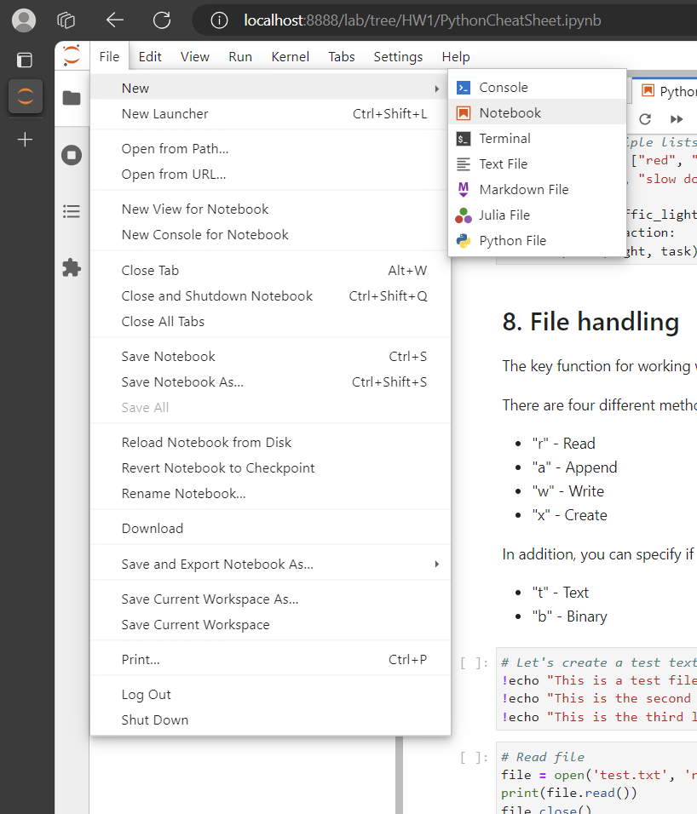

* The kernel is chosen as Python 3 kernel

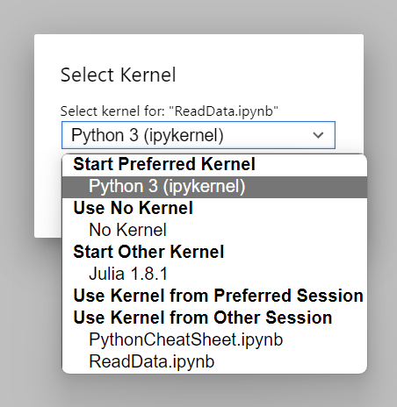

* We import the modules that are used to suppress the warnings and helps in file i/o.

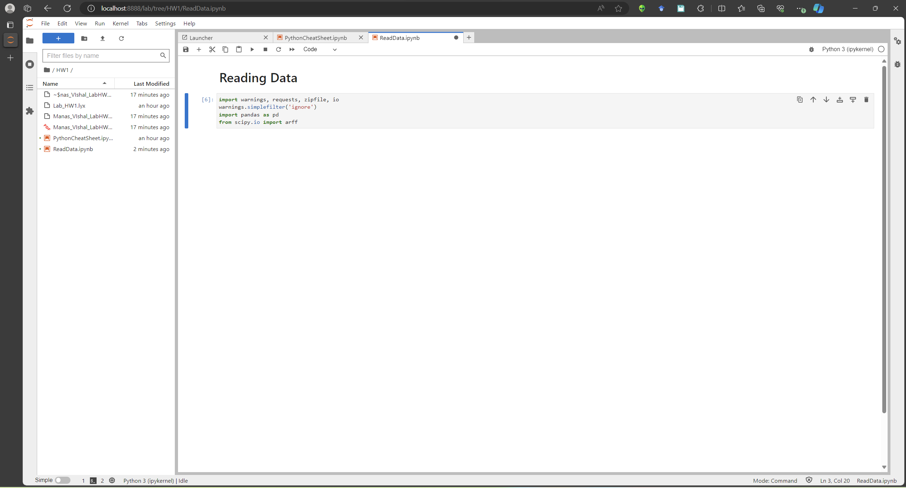

* We now download the data from web using the following commands

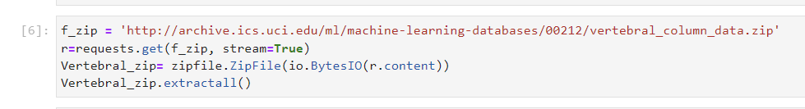

* We examine the four data files downloaded. **Not all the datasets have column headings.**

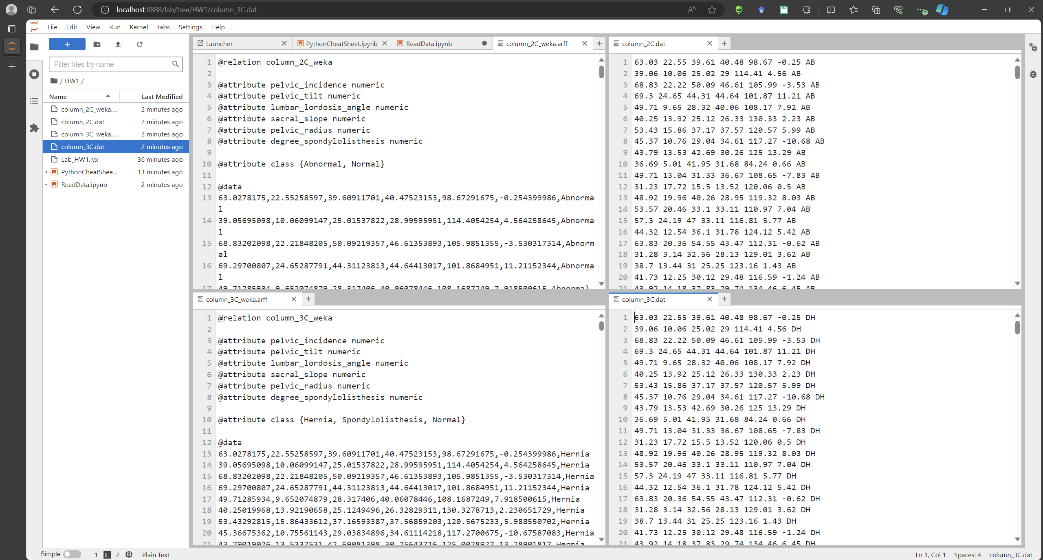

* We now examine the data using pandas for a given data file

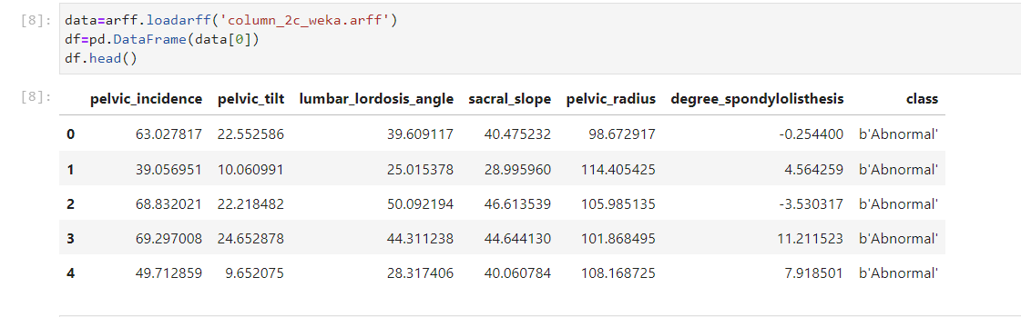

Task 3 : Downloading a notebook

* Right clicking on any file on the left pane of the browser gives us the context menu. From there, we can perform multiple functions

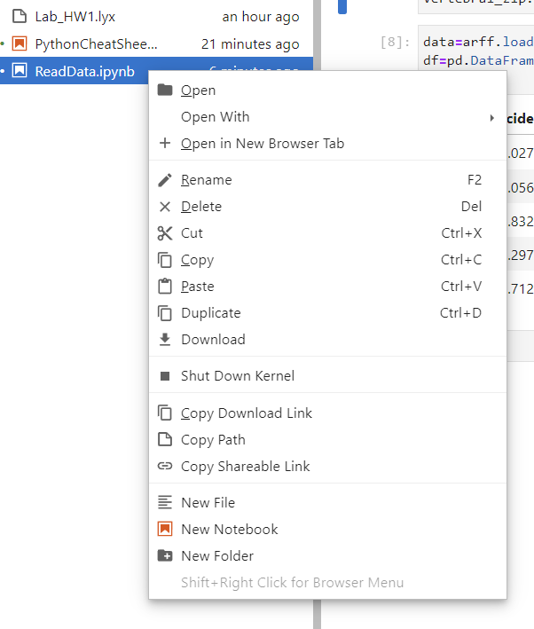

* We use the download function and then specify the path to download the file

Conclusion:

This lab homework taught us :

* How to use Anaconda and Spyder for jupyter notebook/lab
* How to create a new file and upload an existing file to the given jupyter session
* How to run python codes inside a jupyter notebook
* How to add markdown code inside a jupyter notebook
* How to download data and read it using different modules of python
* How to save any notebook to our local storage

In conclusion, after this lab I can work with online datasets in jupyter notebooks.