**PROJECT 05**

**“HTML5 BASICS”**

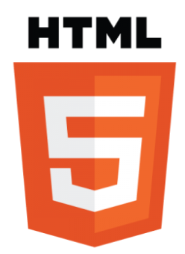

**SUBMITTED BY:**

**MANASWI M. PATIL**

**Objectives:**

HTML5, the fifth version of Hypertext Markup Language, has several objectives aimed at advancing and improving the capabilities of web development. Hypertext means that contains hyperlinks which user can navigate one place to another. Markup Language archive by tags. Markup language give a instruction to computer on how to format text.HTML5 was created to make the web better. It having new features like new element attributes ApIs and removing outdated features. Used doctype html it informs that the written document is in html5.html 5 provide a feature like app cache and web storage so it allows user to work offline and store data locally. It wanted to improve how websites show videos and audio without needing extra tools. It introduced new tags to organize content better, making websites more accessible and easier for search engines to understand. HTML5 also aimed to make forms more interactive and user-friendly. It wanted to enable websites to work offline, even without an internet connection. HTML5 focused on being consistent across different web browsers and making websites usable on various devices. It brought new features for creating dynamic content, real-time communication, and better graphics. Overall, HTML5 aimed to enhance the web experience with improved accessibility, design, and performance. HTML5's objectives collectively aim to modernize web development, providing developers with tools and features to create more dynamic, secure, and accessible web experiences.

**INDEX**

|  |  |  |
| --- | --- | --- |
| **Sr no.** | **Topic** | **Pg no.** |
| 1. | INTRODUCTION | 4 |
| 2. | STRUCTURE OF HTML5 | 8 |
| 3. | WHY HTML5 | 10 |
| 4. | WHERE TO USE HTML5 | 14 |
| 5. | KEY FEATURES OF HTML5 | 16 |
| 6. | ATTRIBUTES OF HTML5 | 18 |
| 7. | HTML LIST | 21 |
| 8. | HTML TABLE | 22 |
| 9. | HTML FORMS | 23 |
| 10. | HEAD ELEMENT | 26 |
| 11. | HTML MEDIA | 28 |
|  | CONCLUSION | 32 |

1. **INTRODUCTION**

**Installation and setup for html5**

1. **Html with notepad editor**

* Open **notepad**🡪write your html code🡪click to ‘**save as’** file option 🡪select html 🡪‘**filename.html’** save with extension **.htm or .html**🡪open your folder with save name🡪right click on folder🡪click ‘**open with’** option choose browser to display output.

1. **Html with visual studio code editor**

* Go to chrome browser 🡪search ‘visual studio code ‘🡪 download to install software in your machine.
* Click to open your editor software ‘VS CODE’ for html5.

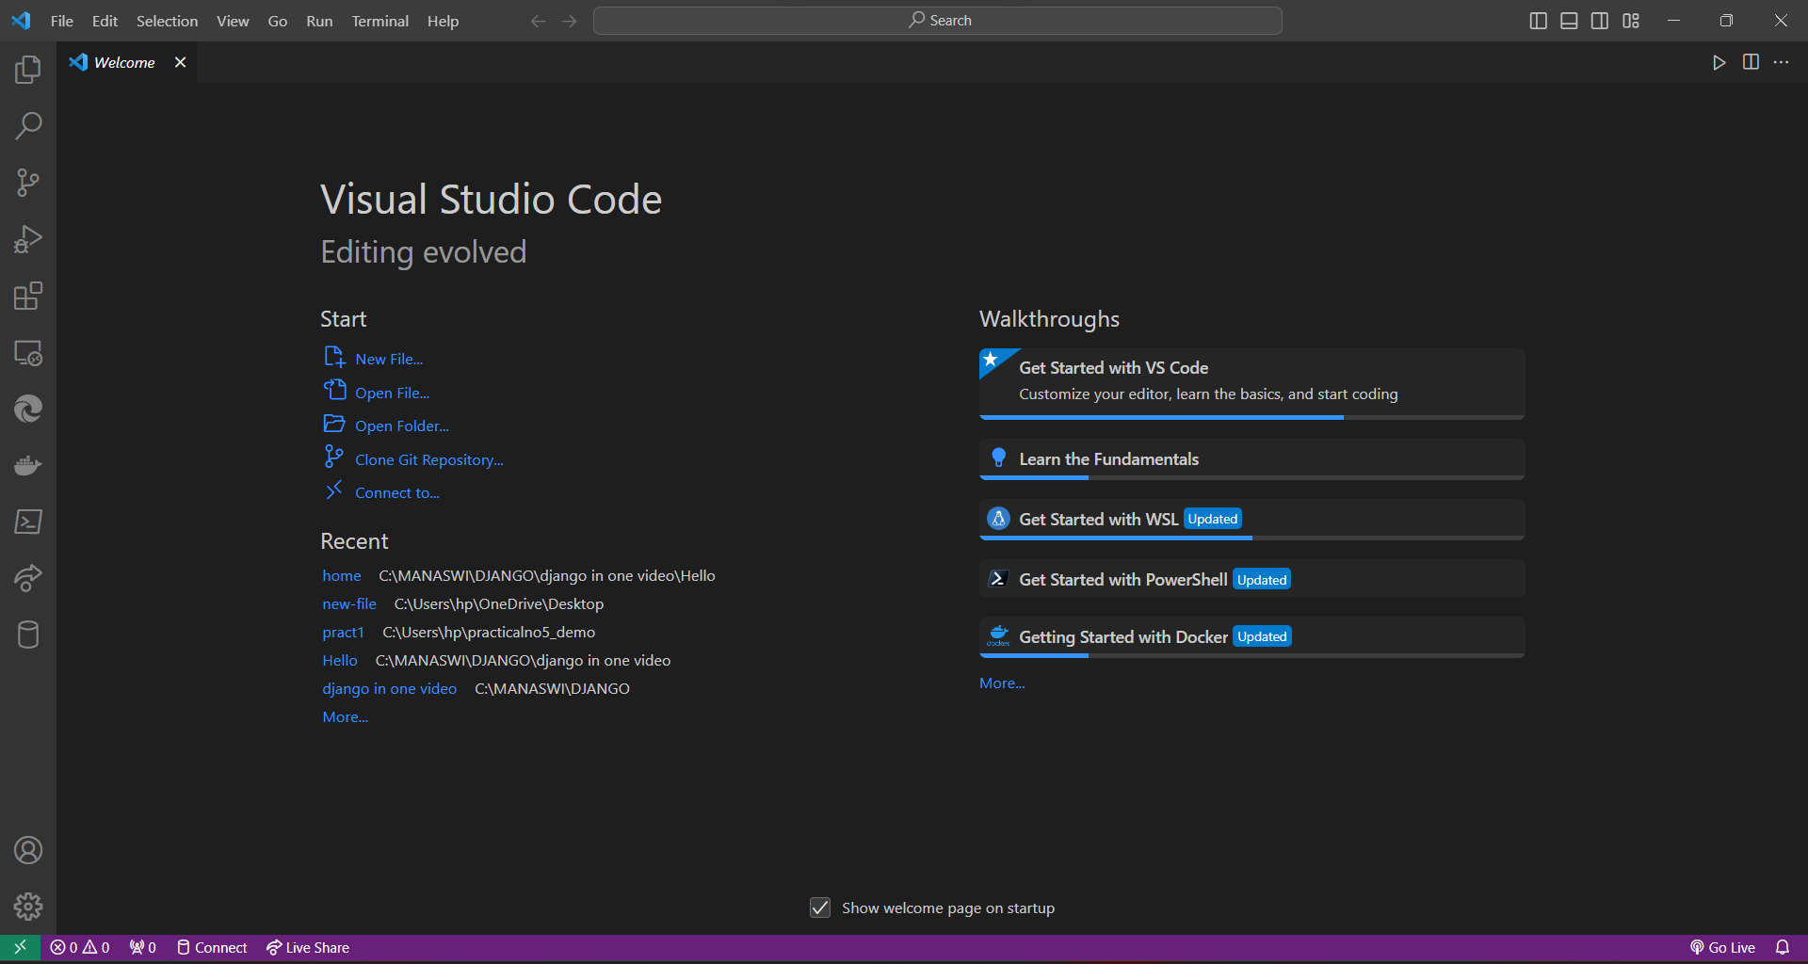

* Go to file menu🡪create new file🡪select file option🡪click🡪open editor window page.

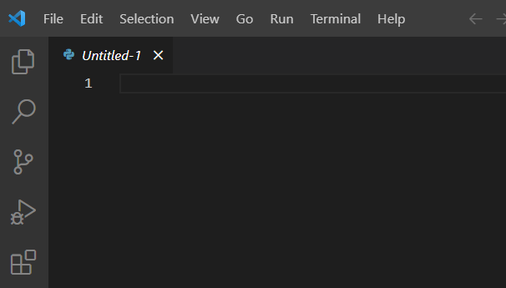

* Write a html code in text editor window🡪save it with extension ‘filename.html’.

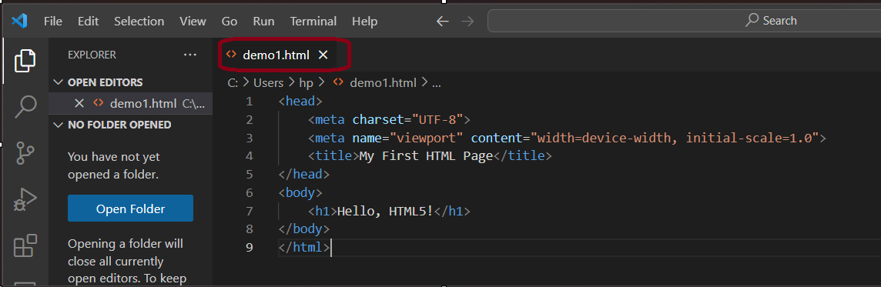

Click on run button from menu bar🡪go start debugging.



**Text Editor Setup:**

Need to Install extension for html and browser extension.

Extensions for Visual Studio Code: If you're using Visual Studio Code, consider installing extensions for HTML development. Search for "HTML" in the Extensions view and install a popular HTML extension.

Customization (Optional):Customize your text editor based on your preferences. This may include adjusting themes, font sizes, or other settings.

* Click🡪extension symbol 🡪 search🡪’html play’🡪click install.

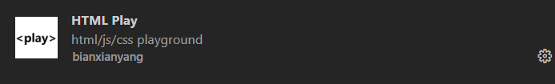

**Additional Tools :**

Web Browser: For testing and viewing your HTML pages, use modern web browsers like Google Chrome , Mozilla Firefox, or Microsoft Edge .

* Click 🡪extension symbol 🡪search🡪’chrome browser extension’🡪install.

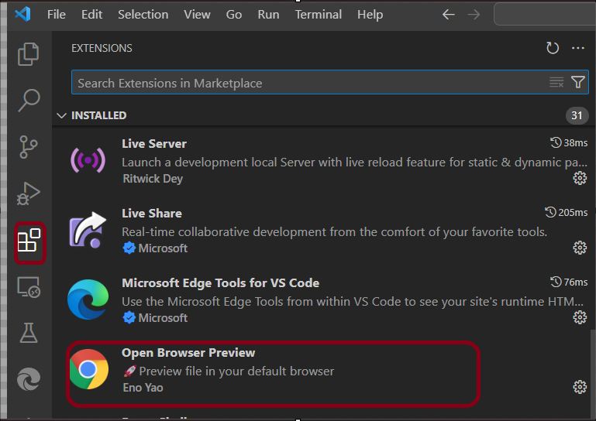

* Select browser type to run🡪select🡪automatically pop up browser window with desired output🡪 output window.

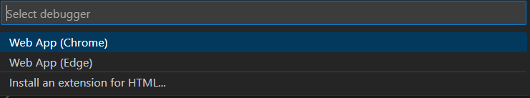

* See your website.

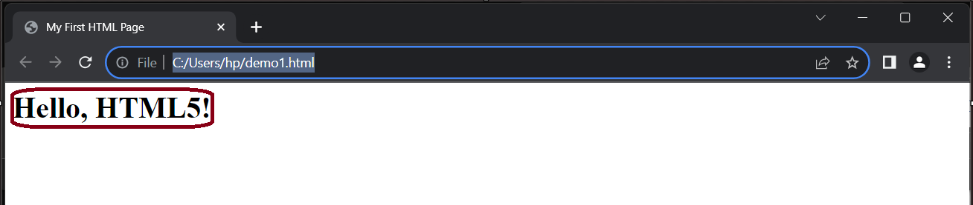

**LIVE PREVIEW EXTENSION**

* Go on extension symbol🡪search ‘live preview’🡪install.

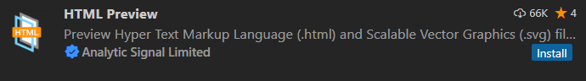

* You will see a button of ‘show preview’ within VS Code🡪Click on this button. 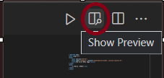
* will allow to preview your HTML right within the editor.

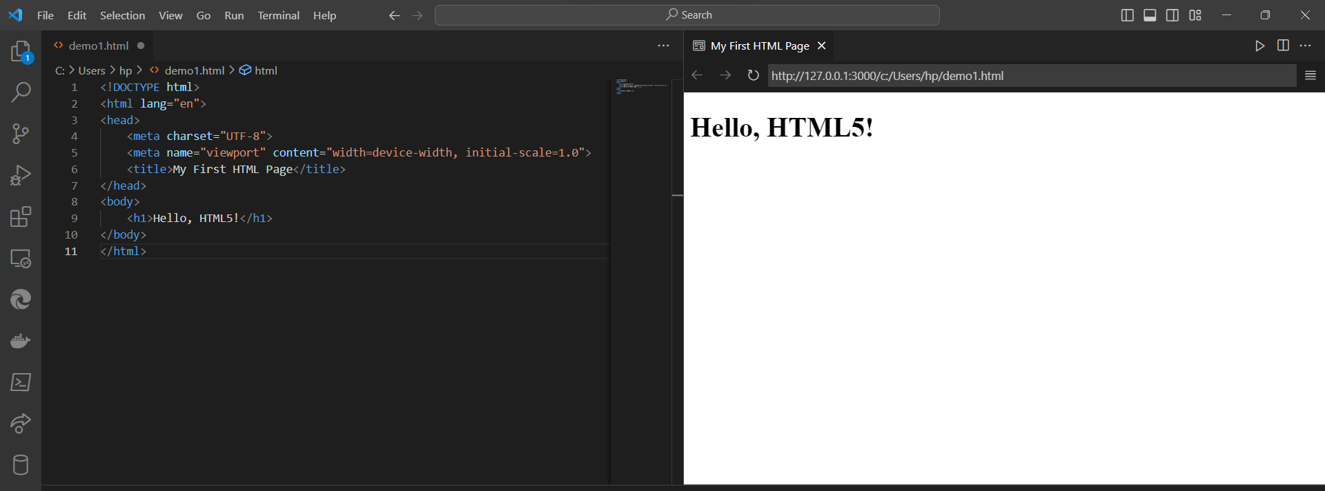

1. **STRUCTURE OF HTML5**

An HTML document is like a set of building blocks where each block is enclosed in angle brackets <...>. These building blocks are called tags, and they organize the content on a webpage.

* <html>: The main container for the entire HTML document.
* <head>: Contains meta-information about the document, like its title and character set.
* <meta charset="UTF-8">: Defines the character encoding for the document (UTF-8 supports a wide range of characters).
* <meta name="viewport" content="width=device-width, initial-scale=1.0">: Helps with responsive design on different devices.
* <title>: Sets the title of the webpage, which appears on the browser tab.
* <style>: Contains styles (CSS) for the HTML document. Here, it's styling the body, h1, and p elements.
* <body>: Holds the visible content of the webpage.
* <h1>: Represents a top-level heading.
* <p>: Represents a paragraph of text.
* <img src="https://placekitten.com/300/200" alt="Cute Kitten">

**How titles appears in page?**

* Open text editor 🡪type your code in editor🡪give title, html ,head tag in your code🡪run it to execute.

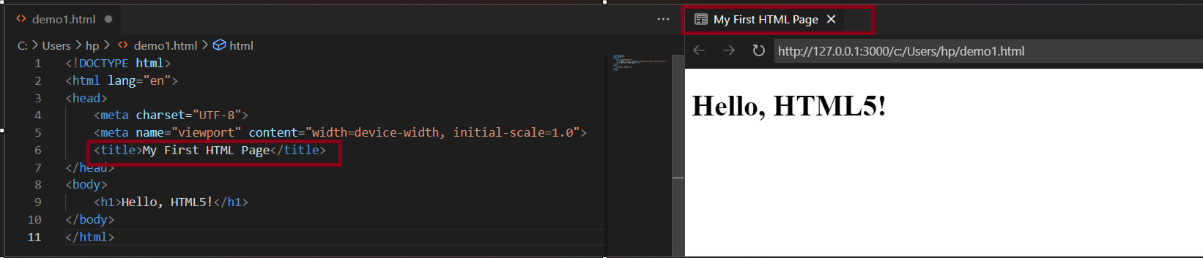

**Elements for a basic HTML document**

* <!DOCTYPE html>
* <html>
* <head>
* <title>
* </head>
* <body>
* </body>
* </html>

|  |  |  |
| --- | --- | --- |
| Start tag | Element content | End tag |
| <h1> | My First Heading | </h1> |
| <p> | My first paragraph. | </p> |
| <br> | none | none |

Some HTML elements have no content (like the <br> element). These elements are called empty elements. Empty elements do not have an end tag.

**Nested element :**

This means that elements can contain other elements .( **<html>, <body>, <h1> and <p>)**

**Html Heading:**

**<h1>** defines the most important heading**,<h6>** defines the least important heading.

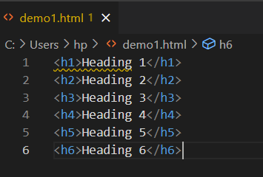 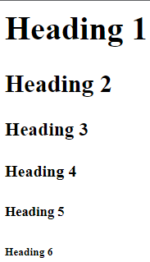

1. **WHY HTML5**

HTML5 is the latest version of Hypertext Markup Language (HTML), and it has the standard for web development .

|  |  |
| --- | --- |
| **STANDARDS** | **USES** |
| Rich Multimedia Support | * HTML5 introduces native support for audio and video elements. * This simplifies multimedia integration and enhances compatibility across browsers. |
| Semantic Structure | * HTML5 includes new semantic elements (e.g., <header>, <footer>, <nav>) that provide a clearer structure to web documents. * This improves accessibility, search engine optimization (SEO), and overall code readability |
| Enhanced Forms | * HTML5 introduces new input types email, tel, date and attributes that enhance form capabilities. validation, placeholders, and the <datalist> element make form development more robust. |
| Improved Accessibility | * Semantic elements and ARIA (Accessible Rich Internet Applications) attributes in HTML5 contribute to better accessibility. * This ensures that web content is more usable for individuals with disabilities. |
| Responsive Design | * HTML5 supports responsive web design principles, making it easier to create websites that adapt seamlessly to different screen sizes and devices. * The <meta> viewport tag and media queries are key features for responsive design. |
| Local Storage | * HTML5 provides the local Storage and session Storage APIs, allowing web applications to store data locally on the user's device. * This performance and enables offline functionality. |
| Canvas and SVG Graphics | * The <canvas> element for dynamic graphics rendering and the <svg> element for scalable vector graphics. * These features enable the creation of interactive and visually appealing content. |
| Web APIs | * HTML5 includes a set of powerful APIs such as Geolocation, Web Storage, Web Workers, and more. These APIs enable developers to access various device features and enhance web application capabilities. |
| Standardization and Cross-Browser Compatibility | * HTML5 is a standardized specification supported by major web browsers. * This reduces compatibility issues and ensures a consistent experience for users across different platforms. |
| Continuous Development and Community Support | * HTML5 is part of an ongoing effort to improve web technologies. * The development community actively contributes to its evolution, providing updates, new features, and best practices. |

**TO CREATE AND DESIGN THE STRUCTURE OF WEB PAGES USING HTML5**

**A) Create HTML5 File:**

* Open VS Code🡪create a new file🡪save it with the ‘.html’ extension.

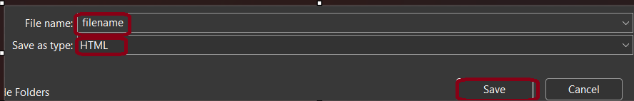

1. **HTML5 Boilerplate:**
   * Use the ! shortcut and press Enter to generate an HTML5 boilerplate code structure quickly.
2. **Emmet Abbreviations:**

Emmet is a powerful toolkit for web developers. Use Emmet abbreviations to generate HTML structure quickly.

* Type ‘html:5 ‘🡪press Tab to create an HTML5 document.

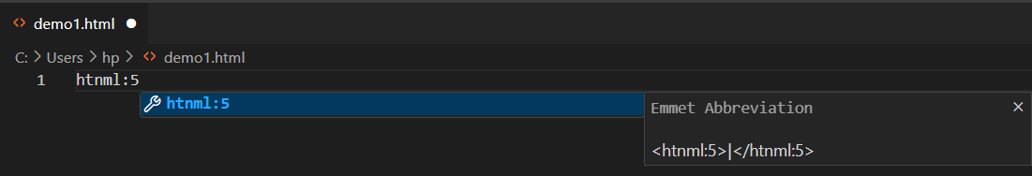

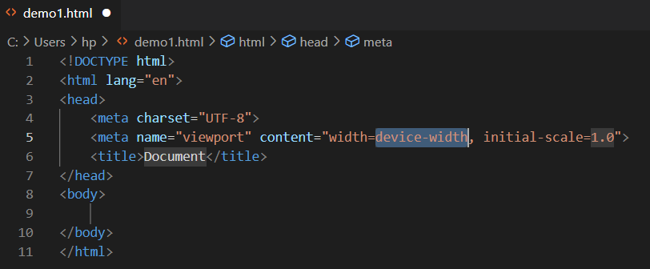

1. **HTML Tags Snippets:**

VS Code provides built-in snippets for HTML tags.

* Type the tag name ‘div’🡪press Tab to generate the complete tag.

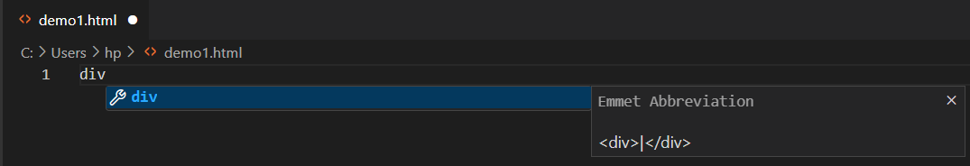

1. **Auto-Close Tags:**

VS Code automatically closes HTML tags as you type.

* type <div>🡪VS Code adds the closing </div> tag.

1. **Formatting HTML:**

* Use the Format Document command ‘Shift + Alt + F’🡪automatically format your HTML code for consistency.

1. **IntelliSense for HTML:**

VS Code provides IntelliSense for HTML, offering suggestions and autocompletions as you type.

* Pressing Enter or Tab accepts the suggestion.

1. **Preview HTML in Browser**:

To preview your HTML file in a browser.

* Click extension🡪 search for Install "Live Server" extension 🡪install🡪 Right-click on the HTML file🡪select "Open with Live Server."

After right click window will pop up like this

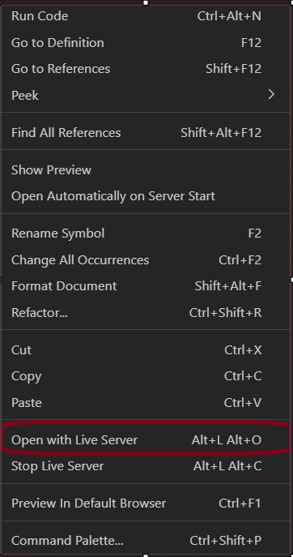

1. **Navigate HTML Structure:**

* Use the "Go to Symbol" command (Ctrl + Shift + O) 🡪to navigate to different sections of your HTML file quickly.

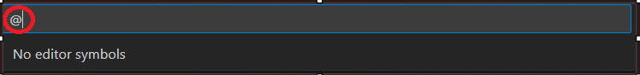

1. **HTML Linting:**

To catch errors and maintain coding standards. It provides feedback on potential issues in your HTML code.

* Click extension🡪search ‘html hint’ 🡪install.

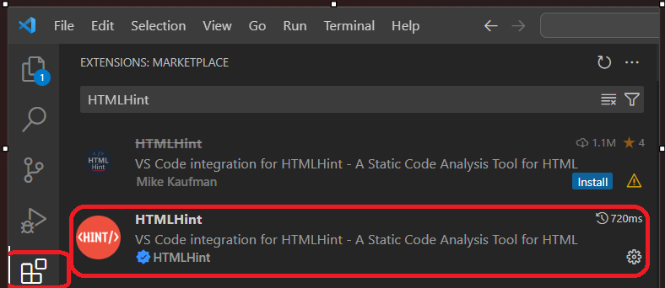

1. **HTML Snippets:**

To get additional snippets for common HTML patterns and structures.

* Go with extension 🡪search "HTML Snippets" extension🡪install.

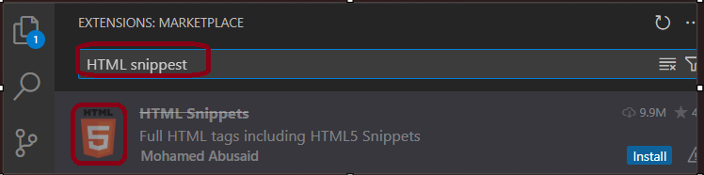

1. **Multi-Cursor Editing:**

To edit multiple occurrences of HTML tags simultaneously.

* Click “Alt + Click” .

1. **Comment and Uncomment:**

Use the Comment Line (Ctrl + /) and Uncomment Line (Ctrl + /) commands to add or remove comments in your HTML code.

1. **WHERE TO USE HTML5**

HTML5 is a versatile and powerful markup language used for structuring and presenting content on the web.

1)**Web Development:**

HTML5 is the foundational language for creating web pages and web applications. It is used to define the structure and content of websites.

2**)Cross-Platform Mobile App Development:**

HTML5, combined with CSS3 and JavaScript, is often used for building mobile applications that can run on various platforms. Frameworks like Apache Cordova and Ionic enable the development of cross-platform mobile apps using HTML5.

3**) Rich Media Content:**

HTML5 introduces native support for audio and video, allowing developers to embed multimedia content directly into web pages without relying on third-party plugins. This is commonly used for online streaming, video playback, and interactive multimedia experiences.

4)**Gaming:**

HTML5 includes the <canvas> element, which provides a drawing surface for creating interactive graphics and animations. This has led to the development of browser-based games using HTML5 and JavaScript.

5)**Web-based Applications:**

HTML5, along with JavaScript and CSS3, is extensively used for building modern, interactive web applications. Single Page Applications (SPAs) often leverage HTML5 features for dynamic content and improved user experiences.

**6)E**-**Learning and Online Courses:**

HTML5 supports the creation of interactive and multimedia-rich e-learning content. Online course platforms and educational websites use HTML5 for delivering engaging educational materials.

**7)Responsive Web Design:**

HTML5, together with CSS3, enables the creation of responsive web designs that adapt to different screen sizes and devices. This is crucial for providing a consistent user experience across desktops, tablets, and smartphones.

**8)Web APIs and Services:**

HTML5 includes APIs (Application Programming Interfaces) that allow web applications to access device features and services. For example, the Geolocation API enables location-based services in web applications.

**9)Offline Web Applications:**

HTML5 introduces features like the Application Cache and Web Storage, allowing web applications to work offline and store data locally on users' devices.

**10)Web VR and Augmented Reality:**

HTML5 is used in the development of virtual reality (VR) experiences on the web. WebVR and WebXR standards enable the creation of immersive VR and augmented reality (AR) content directly in web browsers.

**11)Data Visualization:**

HTML5, along with JavaScript libraries like D3.js, is widely used for creating interactive data visualizations and charts on the web.

**12)Email Newsletters:**

HTML5 is employed in creating visually appealing and responsive email newsletters. Modern email clients support HTML5 for enhanced design and interactivity.

1. **KEY FEATURES OF HTML5**

HTML5 introduces several key features and improvements over its predecessor, HTML4. Here are some basics of HTML5:

HTML5 uses a simplified, shorter document type declaration **<!DOCTYPE html>.** This declaration informs the browser that the document is written in HTML5.

* **Semantic Elements**:HTML5 introduces new semantic elements that provide better structure and meaning to web content. Examples include <header>, <nav>, <article>, <section>, <footer>, and <aside>. These elements help define the different parts of a webpage.
* **Improved Form Elements:** HTML5 enhances form elements, introducing new input types such as email, url, tel, number, date, and more. Also includes attributes like placeholder, required, and pattern for better form validation.
* **Multimedia Support:** Native support for embedding audio and video content without the need for third-party plugins. The <audio> and <video> elements allow developers to include multimedia directly within the document.
* **Canvas Element:** The <canvas> element provides a drawing surface for creating graphics, animations, and interactive content using JavaScript. It is commonly used for games, data visualizations, and dynamic graphics.
* **Local Storage**:HTML5 introduces the localStorage and sessionStorage APIs, allowing web applications to store data locally on the user's device. This is useful for creating persistent client-side storage.
* **New Semantic Elements**:HTML5 introduces several new semantic elements, such as <header>, <nav>, <footer>, <article>, <section>, and <figure>. These elements enhance the structure of web documents and improve accessibility.
* **Responsive Design**:HTML5, when combined with CSS3, facilitates the creation of responsive web designs. Media queries and flexible grid layouts enable web pages to adapt to various screen sizes and devices.
* **Web Storage**:HTML5 includes the localStorage and sessionStorage APIs, providing a way for web applications to store data on the client's device. This is helpful for persistent local storage.
* **Drag and Drop**: HTML5 introduces native support for drag-and-drop interactions. Developers can use the draggable attribute and events like ondragstart and ondragend to enable drag-and-drop functionality.
* **Geolocation API**:HTML5 includes the Geolocation API, allowing web applications to access the user's geographical location. This is useful for location-based services and applications.
* **WebSockets:** WebSockets provide a full-duplex communication channel over a single, long-lived connection. This enables real-time communication between the browser and the server.
* **New Document Structure**: HTML5 simplifies the document structure by introducing new elements and deprecating some older ones. For example, <nav> for navigation links, <article> for self-contained content, and <section> for grouping related content.

1. **ATTRIBUTES OF HTML5**

* **Class:** <element class="classname">

Specifies one or more class names for an element. Used for styling and JavaScript interaction.

* **id:**<element id="uniqueID">

Provides a unique identifier for an element, which can be used for CSS styling and JavaScript targeting.

* **style:**<element style="property: value;">

Applies inline CSS styles to an element, allowing for customization of its appearance.

* **src:** <img src="image.jpg" alt="Description">

Specifies the source (URL) of external resources such as images, scripts, or multimedia elements.

* **alt:** <img src="image.jpg" alt="Description"> Provides alternative text for images, which is displayed if the image cannot be loaded.
* **href:** <a href="https://example.com">Link Text</a>

Specifies the URL of a linked resource, commonly used with anchor (<a>) elements.

* **target**:<a href="https://example.com" target="_blank">Link Text</a>

Defines where to open the linked document. "_blank" opens the link in a new tab or window.

* **width/height:**<img src="image.jpg" width="100" height="100" alt="Description">

Sets the width and height of images or other elements.

* **placeholder:**<input type="text" placeholder="Enter your name">

Provides a short hint that describes the expected value of an input field.

* **disabled:**<button disabled>Click me</button>

Disables interaction with the element, such as buttons or input fields.

* **required:**<input type="text" required>

Specifies that an input field must be filled out before submitting a form.

* **autocomplete**: <input type="text" autocomplete="off">

Controls whether an input field should have autocomplete enabled or disabled.

**HTML Comments**

Comments in HTML are like little notes you leave in your code for understanding.HTML comments are denoted by **<!-- content -->**and used this **s**hortcut **‘Ctrl + /’** for commenting the line.

There are two types of comments in html single line and multiline comments. **Single-line** comments are contained within one line. They are useful for short annotations.



**Multi-line comments** span across multiple lines, making them ideal for detailed explanations or temporarily disabling blocks of code.

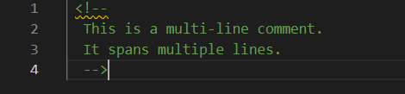

**Horizontal<hr> Line Tag**

**<hr>** tag it is used to add a horizontal line in your HTML document.



The <hr> tag is an empty or self-closing tag, meaning it doesn't require a closing tag. It serves as a visual separator, dividing different sections of your document with a horizontal line.

**Line Break Tag**

To insert a line break in your HTML document, **use <br>** tag.<br> tag is used to insert line breaks in text or paragraphs.



**Anchor Tag**

In HTML, links are created using the <a> tag, also known as the Anchor tag.

Image Tag.

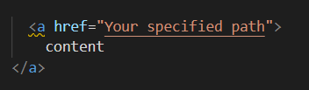

**PreTag**

The <pre> tag preserves the original formatting of text, making it an excellent choice for displaying code where spacing and indentation are key.

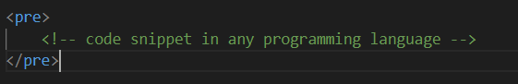

**INLINE & BLOCK ELEMENTS**

**Inline elements** are like text that doesn't start a new line and only uses as much space as needed. They flow within the content of other elements.



The "link" doesn't start a new line and only occupies the space required for the word "link" within the sentence. It's part of the flow of the text.

**Block elements** in HTML are like building blocks for web pages. They usually begin on a new line and stretch across the entire width of their container. Headings, paragraphs, lists, and divs, form the main sections of a webpage. When placed together, they stack on top of each other vertically, creating a structured layout. In simpler terms, block elements help organize and structure content on a webpage.

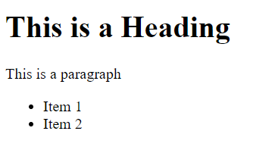 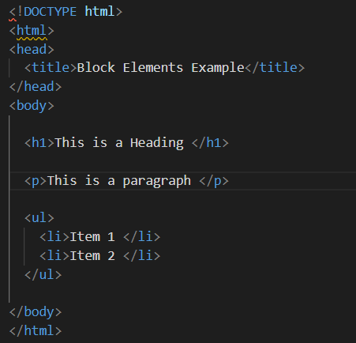

In this example, <h1>, <p>, and <ul> are block-level elements. They each start on a new line and extend to the full width of their containing element (in this case, the <body> element).

1. **HTML LISTS**

In HTML, lists are used to organize and structure content. There are two main types of lists **ordered lists and unordered lists.**

**Ordered List (ol):** This type of list is used when the order of items matters. Each list item is prefixed with a number.

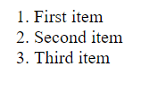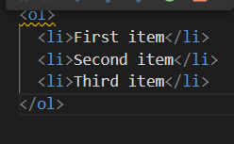

HTML Unordered List

**Unordered List (ul):** This type of list is used when the order of items doesn't matter. Each list item is prefixed with a bullet point.

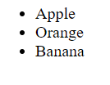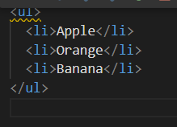

There is a third type called the **Definition List (dl),**this type is used to define terms and their corresponding descriptions.

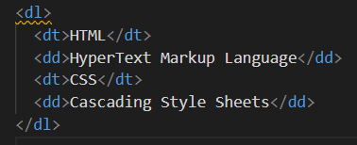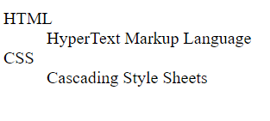

These lists provide a way to structure information in a readable and organized manner on a webpage.

1. **HTML TABLES**

**HTML tables** allow you to arrange data like text, images, and links in rows and columns. You use the <table> tag to start and end a table.

**Syntax:**

<table>

// table content

</table>

**Key Elements of HTML Table**

* <table>: Defines the table itself.
* <tr>: Used for table rows.
* <th>: Used for table headings.
* <td>: Used for table cells (data).

**Basic Table Structure**

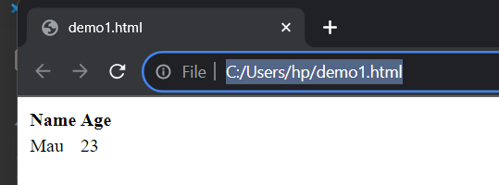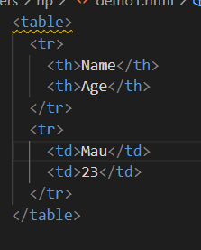

**Attributes of table**

1. rowspan : If you want a table cell to span multiple rows, you can use the rowspan attribute.
2. colspan : If you want a table cell to span multiple columns, you can use the colspan attribute.



1. **HTML FORMS**

HTML forms are essential for collecting user input on web pages. Whether it's a search bar, a login screen, or a multi-field registration form, HTML forms play a key role in web interactions. They enable users to submit data, which can be processed, stored, or returned by a server.The fundamental structure of an HTML form is encapsulated within the <form> tags. Inside these tags, you'll place various form controls like text fields, checkboxes, radio buttons, and buttons for submitting the form.

**How to create form?**

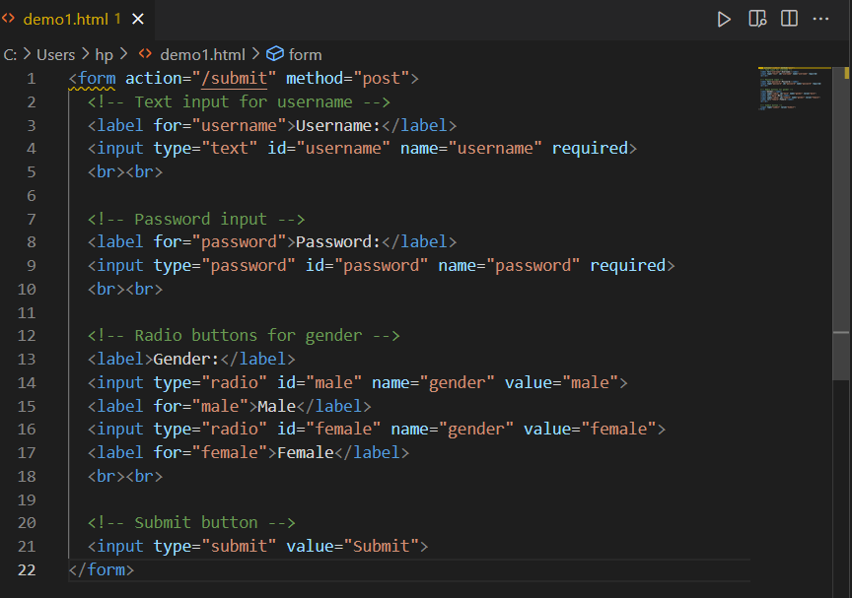

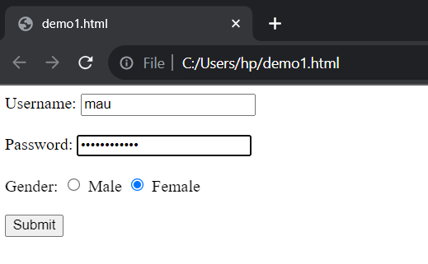

**Usage of control forms:**

<input type="radio" id="male" name="gender" value="male">

**The <input>** tag is commonly used to create form controls. The attributes of this tag define the control's behavior.

The **"type"** attribute specifies the type of input control (e.g., text, password, checkbox).

The "**name"** attribute is used for identifying the control, especially when the data is sent to the server.

The **"value"** attribute sets a default value for the control, which the user can overwrite.

**HTML Input Types**

Input types in HTML forms are the backbone of interactive web applications. They allow users to send information to web servers for various purposes like searching, logging in, or providing feedback.

1. **Text Input**

The text input type is the most basic form of input and is widely used for collecting simple text data.

Syntax: <input type="text" name="username" placeholder="Enter your username">

In the above example, the placeholder attribute provides a hint to the user about what to enter.

1. **Password Input**

The password input type is similar to the text type but hides the characters entered by the user for security reasons.

Syntax: <input type="password" name="password" placeholder="Enter your password">

1. **Radio Buttons**

Radio buttons are used when you want the user to select only one option from a set of choices.

Syntax:<input type="radio" id="male" name="gender" value="male">

<label for="male">Male</label>

<input type="radio" id="female" name="gender" value="female">

<label for="female">Female</label>

1. **Checkbox**

Checkboxes allow the user to select multiple options from a set.

**S**yntax:<input type="checkbox" id="subscribe" name="subscribe" value="yes">

<label for="subscribe">Subscribe to newsletter</label>

More input types

**Common Attributes for form**

1. **action**

The action attribute specifies the URL where the form data should be sent after submission.

Syntax: <form action="/submit.php" method="POST">

</form>

1. **method**

The method attribute defines how data is sent. The two most common methods are GET and POST.

Syntax:<form action="/submit.php" method="POST">

</form>

1. **name**

The name attribute specifies the name for the form element, making it easier to reference in scripts or the server-side code.

Syntax:<input type="text" name="username">

**New Attributes of HTML5**

1. **placeholder**

This attribute provides a hint to the user as to what can be entered in the field.

Syntax:<input type="text" placeholder="Enter your username">

1. **required**

The required attribute makes a field mandatory to fill out.

Syntax:<input type="text" required>

1. **autofocus**

The autofocus attribute automatically focuses the cursor on the particular input when the page loads.

Syntax:<input type="text" autofocus>

**Validation Attributes of HTML5**

1. **required**

This attribute makes a field mandatory.

Syntax:<input type="text" required>

1. **pattern**

The pattern attribute specifies a regular expression that the input must match to be valid.

Syntax:<input type="text" pattern="[a-zA-Z0-9]+">

1. **HEAD ELEMENTS**

The **<meta> tags** in HTML provide metadata about the HTML document. Metadata is data (information) about data. **<meta>** tags always go inside the document's **<head>** tag and are typically used to specify the character set, page description, keywords, author, and other metadata.

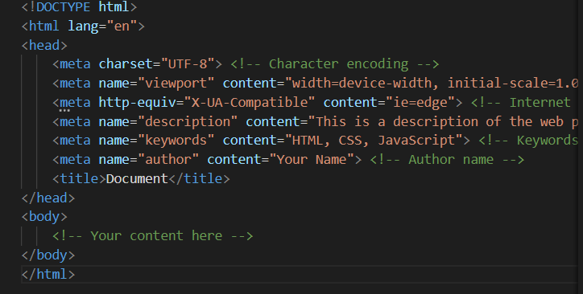

**Character Encoding (charset)**: <meta charset="UTF-8"> sets the character encoding for the webpage.

**Viewport:** <meta name="viewport" content="width=device-width, initial-scale=1.0"> sets the viewport to scale the page to the screen width, useful for responsive design.

**IE Compatibility**: specifies that the page should be rendered using the latest rendering engine available on Internet Explorer.

**Description:** provides a brief description of the webpage, which search engines may use in search results.

**Keywords:** specifies keywords for the webpage, which were historically used by search engines but are less relevant today.

**Author:** indicates the name of the author of the webpage.

**HTML Meta Tags**

**The <link> tag** is commonly used to link external stylesheets to an HTML document. It's a self-closing tag, meaning it doesn't require a closing tag.

**Syntax**:<link rel="stylesheet" type="text/css" href="styles.css">

**The <script> tag** is used to include JavaScript code or files in an HTML document. Unlike the <link> tag, the <script> tag must be closed with a </script> tag.

**Syntax**: <script src="script.js" type="text/javascript"></script>

1. **HTML MEDIA**
2. **The <video> tag** is used to embed video files in an HTML document. It supports multiple attributes to control the video playback.

* <video> Defines a video or movie
* <source> Defines multiple media resources for media elements, such as <video> and<audio>
* <track> Defines text tracks in media players

**Attributes for <video> Tag**

* src: Specifies the path to the video file.
* controls: Adds video controls, like play, pause, and volume.
* autoplay: Automatically starts playing the video when the page loads.
* loop: Repeats the video once it ends.
* muted: Mutes the video by default.
* poster: Specifies an image to be displayed before the video starts playing.
* width and height: Specifies the dimensions of the video.

**Example of <video> tag:**

* Click **notepad** editor 🡪write your code🡪save it🡪**right click** on folder from file🡪click open with **vs code** or any browser🡪from vs code choose run button to run the code🡪output will display.

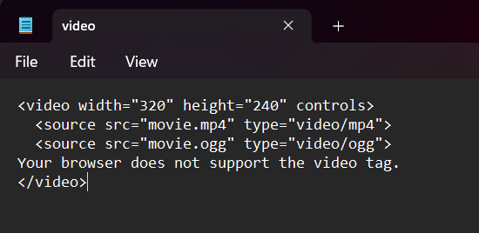

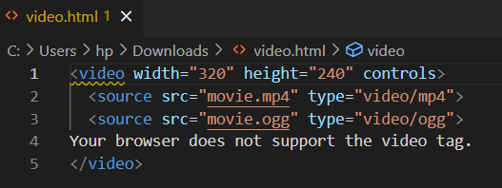



1. **The <audio> tag** is used to embed audio files in an HTML document. It also supports multiple attributes for control**.**

**Attributes for <audio> Tag**

* src: Specifies the path to the audio file.
* controls: Adds audio controls, like play, pause, and volume.
* autoplay: Automatically starts playing the audio when the page loads.
* loop: Repeats the audio once it ends.
* muted: Mutes the audio by default.
* preload: Specifies if and how the audio should be loaded when the page loads . Preload has the these three values ('auto', 'metadata', 'none').

Only MP4, WebM, and Ogg video are supported by the HTML standard.

**Example:**

* Click **notepad** editor 🡪write your code🡪save it🡪**right click** on folder from file🡪click open with **vs code** or any browser🡪from vs code choose run button to run the code🡪output will display.

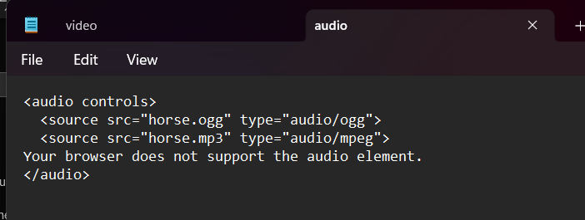

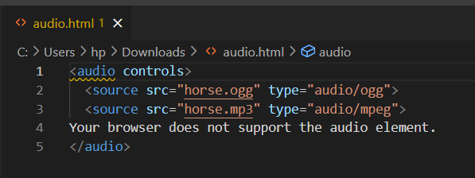

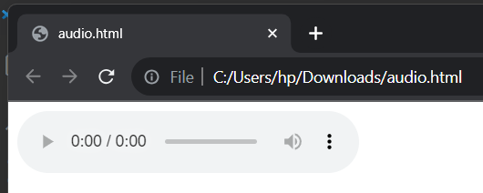

**How to Embed SVG in HTML**

Scalable Vector Graphics (SVG) has become an indispensable part of modern web development. SVG enables developers to create high-quality, scalable graphics that look crisp at any size or resolution. SVG can be embedded in HTML in several ways:

**Inline SVG:** Directly writing the SVG XML code within HTML.

**Using an <img> tag:** Point the src attribute to an SVG file.

**Using CSS:** Setting SVG as a background image in a CSS file.

**I Frames in HTML**

An iFrame is an HTML element that enables an inline frame for the embedding of external content. Essentially, you can load another web page within a designated area of your current webpage.

**Syntax:** <iframe src="URL" width="width" height="height"></iframe>

**Attributes of iframe tag**

* src: Specifies the URL of the page to embed.
* height and width: Define the dimensions.
* frameborder: Indicates whether to display a border.
* scrolling: Controls the scrollbars.
* name: For targeting the iFrame in JavaScript.

**HTML plugins**

Plug-ins are computer programs that extend the standard functionality of the browser.

Plugins are used to different purpose are listed below:

* To run Java applets
* To run Microsoft ActiveX controls
* To display Flash movies
* To display maps
* To scan for viruses
* To verify a bank id

The <embed> element is supported in all major browsers.

The <wbr> (Word Break Opportunity) tag specifies where in a text it would be ok to add a line-break.

**CONCLUSION**

HTML5, is the fifth version of Hypertext Markup Language, is a modern and versatile standard for creating web content. It introduces new elements, attributes, and functionalities that enhance the structure and presentation of websites, making them more dynamic and interactive. With improved support for multimedia, graphics, and offline capabilities, HTML5 has become a fundamental technology for web development, providing a foundation for building engaging and accessible online experiences. Embracing HTML5 empowers developers to create feature-rich, responsive, and forward-looking web applications.