Name: Manaswi Rajne

Section: A

MIS number: 11231501

Subject: Python Lab

Lab 1

Que 1. Write a program to get the Python version you are using.

Code:

#python version using platform module

import platform

print(platform.python_version())

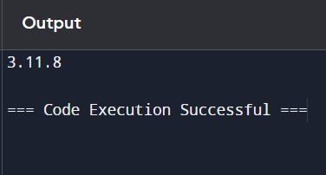

Que 2. Write a Python Program to list all the keyword in Python.

Code:

# importing the module

import keyword

# printing the keywords

print("List of all Keywords are :")

print(keyword.kwlist)

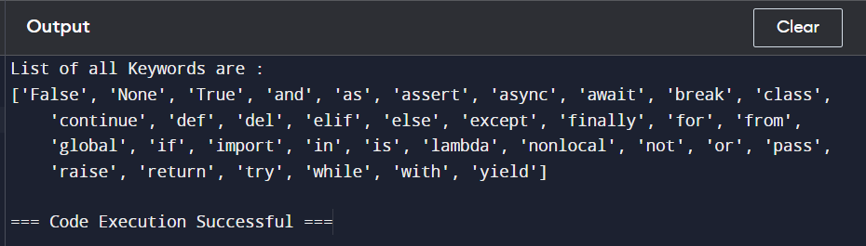

Que 3. Create a program that asks the user to enter their name and their age. Print out a message addressed to them that tells them the year that they will turn 100 years old.

Code:

name = input("Enter your name:")

age = int(input("Enter your age:"))

val = 100-age

print("You will get 100 years old in:")

print(2024+val)

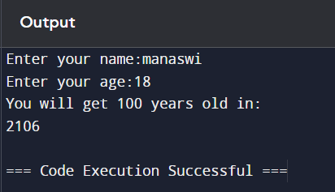

Que 4. Write a python program which accepts the radius of a circle from the user and compute the area.

Code:

PI = 3.14

r = float(input("Enter the radius of a circle: "))

area = PI*r*r

print("Area of the circle : ")

print(area)

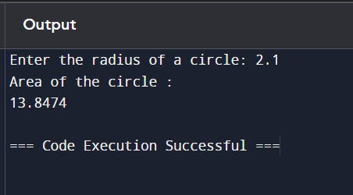

Que 5. Ask the user for a number. Depending on whether the number is even or odd, print out an appropriate message to the user.

Code:

num = int(input("Enter a number: "))

if num&1:

print(num , "is an odd number.")

else:

print(num , "is an even number.")

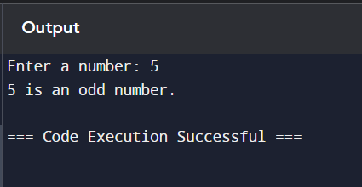

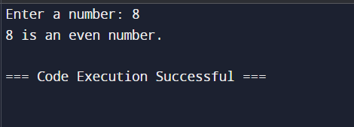

Que 6. Ask the user for a string and print out whether this string is a palindrome or not.

Code:

str = input("Enter a string: ")

num = 1

for i in range(0, int(len(str)/2)):

if str[i] != str[len(str)-i-1]:

num = 0

if num == 1:

print("It is a palindrome.")

else:

print("It is not a palindrome.")

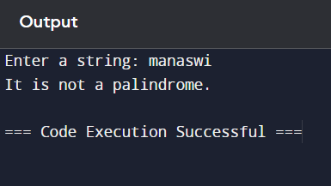

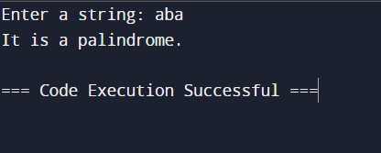

Que 7. Write a python program to get a single string from two given strings, separated by a space and swap the first two characters of each string.

Code:

a = input("Enter the first string of length greater than 1: ")

b = input("Enter the second string of length greater than 1: ")

# Swap the first two characters of a and b

a_new = b[0] + b[1] + a[2:]

b_new = a[0] + a[1] + b[2:]

print(a_new, " ", b_new)

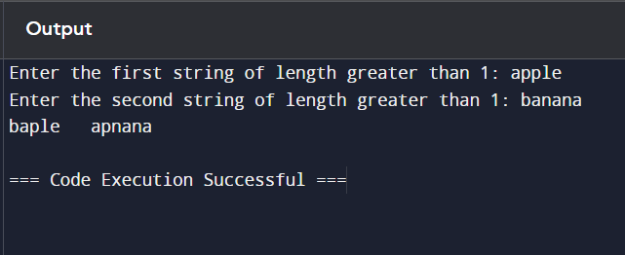

Que 8. Ask the user for a string containing lowercase letters, uppercase letters, digits or underscore or combination of all. Write a python program to check whether the string is a valid identifier.

Code:

ans = input("Enter any string with uppercase, lowercase, digits and underscore containing in it: ")

if ans.isidentifier():

print("Valid Identifier")

else:

print("Invalid Identifier")

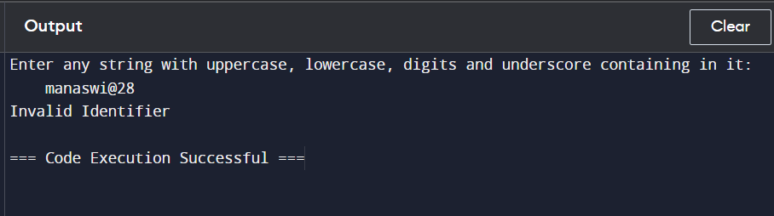

Que 9. Write a program to change a given string to a new string where the first and last chars have been exchanged.

Code:

str = input("Enter a string: ")

st = str[0]

en = str[-1]

fin = en + str[1:-1] + st

print(fin)

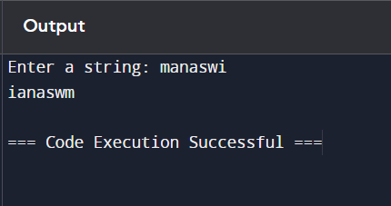

Que10. Write a program that takes input from the user and displays that input in upper and lower cases.

Code:

str = input("Enter a string: ")

print("Upper case: ", str.upper())

print("Lower Case: ", str.lower())



