Name: Manaswi Rajne

Section: A

MIS number: 112315101

Subject: Python Lab

Python Lab Assignment 2

1. Write a Program for checking whether the given number is an even number or not.

Code:

a = int(input());

if a&1 :

print("It is an odd number.")

else :

print("It is ana even number.")

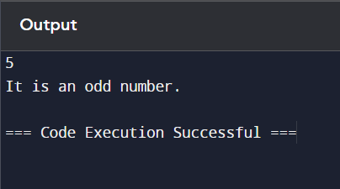

1. Using for loop, write a program that prints out the decimal equivalents of 1/2, 1/3, 1/4, . . . , 1/10.

Code:

for i in range(2,11) :

print(1/i)

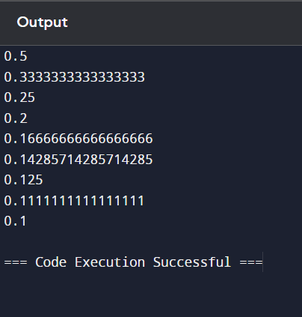

3) Write a program using a while loop that asks the user for a number, and prints a countdown from that

number to zero.

Code:

a = int(input())

while a :

print(a)

a = a-1

print(a)

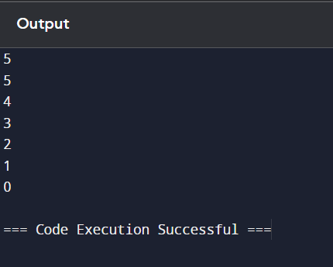

1. Write a python script to print the current date in the following format “Mon August 12 02:26:23 IST 2024”.

Code:

import datetime

now = datetime.datetime.now()

print (now.strftime("%a %B %d"))

current_time = now.strftime("%H:%M:%S")

print(current_time)

print (now.strftime("%Z%Y"))

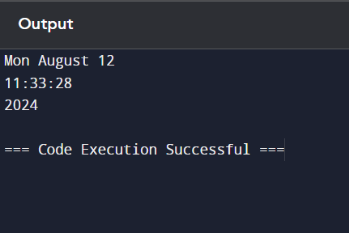

1. Write a python program to find largest of three numbers.

Code:

a = int(input())

b = int(input())

c = int(input())

if a>b and a>c :

print(a)

elif b>a and b>c :

print(b)

else :

print(c)

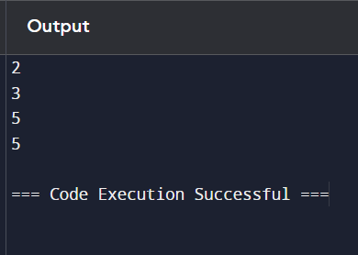

6) Write a Python program to convert temperatures to and from Celsius, Fahrenheit. [ Formula : c/5 = f-32/9 ]

Code:

c = int(input("Enter the temperature in Celcius. "))

b = (c*1.8)+32

f = int(input("Enter the temperature in Fahrenheit. "))

d = (f-32)/1.8

print("The temperature in Fahrenheit is: ",b)

print("The temperature in Celcius is: ",d)

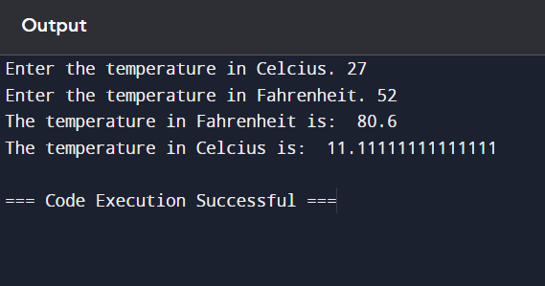

1. Write a Python script that prints prime numbers less than 20.

Code:

for i in range(2,21) :

n = 0;

for j in range(2,i) :

if i%j == 0:

n = n+1

if n == 0 :

print(i)

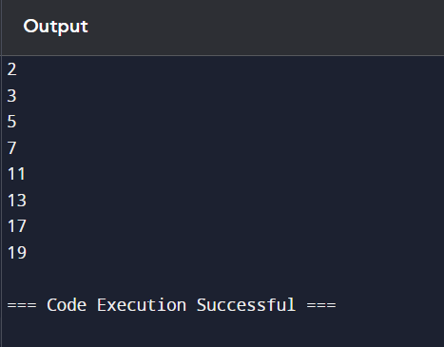

8) Write a program that accepts the lengths of three sides of a triangle as inputs. The program output should

indicate whether or not the triangle is a right triangle (Recall from the Pythagorean Theorem that in a right

triangle, the square of one side equals the sum of the squares of the other two sides).

Code:

a = int(input())

b = int(input())

c = int(input())

if (a*a) == ((b*b)+ (c*c)) :

print("It is a right angled triangle.")

elif (b*b) == ((a*a)+ (c*c)) :

print("It is a right angled triangle.")

elif (c*c) == ((b*b)+ (a*a)) :

print("It is a right angled triangle.")

else :

print("It is not a right angled triangle.")

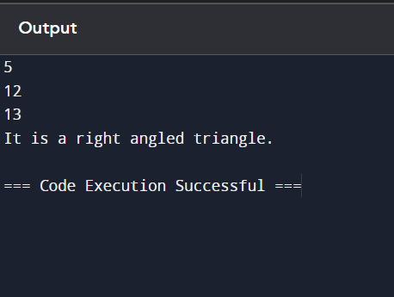

9) Write a python program to find the best of two test average marks out of three test’s marks accepted from

the user.

a = int(input("Enter marks for test1"))

b = int(input("Enter marks for test2"))

c = int(input("Enter marks for test3"))

avg1 = (a+b)/2

avg2 = (b+c)/2

avg3 = (c+a)/2

if(avg1 > avg2 and avg1 > avg3):

print("Average of best two test marks out of three test's marks is: ",avg1)

elif(avg2 > avg2 and avg2 > avg3):

print("Average of best two test marks out of three test's marks is: ",avg2)

else:

print("Average of best two test marks out of three test's marks is: ",avg3)

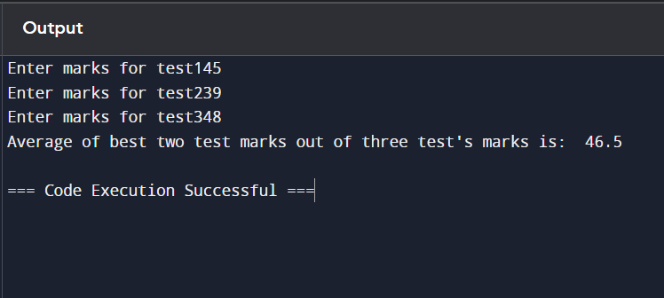

10) Develop a Python program to check whether a given number is palindrome or not and also count the

number of occurrences of each digit in the input number.

Code:

a = input("Enter a value : ")

b = int(str(a) == str(a)[::-1])

if b == 0:

print("Not Palindrome")

else:

print("Palindrome")

mySet = set(a)

for i in mySet:

ct = 0

for j in a:

if j == i:

ct += 1

print(i," appears ",ct," times")

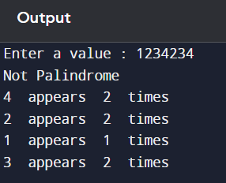

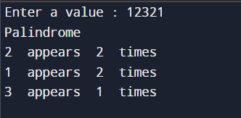

11) Write a Python program that accepts a sentence and find the number of words, digits, uppercase letters

and lowercase letters.

Code:

s = input("Enter a sentence: ")

word, digit, upper, lower = 0, 0, 0, 0

a = s.split()

word = len(a)

for i in s:

if i.isdigit():

digit = digit + 1

elif i.isupper():

upper = upper + 1

elif i.islower():

lower = lower + 1

print ("This sentence has ", word," words")

print ("This sentence has ", digit," digits")

print (upper," upper case letters")

print (lower," lower case letters")