**Class:** Final Year (Computer Science and Engineering)

**Year:** 2024-25 **Semester:** 1

**Course:** High Performance Computing Lab

Batch: B-1

Name: Manaswi Mahesh Devekar

PRN: 22510035

Assignment No. 5

[GitHub Link](https://github.com/manaswi77/HPCL/tree/main)

Problem 1:

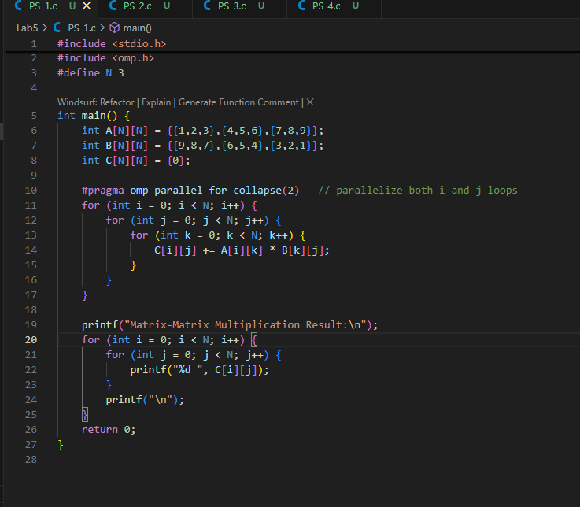

Output:

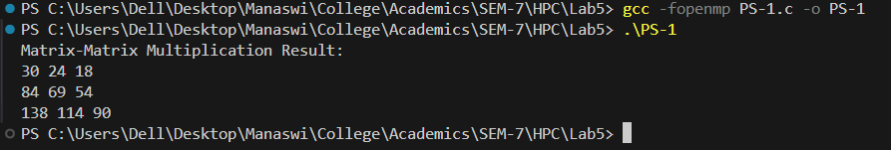

Problem 2:

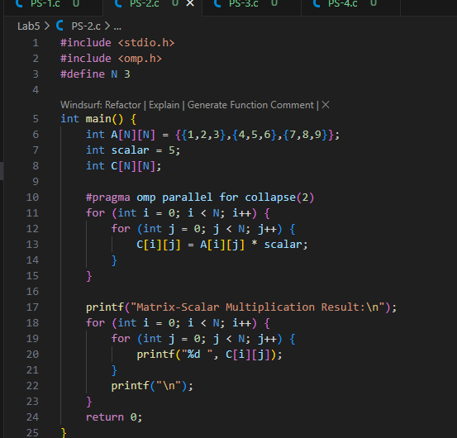

Output:

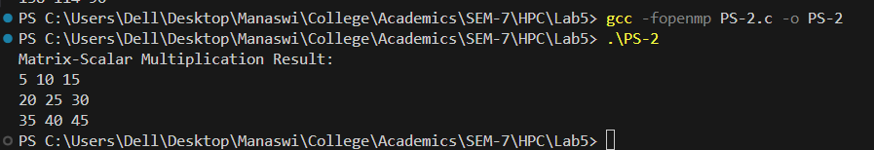

Problem 3:

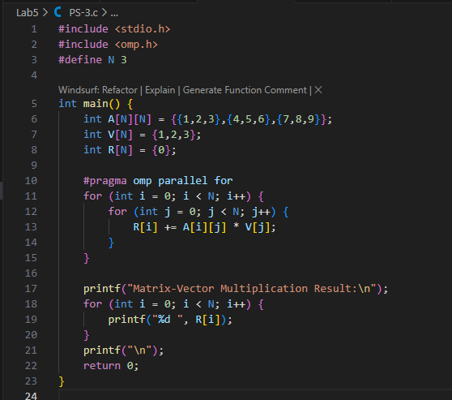

Output:

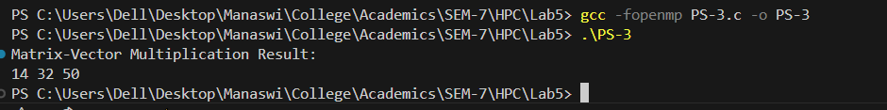

Problem 4:

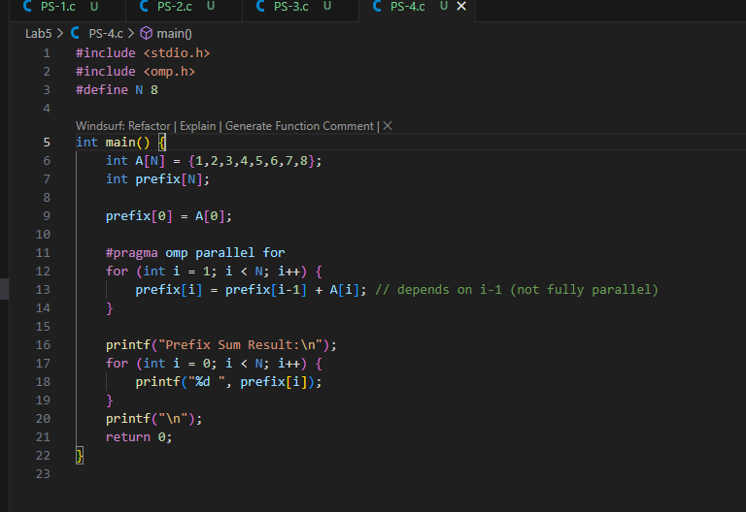

Output:

