INDIAN INSTITUTE OF TECHNOLOGY, PATNA
SUMMER INTERNSHIP REPORT

Design and Verification of DC-DC Boost Converter
Submitted by
Sripada Manaswini
Under the guidance of
Dr. Bussa Vinod Kumar
Department of Electrical Engineering
________________________________

Boost Converter
A boost converter is a non-isolated switched-mode DC–DC converter whose output voltage is always greater than its input voltage. It is used wherever a low, and often varying, source voltage has to be raised to a higher regulated level — photovoltaic front-ends, battery-powered equipment, LED drivers, fuel-cell interfaces and the DC link of many drive systems. Because the converter is a switching circuit it is inherently non-linear and time-varying, so a systematic modelling procedure is required before any linear controller can be designed for it.
This report documents the work carried out on the design of a 100 W boost converter and on the design and verification of a PID voltage-mode controller for it. The work covers the steady-state design of the power stage, small-signal modelling by state-space averaging and closed-loop verification in MATLAB/Simulink for the three disturbance cases specified for the project.

Cases to be verified
- Step change in reference output voltage, with input voltage and load current constant.
- Step change in load current, with input voltage and reference output voltage constant.
- Step change in input voltage, with reference output voltage and load current constant.

Design specification
The complete work is based on the following specification, which was fixed at the beginning of the project:
Quantity | Symbol | Value
Input voltage (nominal) | Vin | 12 V
Output voltage | Vo | 20 V
Load resistance | R | 4 Ω
Output power | Po | 100 W
Switching frequency | fs | 25 kHz
Switching period | Ts | 40 µs
Inductor current ripple | ΔIL | 30 % of IL
Output voltage ripple | ΔVo | 0.2 V
Conduction mode | — | CCM
Design specification of the boost converter
The ripple limits (30 % current ripple and 0.2 V voltage ripple) are design choices
Circuit Diagram

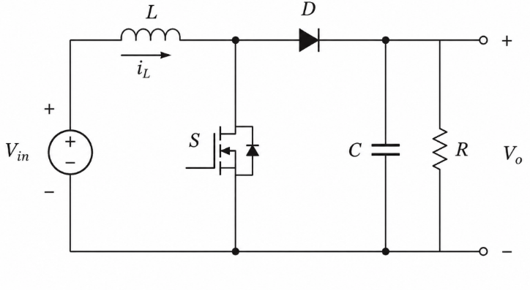

Summary of the designed power stage
Parameter | Expression | Value
Duty ratio | D = 1 − Vin/Vo | 0.4
Complement of duty ratio | D′ = 1 − D | 0.6
Load current | Io = Vo/R | 5 A
Average inductor current | IL = Io/D′ | 8.33 A
Inductor current ripple | ΔIL = 0.30 IL | 2.5 A
Inductor | L = VinD/(ΔIL fs) | 76.8 µH
Capacitor | C = IoD/(ΔVo fs) | 400 µF
Output power | Po = Vo·Io | 100 W
Table 3.1 Calculated power-stage parameters

Open-Loop Simulation
The gate signal is generated by a Pulse Generator block with a period of 40 µs and a pulse width of 40 %, corresponding to fs = 25 kHz and D = 0.4. The source is a 12 V DC voltage source, and the power stage uses the L, C and R values
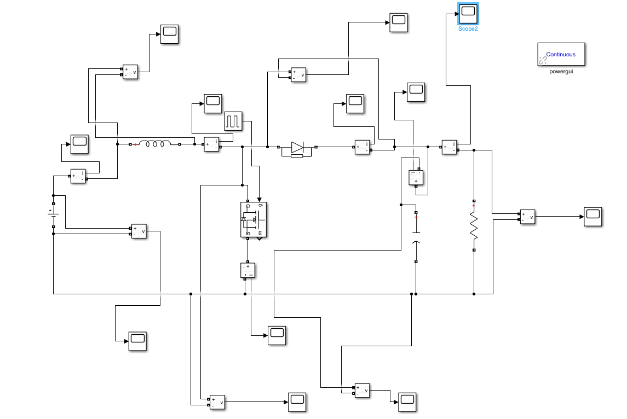
Fig. 4.1 Open loop: Simulink model (open_loop.slx)
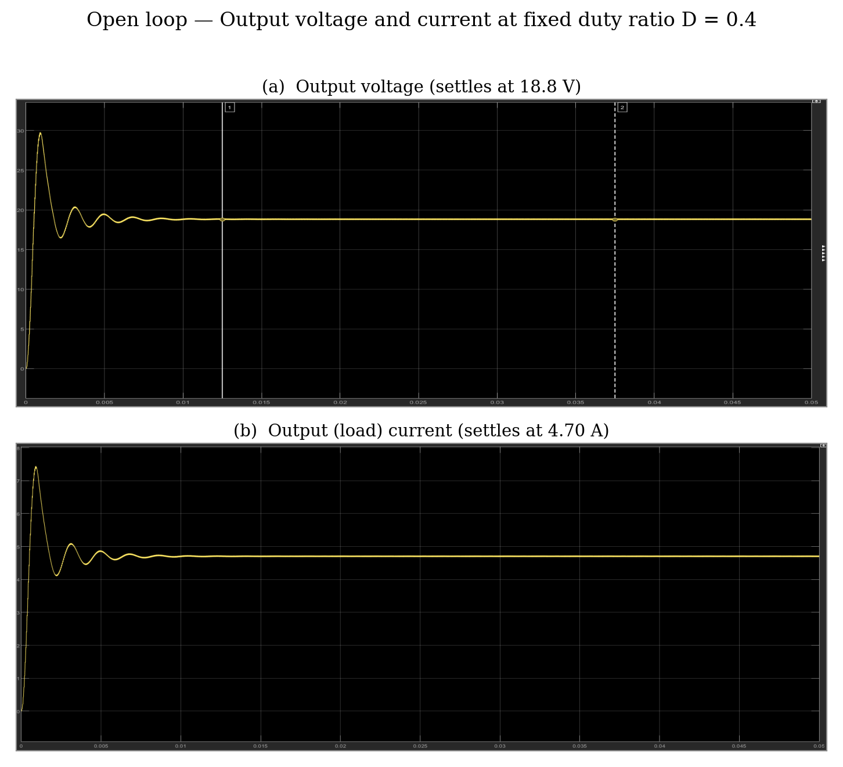
Fig. Open loop: output voltage and load current at fixed duty ratio
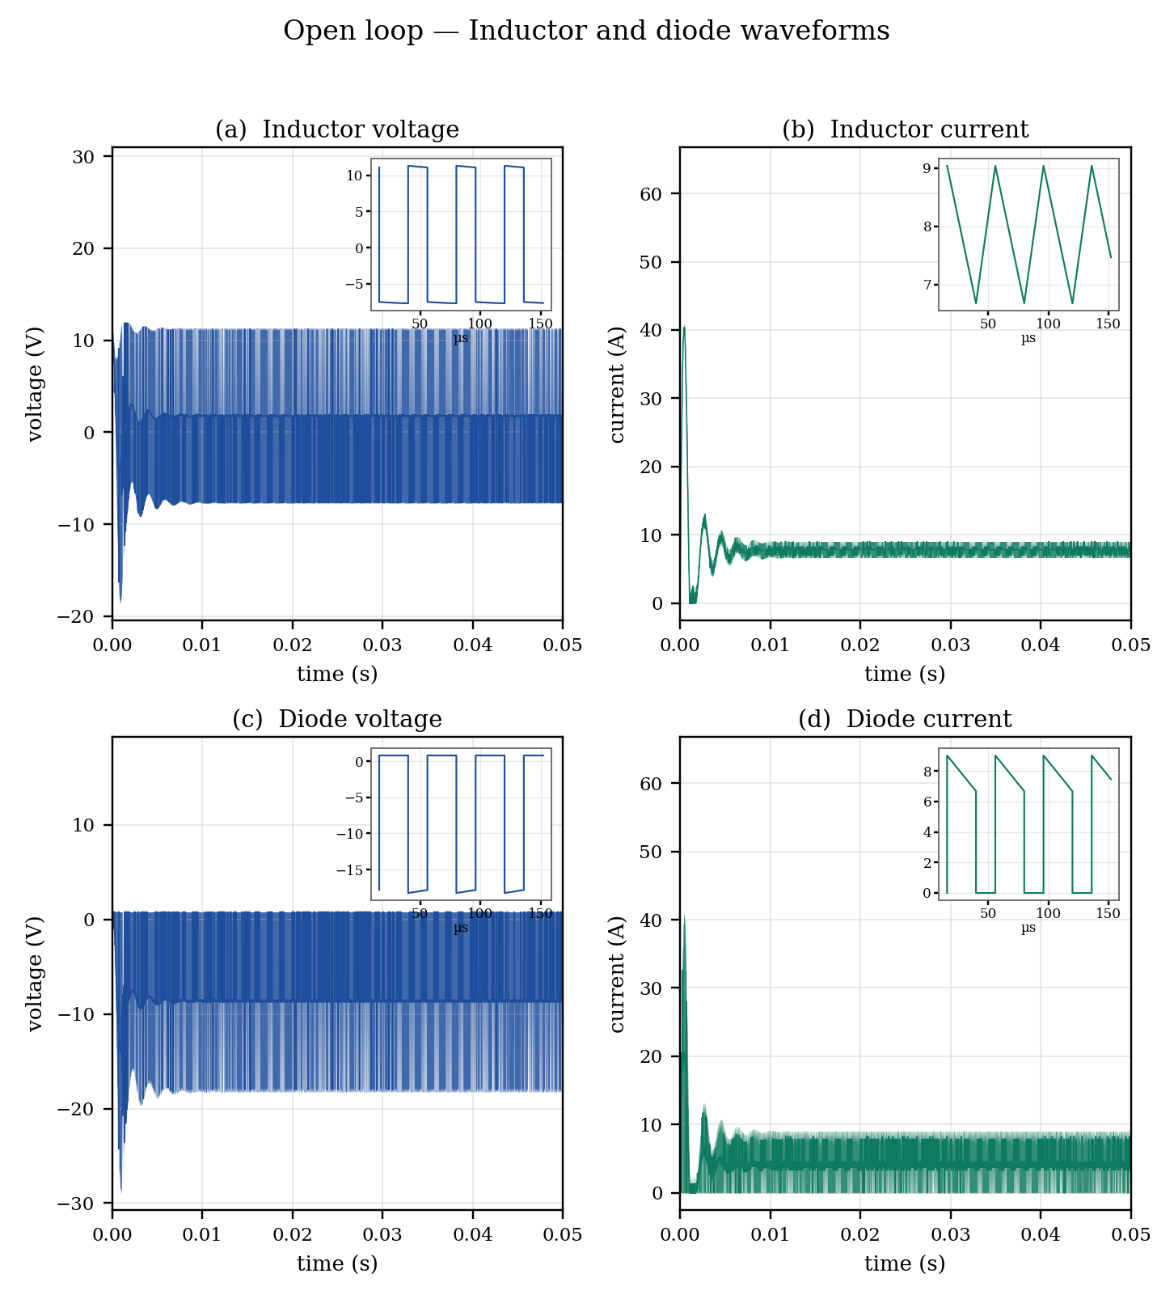
Fig. Open loop: inductor and diode voltage and current waveforms
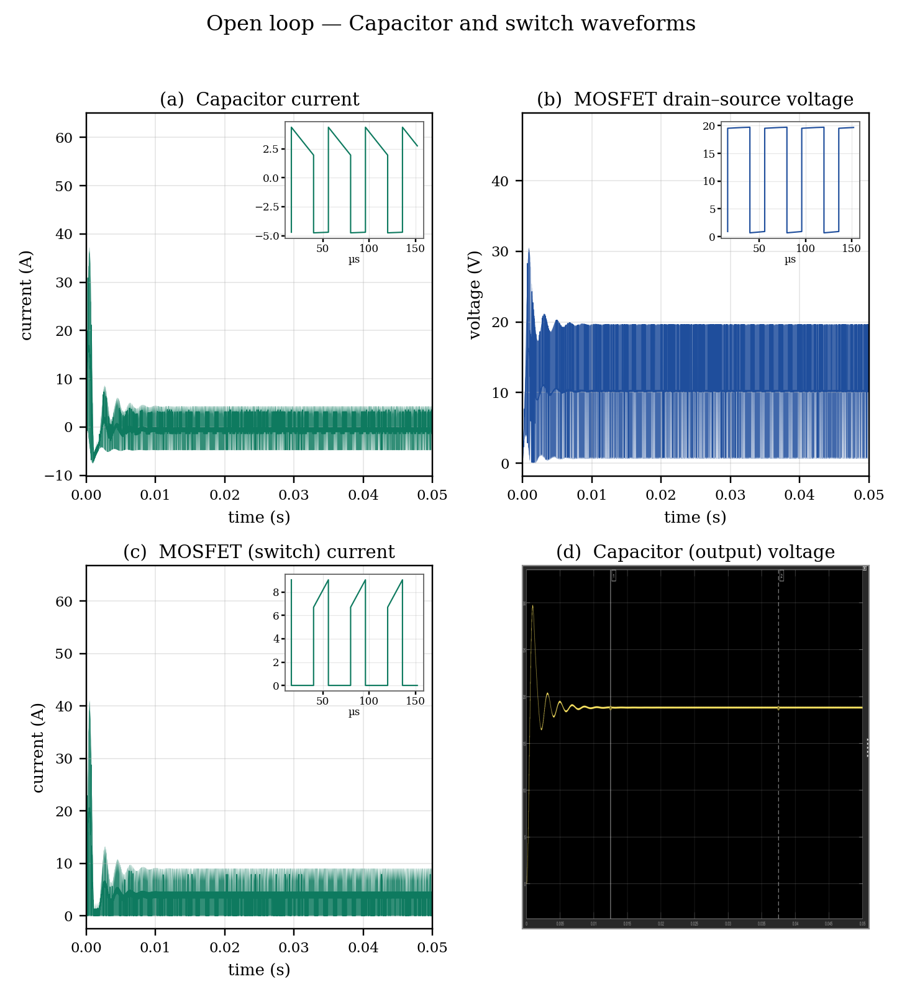
Fig. Open loop: capacitor and switch waveforms

Quantity | Analytical | Simulated
Output voltage, Vo | 20 V | 18.8 V
Load current, Io | 5 A | 4.70 A
Average inductor current, IL | 8.33 A | 7.81 A
Inductor current ripple, ΔIL | 2.5 A | 2.36 A
Average capacitor current | 0 A | 0.014 A
Output power, Po | 100 W | 88.4 W
Open-loop results: analytical vs. simulated
In practice the simulated output voltage is slightly lower than 20 V because the model includes the MOSFET on-state resistance (0.1 Ω), the diode forward drop (0.8 V) and the diode on-state resistance, none of which appear in the ideal expression Vo = Vin/(1 − D). This loss of gain is exactly what the closed loop is later required to remove.

State-space averaging and linearisation

The state-space averaging technique models a switching converter by averaging its state-space equations over one switching period. The ON and OFF state equations are weighted by their respective duty ratios to obtain the averaged model. This model is then linearized around the steady-state operating point using small perturbations, neglecting higher-order terms, to obtain the small-signal model and corresponding transfer function.

Parameter | Expression | Value (rad/s) | Value (Hz)
DC gain | Gd0 = Vo/D′ | 33.33 | —
Resonant frequency | ω₀ = D′/√(LC) | 3474 | 553
Quality factor | Q = D′R√(C/L) | 5.56 | —
RHP zero | ωz = D′²R/L | 19 303 | 3072
Poles | s = −312.5 ± j3460 | — | ≈ 551
Zero | s = +19 303 | — | 3072
Table Small-signal plant parameters at Vin = 12 V (L = 74.6 µH, C = 400 µF, R = 4 Ω)
[ Bode plot of Gvd(s) ]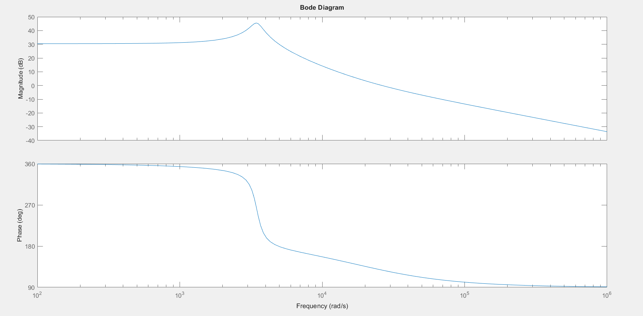
Fig. Bode plot of the control-to-output transfer function Gvd(s)

Effect of the right-half-plane zero
The zero at +19 303 rad/s lies in the right half-plane, such a zero adds gain but phase lag, it cannot be cancelled by the compensator and it caps the achievable bandwidth. The usual design rule is:
fc ≤ min( f₀/2 , fz/10 ) (5.9)
This gives fc ≤ min(276 Hz, 614 Hz). A crossover of fc = 600 Hz was adopted for the first design: it stays below the RHP-zero limit of fz/5 = 614 Hz, but it sits just above the resonance f₀ = 553 Hz, where the plant phase has already rolled off to −143°.

Closed Loop Test Cases and Simulation Results
Closed Loop(const input)
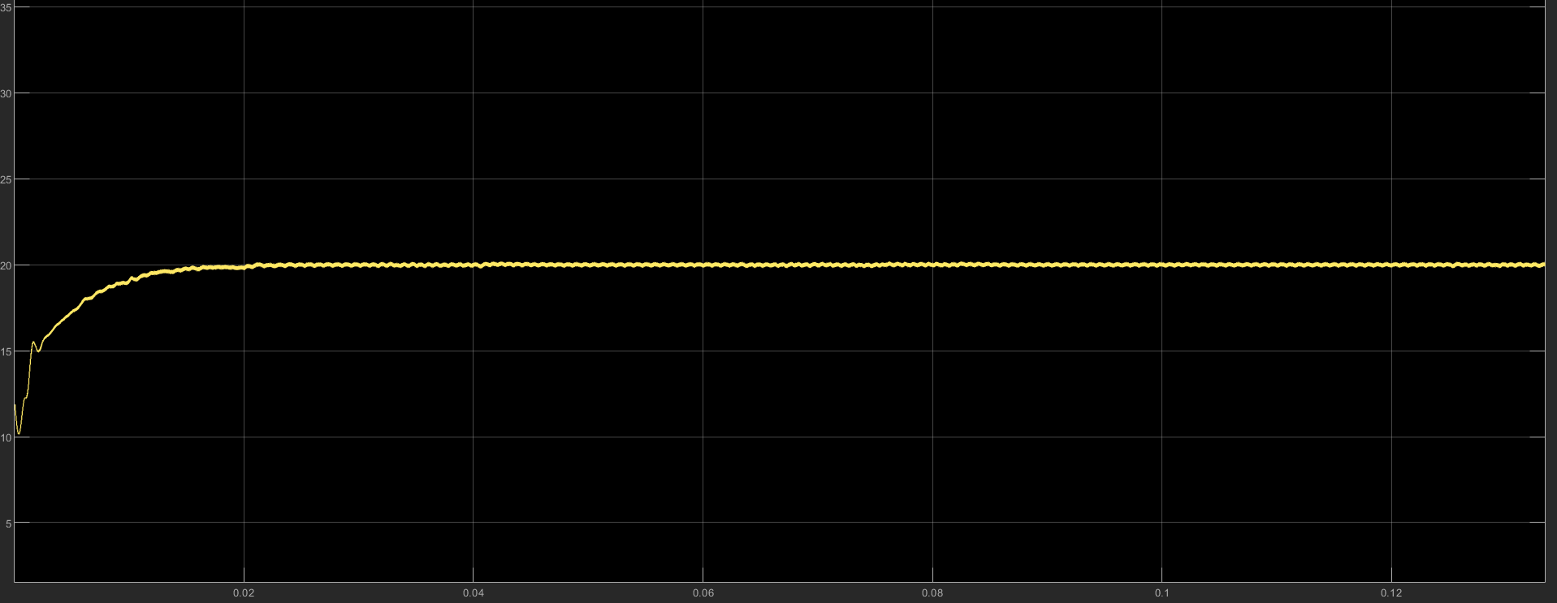
The three cases specified for the project are presented below. In each case only one quantity is disturbed and the remaining two are held constant, so that the response can be attributed unambiguously to that disturbance.

Case 1 — Step change in reference output voltage
The input voltage is held at 12 V and the load resistance at 4 Ω, while the reference is stepped by a Signal Editor block according to the profile below.
Time (s) | Reference Vref (V) | Event
0 – 0.05 | 16 | initial regulation
0.05 – 0.10 | 24 | step-up of 8 V
0.10 – 0.20 | 28 | step-up of 4 V
Table Reference voltage profile for Case 1
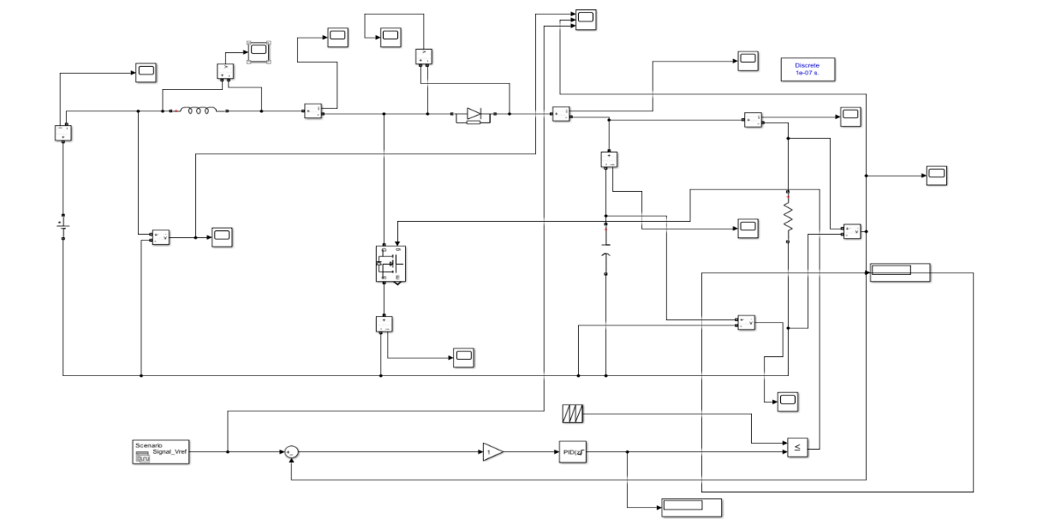
Fig. Case 1: Simulink model (closed_loop_Vref.slx)
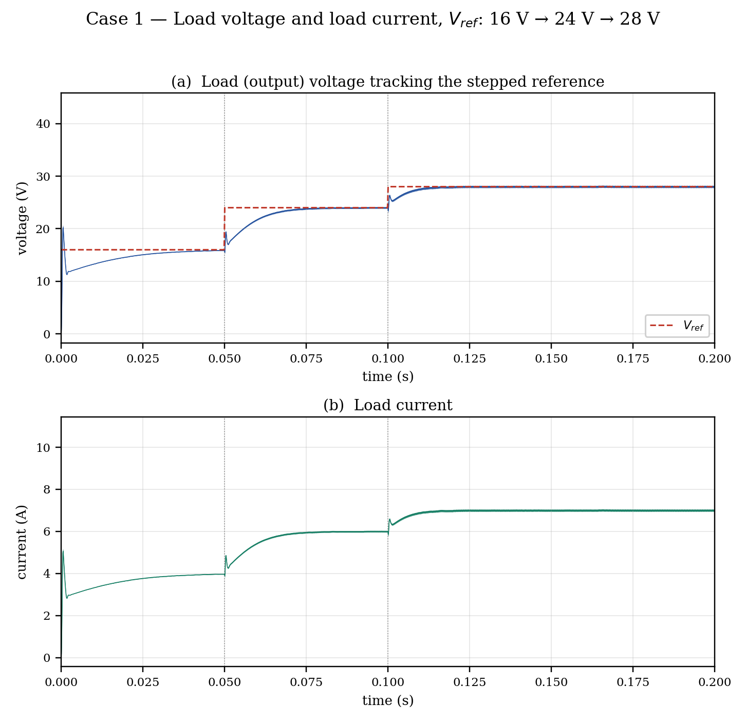
Fig. Case 1: load voltage tracking the reference steps 16 V → 24 V → 28 V, and the corresponding load current
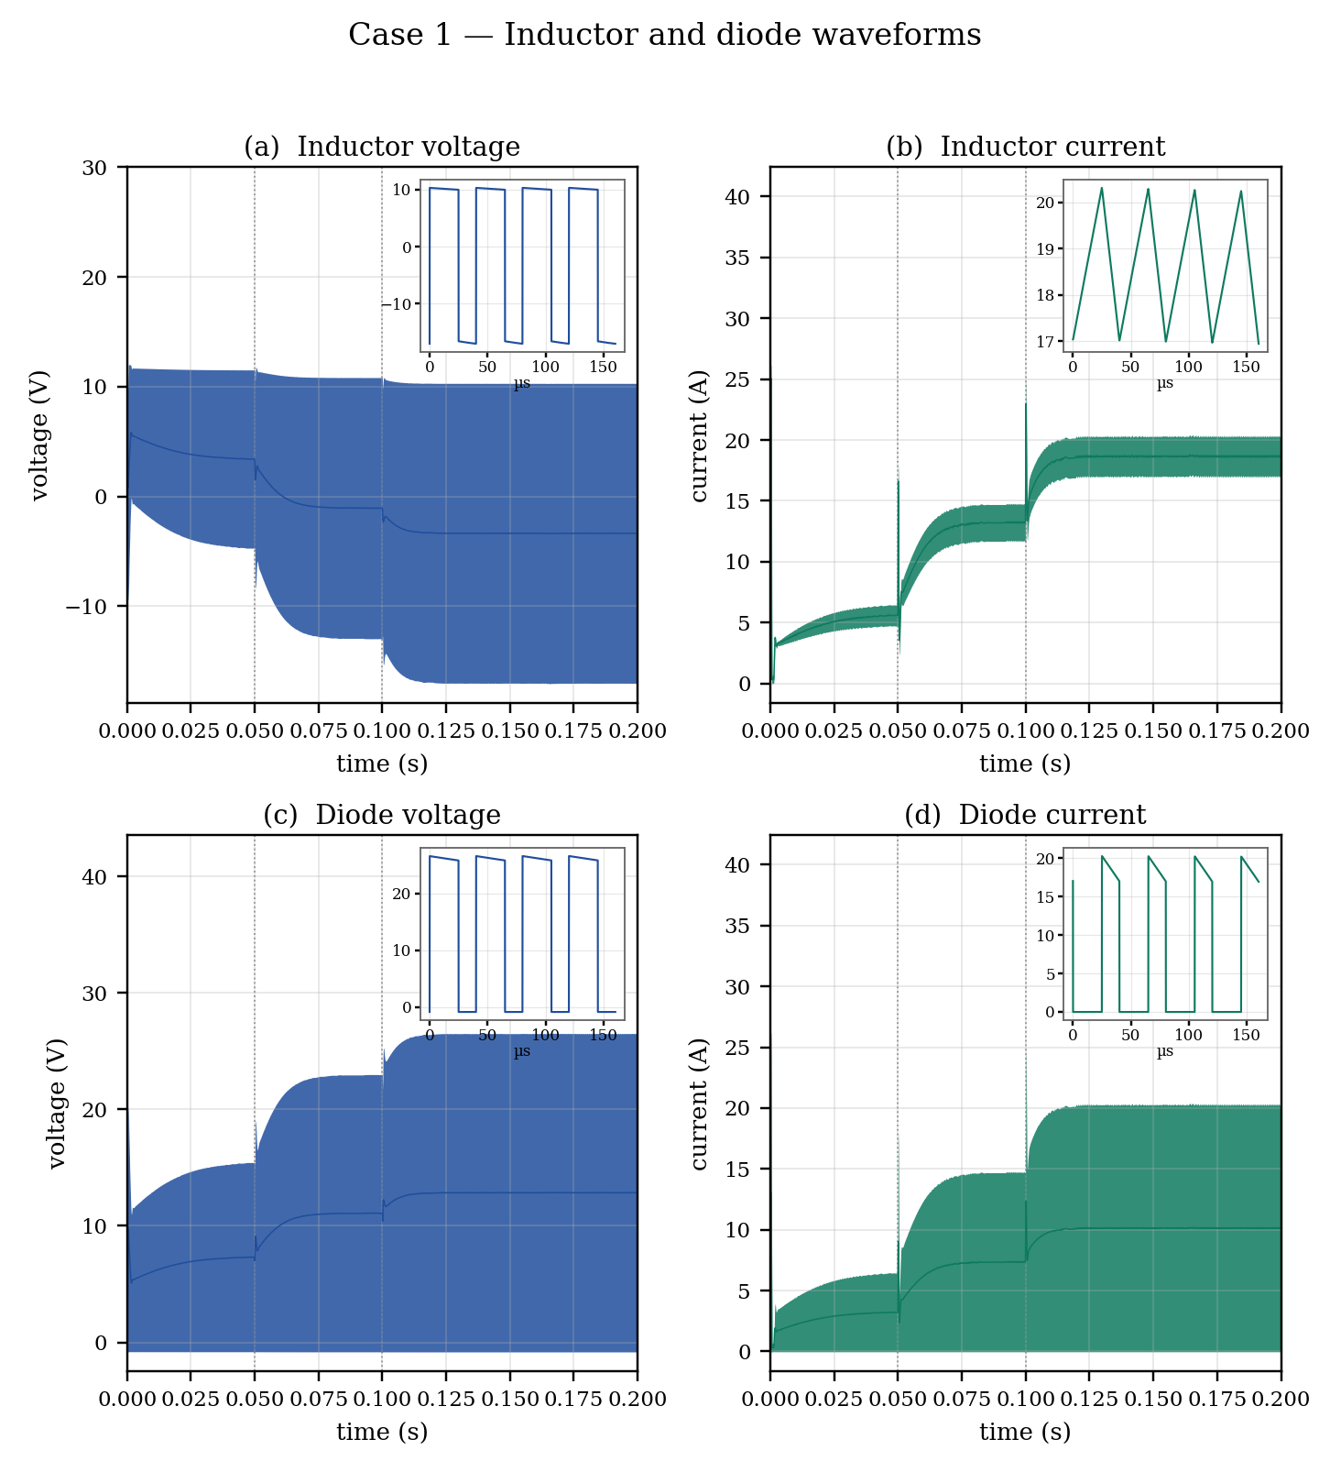
Fig. Case 1: inductor and diode voltage and current waveforms
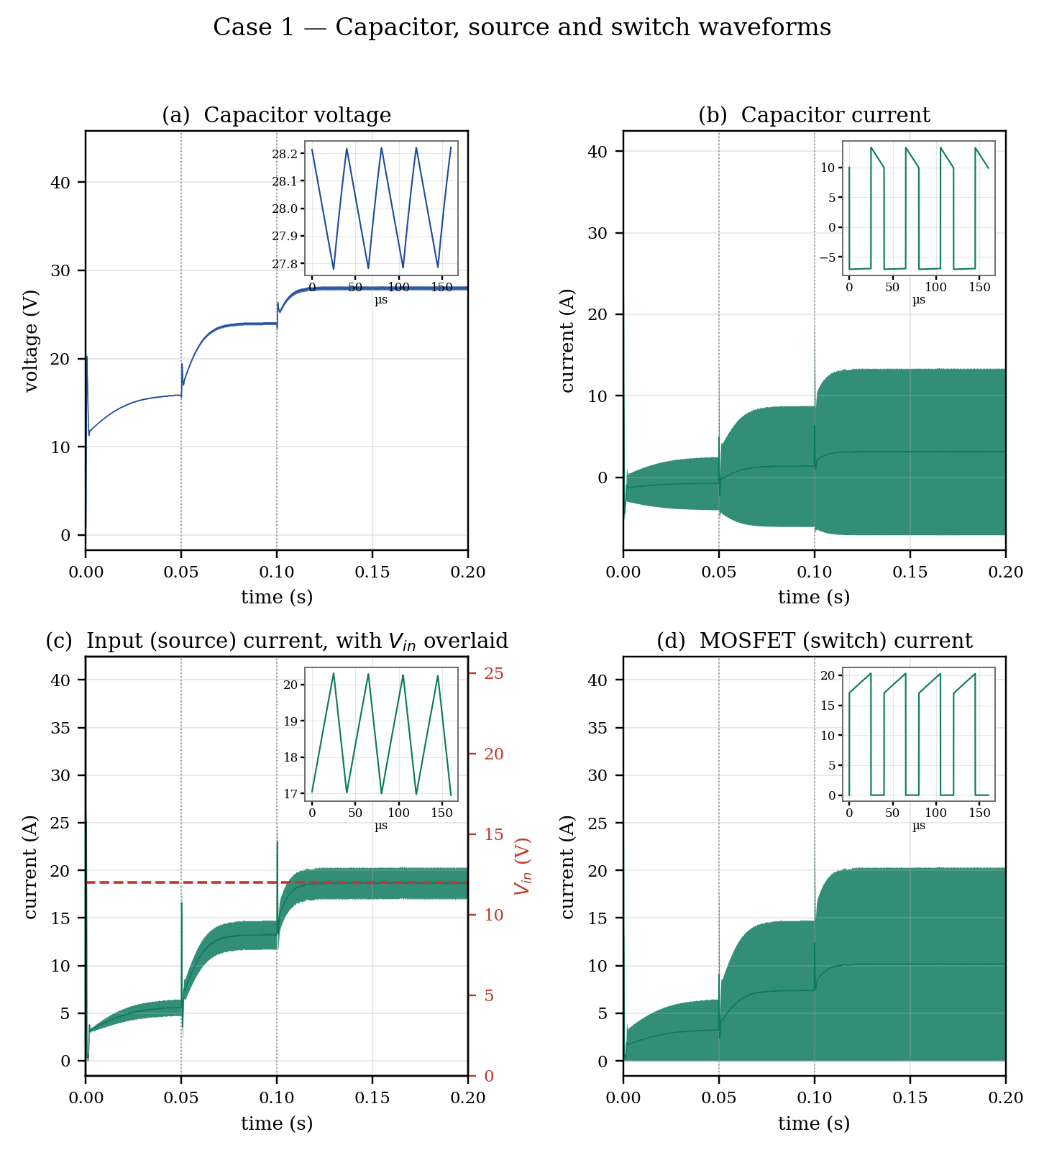
Fig. Case 1: capacitor, source and switch waveforms
The capacitor voltage is the output voltage, and its inset shows the output ripple settling at about 0.46 V peak-to-peak at the 28 V operating point. The capacitor current alternates between −Io during the on-interval and (iL − Io) during the off-interval, and its average is zero over a period, confirming the charge balance of (2.8). The MOSFET and diode currents are complementary: each carries the inductor current for its own part of the period.
Step | Rise/settling time | Overshoot (%) | Steady-state error (V)
16 → 24 V | 22.1 ms (2 %) / 15.0 ms (5 %) | 0.72 | −0.02
24 → 28 V | 11.4 ms (2 %) / 5.7 ms (5 %) | 0.94 | 0.00
Table Case 1: measured transient performance
Measured steady-state values at each operating point are given below; the load current and the inductor current both rise with the reference because the load is a fixed 4 Ω resistor.
Reference | Mean vo (V) | Output ripple (V) | Mean iL (A) | iL ripple (A) | Load current (A)
16 V | 15.69 | 0.15 | 5.48 | 2.03 | 3.92
24 V | 23.98 | 0.33 | 13.21 | 3.19 | 6.00
28 V | 28.00 | 0.46 | 18.66 | 3.45 | 7.00
Table 8.3 Case 1: measured steady-state values at each reference level
The 16 V point still shows a residual error of about 0.3 V because the loop has not fully settled when the next step arrives at t = 0.05 s; at 24 V and 28 V the integrator has removed the error completely.

Case 2-Step change in load current
The input voltage is held at 12 V and the reference at 20 V. An additional load is injected by a Controlled Current Source connected in parallel with the load resistor, driven by a Signal Editor block. Using a current source rather than switching a second resistor in and out allows the size of the load step to be specified exactly.

Fig. 8.5 Case 2: Simulink mod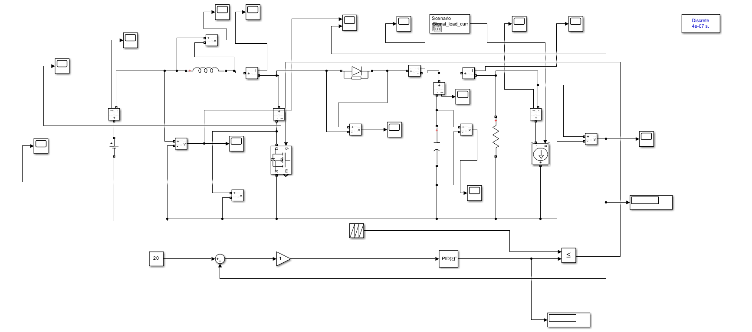
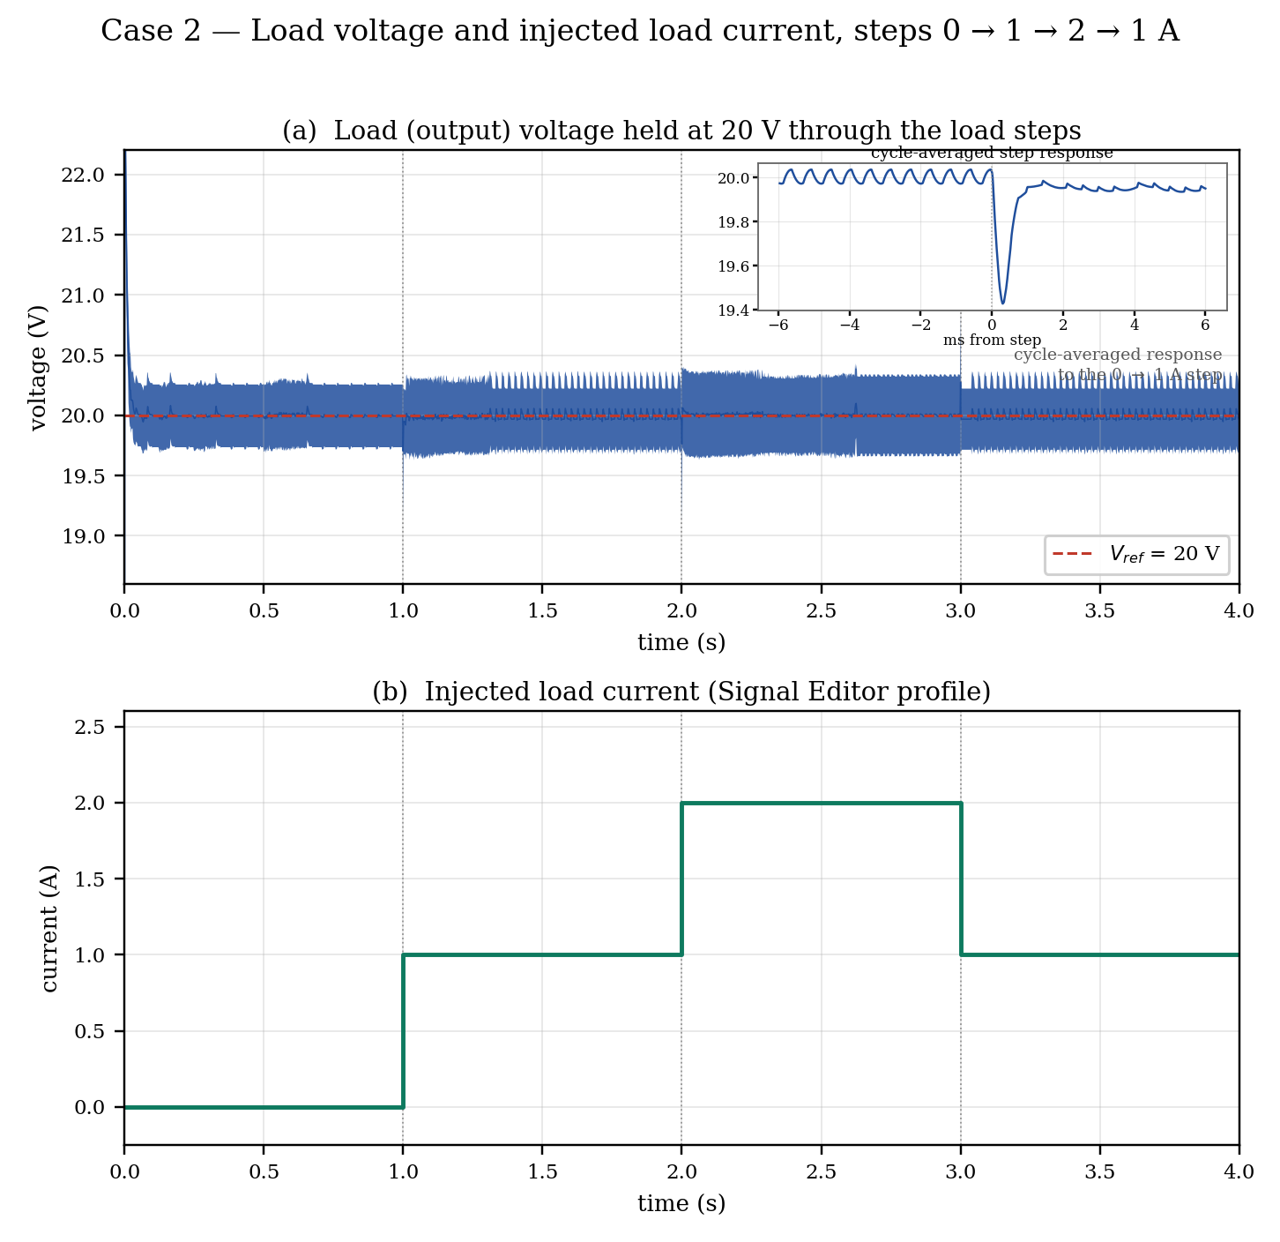
Fig. Case 2: load voltage and the injected load-current profile
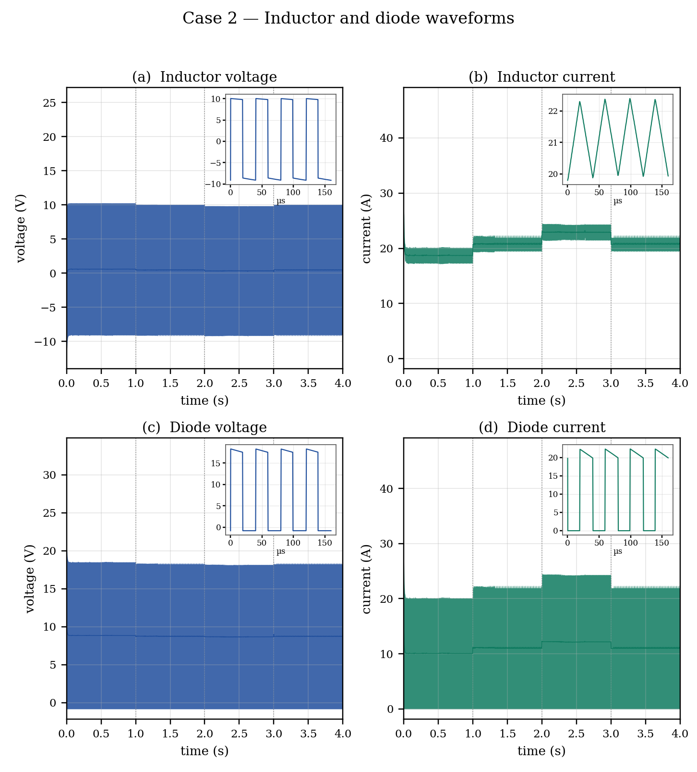
Fig. Case 2: inductor and diode voltage and current waveforms
The inductor current steps up with each load increase and returns when the load is reduced, while its ripple stays essentially constant at about 2.9—3.0 A because ripple depends on Vin, D and L rather than on load. The diode carries that current only during the off-interval, so its average tracks the load while its peak follows the inductor.
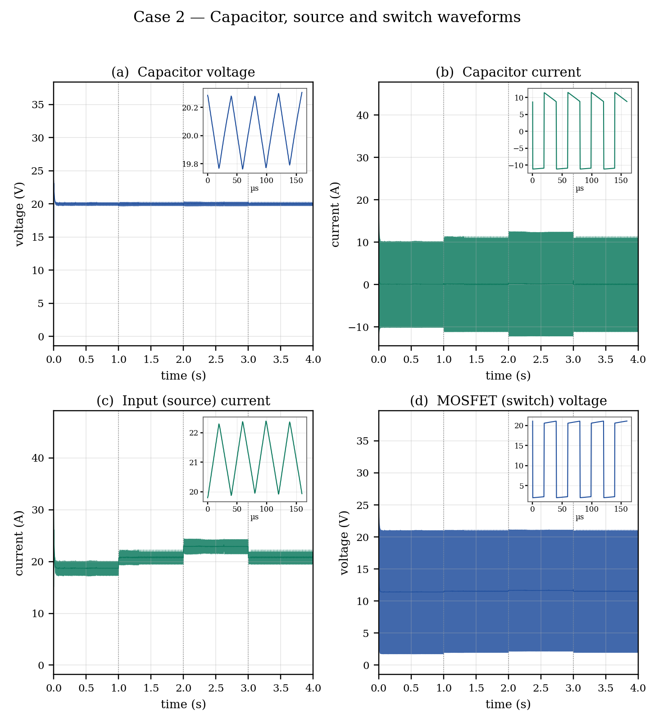
Fig. Case 2: capacitor, source and switch waveforms
The capacitor voltage inset shows the output ripple at about 0.6 V peak-to-peak, and the capacitor current inset shows the corresponding charge and discharge intervals, its envelope widening at each load step. The MOSFET blocking voltage rises to the output level during the off-interval and falls to nearly zero when it conducts, confirming correct switching action throughout the load transients.

Injected current | Total load current | Mean vo (V) | Output ripple (V) | Mean iL (A) | iL ripple (A)
0 A | 10.0 A | 20.000 | 0.56 | 18.73 | 2.94
1 A | 11.0 A | 20.000 | 0.69 | 20.81 | 3.04
2 A | 12.0 A | 20.000 | 0.68 | 22.93 | 2.95
1 A | 11.0 A | 20.000 | 0.69 | 20.81 | 3.04
Table Case 2: measured steady-state values at each load level
Step | Voltage dip / rise (V) | Steady-state error (V)
0 → 1 A | −0.57 (dip) | 0.000
1 → 2 A | −0.60 (dip) | 0.000
2 → 1 A | +0.60 (rise) | 0.000
Table Case 2: measured transient performance (cycle-averaged output)

Case 3 — Step change in input voltage
The reference is held at 20 V and the load at 4 Ω, while the input voltage is varied by a Controlled Voltage Source driven from a Signal Editor block through a gain of 20, each transition being given a 1 ms ramp rather than an ideal step so that the source models a realistic supply.
Time (s) | Input voltage Vin (V)
0 – 0.05 | 12
0.05 – 0.10 | 14
0.10 – 0.15 | 15
0.15 – 0.20 | 13
Table Input voltage profile for Case 3
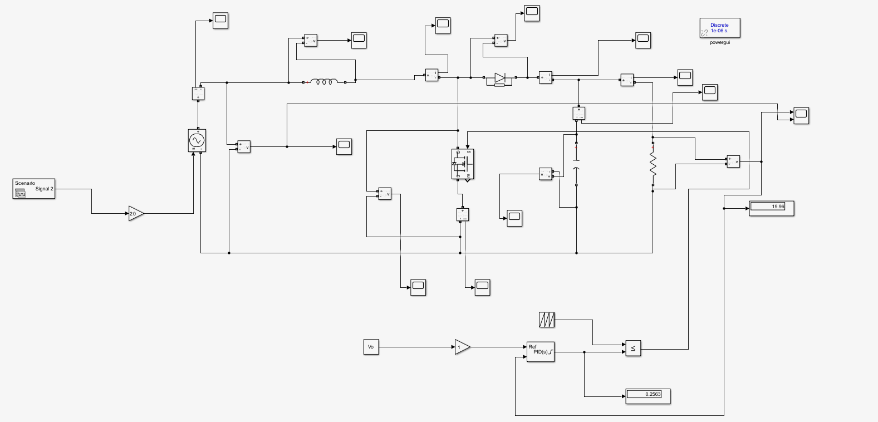
Fig. Case 3: Simulink model (closed_loop_.slx)
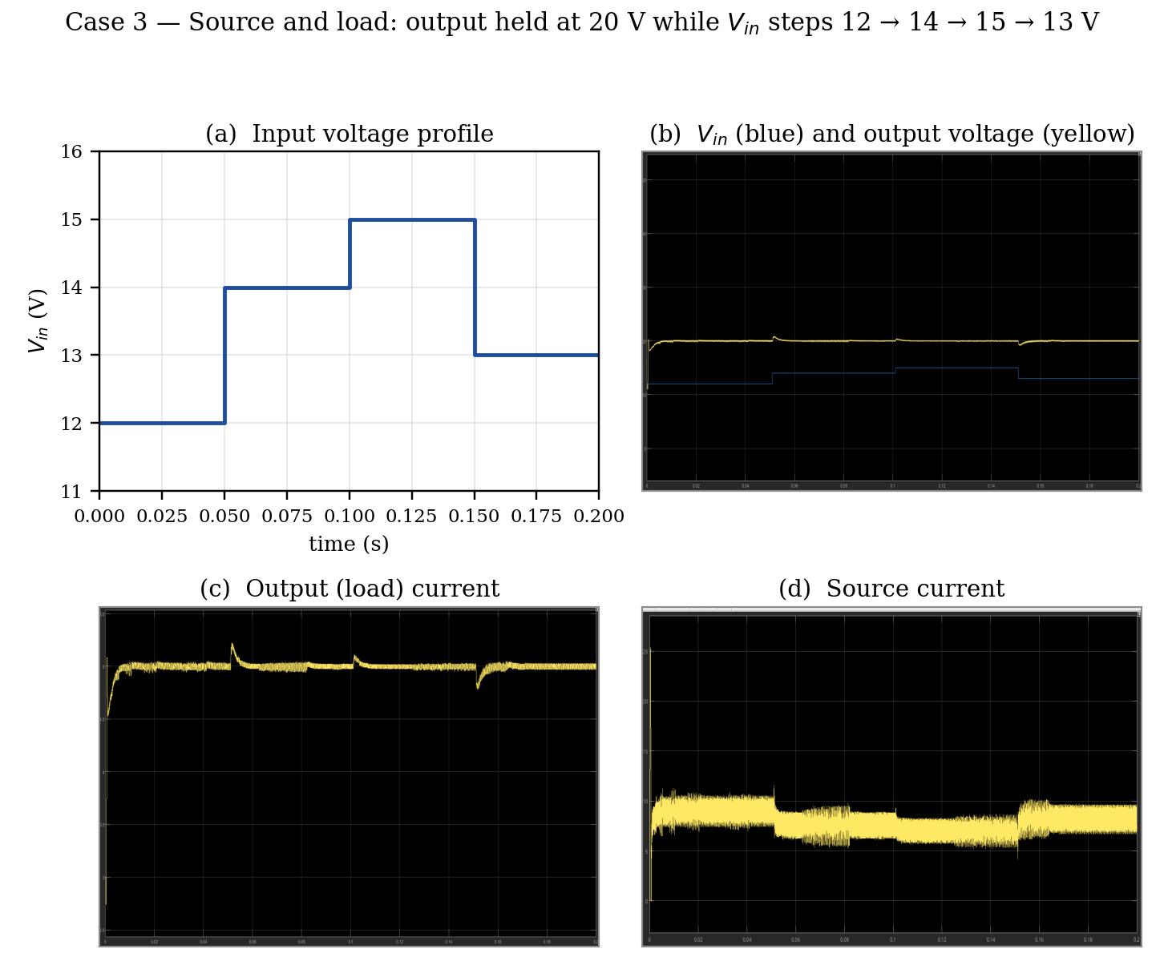
Fig. Case 3: source and load quantities over the input-voltage profile

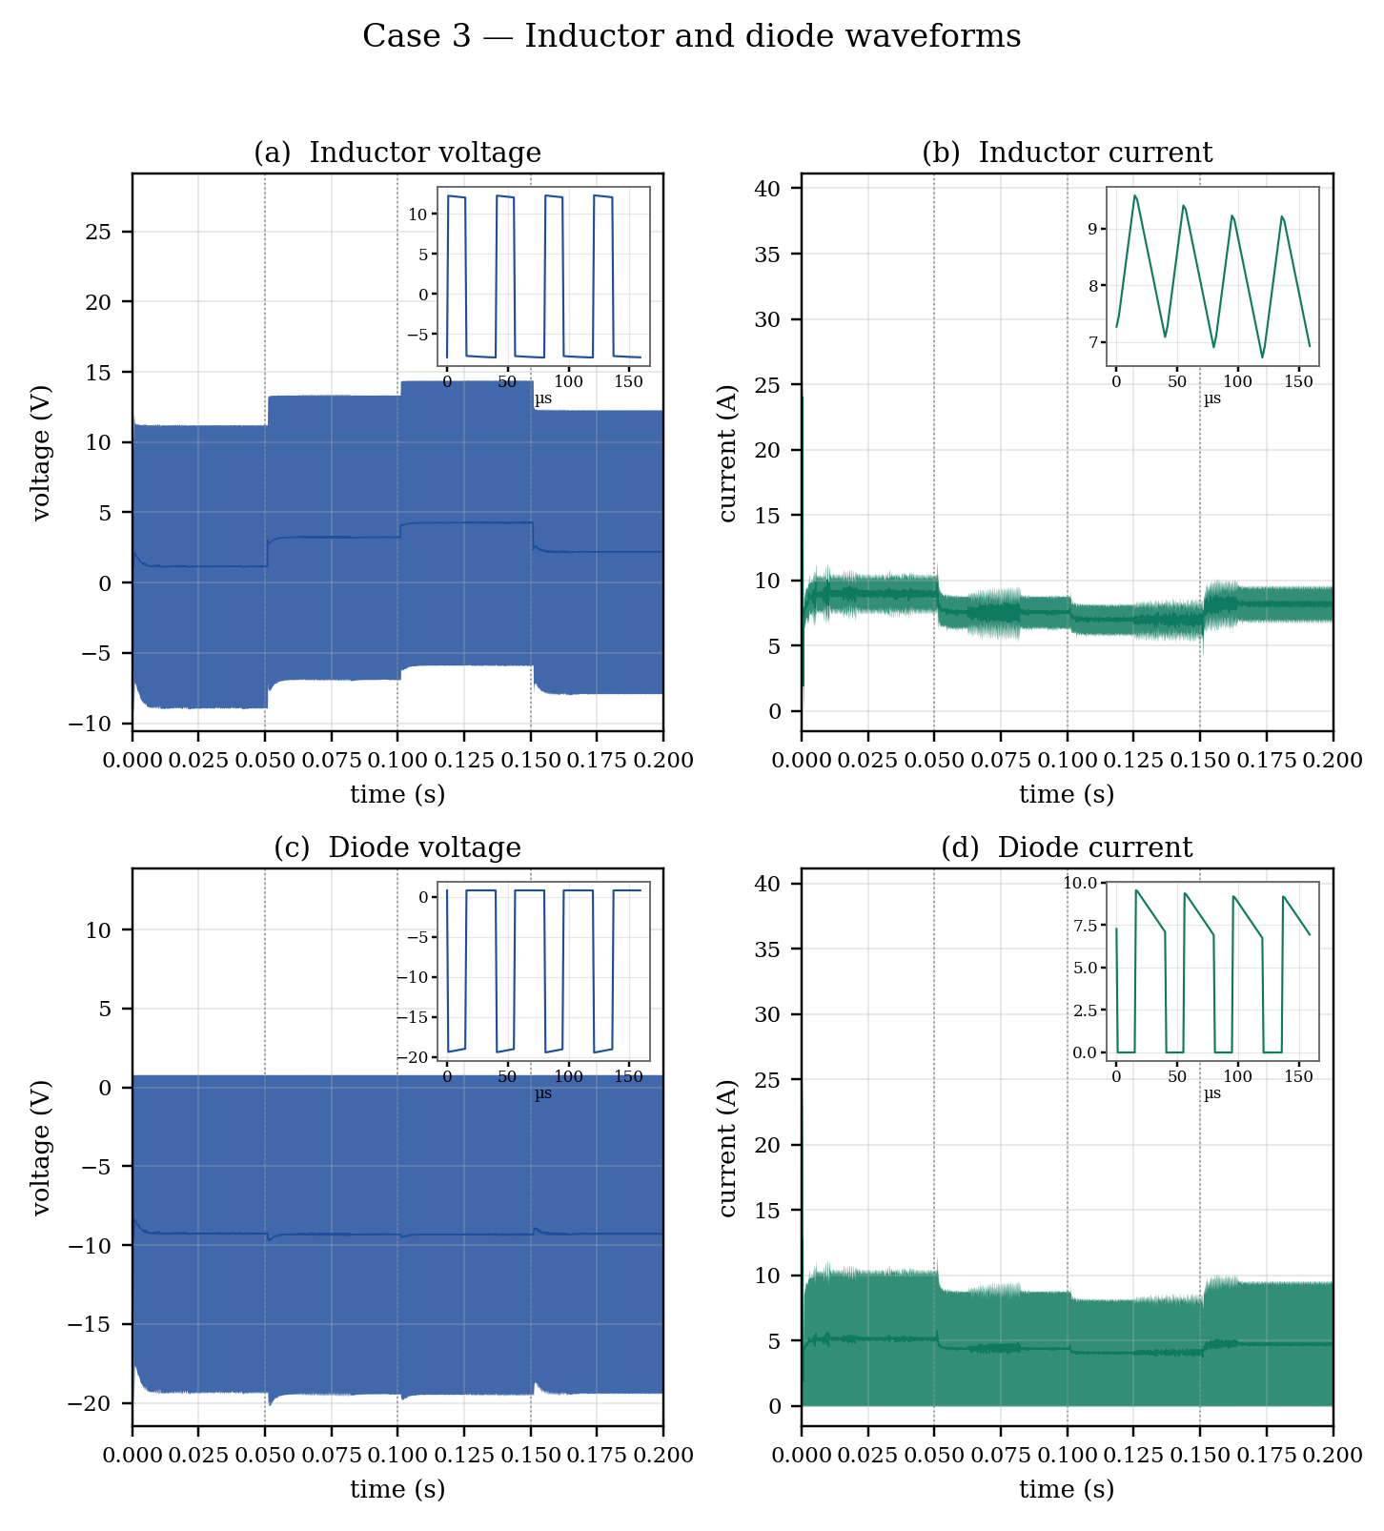
Fig. Case 3: inductor and diode voltage and current waveforms
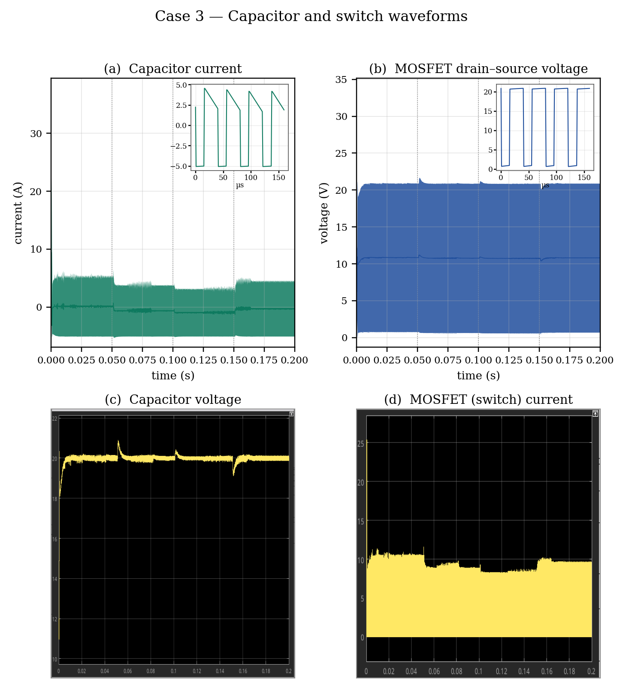
Fig. Case 3: capacitor and switch waveforms
The capacitor current alternates between −Io during the on-interval and (iL − Io) during the off-interval, with zero average at every operating point. The MOSFET blocking voltage stays at about 21 V in all four segments: the switch stand-off voltage in a boost converter is set by vo, not by Vin, so it does not move when the input steps. The switch current falls as the input voltage rises, since less current is needed to deliver the same output power.
Step | Voltage deviation (V) | Final duty ratio
12 → 14 V | +0.9 (rise) | 0.300
14 → 15 V | +0.5 (rise) | 0.250
15 → 13 V | −0.9 (dip) | 0.350
Table Case 3: measured transient performance

Conclusion
A 100 W boost converter operating from 12 V to 20 V at 25 kHz has been designed, modelled and verified. The power stage was sized from the ripple specification, giving L = 76.8 µH and C = 400 µF. A small-signal model was derived by state-space averaging, yielding a second-order control-to-output transfer function with a resonance at 553 Hz and a right-half-plane zero at 3072 Hz. A PID controller was designed in the frequency domain, and a single fixed set of gains was shown to hold a phase margin of at least 42.8° over an input range of 12–15 V. Closed-loop Simulink models were built for the three specified disturbance cases, and the results confirm that the controller regulates the output voltage in each case.

Appendix A — MATLAB script: (Const input)
Computes the power-stage components and the PID gains for the nominal operating point.
%% BOOST CONVERTER - simulation parameters + PID gains
clear; clc;

%% ---------------- INPUTS ----------------
Vin = 12; % input voltage [V]
Vo = 20; % output voltage [V]
R = 4; % load [ohm]
fs = 25e3; % switching frequency [Hz]

dIL_pct = 30; % inductor ripple, % of IL
dVo = 0.2; % output ripple [V]
fc = 600; % crossover frequency [Hz]

%% ---------------- POWER STAGE ----------------
D = 1 - Vin/Vo; % duty cycle
Dp = 1 - D;
Io = Vo/R; % output current
IL = Io/Dp; % avg inductor current

L = (Vin*D)/((dIL_pct/100)*IL*fs); % inductor
C = (Io*D)/(dVo*fs); % capacitor

L = 76.8e-6; % <-- comment out to use the computed L

%% ---------------- PLANT Gvd(s) ----------------
Gd0 = Vo/Dp; % DC gain
w0 = Dp/sqrt(L*C); % resonance
Q = Dp*R*sqrt(C/L); % damping
wz = (Dp^2*R)/L; % RHP zero

wc = 2*pi*fc;
Gmag = Gd0*abs(1 - 1j*wc/wz) / abs(1 - (wc/w0)^2 + 1j*wc/(Q*w0)); % |Gvd(jwc)|

%% ---------------- PID GAINS ----------------
wzc = 1200; % controller zero (must sit below w0)
wd = 2*wzc; % derivative corner
wi = wzc/2; % integrator zero

x = wc/wd - wi/wc;
Kp = 1/(sqrt(1 + x^2)*Gmag);
Ki = Kp*wi;
Kd = Kp/wd;

N = 10*wc; % derivative filter coefficient

%% ---------------- SIMULATION PARAMETERS ----------------
Ts = 1/fs; % switching period
Vref = Vo; % reference for the control loop

fprintf('Vin = %g V\n', Vin);
fprintf('Vref = %g V\n', Vref);
fprintf('R = %g ohm\n', R);
fprintf('fs = %g kHz Ts = %g us\n', fs/1e3, Ts*1e6);
fprintf('D = %.4f\n', D);
fprintf('L = %.2f uH\n', L*1e6);
fprintf('C = %.2f uF\n', C*1e6);
fprintf('----\n');
fprintf('Kp = %.6g\n', Kp);
fprintf('Ki = %.6g\n', Ki);
fprintf('Kd = %.6g\n', Kd);
fprintf('N = %.0f\n', N);

Appendix B — MATLAB script: (Varying input)
Sizes the hardware at the worst case, sweeps the plant over the input-voltage range, computes a single set of PID gains and checks the phase margin at every operating point.
%% BOOST CONVERTER - variable input voltage
clear; clc;

%% ---------------- INPUTS ----------------
Vin_list = [12 14 15 13]; % <-- input voltages to cover [V]
Vo = 20; % output voltage [V]
R = 4; % load [ohm]
fs = 25e3; % switching frequency [Hz]

dIL_pct = 30; % inductor ripple, % of IL
dVo = 0.2; % output ripple [V]
fc = 2700; % crossover frequency [Hz]
wzc = 1200; % controller zero [rad/s]

%% ------- HARDWARE: sized at the worst case (lowest Vin) -------
% L and C are physical parts. They are NOT recomputed per operating
% point - only sized once, for the Vin that demands the most.
Vin_w = min(Vin_list);
D_w = 1 - Vin_w/Vo;
IL_w = (Vo/R)/(1 - D_w);

L = (Vin_w*D_w)/((dIL_pct/100)*IL_w*fs);
C = ((Vo/R)*D_w)/(dVo*fs);

L = 74.6e-6; % <-- comment out to use the computed L

%% ------- PLANT SWEEP over every input voltage -------
wc = 2*pi*fc;
n = numel(Vin_list);
D = zeros(1,n); w0 = D; Q = D; wz = D; Gmag = D; Gph = D;

for k = 1:n
Vin = Vin_list(k);
D(k) = 1 - Vin/Vo;
Dp = 1 - D(k);

Gd0 = Vo/Dp; % DC gain
w0(k) = Dp/sqrt(L*C); % resonance
Q(k) = Dp*R*sqrt(C/L); % damping
wz(k) = (Dp^2*R)/L; % RHP zero

G = Gd0*(1 - 1j*wc/wz(k)) / (1 - (wc/w0(k))^2 + 1j*wc/(Q(k)*w0(k)));
Gmag(k) = abs(G);
Gph(k) = angle(G)*180/pi;
end

%% ------- ONE set of PID gains, sized for the HIGHEST plant gain -------
[Gmax, kw] = max(Gmag); % worst case for loop gain

wd = 2*wzc;
wi = wzc/2;
x = wc/wd - wi/wc;

Kp = 1/(sqrt(1 + x^2)*Gmax);
Ki = Kp*wi;
Kd = Kp/wd;
N = 5*wc;

%% ------- REPORT -------
disp(table(Vin_list(:), D(:), round(w0(:)), round(wz(:)), Q(:), Gmag(:), Gph(:), ...
'VariableNames', {'Vin','D','w0','wz','Q','PlantGain','PlantPhase'}));

% phase margin actually achieved at each input voltage
PM = zeros(1,n);
for k = 1:n
Gc = Kp*(1 + wi/(1j*wc) + 1j*wc/wd);
Gp = (Vo/(1-D(k)))*(1 - 1j*wc/wz(k)) / (1 - (wc/w0(k))^2 + 1j*wc/(Q(k)*w0(k)));
PM(k) = 180 + angle(Gc*Gp)*180/pi;
end
disp(table(Vin_list(:), Gmag(:)*sqrt(1+x^2)*Kp, PM(:), ...
'VariableNames', {'Vin','LoopGain_at_wc','PhaseMargin_deg'}));

fprintf('gains sized at Vin = %g V (highest plant gain)\n', Vin_list(kw));
fprintf('L = %.2f uH\nC = %.2f uF\n', L*1e6, C*1e6);
fprintf('Kp = %.6g\nKi = %.6g\nKd = %.6g\nN = %.0f\n', Kp, Ki, Kd, N);

%% ------- Vin as a time-varying source for Simulink -------
% Steps through the list, holding each for t_hold seconds.
t_hold = 0.02;
t_vec = (0:n)*t_hold;
v_vec = [Vin_list Vin_list(end)];
Vin_ts = timeseries(v_vec(:), t_vec(:)); % feed to a From Workspace block

figure('Color','w');
stairs(t_vec, v_vec, 'LineWidth', 1.5); grid on;
xlabel('time (s)'); ylabel('V_{in} (V)'); title('Input voltage profile');
ylim([min(Vin_list)-1 max(Vin_list)+1]);

