INDIAN INSTITUTE OF TECHNOLOGY PATNA
Department of Electrical Engineering
B.Tech Project — Mid-Term Evaluation Report
Analysis and Simulation of a Single-Switch High-Gain DC–DC Converter with Current Mirror Ripple Cancellation for Fuel Cell Electric Vehicles

Submitted by
Sripada Manaswini
Roll No.: [__________]
B.Tech, Electronics and Communication Engineering
Under the guidance of
[Guide Name]
October 2026

ABSTRACT
This report presents the MATLAB/Simulink implementation of a single-switch, common-ground high-gain dc–dc converter with a current mirror ripple cancellation circuit (CMRCC), proposed for fuel cell electric vehicles in the IEEE paper by Shetty, Mishra and Vinatha (2026). The converter uses one switched inductor–capacitor cell, one switched capacitor cell and a clamping circuit to obtain a voltage gain of (5 − D)/(1 − D), and the CMRCC cancels the ripple of the source current. The design equations were worked out for the 48 V/400 V, 270 W, 40 kHz specification, and the converter was simulated in open loop, with the CMRCC, in PI closed loop and under a 160 W → 270 W load step. In closed loop the output is held at 400.1 V with D = 0.477; the switch blocks 177.2 V and the diodes about 87 V and 176 V, within 2% of the hardware values in the paper. The CMRCC reduces the input current ripple from 14.7 A to 0.81 A peak-to-peak and the controller handles the load step with a 2.5 V dip. Every simulated waveform is explained from the circuit equations. The simulated efficiency of 76.4% is traced to the default snubbers of the Simulink diode blocks; without them it is 95.2%, close to the 94.4% measured in the paper.

1. Introduction
A fuel cell gives a low dc voltage that falls as the load current rises, while an electric vehicle drive needs a dc link of several hundred volts. A high-gain dc–dc converter is therefore needed between the two. A conventional boost converter would need a duty ratio close to one for a gain of about 8, and it would draw a pulsating current that shortens the life of the fuel cell.
The converter studied here, proposed by Shetty, Mishra and Vinatha, reaches a gain of 8.33 (48 V to 400 V) at a duty ratio of about 0.5 using a single switch with a common ground between input and output. A current mirror ripple cancellation circuit at the input makes the source current almost constant. The aim of this work is to build the converter in MATLAB/Simulink, check the design equations against the simulation, explain the simulated waveforms, and compare the results with those reported in the paper.
Objectives:
- Derive the design equations and calculate the expected voltages, currents and component values.
- Model the converter in Simulink in open loop, with the CMRCC, in closed loop at 270 W and under a load step.
- Explain the shape of every simulated waveform and check its values against the calculations.
- Compare the results with the paper and explain the differences.

2. Converter and Operating Principle
The converter (Fig. 2.1(a)) has one switch S, two equal inductors L1 and L2, capacitors C1–C4 and Co, and six diodes D1–D5 and Do. It works on the principle of charging the capacitors in parallel and discharging them in series, and is analysed in continuous conduction mode.
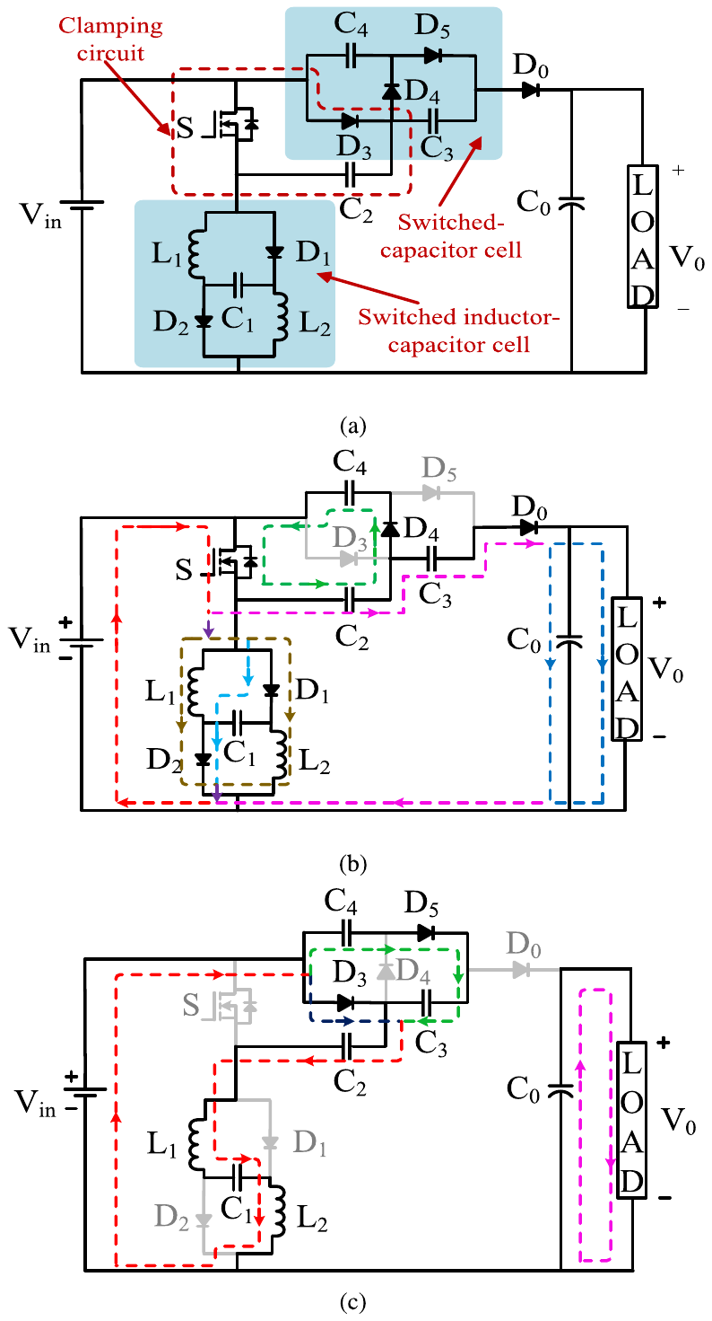
Fig. 2.1 (a) Circuit configuration, (b) Mode-I and (c) Mode-II of the converter
Mode-I (S on, 0 < t < DTs): D1, D2, D4 and Do conduct. L1, L2 and C1 are connected in parallel across the source, C2 passes charge to C4, and C3 in series with the source and C2 feeds the output:
 | $V_{\text{L1}} = V_{\text{L2}} = V_{\text{C1}} = V_{\text{in}}, V_{\text{C4}} = V_{\text{C2}}, V_{o} = V_{\text{in}} + V_{\text{C2}} + V_{\text{C3}}$ | (2.1)
Mode-II (S off, DTs < t < Ts): D3 and D5 conduct. L1, L2 and C1 in series with the source charge C2, C4 recharges C3, and Do is reverse biased, so Co alone supplies the load:
 | $V_{\text{C2}} = V_{\text{L1}} + V_{\text{L2}} + V_{\text{C1}} + V_{\text{in}}, V_{\text{C3}} = V_{\text{C4}}, V_{o} = V_{\text{Co}}$ | (2.2)
Fig. 2.2 shows the ideal waveforms that follow from these two modes. They are used in Section 5 to explain the simulated waveforms.
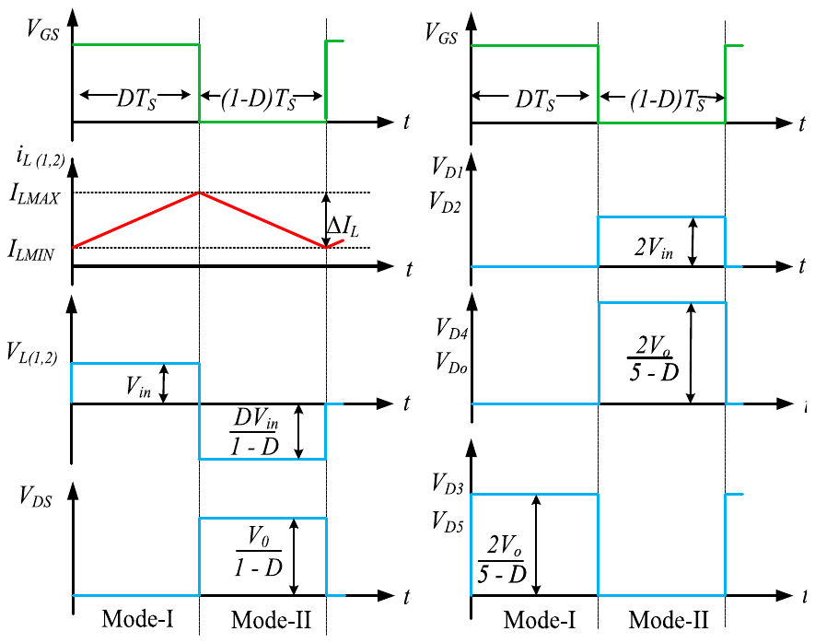
Fig. 2.2 Ideal key waveforms of the converter

3. Design Equations and Calculations

3.1 Voltage Gain
In steady state the average voltage across each inductor over one period must be zero (volt–second balance):
 | $\int_{0}^{DT_{s}}{\left(V_{\text{L1}} + V_{\text{L2}}\right) dt} + \int_{DT_{s}}^{T_{s}}{\left(V_{\text{L1}} + V_{\text{L2}}\right) dt} = 0$ | (3.1)
In Mode-I each inductor is connected across the source, so VL1 + VL2 = 2Vin. In Mode-II the series path Vin–L1–C1–L2 charges C2, so VL1 + VL2 = 2Vin − VC2 (using VC1 = Vin). Substituting the two values into (3.1):
 | $2V_{\text{in}}D + \left(2V_{\text{in}} − V_{\text{C2}}\right)\left(1 − D\right) = 0$ | (3.2)
Expanding and collecting the terms in Vin:
 | $2V_{\text{in}}D + 2V_{\text{in}} − 2V_{\text{in}}D − V_{\text{C2}}(1 − D) = 0$ | (3.3)
The two D terms cancel, leaving 2Vin = VC2(1 − D), so the voltage of C2 is:
 |  | (3.4)
  $V_{\text{C2}} = \frac{2V_{\text{in}}}{1 − D}$
The switched-capacitor cell copies this voltage to C3 and C4, so VC2 = VC3 = VC4. Adding the source and the two series capacitors gives the output voltage:
 | $V_{\text{o}} = V_{\text{in}} + V_{\text{C2}} + V_{\text{C3}} = V_{\text{in}} + \frac{4V_{\text{in}}}{1 − D} = V_{\text{in}}\frac{1 − D + 4}{1 − D}$ | (3.5)
 |  | (3.6)
  $G_{v} = \frac{V_{o}}{V_{\text{in}}} = \frac{5 − D}{1 − D}$
For the design, (3.6) is rearranged for D: Gv(1 − D) = 5 − D, so Gv − 5 = D(Gv − 1) and
 | $D = \frac{G_{\text{v}} − 5}{G_{\text{v}} − 1} = \frac{8.333 − 5}{8.333 − 1} = 0.4545$ | (3.7)
where Gv = 400/48 = 8.333. With this ideal duty ratio, (3.4) gives the capacitor voltages:
 | $V_{\text{C2}} = V_{\text{C3}} = V_{\text{C4}} = \frac{2 × 48}{1 − 0.4545} = 176.0 \text{V}$ | (3.8)
while C1 is charged directly from the source, so VC1 = Vin = 48 V. Check: Vin + VC2 + VC3 = 48 + 176 + 176 = 400 V.
A real converter has diode drops and resistive losses, so it needs a slightly larger duty ratio than 0.455 to reach 400 V. A conventional boost converter would need D = 1 − 48/400 = 0.88 for the same gain.

3.2 Voltage Stress on the Switch and Diodes
Applying KVL in each mode gives the reverse voltage seen by each device when it is off (Table 3.1). The switch and D3–D5, Do block one capacitor voltage of the switched-capacitor cell, and D1, D2 block about half of that.
Table 3.1 Power device stress analysis
Device | Voltage stress | Avg. current (conduction) | Avg. current (cycle) | RMS current
S | $\frac{2V_{o}}{5 − D}$ | $\frac{4I_{o}}{D\left(1 − D\right)}$ | $\frac{4I_{o}}{1 − D}$ | $\frac{4I_{o}}{\sqrt{D}\left(1 − D\right)}$
D1, D2 | $\frac{2V_{o}\left(1 − D\right)}{5 − D}$ | $\frac{2I_{o}}{D\left(1 − D\right)}$ | $\frac{2I_{o}}{1 − D}$ | $\frac{2I_{o}}{\sqrt{D}\left(1 − D\right)}$
D4 | $\frac{2V_{o}}{5 − D}$ | $\frac{I_{o}}{D}$ | $I_{o}$ | $\frac{I_{o}}{\sqrt{D}}$
D3, D5 | $\frac{2V_{o}}{5 − D}$ | $\frac{I_{o}}{1 − D}$ | $I_{o}$ | $\frac{I_{o}}{\sqrt{1 − D}}$
Do | $\frac{2V_{o}}{5 − D}$ | $\frac{I_{o}}{D}$ | $I_{o}$ | $\frac{I_{o}}{\sqrt{D}}$
Substituting Vo = 400 V and D = 0.4545:
 | $V_{\text{DS}} = V_{\text{D3,4,5,o}} = \frac{2V_{\text{o}}}{5 − D} = \frac{2 × 400}{5 − 0.4545} = 176.0 \text{V}$ | (3.9)
 | $V_{\text{D1,2}} = \frac{2V_{\text{o}}(1 − D)}{5 − D} = \frac{2 × 400 × 0.5455}{5 − 0.4545} = 96.0 \text{V}$ | (3.10)
The D1, D2 stress is exactly 2Vin, since 2Vo(1 − D)/(5 − D) = 2Vin by (3.6). The switch therefore blocks only 44% of the output voltage, which is why a 300 V, 16 mΩ MOSFET can be used.

3.3 Inductor Design
During DTs the inductor voltage is Vin, so its current rises by ΔIL = Vin·DTs/L. For a chosen ripple this gives the inductance:
 |  | (3.11)
  $L_{1} = L_{2} ≡ L ≥ \frac{V_{\text{in}}D}{ΔI_{L}f_{S}}$
 | $ΔI_{\text{L}} = \frac{V_{\text{in}}D}{Lf_{\text{s}}} = \frac{48 × 0.4545}{750 µH × 40 kHz} = 0.727 \text{A}$ | (3.12)
The average inductor current follows from the power balance of the converter:
 |  | (3.13)
  $I_{\text{L1}} = I_{\text{L2}} ≡ I_{L} = \frac{2I_{o}}{1 − D}$
 | $I_{\text{L}} = \frac{2 × 0.675}{1 − 0.4545} = 2.48 \text{A} ⟹ ΔI_{\text{L}}/I_{\text{L}} = 29\%$ | (3.14)
The converter stays in continuous conduction while IL > ΔIL/2. Setting IL = ΔIL/2 gives the minimum inductance:
 |  | (3.15)
  $L_{\text{min}} ≥ \frac{{\left(1 − D\right)}^{2}DR_{L}}{4\left(5 − D\right)f_{S}}$
 | $L_{\text{min}} = \frac{0.5455² × 0.4545 × 592.6}{4 × 4.5455 × 40000} = 110 \text{µH}$ | (3.16)
The chosen 750 µH is about 7 times Lmin, so the converter is deep in continuous conduction at 270 W and stays in CCM at the 160 W load step as well.

3.4 Output Capacitor and Output Ripple
During (1 − D)Ts diode Do is off and Co alone feeds the load, while during DTs Co is recharged. Charge balance gives the minimum capacitance for a voltage ripple ΔVCo:
 | $C_{\text{o}} ≥ \frac{DV_{\text{o}}}{ΔV_{\text{Co}}f_{\text{s}}R_{\text{L}}}$ | (3.17)
For a 1% ripple (ΔVCo = 4 V) this requires only Co ≥ 0.4545 × 400/(4 × 40000 × 592.6) = 1.9 µF. Rearranging for the ripple obtained with the chosen 100 µF:
 | $ΔV_{\text{o}} = \frac{0.4545 × 400}{100 µF × 40 kHz × 592.6 Ω} = 0.077 \text{V}$ | (3.18)
With Co = 100 µF the charge ripple is only 77 mV (0.02%). The 50 mΩ ESR of Co adds a step of rC·ΔICo at each switching instant, which is checked against the simulation in Section 5.2.

3.5 Current Mirror Ripple Cancellation Circuit
The CMRCC (Fig. 3.1) is a two-winding transformer with a 1:1 turns ratio placed between the source and the converter. The primary carries the pulsating converter current IP. The secondary, in series with a blocking capacitor CB, is wound in the opposite sense, so it carries a current IS whose ac part is equal and opposite to that of IP. CB blocks dc, so IS has zero average. The source supplies Iin = IP + IS, which keeps the dc part and loses the ripple (Fig. 3.2).
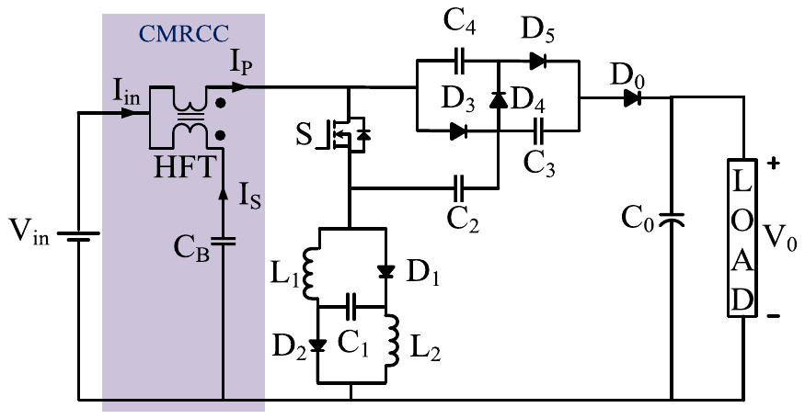
Fig. 3.1 Converter with the CMRCC at the input
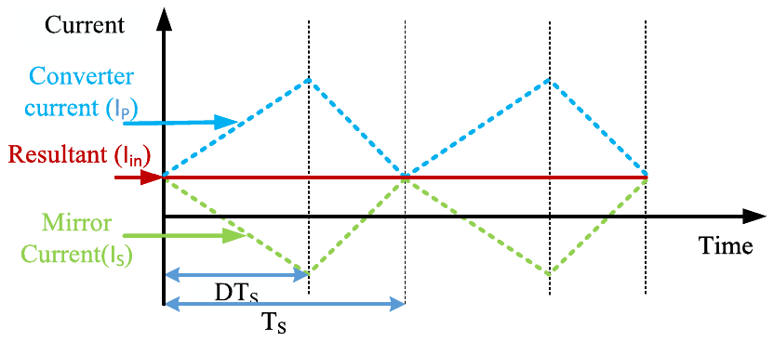
Fig. 3.2 Working principle of the CMRCC
Equal ripple magnitudes require a unity turns ratio (two turns on each side), and the primary inductance is kept small (1.5 µH) so that its voltage, which subtracts from the converter input, stays near 1% of Vin:
 |  | (3.19)
  $\frac{I_{P}}{I_{S}} = \frac{N_{S}}{N_{P}}$
 |  | (3.20)
  $V_{L} = L_{p}\frac{dI_{p}}{dt}$

3.6 PI Controller
The control-to-output transfer function, obtained by state-space averaging and simplified by pole–zero cancellation, is regulated with a PI controller:
 |  | (3.21)
  $G(s) = \frac{ṽ_{o}(s)}{d̃(s)} ≈ \frac{0.46\left(s + 5627\right)\left(s^{2} − 1759s + 8.426×{10}^{8}\right)}{\left(s + 8912\right)\left(s^{2} + 584.4s + 3.01×{10}^{6}\right)}$
 |  | (3.22)
  $H(s) = K_{p} + \frac{K_{i}}{s}, Loop gain = G(s)·H(s)$
  $K_{p} = 0.00159, K_{i} = 0.35$
These gains give a phase margin of 67.8° at a crossover frequency of 562 rad/s. For digital implementation the controller is discretised with the bilinear transform at Ts = 25 µs:
 | $H(z) = \frac{0.001592 − 0.001588z^{−1}}{1 − z^{−1}}$ | (3.23)

4. Simulink Implementation
The converter was built in MATLAB/Simulink R2024b with the Specialized Power Systems library. The powergui block solves the circuit in discrete mode with a 50 ns step (500 samples per switching period), and the gate signal comes from a PWM Generator with a 25 µs carrier period (40 kHz). Each run lasts 50 ms, except the load-step run (140 ms). Four models were built (Table 4.1) with the values in Table 4.2.
Table 4.1 Simulink models
Model | Configuration | Compared with
research_paper.slx | Open loop, D = 0.474, RL = 593 Ω | Ideal waveforms (Fig. 2.2)
research_paper_cmrcc.slx | Open loop with CMRCC, D = 0.477, RL = 593 Ω | Fig. 9 of the paper
research_paper_closed_loop.slx | PI closed loop with CMRCC, Vref = 400 V, RL = 593 Ω (270 W) | Fig. 12 of the paper
research_paper_closed_loop_load_step.slx | As above; 1000 Ω load, 1452 Ω switched in parallel at 40 ms (160 W → 270 W) | Fig. 13(b) of the paper

Table 4.2 Design parameters: paper and Simulink models
Parameter | Paper | Simulink
Vin / Vo / Po | 40–48 V / 400 V / 270 W (350 W max.) | 48 V / 400 V / 270 W
Switching frequency fs | 40 kHz | 40 kHz (PWM period 25 µs)
L1, L2 | 750 µH, 120 mΩ | 750 µH, 120 mΩ
C1–C4 / Co | 100 µF, 3 mΩ / 100 µF, 50 mΩ | 100 µF, 3 mΩ / 100 µF, 50 mΩ
MOSFET S | 300 V, 16 mΩ | Ron = 16 mΩ
Diode forward drop D1, D2 / D3–D5, Do | 0.85 V / 1.12 V | 0.85 V / 0.12 V (Ron = 10 mΩ)
Diode snubber | not used | Block default 500 Ω + 250 nF
Load RL | 592 Ω (270 W), 1000 Ω (160 W) | 593 Ω; 1000 Ω ∥ 1452 Ω = 592.3 Ω
CMRCC Lp, Ls | 1.5 µH, 14 mΩ | 1.5 µH, 14 mΩ, M = 1.485 µH (k = 0.99)
Blocking capacitor CB | 15 µF | 1000 µF, 5.5 mΩ
PI controller | Kp = 0.00159, Ki = 0.35 | Kp = 0.00159, Ki = 0.35, discrete Ts = 25 µs, D limited to 0.1–0.7
Simulation step | — | 50 ns (powergui, discrete)

The capacitors and inductors were given initial values close to the expected steady state (VC1 = 48 V, VC2–VC4 = 176 V, Vo = 400 V, iL = 2.57 A) to shorten the start-up transient.
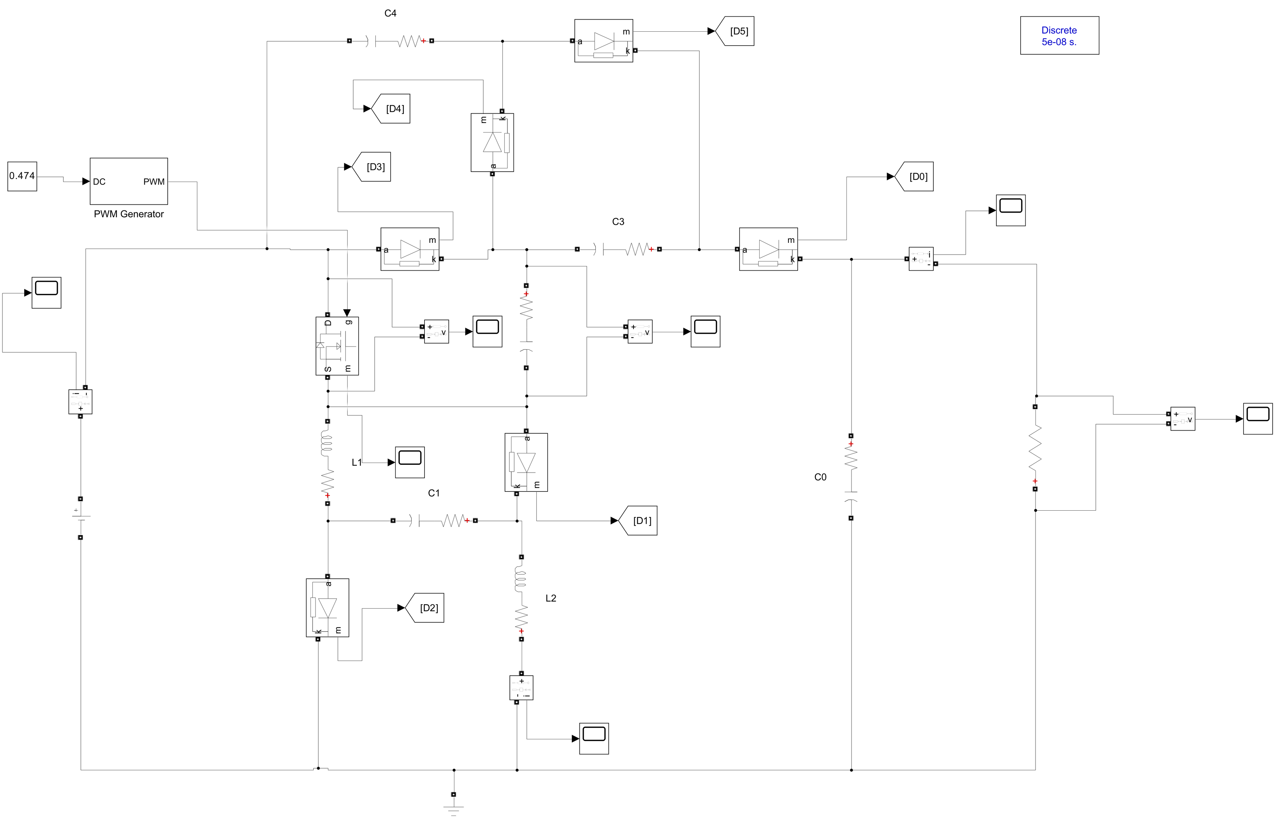
Fig. 4.1 Open-loop Simulink model (research_paper.slx)
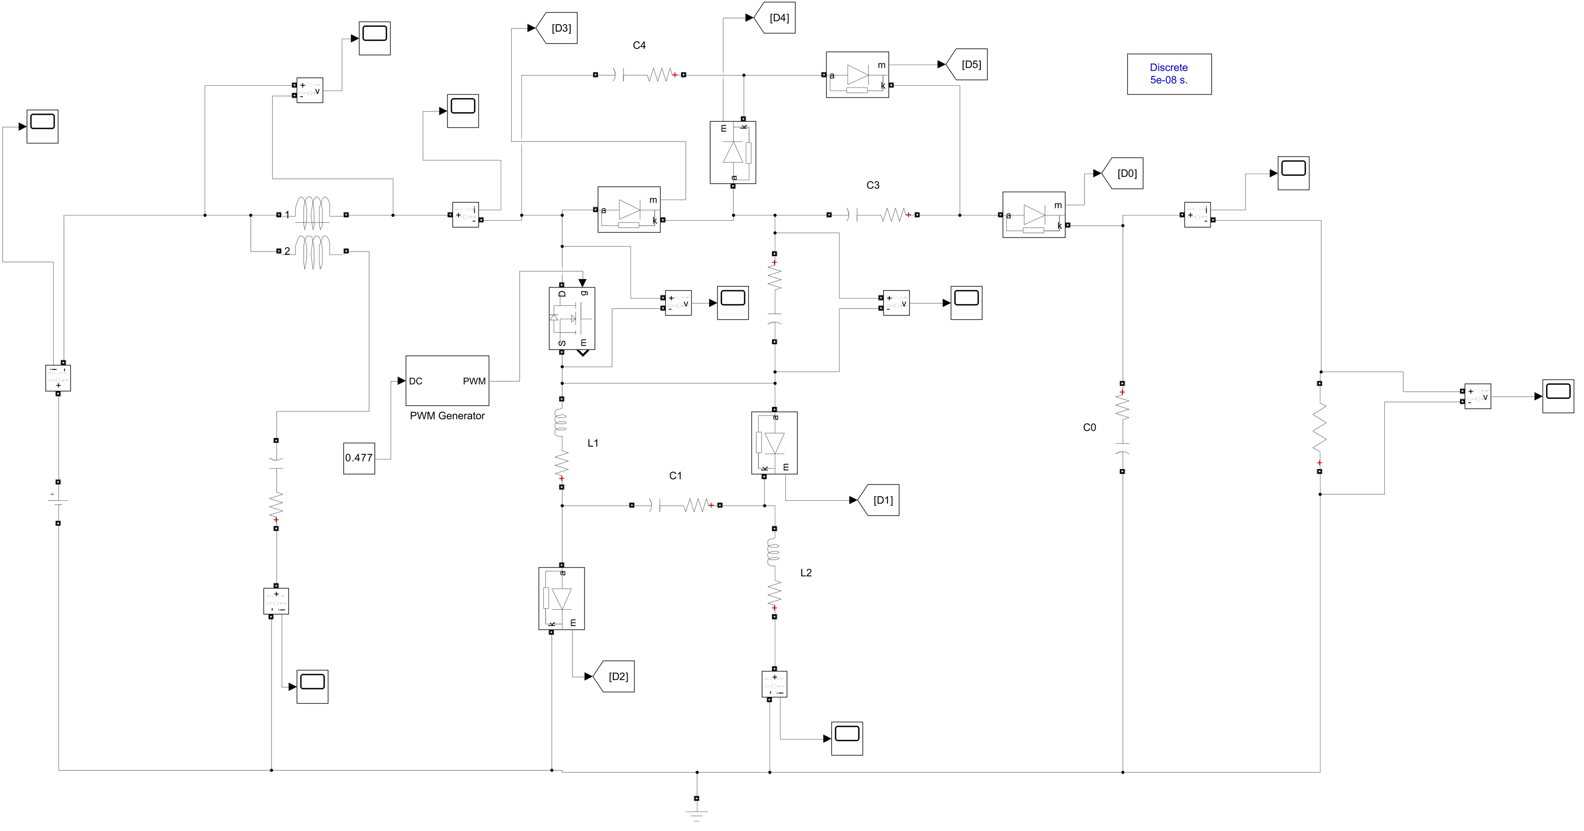
Fig. 4.2 Open-loop Simulink model with the CMRCC (research_paper_cmrcc.slx)
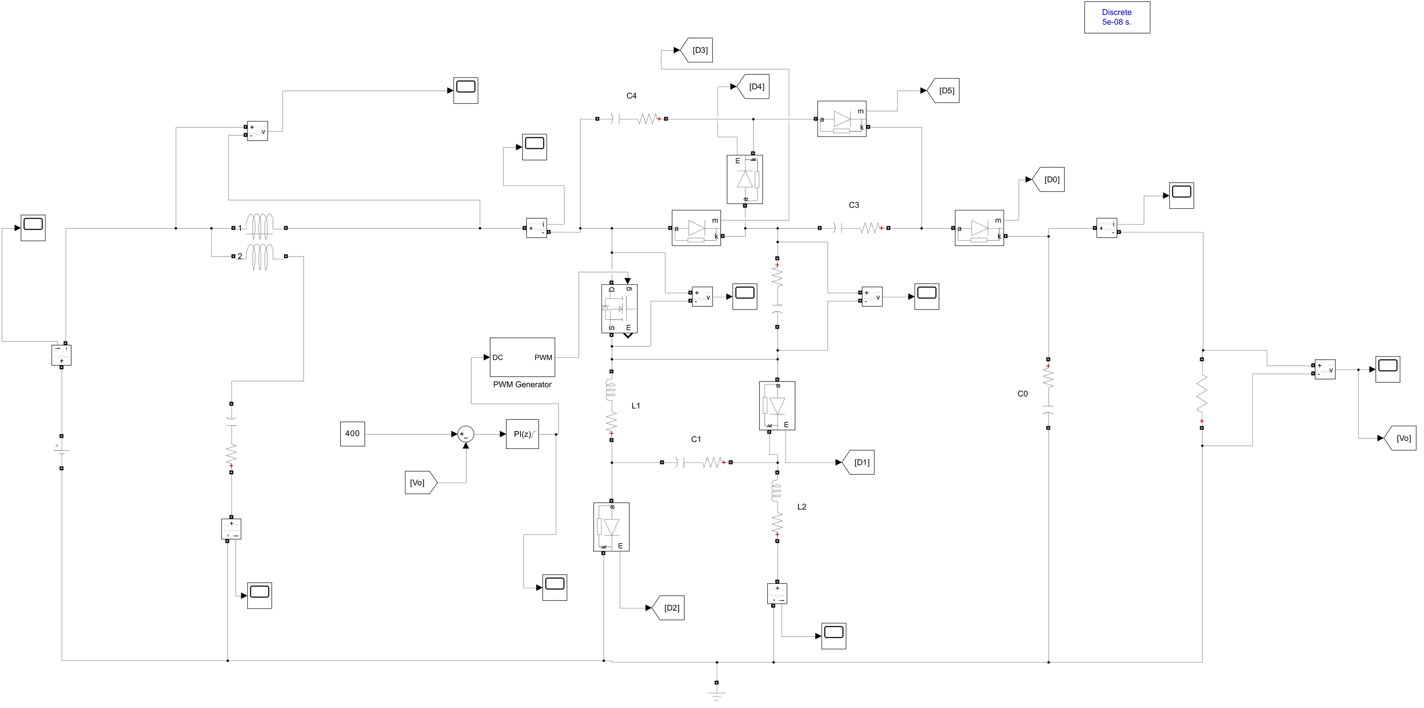
Fig. 4.3 Closed-loop Simulink model with CMRCC and discrete PI controller (research_paper_closed_loop.slx)
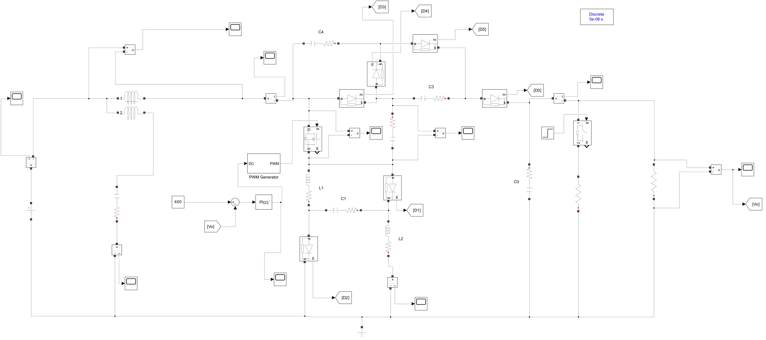
Fig. 4.4 Load-step model: an ideal switch driven by a step at 40 ms connects 1452 Ω in parallel with the 1000 Ω load
In the closed-loop models the measured Vo is subtracted from the 400 V reference, and the error drives the discrete PI controller, whose output (initialised at 0.477) is the duty ratio given to the PWM generator.

5. Results and Waveform Analysis
Steady-state values are taken over the last 5 ms of each run, and reverse diode voltages are plotted as positive values. The gate signal, VDS and the duty ratio were logged by re-running copies of the models with extra To Workspace blocks. These runs reproduce the saved scope data exactly. Each subsection explains why the waveform has its shape and checks its values against the calculations of Section 3.

5.1 Open-Loop Waveforms
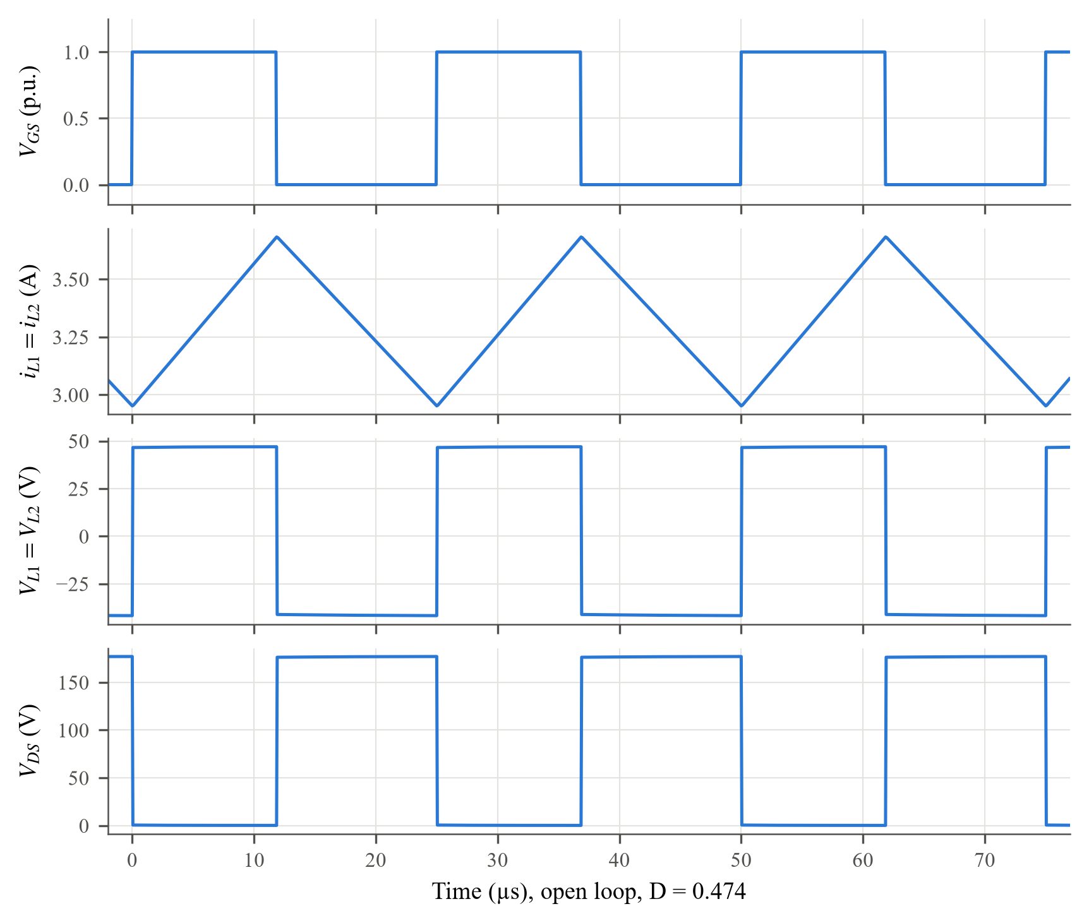
Fig. 5.1 Simulated VGS, inductor current, inductor voltage and VDS in open loop (D = 0.474)
Why the waveforms look like this
Inductor voltage. The inductor voltage is a two-level square wave because each mode connects the inductor to a fixed voltage. During DTs it sits across the source, giving +47.0 V (48 V less about 1 V of diode and winding drop). During (1 − D)Ts it sits in the series path that charges C2, giving −41.7 V. Ideally this is −DVin/(1 − D) = −43.3 V. The positive and negative areas must be equal (volt–second balance), and indeed 47.0 V × 11.85 µs ≈ 41.7 V × 13.15 µs (557 ≈ 549 V·µs).
Inductor current. Because the voltage is constant within each interval, di/dt = VL/L is constant and the current is a triangle. It rises at 47.0/750 µH = 62.6 A/ms for 11.85 µs, a rise of 0.74 A, and falls at 55.6 A/ms for 13.15 µs, a fall of 0.73 A. The simulated ripple is 0.73 A. The current never approaches zero, confirming CCM.
Switch voltage. When S is on, VDS is only Ron·iS ≈ 16 mΩ × 10 A ≈ 0.16 V. When S is off, the clamping circuit holds VDS at one capacitor voltage of the switched-capacitor cell, a flat 177.0 V. This matches 2Vo/(5 − D) = 176.8 V and (Vo − Vin)/2 = 176.0 V. Because the off-state voltage is clamped by a capacitor, there is no spike at turn-off.
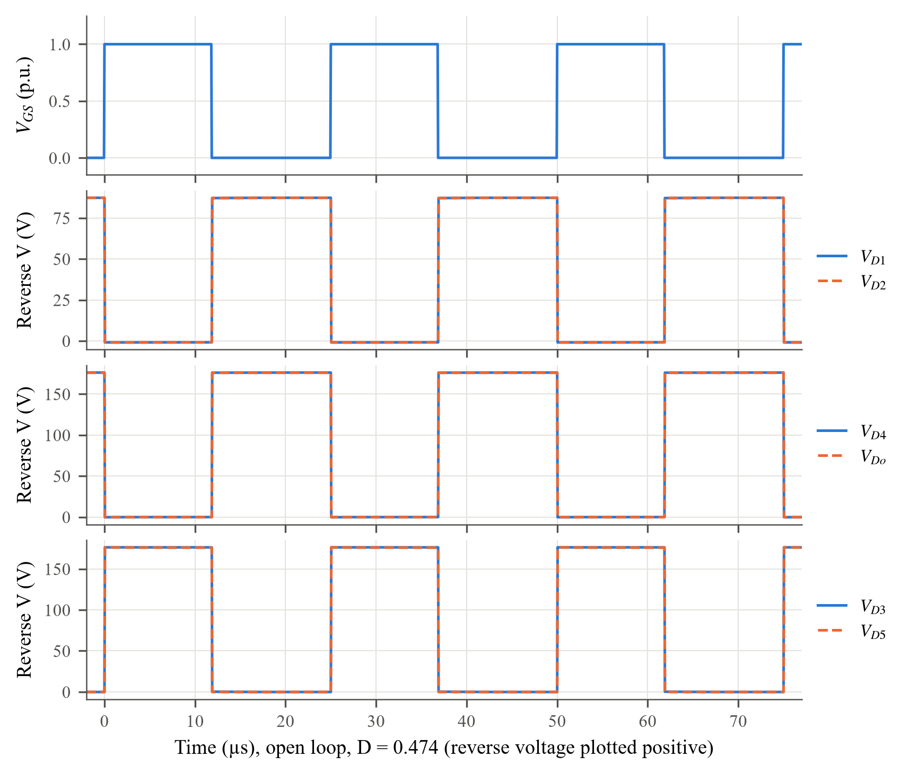
Fig. 5.2 Simulated diode reverse voltages in open loop (D = 0.474)
Why the waveforms look like this
Each diode alternates between conducting (zero voltage) and blocking (a flat voltage set by capacitors), so all the diode voltages are rectangular. D1, D2, D4 and Do conduct in Mode-I and block in Mode-II, so their pulses fall in the OFF interval. D3 and D5 are the opposite, so their pulses line up with the gate signal.
D3, D4, D5, Do. When blocking, each of these diodes has one capacitor of the switched-capacitor cell across it. Their reverse voltage therefore equals VC2 ≈ VC3 ≈ VC4. From the output equation, VC2 = (Vo − Vin)/2 = (400 − 48)/2 = 176 V, and the simulated values are 176.3, 176.2, 176.3 and 176.1 V.
D1, D2. In Mode-II, KVL around the loop formed by D1, C1 and the inductor gives VD1 = VC1 + |VL,OFF|. With the simulated values this is 45.9 + 41.7 = 87.6 V, against 87.3 V in Fig. 5.2. The two diodes see identical voltages because the cell is symmetrical.
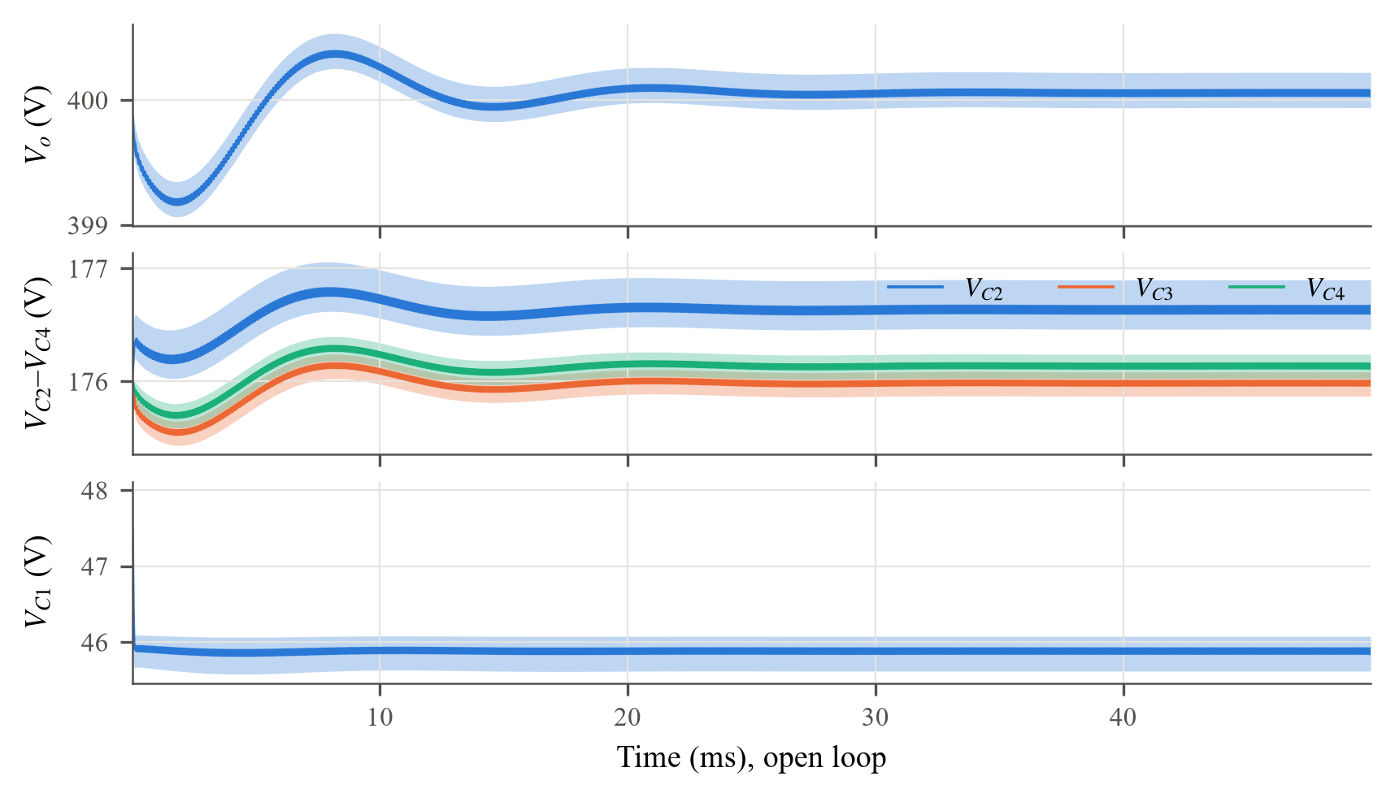
Fig. 5.3 Output and capacitor voltages over the whole open-loop run (shaded band: switching ripple)
Why the waveforms look like this
The run starts with the capacitors pre-charged close to their final values, so the start-up is a small, damped oscillation of about ±0.6 V that settles in about 20 ms. It comes from the LC resonance of the inductors and capacitors, damped by their resistances. In steady state VC2–VC4 settle at 176.0–176.6 V and VC1 at 45.9 V. VC1 is about 2 V below Vin because C1 is charged from the source through D1 or D2 (0.85 V each) and the 0.12 Ω winding resistance. The check Vin + VC2 + VC3 = 48 + 176.6 + 176.0 = 400.6 V agrees with Vo = 400.1 V to within one diode drop.
Table 5.1 Open loop: calculated versus simulated values (D = 0.474)
Quantity | Formula | Calculated | Simulated
Average IL | 2Io/(1 − D) | 2.57 A | 3.32 A
ΔIL | VinD/(Lfs) | 0.76 A | 0.73 A
VL (Mode-I / II) | Vin / −DVin/(1 − D) | 48 V / −43.3 V | 47.0 V / −41.7 V
VDS | 2Vo/(5 − D) | 176.8 V | 177.0 V
VD1, VD2 | VC1 + |VL,OFF| | 87.6 V | 87.3 V
VD3, VD4, VD5, VDo | (Vo − Vin)/2 | 176.0 V | 176.1–176.3 V
Vo | Vin(5 − D)/(1 − D) | 413.0 V (ideal) | 400.1 V

The voltages agree closely. Vo is about 13 V below the ideal value because of the diode and resistive drops. The average inductor current (3.32 A) is higher than 2Io/(1 − D) because that expression assumes no losses, while the simulated input power is about 30% above the output power (Section 5.6).

5.2 Closed Loop at 270 W: Vo, Io and VDS
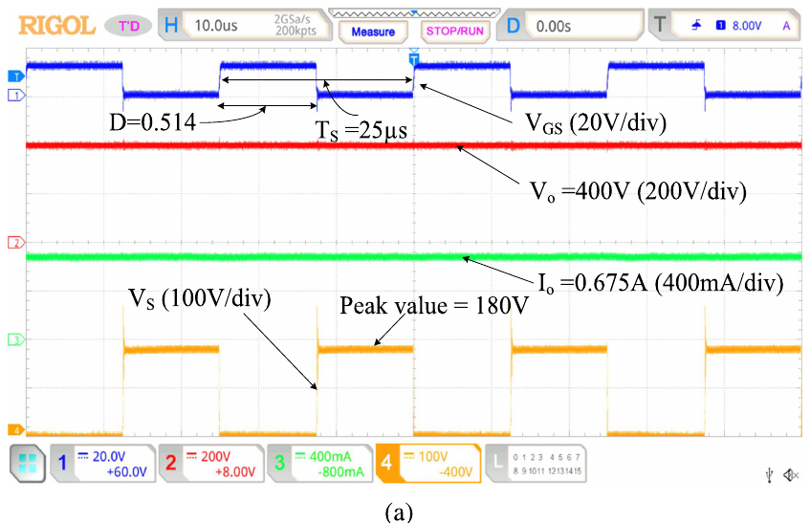
Fig. 5.4 Hardware result reported in the paper: Vo, Io and VDS at 270 W
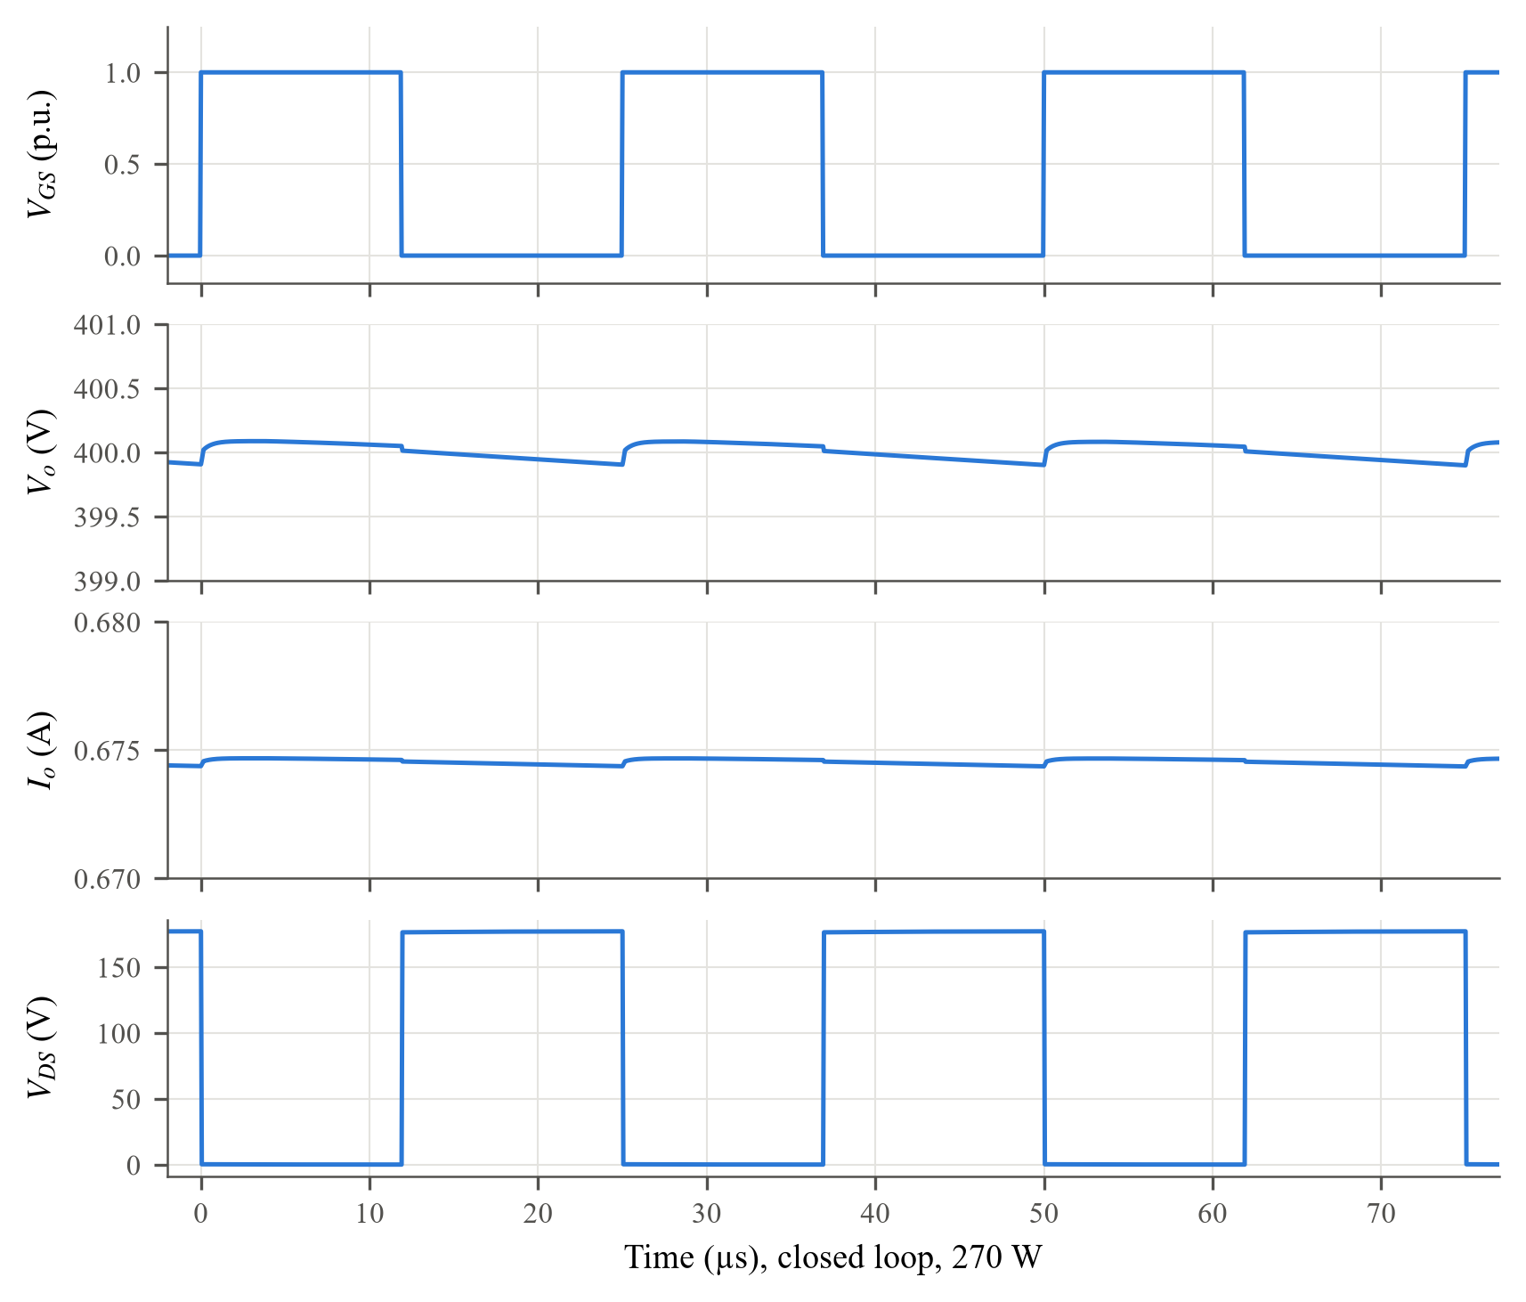
Fig. 5.5 Simulated VGS, Vo, Io and VDS in closed loop at 270 W
Why the waveforms look like this
Output voltage. The PI controller holds the average of Vo at 400.09 V, so Vo looks flat. The small ripple has two parts. The charge part is DVo/(Co·fs·RL) = 77 mV (Section 3.4). The ESR part comes from the Co current jumping between −0.85 A (Co feeding the load in Mode-II) and +2.26 A (Do recharging Co in Mode-I), a step of rC·ΔICo = 0.05 × 3.11 = 0.16 V. Together they predict about 0.23 V. The simulated ripple is 0.19 V within one period, and 0.43 V over 5 ms, which also includes a slow controller oscillation.
Output current. The load is a resistor, so Io = Vo/RL = 400.09/593 = 0.675 A and has the same flat shape as Vo. The output power is 269.9 W.
Switch voltage. The shape is the same as in open loop, but the controller has set D = 0.477, which is higher than the ideal 0.455 because it has to make up for the drops. VDS is clamped at 177.2 V, against 2Vo/(5 − D) = 176.9 V. The paper measures 180 V at D = 0.514, where the formula gives 178.3 V; the extra 2 V in hardware is ringing from stray inductance.
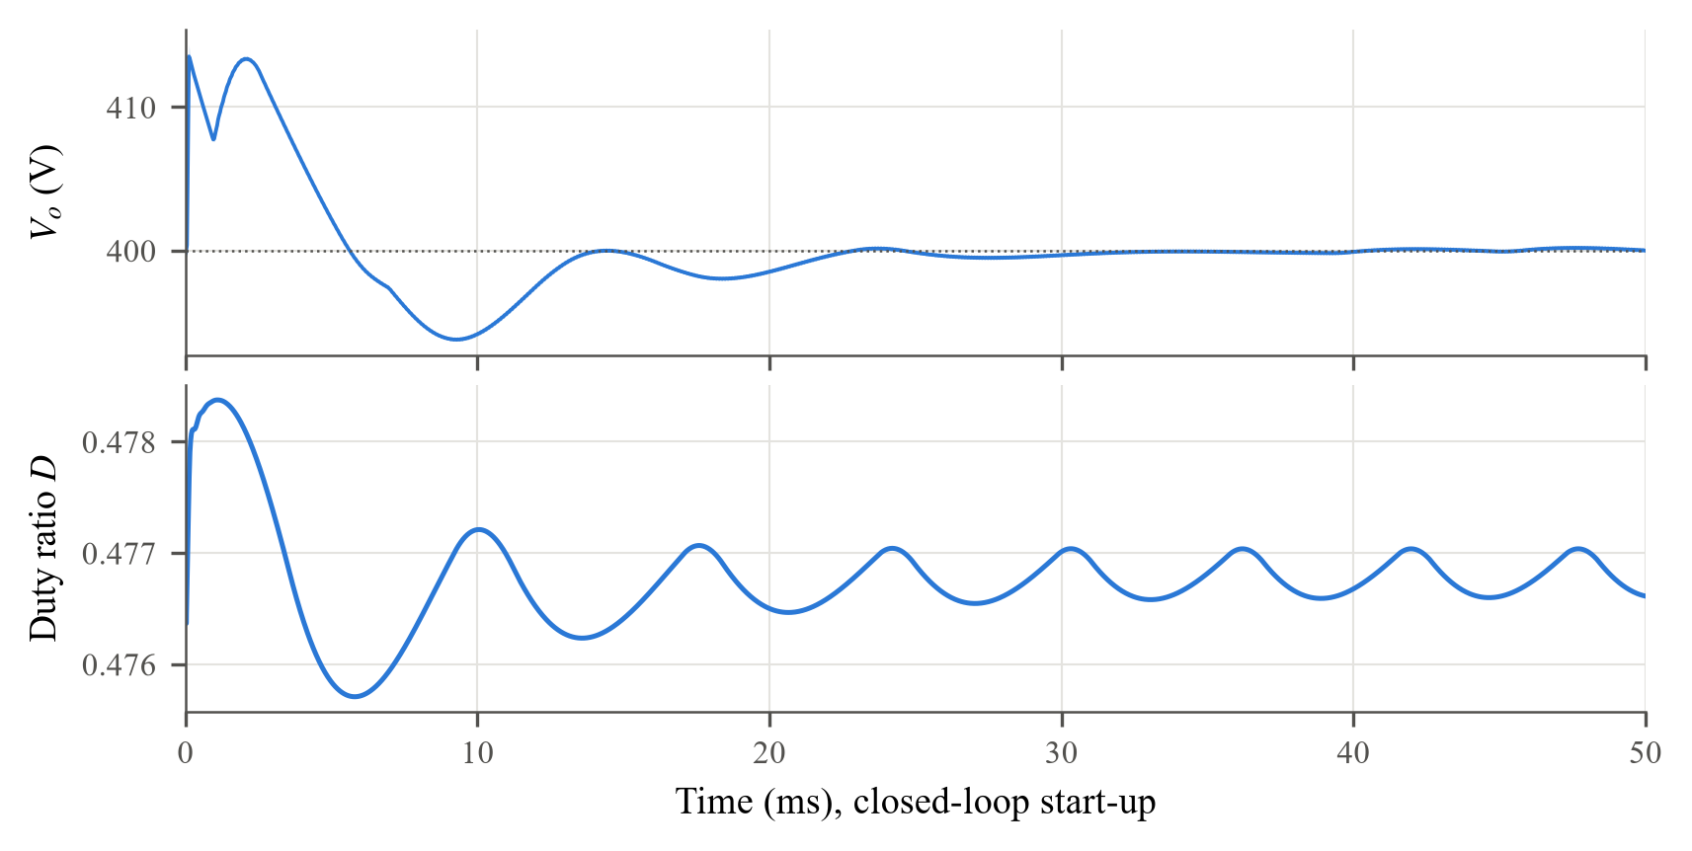
Fig. 5.6 Closed-loop start-up: output voltage and controller duty ratio
Start-up. The capacitor initial values do not exactly match the final operating point, so Vo first jumps to 414.4 V. The controller reacts by lowering the error integral, and Vo swings down to 393.7 V before settling inside ±1% after about 11 ms. With Kp = 0.00159, an error of 10 V changes D by only 0.016, and the integral term with Ki = 0.35 moves D by 0.0035 per millisecond. The duty ratio therefore changes very little and the response is smooth and well damped, as intended by the 67.8° phase margin.
Table 5.2 Closed loop at 270 W
Quantity | Paper (hardware) | Simulated
Vo | 400 V | 400.09 V
Io | 0.675 A | 0.675 A
Po | 270 W | 269.9 W
Duty ratio D | 0.514 | 0.477
Switching period Ts | 25 µs | 25 µs
VDS peak | 180 V | 177.2 V

5.3 Diode Voltage Stresses at 270 W
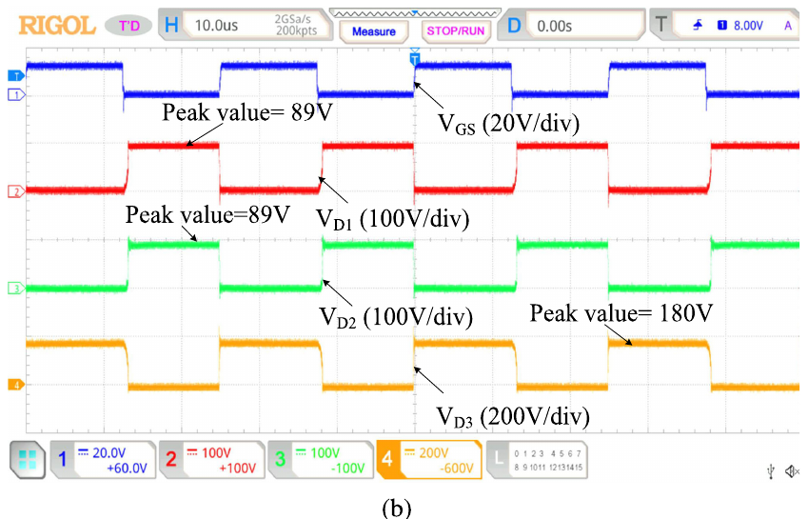
Fig. 5.7 Hardware result reported in the paper: VD1, VD2, VD3
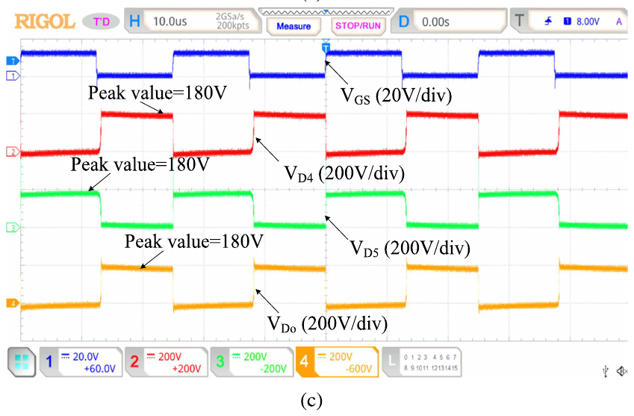
Fig. 5.8 Hardware result reported in the paper: VD4, VD5, VDo
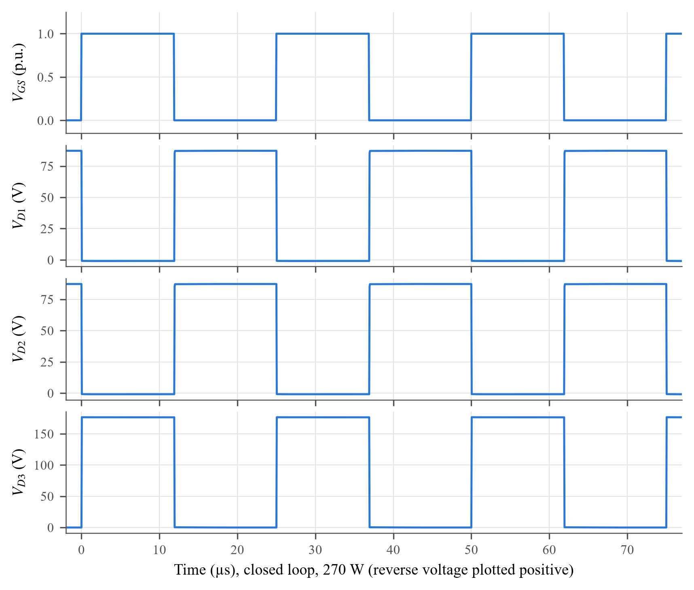
Fig. 5.9 Simulated VD1, VD2 and VD3 in closed loop at 270 W
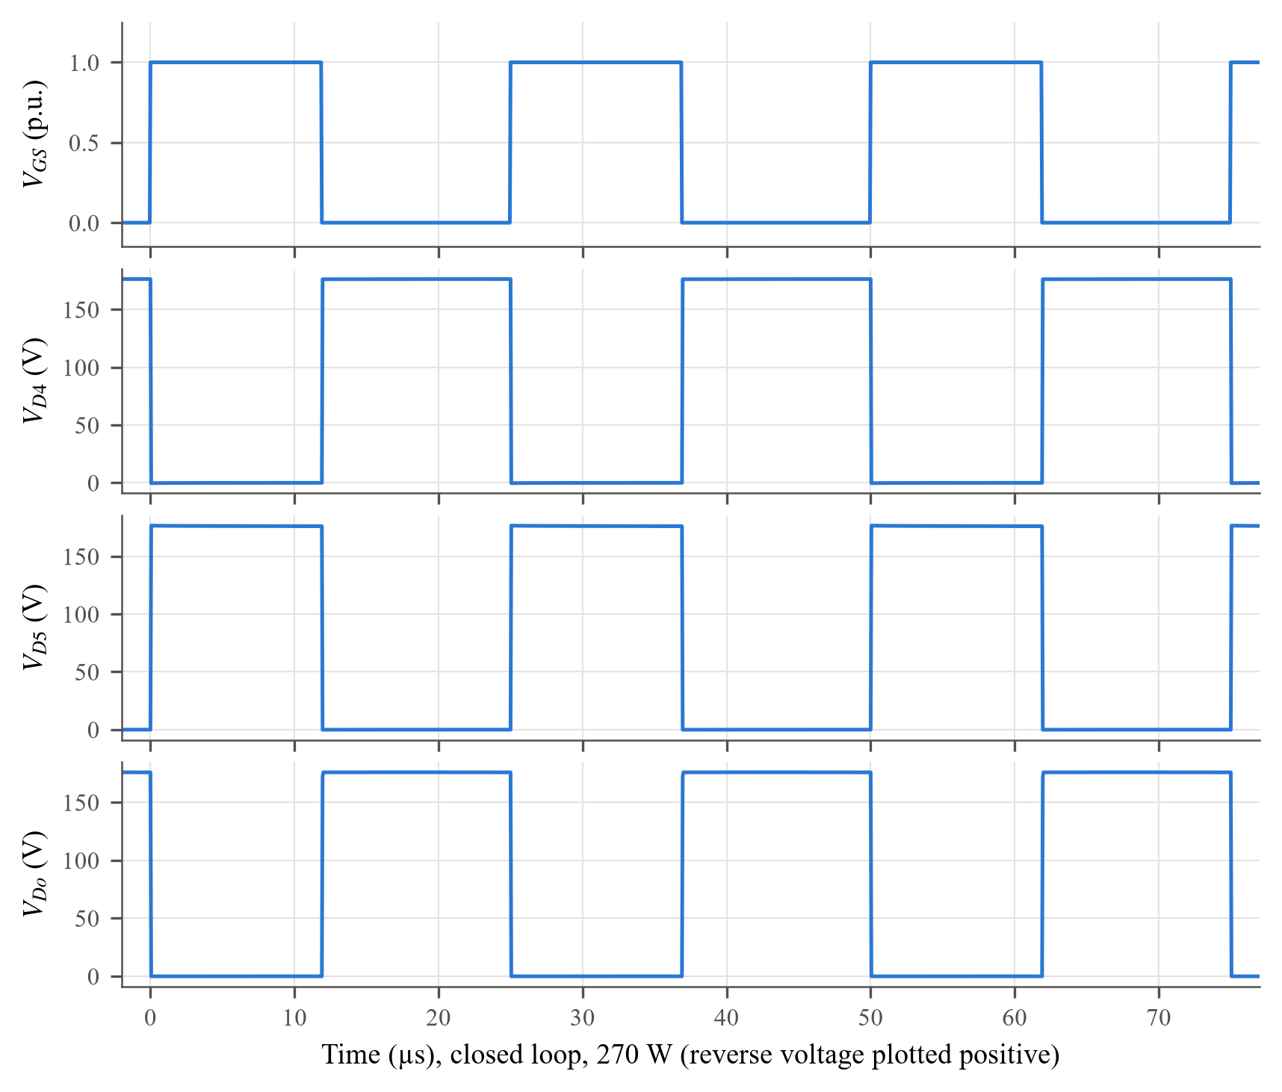
Fig. 5.10 Simulated VD4, VD5 and VDo in closed loop at 270 W
Why the waveforms look like this
The reasoning of Section 5.1 applies unchanged. D3 and D5 block during DTs, at the same time as the gate pulse; D1, D2, D4 and Do block during (1 − D)Ts. The same pattern appears in the hardware traces of Figs. 5.7 and 5.8. The blocking levels are VC1 + |VL,OFF| = 45.6 + 41.9 = 87.5 V for D1, D2 (simulated 87.3 V) and (Vo − Vin)/2 = 176.0 V for the others (simulated 176.0–176.6 V). The tops of the pulses are flat because the capacitors are large (100 µF) and their voltages hardly change within a period.
Table 5.3 Diode voltage stresses at 270 W
Diode | Table 3.1 (D = 0.477) | Paper (hardware) | Simulated
D1, D2 | 92.5 V | 89 V | 87.3 V
D3 | 176.9 V | 180 V | 176.6 V
D4 | 176.9 V | 180 V | 176.4 V
D5 | 176.9 V | 180 V | 176.6 V
Do | 176.9 V | 180 V | 176.0 V

For D1 and D2 the Table 3.1 expression 2Vo(1 − D)/(5 − D) (= 2Vin) gives 92.5 V. The loop expression Vin/(1 − D) = 91.7 V, or 87.5 V with the actual capacitor voltage, is closer to both the simulation and the 89 V hardware value. The two expressions are equal only at D = 0.5.

5.4 Input Current and the CMRCC
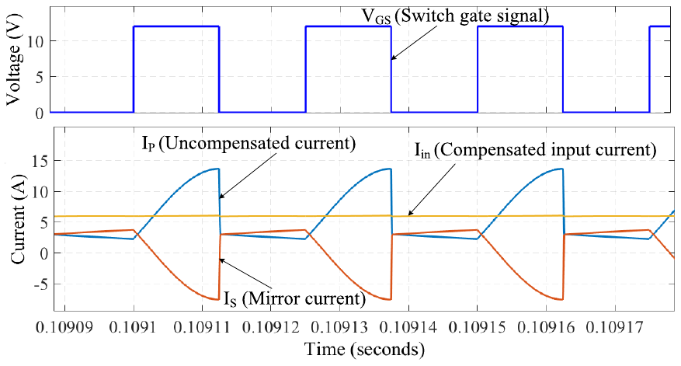
Fig. 5.11 Simulation result reported in the paper: IP, IS and Iin
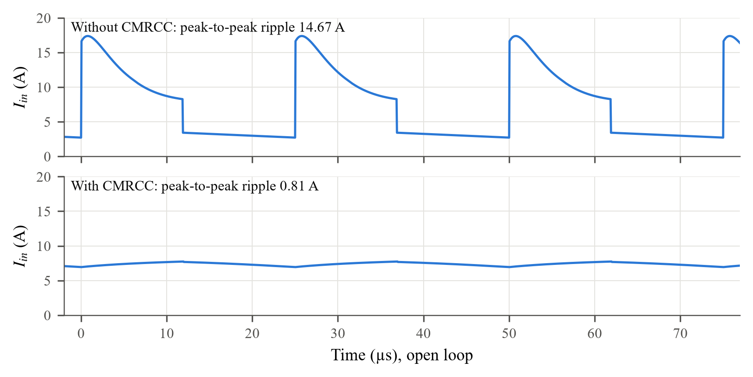
Fig. 5.12 Simulated source current without and with the CMRCC (open loop)
Why the input current without the CMRCC is pulsating
In Mode-II the source sits in the series path Vin–L1–C1–L2, so it carries just one inductor current, about 3.3 A, falling slowly with iL (2.7–3.4 A in Fig. 5.12). In Mode-I both inductors are in parallel across the source (2iL ≈ 6.6 A). On top of this, C1 and C3 are suddenly connected to the source and are recharged through a loop that contains only capacitor ESRs, diode on-resistances and the switch. This produces a charging pulse that lifts the current to 17.4 A about 0.8 µs after turn-on and decays exponentially as the capacitor voltages equalise. The result is a ripple of 14.7 A, twice the average current, which is what the CMRCC has to remove.
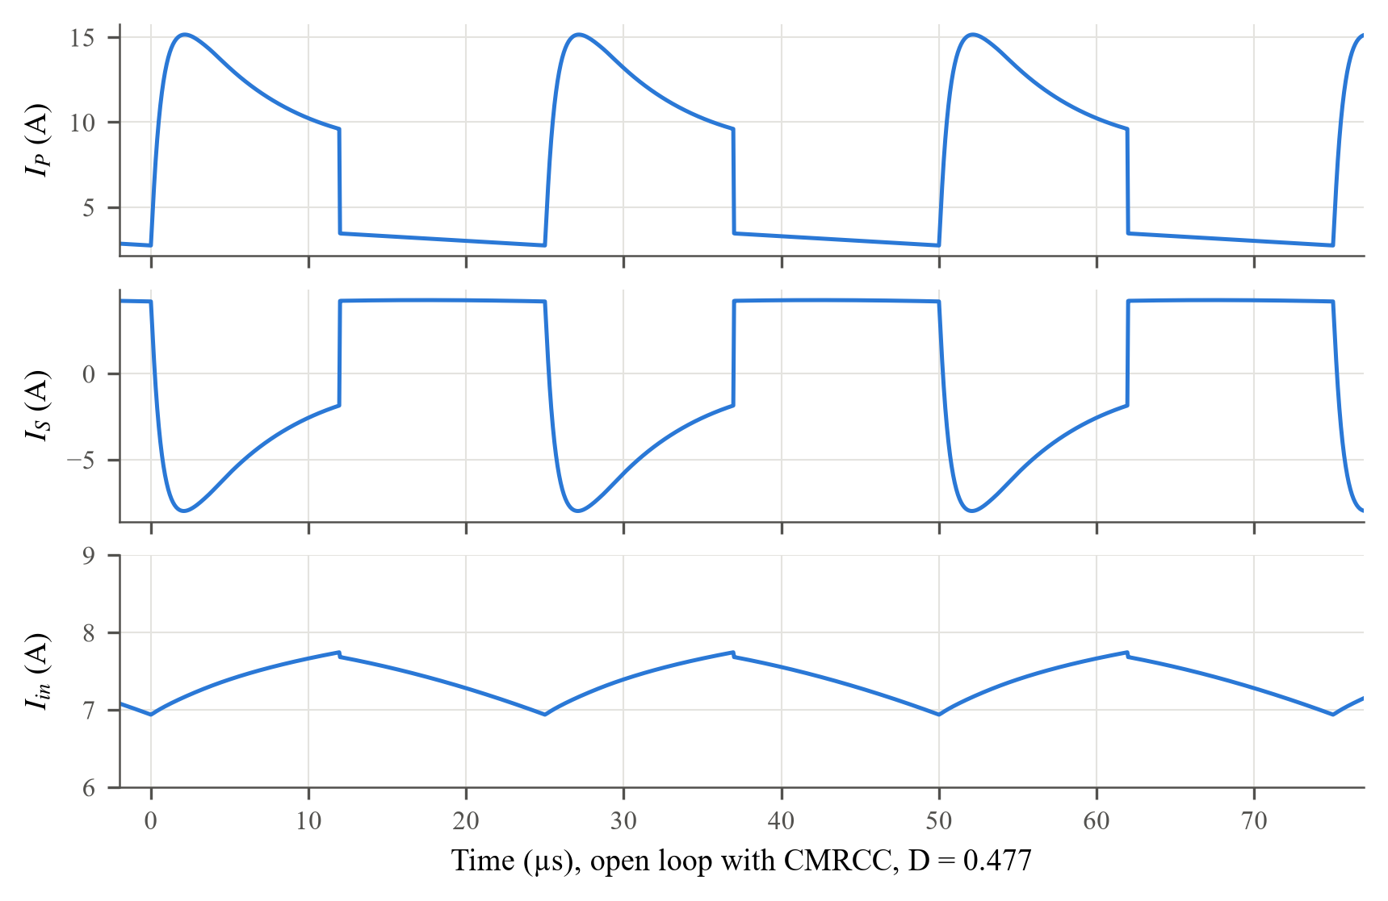
Fig. 5.13 Simulated IP, IS and Iin in open loop with the CMRCC
Why the CMRCC current waveforms look like this
With the CMRCC, IP (the converter-side current) keeps the pulsating shape (12.4 A peak-to-peak). The secondary winding is coupled to the primary with a 1:1 ratio and opposite polarity, so any change in IP induces an equal and opposite change in IS. CB is large, so its voltage is nearly constant and it passes no dc. IS is therefore the mirror image of the ac part of IP, with an average of only 0.5 mA. Adding the two, the pulses cancel and Iin becomes a nearly flat 7.38 A.
The residual ripple of Iin (0.81 A) is a small triangle: it rises during DTs and falls during (1 − D)Ts. This is the magnetising current of the coupled windings. The cancellation is exact only if the winding voltage is zero, but the winding resistances carry the large IP, so the windings see a small voltage (about 0.10 V on average in the simulation). Across the mutual inductance M = 1.485 µH this produces a current ramp:
 | $Δi_{\text{in}} ≈ \frac{v_{\text{w}}DT_{\text{s}}}{M} = \frac{0.10 × 11.9 µs}{1.485 µH} ≈ 0.83 \text{A}$ | (5.1)
This agrees with the simulated 0.81 A and shows that a larger magnetising inductance or lower winding resistance would reduce the residual ripple further.

5.5 CMRCC in Closed Loop
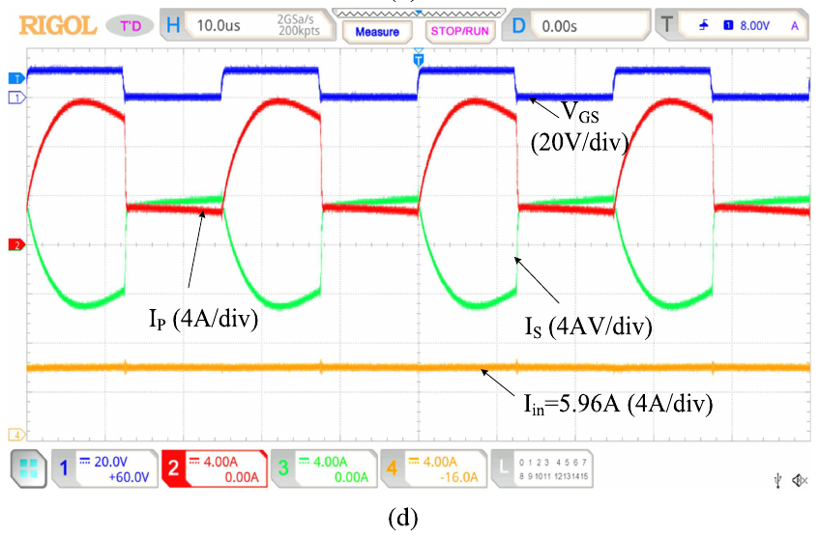
Fig. 5.14 Hardware result reported in the paper: IP, IS and Iin = 5.96 A
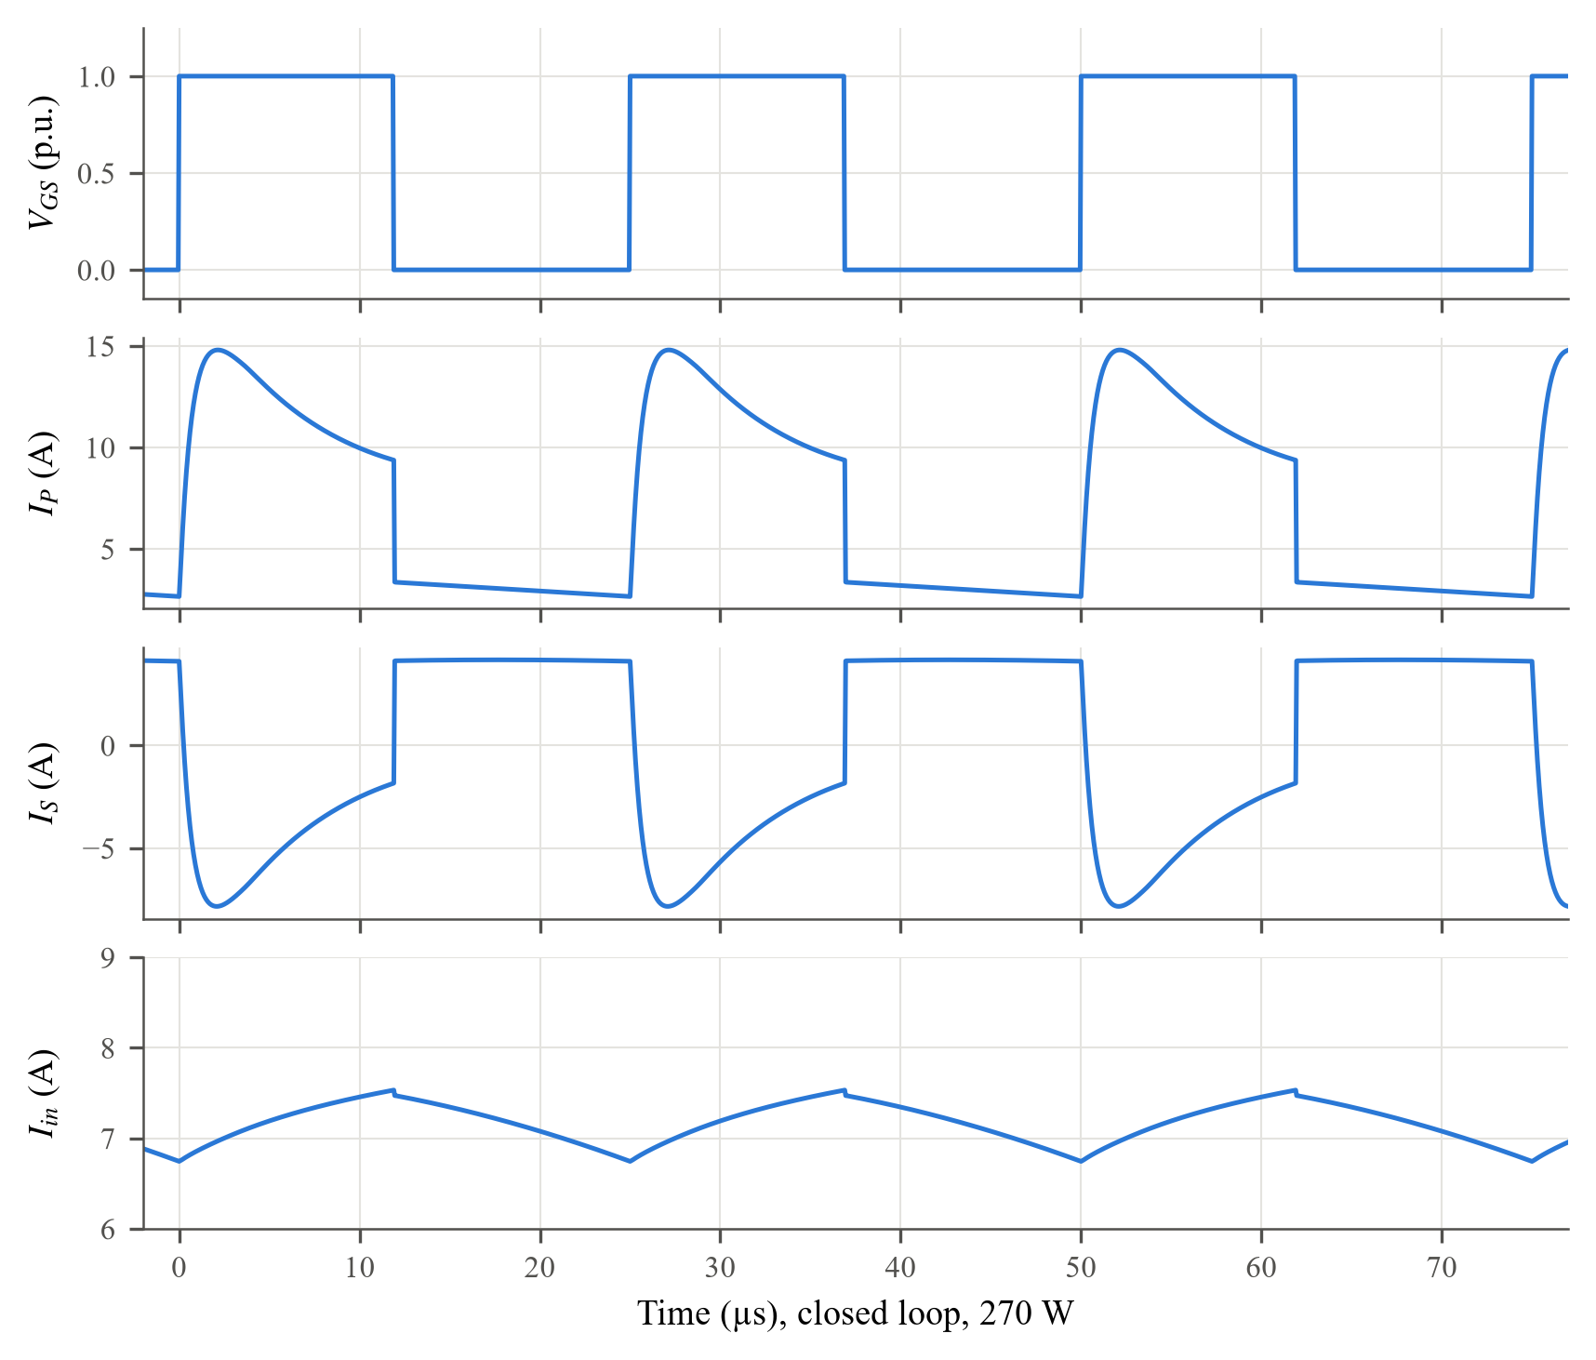
Fig. 5.15 Simulated IP, IS and Iin in closed loop at 270 W (IS = Iin − IP)
In closed loop the duty ratio is almost the same as in open loop, so the waveforms are almost unchanged. IP swings by 12.4 A, while Iin varies by only 0.81 A per period around 7.36 A, a 94.5% reduction compared with the converter without CMRCC. The hardware traces of Fig. 5.14 show the same features: a pulsating IP, an inverted mirror current IS and an almost flat Iin.
Table 5.4 CMRCC results at 270 W
Quantity | Paper | Simulated (open loop) | Simulated (closed loop)
Average Iin | 5.96 A | 7.38 A | 7.36 A
IP ripple (p-p) | — | 12.4 A | 12.4 A
Iin ripple (p-p) | < 1% of rated current | 0.81 A (10.9%) | 0.81 A (11.0%)
Ripple without CMRCC (p-p) | — | 14.7 A | —
Average IS | 0 A | 0.5 mA | 0.5 mA
Primary winding voltage (avg.) | ≈ 1% of Vin | — | 0.10 V (0.2%)

5.6 Load Step 160 W → 270 W
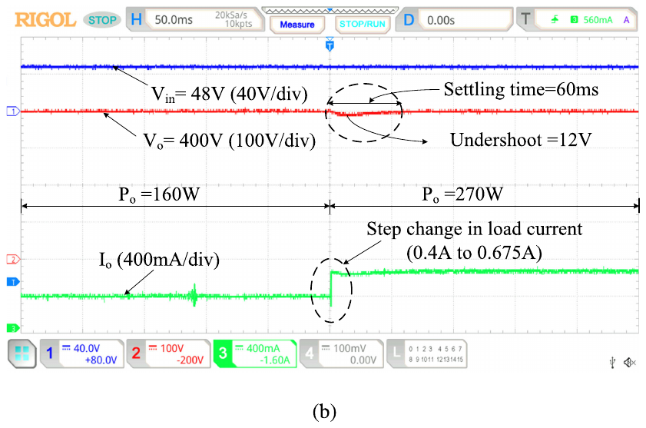
Fig. 5.16 Hardware result reported in the paper: load step-up 160 W → 270 W
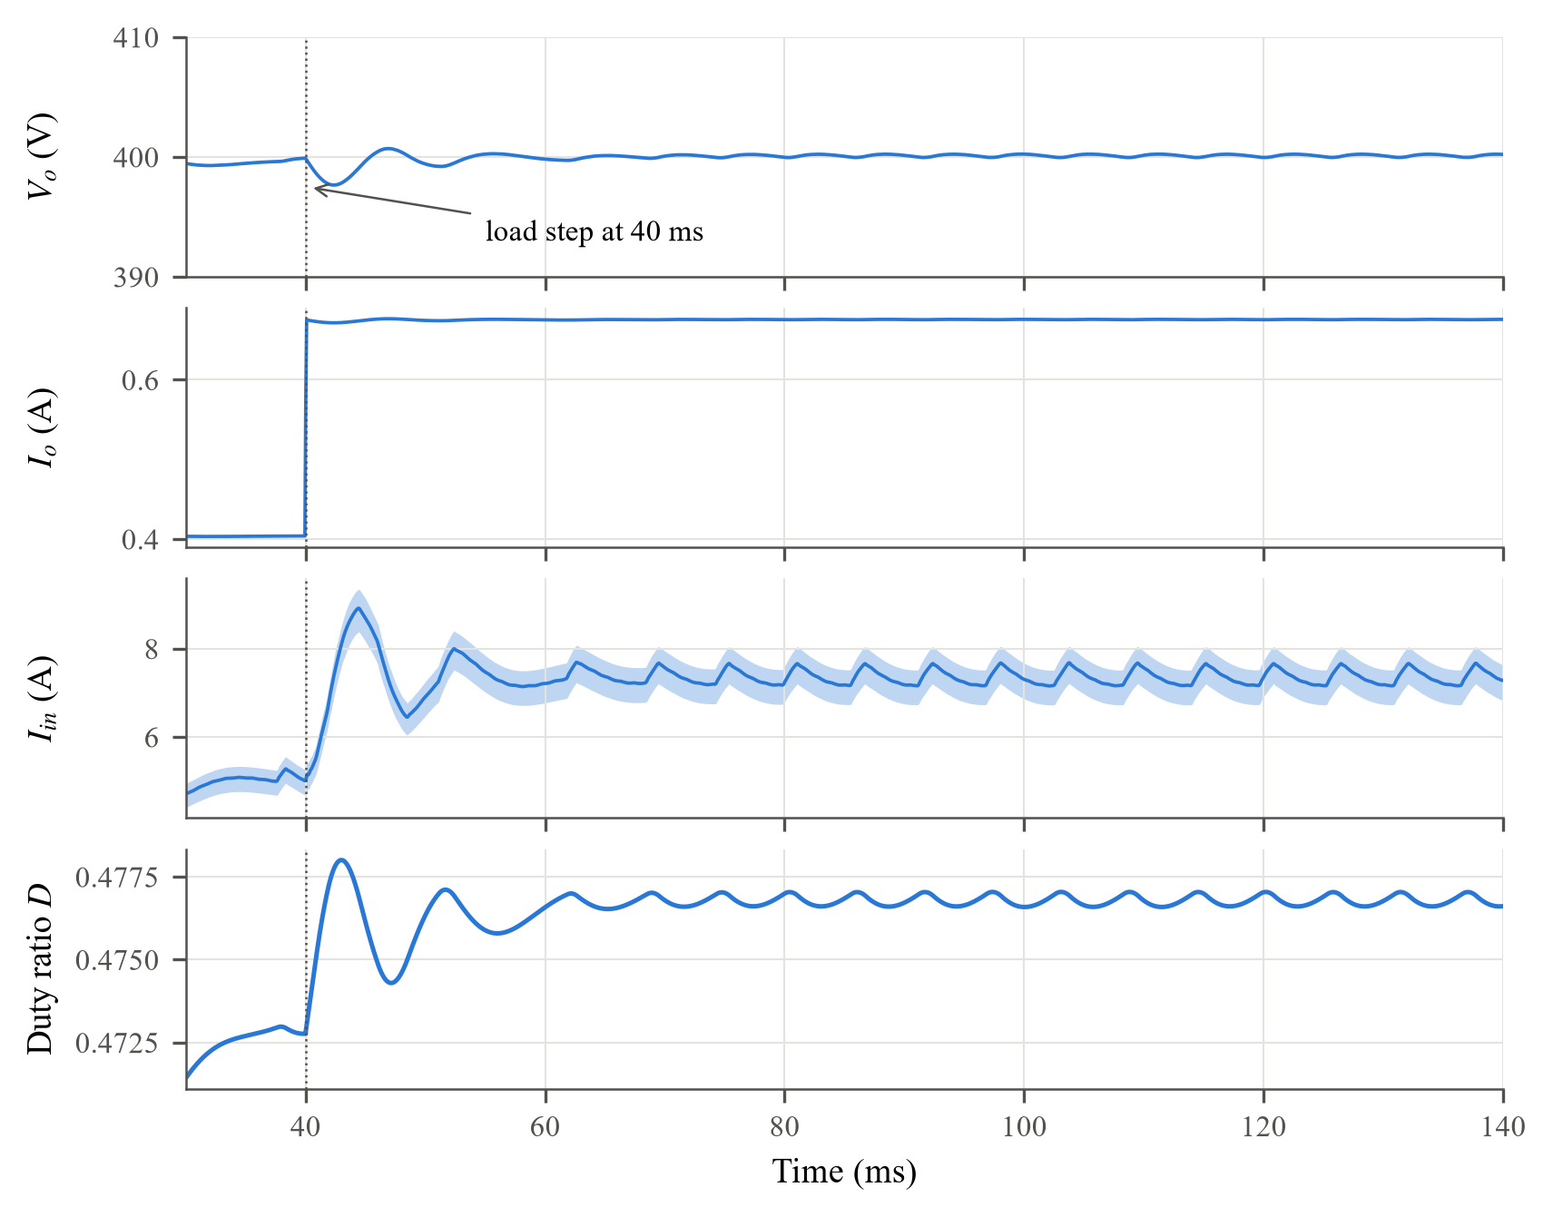
Fig. 5.17 Simulated load step-up 160 W → 270 W at t = 40 ms: Vo, Io, Iin and duty ratio (shaded: switching ripple)
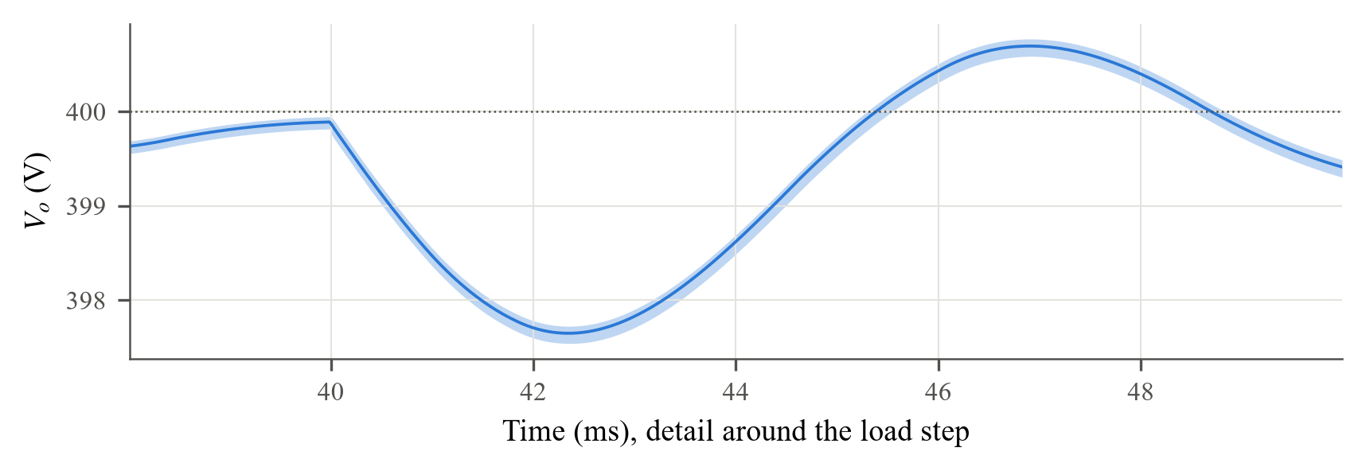
Fig. 5.18 Detail of the output voltage around the load step
Why the waveforms look like this
At t = 40 ms the load resistance drops from 1000 Ω to 1000 ∥ 1452 = 592.3 Ω, so Io jumps at once from 0.404 A to 0.676 A, following Vo/RL. With the old duty ratio the converter cannot supply the extra current at 400 V, since the larger currents cause larger voltage drops. The extra charge therefore comes from Co and Vo starts to fall. The initial slope is ΔIo/Co = 0.272 A/100 µF ≈ 2.7 V/ms.
The controller has to raise D by 0.0040 (from 0.473 to 0.477). With an error of about 2 V the integral term moves D at Ki × e ≈ 0.35 × 2 = 0.7 per second, so it needs about 6 ms to supply the missing duty ratio. This matches the 2.4 ms at which Vo reaches its minimum of 397.5 V (an undershoot of 2.5 V). By then the integrator has slightly overshot, so Vo swings about 0.7 V above 400 V before settling inside ±1 V, 4.5 ms after the step.
The input current follows the power: Iin rises from about 5 A to 7.4 A, with an overshoot of about 1.5 A while the controller recharges Co. A small residual oscillation of about 180 Hz remains in Iin and D (±0.2 V on Vo). It comes from the slow interaction between the controller and the large blocking capacitor and has no practical effect on regulation.
Table 5.5 Load step-up 160 W → 270 W
Quantity | Paper (hardware) | Simulated
Io before / after | 0.4 A / 0.675 A | 0.404 A / 0.676 A
Vo undershoot | 12 V | 2.5 V
Settling time | 60 ms | 4.5 ms (±1 V band)
Duty ratio before / after | — | 0.473 / 0.477

5.7 Power Balance and Efficiency
At 270 W the simulated input power is 48 × 7.36 = 353.4 W, an efficiency of 76.4%. This is well below the 94.4% measured in the paper. The main reason is the RC snubber that Simulink places across every Diode block by default (500 Ω in series with 250 nF). This snubber was not changed in the models.
Snubber loss calculation. The snubber time constant is τ = RC = 500 × 250 nF = 125 µs, five times the switching period. Its capacitor therefore cannot follow the diode voltage and stays at the average value dV, where the diode blocks V for a fraction d of each period. The resistor sees V − dV for a fraction d of the time and −dV for the rest, so its average power is:
 | $P_{\text{snub}} = \frac{d(V − dV)² + (1 − d)(dV)²}{R} = \frac{V² d(1 − d)}{R}$ | (5.2)
 | $P_{\text{D3–5,o}} = \frac{176² × 0.524 × 0.476}{500} = 15.5 \text{W}$ | (5.3)
 | $P_{\text{D1,2}} = \frac{87.3² × 0.524 × 0.476}{500} = 3.8 \text{W}$ | (5.4)
The total for four diodes at 176 V and two at 87 V is 4 × 15.5 + 2 × 3.8 ≈ 70 W. Integrating the RC network with the actual simulated diode voltages gives 69.7 W. The other losses were computed from the simulated currents (Table 5.6).
Table 5.6 Simulated loss breakdown at 270 W (closed loop with CMRCC)
Loss component | Calculation | Power
Diode RC snubbers (6 diodes) | V²d(1 − d)/R per diode | 69.7 W
Diode conduction | Vf·Iavg + Ron·Irms² per diode | 6.6 W
Inductor copper (L1, L2) | 2 × 0.12 Ω × 3.35² A² | 2.7 W
CMRCC windings and CB | Rp·IP,rms² + (Rs + RCB)·IS,rms² | 1.5 W
Capacitor ESR | Σ rC·IC,rms² | 0.2 W
Remainder (MOSFET, other) | Pin − Po − above | 2.7 W
Total loss / efficiency | Pin = 353.4 W, Po = 269.9 W | 83.4 W / 76.4%
Without snubbers | Pin − snubber loss | 283.7 W in, η = 95.2%

Without the snubber loss the input power would be 283.7 W, i.e. Iin = 5.91 A and η = 95.2%, very close to the 5.96 A and 94.4% of the paper. The remaining difference is expected because the model has no switching losses, no core losses and a smaller drop on the fast diodes.

6. Comparison with the Paper
Table 6.1 Simulated results versus the values reported in the paper
Quantity | Paper | This work | Difference | Main reason
Output voltage Vo | 400 V | 400.09 V | +0.0% | Same PI controller
Output current Io | 0.675 A | 0.675 A | -0.0% | Same load
Duty ratio at 270 W | 0.514 | 0.477 | -7.2% | Smaller drops in the model (A)
VDS peak | 180 V | 177.2 V | -1.5% | Lower D; no ringing (B)
VD1, VD2 | 89 V | 87.3 V | -1.9% | Lower D; ideal diodes (B)
VD3–VD5, VDo | 180 V | 176.0–176.6 V | -1.9% | As above (B)
Average Iin | 5.96 A | 7.36 A | +23.5% | Diode snubber losses (C)
Efficiency at 270 W | 94.4% | 76.4% (95.2% w/o snubbers) | -18.0 pts | Diode snubber losses (C)
Iin ripple with CMRCC | < 1% | 11.0% (0.81 A p-p) | higher | Magnetising current (D)
Load-step undershoot | 12 V | 2.5 V | -79.5% | Ideal sensing (E)
Load-step settling time | 60 ms | 4.5 ms | -92.5% | Ideal sensing (E)

Reasons for the differences
(A) Duty ratio. The ideal converter needs D = 0.455. The prototype needed 0.514 because its fast diodes drop 1.12 V and it has switching and core losses. The model needed only 0.477 because four of its diodes drop 0.12 V and its switching is ideal.
(B) Voltage stresses. All stresses depend on D and are set by the capacitor voltages, which the simulation reproduces within 1%. The hardware peaks also include ringing from stray inductance and diode recovery, which an ideal-switch model does not show. A difference below 2% is therefore a good match.
(C) Input current and efficiency. About 70 W is lost in the default Diode-block snubbers (Section 5.7). Removing this gives Iin = 5.91 A and η = 95.2%, close to the paper.
(D) Residual ripple. The remaining 0.81 A is the magnetising current driven by the small resistive voltage across the CMRCC windings (Section 5.4). In addition, CB was 1000 µF instead of 15 µF. The paper quotes its ripple relative to the rated current, read from an oscilloscope.
(E) Dynamic response. The simulation senses Vo with no delay or noise and uses an ideal source and an instantly switched load. The prototype has sensor, ADC and DSP delays and a real source and load bank, which make its transient larger and slower. The shape of the response, a short dip followed by recovery to 400 V, is the same.

7. Conclusion and Future Work
The single-switch high-gain converter with CMRCC was designed, simulated in MATLAB/Simulink in four configurations and analysed. Its key waveforms were explained from the circuit equations. The main findings are:
- the converter steps 48 V up to a regulated 400 V at D = 0.477, close to the calculated 0.455, with one switch and a common ground;
- the inductor current, switch voltage and diode voltages have the shapes and levels predicted by the mode equations; the switch blocks only 177.2 V, within 2% of the hardware value;
- the CMRCC cuts the input ripple from 14.7 A to 0.81 A peak-to-peak, and the residual is explained by the magnetising current of the windings;
- the PI controller holds Vo through a 30% load step with a 2.5 V dip, and the size and timing of the dip follow from the integral gain;
- the lower simulated efficiency is caused by the default diode snubbers; without them it is 95.2%.
Future work:
- Disable the diode snubbers and set the fast-diode drop to 1.12 V, then repeat the efficiency comparison.
- Re-run the CMRCC with CB = 15 µF and a larger magnetising inductance to approach a ripple below 1%.
- Simulate the load step-down (270 W → 160 W) and the 48 V ↔ 40 V source steps.
- Plot the Bode diagram of the loop gain and compare it with the paper.

References
S. Shetty, S. Mishra, and Vinatha U., “High-gain nonisolated DC–DC converter with zero input current ripple for fuel cell electric vehicles,” IEEE Trans. Transport. Electrific., vol. 12, no. 2, pp. 3731–3742, Apr. 2026, doi: 10.1109/TTE.2025.3646211.
The MathWorks, Inc., “Diode: Implement diode model,” Simscape Electrical Specialized Power Systems Documentation, Natick, MA, USA, 2024. [Online]. Available: https://www.mathworks.com/help/sps/powersys/ref/diode.html

