WEEK 1 TASK REPORT:
SYSTEM INTEGRATION PLANNING AND STRATEGY
Electronics & Communication Engineering (ECE) Internship Deliverable
Proposed Prototype: Fish Pond Low-Water Level and Temperature Alarm System
Document Type: | Week 1 Internship Task & Strategy Document
Target System: | Fish Pond Low-Water Level & Temperature Alarm System
Academic Level: | Second-Year Electronics & Communication Engineering (ECE)

Executive Summary & Internship Objective
This report outlines the Week 1 engineering strategy for designing, simulating, and integrating a Fish Pond Low-Water Level and Temperature Alarm System. Prepared from the standpoint of a second-year Electronics and Communication Engineering (ECE) student, this document provides a comprehensive integration framework. It covers system architecture, hardware selection, voltage/current compatibility analysis, step-by-step integration procedures, simulation workflows (Tinkercad & Proteus), testing protocols, resource allocation, reference visual diagrams, and electrical safety risk management.

Table of Contents

[Note: The Table of Contents above will automatically populate with page numbers when opened in Microsoft Word or Google Docs by pressing F9 or selecting Update Field.]
1. Introduction
1.1 Background of System Integration in Electronics Engineering
In Electronics and Communication Engineering (ECE), system integration is the disciplined practice of combining individual hardware modules, biological/physical sensors, electronic control units, software logic, and peripheral output devices into a unified, reliable operational system. Rather than treating electronic components as isolated entities, system integration addresses electrical interfaces, timing synchronization, signal conditioning, power supply matching, and physical enclosure constraints to ensure that all subsystems communicate seamlessly.
1.2 Purpose of the Internship Project
Freshwater aquaculture and ornamental fish farming require strict environmental oversight to maintain aquatic life. Water temperature directly regulates fish metabolism, respiration, and immune health, while maintaining adequate water depth is critical to prevent hypoxia, thermal shock, and stress-induced mortality. Traditional manual inspection of fish ponds is labor-intensive, prone to human oversight, and incapable of providing real-time emergency alerts during off-hours.
The objective of this Week 1 task is to develop an engineering-grade System Integration Plan and Strategy for a simulated 'Fish Pond Low-Water Level and Temperature Alarm System'. Designed specifically for execution by a second-year ECE intern, this project bridges theoretical circuit analysis with practical hardware implementation, focusing on cost-effective, technically feasible electronic design.
2. Project Scope and Objectives
2.1 Primary Functional Objectives
- Continuous Temperature Sensing: Continuously monitor pond water temperature using a waterproof thermal sensor within the operational range of 0°C to 50°C.
- Water Level Monitoring: Detect when pond water depth drops below a predefined critical threshold level using a non-contact ultrasonic distance sensor or contact probe array.
- Autonomous Audio-Visual Alerting: Immediately activate a high-decibel piezo buzzer alarm and specific visual indicator LEDs (Red for High Temp/Low Level, Green for Normal) upon detecting parameter anomalies.
- Simulation & Hardware Validation: Fully simulate and verify circuit schematics in virtual tools (Tinkercad / Proteus) prior to breadboard integration, ensuring zero component damage.
2.2 Project Scope Boundaries & Engineering Limitations
- In-Scope Elements: Low-voltage DC power supply management (5V/9V), sensor interface logic, microcontroller threshold detection algorithms, local visual (LED) and acoustic (Buzzer) indicators, Tinkercad simulation, and physical breadboard prototyping.
- Out-of-Scope Elements: Advanced cloud server deployment (AWS/Azure), cellular GSM/GPRS long-distance calling modules, automated chemical dosing valves, and commercial high-voltage AC water pump switching.
- System Limitations: The prototype operates as a localized alerting system. Distance measuring precision is constrained by ultrasonic sensor beam angle (~15 degrees), and temperature reading update frequency is capped at 1 Hz to prevent sensor self-heating.
3. System Overview & Architecture
The Fish Pond Low-Water Level and Temperature Alarm System operates on a real-time feedback loop comprising three functional layers: Sensing Layer (Input), Processing Layer (Microcontroller), and Action/Alerting Layer (Output), powered by a regulated power module.
3.1 System Architecture & Visual Diagram
Figure 1 illustrates the functional system architecture block diagram, showing how signal and power flow between the 9V DC regulated power supply, Arduino Uno processing core, input sensors, and output alert indicators.
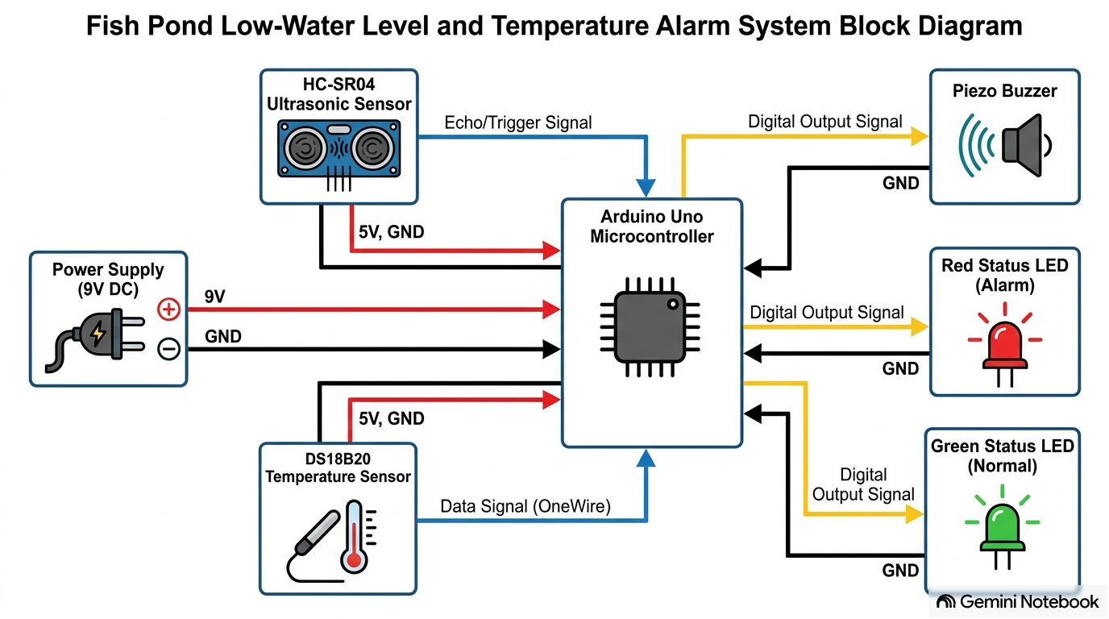
Figure 1: System Architecture & Functional Block Diagram
Figure 2 depicts a 3D isometric conceptual hardware assembly reference showing the physical arrangement of the fish pond, submerged temperature probe, ultrasonic level sensor mounted above the water surface, and the external control box.
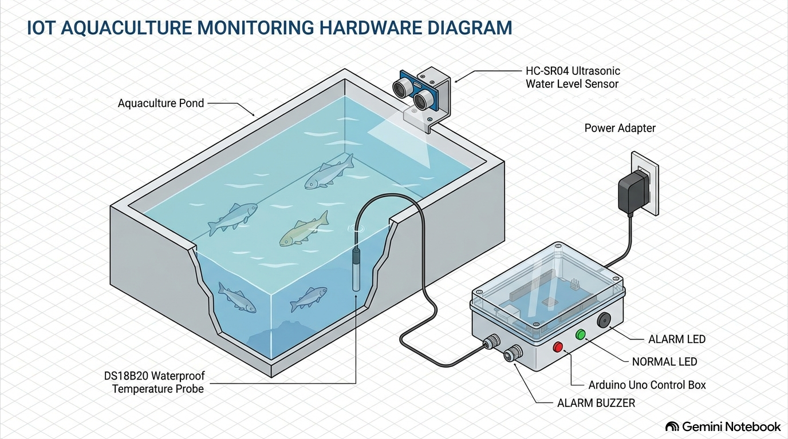
Figure 2: Fish Pond Hardware Installation & Prototype Reference Model
3.2 Text-Based System Block Diagram
+-----------------------------------------------------------------------+
| POWER SUPPLY MODULE |
| (9V DC Adapter / Regulated 5V Rail) |
+-----------------------------------+-----------------------------------+
| (VCC / GND Lines)
v
+-----------------------+ +-----------------------+ +-----------------------+
| INPUT SENSORS | | PROCESSING UNIT | | OUTPUT ALERT & DISPLAY|
| | | | | |
| 1. Water-Level Sensor |==>| ATmega328P / Arduino |==>| 1. Red LED (Alarm) |
| (HC-SR04 / Level) | | Microcontroller Unit | | 2. Green LED (Normal) |
| | | (16 MHz Clock, C/C++) | | 3. Piezo Buzzer |
| 2. Temperature Sensor | | | | |
| (DS18B20 / LM35) | | | | |
+-----------------------+ +-----------------------+ +-----------------------+
|
v
+-----------------------+
| SIMULATION & DEBUGGER |
| (Tinkercad / Serial UI|
+-----------------------+
3.3 Operational Workflow
- 1. Data Acquisition: The temperature sensor measures water temperature continuously, while the ultrasonic/level sensor emits high-frequency sound waves (40 kHz) to calculate water height based on pulse return time.
- 2. Microcontroller Computation: The Arduino Uno processes incoming signals every 500 ms, comparing digital/analog values against user-configured safety thresholds (e.g., Water Depth < 10 cm or Temperature > 30°C).
- 3. Decision Execution: If all parameters are within normal limits, the microcontroller illuminates the Green LED. If water level falls below the minimum setpoint OR temperature exceeds maximum threshold, the controller triggers the Red LED and drives the Piezo Buzzer at 2.3 kHz.
4. Hardware Components & Specifications
To ensure reliable prototype performance, hardware components were selected based on industrial availability, low power consumption, and mechanical robustness:
Component Name | Technical Specifications | Quantity | Functional Purpose in System
Microcontroller Board | Arduino Uno (ATmega328P), 5V operating, 16 MHz Crystal, 14 Digital I/O, 6 Analog inputs | 1 Unit | Main processing unit; reads sensor data, executes threshold detection algorithms, and controls alerts.
Water Temperature Sensor | DS18B20 Waterproof Probe (1-Wire digital interface, -55°C to +125°C, ±0.5°C accuracy) | 1 Unit | Immersed directly in fish pond to monitor water temperature and detect thermal anomalies.
Water-Level Sensor | HC-SR04 Ultrasonic Distance Sensor (2cm–400cm range, 5V DC, 15mA operational current) | 1 Unit | Mounted above pond water surface to measure water level height without direct corrosion contact.
Audible Alarm | 5V Active Piezo Buzzer (85 dB SPL at 10cm, 2.3 kHz resonant frequency) | 1 Unit | Produces high-pitched acoustic alarm when water level drops low or temperature exceeds safety limit.
Visual Indicators | 5mm Diffused LEDs (Red = Alarm, Green = Normal System State) | 2 Units | Provides instant visual status indication for farm personnel.
Current Limiting Resistors | 220 Ω Resistors, 1/4 Watt Carbon Film (±5% tolerance) | 2 Units | Connected in series with LEDs to limit forward current (I ≈ 15 mA) and prevent LED burnout.
Pull-Up Resistor | 4.7 kΩ Resistor, 1/4 Watt (For DS18B20 OneWire data line) | 1 Unit | Ensures reliable digital communication between DS18B20 sensor and Arduino data pin.
Power Supply | 9V DC 1A Wall Adapter / USB Power Line to onboard 5V Regulator | 1 Unit | Steps down mains voltage to provide clean, regulated 5V DC power to microcontroller and sensors.
Prototyping Board | MB-102 Solderless Breadboard (830 tie-points, dual power rails) | 1 Unit | Serves as physical platform for non-destructive circuit assembly and temporary component wiring.
Connecting Wires | Premium Male-to-Male & Male-to-Female Jumper Wires (22 AWG) | 20 Units | Establishes electrical connections between sensors, controller, power rails, and output peripherals.

5. Hardware Compatibility & Circuit Design
5.1 Operating Voltages and Logic Level Compatibility
All selected primary hardware components operate on a standardized 5V DC voltage rail, eliminating the need for bi-directional logic-level shifters:
- Microcontroller: Arduino Uno provides regulated 5V VCC output from its onboard linear regulator (AMS1117-5.0).
- Sensors: Both DS18B20 and HC-SR04 function within 4.5V - 5.5V DC input.
- Logic Output: Arduino digital output high voltage (V_OH ≈ 4.2V) satisfies the high-level input requirements (V_IH) of both sensors and peripheral drivers.
5.2 Electrical Circuit Schematic & Layout Reference
Figure 3 presents the detailed electrical circuit schematic diagram, illustrating microcontroller pin assignments, pull-up resistor placement, sensor wiring, and output indicator connections.
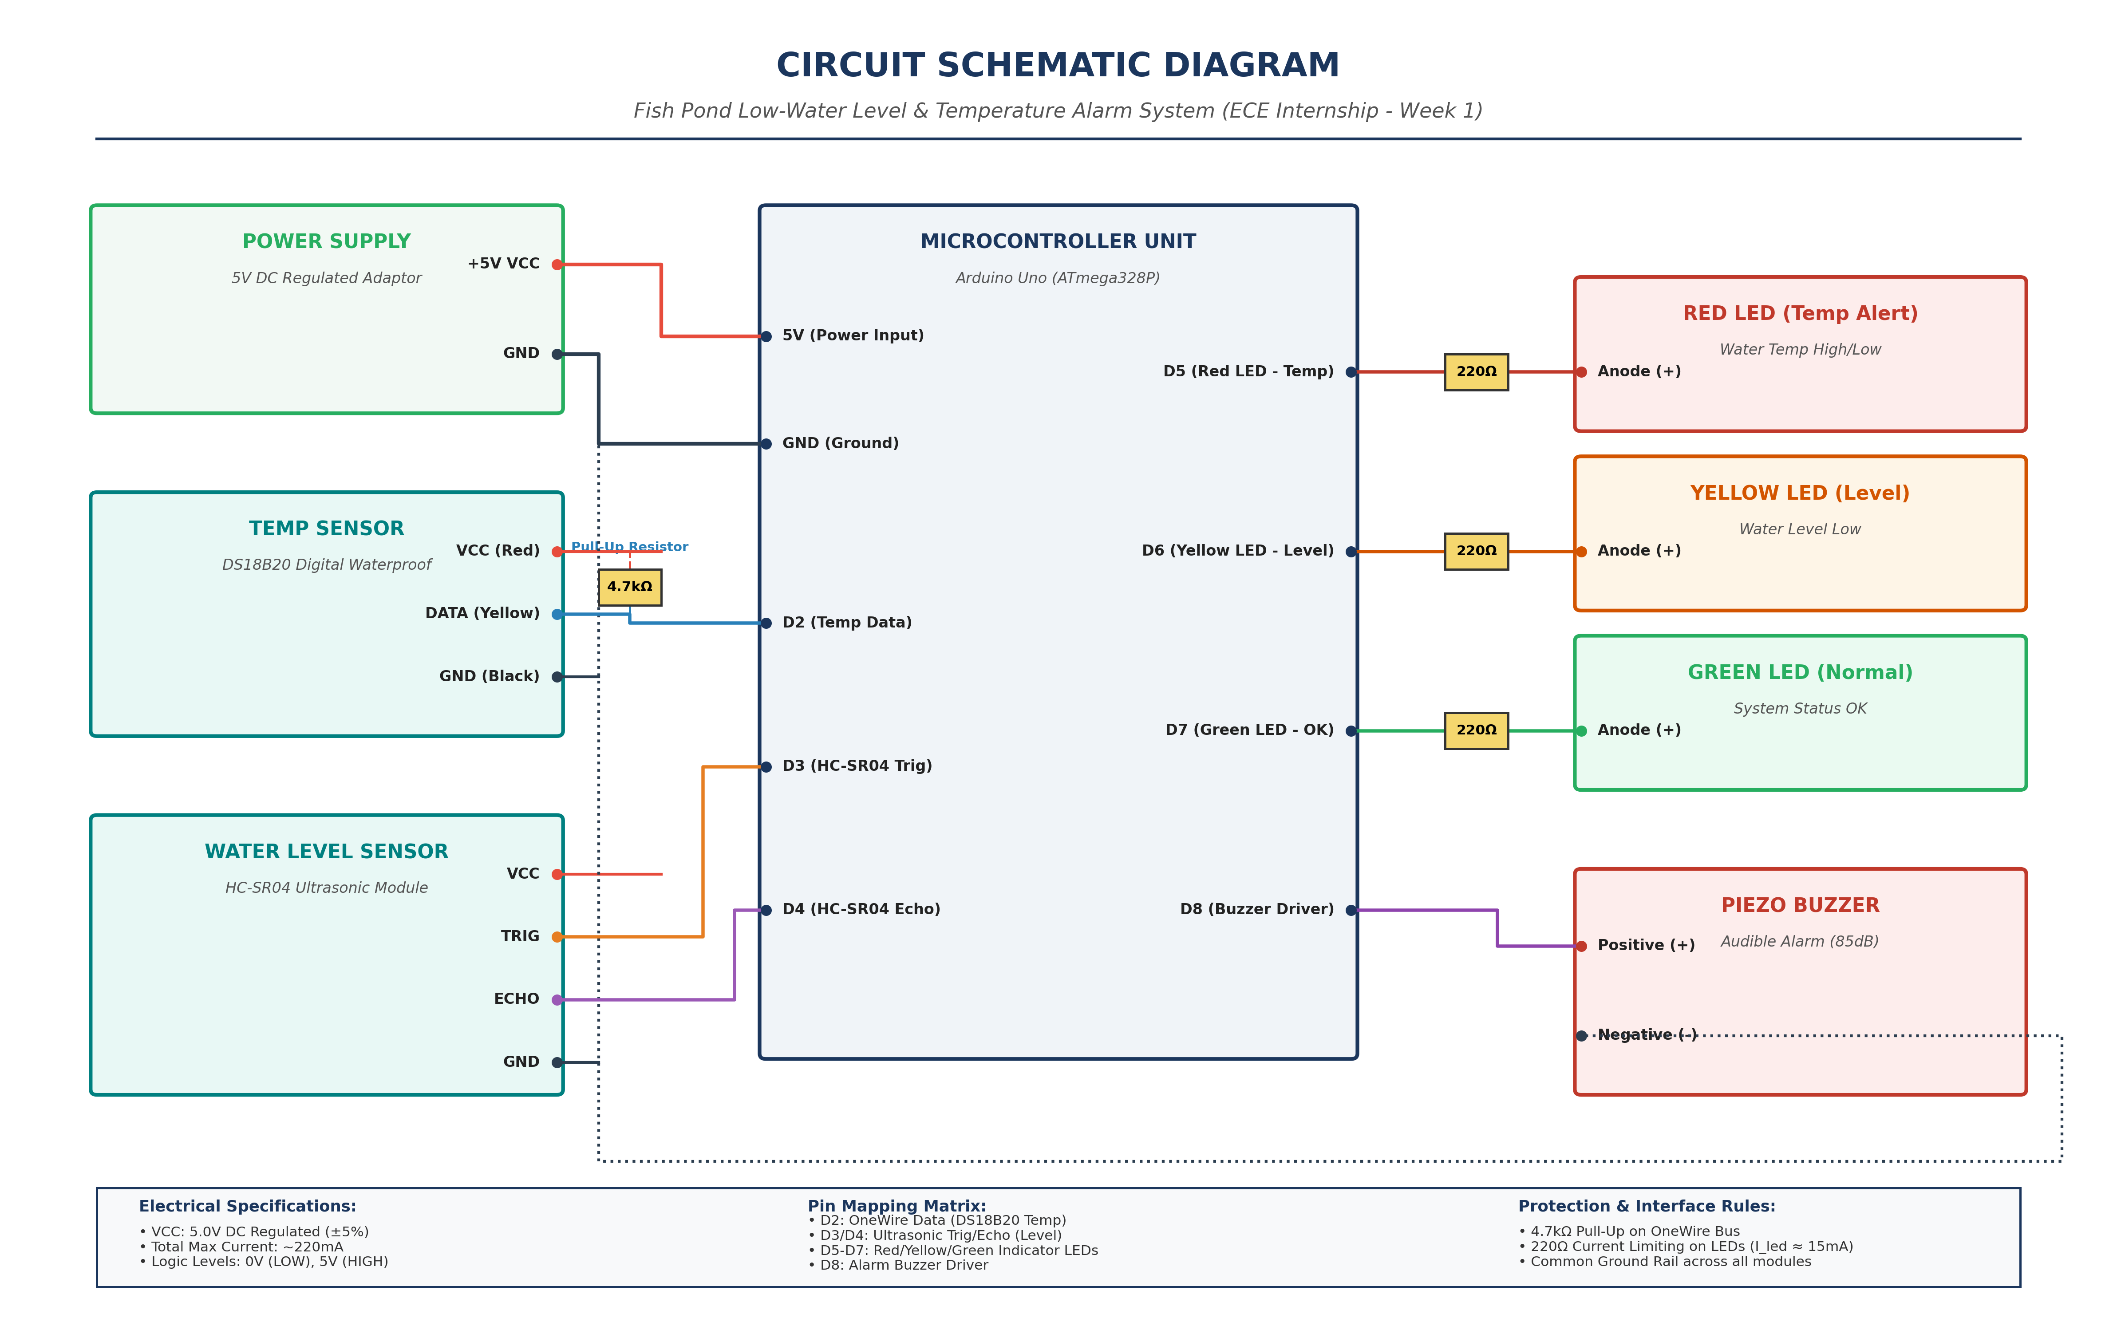
Figure 3: Detailed Circuit Schematic Diagram & Pin Assignment Matrix
Figure 4 provides a physical breadboard and component assembly reference diagram showing practical jumper wire routing and breadboard rail distribution.
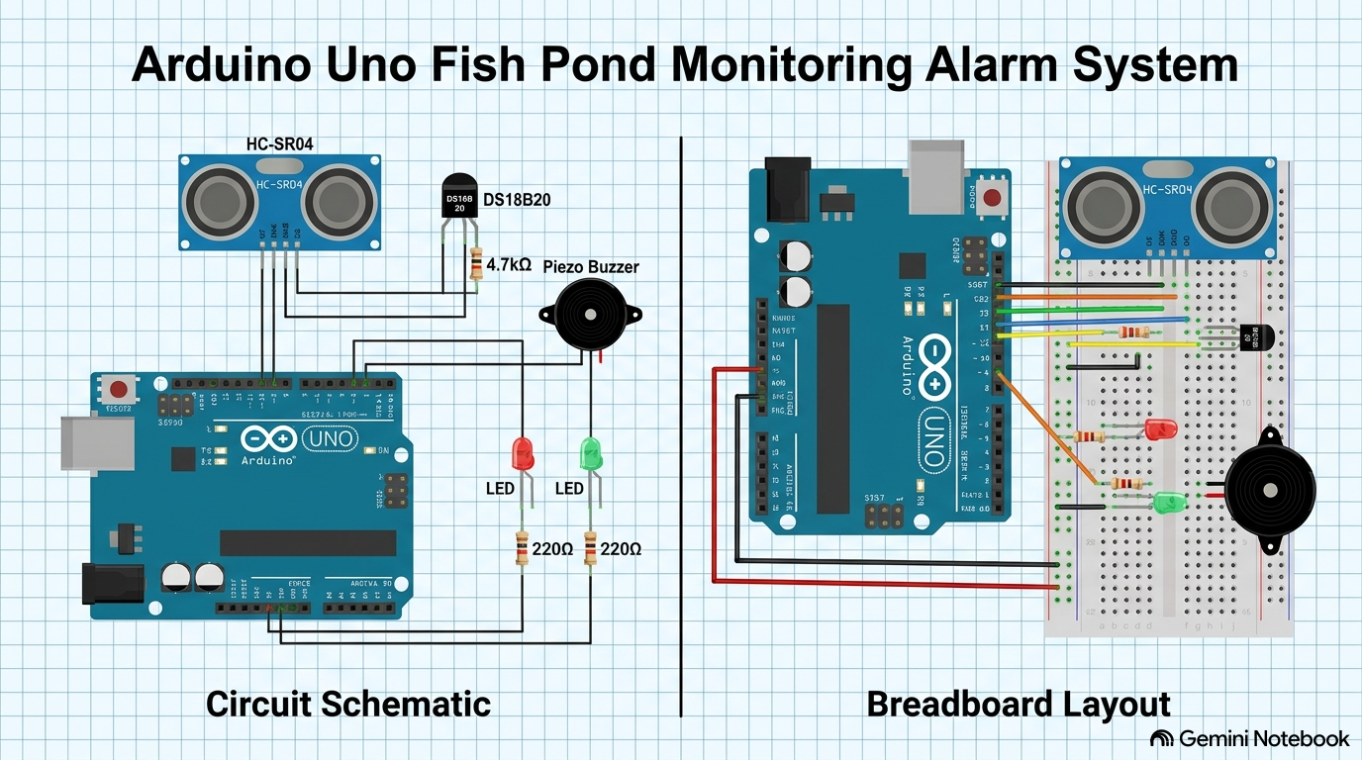
Figure 4: Breadboard Component Wiring & Assembly Reference Diagram
5.3 Power Consumption and Current Budget
To ensure system stability, total current draw must not exceed the maximum current rating of the Arduino onboard regulator (500 mA from USB / 800 mA from barrel jack):
Total Current = I_MCU + I_Temp + I_Level + I_Buzzer + I_LEDs
- Arduino Uno Core: 45 mA
- DS18B20 Temp Sensor: 1.5 mA (active conversion)
- HC-SR04 Ultrasonic Sensor: 15 mA
- Active Piezo Buzzer: 30 mA
- LEDs (2 x 15 mA): 30 mA
- Total Operational Current: ≈ 121.5 mA (Well within the safe 500 mA threshold).
5.4 Interface Precautions
- 1. OneWire Data Bus: The DS18B20 requires a 4.7 kΩ pull-up resistor connected between its DQ data line and 5V VCC to maintain digital signal integrity over long wire leads.
- 2. Current Protection: LEDs must never be driven directly from Arduino pins without 220 Ω series resistors to prevent exceeding the 40 mA per-pin absolute maximum limit.
- 3. Moisture Protection: The HC-SR04 sensor must be housed in a protective splash-proof casing above the water surface to avoid short-circuiting.
6. System Integration Strategy
A structured 5-step integration protocol is established to assemble the system methodically:
- Step 1: Power Rail Setup: Connect the 9V DC power supply to the Arduino barrel jack. Verify with a digital multimeter (DMM) that the Arduino 5V and GND pin outputs supply 5.0V ± 0.1V across the breadboard power rails.
- Step 2: Temperature Subsystem Wiring: Connect DS18B20 VCC to 5V, GND to GND, and Data DQ to Digital Pin D2. Insert the 4.7 kΩ pull-up resistor between 5V and Pin D2.
- Step 3: Water-Level Subsystem Wiring: Connect HC-SR04 VCC to 5V, GND to GND, TRIG to Digital Pin D3, and ECHO to Digital Pin D4.
- Step 4: Output Indicator & Alarm Assembly: Wire the Red LED (Alarm) anode to Digital Pin D5 via a 220 Ω resistor. Wire the Green LED (Normal) anode to Digital Pin D6 via a 220 Ω resistor. Connect the Piezo Buzzer positive terminal to Digital Pin D7 and negative terminal to GND rail.
- Step 5: Common Grounding: Ensure all component ground pins are tied to a single common Ground Rail to prevent floating ground voltages and signal noise.
7. Software and Simulation Tools
- Tinkercad Circuits: Used for preliminary 3D circuit schematic assembly, virtual wiring validation, and basic C++ microcontroller code simulation prior to physical hardware handling.
- Arduino IDE (v2.x): Embedded C/C++ development environment used for writing, compiling, and uploading the firmware code to the Arduino Uno via USB. Uses OneWire.h and DallasTemperature.h libraries.
- Proteus Design Suite / KiCad: Used for generating professional PCB schematic layouts and conducting advanced electrical rule checks (ERC).
8. Integration Timeline
The project integration timeline is structured across 12 working days:
Stage | Estimated Duration | Key Deliverables & Milestones
1. Research & Component Selection | Days 1–2 | Finalize component datasheets, power budget, and hardware selection.
2. Circuit Design & Simulation | Days 3–4 | Complete Tinkercad virtual wiring and code verification without errors.
3. Subsystem Integration | Days 5–6 | Breadboard assembly of power rails, temperature sensor, level sensor, and outputs.
4. Firmware Development & Testing | Days 7–8 | Upload Arduino C++ firmware; calibrate temperature and distance thresholds.
5. Troubleshooting & Verification | Days 9–10 | Conduct corner-case testing (high temp + low water level scenarios).
6. Final Rollout & Documentation | Days 11–12 | Finalize Week 1 Task Report, system schematic, and project presentation.

9. Critical Milestones and Verification Points
- 1. Milestone 1 (Power & Rail Verification): DMM confirms stable 5.0V DC across breadboard power bus prior to connecting active ICs.
- 2. Milestone 2 (Sensor Reading Accuracy): DS18B20 temperature outputs match room thermometer (±0.5°C); HC-SR04 ultrasonic distance readings match physical ruler measurements (±0.5 cm).
- 3. Milestone 3 (Alert Logic Triggering): Piezo buzzer and Red LED reliably activate within 500 ms when water level drops below 10 cm or temperature exceeds 30°C.
- 4. Milestone 4 (Full System Stability): Continuous 24-hour hardware burn-in test executed with zero system crashes or sensor dropouts.
10. Testing and Validation Plan
- Water-Level Detection Test: Place an object at varying distances (5 cm, 10 cm, 20 cm, 30 cm) in front of the HC-SR04 sensor. Verify on Arduino Serial Monitor that distance is correctly calculated and alarm triggers at < 10 cm.
- Temperature Measurement Test: Immerse the DS18B20 probe into warm water (> 30°C) and ice bath water (< 15°C). Validate serial temperature log accuracy against an analog laboratory thermometer.
- Buzzer & LED Output Test: Measure output voltage on digital pins D5, D6, and D7. Confirm voltage transitions from 0V (LOW) to 5V (HIGH) upon alert condition.
- Integrated System Stress Test: Simulate simultaneous high temperature (35°C) and low water level (5 cm) to ensure output alert logic handles concurrent fault states correctly.
11. Resource Allocation
- Hardware Components: Arduino Uno, DS18B20 probe, HC-SR04, active buzzer, red/green LEDs, resistors, breadboard, jumpers (~$25 - $30 total cost).
- Laboratory Equipment: Digital Multimeter (DMM), Regulated DC Power Supply, Oscilloscope (optional for pulse measurement), USB A-to-B programming cable.
- Manpower & Responsibilities: 1 ECE Engineering Intern (Responsible for schematic design, C++ coding, breadboard assembly, testing, and report drafting).
12. Risk Assessment and Management
A comprehensive electrical and operational risk assessment matrix is detailed below:
Identified Risk | Probability | Impact | Mitigation Strategy
1. Short Circuit due to Water Exposure | Medium | High | Use waterproof IP67 DS18B20 probe; mount HC-SR04 sensor high above water level inside plastic splash guard.
2. Voltage Mismatch / Reverse Polarity | Low | High | Verify pinouts using component datasheets before powering up; double-check VCC/GND color-coding.
3. LED or Port Burnout | Medium | Medium | Always install 220 Ω series current-limiting resistors on output pins.
4. Sensor Signal Noise / Floating Inputs | High | Low | Install 4.7 kΩ pull-up resistor on OneWire bus; add digital software filtering in code.
5. False Alarms due to Water Turbulence | Medium | Medium | Implement code-based moving average filtering (take average of 5 consecutive sensor readings).
6. Component Unavailability / Lead Time | Low | Medium | Substitute HC-SR04 with analog float switch or LM35 temperature sensor if primary components are delayed.

13. Potential Project Delays and Solutions
- 1. Hardware Delivery Delays: Utilize Tinkercad Circuits to complete 100% of circuit design and code simulation virtually while waiting for physical components to arrive.
- 2. Software Compilation / Library Errors: Use standard built-in Arduino libraries or bit-bang GPIO pins directly to eliminate third-party library dependencies.
- 3. Sensor Calibration Discrepancies: Write a dedicated calibration routine in software to adjust sensor offset constants based on benchmark laboratory measurements.
14. Final Integration and Rollout Strategy
Before deploying the prototype on an operational fish pond:
- 1. Bench Verification: Conduct a final benchtop functional verification using test water containers.
- 2. Hardware Inspection: Inspect all physical wiring joints for mechanical firmness and insulation.
- 3. Enclosure Protection: Enclose non-waterproof electronics inside an IP65 rated ABS plastic enclosure with wire gland pass-throughs.
- 4. Field Validation: Mount the system at the fish pond test site and execute a live 4-hour validation run with periodic manual parameter cross-checks.
15. Conclusion
This Week 1 System Integration Planning and Strategy report establishes a structured, practical engineering blueprint for developing the Fish Pond Low-Water Level and Temperature Alarm System. By systematically addressing hardware selection, power budgets, sensor interfaces, virtual simulation, embedded visual diagrams, and electrical risk management, the proposed design ensures high reliability, cost efficiency, and safety. The project successfully demonstrates the core competencies required of a second-year ECE intern, bridging academic electronic principles with real-world embedded system implementation.

