**CSEE 5590-0002 : Web/Mobile Programming**

**Project Report**

# **KC Donation Web Application**

# **Team 3**

## Roshna Toke, ClassID: 23

## Manaswini Vedula, ClassID: 24

## Yamini Saraswathi Bommineni, ClassID: 03

### **Motivation:**

Needs are the primary essentials. Many people suffer from them because of a shortage of items and at the same time lots of excessive items have been Trashed. So, the main motivation of this application is to create a bridge between the Donor and users and making excessive items to reach for the people who are in need.

### **Significance:**

The significance of this application is that it can fill the gap between the people having excessive items and people in need who are looking for those items. The people having excessive items like furniture , food, clothes, vehicles etc. can upload their excessive items into the Donor page after uploading the Users can find the items available for donating and can access that through the user's page as per their need.

### **Objectives:**

### **System Features:**

**Main Page**: Welcome Page of this application where User and Donor both **Login** and **Register and can also send suggestions or queries to the Site owners While Login when the user forgets the password a random password will be sent to their corresponding email ID**.

**Donor**: On the donor page, the donor can add items he wants to donate, delete added items and he can see his history of donation from starting and can also change their password from the profile section.

**Requester**: On the requester page, when the donor adds his items then that items will be visible to all requesters and receive an email notification saying that new item has been added. Requesters can request that food item then it will not be visible on requesters as well as donors page. Also, the requester can see his history from starting and can also change their password.

### **Demo Screens:**

**1.Main Page**

These are the screenshots of Main Page of ‘KC Donation’ web application. Here we have given the Following functionalities**.**

The Gallery of Donations can be seen in the Gallery Section.

Anyone can Contact Us by sending their Suggestion or Query through the contact us of Main page.

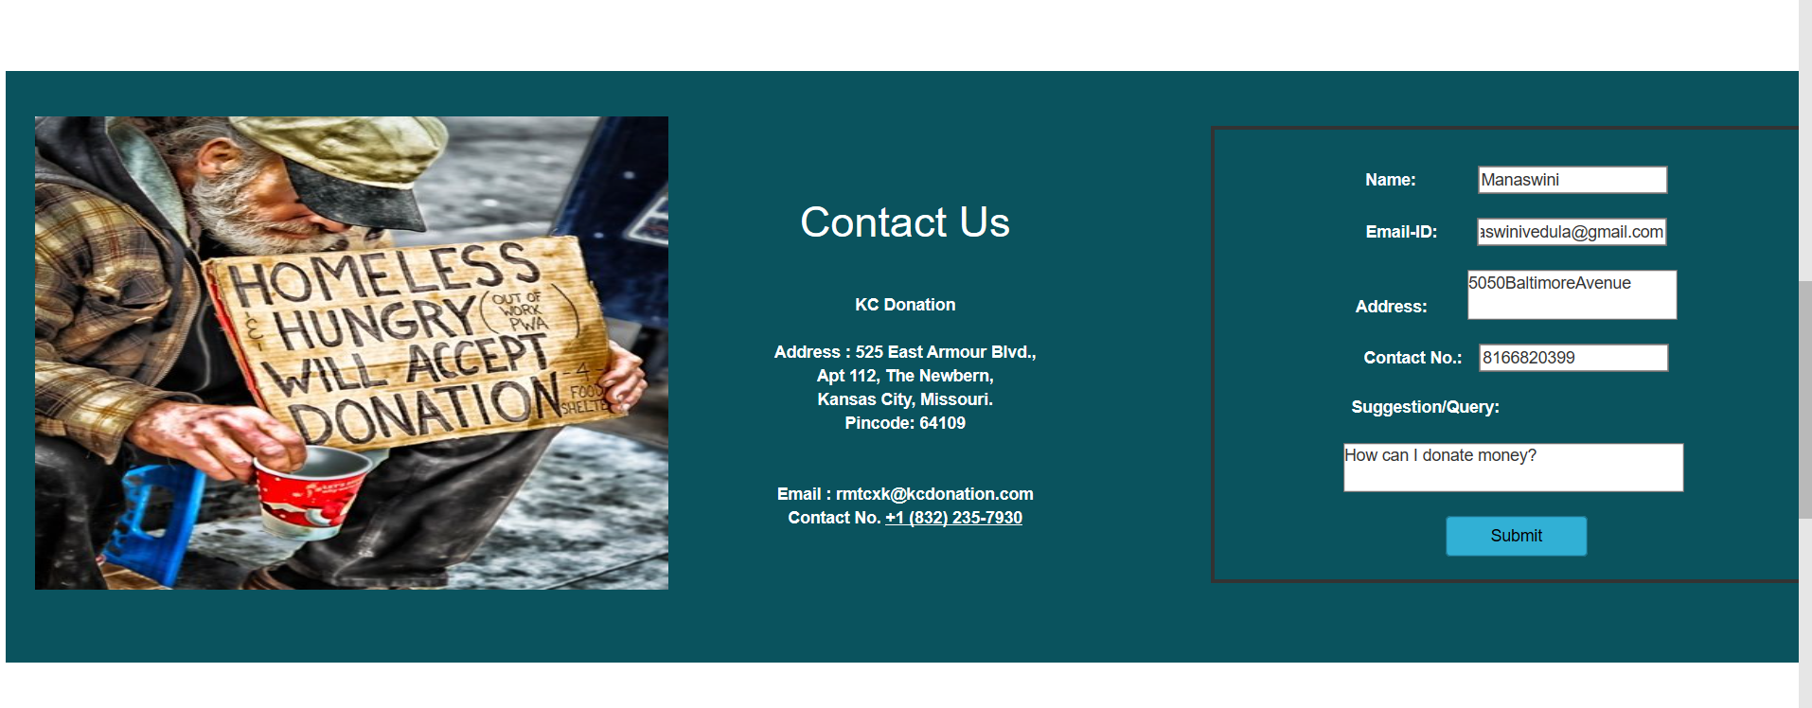

In the about us we can find the details of the contributed people.

**1.Registration Page**

This is the screenshot of the registration page. First time user should sign up before he can login to the application and all the fields in this page are mandatory. We have also included some validations like both password and confirm password are same and check all the fields are filled up after the user clicks sign up.

User type can be either ‘Donor’ or ‘Requestor’.

If the registered credentials match with login details, then it navigates to home page. If the credentials do not match, then it prompts that username or password is wrong.

**Forgot Password**

If the user forgets his/her password, then by clicking forgot password button he will be navigated to this page. Here as the user enters his email and clicks send email then an email with a new password will be sent to users account**.**

A random password will be generated and will be send to the respective Email ID.

**2.Donor Page**

In Donor page we have given two buttons, one is for donation and another one is for seeing history of user’s donation.

When user click on logout button it will re-direct to main page of the application.

When the User clicks on the Donate Button, He need to enter the details of the Item including the category.

When the User clicks on the History button, they can view their donations list.

When the User clicks on the profile button, they can update their Password.

**3.Requester Page**

This is requestor page. Here we have given history button for requestor to see his history. Whatever donor will add in his window, requester can see those item in his bucket. When user click on logout button, they will redirect to main page of the application and when user clicks on the profile the user can change their password.

The Requester can be able to search the items according to the categories.

By clicking on the history, the User can View the History of Items they have accepted.

When new item is added the Requestor will receive an email notification saying that new item has been added.

The profile and Logout Button functionality work same the Donor Page.

### **Heroku cloud deployed Link:**

<https://kcdonation.herokuapp.com/mainpage>

### **GitHub Link:**

<https://github.com/manaswinivedula/KC-donation>

### **Work sharing between teammates:**

All are equally working in developing functionalities and designing webpages.

### **Technologies used:**

MEAN stack

Angular JS

HTML, CSS, Bootstrap

Node JS

Mongo DB

### **References:**

Hackathon Use Case - <https://umkc.app.box.com/s/gg46llw7gye4is7ujhohw00a2sody7mb>

<https://www.w3schools.com/>

[www.google.com](http://www.google.com)

<https://mongoosejs.com/docs/api.html>