**KANTIPUR ENGINEERING COLLEGE**

**(Affiliated to Tribhuvan University)**

**Dhapakhel, Lalitpur**



**[Subject Code: CT654]**

**A MAJOR PROJECT FINAL REPORT**

**ON**

**“DETECTION OF PNEUMONIA USING CNN METHOD AND COVID USING CLINICAL DATAS”**

**Submitted by**

**Sachin Mahajan [65/BCT/2074]**

**Sandeep Sharma [71//BCT/2074]**

**Sumnima Khawahang Rai [88/BCT/2074]**

**Supriya Thapa [90/BCT/2074]**

**A MAJOR PROJECT SUBMITTED IN PARTIAL**

**FULFILLMENT OF THE REQUIREMENT FOR THE DEGREE**

**OF BACHELOR IN COMPUTER ENGINEERING**

**Submitted To**

**Department of Computer and Electronics Engineering 17,July, 2021**

**DETECTION OF PNEUMONIA USING CNN METHOD AND COVID USING CLINICAL DATAS**

**Submitted by**

**Sachin Mahajan [65/BCT/2074]**

**Sandeep Sharma [71//BCT/2074]**

**Sumnima Khawahang Rai [88/BCT/2074]**

**Supriya Thapa [90/BCT/2074]**

**A MAJOR PROJECT SUBMITTED IN PARTIAL**

**FULFILLMENT OF THE REQUIREMENT FOR THE DEGREE**

**OF BACHELOR IN COMPUTER ENGINEERING**

**Submitted to**

**Department of Computer and Electronics Engineering**

**Kantipur Engineering College**

**Dhapakhel, Lalitpur**

TABLE OF CONTENT

[CHAPTER 1: INTRODUCTION 2](#_Toc77418523)

[1.1 BACKGROUND THEORY 2](#_Toc77418524)

[1.2 PROBLEM STATEMENT 3](#_Toc77418525)

[1.3 OBJECTIVES 3](#_Toc77418526)

[1.4 FEASIBILITY ANALYSIS 4](#_Toc77418527)

[**1.4.1** **Operation Feasibility** 4](#_Toc77418528)

[**1.4.2** **Technical Feasibility** 4](#_Toc77418529)

[**1.4.3** **Economic Feasibility** 4](#_Toc77418530)

[1.5 Software Requirements 5](#_Toc77418531)

[CHAPTER 2: LITERATURE REVIEW 6](#_Toc77418532)

[2.1 RELATED WORKS 7](#_Toc77418533)

[CHAPTER 3: METHODOLOGY 8](#_Toc77418534)

[3.1 X-RAY Image Analysis for pneumonia analysis: 9](#_Toc77418535)

[3.2 Classification Algorithm: 10](#_Toc77418536)

[• **Binary Classification:** 11](#_Toc77418537)

[• **Logistic Regression:** 11](#_Toc77418538)

[• **Decision Tree:** 12](#_Toc77418539)

[REFERENCES: 14](#_Toc77418540)

# CHAPTER 1: INTRODUCTION

## 1.1 BACKGROUND THEORY

Pneumonia is a common disease caused by different microbial species such as bacteria, viruses, and fungi that are associated with lung disease. Pneumonia is a disease that causes inflammation of either one or both lung parenchyma. Based on infection, pneumonia occurs as a result of inflammation caused by pathogens which lead the lung’s alveoli to fill up with fluid or pus and thereby leading to a decrease of carbon dioxide (CO2) and oxygen (O2) exchange between blood and the lungs, making it hard for infected persons to breathe. Some of the symptoms of pneumonia include shortness of breath, fever, cough, chest pain, etc.

COVID-19 is an extremely contagious disease caused by severe acute respiratory syndrome coronavirus 2 (SAR-CoV-2) which is a recent disease that is caused by one of the family members of the Coronaviridae family. In the past, two members of this family known as SARS-CoV-1 and Middle East Respiratory Syndrome Coronavirus (MERS-CoV) have caused a global epidemic. COVID-19 can be transmitted through respiratory droplets that are exhaled or secreted by infected persons.

Chest X-rays are the commonly used method to detect Pneumonia infection and locate the infected area in the lungs. Similarly, COVID-19 can be detected using clinical data like Temperature, Oxygen level and Pulse rate. Finding radiological examiners in remote places for analysis for more Chest X-rays is an extremely challenging task. Therefore, designing and developing the deep learning model to solve such problems would save time and computational resources, as the multi-layer Convolutional Neural Network, recognizes visual patterns directly from pixel images with minimal pre-processing. Hence, we can easily detect if the person has pneumonia or not, using chest X-rays. Similarly, by using logistic regression and the given data we can detect Covid-19.

## 1.2 PROBLEM STATEMENT

Different approaches are currently in use for detection of different types of pneumonia. Chest X-ray is one of the best alternative method to detect pneumonia. However, it is tedious work for radiologist to detect pneumonia affected part from the Chest X-ray. It is more time consuming and expensive. But if we can make the system which can detect pneumonia by analysing Chest X-ray, it will be cheaper and faster to detect pneumonia. Similarly, covid-19 patients are growing exponentially and so there is high need for massive detection. In current situation hospitals are full of Covid-19 patients and it is not safe to visit hospitals at this time even for covid diagnosis. So, by making a system which detect Covid-19 by using data like Temperature, Pulse rate and Oxygen level, it really helps people to diagnose covid-19 easily without going to hospital. Thus, the main motive of our project which is "***TITLE***" is to address these challenges by computer-aided detection method using the Deep Learning approach for pneumonia detection using Chest X-rays and logistic regression for detecting covid-19 using clinical data, which is comparatively more accurate, cheaper and faster.

## 1.3 OBJECTIVES

The objective of this project is to:

1. To detect COVID-19 symptoms using clinical data i.e., Temperature, Oxygen level and Pulse reading.
2. TO detect Pneumonia by using images of Chest X-rays.
3. To develop a web application with proper GUI for detection.

## 1.4 FEASIBILITY ANALYSIS

The continuation of the project came out as a result of this analysis. The worthiness of the project is measured through the feasibility analysis. It was conducted taking into considerations of the major fields, where this project can be implemented, such as in the system being developed is economic with respect to any institutions point of view.

The major analysis which come under feasibility analysis are:

### **1.4.1 Operation Feasibility**

Operational Feasibility includes the operational analysis of the overall system. Our system is affordable and operational since it runs under normal computer. For operation of this software, technical professional is not required as all works are automatically performed. The system will scan the chest X-ray image of the patient and detect if the patient has pneumonia, or not automatically. Also, covid-19 can be also detected by using data like temperature from thermometer and Oxygen level and Pulse rate from oximeter. So, the project is operationally feasible.

### **1.4.2 Technical Feasibility**

Technically, our project is feasible because it is programmed in a well re-known programming language – Python. Also, it does not require technical professional during its operation. This system, once made will effectively do its job.

### **1.4.3 Economic Feasibility**

Economic Feasibility is the measure of the cost effectiveness of a project or solution. This is often called the cost benefit analysis. It is the evaluation to determine whether the system is economically acceptable. The financial aspect of the project is mainly focused by the evaluation. It determines whether the investment needed to implement the system will be recovered. Considering the economic feasibility, for the development of this project there will not be high expenses and user also doesn’t require a lot of money to buy the software or to run the program. Hence, it is economically feasible.

**1.5 Software Requirements**

1. Jupyter notebook with GPU enabled
2. Python IDE
3. VS code
4. Python flask
5. HTML
6. CSS

# CHAPTER 2: LITERATURE REVIEW

COVID-19 (coronavirus disease 2019) is an infectious disease caused by severe acute respiratory syndrome coronavirus 2 (SARS-CoV-2), previously known as the 2019 novel coronavirus (2019-nCoV), a species of coronavirus. On 11 February 2020, the WHO officially renamed the clinical condition COVID-19.

Coronaviruses (CoV) are a large family of viruses that cause illness ranging from the common cold to more severe diseases such as Middle East Respiratory Syndrome (MERS-CoV) and Severe Acute Respiratory Syndrome (SARS-CoV). A novel coronavirus (nCoV) is a new strain that has not been previously identified in humans.

It is believed to have zoonotic origins and has close genetic similarity to bat coronaviruses, suggesting it emerged from a bat-borne virus

Infected patients show common signs include respiratory symptoms, fever, cough, shortness of breath and breathing difficulties. In more severe cases, the infection can cause pneumonia, severe acute respiratory syndrome, kidney failure, and even death.

Pneumonia is an acute respiratory infection that affects the lungs. It is a fatal illness in which the air sacs get filled with pus and other liquid [[1](https://www.ncbi.nlm.nih.gov/pmc/articles/PMC7345724/#B1-diagnostics-10-00417)]. There are mainly two types of pneumonia: bacterial and viral. Generally, it is observed that bacterial pneumonia causes more acute symptoms. The most significant difference between bacterial and viral pneumonia is the treatment. Treatment of bacterial pneumonia is done using antibiotic therapy, while viral pneumonia will usually get better on its own [[2](https://www.ncbi.nlm.nih.gov/pmc/articles/PMC7345724/#B2-diagnostics-10-00417)]. It is a prevalent disease all across the globe. Its principal cause includes a high level of pollution. Pneumonia is ranked eight in the list of the top 10 causes of death in the United States [[3](https://www.ncbi.nlm.nih.gov/pmc/articles/PMC7345724/#B3-diagnostics-10-00417)].

According to the WHO, “Every year, it kills an estimated 1.4 million children under the age of five years, accounting for 18% of all deaths of children under five years old worldwide. Pneumonia affects children and families everywhere but is most prevalent in South Asia and sub-Saharan Africa. Children can be protected from pneumonia. It can be prevented with simple interventions and treated with low-cost, low-tech medication and care” [[2](https://www.ncbi.nlm.nih.gov/pmc/articles/PMC7345724/#B2-diagnostics-10-00417)]. Therefore, there is an urgent need to do research and development on computer-aided diagnosis so that the pneumonia-related mortality, especially in children, can be reduced.

One of the following tests can be done for pneumonia diagnosis: chest X-rays, CT of the lungs, ultrasound of the chest, needle biopsy of the lung, and MRI of the chest [[4](https://www.radiologyinfo.org/en/info/pneumonia)]. Currently, chest X-rays are one of the best methods for the detection of pneumonia [[5](https://scholar.google.com/scholar_lookup?title=Standardization+of+Interpretation+of+Chest+Radiographs+for+the+Diagnosis+of+Pneumonia+in+Children&publication_year=2001&)]. X-ray imaging is preferred over CT imaging because CT imaging typically takes considerably more time than X-ray imaging, and sufficient high-quality CT scanners may not be available in many underdeveloped regions. In contrast, X-rays are the most common and widely available diagnostic imaging technique, playing a crucial role in clinical care and epidemiological studies [[6](https://www.ncbi.nlm.nih.gov/pmc/articles/PMC2626240/)].

Another issue with this disease is that sometimes, the features that describe the very existence of the disease often get mixed with other diseases, and hence, radiologists find it challenging to diagnose this disease. Deep learning techniques solve all these problems, and their accuracy in the prediction of the disease is the same and sometimes even greater than an average radiologist [[8](https://www.ncbi.nlm.nih.gov/pmc/articles/PMC6268174/)]. Among the deep learning techniques, convolutional neural networks (CNNs) have shown great promise in image classification and segmentation and therefore are widely adopted by the research community. Biomedical image diagnosis that uses the techniques of deep learning and computer vision has proven to be very helpful to provide a quick and accurate diagnosis of the disease that matches the accuracy of a reliable radiologist [[16](https://www.ncbi.nlm.nih.gov/pmc/articles/PMC7345724/#B16-diagnostics-10-00417)]. Currently, deep learning based methods cannot replace trained clinicians in medical diagnosis, and they aim to supplement clinical decision making.

**2.1 RELATED WORKS**

Deep learning based methods are already being used in various fields [[10](https://www.mdpi.com/2313-433X/4/5/65)]. Different authors have already proposed several biomedical image detection techniques. M.I.Razaak [[15](https://scholar.google.com/scholar_lookup?title=Classification+in+BioApps&author=M.I.+Razzak&author=S.+Naz&author=A.+Zaib&publication_year=2018&)] discussed the challenges and the future of medical image processing. Much work has already been done for the detection of numerous diseases by using deep learning based techniques, as stated by Dinggang Shen [[16](https://www.annualreviews.org/doi/10.1146/annurev-bioeng-071516-044442)].

The Three dimensional Convolutional Neural Network framework was proposed by Jamaludin et al. to produce radiological grading of spinal lumbar MRIs and also localize the predicted pathologies using intervertebral disc volumes. The authors Azimi et al. proposed an ECG data classifications model using Convolutional Neural Network, deployed the model in Internet of Things devices. This approach uses the existing ECG dataset to classify the patient’s health status. The edge computing devices reduced the cost of implementation and increased the portability of the device. The authors Obinikpo and Kantarci, reviewed applications and challenges of Internet of Things and deep learning techniques in smart connected health systems through wearable or invasive devices. Also, the authors discussed the open challenges in sensed and captured medical data. The authors Kumar and Gandhi ([2018](https://link.springer.com/article/10.1007/s12652-021-03075-2#ref-CR12)) proposed a scalable Internet of Things device toward diagnosis of heart diseases. The logistic regression technique was used to process the sensed data form Internet of Things device. The cloud services were used to store and retrieve the large volume of collected data from patients. Performance of the logistic regression was examined using the Receiver Operating Characteristic (ROC) analysis to predict heart disease.

Likewise, the authors Abdelaziz et al., proposed a diagnosis for healthcare services for chronic kidney diseases using the linear regression (LR) and neural network (NN) approaches. The model was deployed in the cloud platform to enhance the execution performance. The author compared the performance of various machine learning techniques. The model predicts the chronic kidney diseases with an accuracy of 97.8 in percentage. The authors Wale and Sonawani reviewed various machine learning and deep learning techniques to diagnose the various human health challenges using imaging and sensing data. The authors discussed the advantages and challenges of numerous machine learning based healthcare applications. The succeeding section presents the fundamentals of the implemented Pneumonia infection diagnosis model and the training and testing dataset.

**CHAPTER 3: METHODOLOGY**

## 3.1 X-RAY Image Analysis for pneumonia analysis:

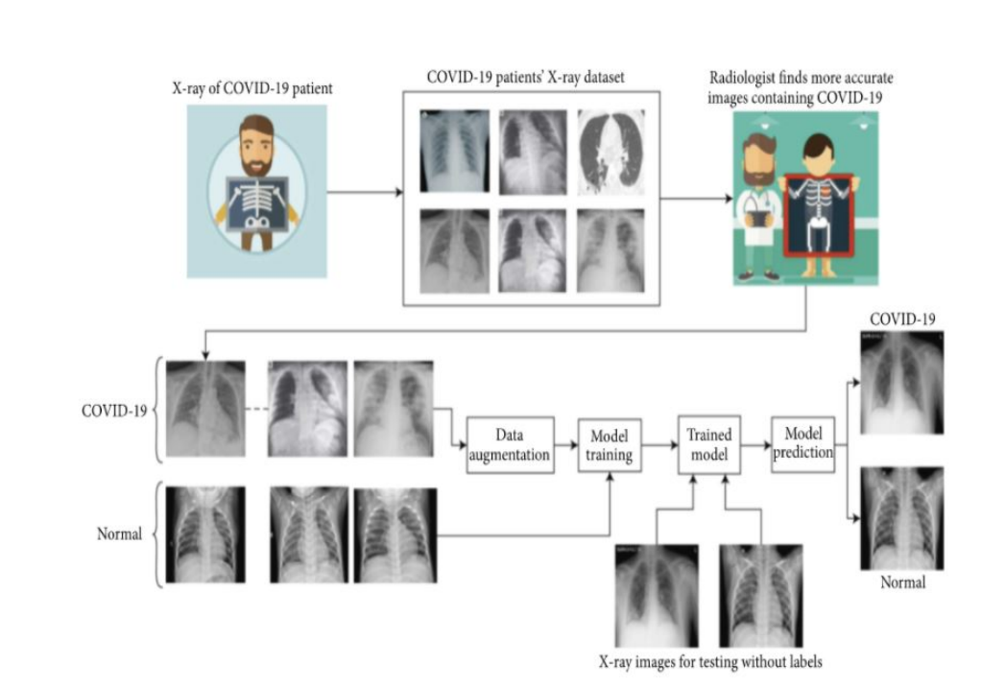

X-ray report obtained from electromagnetic form of penetrating radiation is analysed through image processing. In this work, an automatic diagnostic system has been developed using CNN which uses chest X-ray images to diagnose whether a person has pneumonia or not. The study begins with collection of primary dataset containing two image classes: one class belonged to chest X-rays of pneumonia confirmed cases and the other class of images belonged to the normal people without the disease. The open source dataset is concerned medical professionals analysed the dataset and removed some of the X-ray images which were not clear in terms of quality and diagnostic parameters which result dataset very clean, as each X-ray image was of good quality as well as clear in terms of significant diagnostic parameters according to their expertise. The dataset will be augmented to increase its size. The resulted dataset is used to train the model in the next phase. After training, the model will be tested for its performance in the disease detection. The testing of proposed CNN model has been done using test dataset held from the primary dataset as well as using the independent validation dataset.

## 3.2 Classification Algorithm:

Classification can be performed on structured or unstructured data. Classification is a technique where we categorize data into a given number of classes. The main goal of a classification problem is to identify the category/class to which a new data will fall under.

We focus on Binary Classification for our project since our dependent variable is dichotomous in nature (e.g., presence vs. absent).

### **Binary Classification:**

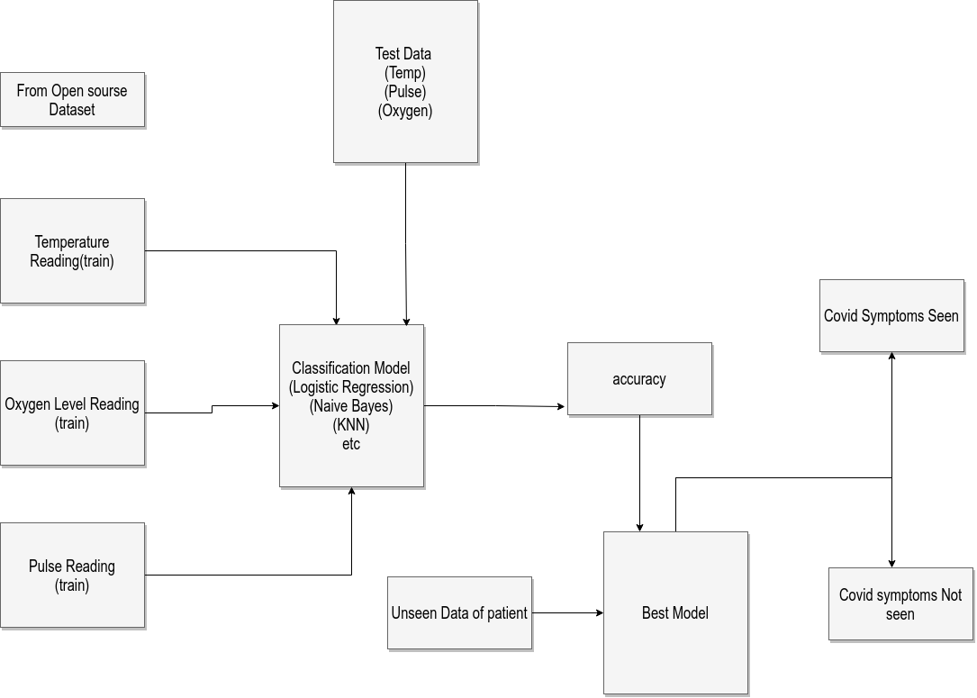

Temperature reading, pulse reading and oxygen level is analysed from both covid positive and covid negative patient. In this work, we will develop an automatic diagnostic system that will detect whether a person has covid symptoms or not. We will use many classification technique like logistic regression, KNN, Decision tree, etc. and choose the best model for better accuracy. Our model will finally result in detection of covid symptoms through the best model.

### **Logistic Regression:**

Logistic regression is the appropriate regression analysis to conduct when the dependent variable is dichotomous (binary). Like all regression analyses, the logistic regression is a predictive analysis. Logistic regression is used to describe data and to explain the relationship between one dependent binary variable and one or more nominal, ordinal, interval or ratio-level independent variables.

At the centre of the logistic regression analysis is the task estimating the log odds of an event. Mathematically, logistic regression estimates a multiple linear regression function defined as:

logit(p).

https://www.statisticssolutions.com/wp-content/uploads/2010/01/log23.jpg

### **Decision Tree:**

Decision Tree algorithm belongs to the family of supervised learning algorithms. Unlike other supervised learning algorithms, the decision tree algorithm can be used for solving regression and classification problems too.

The goal of using a Decision Tree is to create a training model that can be used to predict the class or value of the target variable by learning simple decision rules inferred from prior data (training data). In Decision Trees, for predicting a class label for a record we start from the root of the tree. We compare the values of the root attribute with the record’s attribute. On the basis of comparison, we follow the branch corresponding to that value and jump to the next node.

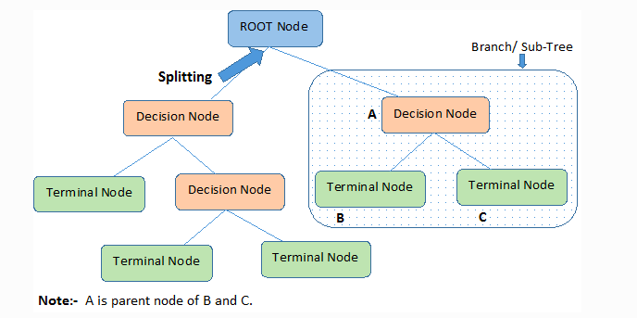

If we follow a random approach, it may give us bad results with low accuracy.

For solving this attribute selection problem, researchers worked and devised some solutions. They suggested using some criteria like: Entropy, Information gain, Gini index, Chi-Square.

# REFERENCES:

1. Johns Hopkins Medicine Pneumonia. [(accessed on 31 December 2019)]; Available online: <https://www.hopkinsmedicine.org/health/conditions-and-diseases/pneumonia>.
2. Johnson S., Wells D., Healthline Viral Pneumonia: Symptoms, Risk Factors, and More. [(accessed on 31 December 2019)]; Available online: <https://www.healthline.com/health/viral-pneumonia>.
3. Healthcare, University of Utah. Pneumonia Makes List for Top 10 Causes of Death. [(accessed on 31 December 2019)];2016 Available online: <https://healthcare.utah.edu/the-scope/shows.php?shows=0_riw4wti7>.
4. Pneumonia. [(accessed on 31 December 2019)]; Available online: <https://www.radiologyinfo.org/en/info.cfm?pg=pneumonia>.
5. World Health Organization . *Standardization of Interpretation of Chest Radiographs for the Diagnosis of Pneumonia in Children.* World Health Organization; Geneva, Switzerland: 2001. Technical Report. [[Google Scholar](https://scholar.google.com/scholar_lookup?title=Standardization+of+Interpretation+of+Chest+Radiographs+for+the+Diagnosis+of+Pneumonia+in+Children&publication_year=2001&)]
6. Cherian T., Mulholland E.K., Carlin J.B., Ostensen H., Amin R., Campo M.D., Greenberg D., Lagos R., Lucero M., Madhi S.A., et al. Standardized interpretation of paediatric chest radiographs for the diagnosis of pneumonia in epidemiological studies. *Bull. World Health Organ.*2005;83:353–359. [[PMC free article](https://www.ncbi.nlm.nih.gov/pmc/articles/PMC2626240/)] [[PubMed](https://www.ncbi.nlm.nih.gov/pubmed/15976876)] [[Google Scholar](https://scholar.google.com/scholar_lookup?journal=Bull.+World+Health+Organ.&title=Standardized+interpretation+of+paediatric+chest+radiographs+for+the+diagnosis+of+pneumonia+in+epidemiological+studies&author=T.+Cherian&author=E.K.+Mulholland&author=J.B.+Carlin&author=H.+Ostensen&author=R.+Amin&volume=83&publication_year=2005&pages=353-359&pmid=15976876&)]
7. Franquet T. Imaging of pneumonia: Trends and algorithms. *Eur. Respir. J.*2001;18:196–208. doi: 10.1183/09031936.01.00213501. [[PubMed](https://www.ncbi.nlm.nih.gov/pubmed/11510793)] [[CrossRef](https://dx.doi.org/10.1183%2F09031936.01.00213501" \t "_blank)] [[Google Scholar](https://scholar.google.com/scholar_lookup?journal=Eur.+Respir.+J.&title=Imaging+of+pneumonia:+Trends+and+algorithms&author=T.+Franquet&volume=18&publication_year=2001&pages=196-208&pmid=11510793&doi=10.1183/09031936.01.00213501&)]
8. Hosny A., Parmar C., Quackenbush J., Schwartz L.H., Aerts H.J. Artificial intelligence in radiology. *Nat. Rev. Cancer.*2018;18:500–510. doi: 10.1038/s41568-018-0016-5. [[PMC free article](https://www.ncbi.nlm.nih.gov/pmc/articles/PMC6268174/)] [[PubMed](https://www.ncbi.nlm.nih.gov/pubmed/29777175)] [[CrossRef](https://dx.doi.org/10.1038%2Fs41568-018-0016-5" \t "_blank)] [[Google Scholar](https://scholar.google.com/scholar_lookup?journal=Nat.+Rev.+Cancer&title=Artificial+intelligence+in+radiology&author=A.+Hosny&author=C.+Parmar&author=J.+Quackenbush&author=L.H.+Schwartz&author=H.J.+Aerts&volume=18&publication_year=2018&pages=500-510&pmid=29777175&doi=10.1038/s41568-018-0016-5&)]
9. Naicker S., Plange-Rhule J., Tutt R.C., Eastwood J.B. Shortage of healthcare workers in developing countries–Africa. *Ethn. Dis.*2009;19:60. [[Google Scholar](https://scholar.google.com/scholar_lookup?journal=Ethn.+Dis.&title=Shortage+of+healthcare+workers+in+developing+countries%E2%80%93Africa&author=S.+Naicker&author=J.+Plange-Rhule&author=R.C.+Tutt&author=J.B.+Eastwood&volume=19&publication_year=2009&pages=60&)]
10. Douarre C., Schielein R., Frindel C., Gerth S., Rousseau D. Transfer learning from synthetic data applied to soil–root segmentation in x-ray tomography images. *J. Imaging.*2018;4:65. doi: 10.3390/jimaging4050065. [[CrossRef](https://dx.doi.org/10.3390%2Fjimaging4050065" \t "_blank)] [[Google Scholar](https://scholar.google.com/scholar_lookup?journal=J.+Imaging&title=Transfer+learning+from+synthetic+data+applied+to+soil%E2%80%93root+segmentation+in+x-ray+tomography+images&author=C.+Douarre&author=R.+Schielein&author=C.+Frindel&author=S.+Gerth&author=D.+Rousseau&volume=4&publication_year=2018&pages=65&doi=10.3390/jimaging4050065&)]
11. Zhang Y., Wang G., Li M., Han S. Automated classification analysis of geological structures based on images data and deep learning model. *Appl. Sci.*2018;8:2493. doi: 10.3390/app8122493. [[CrossRef](https://dx.doi.org/10.3390%2Fapp8122493" \t "_blank)] [[Google Scholar](https://scholar.google.com/scholar_lookup?journal=Appl.+Sci.&title=Automated+classification+analysis+of+geological+structures+based+on+images+data+and+deep+learning+model&author=Y.+Zhang&author=G.+Wang&author=M.+Li&author=S.+Han&volume=8&publication_year=2018&pages=2493&doi=10.3390/app8122493&)]
12. Wang Y., Wang C., Zhang H. Ship classification in high-resolution SAR images using deep learning of small datasets. *Sensors.*2018;18:2929. doi: 10.3390/s18092929. [[PMC free article](https://www.ncbi.nlm.nih.gov/pmc/articles/PMC6164978/)] [[PubMed](https://www.ncbi.nlm.nih.gov/pubmed/30177668)] [[CrossRef](https://dx.doi.org/10.3390%2Fs18092929" \t "_blank)] [[Google Scholar](https://scholar.google.com/scholar_lookup?journal=Sensors&title=Ship+classification+in+high-resolution+SAR+images+using+deep+learning+of+small+datasets&author=Y.+Wang&author=C.+Wang&author=H.+Zhang&volume=18&publication_year=2018&pages=2929&pmid=30177668&doi=10.3390/s18092929&)]
13. Sun C., Yang Y., Wen C., Xie K., Wen F. Voiceprint identification for limited dataset using the deep migration hybrid model based on transfer learning. *Sensors.*2018;18:2399. doi: 10.3390/s18072399. [[PMC free article](https://www.ncbi.nlm.nih.gov/pmc/articles/PMC6068892/)] [[PubMed](https://www.ncbi.nlm.nih.gov/pubmed/30041500)] [[CrossRef](https://dx.doi.org/10.3390%2Fs18072399" \t "_blank)] [[Google Scholar](https://scholar.google.com/scholar_lookup?journal=Sensors&title=Voiceprint+identification+for+limited+dataset+using+the+deep+migration+hybrid+model+based+on+transfer+learning&author=C.+Sun&author=Y.+Yang&author=C.+Wen&author=K.+Xie&author=F.+Wen&volume=18&publication_year=2018&pages=2399&pmid=30041500&doi=10.3390/s18072399&)]
14. Chen Z., Zhang Y., Ouyang C., Zhang F., Ma J. Automated landslides detection for mountain cities using multi-temporal remote sensing imagery. *Sensors.*2018;18:821. doi: 10.3390/s18030821. [[PMC free article](https://www.ncbi.nlm.nih.gov/pmc/articles/PMC5876587/)] [[PubMed](https://www.ncbi.nlm.nih.gov/pubmed/29522424)] [[CrossRef](https://dx.doi.org/10.3390%2Fs18030821" \t "_blank)] [[Google Scholar](https://scholar.google.com/scholar_lookup?journal=Sensors&title=Automated+landslides+detection+for+mountain+cities+using+multi-temporal+remote+sensing+imagery&author=Z.+Chen&author=Y.+Zhang&author=C.+Ouyang&author=F.+Zhang&author=J.+Ma&volume=18&publication_year=2018&pages=821&doi=10.3390/s18030821&)]
15. Razzak M.I., Naz S., Zaib A. *Classification in BioApps.* Springer; Cham, Switzerland: 2018. Deep learning for medical image processing: Overview, challenges and the future; pp. 323–350. [[Google Scholar](https://scholar.google.com/scholar_lookup?title=Classification+in+BioApps&author=M.I.+Razzak&author=S.+Naz&author=A.+Zaib&publication_year=2018&)]
16. Shen D., Wu G., Suk H.I. Deep learning in medical image analysis. *Annu. Rev. Biomed. Eng.*2017;19:221–248. doi: 10.1146/annurev-bioeng-071516-044442. [[PMC free article](https://www.ncbi.nlm.nih.gov/pmc/articles/PMC5479722/)] [[PubMed](https://www.ncbi.nlm.nih.gov/pubmed/28301734)] [[CrossRef](https://dx.doi.org/10.1146%2Fannurev-bioeng-071516-044442" \t "_blank)] [[Google Scholar](https://scholar.google.com/scholar_lookup?journal=Annu.+Rev.+Biomed.+Eng.&title=Deep+learning+in+medical+image+analysis&author=D.+Shen&author=G.+Wu&author=H.I.+Suk&volume=19&publication_year=2017&pages=221-248&pmid=28301734&doi=10.1146/annurev-bioeng-071516-044442&)]