Aim
To compute and analyze the similarity between:
- Original song
- Karaoke (music-only) version of the same song
- Completely different song
using Cross-Correlation and Auto-Correlation techniques.

Cross-correlation:
- The cross-correlation between two different signals or functions or waveforms is defined as the measure of similarity or coherence between one signal and the timedelayed version of another signal.
The cross-correlation between two different signals indicates the degree of relatedness between one signal and the time-delayed version of another signal.
- There are also many applications of signal crosscorrelation in signal processing systems, especially when the signal is corrupted by another undesirable signal (noise) so that the signal estimation (detection) from a noisy signal has to be performed.

Auto-Correlation:
- The autocorrelation function is defined as the measure of similarity or coherence between a signal and its time delayed version. Therefore, the autocorrelation is the correlation of a signal with itself.
- Physically, signal autocorrelation indicates how the signal energy (power) is distributed within the signal, and as such is used to measure the signal power. Typical applications of signal autocorrelation are in radar, sonar, satellite, and wireless communications systems. Devices that measure signal power using signal correlation are known as signal correlators.

Cross-Correlation
Cross-correlation is a mathematical operation used to measure the similarity between two different signals. It compares one signal with a time-shifted or delayed version of another signal.
In simple words, cross-correlation helps us answer the question:
"How similar are these two signals when one of them is shifted in time?"
When one signal is shifted by different time delays, the samples of both signals are compared at each delay. The resulting correlation value indicates how closely the two signals match at that particular time lag.
If the correlation value is high, it means the two signals are highly similar at that particular time delay. If the value is low, the signals have less similarity.
For example, if one signal is a delayed version of another signal, cross-correlation can be used to determine approximately how much delay exists between them.
Applications of Cross-Correlation
Cross-correlation is widely used in Digital Signal Processing (DSP) and communication systems.
It is especially useful when a desired signal is mixed with an unwanted signal such as noise. By comparing the received signal with a known reference signal, cross-correlation can help determine whether the desired signal is present and estimate its position or delay.
Some common applications include:
- Signal detection
- Noise and signal analysis
- Time-delay estimation
- Radar systems
- Sonar systems
- Communication systems
- Pattern matching
Therefore, cross-correlation is an important technique for detecting and identifying signals in noisy environments.
Auto-Correlation
Autocorrelation is a special type of correlation in which a signal is compared with itself at different time delays.
In simple words, autocorrelation answers the question:
"How similar is this signal to a delayed version of itself?"
Unlike cross-correlation, where two different signals are compared, autocorrelation uses the same signal for both inputs.
If the signal contains a repeating or periodic pattern, the autocorrelation function will show high correlation at time lags corresponding to that repetition.
For example, if a signal contains a repeating pattern, autocorrelation can help determine the period or repetition rate of that signal.
Applications of Auto-Correlation
Autocorrelation is widely used in signal processing and communication systems to analyze the internal characteristics of a signal.
It can be used to study:
- Signal power and energy
- Periodicity of signals
- Repetitive patterns
- Signal detection
- Radar systems
- Sonar systems
- Satellite communication
- Wireless communication
Autocorrelation is also useful for identifying hidden periodic patterns in a signal that may not be immediately visible in the original waveform.

Cross-Correlation | Auto-Correlation
Compares two different signals. | Compares a signal with itself.
Measures similarity between two signals at different time delays. | Measures similarity between a signal and its delayed version.
Useful for finding the relationship or delay between signals. | Useful for finding periodicity and internal characteristics of a signal.
Commonly used for signal detection and time-delay estimation. | Commonly used for periodicity, power, and signal analysis.
Example: comparing a transmitted signal with a received signal. | Example: comparing a signal with its delayed version.

In this experiment, cross-correlation is calculated between signal1 and signal2, while autocorrelation is calculated for signal1 itself. The resulting values are displayed using stem plots. By observing these plots, we can understand how the similarity between signals changes with different time lags and how a signal relates to its own delayed versions.

PROGRAM:
import librosa import numpy as np
import matplotlib.pyplot as plt

# Load audio files
song1, sr = librosa.load("kesariya.mp3", sr=None)
song2, sr = librosa.load("kesariya_instrumental.mp3", sr=None) song3, sr = librosa.load("believer.mp3", sr=None)

# Take first 10 seconds song1 = song1[:10 * sr] song2 = song2[:10 * sr] song3 = song3[:10 * sr]
# Make all songs same length
n = min(len(song1), len(song2), len(song3))

song1 = song1[:n] song2 = song2[:n] song3 = song3[:n]

# Cross Correlation
corr12 = np.correlate(song1, song2, mode='full') corr13 = np.correlate(song1, song3, mode='full') corr23 = np.correlate(song2, song3, mode='full')

# Similarity values
sim12 = np.max(np.abs(corr12)) sim13 = np.max(np.abs(corr13)) sim23 = np.max(np.abs(corr23))
print("Similarity Values") print(" ")
print("Original vs Karaoke =", sim12) print("Original vs Different Song =", sim13) print("Karaoke vs Different Song =", sim23)

# Cross Correlation Graphs plt.figure(figsize=(8,4))

plt.plot(corr12)
plt.title("Cross Correlation: Original vs Karaoke") plt.xlabel("Lag")
plt.ylabel("Correlation") plt.show()
plt.figure(figsize=(8,4)) plt.plot(corr13)
plt.title("Cross Correlation: Original vs Different Song") plt.xlabel("Lag")
plt.ylabel("Correlation") plt.show()

plt.figure(figsize=(8,4)) plt.plot(corr23)
plt.title("Cross Correlation: Karaoke vs Different Song") plt.xlabel("Lag")
plt.ylabel("Correlation") plt.show()

# Auto Correlation
auto1 = np.correlate(song1, song1, mode='full') auto2 = np.correlate(song2, song2, mode='full') auto3 = np.correlate(song3, song3, mode='full')
# Auto Correlation Graphs plt.figure(figsize=(8,4)) plt.plot(auto1)
plt.title("Auto Correlation: Original Song") plt.xlabel("Lag")
plt.ylabel("Correlation") plt.show()

plt.figure(figsize=(8,4)) plt.plot(auto2)

plt.title("Auto Correlation: Karaoke Song") plt.xlabel("Lag")
plt.ylabel("Correlation") plt.show()

plt.figure(figsize=(8,4)) plt.plot(auto3)
plt.title("Auto Correlation: Different Song") plt.xlabel("Lag")
plt.ylabel("Correlation") plt.show()

OUTPUTS:
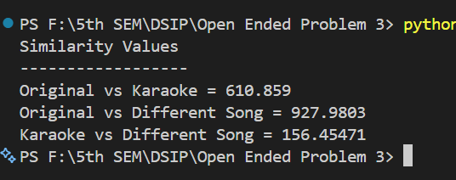

The correlation values between the three audio tracks were calculated successfully. Cross-correlation and auto-correlation graphs were generated for further analysis.

Cross Correlation - Original vs Karaoke:
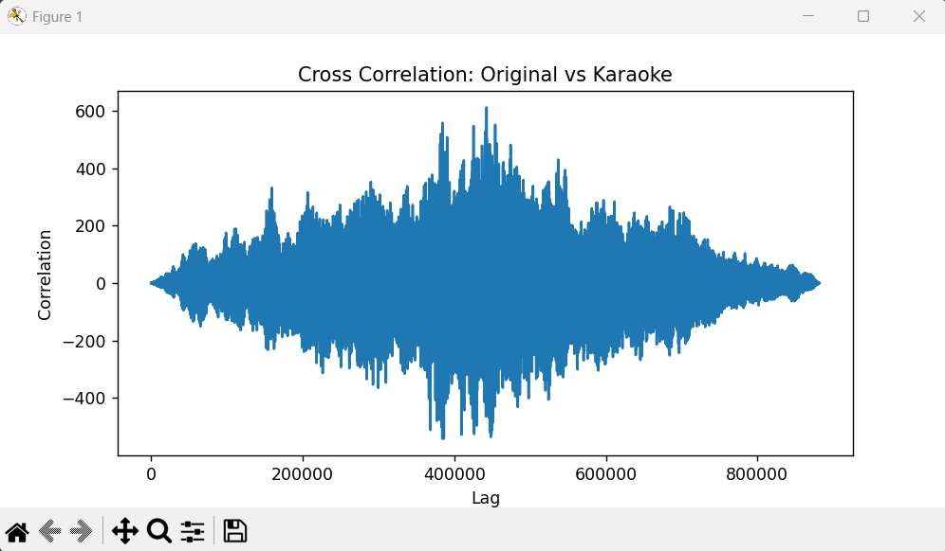

Observation:
The graph shows a noticeable similarity between the original song and the karaoke version. Since both tracks contain similar music patterns and rhythm, the correlation values are relatively high.

Cross Correlation - Original vs Different Song:
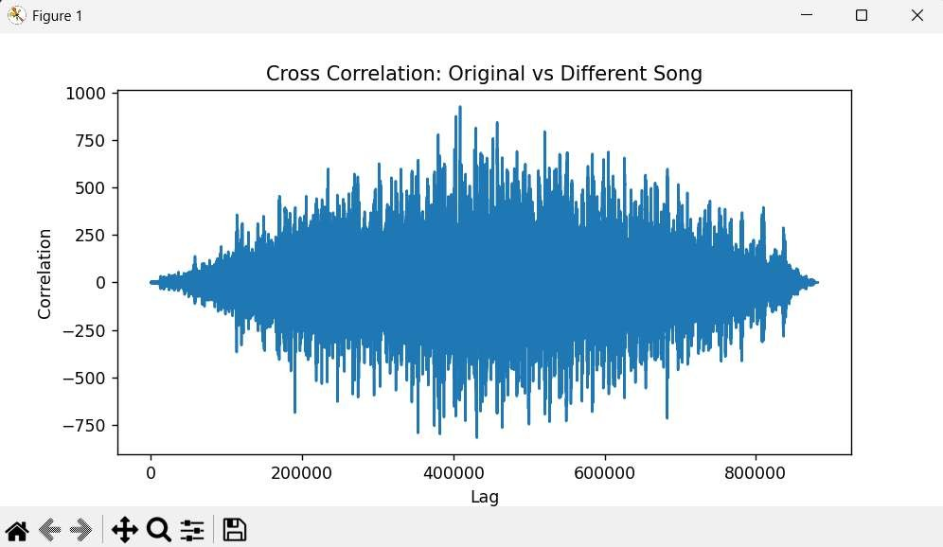

Observation:
The graph appears more irregular because the two songs have different musical structures and frequency components. The similarity between the signals is comparatively lower.

Cross Correlation - Karaoke vs Different Song:
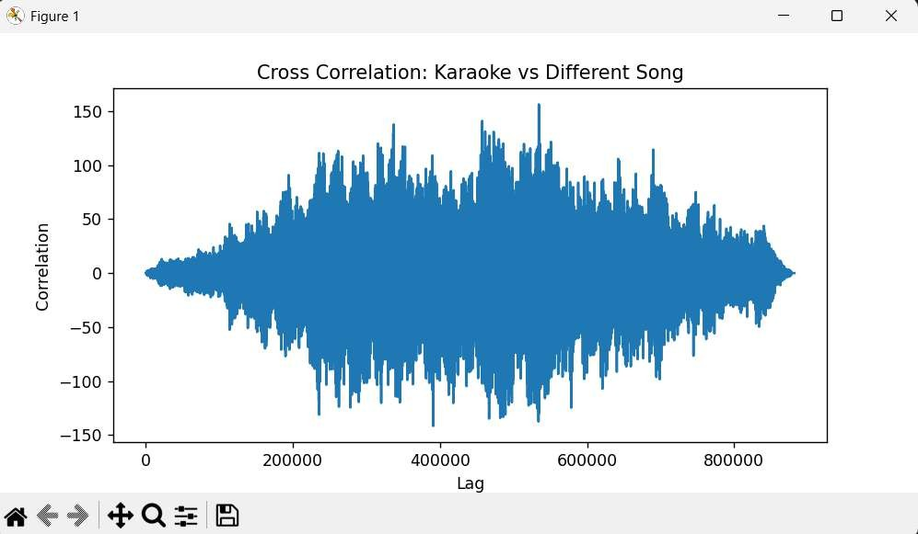

Observation

This comparison produced the lowest similarity among the related tracks. The two songs do not share common musical characteristics, resulting in weaker correlation.

Auto Correlation - Original Song:
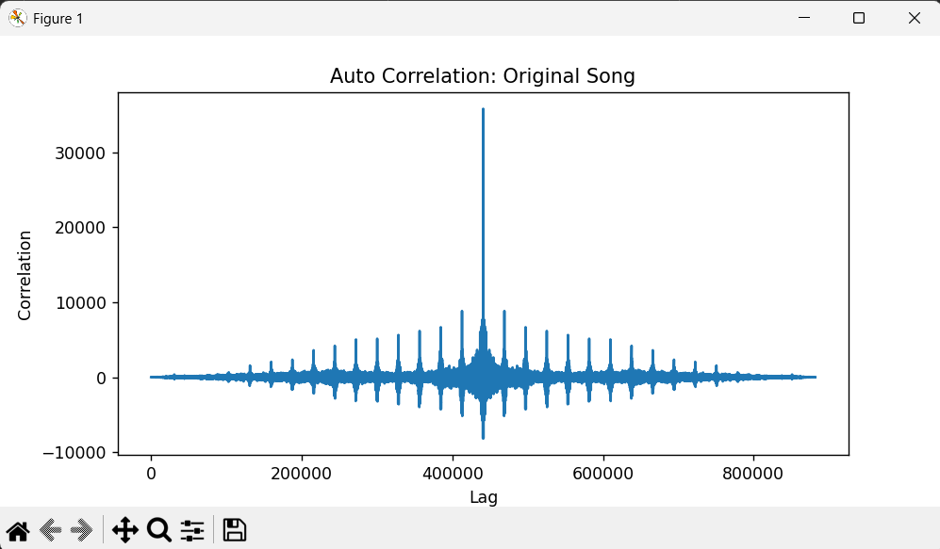
Observation
A strong peak is visible at the center because the signal is compared with itself. Smaller peaks indicate repeating musical patterns in the song.

Auto Correlation - Karaoke Song:
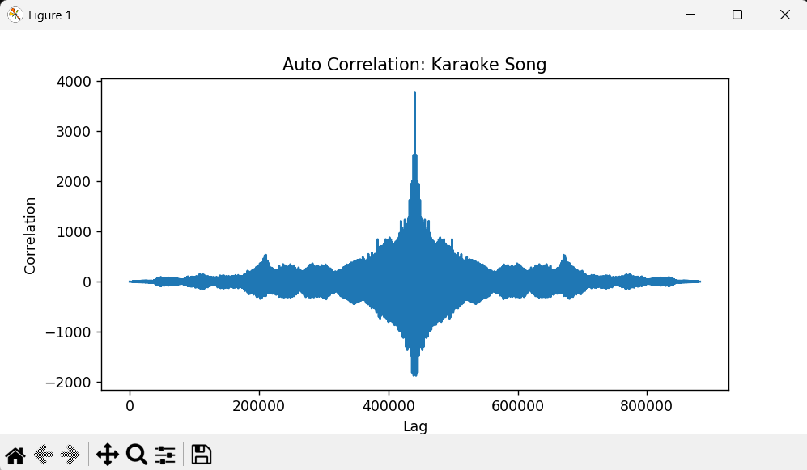

Observation

The graph contains a strong central peak and several repeating peaks around it. These peaks represent recurring instrumental patterns present in the karaoke track.

Auto Correlation - Different Song:
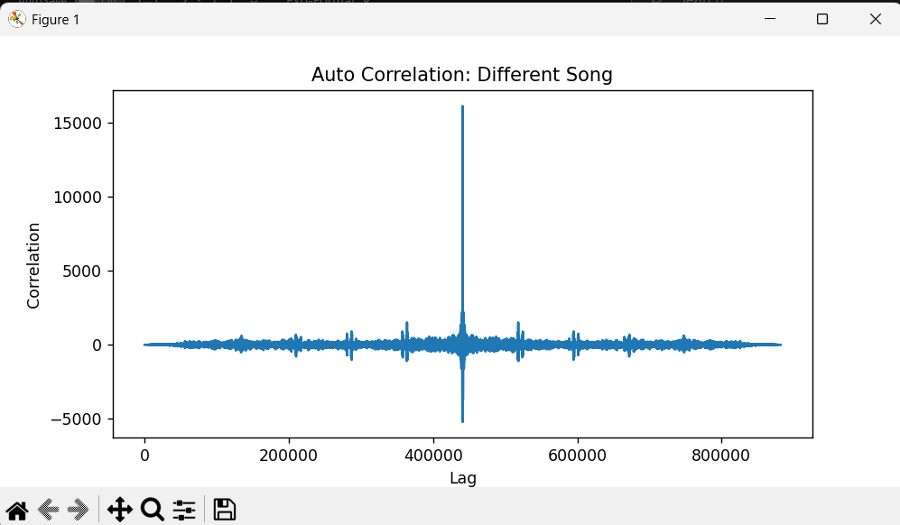
Observation
The central peak is the highest because the signal is perfectly correlated with itself. The surrounding pattern differs due to the unique musical content of the song.

Rigorous Analysis:
- Effect of Audio Duration Decrease: (5sec)

Audio duration reduced from 10 seconds to 5 seconds.
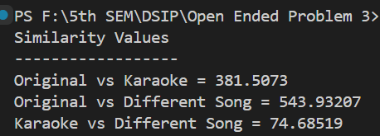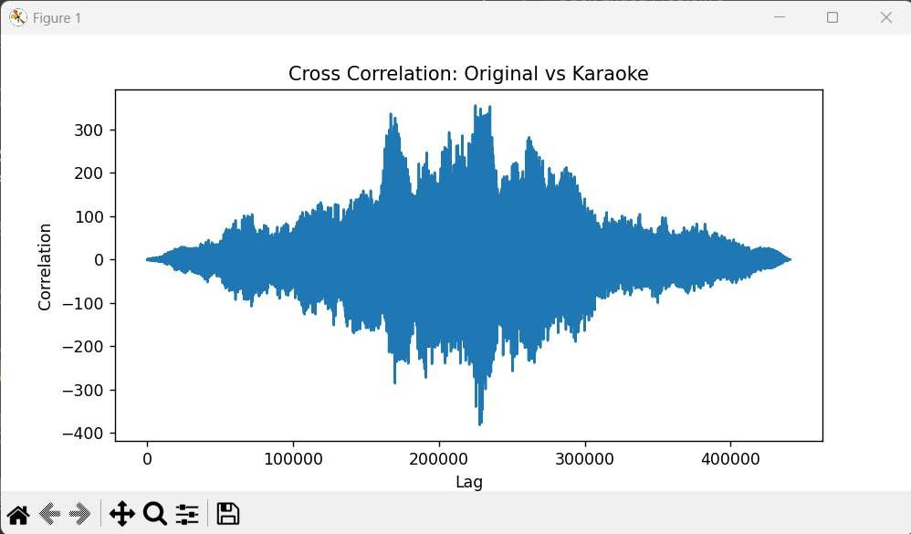

Observation:
When only 5 seconds of audio were used, the correlation values changed slightly. Since less audio information was available, the correlation result became less stable compared to the 10-second signal.

Effect of Aduio Duration Increase:(15 sec)

Audio duration increased from 10 seconds to 15 seconds.
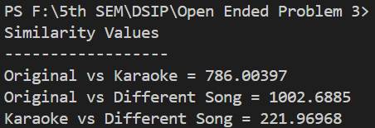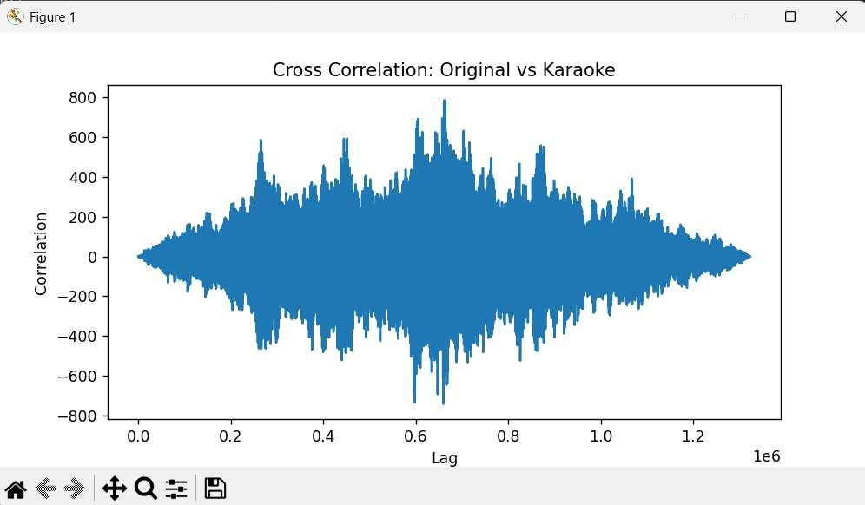

Observation:

Increasing the audio duration provided more signal information for comparison. The correlation values became more reliable and represented the similarity between the songs more accurately.

- Effect of Noise: (Noise add to the song)
Random noise added to the original song. noise = np.random.normal(0, 0.05, len(song1)) song1 = song1 + noise
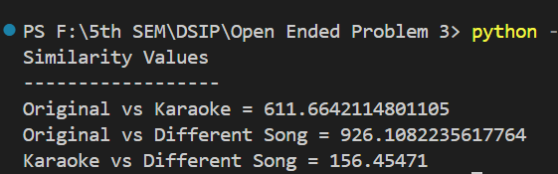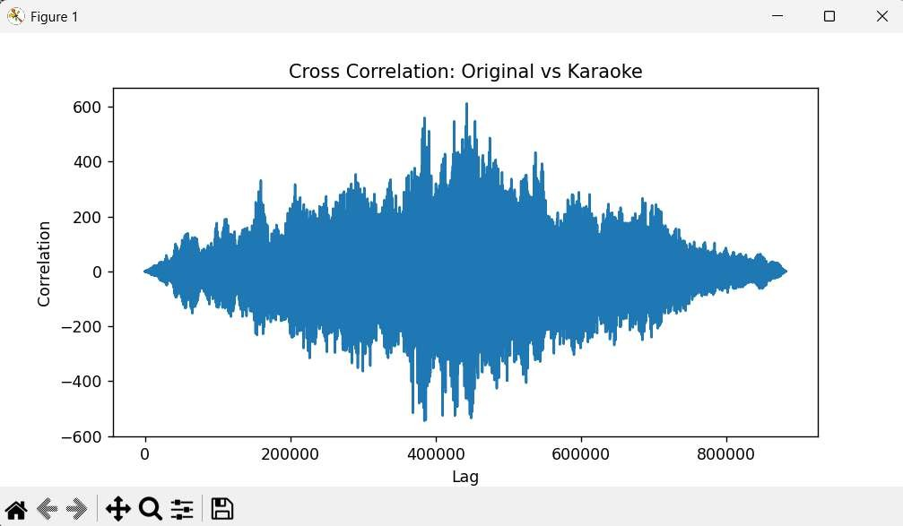

Observation:
After adding noise, the correlation value decreased because the original waveform was disturbed. The graph became more irregular, showing reduced similarity between the signals.

Effect of Time Shift:
Karaoke signal shifted by 3000 samples. song2 = np.roll(song2, 3000)
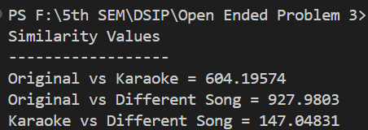
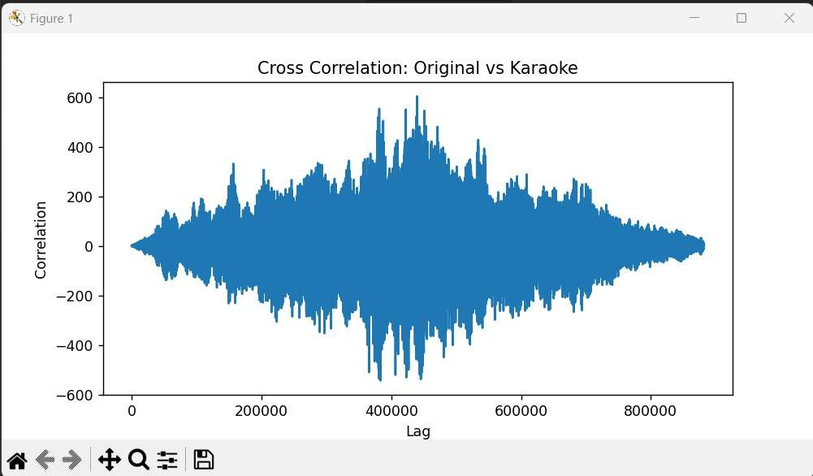

Observation
- The experiment successfully calculates both cross-correlation and autocorrelation of the given discrete-time signals using NumPy.
- In cross-correlation, signal1 and signal2 are compared at different time lags. Since signal2 is directly related to signal1 (signal2 = 2 × signal1), a strong correlation is observed between the two signals.
- The cross-correlation output contains a maximum value near the central lag, indicating that the two signals have their highest similarity when they are properly aligned.
- The cross-correlation values decrease as the time lag moves away from the point of maximum correlation because the overlapping portions of the two signals become smaller.
- In autocorrelation, signal1 is compared with its own delayed versions. The maximum value occurs at zero time lag, because the signal is being compared with itself without any shift.
- As the time lag increases in either direction, the autocorrelation value decreases because fewer samples overlap and the similarity between the original and shifted signal becomes smaller.
- The autocorrelation plot is symmetric about zero lag, which is an important characteristic of autocorrelation for real-valued signals.
- The experiment shows that cross-correlation is useful for finding similarity and relative delay between two signals, while autocorrelation is useful for studying the internal pattern, periodicity, and characteristics of a single signal.
- Overall, the obtained plots clearly demonstrate how correlation changes with time lag and provide a practical understanding of correlation techniques used in Digital Signal Processing (DSP).

Rigorous Analysis:(conclusion)
The program is used to calculate and visualize the cross-correlation and autocorrelation of two discrete-time signals. NumPy is used for the correlation calculations, while Matplotlib is used to display the results using stem plots.

Step 1: Import Required Libraries
import numpy as np
import matplotlib.pyplot as plt
numpy is used to create signals and perform correlation operations. matplotlib.pyplot is used to plot the calculated correlation results.

Step 2: Define the Cross-Correlation Function
def cross_correlation(signal1, signal2):
cross_corr = np.correlate(signal1, signal2, mode='full')
return cross_corr
This function calculates the cross-correlation between signal1 and signal2.
The mode='full' option calculates correlation for all possible time lags between the two signals.
The resulting correlation values are returned and stored in cross_corr.

Step 3: Define the Autocorrelation Function
def autocorrelation(signal):
auto_corr = np.correlate(signal, signal, mode='full')
return auto_corr
This function calculates the autocorrelation of a signal.
Here, the same signal is provided twice to np.correlate(). Therefore, the signal is compared with its different time-shifted versions.
The resulting values are stored in auto_corr.

Step 4: Define the Signals
signal1 = np.array([1, 2, 3, 4, 5])
signal2 = np.array([2, 4, 6, 8, 10])
Two discrete-time signals are created using NumPy arrays.
Here, signal2 is twice the value of signal1, so the two signals have a strong relationship with each other.

Step 5: Calculate Cross-Correlation
cross_corr = cross_correlation(signal1, signal2)
The cross-correlation function is called using signal1 and signal2.
This determines how similar the two signals are at different time lags.
A larger correlation value indicates greater similarity between the signals at that particular lag.
Step 6: Calculate Autocorrelation
auto_corr = autocorrelation(signal1)
The autocorrelation function is applied to signal1.
This compares signal1 with its own shifted versions and determines how similar the signal is to itself at different time lags.
The highest value normally occurs at zero lag, where the signal is compared directly with itself.

Step 7: Create the Plot
plt.figure(figsize=(10, 6))
A figure of size 10 × 6 is created to display both correlation results.

Step 8: Plot Cross-Correlation
plt.subplot(2, 1, 1)
plt.stem(cross_corr)
plt.title('Cross-correlation')
plt.xlabel('Time Lag')
plt.ylabel('Magnitude')
The first subplot displays the cross-correlation result.
The x-axis represents the time lag, while the y-axis represents the correlation magnitude.
The plot helps identify the lag at which the two signals have the highest similarity.

Step 9: Plot Autocorrelation
plt.subplot(2, 1, 2)
plt.stem(auto_corr)
plt.title('Autocorrelation')
plt.xlabel('Time Lag')
plt.ylabel('Magnitude')
The second subplot displays the autocorrelation result.
It shows how the similarity of signal1 changes as the signal is shifted by different time lags.

Step 10: Display the Results
plt.tight_layout()
plt.show()
plt.tight_layout() properly adjusts the spacing between the two plots.
Finally, plt.show() displays the cross-correlation and autocorrelation plots.

Overall Working
The program takes two discrete-time signals and performs two different operations. Cross-correlation compares the two different signals to determine their similarity at different time lags, while autocorrelation compares one signal with itself to determine its similarity with delayed versions. The results are represented graphically using stem plots, which makes the correlation values and their variation with time lag easy to observe.

Conclusion
The experiment successfully demonstrates the implementation of cross-correlation and autocorrelation for discrete-time signals using Python. Cross-correlation was used to measure the similarity between two different signals at different time lags, while autocorrelation was used to measure the similarity of a signal with its own delayed versions. The resulting correlation values were represented using stem plots, making it easier to observe the relationship between the signals. Cross-correlation is useful for applications such as signal detection, time-delay estimation, noise analysis, radar, and communication systems. Autocorrelation is useful for identifying periodicity, signal characteristics, and power-related information. Overall, the experiment provides a practical understanding of correlation techniques and their importance in Digital Signal Processing (DSP).

GitHub:
https://github.com/manav-chotai081/DSIP/tree/main/OPQ_3

