Theory
Audio convolution is a signal processing technique used to modify an audio signal by combining it with another signal called an impulse response (IR) or kernel. It is widely used in Digital Signal Processing (DSP) for applications such as audio filtering, echo generation, reverberation, noise reduction, and sound enhancement.
In convolution, each sample of the input audio signal is multiplied and summed with the impulse response to produce a new output signal. The characteristics of the output depend on the selected impulse response. Different impulse responses produce different audio effects, such as smoothing, amplification, or attenuation of certain frequencies.
In this experiment, an MP3 audio file is loaded, converted into a mono signal, and convolved with a predefined kernel using the SciPy library. The processed audio is then normalized, saved as a WAV file, and compared with the original signal using waveform plots. This helps in understanding how convolution affects audio signals and demonstrates its practical applications in audio processing and filtering.

Explanation
In this program, we perform audio convolution on an MP3 audio file using a predefined impulse response (kernel). Convolution is a mathematical operation that combines an input signal with another signal called an impulse response or kernel to produce a modified output signal. In Digital Signal Processing (DSP), convolution is commonly used for filtering, adding effects, noise reduction, and analyzing audio signals.
The purpose of this program is to load an MP3 audio file, apply convolution using a simple kernel, save the processed audio as a WAV file, and compare the original and processed signals graphically.

Step 1: Import the Required Libraries
from pydub import AudioSegment
import numpy as np
import matplotlib.pyplot as plt
from scipy.signal import convolve
The program begins by importing the required Python libraries.
- PyDub (AudioSegment) is used to load, process, and save audio files.
- NumPy (numpy) is used for numerical computations and handling audio samples as arrays.
- Matplotlib (matplotlib.pyplot) is used to plot the original and processed audio signals.
- SciPy (scipy.signal.convolve) provides the built-in convolution function used to filter the audio signal.

Step 2: Load the MP3 File
audio = AudioSegment.from_mp3("/content/Paon Ki Jutti - Jyoti Nooran _ Isha Malviya _ Shiv Panditt _ Jaani _ Arvvindr S Khaira _ Bunny.mp3")
The from_mp3() function loads the MP3 file into the program.
The loaded audio is stored in the variable:
audio
This audio file acts as the input signal for the convolution process.

Step 3: Convert the Audio to Mono and Extract Samples
audio = audio.set_channels(1)
samples = np.array(audio.get_array_of_samples()).astype(np.float32)
The audio is converted to mono using
audio.set_channels(1)
Mono audio contains only one channel, making signal processing simpler.
Next,
audio.get_array_of_samples()
extracts all the audio samples.
These samples are converted into a NumPy array of type float32 so that mathematical operations such as convolution can be performed efficiently.

Step 4: Define the Convolution Kernel
kernel = np.array([1, 0, 1, 0, 1], dtype=np.float32)
A simple impulse response (kernel) is defined.
The kernel
[1, 0, 1, 0, 1]
determines how the audio signal will be modified during convolution.
Different kernels produce different filtering effects. You can replace this kernel with other values to observe different audio processing results.

Step 5: Perform Convolution
convoluted = convolve(samples, kernel, mode='same')
The convolve() function performs convolution between the audio samples and the kernel.
The parameter
mode='same'
ensures that the output signal has the same length as the original audio signal.
The resulting processed audio is stored in
convoluted

Step 6: Normalize the Convoluted Signal
convoluted = convoluted / np.max(np.abs(convoluted))
After convolution, some sample values may become larger than the allowed audio range.
To prevent distortion or clipping, the signal is normalized.
Normalization scales all sample values between -1 and 1.

Step 7: Convert to 16-bit Integer Format
convoluted_int16 = (convoluted * 32767).astype(np.int16)
Most WAV audio files store samples as 16-bit signed integers.
Therefore, the normalized floating-point values are multiplied by 32767 and converted into int16 format.
This prepares the processed signal for saving as an audio file.

Step 8: Create a New Audio Segment
convoluted_audio = AudioSegment(
convoluted_int16.tobytes(),
frame_rate=audio.frame_rate,
sample_width=2,
channels=1
)
A new AudioSegment object is created using the processed audio samples.
The parameters specify:
- Audio data converted into bytes.
- Frame rate (sampling frequency) same as the original audio.
- Sample width = 2 bytes, indicating 16-bit audio.
- One audio channel (Mono).
This creates a complete audio object that can be saved.

Step 9: Export the Processed Audio
convoluted_audio.export("output_convoluted.wav", format="wav")
The processed audio is saved as
output_convoluted.wav
in WAV format.
The message
print("Convoluted audio saved as 'output_convoluted.wav'.")
confirms that the audio file has been created successfully.

Step 10: Normalize the Original Signal for Plotting
samples_norm = samples / np.max(np.abs(samples))
convoluted_norm = convoluted
Before plotting, the original audio samples are normalized.
This allows both the original and processed signals to be displayed on similar amplitude scales, making visual comparison easier.

Step 11: Create a Figure
plt.figure(figsize=(12, 6))
A figure is created with a width of 12 inches and a height of 6 inches to display both graphs.

Step 12: Plot the Original Audio Signal
plt.subplot(2, 1, 1)
plt.plot(samples_norm, color='blue')
plt.title("Original Audio Signal")
The first subplot displays the original audio signal.
- The graph is plotted in blue.
- The title is "Original Audio Signal".
This graph represents the waveform before convolution.

Step 13: Plot the Convoluted Audio Signal
plt.subplot(2, 1, 2)
plt.plot(convoluted_norm, color='red')
plt.title("Convoluted Audio Signal with Kernel [1, 0, 1, 0, 1]")
The second subplot displays the processed (convoluted) audio signal.
- The graph is plotted in red.
- The title indicates the kernel used for convolution.
Comparing this graph with the original waveform helps visualize how convolution modifies the audio signal.

Step 14: Display the Graphs
plt.tight_layout()
plt.show()
plt.tight_layout() adjusts the spacing between the two graphs to prevent overlapping.
plt.show() displays both graphs in a single figure window.

Code:-
from pydub import AudioSegment
import numpy as np
import matplotlib.pyplot as plt
from scipy.signal import convolve

# Load MP3 file
audio = AudioSegment.from_mp3("/content/Paon Ki Jutti - Jyoti Nooran _ Isha Malviya _ Shiv Panditt _ Jaani _ Arvvindr S Khaira _ Bunny.mp3")

# Convert to mono and extract raw samples
audio = audio.set_channels(1)
samples = np.array(audio.get_array_of_samples()).astype(np.float32)

# Define convolution kernel
kernel = np.array([1, 0, 1, 0, 1], dtype=np.float32)

# Perform convolution
convoluted = convolve(samples, kernel, mode='same')

# Normalize to int16 range for saving
convoluted = convoluted / np.max(np.abs(convoluted)) # Normalize to [-1, 1]
convoluted_int16 = (convoluted * 32767).astype(np.int16) # Scale to int16

# Save as WAV using PyDub
convoluted_audio = AudioSegment(
convoluted_int16.tobytes(),
frame_rate=audio.frame_rate,
sample_width=2, # 16-bit samples = 2 bytes
channels=1
)

# Export to file
convoluted_audio.export("output_convoluted.wav", format="wav")
print("Convoluted audio saved as 'output_convoluted.wav'.")

# Plot original and convoluted signals (optional)
samples_norm = samples / np.max(np.abs(samples))
convoluted_norm = convoluted

plt.figure(figsize=(12, 6))

plt.subplot(2, 1, 1)
plt.plot(samples_norm, color='blue')
plt.title("Original Audio Signal")

plt.subplot(2, 1, 2)
plt.plot(convoluted_norm, color='red')
plt.title("Convoluted Audio Signal with Kernel [1, 0, 1, 0, 1]")

plt.tight_layout()
plt.show()

Output :-
Convoluted audio saved as 'output_convoluted.wav'.
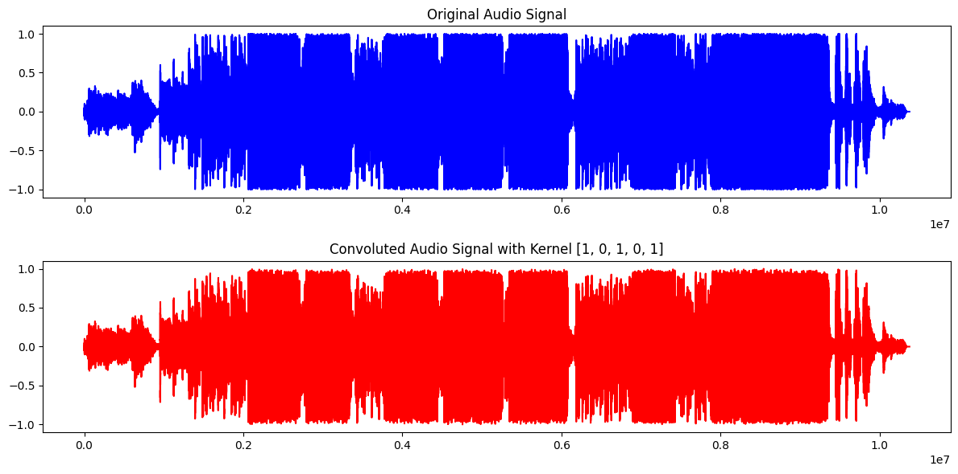

Conclusion
This program successfully demonstrates the implementation of audio convolution using Python. An MP3 audio file is processed by applying a predefined convolution kernel, resulting in a modified audio signal. The processed signal is normalized and saved as a WAV file while the original and convoluted waveforms are displayed for comparison. The experiment shows how convolution changes the characteristics of an audio signal depending on the selected kernel. It provides practical knowledge of convolution and highlights its importance in Digital Signal Processing (DSP) for applications such as audio filtering, sound enhancement, and audio effect generation.

