Name :- Manav Chotai
Enrollment Number :- 92400133081
Subject :- Machine Learning
Class :- 5EK1

Question 1:-
Determine the Number of Tags Per Question
Interpretation:-
Most questions carry 2 or 3 tags which is what we expected since people usually describe a problem with a couple of keywords the average come 2.84 tags per question only 26 questions have 6 tags which is odd because the site allows at most 5 so those are probably left overs from older data
Output:-
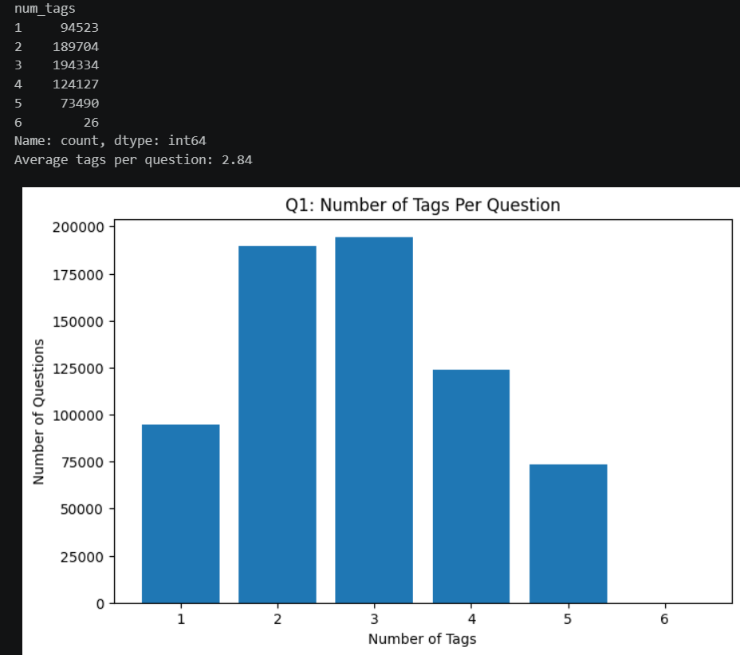

Question 2:-
Determine the Total Number of Unique Tags
Interpretation:-
Total 1.92 million tag used there are only 25,310 different tags this show the same tag are used again and again instead of people new tag for each question
Output:-

Question 3:-
Determine the top-25 Tags appearing frequently
Interpretation:-
The distribution follows a power law, also called a long tail. On the normal plot the curve drops sharply and then flattens, and on the log-log plot it comes close to a straight line. In simple terms, a handful of tags are used extremely often, while most of the rest are used only a few times
Output:-
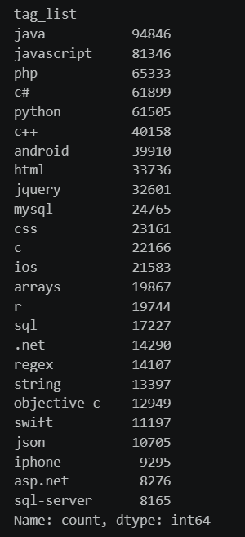
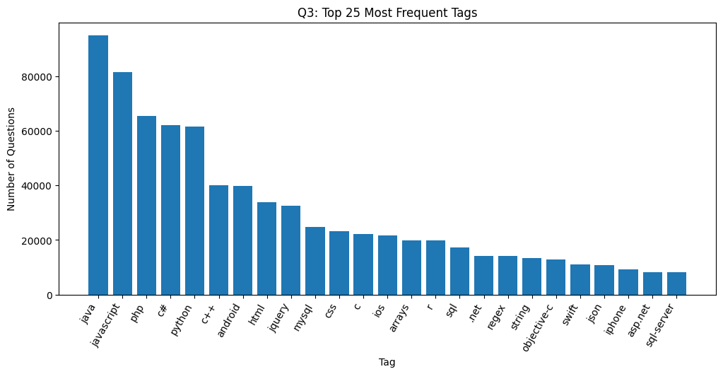
Question 4:-
Determine the nature of the distribution of top-500 tags
Interpretation :-
The distribution follows a power law, also called a long tail. On the normal plot the curve drops sharply and then flattens, and on the log-log plot it comes close to a straight line. In simple terms, a handful of tags are used extremely often, while most of the rest are used only a few times.
Output:-
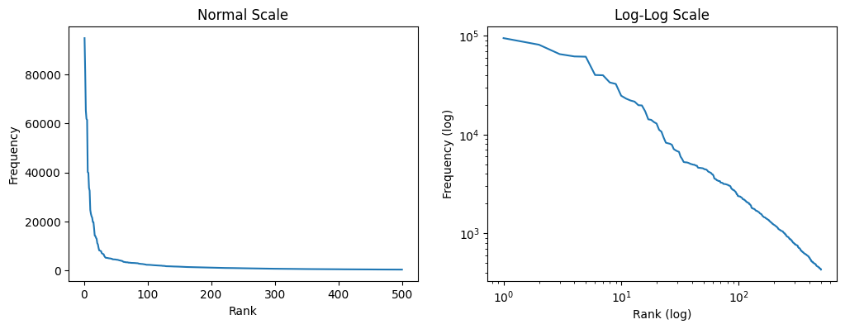

Question 5:-
Determine the ratio of duplicate questions asked in each month For the given dataset, generate a line graph as follows. You need to consider the time between 2008 and 2018.
Interpretation:-
The share of duplicates starts small in 2008 (under 4% in August 2008) and generally goes up as the years pass. A likely reason is that as more questions get answered, there are more chances for a new question to repeat an old one. One thing to keep in mind is that almost 59% of the questions in this dataset are duplicates, far above the real site’s rate, so the file appears to be filtered. The ratios should be read as relative to this dataset, not to the whole site.
Output:-
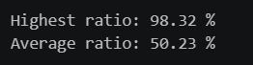
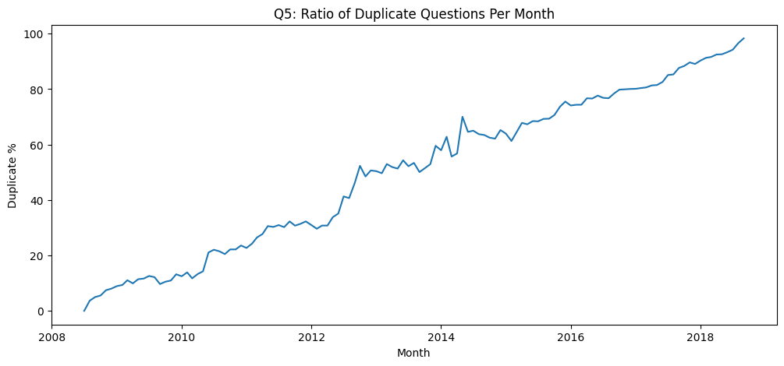
Question 6:-
Determine the percentage of duplicate questions associated with different tags Each Stack Overflow question has some tags associated with it which is an identification of the topic of the question content. For each tag in your dataset, determine the number of duplicate questions associated with the tag over the total number of questions (calculate the percentage). Determine the top-20 tags based on the previously calculated numbers and then show the percentage in a bar chart
Interpretation:-
Tags such as nullreferenceexception, lnk2019, undefined-index, cannot-find-symbol and nullpointerexception have duplicate rates of roughly 89% to 94%. These are mostly error messages that beginners run into over and over, so the same question keeps coming back. I only included tags with at least 50 questions, so a tag with a single duplicate does not unfairly show 100%
Output:-
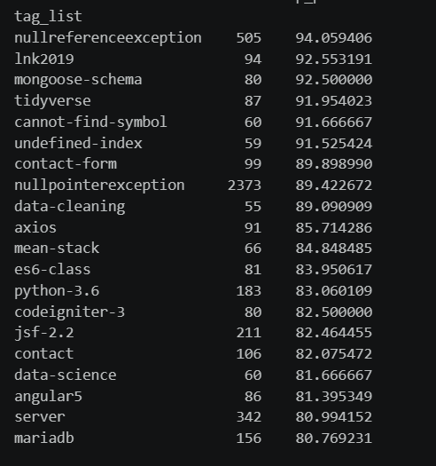
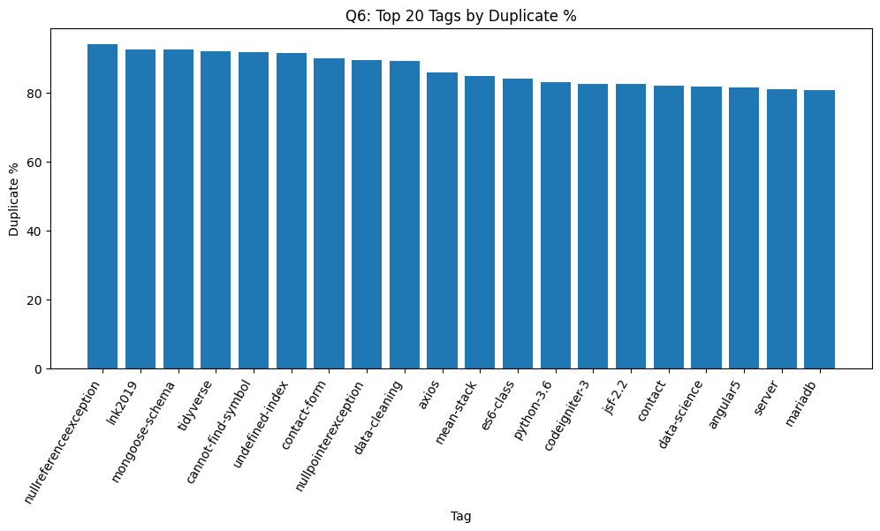
Question 7:-
Determine the time required to close duplicate questions You need to generate a bar chart
Interpretation :-
Most duplicates are dealt with very quickly: roughly seven out of ten are linked within the first 24 hours. A smaller group takes months or even longer to be marked as duplicates. Since the dataset has no exact closing date, I used the date the duplicate link was created as a stand-in for it.
Output:-
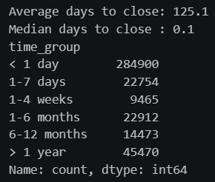
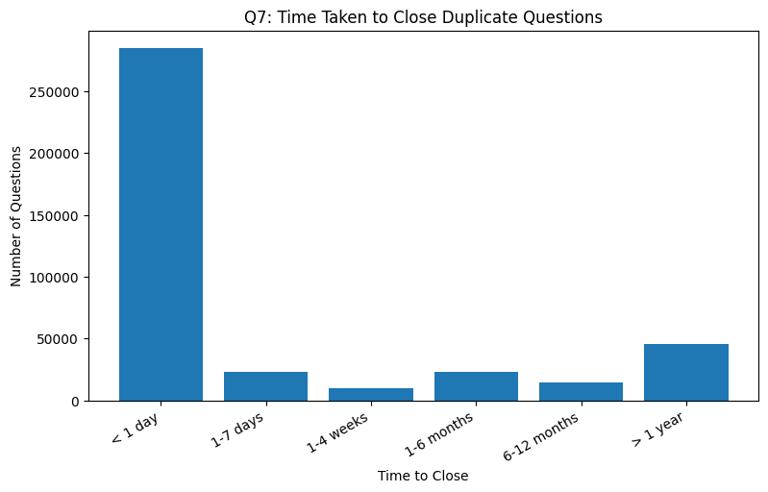

Question 8:-
Distribution of the reputation of users whose questions are closed as duplicates The goal of this analysis is to verify whether duplicated questions are only asked by low-reputation users or not. If that is the case, we need to educate novice or lowreputation users to avoid creating duplicate questions. You can generate a bar chart to show the number of users for different reputation categories. Use your own judgement to answer the question properly (e.g., break the reputation into different ranges).
Interpretation:-
Users with low reputation account for a large part of the duplicates, nearly half in my results, but they are not the only ones. Users with high reputation, even above 10,000, also asked duplicate questions. So the problem is not limited to beginners. Educating new users would help, but it would not remove duplicates completely.
Output:-
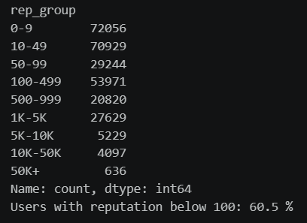
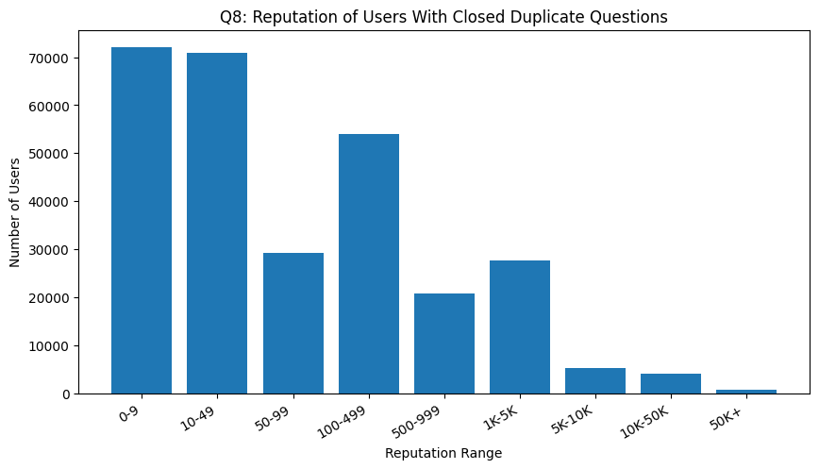

Question 9:-
Consider the first 500 tags and determine how many percentage of questions are been covered
Interpretation:-
The top 500 tags cover about 97.98% of all questions, since a question counts as covered if at least one of its tags is in that list. So just 500 tags out of more than 25,000 describe almost every question.
Output:-
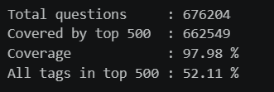
Question 10:-
Repeat Q.9 for first 5000 tags
Interpretation:-
The top 500 tags cover about 97.98% of all questions, since a question counts as covered if at least one of its tags is in that list. So just 500 tags out of more than 25,000 describe almost every question.

Output:-
