Question 1:-
How are all users spread across reputation ranges? (Groups: 1, 2 to 10, 11 to 100, 101 to 1000 and above 1000)
Interpretation:-
The bar chart shows how many users fall in each reputation range. The tallest bar is the most common type of user, and it is the lowest group, because most people who sign up ask or answer very little and never earn many reputation points. As the reputation range goes higher the bars become much shorter, which means only a small number of users become active and trusted members of the site.
Output:-
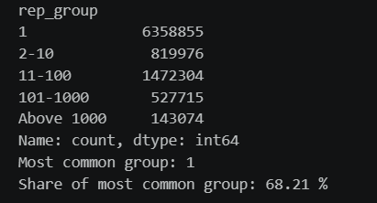
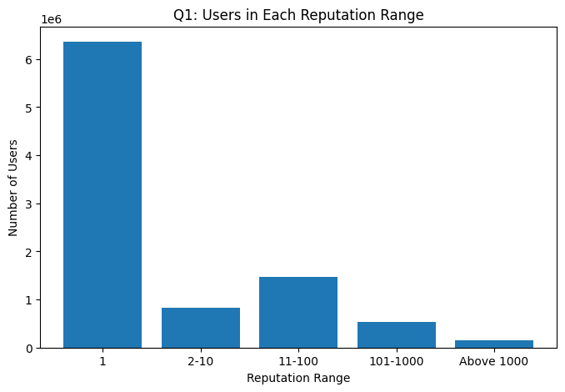

Question 2:-
What is the average view count of questions in each year?
Interpretation:-
The chart shows the average number of views that a question got in each year. The early years have the highest averages because older questions have had a lot more time to be found by search engines and opened by many people. The newer years show lower averages simply because those questions have had less time to collect views, not because they are less useful.
Output:-
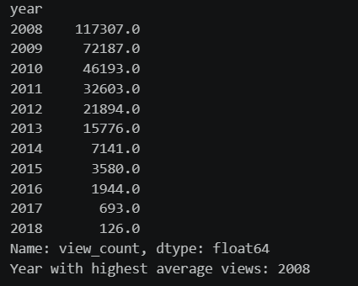
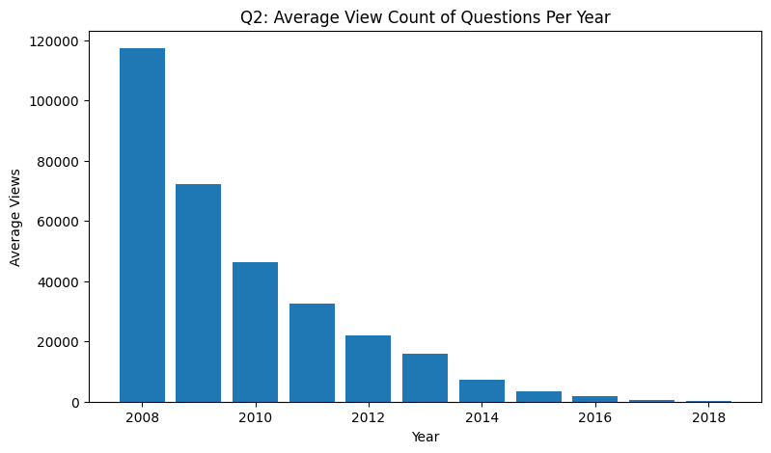

Question 3:-
Which 10 questions have the most comments?
Interpretation:-
The chart shows the 10 questions with the highest number of comments. Questions with so many comments are usually popular, confusing or debated topics where people keep asking for more details or sharing their own opinion. Only the first 40 characters of each title are shown in the chart so that the labels stay readable.
Output:-
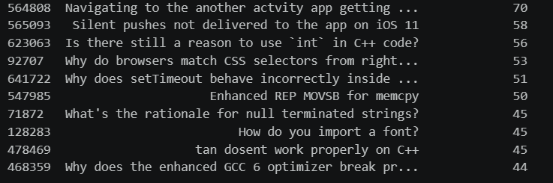
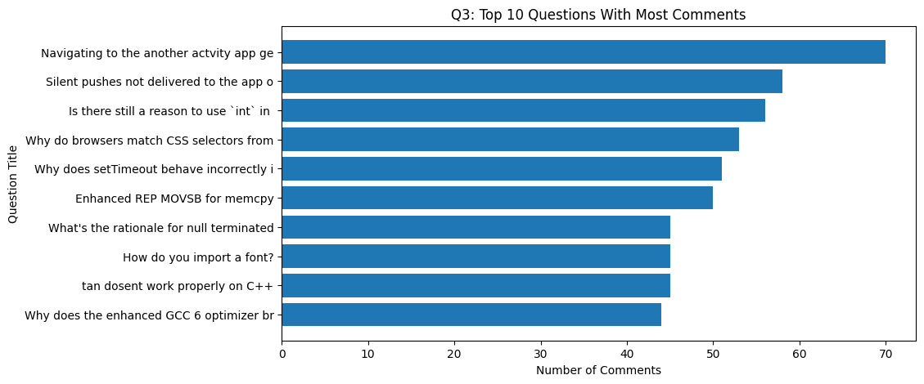

Question 4:-
How many users joined Stack Overflow in each year?
Interpretation:-
The line graph shows how many new users joined the site in each year. A rising line means the site was growing, and the highest point of the line is the year in which the most users joined. When the line goes down or becomes flat after that, it means fewer new users were joining than before.
Output:-
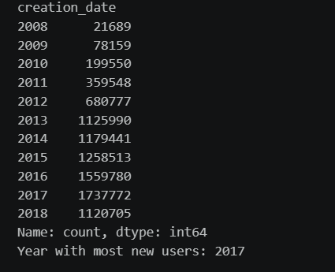
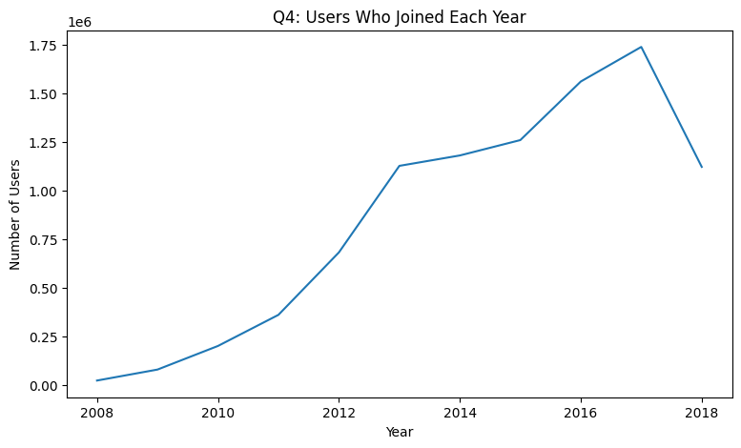

Question 5:-
Which 10 users have the most profile views?
Interpretation:-
The bar chart shows the 10 users whose profiles were viewed the most. We also checked how many of these users are in the top 10 by reputation. If only a few of them are common, it means profile views and reputation are different things, and a user can be viewed a lot without having the highest reputation. If many of them are common, it means the most popular users are also the most trusted users.
Output:-
