Installation Steps:-

Step1:- Install the extension.
Step2:- To show the company field under account section in order detail at admin section, place the below code,
under “yourprojectdir/app/design/adminhtml/default/default/template/sales/order/view/info.phtml” file after closing of foreach, at line number 142 under “Account information” section.

<!--- Custom code starts here to add copany name field -->
<tr>
<td class="label"><label><?php echo Mage::helper('sales')->__('Company Name') ?></label></td>
<td class="value">
<strong><?php echo $_order->getBillingAddress()->getCompany(); ?></strong>
</td>
</tr>
<!--- Custom code ends here to add copany name field -->

For detail see the scren shot given flow:-

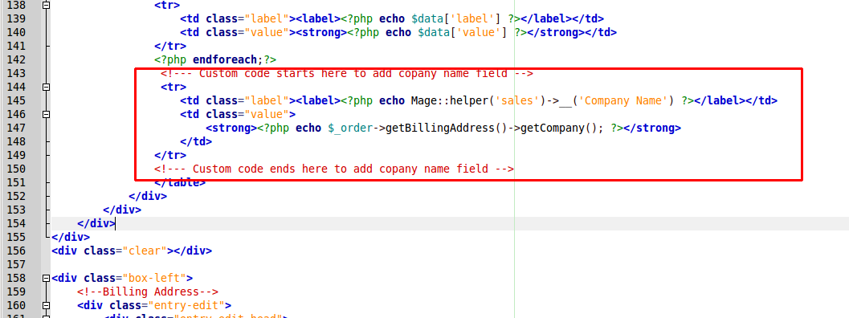

screen shot URL:- http://i.prntscr.com/4475e80a05df40c59fb3d7bb82c81e26.png

