Installation Steps:-

Step1:- Install the extension.
Step2:- after installation place the below code

<!---- Code to get Customer custom tab starts ---->
<?php
$tabId = "";
if (isset($tabId)) {
$tabId = $this->getRequest()->getParam('tabId');
}
$customerData = Mage::getSingleton('customer/session')->getCustomer();
$customerId = $customerData->getId();
$resource = Mage::getSingleton('core/resource');
$readConnection = $resource->getConnection('core_read');
$query = "SELECT * FROM customer_custom_tab where customer_id = $customerId;";
$tabData = $readConnection->fetchAll($query);
$baseurl = Mage::getBaseUrl();
if (!empty($tabData)) {
foreach ($tabData as $tabKey => $tabVal) {
?>
<li>
<a href="<?= $baseurl."mymodule_customerpage/index/index?tabId=".$tabVal['tab_id'] ?>">
<?php if ($tabId == $tabVal['tab_id']) { ?>
<strong><?php echo strtoupper($tabVal['tab_name']); ?></strong>
<?php } else {
echo strtoupper($tabVal['tab_name']);
}
?>
</a>
</li>
<?php
}
}
?>
<!---- Code to get Customer custom tab end ---->

under “yourprojectdir/app/design/frontend/rwd/default/template/customer/account/navigation.phtml” file.
Note:- Paste this code just before the closing of “ul” tag.

For detail see the scren shot given flow:-

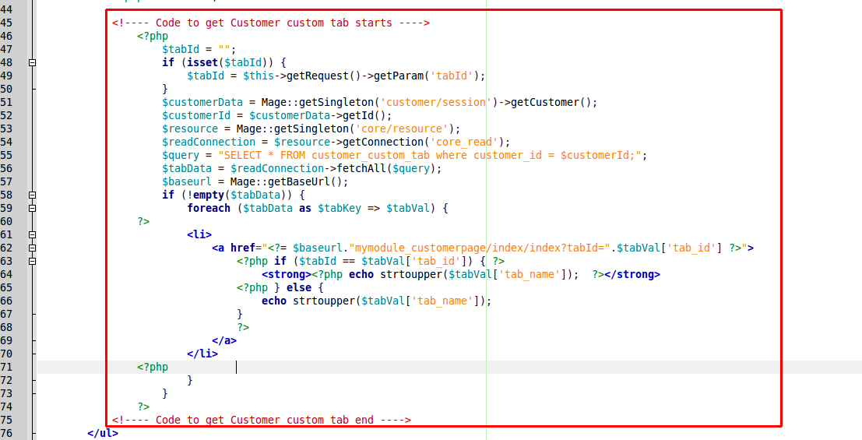

screen shot URL:- http://i.prntscr.com/9765844e01e1499ca1fe16dc3c86347d.png

