week9_pdf

Mathi Manavalan

3/21/2020

## R Studio API

## Libraries

library(tidyverse)  
library(lubridate)  
library(ggplot2)

## Data Import

week9_tbl <- as.tibble(read_csv(file = "../data/week3.csv")) %>%   
 mutate(timeStart = ymd_hms(timeStart), timeEnd = ymd_hms(timeEnd)) %>%   
 mutate(condition = factor(condition, levels = c("A", "B", "C"), labels = c("Block A", "Block B", "Control")), gender = factor(gender, levels = c("M", "F"), labels = c("Male", "Female"))) %>%   
 mutate(avg15 = (q1 + q2 + q3 + q4 + q5)/5, avg610 = (q6 + q7 + q8 + q9 + q10)/5)

Cleaning steps done

* formatted date and time into appropriate variable types
* formatted condition and gender into appropriately labeled factors
* created two new columns of data
  + column of average of scores on questions Q1-Q5
  + column of average of score on questions Q6-Q10

## Visualization

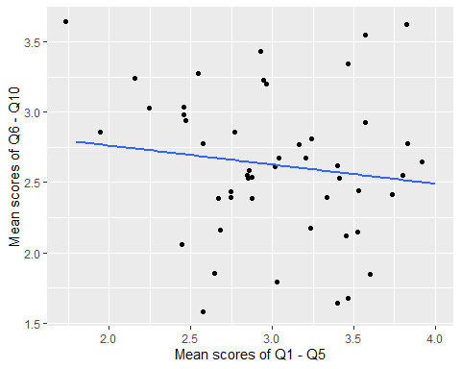

The above plot displays a scatterplot of the average scores of participants in questions Q1 through Q5 and the average scores of same participants in questions Q6 through Q10.

## Analysis

analysis <- summary(lm(week9_tbl$avg610 ~ week9_tbl$avg15))  
analysis

##   
## Call:  
## lm(formula = week9_tbl$avg610 ~ week9_tbl$avg15)  
##   
## Residuals:  
## Min 1Q Median 3Q Max   
## -1.0804 -0.2533 0.0010 0.2924 1.0824   
##   
## Coefficients:  
## Estimate Std. Error t value Pr(>|t|)   
## (Intercept) 3.0334 0.4392 6.906 1.13e-08 ***  
## week9_tbl$avg15 -0.1358 0.1437 -0.945 0.35   
## ---  
## Signif. codes: 0 '***' 0.001 '**' 0.01 '*' 0.05 '.' 0.1 ' ' 1  
##   
## Residual standard error: 0.5196 on 47 degrees of freedom  
## Multiple R-squared: 0.01863, Adjusted R-squared: -0.002248   
## F-statistic: 0.8923 on 1 and 47 DF, p-value: 0.3497

The correlation was 0.3496752 (p<.05), which is not statistically significant.