**MealShare**

**An initiative to help:**

1. **People who are looking for homecooked authentic meals**
2. **Homemakers and chefs who want to sell their meals and generate some income**
3. **People to donate meals to help reduce wasteage**

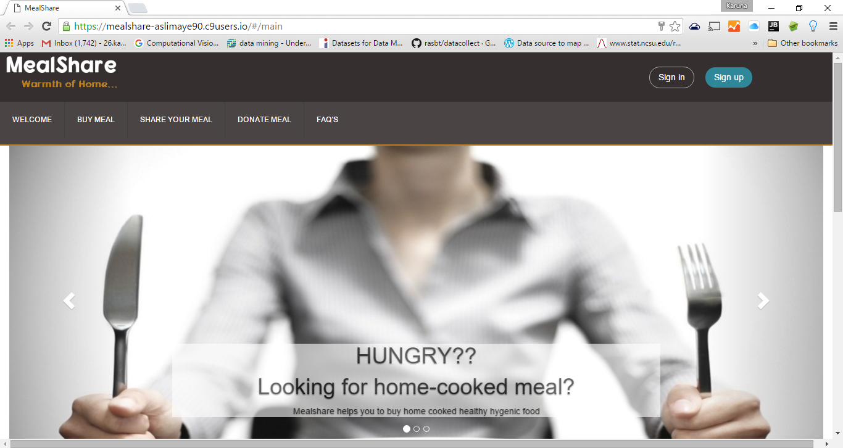

**Home Page**

1. **Buy Meal**

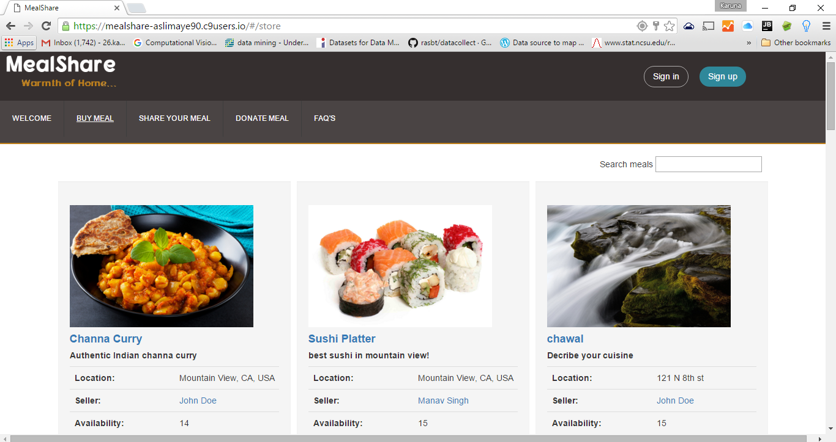

**Meals displayed closest to the user by geolocation**

**2. Choose a meal**

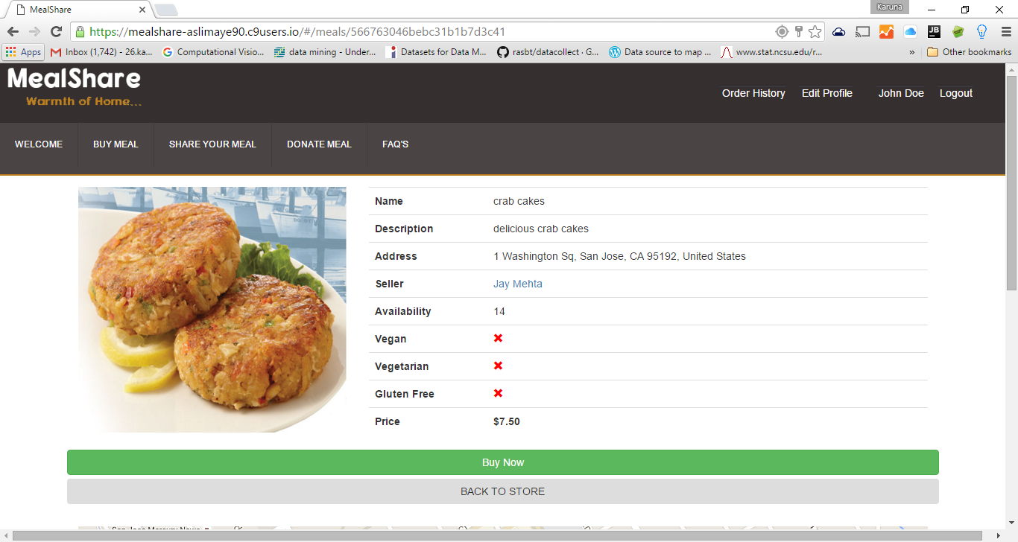

**Choosing a meal and buy it**

1. **Make Payment**

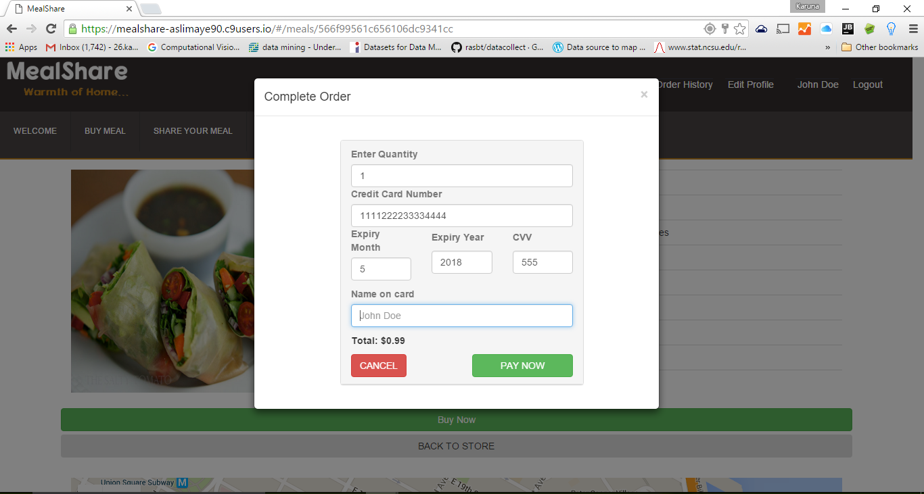

1. **Payment accepted and order placed**

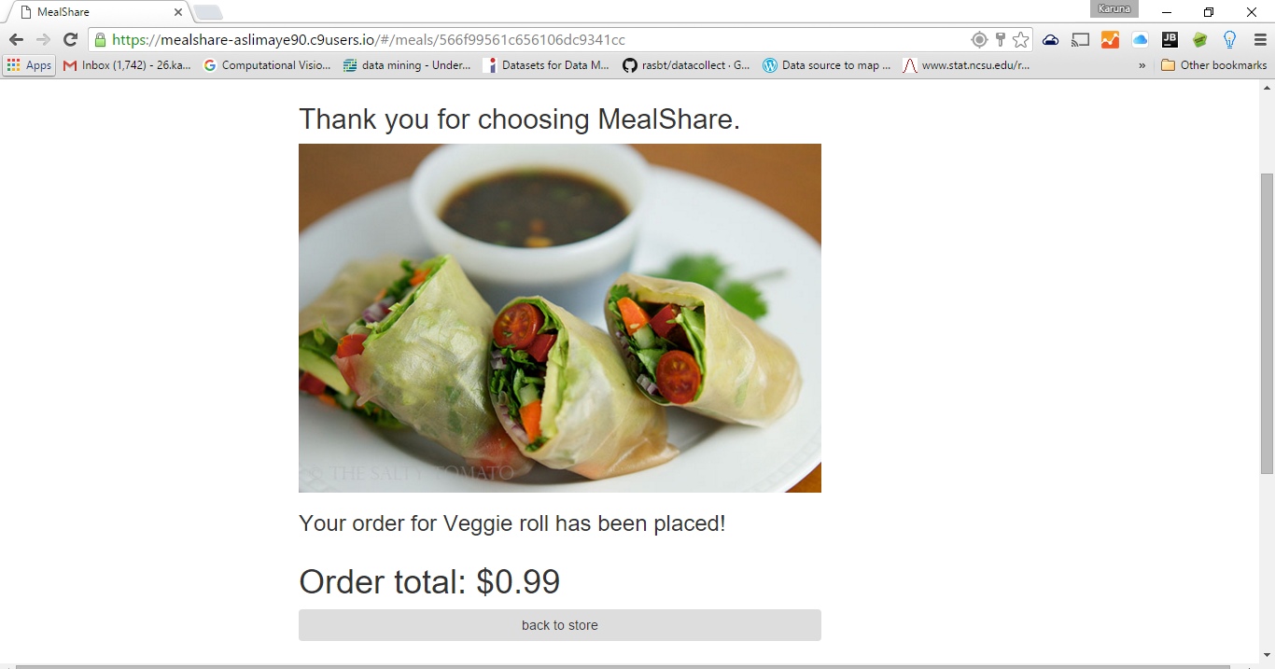

1. **Sell Meal**

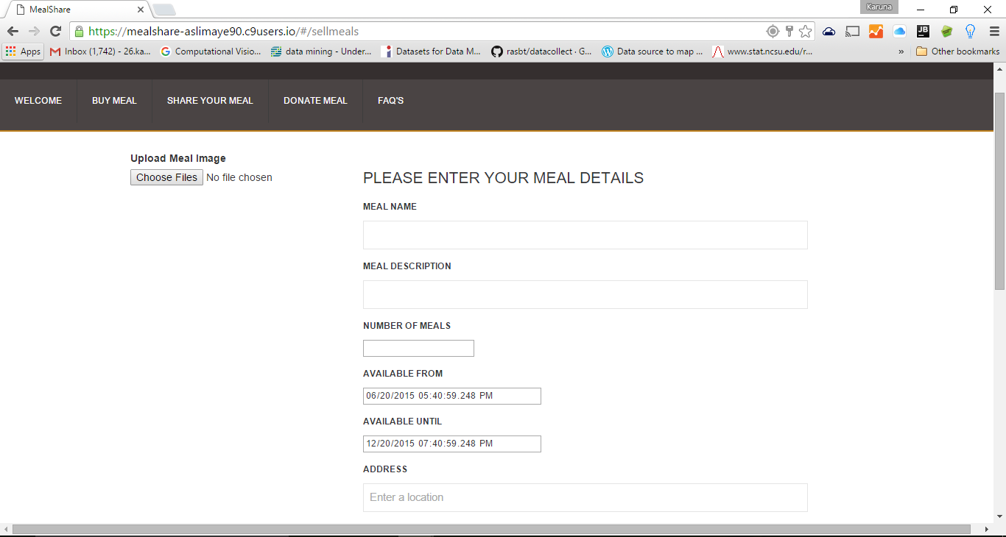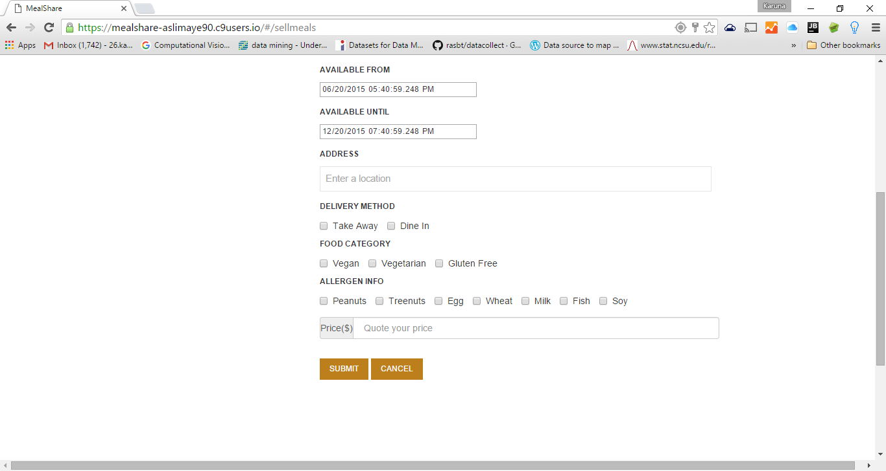

1. **Donate Meal**

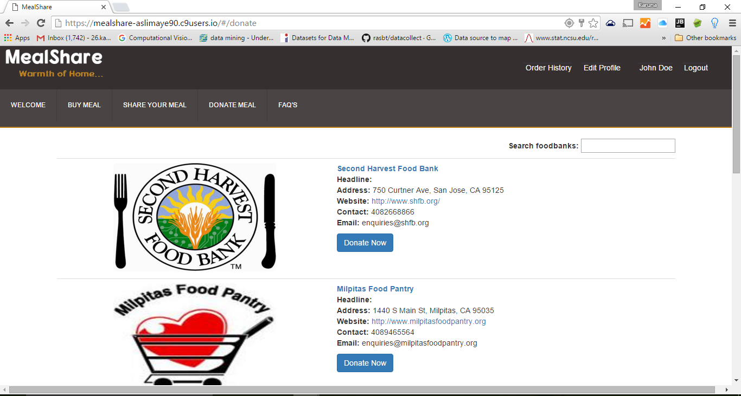

1. **Donate meal**

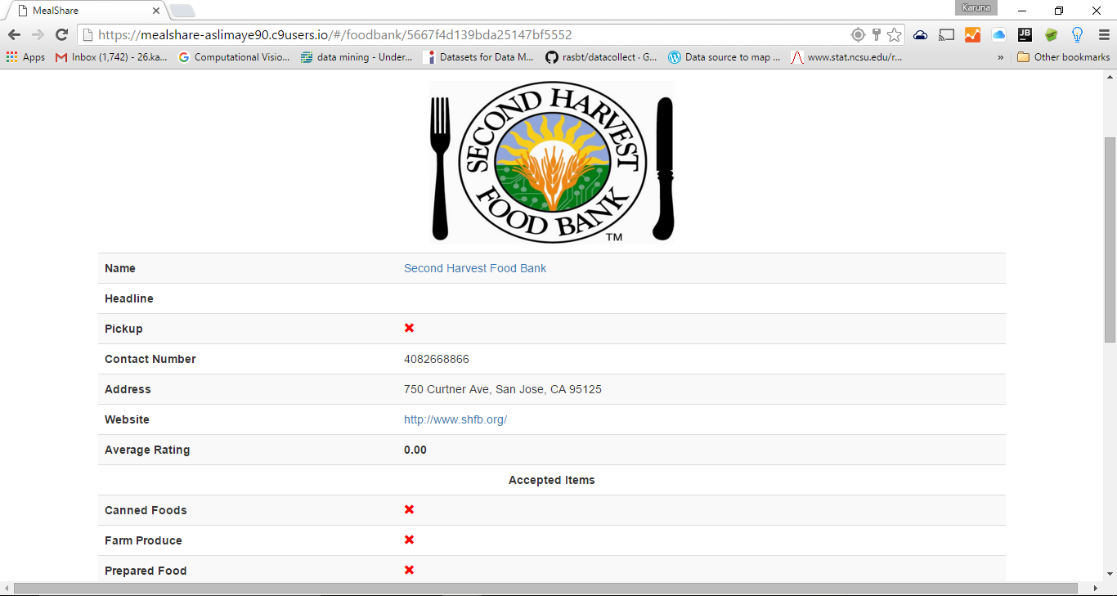

1. **Donate meal**

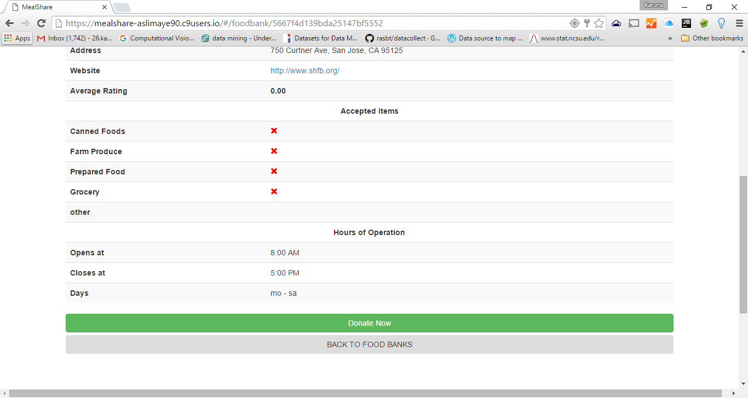

1. **A message goes to the bank selected**

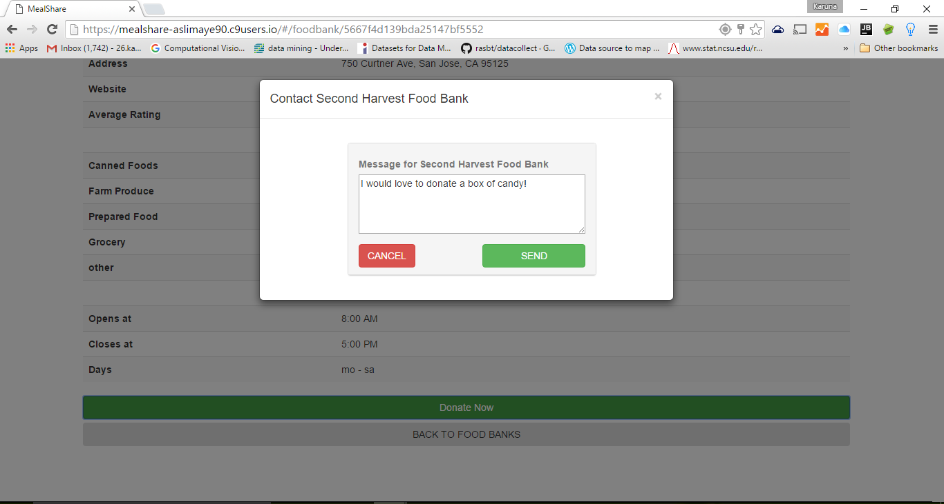

1. **User Profile**

