Many viewed Vice President Humphrey’s move to leak the Nixon-Chennault affair was a very gutsy, and controversial move. It exposed Johnson’s wiretapping of the South Vietnamese government, a key diplomatic ally, and his own political opponents. Nixon cried foul, denying any involvement and pointing to Johnson’s surveillance and his own flip-flopping on the Vietnam issue. Humphrey fired back, accusing Nixon of sabotaging the Vietnamese peace deal and threatening thousands of American lives. Humphrey also acknowledged that the accusations were extreme, but justified in that a key Republican agent, Anna Chennault, had told President Thieu to not send a peace delegation. “It is a moral outrage and a flagrant violation of the Logan Act. And based on Anna Chennault’s words, it is quite clear that her boss is probably Nixon himself, commanding her to do his dirty work.”

President Johnson was terrified at the bombshell of the reveal and the fact that Humphrey would do such an unexpected thing. Humphrey had lacked Johnson’s ruthlessness and disregard for decency, but something was different this time. His main worry was the lack of a smoking gun connecting Nixon to Chennault’s actions; this changed on November 4th when Haldeman’s notes were leaked by a young strategist, Kevin Phillips, who found them and was disgusted by the contents of the note. While he was a staunch and committed Republican, he had hoped as many Americans had that Johnson could have negotiated a peace and brought an end to the costly, divisive Vietnam War. When he learned that Nixon had thrown a “monkey wrench in” for his own selfish gain, he couldn’t take it. He leaked the news to every major studio with a photocopy of Haldeman’s note and promptly resigned his position in the campaign.

While the revelation came only a day before the election and its authenticity was doubted by many, it convinced enough Americans to change their minds at the last minute and vote in Humphrey……….

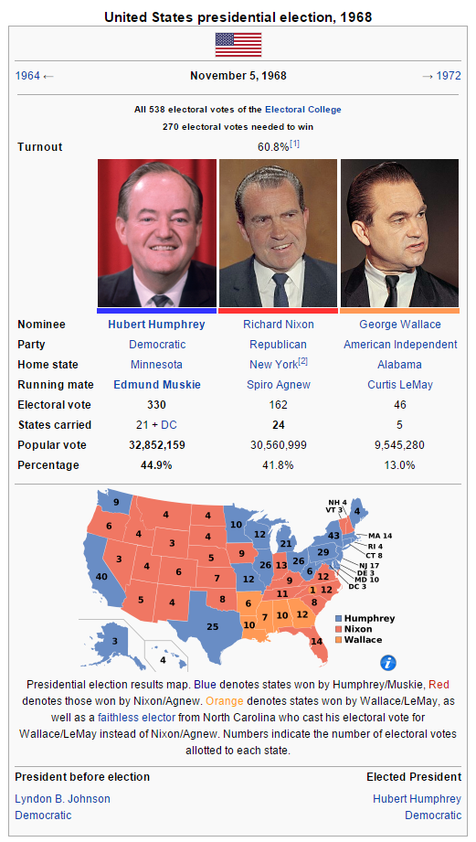

Upon his victory, Humphrey promised two things. First, to prosecute Nixon, Haldeman, Chennault, and other Republican advisors for violating the Logan Act. Second, to pull the troops out of Vietnam and negotiate a solid peace between both North and South Vietnam. All these tasks were easier said than done.

-American History Coming Alive, Michael Moore, 2020