Declaration

I hereby declare that the project work entitled
“Food delivery by drones”,
Submitted to department of computer science
Siddhartha Public School,delhi is prepared by me. All the coding are result of my personal efforts.

Manav Babber
XII
Siddhartha Public School
Kanjhawala Rd, Tatesar Extn
Jaunti, Delhi, 110081

CERTIFICATE

The project report entitled
“Food Delivery By Drones” is prepared and submitted by Manav Babber , has been found satisfactory in terms of scope,quality and presentation.

Signature...._________

CONTENTS

1.HEADER FILES USED........................

2.CODING................................................

3.OUTPUT SCREENS.............................

4.CONCLUSION......................................

5.BIBLIOGRAPHY...................................

HEADER FILES USED

1.FSTREAM – for file handling ,cin and cout

2.IOSTREAM – for handling input and output streams

3.STDIO.H – for standard I/O operations

4.STRING.H– for string handling

5.CMATH– for mathematical operations

6.PROCESS.H– For exit() functions

7.IOMANIP– to affect the state of iostream functions

PROCEDURE

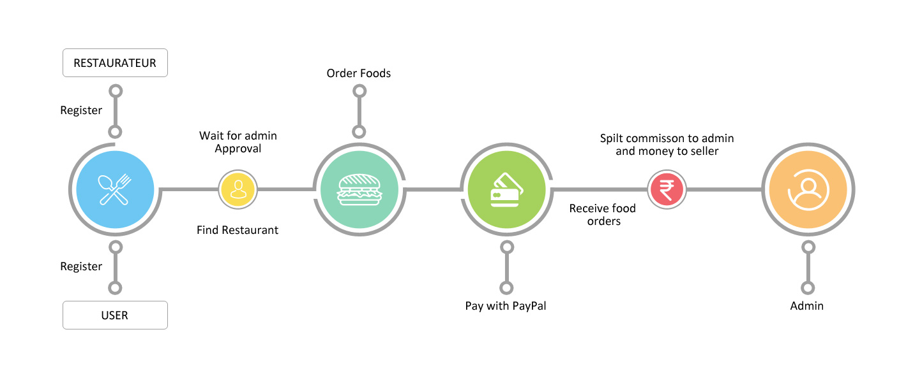

CODING

LOGIN.H FILE

// For Login and Signup

#include <iostream> // }
#include <fstream> // } Libraries
#include <string> // } Used
#include <stdio.h> // }

using namespace std;

bool blust = true;

//********************
// Signup Function *
//********************

void
registerme()
{
string name;
string pwd;
ofstream myfile("User.txt", ios::out | ios::app);
cout << " Enter Username: ";
cin >> name;
cout << " Enter User Password: ";
cin >> pwd;
myfile << endl << name << endl << pwd;
myfile.close();
cout << " :) Successfully Registered :) " << endl;
}

//********************
// Login Function *
//********************

void
login()
{
string name, pwd;
int pass = 0, pass1 = 0;
cout << " Enter Username: ";
cin >> name;
cout << " Enter User Password: ";
cin >> pwd;
ifstream myfile("User.txt");
if (myfile.is_open()) {
while (!myfile.eof()) {
signed int pos;
string line;
getline(myfile, line);
pos = line.find(name);
if (pos != string::npos) {
pass = 1;
break;
}
}
}
if (myfile.is_open()) {
while (!myfile.eof()) {
signed int pos;
string line;
getline(myfile, line);
pos = line.find(pwd);
if (pos != string::npos) {
pass1 = 1;
break;
}
}
myfile.close();
}

if (pass == 1 && pass1 == 1) {
cout << endl;
cout << " :) login successful :) " << endl;
cout << endl;
blust = false;
} else
cout << "Login Unsuccessful" << endl;
}

//********************
// Mainmenu *
//********************

void
mainmenu()
{
int choice;
bool counter = true;
while (counter == true) {
for (int i = 0; i <= 301; i++) {
cout << "-";
}
cout << " Main Menu:" << endl;
cout << " 01 - Login" << endl;
cout << " 02 - Register" << endl;
cout << " 03 - Exit" << endl;
for (int i = 0; i <= 301; i++) {
cout << "-";
}
cout << " Enter your choice from 1 to 3: ";
cin >> choice;
switch (choice) {
case 1:
login();
if (blust == false) {
counter = false;
} // Switch Statement
break;
case 2:
registerme();
break;
case 3:
counter = false;
exit(1);
default:
cout << "Enter a valid choice" << endl;
break;
}
}
}

HOTEL.H FILE

#include "mysql_connection.h"
#include <cppconn/driver.h>
#include <cppconn/exception.h>
#include <cppconn/resultset.h>
#include <cppconn/statement.h>
using namespace std;
using namespace sql;
void back();
void Show();
int size;
string fi[1000];

int connector(string str2)
{
cout << endl;
try {
sql::Driver* driver;
sql::Connection* con;
sql::Statement* stmt;
sql::ResultSet* res;
driver = get_driver_instance();
con = driver->connect("tcp://127.0.0.1:3306", "root", "snappy");
con->setSchema("mainmenu");
stmt = con->createStatement();
res = stmt->executeQuery(str2);
cout << endl;
for (int i = 0; i <= 301; i++) {
cout << "*";
}
while (res->next()) {
for (int i = 1; i < 6; ++i) {
cout << setw(18) << left << res->getString(i) << "\t";
}
cout << endl;
}
for (int i = 0; i <= 301; i++) {
cout << "*";
}
cout << endl;
delete res;
delete stmt;
delete con;
} catch (sql::SQLException& e) {
cout << "# ERR: SQLException in " << __FILE__;
cout << "(" << __FUNCTION__ << ") on line " << __LINE__ << endl;
cout << "# ERR: " << e.what();
cout << " (MySQL error code: " << e.getErrorCode();
cout << ", SQLState: " << e.getSQLState() << " )" << endl;
}
cout << endl;
return EXIT_SUCCESS;
}

int connector2(string str2)
{
cout << endl;
try {
sql::Driver* driver;
sql::Connection* con;
sql::Statement* stmt;
sql::ResultSet* res;
driver = get_driver_instance();
con = driver->connect("tcp://127.0.0.1:3306", "root", "snappy");
con->setSchema("mainmenu");
stmt = con->createStatement();
res = stmt->executeQuery(str2);
cout << endl;
while (res->next()) {
ofstream mefile("cart.txt", ios::out | ios::app);
for (int i = 1; i < 6; ++i) {
cout << setw(18) << left << res->getString(i) << "\t";
mefile << res->getString(i) << "\t";
// cout<<endl;
}
cout << endl;
mefile << endl;
mefile.close();
}
cout << endl;
delete res;
delete stmt;
delete con;
} catch (sql::SQLException& e) {
cout << "# ERR: SQLException in " << __FILE__;
cout << "(" << __FUNCTION__ << ") on line " << __LINE__ << endl;
cout << "# ERR: " << e.what();
cout << " (MySQL error code: " << e.getErrorCode();
cout << ", SQLState: " << e.getSQLState() << " )" << endl;
}
cout << endl;
return EXIT_SUCCESS;
}

void reading()
{
cout << " Enter the total number of items you want to order: ";
cin >> size;
for (int i = 0; i < size; i++) {
cout << " Enter the item id you want to order: ";
cin >> fi[i];
}}

void display()
{for (int i = 0; i < size; i++) {
cout << fi[i];}}
//********************
// Function of cart *
//********************
void cart()
{
int ch;
cout << endl;
cout << " You are in your cart" << endl
<< " The Items in your cart are:" << endl;
cout << "\t\t\t\t\t\t\t\t\t"
"CART"
<< endl;
for (int i = 0; i <= 301; i++) {
cout << "*";
}
char get;
ifstream mefile;
mefile.open("cart.txt", ios::out | ios::app);
if (!mefile) {
cout << "Cannot open file" << endl;
}
while (mefile) {
mefile.get(get);
cout << get;
}
for (int i = 0; i <= 301; i++) {
cout << "*";
}
mefile.close();
cout << endl;
cout << " To confirm the order press 1 otherwise press anykey for "
"cancellation: ";
cin >> ch;
cout << endl;
if (ch == 1)
cout << "\t\t\t\t\t\t"
":) Your ordered is successfully placed :)"
<< endl;
else
exit(1);
}

//*******************************
// Function to go to your cart *
//*******************************
void back()
{
int choice5;
cout << " Press 0 for cart or press anykey to return to the main menu: ";
cin >> choice5;
if (choice5 == 0)
cart();
else
Show();
}

//***************************************
// Function to select the type of Drone *
//***************************************

void drone()
{
int choice4;
cout << endl;
for (int i = 0; i <= 301; i++) {
cout << "=";
}
cout << " Drones Available:" << endl;
cout << " 01 - Single-Rotor HelicopterX"
<< " "
<< "(Speed 20km/hr)" << endl;
cout << " 02 - Multi-Rotor Helicopter"
<< "(Speed 25km/hr)" << endl;
cout << " 03 - Fixed-Wing Hybrid VTOL"
<< " "
<< "(Speed 10km/hr)" << endl;
cout << " 04 - Fixed-Wing"
<< " "
<< "(Speed 15km/hr)" << endl;
for (int i = 0; i <= 301; i++) {
cout << "="; }
cout << " Enter your choice like(1,2,3,4) to select the restaurant: ";
cin >> choice4;
switch (choice4) {
case 1:
cout << endl;
cout << "\t\t\t\t\t"
"Great!!! You Will received it in about 1 an hour"
<< endl;
cout << endl;
break;
case 2:
cout << endl;
cout << "\t\t\t\t\t"
"Great!!! You Will received it in about 45 minutes"
<< endl;
cout << endl;
break;
case 3:
cout << endl;
cout << "\t\t\t\t\t"
"Great!!! You Will received it in about 1 hour and 45 minutes"
<< endl;
cout << endl;
break;
case 4:
cout << endl;
cout << "\t\t\t\t\t"
"Great!!! You Will received it in about 1 hour and 25 minutes"
<< endl;
cout << endl;
break;}}
//*******************************************
//Function to show the mainmenu of hotels *
//*******************************************

void Show(){
int choice2;
cout << endl;
for (int i = 0; i <= 301; i++) {
cout << "*"; }
cout << endl;
cout << " Restaurants Available:" << endl;
cout << " 01 - The Avenue" << endl;
cout << " 02 - Konjiki Ramen" << endl;
cout << " 03 - Tocador Cappilary" << endl;
for (int i = 0; i <= 301; i++) {
cout << "*"; }
cout << " Enter your choice like(1,2,3) to select the restaurant: ";
cin >> choice2;
string str;
switch (choice2) {
case 1:
str = "select * from avenue";
connector(str);
reading();
for (int i = 0; i < size; ++i) {
str = "SELECT * FROM avenue WHERE itemid=\'" + fi[i] + "\'";
connector2(str);}
cout << "\t\t\t\t\t\t" " :) Your Items are In Your Cart!! :) "<< endl;
cout << endl;
back();
break;
case 2:
str = "select * from konjikiramen";
connector(str);
reading();
for (int i = 0; i < size; ++i) {
str = "SELECT * FROM konjikiramen WHERE itemid=\'" + fi[i] + "\'";
connector2(str);
}
cout << "\t\t\t\t\t\t" " :) Your Items are In Your Cart!! :) "<< endl;
cout << endl;
back();
break;
case 3:
str = "select * from tocadorcapillary";
connector(str);
reading();
for (int i = 0; i < size; ++i) {
str = "SELECT * FROM tocadorcapillary WHERE itemid=\'" + fi[i] + "\'";
connector2(str);}
cout << "\t\t\t\t\t\t" " :) Your Items are In Your Cart!! :) " << endl;
cout << endl;
back();
break;}}

int main(){
mainmenu();
Show();
drone(); }
OUTPUT

REGISTER AND LOGIN :

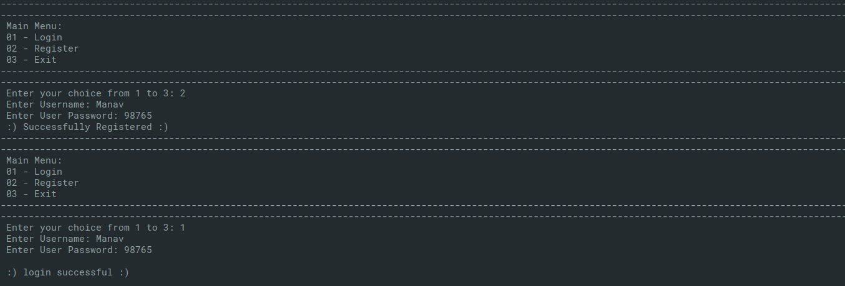

HOTEL AND ITS MAIN MENU :

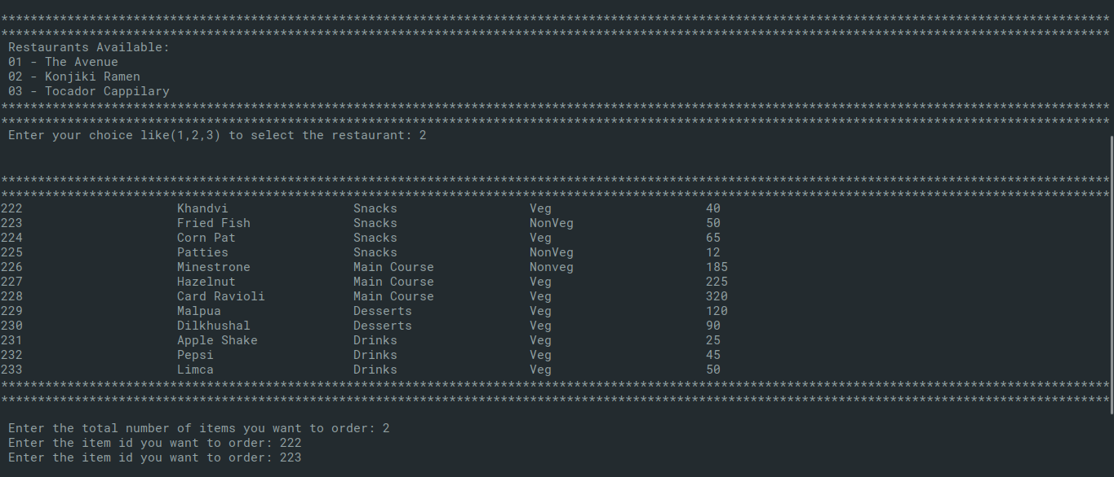

CART :

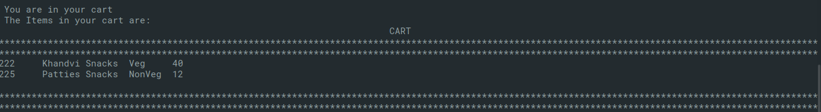

DRONE SELECTION :
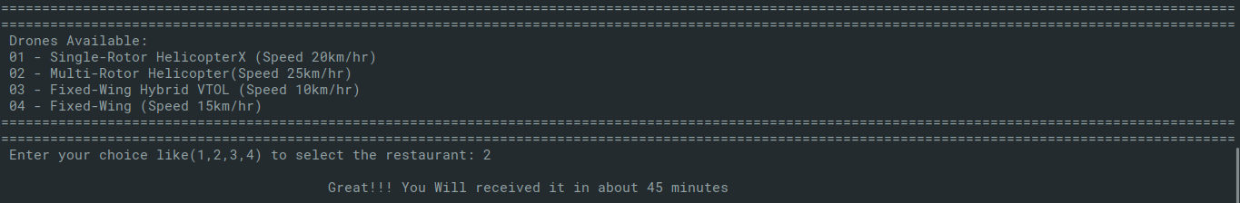
TO EXIT :

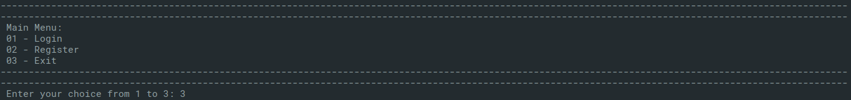

BIBLIOLOGY

- https://www.google.com

- https://www.stackoverflow.com

- Computer Science with C++ By Sumita Arora

- https://stackoverflow.com/questions
16424828/how-to-connect-mysql-database-
using-c/16424893

