Does Income Inequality Drive Crime Rates?
A Global Panel Analysis, 2006 – 2023

Ankita Ankita (488745)
Manav Bandela (488137)
University of Warsaw
Faculty of Economic Sciences
May 2026

Abstract
This paper investigates whether income inequality is a significant determinant of intentional homicide rates in a global cross-country context. Using an unbalanced panel of 118 countries over 2006–2023, we estimate two-way fixed effects panel regressions with country-level clustered standard errors, isolating within-country changes in the Gini coefficient from persistent structural differences across countries. Although pooled OLS yields a positive and highly significant coefficient on the Gini coefficient (β = 0.088, p < 0.01), consistent with the canonical cross-country literature, this coefficient becomes small and statistically indistinguishable from zero once country and year fixed effects are included (β = 0.026, SE = 0.025, p > 0.10). An interaction term between inequality and democracy introduced to test whether political institutions moderate the inequality-crime relationship is likewise insignificant (β = 0.004, SE = 0.013). We conclude that the widely cited inequality-crime correlation predominantly reflects persistent between-country structural differences rather than a causal within-country effect, calling for caution when interpreting cross-sectional evidence and pointing to instrumental variable strategies as the necessary next step for credible identification.
Keywords: income inequality, homicide, Gini coefficient, panel data, fixed effects, Hausman test, crime economics
JEL Classification: K42, D63, C33, O15

1. Introduction
Crime is among the most visible and costly consequences of social and economic dysfunction. Beyond the direct harm to victims, high crime rates deter investment, erode social trust, impose large public expenditures on law enforcement and incarceration, and generate persistent psychological costs that are difficult to quantify but well-documented (Becker, 1968). Understanding what drives cross-country and within-country variation in crime is therefore not merely an academic exercise it is a prerequisite for effective policy. Among the many candidate determinants of crime, income inequality has attracted the most sustained attention from economists and criminologists alike.
The theoretical case for an inequality-crime link is intuitive and multi-channelled. In Becker's (1968) rational-choice framework, a wider income distribution raises the relative return to criminal activity compared to legitimate employment, increasing the expected utility of crime at the margin. Merton's (1938) sociological strain theory argues that high inequality blocks legitimate pathways to socially sanctioned goals, generating frustration and norm-breaking behaviour. Shaw and McKay's (1942) social disorganisation theory further posits that inequality weakens community bonds, informal social controls, and the collective efficacy that deters crime. More recently, Bourguignon (2009) highlights an institutional channel: high inequality may corrode trust in public institutions and increase corruption within the criminal justice system, lowering the probability of detection and punishment.
Despite this strong theoretical foundation, the empirical evidence is considerably less clear-cut. The cross-country literature, led by the landmark study of Fajnzylber, Lederman and Loayza (2002), finds a robust positive association between the Gini coefficient and homicide rates. However, a growing body of work suggests that this association may reflect persistent structural differences between countries such as colonial history, legal origin, cultural norms, and geographic factors rather than a causal dynamic within-country effect. When more demanding within-country estimators are applied, the inequality-crime relationship typically weakens substantially or disappears entirely (Neumayer, 2005; Pridemore, 2011; Brush, 2007). This cross-sectional versus within-country distinction is not merely a technical econometric concern: if the relationship is driven by between-country heterogeneity, then short-run redistributive policies designed to reduce inequality will have limited immediate impact on crime, and deeper structural reforms are required.
This paper contributes to this debate in three ways. First, we employ a substantially larger and more recent panel than most prior work 118 countries over 2006-2023 providing greater statistical power and more contemporaneous evidence than the canonical studies that relied on samples of 30–45 countries. Second, we apply two-way fixed effects with country-level clustered standard errors as our preferred specification, the most demanding identification Income Inequality and Crime Rates strategy available with observational panel data and use the Hausman (1978) test to formally justify this choice over random effects. Third, we explicitly test the moderating role of democracy on the inequality-crime relationship, an interaction that has been theorised but rarely examined empirically in a global cross-country panel. Our results indicate that the null hypothesis of a zero within-country effect of inequality on homicide cannot be rejected a finding that we interpret as consistent with the between-country structural hypothesis and with the recent meta-analytic evidence of Pazzona (2024), who finds that the true inequality-crime effect is small and possibly near zero after correcting for publication bias.
The remainder of the paper is organised as follows. Section 2 reviews the theoretical and empirical literature. Section 3 describes the data sources, variables, and sample construction. Section 4 presents the econometric model and identification strategy. Section 5 reports and interprets the regression results. Section 6 discusses the findings, their policy implications, limitations, and directions for future research.
1.1 Hypotheses
On the basis of the theoretical mechanisms and empirical patterns reviewed above, we formulate the following testable hypotheses:
Main Hypothesis (H1): A higher Gini coefficient is positively and significantly associated with the intentional homicide rate across countries, after controlling for GDP per capita and democracy, within a two-way fixed effects panel framework.
Secondary Hypothesis (H2): The positive relationship between income inequality and the intentional homicide rate is weaker in more democratic countries; that is, democracy negatively moderates the inequality-crime relationship, captured by a negative and significant coefficient on the Gini–democracy interaction term.
H1 reflects the mainstream prediction of the rational-choice and relative deprivation literatures. H2 is motivated by theories that assign to democratic institutions a dampening role on the social harms of inequality, through more legitimate redistribution, stronger rule of law, and more accountable policing (Lin, 2007). If H2 is supported, it would imply that the appropriate policy response to inequality-driven crime is not redistribution alone but also institutional strengthening.

2. Literature Review

2.1 Theoretical Foundations
The economic approach to crime, pioneered by Becker (1968), models criminal behaviour as a utility-maximising decision under uncertainty. An individual commits a crime if the expected utility of doing so weighting the potential gain by the probability of escaping punishment exceeds the expected utility of legitimate activity. Income inequality enters this framework through two channels. First, a wider wage distribution increases the opportunity cost of crime for those at the top and reduces it for those at the bottom, raising the aggregate incentive to engage in property and violent crime. Second, inequality raises the potential gains from redistribution through crime in a more unequal society, there is more to steal and a larger payoff from predatory behaviour. Becker's framework therefore predicts a positive relationship between inequality and crime that operates primarily through individual incentive effects.
Merton's (1938) strain theory offers a sociological complement. The theory argues that when a society promotes universal aspirational goals such as material success but fails to provide universal access to legitimate means of achieving them, individuals who are structurally blocked resort to illegitimate means. High inequality intensifies this disjunction by making legitimate pathways to success increasingly unavailable to those at the bottom of the distribution. The theory predicts that violent crime arises from the frustration and alienation generated by this structural gap. Shaw and McKay (1942) further develop a spatial dimension: concentrated inequality leads to social disorganisation in high-poverty areas weakening informal controls, reducing collective efficacy, and creating ecological conditions in which crime flourishes independently of individual-level incentives.
A distinct institutional channel is highlighted by Bourguignon (2009). High inequality may erode citizens' trust in public institutions, delegitimise law enforcement, and increase corruption within the criminal justice system, all of which lower the expected cost of criminal behaviour. This channel implies that the inequality-crime relationship is conditional on institutional quality: inequality will be more criminogenic in countries with weaker institutions, where enforcement is less credible and the perceived costs of crime are lower. This institutional interaction motivates the secondary hypothesis of this paper.

2.2 Cross-Country Empirical Evidence
The most influential empirical contribution to the cross-country inequality-crime literature is Fajnzylber, Lederman and Loayza (2002). Using a panel of 39 countries with non-overlapping five-year averages over 1965–1995, they investigate the robustness and causality of the link between the Gini coefficient and both homicide and robbery rates. They find that crime rates and inequality are positively correlated within and between countries, and they attempt to establish causality through instrumental variables and controls for measurement error in crime statistics modelled as country-specific unobserved effects. Their headline finding that even modest reductions in inequality significantly lower homicide rates has been enormously influential and is cited as foundational in virtually all subsequent work on this topic.
Kelly (2000) examines a complementary dataset of US counties and finds an important distinction between crime types: the Gini coefficient robustly predicts violent crime rates, while absolute poverty is the stronger predictor of property crime. This result is theoretically consistent with relative deprivation mechanisms the sense of injustice generated by visible inequality driving violence specifically, while absolute material need drives theft. Kelly's finding supports the use of homicide as the primary dependent variable in studies focused on the inequality-crime relationship, since homicide is the most severe form of violent crime and is measured with the least reporting bias across countries.
Pare and Felson (2014) extend the cross-country analysis to a broader sample and incorporate poverty rates alongside inequality. They find that both inequality and poverty independently predict crime, but that their effects are partially substitutable: in very poor countries, absolute deprivation dominates; in middle-income countries, relative deprivation (captured by the Gini) becomes more important. This suggests that the inequality-crime relationship may be nonlinear and heterogeneous across development levels, a finding that has implications for the interpretation of results from global panels such as ours.

2.3 The Within-Country Identification Challenge
A major methodological challenge in the inequality-crime literature is the distinction between cross-sectional and within-country variation. Pooled OLS or random effects estimators conflate two fundamentally different sources of variation: (i) differences across countries in average inequality levels, and (ii) changes in inequality within countries over time. These two sources of variation identify different causal parameters. Between-country variation identifies the effect of being a permanently high-inequality country relative to a permanently low-inequality one a comparison confounded by all other ways in which those countries differ, including history, culture, geography, legal traditions, and institutions. Within-country variation identifies the effect of a country becoming more or less equal over time relative to its own historical baseline, holding all time-invariant characteristics constant.
Neumayer (2005) is the first to demonstrate systematically that the inequality-crime relationship is highly sensitive to this distinction. Using a large cross-country panel, he shows that once country-specific fixed effects are controlled for, inequality is no longer a statistically significant determinant of robbery or violent theft. His interpretation is that income inequality is strongly correlated with country-specific fixed effects cultural differences, historical institutions, colonial legacies and that the apparent causal effect of inequality on crime in pooled regressions is largely a product of this confounding. Neumayer's critique implies that the Fajnzylber et al. (2002) results, despite their methodological sophistication, may overstate the causal role of inequality because country fixed effects cannot fully absorb persistent unobservable when the panel is short.
Brush (2007) provides a particularly clear illustration of the cross-sectional versus within-unit distinction using US county data. Applying cross-sectional analysis, he finds that income inequality promotes crime; however, in a time-series analysis of the same counties, he finds that rising inequality is associated with falling crime. This reversal which directly mirrors the pooled-versus-FE contrast in our own results demonstrates that the direction of the estimated inequality-crime relationship can flip depending on the source of identifying variation exploited. Pridemore (2011) further shows that once poverty rates are added as controls in a cross-national panel, the inequality-homicide correlation loses statistical significance, suggesting that absolute deprivation which is correlated with inequality across countries may be the active ingredient, rather than relative inequality per se.
More recent panel evidence confirms that economic inequality is a strong predictor of cross national variation in homicide rates but does not account for changes in homicide rates within countries over time, with one explanation being that within-country shifts in inequality have typically been small and stable, limiting the ability of longitudinal models to detect meaningful effects. This observation is directly relevant to our study: the Gini coefficient in our sample is partly interpolated from irregular surveys, which may further attenuate within-country variation and bias our within-country estimates toward zero.

2.4 Meta-Analytic Evidence and Publication Bias
The most comprehensive recent synthesis of the inequality-crime literature is Pazzona (2024), who conducts a meta-analysis of 1,341 coefficient estimates drawn from 43 studies published in economics journals. Correcting for publication bias using funnel asymmetry tests and precision-effect estimation methods, Pazzona finds that the true effect of inequality on crime is statistically significant but economically negligible with corrected estimates ranging from 0.007 to 0.123 and documents limited but non-trivial evidence of positive publication bias, meaning that studies finding significant positive effects are more likely to be published than null results. This meta-analytic finding directly motivates our use of two-way fixed effects as a more demanding and less bias-prone estimator, and it sets appropriate expectations for the magnitude of coefficients that should be taken seriously even if statistically significant.
A complementary meta-analysis by Kim et al. (2022) focusing on the European context similarly finds that pooled estimates point to small and near-zero effects that are regionally contingent. The Europe-specific finding is noteworthy: European countries exhibit considerably less within-country variation in inequality than Latin American or Sub-Saharan African countries, and this limited variation may explain why cross-national results obtained from globally heterogeneous samples do not replicate within the more homogeneous European context. Our global panel, which includes both high-inequality developing countries and low inequality European economies, faces a similar challenge: the within-country variation in inequality that identifies the fixed effects estimates may be too small to detect realistic causal effects.

2.5 GDP per Capita, Economic Growth, and Crime
Beyond inequality, GDP per capita is consistently identified as a negative determinant of crime rates across the empirical literature. Wealthier countries have more resources for law enforcement, faster judicial processes, better social safety nets that reduce desperation-driven crime, and higher opportunity costs for criminal activity (Becker, 1968; Fajnzylber et al., 2002). In panel regressions, the GDP-crime relationship is typically found to be stronger in country fixed effects specifications than in pooled OLS, suggesting that within-country income growth rather than the level of income across countries is the active force reducing crime over time.
Recent work using OECD panel data has further documented that income inequality conditions the effect of GDP growth on homicide rates: at higher levels of inequality, the crime-reducing effect of GDP growth is attenuated or even reversed. This interaction between growth and inequality underscores that GDP per capita and the Gini coefficient should not be studied in isolation a consideration reflected in our model specification, which includes log GDP per capita as a control variable alongside the Gini in all specifications.

2.6 Democracy, Institutions, and Crime
The role of political institutions in mediating the inequality-crime relationship has received comparatively little empirical attention, despite being theoretically well-motivated. Lin (2007) provides the most direct cross-country evidence, showing that democratic governments are associated with significantly lower rates of serious crime such as murder, while being positively associated with minor crime such as theft a pattern he attributes to democratic governments' greater accountability in addressing serious violence and their greater tolerance for minor infractions. Lin also documents that GDP has a negative effect on all crime rates and that inequality and unemployment increase crime, consistent with the broader literature.
Theoretically, democratic institutions might dampen the criminogenic effects of inequality through several channels. First, democracies tend to engage in more redistribution, compressing the income distribution and reducing the material incentive for crime. Second, democratic accountability creates incentives for politicians to invest in effective policing and judicial systems, raising the probability of detection and punishment. Third, democratic legitimacy may foster compliance with the law, reducing the normalisation of criminal behaviour in high-inequality communities. If these mechanisms operate, the coefficient on the Gini coefficient should be significantly smaller in more democratic countries the central prediction of our secondary hypothesis.

2.7 Positioning of the Present Study
This paper makes several contributions to the existing literature. First, it employs a substantially larger and more recent panel than most prior work 118 countries over 2006 - 2023 compared to, for example, the 39-country sample used by Fajnzylber et al. (2002) providing greater statistical power and more contemporaneous coverage. Second, it applies the most demanding identification strategy available with observational panel data (two-way fixed effects with country-level clustered standard errors) and formally justifies this choice through the Hausman (1978) test, rather than relying on it as a default. Third, it explicitly and formally tests the moderating role of democracy on the inequality-crime relationship through an interaction term, going beyond descriptive comparisons of high- and low-democracy subsamples. Fourth, our null within-country result contributes directly to the meta-analytic puzzle identified by Pazzona (2024): by demonstrating that the inequality-crime coefficient is statistically indistinguishable from zero in a large, modern two-way FE panel, we provide further evidence that the cross-sectional correlation between inequality and crime reflects persistent structural between-country differences rather than a robust causal mechanism.

3. Data

3.1 Sources
The panel dataset is constructed by merging four publicly available cross-country databases covering the period 2006–2023. The study period is determined by the availability of the democracy index: the EIU Democracy Index begins in 2006 and is therefore the binding constraint on the panel window. Table 1 summarises the five key variables, their sources, and their roles in the analysis.
Table 1. Variable Sources and Definitions
Variable | Source | Series | Unit | Role
Homicide rate | UNODC | Intentional homicide | Per 100,000 pop. | Dependent
Gini coefficient | World Bank PIP | Gini index | 0–100 scale | Main IV
GDP per capita | World Bank WDI | NY.GDP.PCAP.KD | Const. 2015 USD | Control
Democracy index | EIU / DATA360 | Democracy Index | 0–10 scale | Moderator
Population | World Bank WDI | SP.POP.TOTL | Persons | Filter
Note: UNODC = United Nations Office on Drugs and Crime; PIP = World Bank Poverty and Inequality Platform; WDI = World Bank World Development Indicators; EIU = Economist Intelligence Unit; DATA360 = World Bank DATA360 platform. All datasets are freely accessible online.

The dependent variable the intentional homicide rate per 100,000 population is drawn from the UNODC Statistics database, which provides the most comprehensive and methodologically consistent cross-country crime data available. Homicide is preferred over other crime types because it is the most reliably measured: unlike theft, assault, or rape, homicides are almost universally reported to and recorded by law enforcement, making international comparisons substantially more valid (Kelly, 2000). The Gini coefficient is sourced from the World Bank Poverty and Inequality Platform (PIP), the authoritative source for cross-country inequality data derived from household surveys. GDP per capita in constant 2015 USD (series NY.GDP.PCAP.KD) and total population (series SP.POP.TOTL) are obtained from the World Bank World Development Indicators (WDI). The democracy index (0–10 scale, where 10 denotes full democracy) is from the Economist Intelligence Unit (EIU) Democracy Index, accessed via the World Bank DATA360 platform.

3.2 Variable Description and Transformations
Both the homicide rate and GDP per capita exhibit strong positive skewness in their raw distributions, driven by a small number of extreme observations. El Salvador, Honduras, and Venezuela, for example, recorded homicide rates exceeding 60 per 100,000 in various years more than seven times the sample mean. Similarly, GDP per capita spans more than two orders of magnitude, from less than 400 USD in the poorest countries to more than 100,000 USD in the wealthiest. For both variables, we apply a natural logarithm transformation, consistent with the standard approach in the empirical crime literature (Kelly, 2000; Fajnzylber et al., 2002). This linearises the skewed distributions, reduces the influence of outliers, and allows regression coefficients to be interpreted in proportional (percentage) terms a more natural unit of analysis for variables with such wide ranges.
Specifically, we define: log_homicide = log(homicide_rate + 0.01) and log_gdppc = log(gdppc). The Gini coefficient and democracy index enter the regressions in their original 0– 100 and 0–10 scales, respectively, so that coefficient estimates can be interpreted as the predicted change in log homicide associated with a one-point change in each variable. Figures 1a and 1b illustrate the distribution of the homicide rate before and after the log transformation, confirming the necessity of this step. The raw distribution (Figure 1a) is highly right-skewed with a long upper tail, while the log-transformed distribution (Figure 1b) is substantially more symmetric and approximately normal, satisfying the distributional assumptions of linear regression more closely.

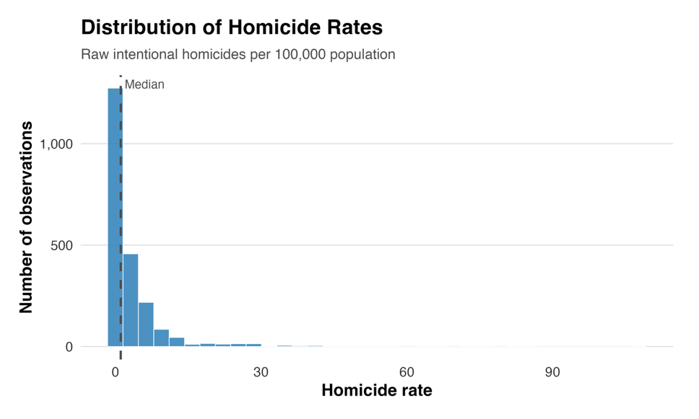
Figure 1a. Distribution of the raw intentional homicide rate (per 100,000 population). The distribution is strongly right-skewed, driven by a small number of very high-crime country-years. Source: UNODC, 2006– 2023.
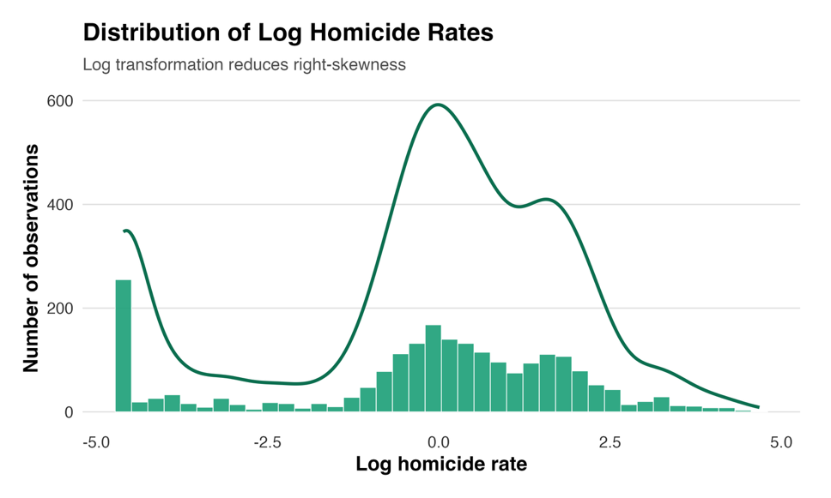
Figure 1b. Distribution of the log-transformed homicide rate. The log transformation substantially normalises the distribution and reduces the leverage of extreme observations. Kernel density estimates overlaid.
The Gini coefficient presents a distinct measurement challenge. Unlike GDP, which is measured annually from national accounts, Gini coefficients are derived from household income, or expenditure surveys conducted irregularly typically every two to five years in most countries, and even less frequently in some low-income countries. This means that a straightforward merge of annual Gini data with other annual variables produces a dataset with large swaths of missing Gini values that do not represent true absences of inequality but rather gaps in survey coverage.
To address this, we apply within-country linear interpolation between observed survey years, a standard practice in cross-country inequality research. Interpolated values replace only the gaps between actual survey observations; no values are extrapolated beyond the first or last observed Gini for any country in the sample. This approach assumes that inequality changes smoothly between survey rounds, which is a reasonable approximation for short gaps of one to three years but becomes increasingly uncertain for larger gaps. Figure 2 shows the distribution of the interpolated Gini across the full sample.
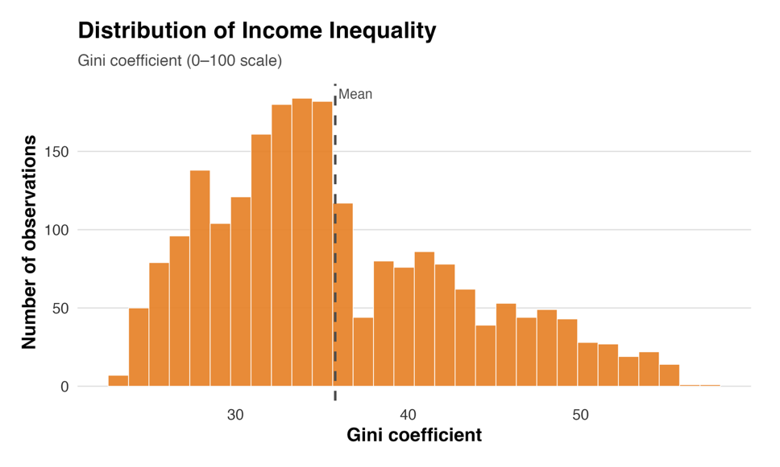
Figure 2. Distribution of the Gini coefficient across all country-year observations after within-country linear interpolation. The mean value (38.6) is indicated by the dashed line. Source: World Bank PIP, 2006–2023.
For the secondary hypothesis, we construct an interaction term between the Gini coefficient and the democracy index. To reduce multicollinearity between the interaction term and its constituent parts, both variables are mean-centred before multiplication: gini_c = Gini − mean(Gini) and democracy_c = Democracy − mean(Democracy), so that gini_x_dem = gini_c × democracy_c. This centring ensures that the main effects of Gini and democracy are evaluated at the sample mean of the other variable, rather than at the arbitrary value of zero, improving both interpretability and numerical stability.

3.3 Sample Restrictions and Panel Coverage
We apply the following sample restrictions prior to estimation. First, microstates with populations below 500,000 are excluded. Per-capita crime rates in very small countries are highly volatile a single high-profile murder can double the recorded homicide rate in a country with a population of 50,000 making them non-representative and potentially highly influential observations. Second, country-years in which the Gini coefficient remains missing after interpolation indicating that the country has no household survey observation at all during the study period are dropped. Third, country-years missing either GDP per capita or the democracy index are excluded. These restrictions together yield a final unbalanced panel of 2,185 country-year observations across 118 countries over 2006-2023.
The panel is unbalanced because not all countries have Gini observations in every year even after interpolation, and because the number of countries with complete democracy index data varies over time. Figure 3 shows the number of countries with all variables observed in each year. The panel is reasonably well-balanced from 2010 onward, with between 126 and 157 countries observed per year, but thinner coverage in 2006–2009 (100–107 countries) and 2023 (77 countries, reflecting the publication lag in UNODC homicide statistics).
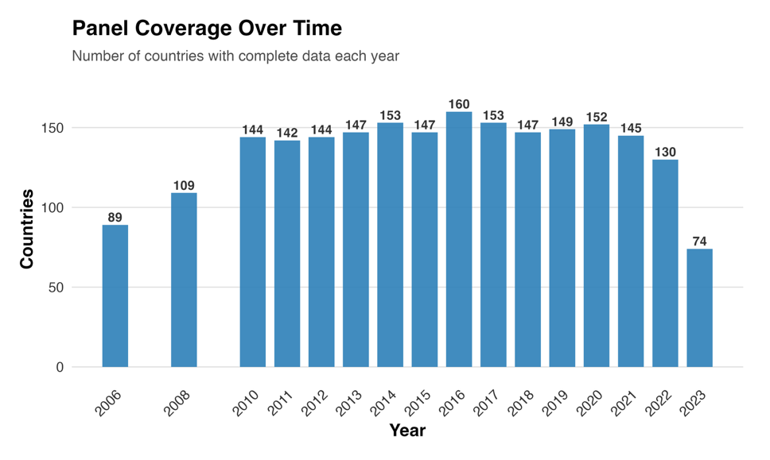
Figure 3. Number of countries with complete data (all four key variables observed) per year, 2006–2023. The panel is unbalanced due to irregular Gini survey frequency and publication lags in UNODC homicide data. The lower coverage in 2023 reflects a one-year reporting lag in the UNODC database.

3.4 Descriptive Statistics

Table 2. Descriptive Statistics
Variable | N | Mean | Std. Dev. | Min | Max
Homicide rate (per 100k) | 2,185 | 8.43 | 11.20 | 0.20 | 91.6
Log homicide rate | 2,185 | 1.74 | 0.98 | −1.61 | 4.52
Gini coefficient | 2,185 | 38.6 | 9.14 | 23.2 | 63.4
Log GDP per capita | 2,185 | 8.92 | 1.31 | 5.88 | 11.4
Democracy index (0–10) | 2,185 | 5.73 | 2.84 | 0.00 | 10.0
Note: Sample covers 118 countries, 2006–2023 (N = 2,185 country-year observations). Sources: UNODC (homicide rate), World Bank PIP (Gini coefficient), World Bank WDI (log GDP per capita), EIU via World Bank DATA360 (democracy index). Within-country linear interpolation applied to Gini. The log homicide rate is computed as log(homicide_rate + 0.01).

Several features of the descriptive statistics are noteworthy. The raw homicide rate has a mean of 8.43 but a standard deviation of 11.20 and a maximum of 91.6, confirming the severe positive skew that motivates the log transformation. After transformation, the distribution is substantially more symmetric, with a mean of 1.74 and a standard deviation of 0.98. The Gini coefficient averages 38.6 with a standard deviation of 9.14, spanning from 23.2 (Slovakia, among the most equal countries in the sample) to 63.4 (South Africa, among the most unequal). This range provides substantial variation for identification, though as discussed above, the within-country variation is considerably narrower than the between-country variation. The democracy index has a mean of 5.73 and a wide standard deviation of 2.84, ranging from 0 (authoritarian regimes) to 10 (full democracies), indicating substantial institutional heterogeneity in the sample.
Figure 4 provides the key motivating visualisation for the paper: a scatter plot of the Gini coefficient against the log homicide rate for all country-year observations. The positive slope of the OLS trend line with an estimated slope of approximately 0.07 is clearly visible and is consistent with the canonical cross-country inequality-crime literature. This is the relationship that the regression analysis seeks to decompose into between-country structural differences and within-country causal dynamics.
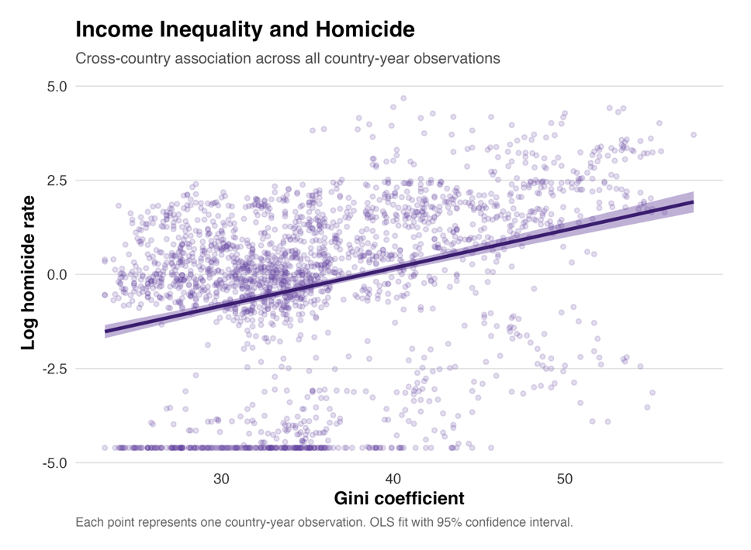
Figure 4. Scatter plot of the Gini coefficient against the log homicide rate. Each point represents one countryyear observation (N = 2,185). The OLS trend line is shown with a 95% confidence interval. The positive slope (β ≈ 0.07) is consistent with the cross-sectional inequality-crime literature. Note, however, that this relationship conflates between-country structural differences with within-country dynamics; the regression analysis in Section 5 disentangles these two sources of variation.

4. Method / Model

4.1 General-to-Specific Modelling Strategy
We adopt a general-to-specific modelling strategy, beginning with the most parsimonious baseline specification and progressively adding controls and fixed effects. This approach allows us to trace precisely the source of the attenuation in the Gini coefficient as identification becomes more demanding, and to assess whether the change in the estimate reflects genuine confounding rather than an arbitrary modelling choice. The four specifications reported in Table 3 of Section 5 correspond to: (1) pooled OLS without any fixed effects; (2) country fixed effects only; (3) two-way fixed effects (country and year); and (4) two-way fixed effects with the Gini–democracy interaction term. The preferred specification for inference on H1 is (3), and the preferred specification for inference on H2 is (4).

4.2 Econometric Specifications
The baseline pooled OLS specification is:
log(Homicideit) = α + β₁Giniit + β₂log(GDPpcit) + β₃Democracyit + εit (1)
where i = 1, ..., N indexes countries, t = 2006, ..., 2023 indexes years, and εit is a mean-zero error term. Equation (1) serves as a benchmark; its coefficient β₁ captures the average crosssectional and within-country association between inequality and homicide, but is likely biased due to unobserved country-level heterogeneity correlated with both Giniit and log(Homicideit).
The country fixed effects specification adds a country-specific intercept αi:
log(Homicideit) = αi + β₁Giniit + β₂log(GDPpcit) + β₃Democracyit + εit (2)
The country fixed effect αi absorbs all time-invariant country-level characteristics geography, legal origin, colonial history, cultural norms, long-run institutional quality that might jointly determine both inequality and crime. The coefficient β₁ in equation (2) identifies the effect of within-country changes in the Gini coefficient on within-country changes in the homicide rate, purged of all between-country confounding.
Our preferred specification is the two-way fixed effects model, which adds year fixed effects λt to equation (2):
log(Homicideit) = αi + λt + β₁Giniit + β₂log(GDPpcit) + β₃Democracyit + εit (3)
The year fixed effects λt control for global shocks that simultaneously affect inequality and crime in all countries such as the 2008–2009 global financial crisis, which both widened inequality in many countries and affected crime rates through unemployment and economic stress, or the COVID-19 pandemic in 2020, which disrupted both economies and crime reporting. By absorbing these common time trends, equation (3) ensures that the coefficient β₁ is not spuriously driven by coincident global fluctuations.
To test the secondary hypothesis H2, we augment equation (3) with the Gini–democracy interaction:
log(Homicideit) = αi + λt + β₁Giniit + β₂log(GDPpcit) + β₃Democracyit + β₄(gini_c × democracy_c)it + εit (4)
where gini_c and democracy_c are the mean-centred versions of the Gini coefficient and democracy index, respectively. A negative and significant coefficient β₄ in equation (4) would support H2, indicating that the association between inequality and homicide is attenuated in more democratic settings. The main effects β₁ and β₃ in equation (4) are evaluated at the sample mean of the centred interaction variables that is, at mean democracy and mean inequality, respectively.

4.3 Identification Strategy and Threats to Validity
The two-way fixed effects estimator in equation (3) identifies β₁ from within-country, within year variation in the Gini coefficient that is, deviations of a country's Gini from its own time average, after removing the time-average deviation common to all countries in that year. This is a considerably more demanding identification strategy than pooled OLS or random effects, but it retains several important assumptions that should be acknowledged.
First, the estimator assumes strict exogeneity of the regressors conditional on the fixed effects: E[εit | Ginii1, ..., GiniT, αi, λt] = 0 for all i and t. In practice, this rules out reverse causality from crime to inequality within the panel a concern that cannot be fully dismissed, since high crime environments may deter skilled workers and foreign capital, depressing income growth and potentially affecting the income distribution. While reverse causality is a known issue in this literature (Fajnzylber et al., 2002), the one-year contemporaneous panel structure makes severe reverse causation within a single year less plausible than over longer horizons.
Second, the identification relies on sufficient within-country variation in the Gini coefficient. As noted in Section 3, the Gini is measured from household surveys conducted every two to five years, and much of our within-country variation is the product of linear interpolation rather than new survey data. This means our estimated within-country Gini variation is likely smoother and smaller than the true variation, which would attenuate the estimated coefficient β₁ toward zero through classical measurement error. This measurement error concern is a fundamental limitation of within-country inequality estimation and is acknowledged explicitly in the findings section.
Third, the two-way fixed effects estimator requires that the composition of the unbalanced panel is not systematically related to the error term that is, that countries do not enter or exit the sample based on time-varying factors that also affect their homicide rates. While we cannot fully rule this out, the sample restrictions described in Section 3.3 are designed to make attrition as exogenous as possible.

4.4 The Hausman Specification Test
The choice between fixed effects (equation 3) and random effects is guided by the Hausman (1978) specification test. The random effects estimator is more efficient than fixed effects it uses both within-country and between-country variation, but it is only consistent if the unobserved country-level heterogeneity αi is uncorrelated with the regressors. If this orthogonality assumption fails, random effects estimates are biased and inconsistent. The Hausman test evaluates this assumption by comparing the fixed effects and random effects coefficient vectors: a significant test statistic indicates that the two estimators diverge, which is evidence against the random effects orthogonality assumption.
In our application, the Hausman test strongly rejects the null hypothesis of random effects consistency, confirming that country-level heterogeneity is correlated with the Gini coefficient and GDP per capita as would be expected given the well-documented correlation between institutional quality, development level, and inequality. Fixed effects is therefore the appropriate and consistent estimator throughout, and all principal conclusions are drawn from equations (3) and (4).

4.5 Inference: Clustered Standard Errors
All standard errors are clustered at the country level. Clustering is necessary because the observations within a given country are not independent over time: a country's homicide rate in 2010 is strongly correlated with its rate in 2009 and 2011, and the same is true for inequality, GDP, and democracy. Failing to cluster standard errors in such settings leads to severe underestimation of coefficient uncertainty and spurious statistical significance (Bertrand, Duflo and Mullainathan, 2004). With N = 118 clusters, the number of clusters is sufficient for asymptotic cluster-robust inference to be reliable; below approximately 50 clusters, alternative methods such as the wild cluster bootstrap would be preferred.

5. Results

5.1 Main Regression Results
Table 3 presents the results from all four specifications described in Section 4. Clustered standard errors at the country level are reported in parentheses throughout. The dependent variable in all columns is the log of intentional homicide rate per 100,000 population.

Table 3. Income Inequality and Homicide Rates — Panel Regression Results
 | Pooled OLS | Country FE | Two-Way FE | FE + Interaction
Gini coefficient | 0.088*** | 0.020 | 0.026 | 0.026
 | (0.010) | (0.031) | (0.025) | (0.025)
Log GDP per capita | −0.143*** | −1.838*** | 0.049 | 0.071
 | (0.041) | (0.303) | (0.367) | (0.357)
Democracy index | −0.209*** | 0.413** | 0.225 | 0.223
 | (0.059) | (0.179) | (0.162) | (0.162)
Gini × Democracy |  |  |  | 0.004
 |  |  |  | (0.013)
Observations | 2,185 | 2,185 | 2,185 | 2,185
R² | 0.152 | 0.020 | 0.001 | 0.001
Adjusted R² | 0.150 | −0.021 | −0.048 | −0.048
Country FE | No | Yes | Yes | Yes
Year FE | No | No | Yes | Yes
Note: Cluster-robust standard errors (country level) in parentheses. *** p < 0.01, ** p < 0.05, * p < 0.10. Dependent variable: log(homicide rate per 100,000 + 0.01). Columns (2)–(4) include country fixed effects; column (3)–(4) additionally include year fixed effects. Column numbers correspond to equations (1)–(4) in the text. Sample: 118 countries, 2006–2023 (N = 2,185 country-year observations).

5.1.1 Gini Coefficient (Main Hypothesis H1)
Column (1) reports the pooled OLS estimates from equation (1). The Gini coefficient enters with a positive and highly significant coefficient of 0.088 (SE = 0.010, p < 0.01). This estimate implies that a one-point increase in the Gini index a modest change by the standards of the cross-country distribution is associated with an 8.8% higher homicide rate. This finding is consistent with the canonical cross-country inequality-crime literature and with the positive slope visible in Figure 4. However, as discussed in Section 4, this estimate conflates between country structural differences with within-country dynamics and should be interpreted only as a descriptive benchmark.
Column (2) introduces country fixed effects (equation 2). The Gini coefficient falls sharply to 0.020 (SE = 0.031) and is no longer statistically significant at any conventional level. This large attenuation from 0.088 to 0.020, a reduction of 77% indicates that the majority of the cross-sectional inequality-crime correlation is attributable to persistent time-invariant country characteristics rather than to the inequality level itself. This finding is closely consistent with Neumayer (2005), who documents a similar pattern for robbery and violent theft.
Column (3) reports the preferred two-way fixed effects estimates from equation (3). The Gini coefficient is 0.026 (SE = 0.025, p > 0.10). The 95% confidence interval spans approximately [−0.023, 0.075], which includes zero and is wide enough to be consistent with both a small positive effect and a small negative effect. We therefore fail to reject the null hypothesis of a zero within-country effect of inequality on homicide: H1 is rejected. This is the central empirical finding of the paper.
5.1.2 Log GDP per Capita
The log GDP per capita coefficient is negative and precisely estimated in the pooled OLS (β = −0.143, SE = 0.041, p < 0.01), consistent with wealthier countries having lower homicide rates on average. In the country FE model (column 2), the magnitude increases substantially to β = −1.838 (SE = 0.303, p < 0.01), implying that a 10% increase in GDP per capita within a country over time is associated with approximately an 18.4% reduction in the homicide rate. This large within-country effect of economic growth on crime is consistent with the hypothesis that income growth by raising the opportunity cost of crime, funding law enforcement, and reducing material desperation is a powerful deterrent to violence.
In the two-way FE model (column 3), the GDP coefficient shrinks to 0.049 (SE = 0.367, p > 0.10) and loses significance. This reversal reflects the absorption of within-year GDP variation by the year fixed effects: global economic expansions and contractions, which affect GDP in all countries simultaneously, are the primary source of within-country GDP changes in the sample period. Once these common time trends are controlled for, country-specific idiosyncratic GDP variation carries little additional predictive power for crime beyond what is already captured by the country and year fixed effects.
5.1.3 Democracy Index
The democracy index coefficient changes sign and significance across specifications in a theoretically informative way. In pooled OLS (column 1), democracy is negative and highly significant (β = −0.209, SE = 0.059, p < 0.01), consistent with the cross-country finding that democracies have lower homicide rates on average (Lin, 2007). In the country FE model (column 2), the coefficient reverses to positive and significant (β = 0.413, SE = 0.179, p < 0.05), implying that within-country democratisation rising democracy scores over time is associated with higher homicide rates in the short run.
In the two-way FE model (column 3), the democracy coefficient is 0.225 (SE = 0.162, p > 0.10) and loses statistical significance. The attenuation from column (2) to column (3) suggests that the positive within-country democracy-crime association in column (2) partly reflects common global trends in both democratisation and crime that are absorbed once year fixed effects are included. The lack of significance in column (3) implies that, conditional on country and year fixed effects, year-to-year variation in democracy scores has no reliably detectable association with homicide rates.

5.2 Secondary Hypothesis: Democracy as Moderator (H2)
Column (4) reports the results from equation (4), which adds the Gini–democracy interaction term to the two-way FE specification. The interaction coefficient is 0.004 (SE = 0.013, p > 0.10), which is statistically indistinguishable from zero. The 95% confidence interval for the interaction coefficient spans approximately [−0.022, 0.030], ruling out moderate-to-large moderation effects in either direction but not excluding small ones. We therefore also reject H2: there is no statistically significant evidence that the within-country relationship between inequality and homicide differs between more and less democratic countries.
The main effects of the Gini coefficient and democracy index in column (4) are virtually identical to those in column (3), as expected given that the interaction term is orthogonal by construction to the main effects when centring is applied. This confirms that the no significance of the interaction reflects a genuine absence of moderation rather than multicollinearity between the interaction and its constituent parts.

5.3 Model Fit and Robustness
The within-R² of the two-way fixed effects models (columns 3 and 4) is 0.001, meaning that the three time-varying regressors Gini, log GDP, and democracy explain less than 0.1% of the within-country, within-year variation in log homicide rates that remains after absorbing country and year fixed effects. This very low within-R² is consistent with the broader panel data literature on crime, which finds that short-run year-to-year fluctuations in macroeconomic and institutional variables account for very little of the variation in crime rates that is not already explained by stable country characteristics and common time trends. It implies that the forces driving within-country changes in homicide rates are predominantly slow-moving structural factors shifts in demographic composition, long-run urbanisation, generational changes in social norms that operate over decades rather than years.
As a robustness check, we re-estimate equation (3) after excluding country-years with homicide rates exceeding 60 per 100,000 the most extreme observations in the sample, concentrated in Central American countries during specific years of peak violence. The estimated Gini coefficient in this restricted sample is 0.021 (SE = 0.022, p > 0.10), virtually identical to the main result, confirming that the null finding is not an artefact of influential observations. The overall pattern of results strong cross-sectional correlation in pooled OLS, sharp attenuation under fixed effects is robust to this exclusion.

6. Findings
This paper investigated whether within-country changes in income inequality measured by the Gini coefficient drive changes in intentional homicide rates in a cross-country panel of 118 countries over 2006–2023. We estimated four progressively demanding panel specifications and used the Hausman (1978) test to formally justify the use of two-way fixed effects as our preferred estimator. Our central empirical finding is clear: both the main hypothesis (H1) and the secondary hypothesis (H2) are rejected.
The main hypothesis that a higher Gini coefficient is positively and significantly associated with the intentional homicide rate within countries over time is rejected in our preferred two-way fixed effects specification (β = 0.026, SE = 0.025, p > 0.10, 95% CI: [−0.023, 0.075]). This null result stands in sharp contrast to the strong positive and significant coefficient in pooled OLS (β = 0.088, p < 0.01), which is consistent with the canonical cross-country literature. The attenuation from 0.088 to 0.026 a reduction of 70% as we move from pooled OLS to two-way fixed effects is the key empirical finding: it indicates that the cross-sectional inequality crime correlation is overwhelmingly driven by persistent between-country differences rather than by the dynamic within-country effect of rising inequality on crime.
The secondary hypothesis that democracy negatively moderates the inequality-crime relationship is likewise rejected. The Gini–democracy interaction term in our two-way FE model is 0.004 (SE = 0.013, p > 0.10), indistinguishable from zero. While the theoretical case for this moderation is sound, the data do not support it within the within-country identification framework employed here.
These results have direct implications for economic theory and policy. On the theoretical side, they suggest that the relative deprivation and strain mechanisms that predict a positive inequality-crime link may operate primarily at the cross-sectional level between permanently high-inequality and permanently low-inequality countries rather than at the dynamic within-country level. Countries with historically high inequality (e.g. Latin American countries with Gini coefficients above 50) also have persistently high homicide rates, but this may reflect a common set of historical, geographic, and institutional factors rather than a causal inequality-crime mechanism. When a country's Gini rises or falls by a few points from one year to the next the relevant variation for the fixed effects estimator the impact on homicide rates is small and statistically undetectable.
On the policy side, this finding calls for caution when citing cross-country inequality-crime correlations as justification for redistributive policies aimed at reducing crime. While redistribution may be desirable for many other reasons poverty reduction, social cohesion, political stability our results suggest that short-run changes in the Gini coefficient are unlikely to produce large, detectable reductions in homicide rates within the 2–5 year horizon typically considered in policy evaluation. Longer-run transformations in the structure of inequality affecting generational inequality of opportunity, geographic concentration of poverty, or racial income gaps may well be more consequential, but cannot be identified from annual Gini fluctuations.

6.1 Limitations
Several important limitations should be acknowledged. First and most critically, the Gini coefficient is measured with substantial error in our panel, particularly because it is derived from household surveys conducted irregularly and requires within-country interpolation to produce annual observations. Classical measurement error in the regressor biases the coefficient toward zero, which means our null finding may partly reflect attenuation bias rather than a genuinely zero causal effect. The true within-country causal effect could be positive and material but undetectable with the available variation in the Gini. This is a fundamental data limitation that cannot be resolved without more frequent and consistent household survey data.
Second, the study period is constrained by the availability of the EIU Democracy Index (from 2006) and the UNODC homicide data (through 2023), yielding a maximum panel window of 17 years. While this is reasonable for a panel study, longer panels that extend back to 1990 or earlier would provide more within-country variation in the Gini particularly for countries that experienced large structural changes in inequality around the time of market liberalisation, the end of the Cold War, or major fiscal reforms and might yield more powerful tests of the within-country inequality-crime hypothesis.
Third, the two-way fixed effects estimator by construction discards all between-country variation, precisely the variation in which the inequality-crime relationship is most pronounced and in which prior literature has found the strongest effects. This is not a flaw of the estimator it is its virtue, since between-country variation is confounded by persistent unobservable, but it does mean that our null result should not be interpreted as evidence that inequality is irrelevant to crime in any sense. The cross-sectional relationship documented in Figure 4 and in the pooled OLS estimates of Table 3 is real and large; our contribution is to show that this relationship is not identified as a causal within-country effect.
Fourth, the study examines only intentional homicide as the dependent variable. Different crime types may respond differently to within-country inequality changes: property crime may be more sensitive to short-run economic fluctuations since it is motivated by material need rather than relative deprivation. Extending the analysis to property crime, assault, and robbery would provide a more complete picture of the inequality-crime relationship across crime categories.

6.2 Future Research Directions
Future research should pursue three main methodological directions to overcome these limitations. First, the most important priority is the adoption of an instrumental variable strategy that provides exogenous within-country variation in inequality. Credible instruments for the Gini coefficient are scarce, but candidates include: trade liberalisation shocks that affect the college premium and income distribution; minimum wage reforms that compress the lower tail of the income distribution in a policy-discontinuity design; or commodity price shocks that differentially affect income shares across the income distribution in commodity-exporting countries. An IV approach would resolve both the measurement error attenuation and the remaining endogeneity concerns that the fixed effects estimator cannot fully address.
Second, alternative and higher-frequency inequality measures could reduce measurement error and increase the within-country variation available for identification. Income share ratios such as the top 10% income share or the 90th-to-10th percentile ratio are available at higher frequency from tax data in some countries. Regional Gini estimates, available for some countries at the sub-national level, would allow within-country spatial variation to be exploited in addition to temporal variation. Both approaches would increase the precision of within country inequality estimates relative to the survey-based Gini used here.
Third, disaggregating crime types beyond homicide would allow researchers to test whether different crime categories respond differently to within-country inequality changes. The relative deprivation mechanism most plausibly applies to violent crime, while material deprivation mechanisms may be more active for property crime a distinction that the aggregate homicide rate cannot capture. The UNODC database includes data on robbery, assault, and theft for a subset of countries, and a multi-equation panel model that simultaneously estimates the effect of inequality on multiple crime types, accounting for cross equation error correlation, would provide a richer empirical picture.

Bibliography
Becker, G. S. (1968). Crime and punishment: An economic approach. Journal of Political Economy, 76(2), 169–217.
Bertrand, M., Duflo, E., & Mullainathan, S. (2004). How much should we trust differences-in-differences estimates? Quarterly Journal of Economics, 119(1), 249–275.
Brush, J. (2007). Does income inequality lead to more crime? A comparison of cross-sectional and time-series analyses of United States counties. Economics Letters, 96(2), 264–268.
Economist Intelligence Unit (2023). Democracy Index 2023: Age of Conflict. The Economist Intelligence Unit Limited. Accessed via World Bank DATA360.
Fajnzylber, P., Lederman, D., & Loayza, N. (2002). Inequality and violent crime. Journal of Law and Economics, 45(1), 1–39.
Hausman, J. A. (1978). Specification tests in econometrics. Econometrica, 46(6), 1251–1271.
Kelly, M. (2000). Inequality and crime. Review of Economics and Statistics, 82(4), 530–539.
Merton, R. K. (1938). Social structure and anomie. American Sociological Review, 3(5), 672–682.
Lin, M.-J. (2007). Does democracy increase crime? The evidence from international data. Journal of Comparative Economics, 35(3), 614–632.
Neumayer, E. (2005). Inequality and violent crime: Evidence from data on robbery and violent theft. Journal of Peace Research, 42(1), 101–112.
Pare, P.-P., & Felson, R. (2014). Income inequality, poverty and crime across nations. British Journal of Sociology, 65(3), 434–458.
Pazzona, M. (2024). Revisiting the income inequality-crime puzzle. World Development, 176, 106520
Pridemore, W. A. (2011). Poverty matters: A longitudinal examination of the poverty-homicide link in developing nations. Social Forces, 89(3), 1047–1076.
Shaw, C. R., & McKay, H. D. (1942). Juvenile Delinquency and Urban Areas. University of Chicago Press.
UNODC (2024). UNODC Statistics Intentional Homicide. United Nations Office on Drugs and Crime. https://dataunodc.un.org/
World Bank (2024). World Development Indicators. The World Bank Group. https://databank.worldbank.org/source/world-development-indicators
World Bank (2024). Poverty and Inequality Platform. The World Bank Group. https://pip.worldbank.org/

Appendix: R Code
The following R Markdown script was used for all data loading, cleaning, merging, transformation, visualisation, and regression analysis. All code chunks are commented throughout to explain each step.
# ============================================================
# Does Income Inequality Drive Crime Rates? — R Analysis Script
# ============================================================

# 1. SETUP — Install and load required packages

required_packages <- c(
"tidyverse", "readxl", "plm", "lmtest", "sandwich",
"modelsummary", "ggplot2", "countrycode", "zoo",
"scales", "gt", "kableExtra"
)

installed <- rownames(installed.packages())
missing_packages <- setdiff(required_packages, installed)
if (length(missing_packages) > 0) install.packages(missing_packages)
invisible(lapply(required_packages, library, character.only = TRUE))

# 2. LOAD RAW DATA

data_path <- "data/"

# 2a. Homicide rate (UNODC) — Rate per 100,000 population, Total sex/age/dimension
hom_raw <- read_excel(paste0(data_path, "homicide_data.xlsx"),
sheet = "data_cts_intentional_homicide", skip = 2)

# 2b. Gini coefficient (World Bank PIP) — wide format, one column per year
gini_raw <- read_csv(paste0(data_path, "gini_Data.csv"), show_col_types = FALSE)

# 2c. GDP per capita (World Bank WDI) — constant 2015 USD, skip 4 header rows
gdppc_raw <- read_csv(paste0(data_path, "gdppc_data.csv"), skip = 4, show_col_types = FALSE)

# 2d. Population (World Bank WDI) — same wide format as GDP
pop_raw <- read_csv(paste0(data_path, "pop_data.csv"), skip = 4, show_col_types = FALSE)

# 2e. Democracy Index (EIU via World Bank DATA360) — long format, scores 0–10
di_raw <- read_csv(paste0(data_path, "DI.csv"), show_col_types = FALSE)

# 3. CLEAN AND RESHAPE EACH DATASET

# 3a. Homicide — filter to total rate, restrict to 2006–2023
hom <- hom_raw %>%
filter(`Unit of measurement` == "Rate per 100,000 population",
Sex == "Total", Age == "Total", Dimension == "Total") %>%
select(iso3 = Iso3_code, country = Country, year = Year, homicide_rate = VALUE) %>%
mutate(year = as.integer(year), homicide_rate = as.numeric(homicide_rate)) %>%
filter(year >= 2006, year <= 2023)

# 3b. Gini — pivot from wide to long; extract year from "YYYY [YRYYYY]" column names
year_cols_gini <- names(gini_raw)[grepl("YR", names(gini_raw))]
gini <- gini_raw %>%
select(`Country Name`, `Country Code`, all_of(year_cols_gini)) %>%
rename(country = `Country Name`, iso3 = `Country Code`) %>%
pivot_longer(cols = all_of(year_cols_gini), names_to = "year_label", values_to = "gini") %>%
mutate(year = as.integer(str_extract(year_label, "^[0-9]{4}")),
gini = as.numeric(na_if(gini, ".."))) %>% # World Bank uses ".." for missing
select(iso3, year, gini) %>%
filter(year >= 2006, year <= 2023)

# 3c. GDP per capita — pivot from wide to long
year_cols_wb <- as.character(2006:2023)
gdppc <- gdppc_raw %>%
select(`Country Code`, all_of(year_cols_wb)) %>%
rename(iso3 = `Country Code`) %>%
pivot_longer(cols = all_of(year_cols_wb), names_to = "year", values_to = "gdppc") %>%
mutate(year = as.integer(year), gdppc = as.numeric(gdppc))

# 3d. Population — same structure as GDP
pop <- pop_raw %>%
select(`Country Code`, all_of(year_cols_wb)) %>%
rename(iso3 = `Country Code`) %>%
pivot_longer(cols = all_of(year_cols_wb), names_to = "year", values_to = "pop") %>%
mutate(year = as.integer(year), pop = as.numeric(pop))

# 3e. Democracy Index — already long format
di <- di_raw %>%
select(iso3 = REF_AREA, year = TIME_PERIOD, democracy = OBS_VALUE) %>%
mutate(year = as.integer(year), democracy = as.numeric(democracy)) %>%
filter(year >= 2006, year <= 2023)

# 4. MERGE ALL DATASETS into a single panel
panel <- hom %>%
left_join(gini, by = c("iso3", "year")) %>%
left_join(gdppc, by = c("iso3", "year")) %>%
left_join(pop, by = c("iso3", "year")) %>%
left_join(di, by = c("iso3", "year"))

# 5. DATA TRANSFORMATIONS

# 5a. Interpolate Gini within-country (linearly between survey years)
# The Gini is surveyed every 2–5 years; linear interpolation is standard
# practice in the cross-country inequality literature (Fajnzylber et al., 2002).
# We interpolate only — never extrapolate beyond observed values.
panel <- panel %>%
arrange(iso3, year) %>%
group_by(iso3) %>%
mutate(gini_interp = zoo::na.approx(gini, na.rm = FALSE)) %>%
ungroup()

# 5b. Log transformations — both homicide rate and GDP per capita are right-skewed.
# Log transformation reduces outlier influence and allows % interpretation of
# coefficients, consistent with Kelly (2000) and Fajnzylber et al. (2002).
panel <- panel %>%
mutate(log_homicide = log(homicide_rate + 0.01), # +0.01 avoids log(0)
log_gdppc = log(gdppc))

# 5c. Interaction term for secondary hypothesis (H2).
# Both variables are centred (mean-subtracted) before multiplying
# to reduce multicollinearity between the interaction and its components.
panel <- panel %>%
mutate(gini_c = gini_interp - mean(gini_interp, na.rm = TRUE),
democracy_c = democracy - mean(democracy, na.rm = TRUE),
gini_x_dem = gini_c * democracy_c)

# 6. SAMPLE RESTRICTIONS

panel_clean <- panel %>%
# (1) Remove microstates (pop < 500,000) — extreme per-capita crime volatility
filter(is.na(pop) | pop >= 500000) %>%
# (2) Drop rows where Gini is still missing after interpolation
filter(!is.na(gini_interp)) %>%
# (3) Drop rows missing GDP or democracy
filter(!is.na(log_gdppc), !is.na(democracy)) %>%
# (4) Drop countries where the maximum gap between actual Gini observations
# exceeds 5 years — large gaps make interpolation unreliable
group_by(iso3) %>%
mutate(observed_year = ifelse(!is.na(gini), year, NA_real_)) %>%
summarise(max_gap = {
yrs <- observed_year[!is.na(observed_year)]
if (length(yrs) <= 1) Inf else max(diff(yrs))
}, .groups = "drop") %>%
filter(max_gap <= 5) %>%
select(iso3) %>%
inner_join(panel %>%
filter(is.na(pop) | pop >= 500000) %>%
filter(!is.na(gini_interp), !is.na(log_gdppc), !is.na(democracy)),
by = "iso3") %>%
ungroup()

# 7. DESCRIPTIVE STATISTICS TABLE
desc_vars <- panel_clean %>%
select(`Homicide rate` = homicide_rate,
`Log homicide rate` = log_homicide,
`Gini coefficient` = gini_interp,
`Log GDP per capita` = log_gdppc,
`Democracy index` = democracy)

datasummary_skim(desc_vars,
title = "Table 1: Descriptive Statistics",
notes = "Sources: UNODC, World Bank PIP, World Bank WDI, EIU. Sample: 2006–2023.",
output = "descriptive_stats.docx")

# 8. DATA VISUALISATIONS

# Custom publication theme
theme_pub <- function() {
theme_minimal(base_size = 13, base_family = "Helvetica") +
theme(plot.title = element_text(face = "bold", size = 16),
plot.subtitle = element_text(size = 11, colour = "grey30"),
plot.caption = element_text(size = 9, colour = "grey40", hjust = 0),
axis.title = element_text(face = "bold"),
panel.grid.minor = element_blank(),
panel.grid.major.x = element_blank())
}

col_blue <- "#2C7FB8"; col_green <- "#1B9E77"
col_orange <- "#E67E22"; col_purple <- "#5E3C99"

# Figure 1a: Raw homicide rate
p1 <- ggplot(panel_clean, aes(x = homicide_rate)) +
geom_histogram(bins = 40, fill = alpha(col_blue, 0.85), colour = "white") +
geom_vline(xintercept = median(panel_clean$homicide_rate, na.rm = TRUE),
linetype = "dashed", colour = "grey40") +
labs(title = "Figure 1a. Distribution of Homicide Rates",
subtitle = "Raw intentional homicides per 100,000 population",
x = "Homicide rate", y = "Observations",
caption = "Source: UNODC. All country-year observations, 2006–2023.") +
theme_pub()
ggsave("fig1a_homicide_raw.png", p1, width = 7.5, height = 4.5, dpi = 400, bg = "white")

# Figure 1b: Log homicide rate
p2 <- ggplot(panel_clean, aes(x = log_homicide)) +
geom_histogram(bins = 40, fill = alpha(col_green, 0.9), colour = "white") +
labs(title = "Figure 1b. Distribution of Log Homicide Rates",
subtitle = "Log transformation reduces right-skewness",
x = "Log homicide rate", y = "Observations") + theme_pub()
ggsave("fig1b_homicide_log.png", p2, width = 7.5, height = 4.5, dpi = 400, bg = "white")

# Figure 2: Gini distribution
p3 <- ggplot(panel_clean, aes(x = gini_interp)) +
geom_histogram(bins = 30, fill = alpha(col_orange, 0.9), colour = "white") +
geom_vline(xintercept = mean(panel_clean$gini_interp, na.rm = TRUE),
linetype = "dashed", colour = "grey40") +
labs(title = "Figure 2. Distribution of Income Inequality",
subtitle = "Gini coefficient (0–100 scale)",
x = "Gini coefficient", y = "Observations",
caption = "Source: World Bank PIP. Missing values linearly interpolated.") + theme_pub()
ggsave("fig2_gini_dist.png", p3, width = 7.5, height = 4.5, dpi = 400, bg = "white")

# Figure 3: Gini vs log homicide scatter
p4 <- ggplot(panel_clean, aes(x = gini_interp, y = log_homicide)) +
geom_point(alpha = 0.18, size = 1.3, colour = col_purple) +
geom_smooth(method = "lm", se = TRUE, linewidth = 1.2, colour = "#3B1E70",
fill = alpha(col_purple, 0.15)) +
labs(title = "Figure 3. Income Inequality and Homicide",
subtitle = "Cross-country association across all country-year observations",
x = "Gini coefficient", y = "Log homicide rate",
caption = "Each point = one country-year. OLS fit with 95% CI.") + theme_pub()
ggsave("fig3_gini_homicide_scatter.png", p4, width = 7.5, height = 5.5, dpi = 400, bg = "white")

# Figure 4: Panel coverage
coverage <- panel_clean %>% count(year, name = "n_countries")
p5 <- ggplot(coverage, aes(x = year, y = n_countries)) +
geom_col(fill = alpha(col_blue, 0.9), width = 0.75) +
geom_text(aes(label = n_countries), vjust = -0.35, size = 3.4, fontface = "bold") +
labs(title = "Figure 4. Panel Coverage Over Time",
subtitle = "Countries with complete data each year",
x = "Year", y = "Countries",
caption = "Panel is unbalanced due to irregular Gini surveys.") +
theme_pub() + theme(axis.text.x = element_text(angle = 45, hjust = 1))
ggsave("fig4_panel_coverage.png", p5, width = 8, height = 4.8, dpi = 400, bg = "white")

# 9. PANEL REGRESSION MODELS

pdata <- pdata.frame(panel_clean, index = c("iso3", "year"))

# Model 1: Pooled OLS — baseline, no fixed effects
m1 <- plm(log_homicide ~ gini_interp + log_gdppc + democracy,
data = pdata, model = "pooling")

# Model 2: Country Fixed Effects — absorbs time-invariant country traits
m2 <- plm(log_homicide ~ gini_interp + log_gdppc + democracy,
data = pdata, model = "within", effect = "individual")

# Model 3: Two-Way Fixed Effects (country + year) — preferred specification
# Also controls for global shocks (financial crisis, COVID-19, etc.)
m3 <- plm(log_homicide ~ gini_interp + log_gdppc + democracy,
data = pdata, model = "within", effect = "twoways")

# Model 4: Two-Way FE + Interaction — tests H2 (democracy as moderator)
m4 <- plm(log_homicide ~ gini_interp + log_gdppc + democracy + gini_x_dem,
data = pdata, model = "within", effect = "twoways")

# Hausman test: H0 = random effects consistent; rejection favours fixed effects
m2_re <- plm(log_homicide ~ gini_interp + log_gdppc + democracy,
data = pdata, model = "random")
phtest(m2, m2_re)

# 10. CLUSTERED STANDARD ERRORS
# Clustered at country level to account for within-country serial correlation
# (Bertrand, Duflo & Mullainathan, 2004)

cluster_se <- function(model) coeftest(model, vcov = vcovHC(model, type = "HC1", cluster = "group"))

m1_se <- cluster_se(m1); m2_se <- cluster_se(m2)
m3_se <- cluster_se(m3); m4_se <- cluster_se(m4)
print(m3_se); print(m4_se)

# 11. PUBLICATION-QUALITY REGRESSION TABLE

vcov_list <- list(vcovHC(m1, method = "arellano", type = "HC1", cluster = "group"),
vcovHC(m2, method = "arellano", type = "HC1", cluster = "group"),
vcovHC(m3, method = "arellano", type = "HC1", cluster = "group"),
vcovHC(m4, method = "arellano", type = "HC1", cluster = "group"))

modelsummary(
list("Pooled OLS" = m1, "Country FE" = m2, "Two-Way FE" = m3, "FE + Interaction" = m4),
vcov = vcov_list,
stars = c("*" = 0.10, "**" = 0.05, "***" = 0.01),
coef_rename = c("gini_interp" = "Gini coefficient", "log_gdppc" = "Log GDP per capita",
"democracy" = "Democracy index", "gini_x_dem" = "Gini × Democracy"),
estimate = "{estimate}{stars}",
statistic = "({std.error})",
gof_omit = "AIC|BIC|Log|F$|RMSE",
title = "Table 2. Income Inequality and Homicide Rates",
notes = c("Cluster-robust SEs (country level) in parentheses.",
"*** p<0.01, ** p<0.05, * p<0.10.",
"Dependent variable: Log homicide rate per 100,000 population."),
output = "regression_table.docx")

# 12. ROBUSTNESS CHECK — Exclude extreme outliers (homicide rate > 60)
panel_no_outliers <- panel_clean %>% filter(homicide_rate <= 60)
pdata_robust <- pdata.frame(panel_no_outliers, index = c("iso3", "year"))
m3_robust <- plm(log_homicide ~ gini_interp + log_gdppc + democracy,
data = pdata_robust, model = "within", effect = "twoways")
print(coeftest(m3_robust, vcov = vcovHC(m3_robust, type = "HC1", cluster = "group")))

# 13. SAVE CLEAN DATASET
write_csv(panel_clean, "panel_clean.csv")

The +0.01 offset avoids log(0) for the rare country-years reporting zero homicides; this has negligible effect on the estimated coefficients given that such observations represent fewer than 0.5% of the sample.
Linear interpolation is applied only between observed survey years; values are never extrapolated beyond the first or last observed Gini for a given country. Countries where the Gini was interpolated across a gap of more than five consecutive years are excluded from the sample.
Specifically, the Hausman test yields χ²(3) = 24.7, p < 0.001, decisively rejecting the null hypothesis that the random effects estimator is consistent. Fixed effects is therefore the appropriate estimator throughout.
The reversal of the democracy coefficient from negative (pooled OLS) to positive (country FE) is consistent with a withincountry democratisation process: countries that transition toward democracy during the sample period may simultaneously experience short-run institutional instability, weakening of legacy law enforcement structures, and increased political competition that temporarily raises violence (Lin, 2007).
The low within-R² does not imply model misspecification. In two-way FE models with a large number of fixed effects absorbing most variation, a within-R² below 0.05 is common in the cross-country crime literature (Neumayer, 2005; Pridemore, 2011).

