ResNet – When we increase the number of layers, it creates a problem called Vanishing/Exploding Gradients. This causes the gradient to become 0 or too large. Thus when we increase number of layers, the training and testing error also increases.

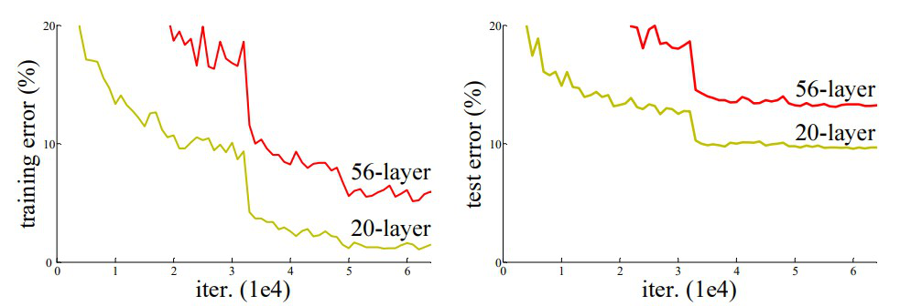

Here 56 layer CNN gives more errors than the 20 Layer CNN. In order to solve the problem of Vanishing/exploding gradient, we use Residual Network. In this network we use technique called skip connections, which skips few layers and directly connects to the output layer. The main advantage of this network is that if any layer hurts the performance, that layer can be skipped by regularization.