GOVERNMENT ENGINEERING COLLEGE, BHAVNAGAR
DEPARTMENT OF COMPUTER ENGINEERING
PBL ACTIVITY 2
ZERO-TRUST NETWORK ARCHITECTURE: ARCHITECTURE AND PROTOCOL OPERATION
Subject: Computer Networks
Semester: V (Third Year)
Academic Year: 2026–2027
Student Name: Sanjay Bhut
Enrolment Number: 240210107005
Division: V Division E
Topic Number (Y): 5
Focus Dimension (X): 0 – Architecture and Protocol Operation
Faculty Name: ____________________
Student Signature: ____________________

Abstract
Zero-Trust Network Architecture (ZTNA) is a modern cybersecurity approach that does not automatically trust users, devices, or applications based on their location inside or outside an organization’s network [1], [2]. Traditional security models often depend on a trusted internal network protected by a firewall [1]. However, cloud computing, remote work, mobile devices, and cyberattacks have made this approach less effective [1]. Zero Trust follows the principle of “never trust, always verify,” requiring access requests to be authenticated, authorized, and evaluated according to security policies.
This report studies the architecture and protocol operation of Zero Trust. It explains its main components, including the Policy Engine, Policy Administrator, Policy Enforcement Point, identity provider, and security monitoring systems [1]. It also describes how protocols such as OAuth 2.0 [3], OpenID Connect [4], and Transport Layer Security (TLS) support secure authentication, authorization, and communication. A comparison between traditional network security and Zero Trust highlights the benefits and implementation challenges of this approach. Zero Trust can improve access control, reduce unauthorized access, and support secure communication in modern network environments when implemented with suitable policies and continuous monitoring.

1. Introduction
Network security is an important requirement for organizations that use computer networks to store, process, and exchange information. Traditional network security generally follows a perimeter-based approach in which a firewall protects the internal network from external threats. Users and devices inside the network may receive greater trust than those outside it [1].
However, modern organizations use cloud platforms, remote access, mobile devices, and distributed applications. Employees may access organizational resources from different locations and devices. Attackers may also obtain valid credentials or compromise devices and attempt to access internal resources. Therefore, being connected to an internal network does not necessarily mean that a user or device is safe [1].
Zero-Trust Network Architecture addresses this problem by removing automatic trust based on network location. Every access request must be evaluated according to identity, device condition, requested resource, and applicable security policies. Access should be limited to the resources required for a particular task [1].
The National Institute of Standards and Technology (NIST) describes Zero Trust as a collection of concepts and principles designed to reduce uncertainty when making access decisions [1]. This report focuses on the architecture and protocol operation of Zero Trust and explains how its components cooperate to provide secure access to network resources.

2. Technical Background

2.1 Traditional Network Security
Traditional network security commonly uses a perimeter-based model. Firewalls, gateways, and intrusion detection systems protect an organization’s internal network from external threats. Once a user enters the trusted network, access may depend largely on network location and assigned permissions [1].
This approach can be useful for clearly defined network environments, but it has limitations. If an attacker compromises an authorized account or gains access to an internal device, the attacker may attempt to move toward other systems. Remote work and cloud services also make it difficult to define a single trusted network boundary [1].

2.2 Zero-Trust Principles
Zero Trust is based on several important principles [1]:
- Verify explicitly: Authenticate and authorize access using available identity, device, and contextual information.
- Use least privilege: Give users and devices only the permissions necessary to perform their tasks.
- Assume breach: Design security controls with the expectation that an attacker may already be present.
- Monitor continuously: Collect and evaluate security information to identify suspicious activity.
- Protect every resource: Apply security controls to applications, services, data, and devices rather than relying only on network location.
Zero Trust is not a single product. It is a security architecture that combines identity management, access control, monitoring, and enforcement technologies [1].

3. Architecture and Protocol Operation

3.1 Main Components of Zero-Trust Architecture
The architecture described in NIST Special Publication 800-207 includes several logical components that work together to make and enforce access decisions [1].

3.1.1 Policy Engine (PE)
The Policy Engine makes the final decision about whether a particular access request should be allowed, denied, or handled under specified conditions. It evaluates information such as the user’s identity, device security status, requested resource, and organizational security policies.
The Policy Engine may also consider information from security monitoring systems and threat intelligence sources [1]. Its decision is based on the organization’s defined rules and the available evidence.

3.1.2 Policy Administrator (PA)
The Policy Administrator carries out the decision made by the Policy Engine. It establishes, adjusts, or terminates the communication path between the requesting subject and the protected resource through the relevant enforcement mechanism [1].
The Policy Administrator does not independently replace the Policy Engine’s decision-making role. Instead, it helps translate the access decision into an operational action [1].

3.1.3 Policy Enforcement Point (PEP)
The Policy Enforcement Point controls access between a user or device and a protected resource. It applies the access decision by allowing, restricting, or blocking the connection [1].
A PEP may be implemented through a gateway, proxy, endpoint agent, or another suitable enforcement mechanism [1]. Its purpose is to ensure that access is provided only according to the applicable policy.

3.1.4 Identity Provider (IdP)
The Identity Provider verifies the identity of users and may support authentication through passwords, multi-factor authentication, certificates, or other mechanisms [1]. It provides identity-related information that can be used during access evaluation.
Identity verification is an important part of Zero Trust, but successful authentication alone does not automatically guarantee access to every resource [1].

3.1.5 Security Monitoring and Data Sources
Monitoring systems collect information about network traffic, user activity, device health, authentication events, and possible threats [1]. This information can support access decisions and help identify suspicious behavior.
Security information and event management systems (SIEM), endpoint detection tools, and device-management systems may contribute relevant information to a Zero-Trust deployment.

3.2 Working of Zero-Trust Architecture
The access process can be explained through the following steps:
Step 1: Access Request
A user or device requests access to a protected application, server, or other organizational resource. The request reaches the relevant access enforcement mechanism.
Step 2: Identity Verification
The user’s identity is verified through the Identity Provider. Multi-factor authentication may be required when the resource or risk level demands stronger verification.
Step 3: Device and Context Evaluation
The organization evaluates relevant information, such as device security status, location-related risk signals, the requested resource, and the user’s assigned permissions [1]. The exact information depends on the implementation.
Step 4: Policy Decision
The Policy Engine evaluates the available information against organizational security policies. It decides whether the request should be allowed, denied, or subject to additional conditions [1].
Step 5: Policy Enforcement
The Policy Administrator coordinates the operational response, while the Policy Enforcement Point applies the decision. If access is permitted, communication is established according to the policy. If access is denied, the connection is blocked [1].
Step 6: Monitoring and Re-evaluation
The organization monitors relevant activity and may re-evaluate access when the risk level or security context changes. Access can be restricted or terminated when policy requirements are no longer satisfied [1].
This process helps ensure that access is based on verified identity, permissions, and relevant security conditions rather than simply trusting a device because it is connected to an internal network [1].

3.3 Protocols Used in Zero-Trust Architecture

3.3.1 OAuth 2.0
OAuth 2.0 is an authorization framework that allows an application to obtain limited access to protected resources through access tokens. Instead of sharing a user’s password with every application, a client can obtain a token according to the authorization server’s rules [3].
In a Zero-Trust environment, OAuth 2.0 can support controlled access to APIs and applications. The resource server validates the token and applies the relevant authorization rules. OAuth 2.0 is primarily an authorization framework; it does not, by itself, define a complete user-authentication system [3], [4].

3.3.2 OpenID Connect (OIDC)
OpenID Connect is an identity layer built on top of OAuth 2.0. It enables a client application to verify a user’s identity through an OpenID Provider and receive identity information in an ID Token [4].
OIDC can support centralized authentication and single sign-on. In a Zero-Trust architecture, it helps establish identity information that can be considered alongside device status, permissions, and other security conditions.

3.3.3 Transport Layer Security (TLS)
Transport Layer Security protects communication between systems by providing encryption, integrity protection, and authentication according to the configured TLS version and certificate validation process.
TLS helps protect access requests and data exchanged between clients, gateways, and services. Mutual TLS can also be used when both communicating systems need to authenticate using certificates.

3.3.4 Multi-Factor Authentication (MFA)
Multi-factor authentication requires users to verify their identity using more than one category of authentication factor. These may include something the user knows, something the user possesses, or a biometric characteristic.
MFA can reduce the risk associated with stolen passwords. However, it should be combined with authorization controls, device assessment, monitoring, and other security measures [1].

3.4 Example of Protocol Operation
Consider an employee who wants to access a company’s internal application from a laptop.
First, the employee submits an access request. The identity system authenticates the employee and may require MFA. The application or access gateway obtains the necessary identity and authorization information. Device-security information and the requested resource are then evaluated according to the organization’s policy.
The Policy Engine decides whether the request satisfies the required conditions. The Policy Administrator coordinates the decision, and the Policy Enforcement Point permits or blocks the connection [1]. If access is allowed, TLS can protect communication with the application. An authorization token may be used where the application architecture supports OAuth 2.0 [3].
Security monitoring continues during use, and the organization may reassess access if suspicious activity or a change in device status is detected [1].

3.5 Zero-Trust Architecture Diagram
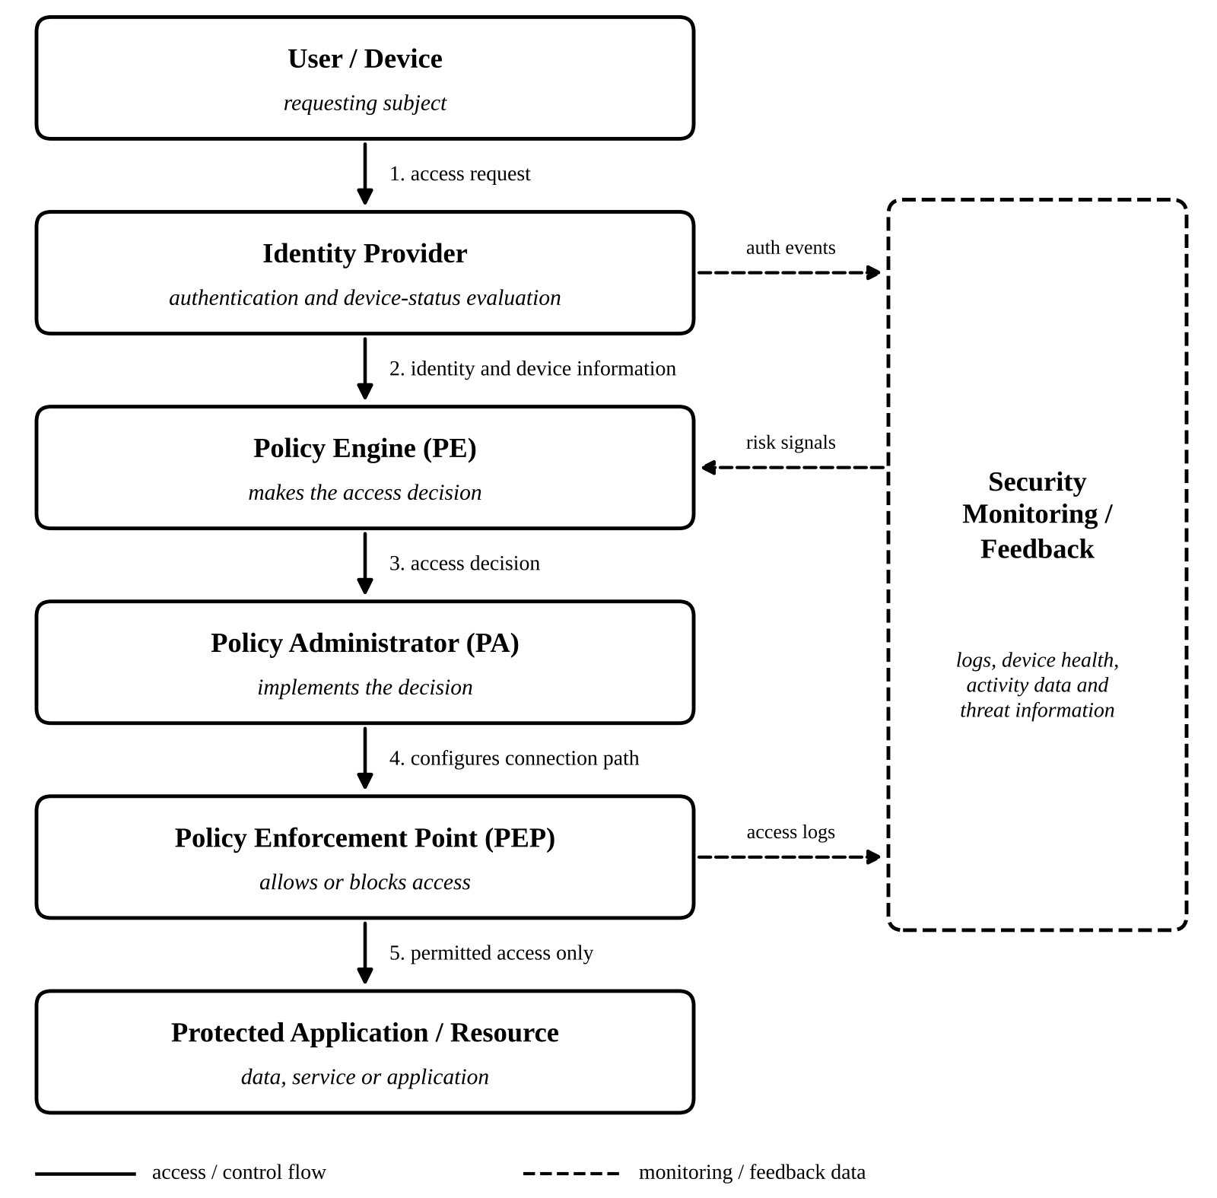
Figure 1: Logical Zero-Trust Access Architecture.
Security monitoring and policy feedback support the process throughout the architecture [1].
Note: This is a simplified logical representation. Actual deployments may combine components or implement them using different technologies [1].

4. Comparison Between Traditional Security and Zero Trust
Feature | Traditional Perimeter Security | Zero-Trust Architecture
Trust model | Often gives greater trust to the internal network [1] | Does not automatically trust based on network location [1]
Access decision | May depend heavily on network boundary and permissions | Evaluates identity, resource, context, and policy [1]
Authentication | Often performed at network entry or application login | Can use explicit verification and additional checks [1]
Access privileges | May provide broad internal access in some deployments [1] | Encourages least-privilege access [1]
Monitoring | Often emphasizes perimeter traffic | Can monitor users, devices, applications, and sessions [1]
Remote access | Commonly relies on VPN or perimeter gateways | Can use identity-aware, resource-specific access controls
Implementation | May be simpler in established environments | Requires coordination among identity, devices, policies, and monitoring
Zero Trust does not mean that firewalls, VPNs, or other traditional security technologies must be removed. These technologies may continue to be useful as part of a broader Zero-Trust implementation [1].

5. Discussion
Zero-Trust Network Architecture offers several benefits for modern organizations. It reduces dependence on the traditional network perimeter and encourages access decisions based on verified identity, permissions, and contextual information. Least-privilege access can limit unnecessary permissions, while monitoring and re-evaluation can help identify suspicious activity [1].
Zero Trust is particularly relevant to organizations that use cloud services, remote access, distributed applications, and devices operating from different locations. It can also support more controlled access to sensitive applications and data [1].
However, implementation has challenges. Organizations may need to integrate identity providers, device-management platforms, application gateways, monitoring systems, and existing infrastructure [1]. Legacy applications may not support modern authentication or fine-grained access controls. Collecting and evaluating security information also requires suitable policies, trained staff, and careful configuration.
Another challenge is balancing security and usability. Excessive authentication requirements or incorrect access policies can interrupt legitimate work [1]. Therefore, policies should be tested, access requirements should be clearly defined, and monitoring should be reviewed regularly.
The effectiveness of Zero Trust depends on the quality of its implementation. Adopting a product labelled as Zero Trust does not automatically make a network secure. Organizations should apply the architecture according to their risks, protect credentials, review permissions, monitor activity, and improve controls continuously [1], [5].

6. Conclusion
Zero-Trust Network Architecture is an important approach to protecting modern networks. Instead of trusting users and devices based on their network location, it requires access requests to be evaluated using identity, authorization, contextual information, and security policies [1].
The Policy Engine, Policy Administrator, and Policy Enforcement Point perform complementary roles in making and enforcing access decisions [1]. Protocols such as OAuth 2.0 [3], OpenID Connect [4], and TLS support authorization, identity verification, and secure communication in suitable deployments.
Although Zero Trust can improve access control and reduce unnecessary trust, successful implementation requires planning, integration, monitoring, and regular evaluation. Organizations should introduce Zero-Trust controls according to their operational requirements and security risks [1], [5]. When properly implemented, this architecture can improve the protection of applications, data, and network resources.

7. References
[1] S. Rose, O. Borchert, S. Mitchell, and S. Connelly, “Zero Trust Architecture,” NIST Special Publication 800-207, National Institute of Standards and Technology, Aug. 2020. [Online]. Available: https://doi.org/10.6028/NIST.SP.800-207
[2] National Institute of Standards and Technology, “Zero Trust Architecture.” [Online]. Available: https://www.nist.gov/publications/zero-trust-architecture
[3] D. Hardt, Ed., “The OAuth 2.0 Authorization Framework,” RFC 6749, Internet Engineering Task Force, Oct. 2012. [Online]. Available: https://www.rfc-editor.org/rfc/rfc6749
[4] OpenID Foundation, “OpenID Connect Core 1.0 Incorporating Errata Set 2.” [Online]. Available: https://openid.net/specs/openid-connect-core-1_0.html
[5] Cybersecurity and Infrastructure Security Agency, “Zero Trust Maturity Model.” [Online]. Available: https://www.cisa.gov/zero-trust-maturity-model

Student Declaration
I declare that I have reviewed this report and understand the concepts discussed in it. I have identified the sources used and will verify the content, make the required changes in my own words, and follow the institution’s academic-integrity requirements.
Student Signature: ____________________
Date: ____________________

