GOVERNMENT ENGINEERING COLLEGE, BHAVNAGAR
DEPARTMENT OF COMPUTER ENGINEERING
PBL ACTIVITY 3
COLONIAL PIPELINE RANSOMWARE ATTACK:
CONTAINMENT AND RECOVERY
Subject: Computer Networks
Semester: V (Third Year)
Academic Year: 2026–2027
Student Name: Sanjay Bhut
Enrolment Number: 240210107005
Division: V Division E
Incident Number (X): 0
Analysis Dimension (Y): 5 – Containment and Recovery
Faculty Name: ____________________
Student Signature: ____________________

Abstract
The Colonial Pipeline ransomware attack of May 2021 showed how a cybersecurity incident can disrupt critical infrastructure. Colonial Pipeline stated that it took certain systems offline to contain the threat, which temporarily halted pipeline operations [3]. The Federal Bureau of Investigation (FBI) confirmed that DarkSide ransomware was responsible for the compromise [2]. This report examines the incident with a focus on containment and recovery. It also recommends network segmentation, strong access controls, tested backups, incident-response planning, and continuous monitoring. These recommendations reflect general good practice [5]; they are not confirmed facts about Colonial Pipeline’s own systems.

1. Incident at a Glance
Item | Details
Organization | Colonial Pipeline Company
Sector | Fuel transportation and critical infrastructure
Country | United States
Incident date | May 7, 2021 (the date the company learned of the attack) [3]
Incident type | Ransomware cyberattack [3]
Threat group | DarkSide, as confirmed by the FBI [2]
Main response | Systems taken offline to contain the threat; temporary halt of operations; restart initiated May 12 [3]
Analysis focus | Containment and Recovery

2. Background
Colonial Pipeline Company operates a major pipeline system that moves refined petroleum products, including gasoline, diesel, and jet fuel, across parts of the United States [3]. Colonial Pipeline stated that it learned on May 7, 2021 that it had been the victim of a cybersecurity attack, later determined to involve ransomware. It took certain systems offline to contain the threat, which temporarily halted pipeline operations and affected some of its information technology (IT) systems [3]. The sources reviewed do not state that operational technology (OT) systems were directly compromised, and this report makes no such claim.
The incident shows that a problem in corporate IT systems can have consequences beyond data. This report focuses on containment and recovery: limiting the consequences of an attack, investigating it, and restoring services in a controlled manner.

3. What Happened? — Incident Timeline

3.1 May 7, 2021: Incident Discovered
The FBI was notified of a network disruption at Colonial Pipeline on May 7 [1]. The company learned that day that it was the victim of a cybersecurity attack and took certain systems offline to contain the threat, temporarily halting pipeline operations [3].

3.2 May 8–9, 2021: Response and Investigation
Colonial Pipeline continued to publish updates on its response [3]. On May 9, the FBI stated that it was working closely with the company and government partners [1]. That statement did not name a ransomware group.

3.3 May 10, 2021: FBI Attribution to DarkSide
The FBI confirmed that DarkSide ransomware was responsible for the compromise of Colonial Pipeline networks [2].

3.4 May 12, 2021: Pipeline Restart Initiated
Colonial Pipeline initiated the restart of pipeline operations at approximately 5 p.m. ET on May 12 [3]. On May 13 it said the supply chain would need several days to return to normal. By May 17 it reported products moving at normal levels, while noting that the fuel supply chain would need time to fully catch up [3].

3.5 June 7, 2021: Cryptocurrency Seizure Announced
The U.S. Department of Justice (DOJ) announced the seizure of 63.7 bitcoins, valued at approximately $2.3 million, which it described as proceeds of the ransom payment that Colonial Pipeline reported making [4]. Figure 2 summarizes the confirmed events described above [1]–[4].
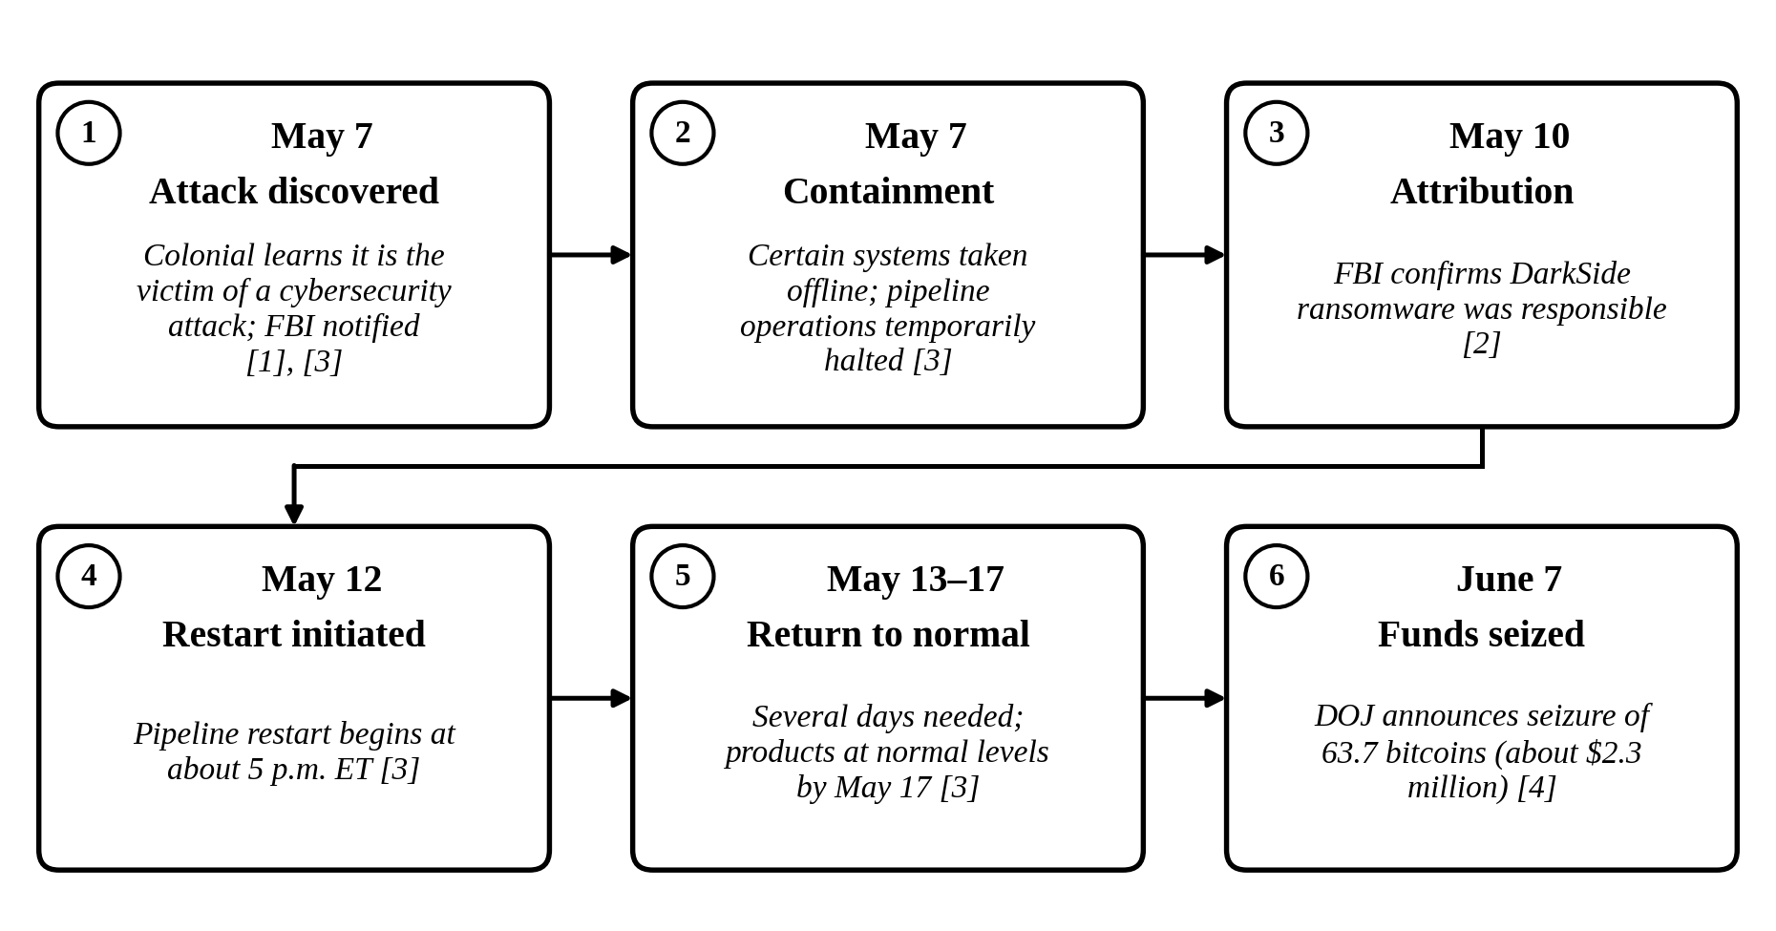
Figure 2: Incident-Specific Timeline of the Colonial Pipeline Response (confirmed public statements only)

4. Core Analysis: Containment and Recovery

4.1 Containment Measures
Containment limits the damage from a cyber incident and helps prevent further spread or unauthorized activity. Colonial Pipeline stated that it took certain systems offline to contain the threat, temporarily halting pipeline operations [3].
This illustrates the tension between security and availability: continuing operations without understanding the risk adds uncertainty, while stopping a critical service affects customers and supply chains. The public statements reviewed do not describe every internal containment action, so this report does not claim that any particular server, account, or network segment was isolated or disabled.
Recommended practice (not confirmed for this incident): isolate affected systems, restrict compromised accounts, preserve logs and forensic evidence, and check whether other systems are affected [5].

4.2 Recovery Measures
Recovery restores services while ensuring the environment is sufficiently secure. Colonial Pipeline initiated the restart of its pipeline system on May 12, 2021 [3]. A restart is a milestone rather than the end of recovery: the company itself said the supply chain would need several days to normalize [3].
Recommended practice: assess affected systems, validate integrity, investigate the cause, restore services in order of importance, and monitor during and after restoration [5]. Business-continuity planning, including backup arrangements, alternative procedures, communication channels, and recovery priorities, should be prepared before an incident occurs [5].

4.3 Coordination with Government Agencies
The FBI worked with Colonial Pipeline and government partners [1], [2] and publicly confirmed DarkSide’s involvement on May 10 [2]. On June 7, the DOJ announced the seizure of cryptocurrency associated with the ransom payment [4]. Response can therefore extend beyond technical recovery to financial investigation.

4.4 Challenges in Containment and Recovery
The incident highlights several challenges.
- Early uncertainty: The full extent of a compromise may not be known at the start.
- Security versus availability: Suspending a critical service reduces uncertainty but can disrupt essential supply.
- Safe restoration: Systems must be checked before services return to normal.
- Coordination: Technical teams, management, agencies, and the public may need timely information.
- Longer-term recovery: A restart does not mean the wider supply chain is immediately normal [3].

4.5 Recommended Containment and Recovery Workflow
Figure 1 shows a recommended workflow for critical-infrastructure operators, based on general incident-response principles [5]. It does not claim that Colonial Pipeline followed each step, and it is not an internal attack-path diagram.
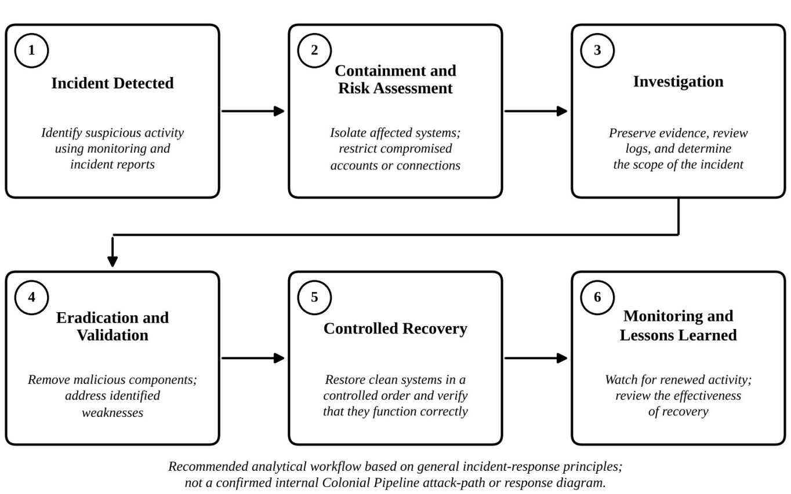
Recommended analytical workflow based on general incident-response principles; not a confirmed internal Colonial Pipeline attack-path or response diagram.
Figure 1: Recommended Containment and Recovery Workflow

5. Impact of the Incident

5.1 Operational Impact
Taking systems offline temporarily halted pipeline operations [3], and the DOJ described the attack as taking portions of Colonial Pipeline’s infrastructure out of operation [4]. The event shows how a cyber incident can interrupt an essential physical service.

5.2 Impact on Fuel Supply and the Public
On May 13, Colonial Pipeline said some markets might see intermittent service interruptions while the supply chain returned to normal [3]. The sources reviewed do not quantify shortages.

5.3 Economic Impact
A major interruption to fuel transportation can create costs for incident response, system recovery, logistics, and business continuity. The sources reviewed give no cost figures, so none are claimed.

5.4 Cybersecurity and National Security Impact
The involvement of the FBI and the DOJ [2], [4] reflects the national importance of fuel transportation. The incident illustrates the need for ransomware preparedness, recovery planning, and cooperation between private organizations and government agencies.

6. Lessons Learned and Recommendations
The following are recommended practices based on general guidance such as [5], not confirmed findings about Colonial Pipeline’s own controls.

6.1 Network Segmentation
Separate corporate IT and OT networks where appropriate, and restrict, monitor, and test access between them to reduce the risk that a compromise in one environment affects the other.

6.2 Strong Access Controls
Use multi-factor authentication, strong authentication policies, and least-privilege access. Review privileged accounts regularly and remove access that is no longer required.

6.3 Regular Backups and Recovery Testing
Back up data and system configurations regularly, protect backups from unauthorized modification, and test restoration periodically to confirm that recovery meets time objectives.

6.4 Incident-Response and Business-Continuity Planning
Maintain a plan that defines responsibilities, escalation, communication, and recovery priorities, and exercise it against ransomware scenarios.

6.5 Continuous Monitoring and Employee Awareness
Monitor suspicious logins, unusual network traffic, and unexpected system changes. Train employees to recognize phishing and to report unusual activity early.
Controls should reflect each organization’s risk assessment and be tested carefully to avoid creating additional operational risk.

7. Own Assessment / Critical Evaluation
In my assessment, the incident shows that cybersecurity is directly connected to the reliability of critical infrastructure. Taking systems offline to contain the threat illustrates how difficult it is to balance security risk against the need to maintain essential services.
Preparation matters most. Segmentation, strong authentication, tested backups, monitoring, and a documented response plan can limit damage and support recovery, but only if tested regularly and supported by trained staff. The incident also shows the value of cooperation between companies and government agencies.
In my opinion, recovery should not be measured only by how quickly a service restarts. It should include verifying security, monitoring for further threats, reviewing causes, and improving procedures. A limitation of this analysis is that it relies on public high-level statements, which do not reveal Colonial Pipeline’s internal technical actions.

8. Conclusion
The Colonial Pipeline ransomware attack of May 2021 showed the serious consequences a cyber incident can have for critical infrastructure. Colonial Pipeline took certain systems offline to contain the threat, temporarily halting operations, and initiated the restart of the pipeline on May 12 [3].
The incident emphasizes effective containment, careful restoration, incident-response planning, and cooperation with authorities. Organizations should strengthen access controls, segment networks, test backups, and practise recovery procedures.

9. References
[1] Federal Bureau of Investigation, “FBI Statement on Network Disruption at Colonial Pipeline,” May 9, 2021. Accessed: Oct. 11, 2026. [Online]. Available: https://www.fbi.gov/news/press-releases/fbi-statement-on-network-disruption-at-colonial-pipeline
[2] Federal Bureau of Investigation, “FBI Statement on Compromise of Colonial Pipeline Networks,” May 10, 2021. Accessed: Oct. 11, 2026. [Online]. Available: https://www.fbi.gov/news/press-releases/fbi-statement-on-compromise-of-colonial-pipeline-networks
[3] Colonial Pipeline Company, “Media Statement Update: Colonial Pipeline System Disruption,” May 2021 (updates dated May 8–17, 2021). Accessed: Oct. 11, 2026. [Online]. Available: https://www.colpipe.com/news-insights/media-resources/post/media-statement-update-colonial-pipeline-system-disruption/
[4] U.S. Department of Justice, “Department of Justice Seizes $2.3 Million in Cryptocurrency Paid to the Ransomware Extortionists Darkside,” June 7, 2021. Accessed: Oct. 11, 2026. [Online]. Available: https://www.justice.gov/archives/opa/pr/department-justice-seizes-23-million-cryptocurrency-paid-ransomware-extortionists-darkside
[5] Cybersecurity and Infrastructure Security Agency, Multi-State Information Sharing and Analysis Center, National Security Agency, and Federal Bureau of Investigation, “#StopRansomware Guide,” 2023. Accessed: Oct. 11, 2026. [Online]. Available: https://www.cisa.gov/stopransomware/ransomware-guide

Student Declaration
I declare that I have reviewed this report and understand the concepts discussed in it. I have identified the sources used and will verify the content, make the required changes in my own words, and follow the institution’s academic-integrity requirements.
Student Signature: ____________________
Date: ____________________

Presentation Handout: Nine Slides
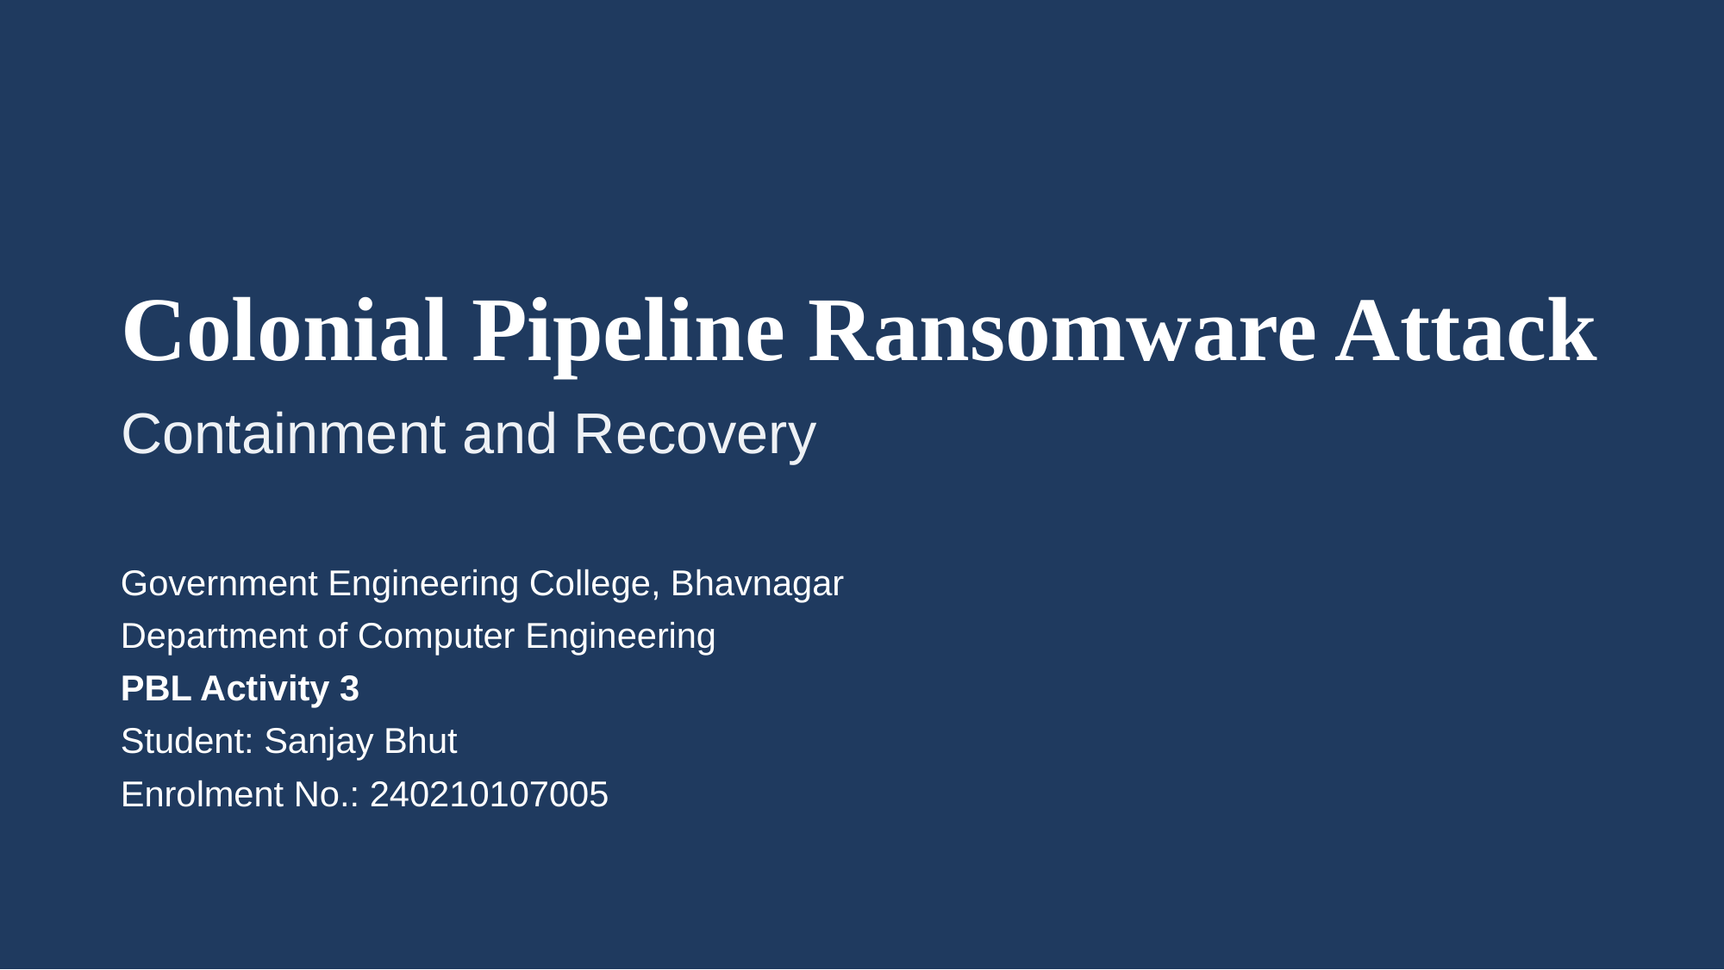
Slide 1 of 9 — References: Title slide (no references)

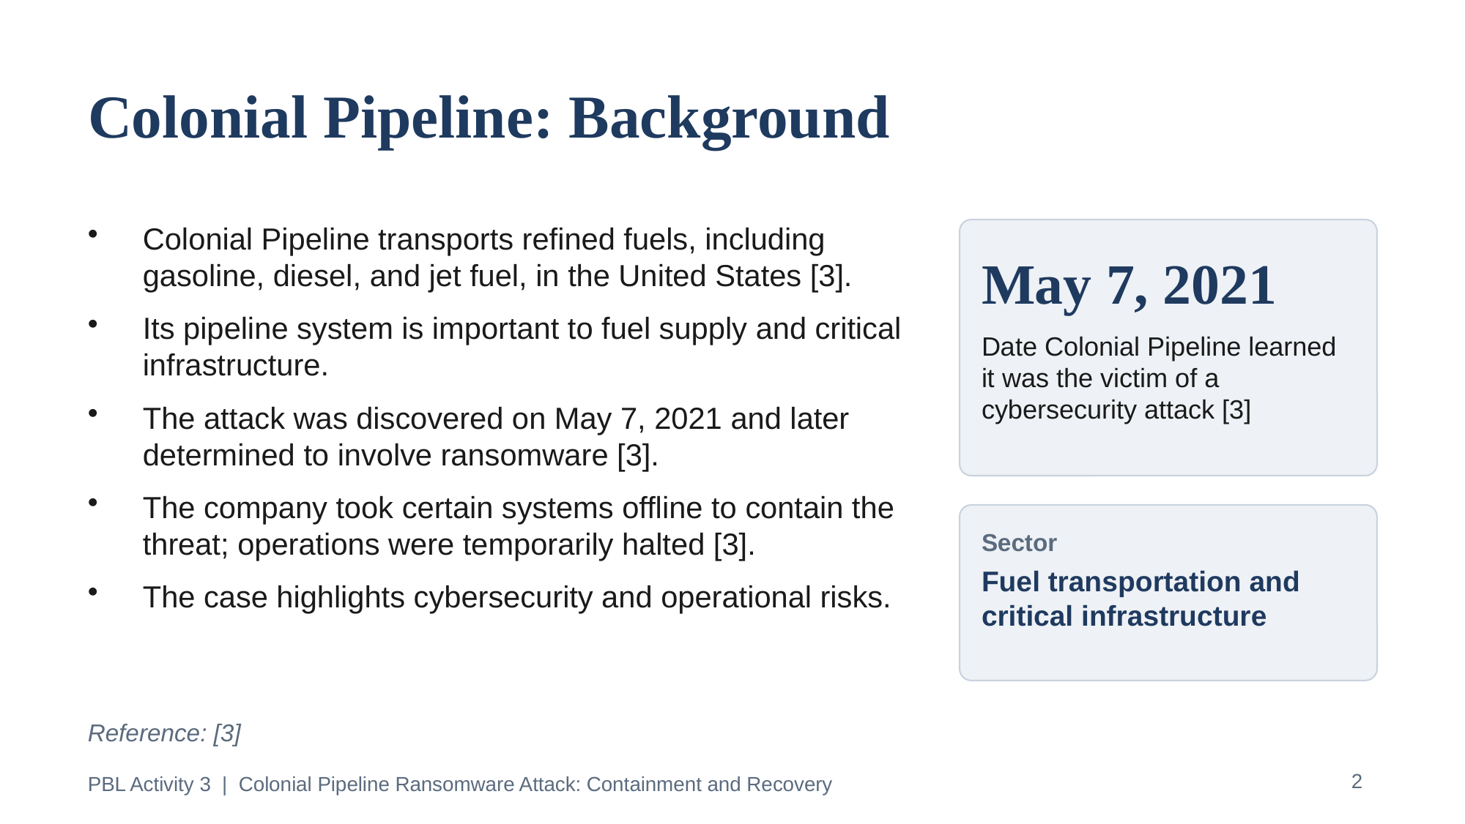
Slide 2 of 9 — References: [3]

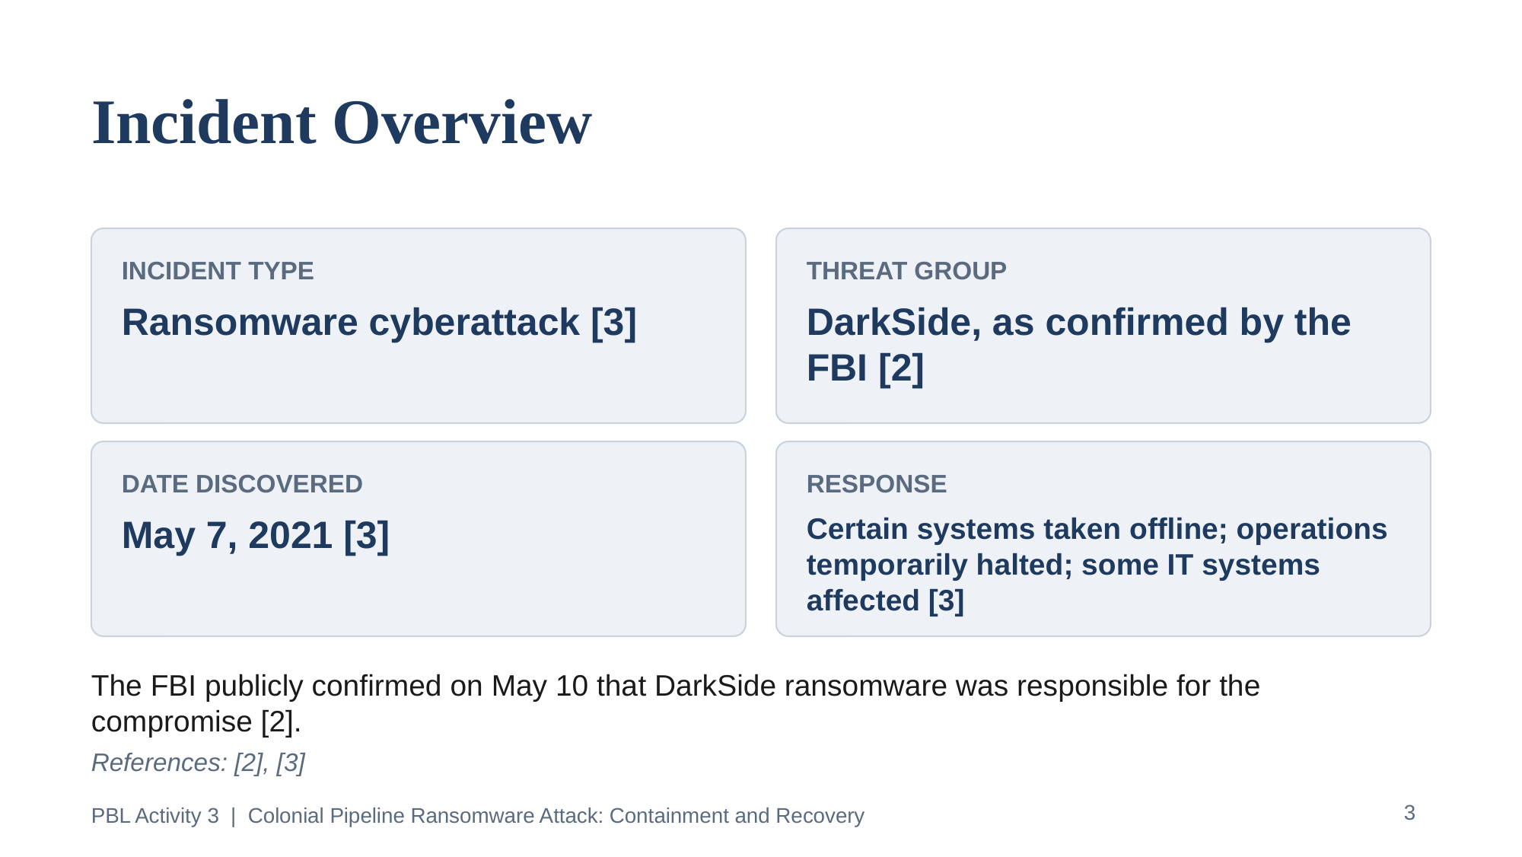
Slide 3 of 9 — References: [2], [3]

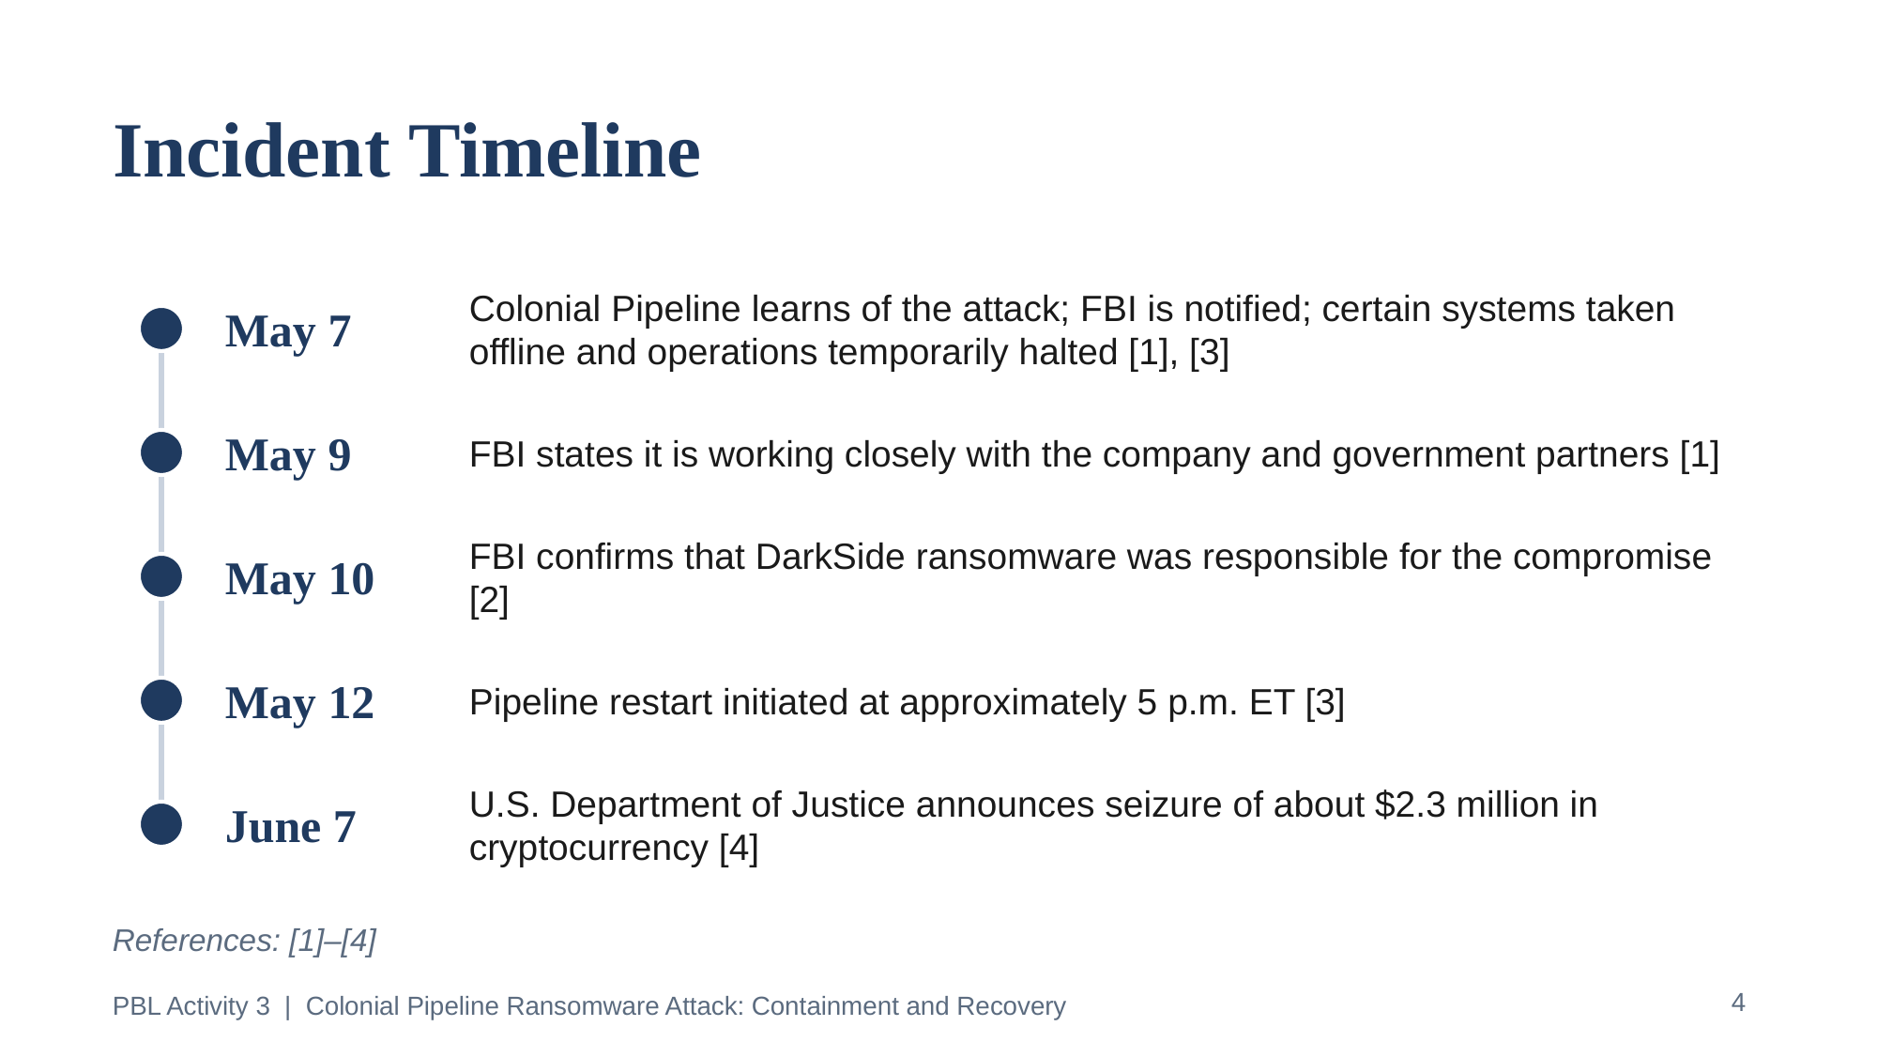
Slide 4 of 9 — References: [1]–[4]

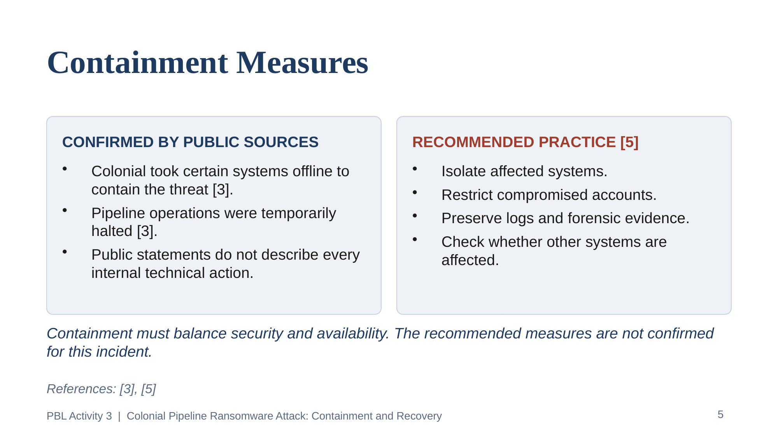
Slide 5 of 9 — References: [3], [5]

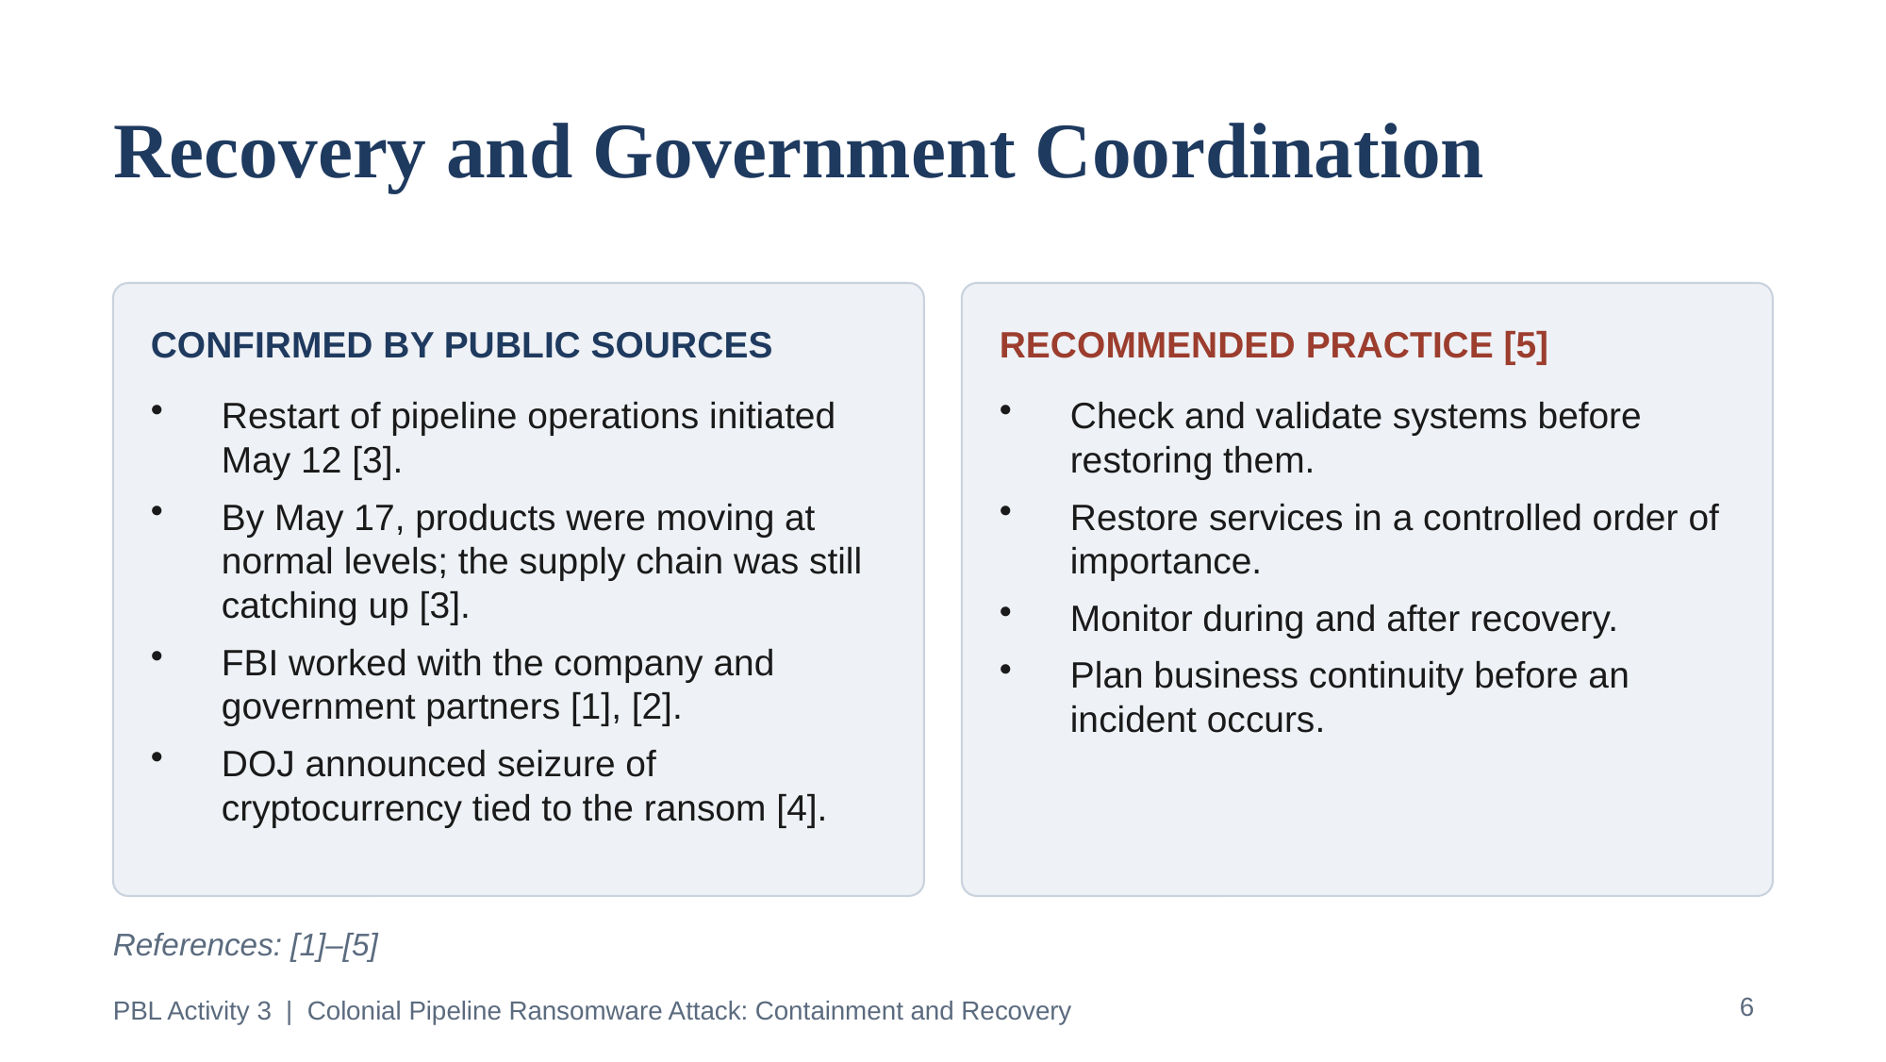
Slide 6 of 9 — References: [1]–[5]

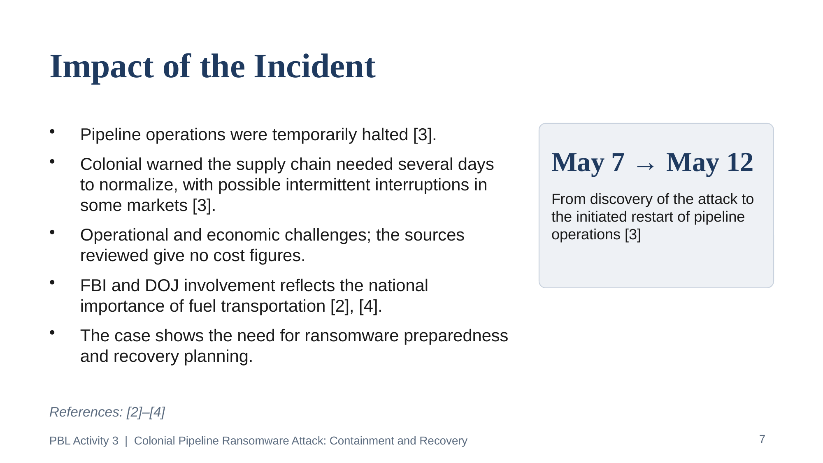
Slide 7 of 9 — References: [2]–[4]

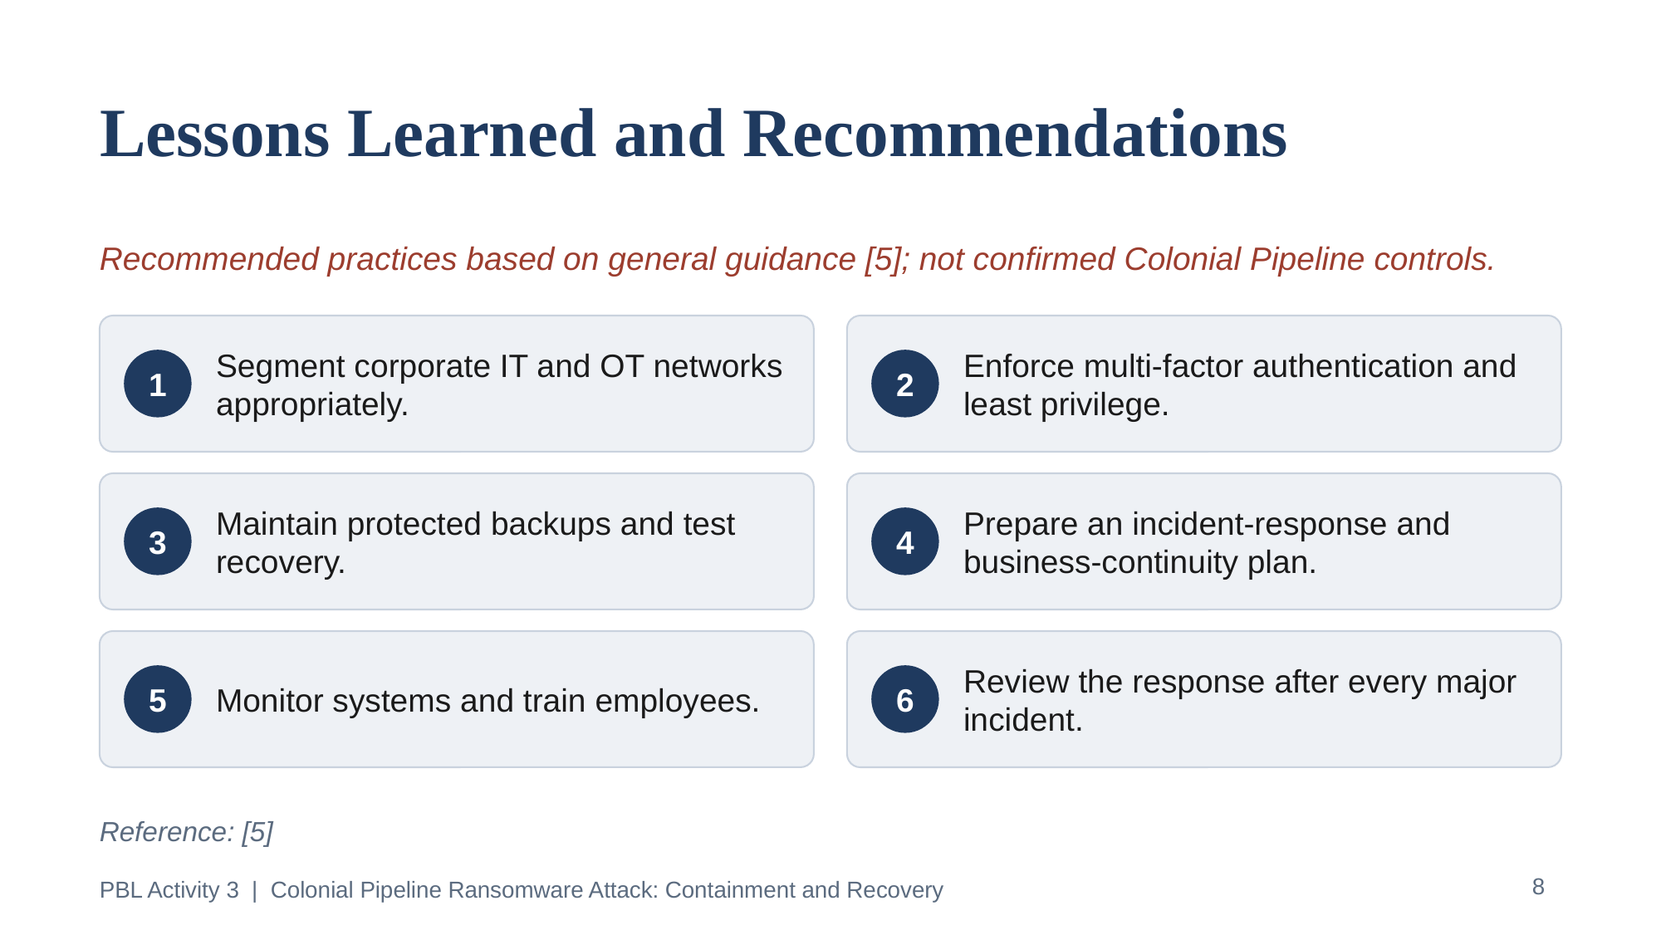
Slide 8 of 9 — References: [5]

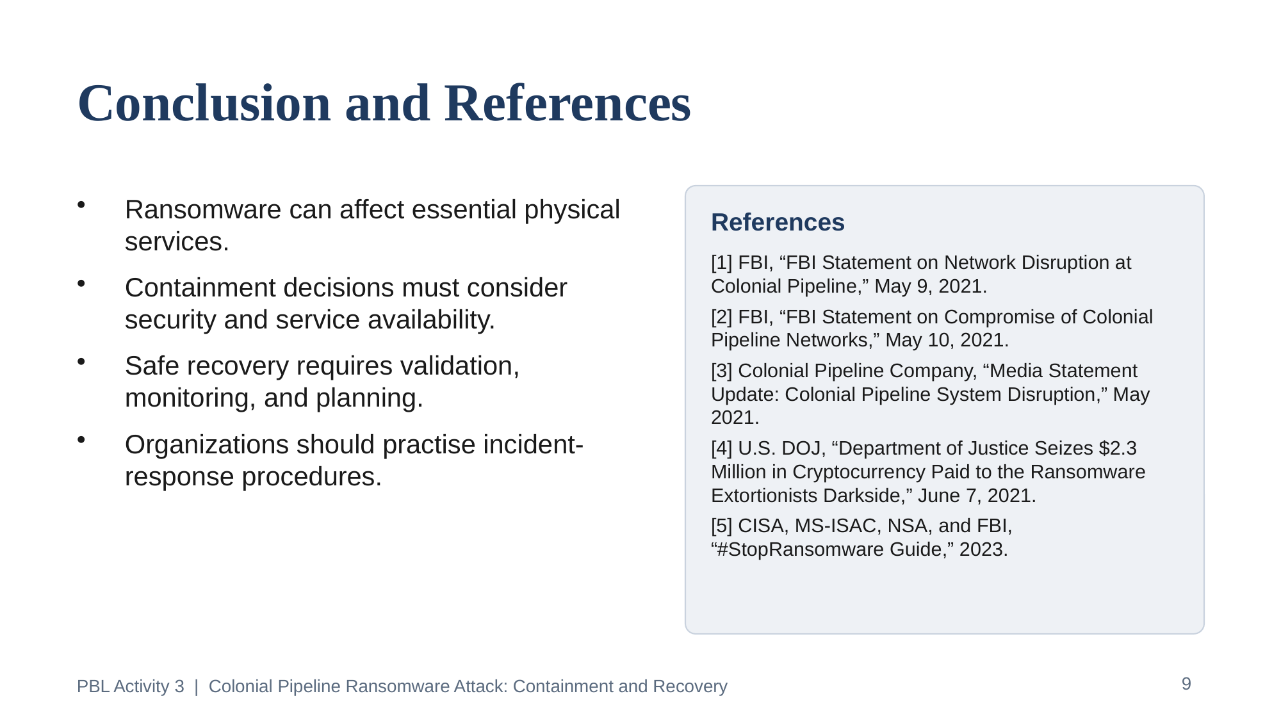
Slide 9 of 9 — References: [1]–[5] (full details in Section 9)

