U24AI034 | OS Assignment-2 | Manav Dhamecha

1. Write a Shell Script to find factorial of a number.

#!/usr/bin/env bash

echo "Enter a number:"
read n

# Check for negative number
if [ "$n" -lt 0 ]; then
echo "Factorial not defined for negative numbers"
exit 0
fi

fact=1

for (( i=1; i<=n; i++ ))
do
fact=$(printf "%s * %s\n" "$fact" "$i" | bc)
done

echo "Factorial of $n is $fact"

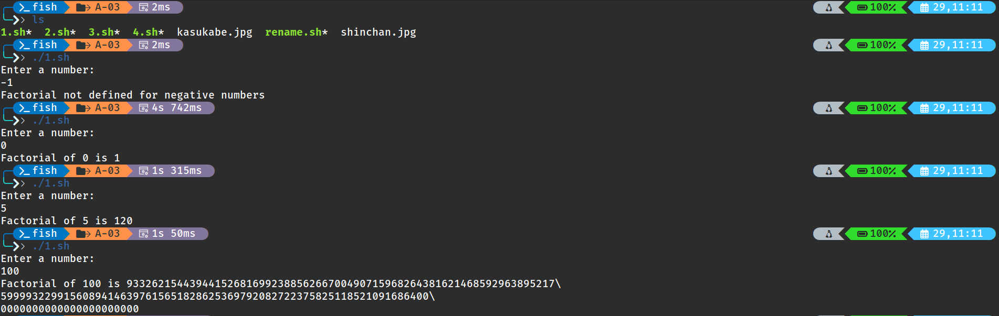

2. Write a shell script for a program to implement an address book with the options
given below:
a) Create an address book.
b) View the address book.
c) Insert a record.
d) Delete a record.
e) Modify a record.
f) Exit.

#!/bin/bash

file="addressbook.txt"

while true
do
echo "--------------------"
echo "ADDRESS BOOK MENU"
echo "1. Create Address Book"
echo "2. View Address Book"
echo "3. Insert Record"
echo "4. Delete Record"
echo "5. Modify Record"
echo "6. Exit"
echo "--------------------"

echo "Enter your choice:"
read ch

case $ch in

1)
> $file
echo "Address Book Created"
;;

2)
cat $file
;;

3)
echo "Enter Name:"
read name
echo "Enter Phone:"
read phone
echo "Enter Email:"
read email

echo "$name $phone $email" >> $file
echo "Record Added"
;;

4)
echo "Enter Name to Delete:"
read name

grep -v "$name" $file > temp.txt
mv temp.txt $file
echo "Record Deleted"
;;

5)
echo "Enter Name to Modify:"
read name

grep -v "$name" $file > temp.txt
mv temp.txt $file

echo "Enter New Phone:"
read phone
echo "Enter New Email:"
read email

echo "$name $phone $email" >> $file
echo "Record Modified"
;;

6)
exit
;;

*)
echo "Invalid Choice"
;;
esac
done

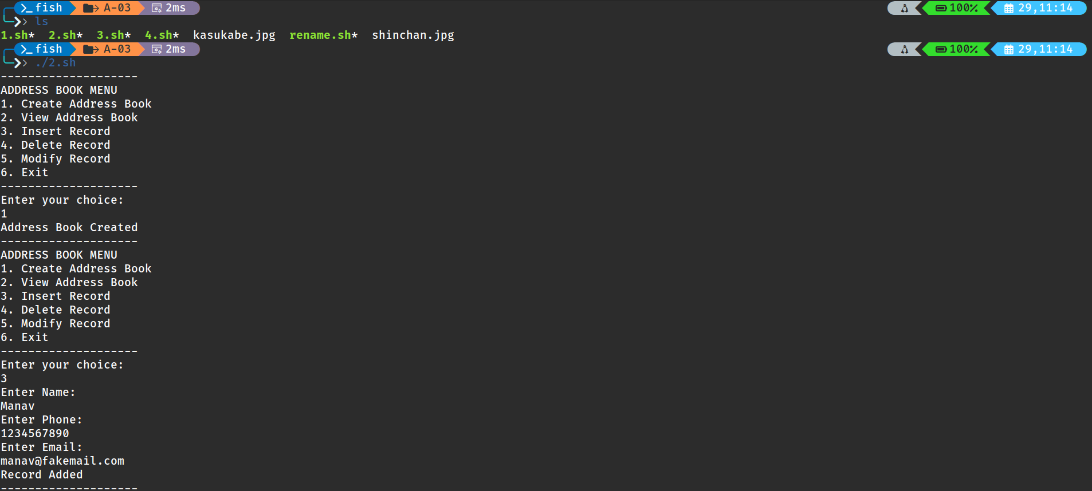

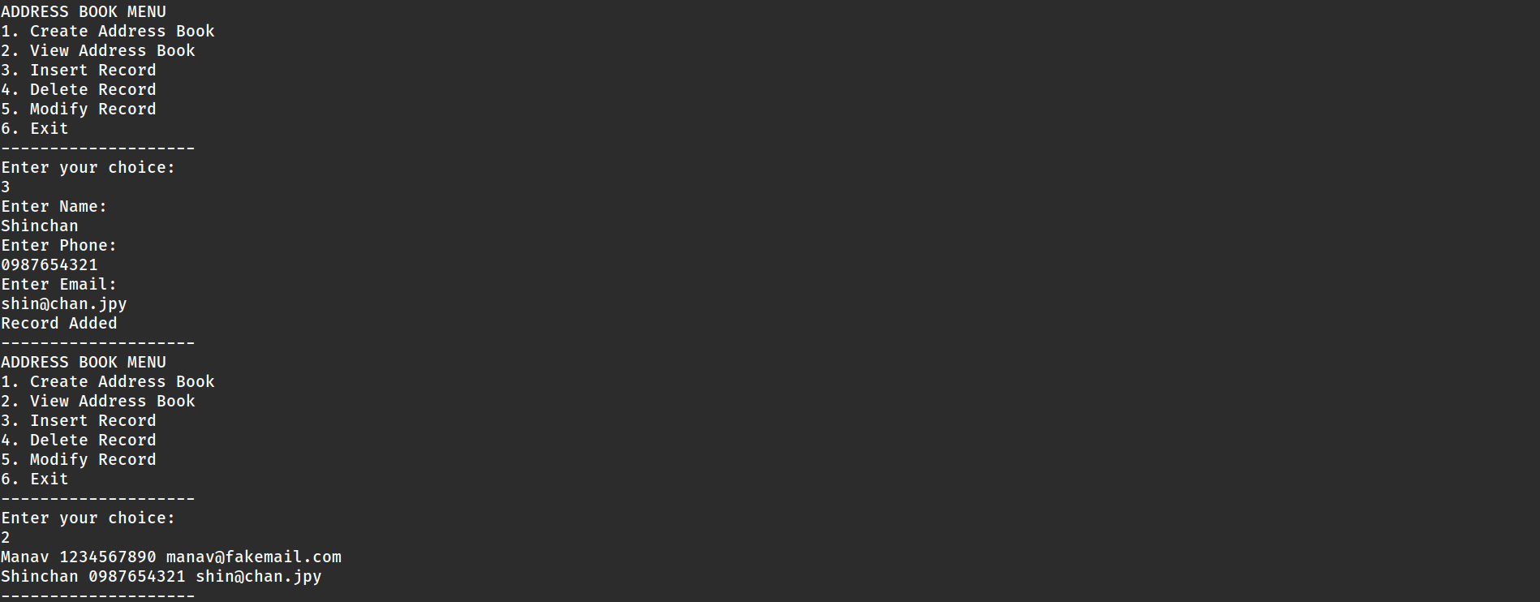
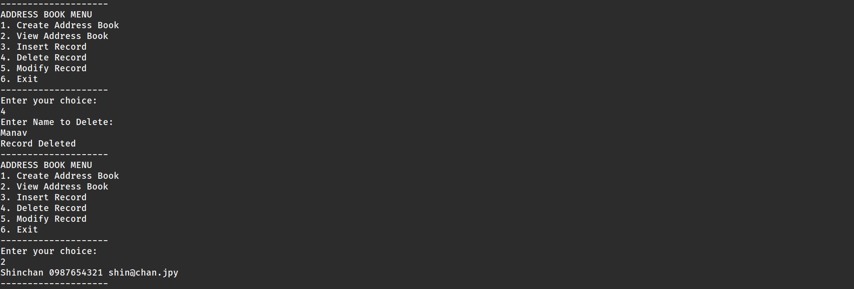
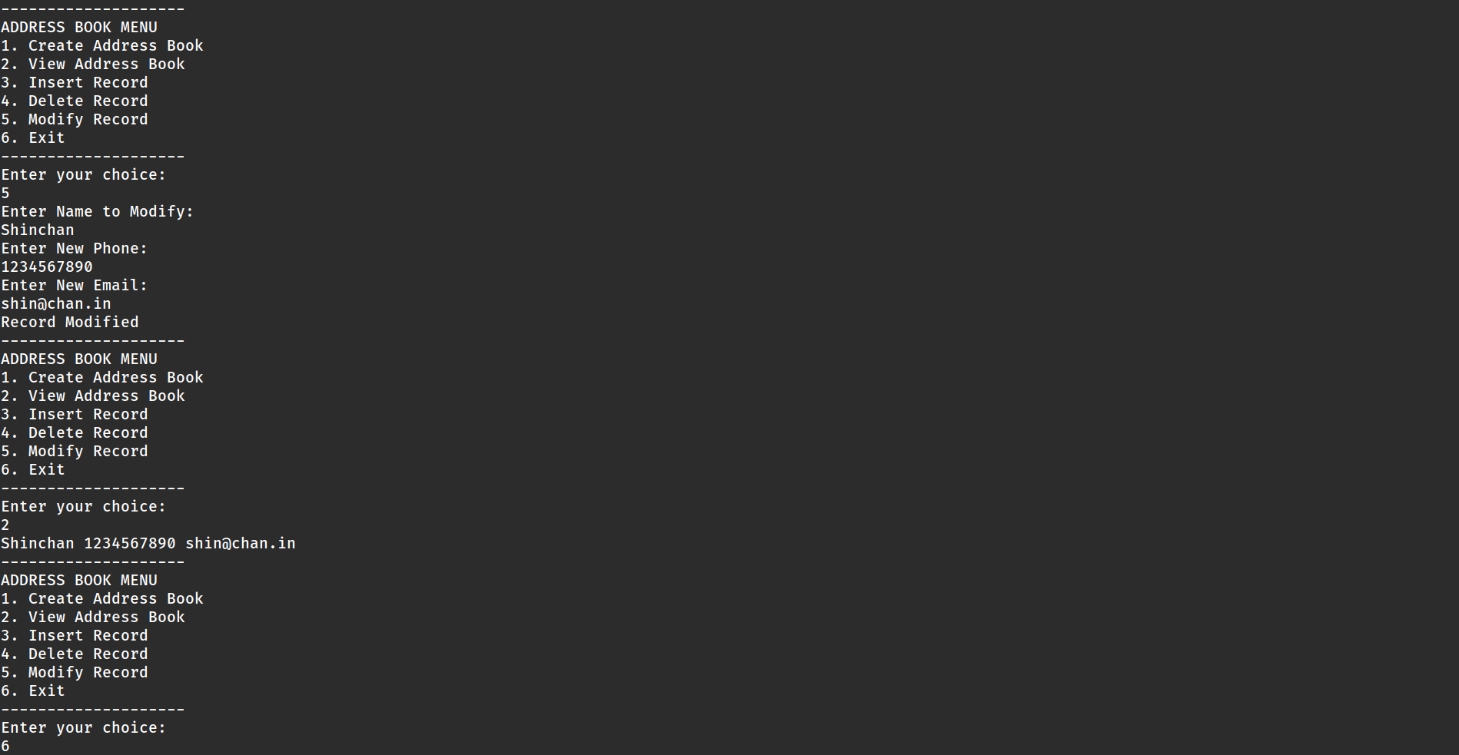

3. Write the shell script that renames all files in the current directory that end in “.jpg”
to begin with today’s date in the following format: YYYY-MM-DD.
For example, if a picture of cat was in the current directory and today was October
31,2016 it would change name from “mycat.jpg” to “2016–10–31-mycat.jpg”

#!/bin/bash

date=$(date +%Y-%m-%d)

for file in *.jpg
do
mv "$file" "$date-$file"
done

echo "All .jpg files renamed successfully"

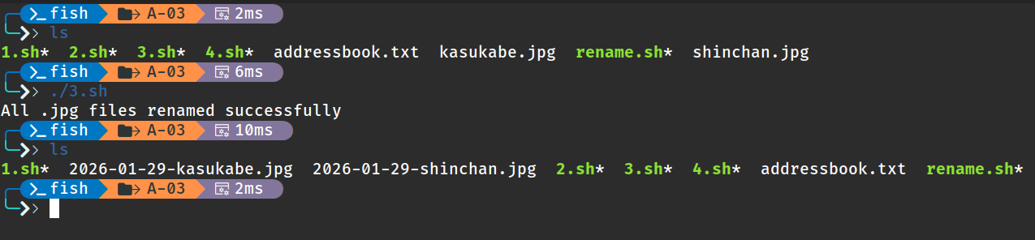

4. Write a shell script for a program with options to calculate the following:
a) Area of a circle
b) Circumference of a circle
c) Area of a rectangle
d) Area of a square

#!/bin/bash

while true
do
echo "-------------------------"
echo "AREA CALCULATION MENU"
echo "1. Area of Circle"
echo "2. Circumference of Circle"
echo "3. Area of Rectangle"
echo "4. Area of Square"
echo "5. Exit"
echo "-------------------------"

echo "Enter your choice:"
read ch

case $ch in

1)
echo "Enter radius:"
read r
area=$(echo "3.14 * $r * $r" | bc)
echo "Area of Circle = $area"
;;
2)
echo "Enter radius:"
read r
circ=$(echo "2 * 3.14 * $r" | bc)
echo "Circumference of Circle = $circ"
;;
3)
echo "Enter length:"
read l
echo "Enter breadth:"
read b
area=$((l * b))
echo "Area of Rectangle = $area"
;;
4)
echo "Enter side:"
read s
area=$((s * s))
echo "Area of Square = $area"
;;
5)
exit
;;
*)
echo "Invalid Choice"
;;
esac
done

